CENTRO DE INVESTIGACIÓN Y DOCENCIA ECONÓMICAS, A.C.



COVID-19 EXCESS MORTALITY AND THE COST-EFFECTIVENESS OF TREATMENTS OPTIONS

TESINA

PARA OBTENER EL GRADO DE

MAESTRÍA EN MÉTODOS PARA EL ANÁLISIS DE POLÍTICAS PÚBLICAS

PRESENTA

HIRVIN AZAEL DIAZ ZEPEDA

DIRECTOR DE LA TESIS: DR. FERNANDO ALARID ESCUDERO

AGUASCALIENTES 2021

Table of Contents

Introduction 1

Methods 1

Relative Survival and Disease-specific Hazard 1

Decision Analytic Model 3

Cost-Effectiveness Analysis 5

Health Outcomes 6

Costs 6

Sensitivity Analyses 6

Results 9

Disease-specific Hazard 9

Cost-effectiveness Analysis 10

Sensitivity Analysis 12

Discussion 15

Key Points for Decision Makers 15

Conslusions 15

List of Tables 17

List of Figures 17

References 18

Appendix 22

COVID-19 specific hazard by month 22

Parameter distributions 23

EVPI and Expected Loss Curves 26

QALEs Table 27

# Introduction

Mexico has experienced one of the worst COVID-19 epidemics worldwide, with high hospitalization and case fatality rates. On March 21, 2021, the Mexican government reported 2,238,887 accumulated cases of COVID-19 and 203,210 deaths1, making Mexico the fourteenth country in the world in confirmed cases and the third in reported deaths.2 Due to this situation, it is essential to study mortality associated with COVID-19 and evaluate treatment options.

Excess mortality during the pandemic has been studied in several countries3–7. These estimates often use public data to estimate expected deaths during the pandemic period and calculate the difference from observed deaths. For example, according to Mexico’s Ministry of Health, the excess mortality for all causes as of March 15, 2021, was 473,581, representing 47.9% more than the expected deaths for this period8. These public data allow us to quantify the COVID-19-specific mortality.

The disease-specific mortality rate is a valuable and essential measure for decision-makers since it allows them to evaluate different strategies to modify and mitigate this outcome. An advantage of this approach is that it provides an opportunity to analyze policies that have not yet been implemented and support decision-making and planning. Obtain this outcome for a cohort with COVID-19 makes it possible to implement an analytic decision model that evaluates different strategies simulating the application of several treatments.

The aims of this analysis are twofold. First, estimate the COVID-19 specific mortality for Mexico’s population aged 45 years and older using relative survival methods. Second, quantify the health outcomes, costs, and cost-effectiveness of different treatments that aim to reduce COVID-19-specific mortality using a microsimulation model.

# Methods

## Relative Survival and Disease-specific Hazard

We used relative survival methods to estimate the COVID-19 specific mortality for Mexico’s population aged 45 years and older. We used data from the Mexican National Epidemiological Surveillance System (SINAVE- Spanish acronym). This dataset includes people tested for SARS-CoV-2 in Mexico. It contains only data obtained from tests performed on those suspected of infection during stays in the medical units of the health sector9. We analyze data only for people with a positive test result, 45 years of age and older, and hospitalized. We classify these patients by sex, age group, and whether they were intubated. We obtained estimates for provide background mortality rates for the Mexican population from the National Population Council demographic indicators in 202010.

A relative survival approach to estimate disease-specific mortality is appropriate when studying data on a cohort of people diagnosed with a specific disease, where follow-up time and information on vital status is available, but the definitive cause of death information is not11. Relative survival is expressed as a time-specific ratio between the survival of the cohort analyzed and the expected survival of a cohort . The relative survival ratio is defined as .11,12 This ratio is similar to the marginal relative survival ratio or net survival 11. This measure is defined as the exponent of the disease-specific hazard : .

The disease-specific hazard or “excess hazard” is derived from the equation of the overall hazard , which is composed of two terms: the previously mentioned excess or disease-specific mortality rate: and a population hazard or a background mortality rate, usually sex- and age-specific : . Thus, the overall hazard or mortality rate is then defined as13:

|  |  |  |
| --- | --- | --- |
|  |  | (1) |

Equation (1) assumes that the overall mortality hazard of cohort with a specific disease divides has an additive structure and that does not change when other causes of death are removed14.

Disease-specific hazard or “excess-hazard” estimates allow for the computation of disease-specific mortality rates and, consequently, the extrapolation of intervention effects derived from RCTs (i.e., hazard rate ratios) in computing survival in the presence of interventions. Thus, incorporating the effect of an intervention, such as a pharmacological treatment for a disease, involves modifying . Published hazard ratios (HR) from clinical trials , often report modification in the overall mortality making them overall hazard ratios 13. This estimate is then applied to the overall mortality rate which in turn alters the overall total mortality rate and therefore and :

*

* * *

We estimated the disease COVID-19 specific mortality using the *relsurv* package by Pohar-Perme14 and background hazards for sex and age () over a 50-day follow-up period from time of diagnosis.

## Decision Analytic Model

We used the previously described hazards to compute the daily disease-specific and background mortality probabilities by age group and sex, assuming an exponential distribution of the hazard rate within each year of age.

Then, we incorporated these outputs into a decision-analytic microsimulation model that follows individuals infected with COVID-19 in Mexico for 50 days. We used the model to simulate alternative treatment strategies by incorporating the effects of treatments that have demonstrated mortality reductions for people with COVID-19: Dexamethasone15, Remdesivir16, and Remdesivir in combination with Baricitinib17. The overall HR of the clinical trials of these treatments was applied to obtain the COVID-19 specific and background mortality probabilities under the effect of different drugs. Because the HR for Remdesivir and Baricitinib is reported in comparison to a group treated with Remdesivir, the effect of Baricitinib is applied to .

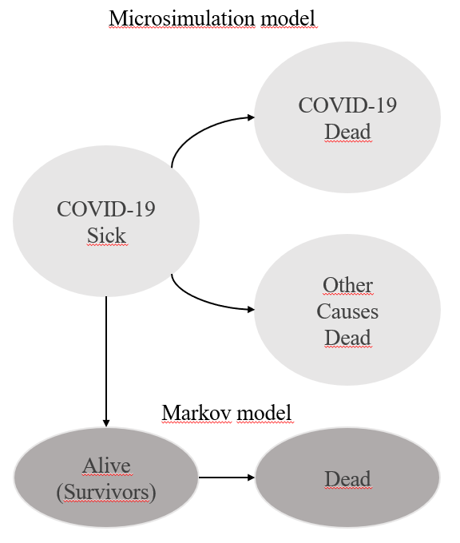

Figure 1: Model structure. States for the microsimulation and markov model.

The microsimulation model includes three health states: *hospitalized COVID-19 detected infection, COVID-19 Dead and Other Causes* *Dead* (Figure 1) and tracks whether simulated individuals die from COVID-19 or other causes. After simulating the individuals for 50 days, we assigned an age- and sex-specific lifetime healthcare costs and quality-adjusted life expectancy (QALE) to the surviving population. These values were calculated using an age-dependent Markov model with two states: Alive and Dead. The transition probabilities utilized in the Markov model were derived from the age- and sex-specific background mortality rates for the Mexican population and for the health outcomes we used age group- and sex-specific health utilities. The table of estimates of these projections can be found in the appendix section. We built the microsimulation model in R18.

## Cost-Effectiveness Analysis

We conducted two separate cost-effectiveness analysis (CEA): For hospitalized non-intubated patients, we compared three strategies: *Treat with Remdesivir*, *Treat with Remdesivir and Baricitinib,* and *Standard of Care (SoC)*. For hospitalized intubated patients, we evaluated two strategies: *Treat with Dexamethasone* and *Standard of Care (SoC)*. The primary outcomes of interest were discounted QALEs and lifetime costs for all strategies and the incremental cost-effectiveness ratio (ICER) between non-dominated strategies. We assumed a willingness-to-pay (WTP) threshold of one Mexico’s per-capita GDP, consistent with that recommended by the Mexican General Health Council19.

All costs are reported in 2021 Mexican pesos ($MXN) and health outcomes and costs are discounted at a 5% determined by the Mexican Health Supplies Evaluation Guide19.

## Health Outcomes

To get the QALE, we calculated the quality-adjusted life years (QALYs) for the simulated patients. We used age- and sex-specific health utilities reported in a study by Hanmer et al.20 and lifetime health costs to incorporate the associated utility in the different health states of the Markov model. This model is a cohort state-transition model (cSTM) based in the approach with multidimensional arrays proposed by Krikjamp et al.18, that projects the QALYs for each age range 45-100 years-old and by sex incorporating the increase in the risk of dying, the increase in healthcare costs and the decrease in the quality of life with the increase of the years while people get older.

## Costs

We obtained hospitalization costs from the Mexican Social Security Institute (IMSS – Spanish acronym)21. For treatment costs, we used the Remdesivir price estimated by the Institute for Clinical and Economic Review22 and an estimation of the most commonly accepted price at U.S. pharmacies for Baricitinib23. Dexamethasone costs were derived from public purchases by IMSS. Lifetime health expenditure comes from the World Health Organization Global Health Expenditure database24 that reports health expenditure per capita. To obtain age- and sex-specific costs, we applied specific ratios for each and group sex derived to the global lifetime expenditure. These ratios come from the age- and sex- specific per capita disease prevention expenditure reported by the Mexican budget for disease prevention25.

|  |  |  |  |
| --- | --- | --- | --- |
| **Cohorts characteristics** | | | |
| Hospitalized, not intubated | | | |
| Sex | Age Group | N | Proportion |
| Male | 45 - 54 yo. | 32,154 | 16% |
| 55 -64 yo. | 35,973 | 18% |
| 65 - 69 yo. | 16,133 | 8% |
| 70 + yo. | 34,915 | 17% |
| Female | 45 - 54 yo. | 19,869 | 10% |
| 55 -64 yo. | 24,948 | 12% |
| 65 - 69 yo. | 11,512 | 6% |
| 70 + yo. | 25,189 | 13% |
| Total |  | 200,693 |  |
| Hospitalized, intubated | | | |
| Sex | Age Group | N | Proportion |
| Male | 45 - 54 yo. | 5,898 | 15% |
| 55 -64 yo. | 7,837 | 20% |
| 65 - 69 yo. | 3,838 | 10% |
| 70 + yo. | 7,295 | 19% |
| Female | 45 - 54 yo. | 2,719 | 7% |
| 55 -64 yo. | 4,451 | 11% |
| 65 - 69 yo. | 2,268 | 6% |
| 70 + yo. | 4,578 | 12% |
| Total |  | 38,884 |  |
| **Model Assumptions** | | | |
| Markov Model COVID-19 Sick - Dead | | | |
| Time horizon | 50 days | | |
| Number of states | 3 | | |
| Name of states | Cov-19 + | | |
| Cov-19 Dead | | |
| Dead Other causes | | |
| Markov Model COVID-19 Alive - Dead | | | |
| Time horizon | Lifetime | | |
| Number of states | 2 | | |
| Name of states | Alive | | |
| Dead | | |
| Discount rate | 0.05 | | |
| **Utilities and Costs** | | | |
| Treatment |  | Frequency | |
| Remdesivir Treatment | 6,188 | Daily | |
| Baricitinib Treatment | 3,672 | Daily | |
| Dexamethasone treatment | 4 | Daily | |
| Mean Hospitalization costs, not intubated | 9,272 | Daily | |
| Mean Hospitalization costs, intubated | 44,151 | Daily | |
| Anual Healthcare expenditure by patient | | | |
| Age - Group | Male | Female | |
| 20 - 59 | 10,912 | 13,519 | |
| 60 ≤ | 24,382 | 24382 | |
| **Health outcomes** | | | |
| Age - Group | Male | Female | |
| 45 - 49 | 0.887 | 0.863 | |
| 50 - 59 | 0.861 | 0.837 | |
| 60 - 69 | 0.84 | 0.811 | |
| 70 - 79 | 0.802 | 0.771 | |
| 80 ≤ | 0.782 | 0.724 | |

Table 1: Model Values, Utilities and Costs.

## Sensitivity Analyses

To incorporate uncertainty in the information on the effectiveness of treatments and hospital costs and time we performed a probabilistic sensitivity analysis (PSA). Using the sensitivity ranges of published sources, we created 1,000 sets of parameters and calculated the health outcomes and costs for each of these sets. Finally, we calculated the average costs and mean QALYs for each strategy. The distribution of parameters is shown in the supplemental material.

|  |  |  |  |
| --- | --- | --- | --- |
| **Hospitalization costs, not intubated** | **Value** | **Distribution** | **Source** |
| Hospitalization time: Not intubated Cohort | μ = 13.29; SD = 7.17 | Lognormal μ = 2.43, σ = 0.51 | 26 |
| Hospitalization time: Intubated Cohort | μ = 13.89; SD = 13.17 | Lognormal μ = 2.31, σ = 0.80 | 26 |
| Hospitalization costs $: Not intubated Cohort | μ = 9,272; SD = 3278 | Gamma  α = 8, β= 1159 | 21 |
| Hospitalization costs $: Intubated Cohort | μ = 44,151; SD = 15,610 | Gamma  α = 8, β= 5519 | 21 |
| Remdesivir Intervention effect | HR: 0.73, CI: 0.52 - 1.03 | Lognormal μ = 0.73, σ = 0.17 | 16 |
| Baricitinib Intervention effect | HR: 0.65, CI: 0.39 - 1.09 | Lognormal μ = 0.65, σ = 0.26 | 17 |
| Dexamethasone intervention effect | HR: 0.64, CI: 0.51 - 0.81 | Lognormal μ = 0.64, σ = 0.11 | 15 |

Table 2: Parameter Distributions for Probabilistic Sensitivity Analysis.

We calculated the cost-effectiveness acceptability curves (CEAC) that show the probability that each strategy is cost-effective, the frontier (CEAF) with the probability that the optimal strategy is cost-effective, and the expected loss curves (ELC)27over a wide range of WTP thresholds. To quantify the value of additional potential future research on the decision model parameters, we conducted a value of information (VOI) analysis. We calculated the expected value of perfect information (EVPI).

We carried out one- and two-way sensitivity analyses using a linear regression metamodeling approach on the PSA dataset28. Briefly, …(pending deeper explanation)

All calculations, models and graphs were done using R.29 The ICER estimation, and all the sensitivity analysis and visualizations were carried out with *dampack*30package*.*

# Results

## Disease-specific hazard

The COVID-19-specific mortality rate practically represents the total mortality rate since the daily background population rates are nearly negligible. The highest rates are around day 10 for the non-intubated cohort, extending to 20 days for the intubated. COVID-19-specific mortality rate increases with age: For the non-intubated cohort, 45-54-year-old patients have a COVID-19-specific mortality rate of 507 per 100,000, while for patients 70 + years old, this rate increases to 1,347 per 100,000. For the intubated cohort, these rates are 2,503 and 3,770 per 100,000, respectively (Figure 2).

We estimated that men face higher mortality rates than women. The overall estimated mean COVID-19 mortality rate for men is 2,101 per 100,000, while for women, is 1,967 per 100,000. For non-intubated patients, estimated mortality rates for men are 1,006 per 100,000 and 841 per 100,000 for women. Intubated cohort presents 3,196 and 3,093, respectively. We found that that age is a stronger factor than sex in the COVID-19 mortality rates.

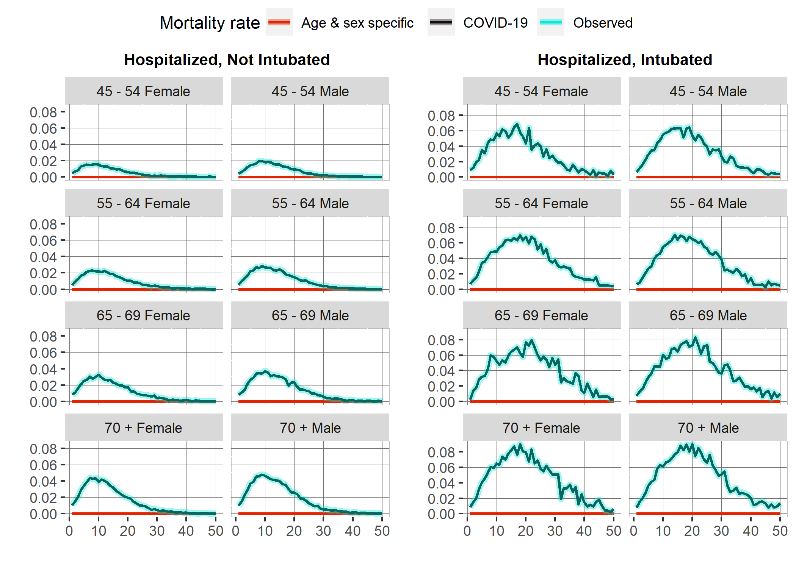

Figure 2: COVID-19 Daily hazards by cohort, age and sex group. Source: Created by authors with information published by Mexico´s Ministry of Health.

## Cost-effectiveness Analysis

Following current guidelines, we conducted the cost-effectiveness analysis base-case using the expected discounted costs and QALYs across all PSA simulations31 (Figure 3). For the hospitalized non-intubated, we estimated a mean discounted QALE of 5.27 years and lifetime costs of $250,000 under SoC. The strategy of Remdesivir alone generates a mean discounted QALE of 5.97 years and $332,000 lifetime costs. The estimated mean discounted QALE for Remdesivir and Baricitinib is 6.70 and $401,300 of expected lifetime costs. The ICER reported by this strategy, in comparison to no treatment, is 102,308. Table 2 shows the mean QALYs, average costs, incremental QALYs, costs and calculated ICERs for the five strategies evaluated through the PSA.

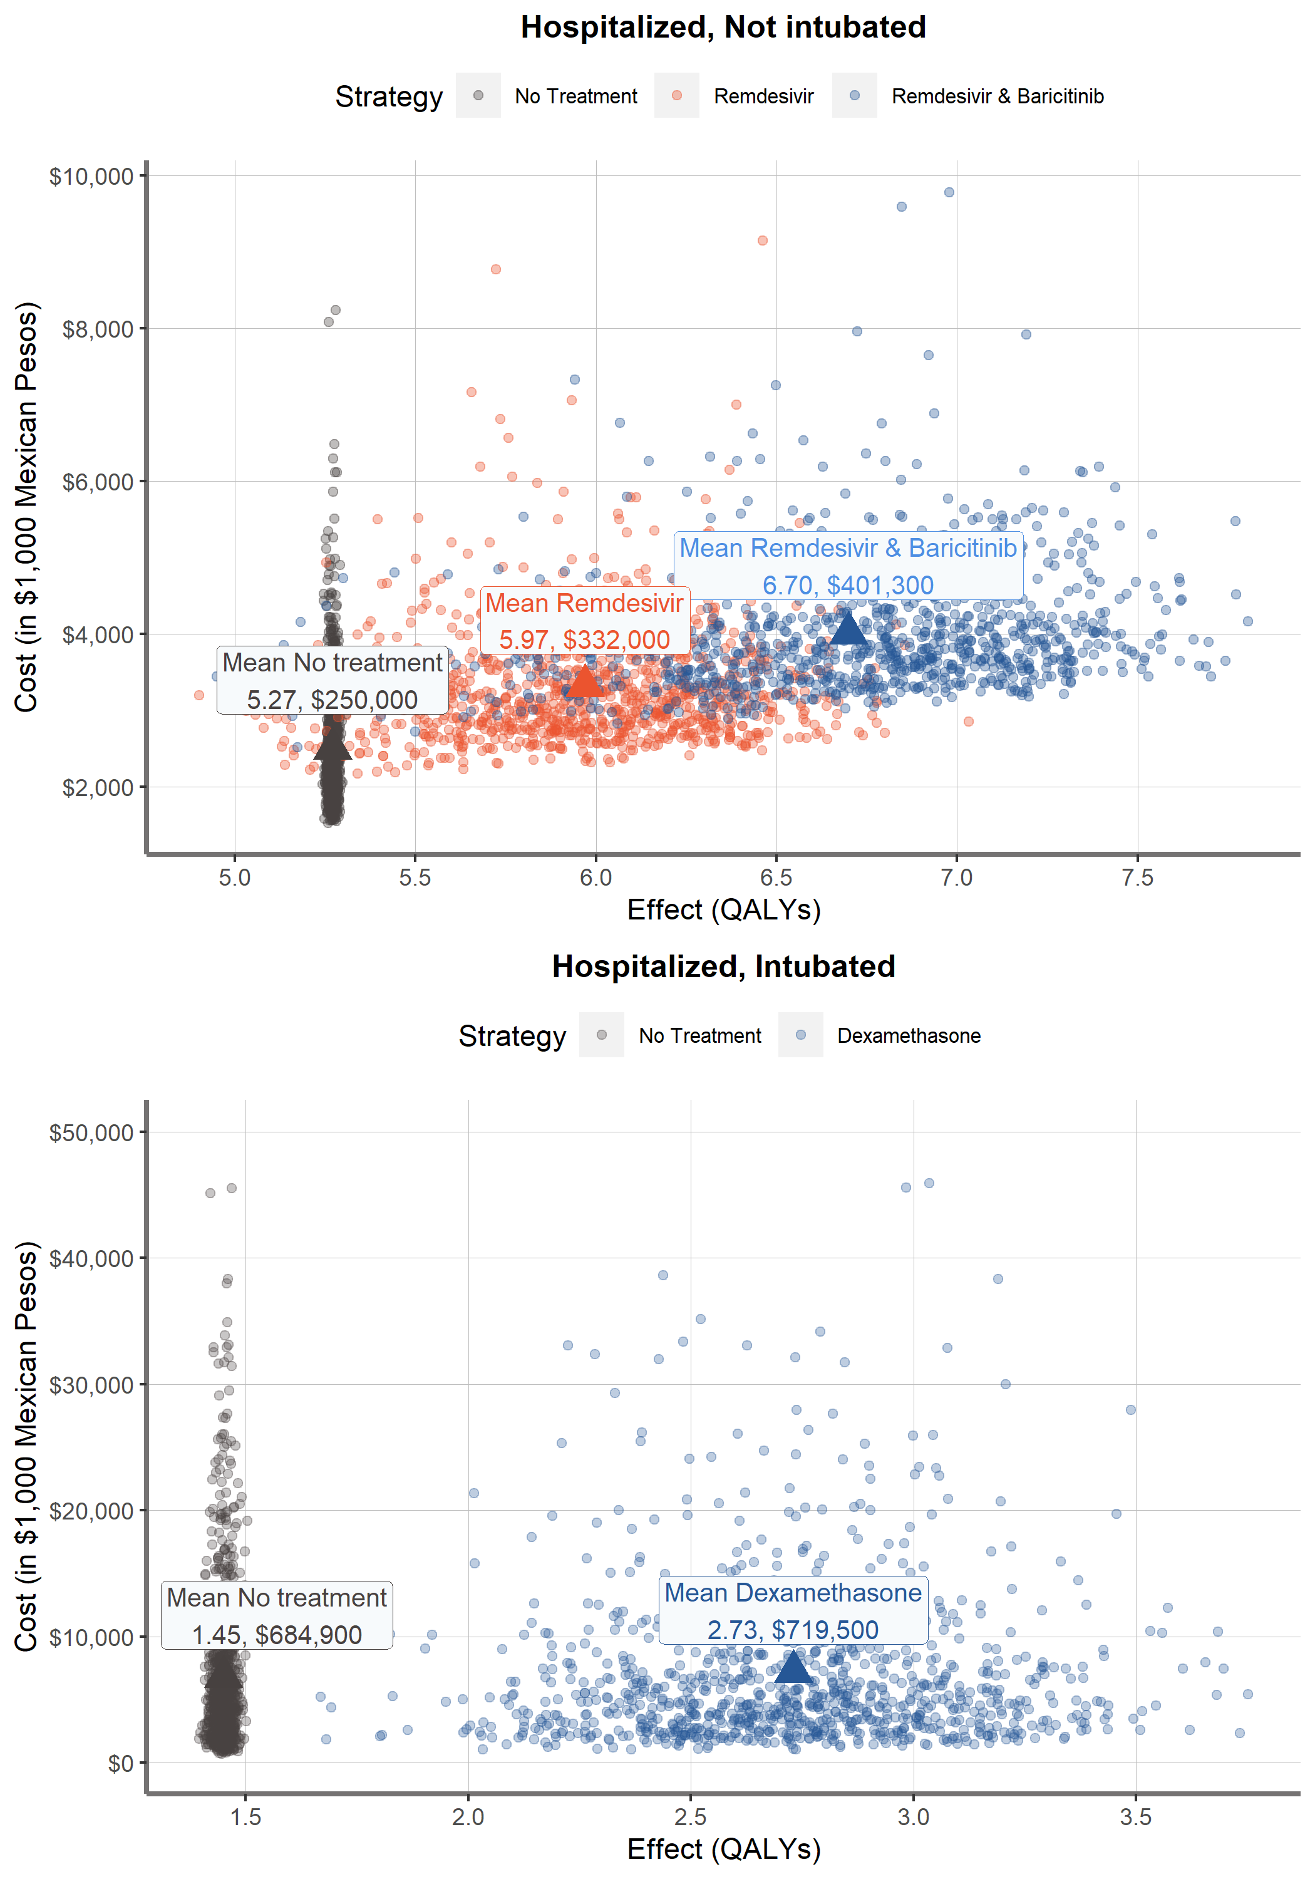

Figure 3: Probability Sensitivity Analysis results and mean outcomes.

Remdesivir alone is a weakly dominated strategy because … “Remdesivir and Baricitinib” strategy is always chosen if the willingness to pay increases above the “No treatment” limit (Figure 4).

Figure 4: Efficient Frontier. On the left side, for non-intubated patients it is observed that Remdesivir is a weakly dominated strategy since it is not contained by the Efficiency line. Created by authors with outcomes of the decision analytic model.

|  |  |  |  |  |  |
| --- | --- | --- | --- | --- | --- |
| **Strategy** | **Costs ($)** | **Incremental Costs** | **QALYs** | **Incremental QALYs** | **ICERs ($/QALYs)** |
| Cohort: Hospitalized, Not Intubated | | | | | |
| No treatment | 255,000 | - | 5.27 | - | - |
| Remdesivir & Baricitinib | 401,300 | 146,300 | 6.70 | 1.43 | 102,308 |
| Remdesivir* | 332,000 | - | 5.97 | - | - |
| Cohort: Hospitalized, Intubated | | | | | |
| No treatment | 684,900 |  | 1.45 | - | - |
| Dexamethasone | 719,500 | 34,600 | 2.73 | 1.28 | 27,031 |
| * Weakly Dominated Strategy | | | | | |

Table 3: Health outcomes and costs mean estimates from probabilistc sensitivity analysis.

For the hospitalized, intubated cohort, treating with Dexamethasone yields 2.73 of mean discounted QALE with lifetime costs of $719,500, while for SoC we estimated a mean discounted QALE of 1.45 and lifetime costs of $684,900. The cost of dexamethasone is minimal compared to other treatments, so most of the extra costs are generated by higher hospital costs among the surviving population.

## Sensitivity Analysis

The most influential parameter on the Net Monetary Benefit of the strategies of the strategies of the non-intubated cohort was the effectiveness of Remdesivir (expressed as hazard ratio). This is expected because it is the most expensive drug and the variation in its effect impacts two of the three strategies evaluated for these patients. In addition, the variation in the effectiveness of dexamethasone also has a high impact on the NMB. However, since the distribution of the HR of XYZ always shows a positive effect in reducing mortality, dexamethasone is always the preferred strategy.

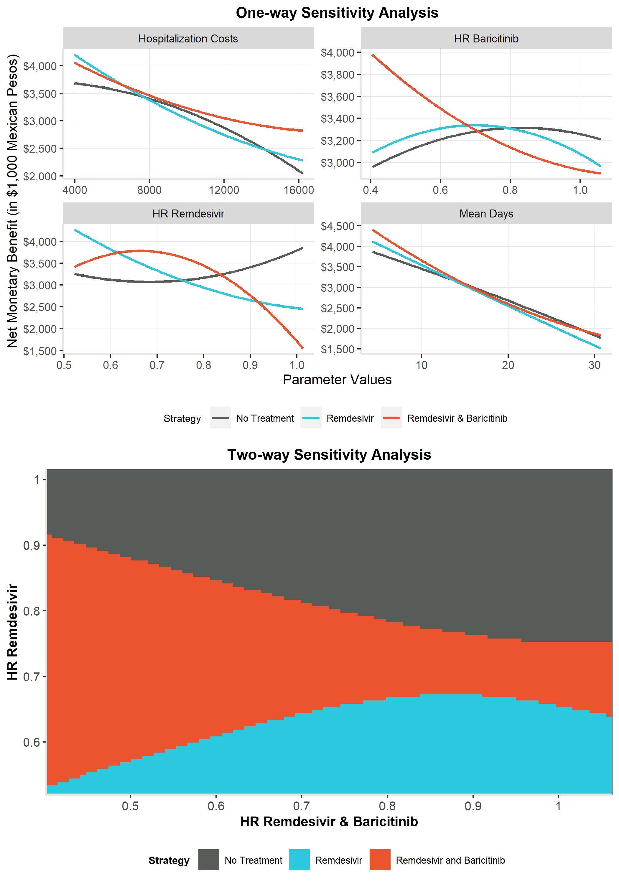

Figure 4: One-way and two-way sensitivity analysis for hospitalized, not intubated cost-effectiveness analysis.

Figure 4 shows the CEACs that displays the probability of a strategy of being cost-effective for a wide range of WTP thresholds. The CEAF indicates which strategy has the highest expected net monetary benefit as a function of WTP threshold. For the hospitalized non-intubated patients, Remdesivir in combination with Baricitinib had the highest probability of being cost-effective for WTP thresholds greater than $102,976/QALY. Dexamethasone is highly likely to be cost-effective, since it has the highest probability of being cost-effective from WTP thresholds greater than $29,308/QALY.

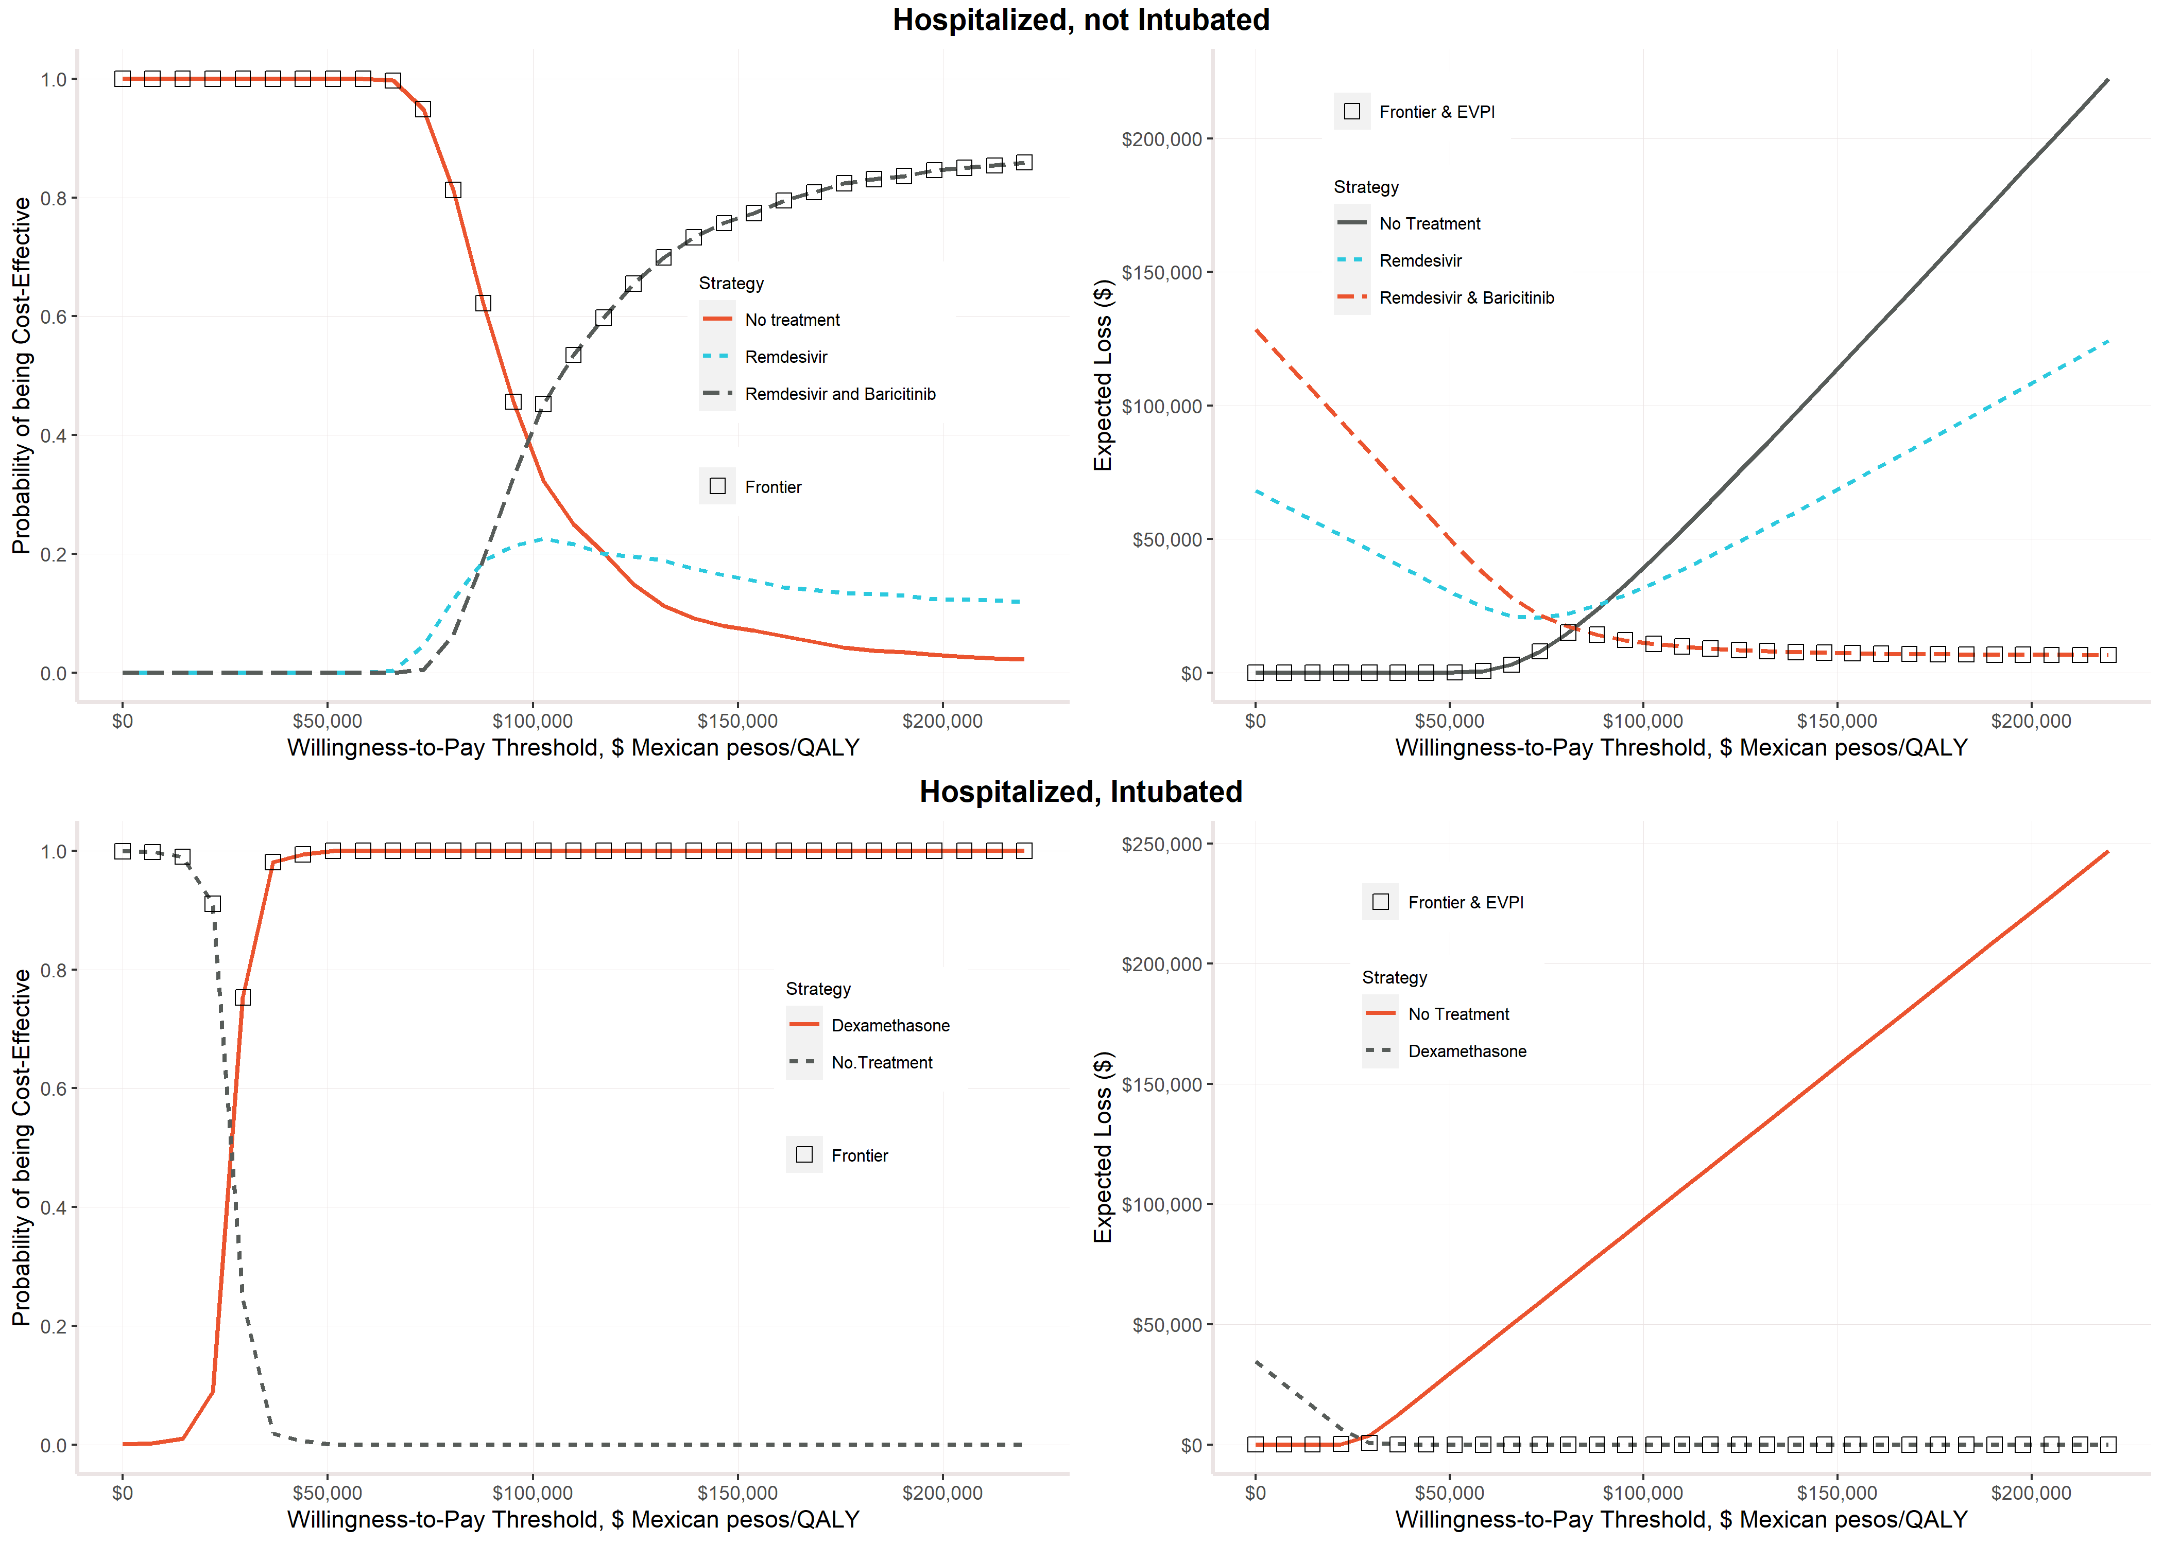

Figure 5: Cost-effectiveness acceptability curve and frontier (CEACs & CEAFs), and Cost-effectiveness acceptability curve and frontier (CEACs & CEAFs).

# 

# Discussion and Key Points for Decision Makers

Our study used relative survival methods to estimate COIVID-19-specific mortality by age and sex and use these in a decision analysis to quantify the effectiveness, costs, and cost-effectiveness associated with … We found that mortality rates increase with age, and men face higher mortality rates than women. In both cohorts, COVID-19-specific mortality rates drastically decrease after day 30 for non-intubated patients, while for intubated patients, this decrease is not observed until day 50. For a cohort of non-intubated people, we found that Remdesivir and Baricitinib is the most cost-effective strategy, while Remdesivir alone is a weakly dominated strategy. For the intubated cohort, we found that Dexamethasone is the cost-effective strategy compared to Standard of Care.

The lack of specific cost-effectiveness studies for these treatment options means that decision-makers do not have ample evidence or information to choose courses of action during this pandemic. A simulation model that incorporates the uncertainty of various parameters can be a handy tool for public health authorities or managers responsible for managing the public health crisis in Mexico. Although this study does not give certainty about which strategy should be chosen under a limited budget, it could reference if options similar to those addressed in this work are being considered.

More published information resources are needed to improve the accuracy of these analyzes. Counting these types of inputs is a significant advantage when we have scenarios such as the current pandemic. Unfortunately, the amount of empirical evidence is limited, and we have to rely on simulations to project different scenarios and make evidence-based decisions. As the available public information improves, the estimates of this type of analysis models improve, and the quality of evidence to generate health policies improves.

Our analysis has several limitations. The evidence utilized in our decision model is limited and might be sensitive to new information that may emerge on any of the parameters used so far. There is also no specific information for the Mexican case on the effects of treatments or public prices for the Mexican population. The prices used of Remdesivir and Baricitinib are set for high-income countries32; however, it is foreseeable that there will be lower rates for middle-income countries, as in the case of Mexico. Although necessary due to the lack of specific information for the Mexican case, another possible factual discrepancy arises from the assumption that health benefits are similar in Mexico and the United States. Despite these limitations, our analysis provides a robust evaluation of different strategies to reduce the burden of this pandemic in Mexican hospitalized patients using publicly available information without having to rely on clinical trials or empirical evidence for Mexican patients. Although the evidence in favor of the evaluated treatments have been debated33 and is not conclusive, the sensitivity analysis of the decision model allowed us to consider these parameters and give robust results to this uncertainty.

Our analysis demonstrates that treating COVID-19 hospitalized patients in Mexico is a cost-effective compared to no treatment. Remdesivir and Baricitinib is the best strategy for all non-intubated hospitalized and Dexamethasone for intubated patients. The results of this study may provide a starting point for other analysis looking at the best treatment options for COVID-19.

# References

1 Secretaria de Salud. Informe Técnico Diario COVID-19 MÉXICO. 2020. https://www.gob.mx/cms/uploads/attachment/file/593517/Comunicado_Tecnico_Diario_COVID-19_2020.11.19.pdf.

2 John Hopkins University. COVID-19 Dashboard by the Center for Systems Science and Engineering (CSSE) at Johns Hopkins University (JHU). 2020. https://coronavirus.jhu.edu/map.html (accessed Dec 9, 2020).

3 Stang A, Standl F, Kowall B, *et al.* Excess mortality due to COVID-19 in Germany. *J Infect* 2020; **81**: 797–801.

4 Nogueira PJ, Nobre MDEA, Nicola PJ, Furtado C. Excess Mortality Estimation During the COVID-19 Pandemic : Preliminary Data from Portugal Estimativa do Excesso de Mortalidade Durante a Pandemia COVID-19 : Dados Preliminares Portugueses. 2020; : 376–83.

5 Vandoros S. Has mortality due to other causes increased during the Covid-19 pandemic ? Early evidence from England and Wales. 2020; : 1–14.

6 Beaney T, Clarke JM, Jain V, *et al.* Excess mortality: the gold standard in measuring theimpact of COVID-19 worldwide? *R Soc Med* 2020; **113**: 329–34.

7 Karlinsky A, Kobak D, Planck M. The World Mortality Dataset : Tracking excess mortality across countries during the COVID-19 pandemic. 2021; : 1–10.

8 Secretaría de Salud (SISVER). Exceso de Mortalidad en México – Coronavirus. Datos- Exceso Mortal. 2021. https://coronavirus.gob.mx/exceso-de-mortalidad-en-mexico/ (accessed June 11, 2021).

9 Secretaría de Salud. Información referente a casos COVID-19 en México. Bases datos COVID 19 en México. 2020; published online Nov 19. https://datos.gob.mx/busca/dataset/informacion-referente-a-casos-covid-19-en-mexico/resource/3d7fb4a8-5763-4dba-a23f-a20edc7783f7 (accessed Dec 9, 2020).

10 Consejo Nacional de Población (CONAPO). Proyecciones de la Población de los Municipios de México, 2015-2030. 2019; published online Sept 22. https://www.gob.mx/conapo/documentos/proyecciones-de-la-poblacion-de-los-municipios-de-mexico-2015-2030 (accessed Dec 9, 2020).

11 Pohar Perme M, Klemen P. Pohar Perme, Pavlič - 2018 - Nonparametric relative survival analysis with the R package relsurv.pdf. *J Stat Softw* 2018; **87**. DOI:https://doi.org/10.18637/jss.v087.i08.

12 EDERER F, AXTELL L, CUTLER S. The relative survival rate: a statistical methodology. *Natl Cancer Inst Monogr* 1961; **6**: 101.

13 Alarid-Escudero F, Kuntz KM. Potential Bias Associated with Modeling the Effectiveness of Healthcare Interventions in Reducing Mortality Using an Overall Hazard Ratio. *Pharmacoeconomics* 2020; **38**: 285–96.

14 Pohar Perme M. Package ‘ relsurv ’. 2018. https://cran.r-project.org/web/packages/relsurv/relsurv.pdf.

15 The RECOVERY Collaborative Group. Dexamethasone in Hospitalized Patients with Covid-19 — Preliminary Report. *N Engl J Med* 2020; : 1–11.

16 Beigel JH, Tomashek KM, Dodd LE, *et al.* Remdesivir for the Treatment of Covid-19 — Final Report. *N Engl J Med* 2020; **383**: 1813–26.

17 Marconi VC, Palacios GMR, Hsieh L, *et al.* Baricitinib plus Remdesivir for Hospitalized Adults with Covid-19. 2020; : 1–13.

18 Krijkamp EM, Alarid-Escudero F, Enns EA, Jalal HJ, Hunink MGM, Pechlivanoglou P. Microsimulation Modeling for Health Decision Sciences Using R: A Tutorial. *Med Decis Mak* 2018; **38**: 400–22.

19 Consejo de Salubridad General. Guía de Evaluación de Insumos para la Salud. 2017; : 67.

20 Hanmer J, Lawrence WF, Anderson JP, Kaplan RM, Fryback DG. Report of nationally representative values for the noninstitutionalized US adult population for 7 health-related quality-of-life scores. *Med Decis Mak* 2006; **26**: 391–400.

21 H. Consejo Técnico. Acuerdo relativo a la Aprobación de los Costos Unitarios por Nivel de Atención Médica actualizadas al año 2021. México: Diario Oficial de la Federación, 2020.

22 Campbell JD, Whittington MD, Rind DM, Pearson SD. Alternative Pricing Models for Remdesivir and Other Potential Treatments for COVID-19. 2020; : 1–18.

23 Drugs.com. Olumiant Prices, Coupons & Patient Assistance Programs. Price Guid. 2021. https://www.drugs.com/price-guide/olumiant (accessed June 4, 2021).

24 The World Bank. Current health expenditures per capita (current $US). 2018. https://data.worldbank.org/indicator/SH.XPD.CHEX.PC.CD?locations=MX.

25 Méndez JS. Presupuesto para prevención y control de enfermedades. Cent. Investig. Económica y Presup. 2020. https://ciep.mx/OqSV (accessed June 7, 2021).

26 Alarid-escudero AF, Gracia V, Luviano A, *et al.* How do Covid-19 policy options depend on end-of-year holiday contacts in Mexico City Metropolitan Area? A Modeling Study. 2020; **52**: 1–21.

27 Alarid-Escudero F, Enns EA, Kuntz KM, Michaud TL, Jalal H. “Time Traveling Is Just Too Dangerous” but Some Methods Are Worth Revisiting: The Advantages of Expected Loss Curves Over Cost-Effectiveness Acceptability Curves and Frontier. *Value Heal* 2019; **22**: 611–8.

28 Jalal HJ, Dowd B, Sainfort F, Kuntz KM. Linear Regression Metamodeling as a Tool to Summarize and Present Simulation Model Results. *Med Decis Mak* 2013; **33**: 880–90.

29 R Core Team. R: A Language and Environment for Statistical Computing. 2013. http://www.r-project.org.

30 Alarid-Escudero F, Krijkamp EM, Pechlivanoglou P, *et al.* A need for change! A coding framework for improving transparency in decision modeling. *Pharmacoeconomics* 2019; **37**: 1329–1339.

31 Sculpher MJ, Basu A, Kuntz KM, Meltzer DO. Reflecting Uncertainty in Cost-Effectiveness Analysis. In: Cost-Effectiveness in Health and Medicine, Second. New York. NY.: Oxford University Press, 2017: 289–318.

32 Kolata J. Remdesivir, the First Coronavirus Drug, Gets a Price Tag - The New York Times. New York Times. 2020; published online June 29. https://www.nytimes.com/2020/06/29/health/coronavirus-remdesivir-gilead.html (accessed Dec 9, 2020).

33 Zimmer C, Wu KJ, Corum J. Tratamientos y medicamentos para el coronavirus: monitoreo de efectividad. New York Times. 2020. https://www.nytimes.com/es/interactive/2020/science/coronavirus-tratamientos-curas.html (accessed Dec 9, 2020).

# List of Tables

Table 1: Model Values, Utilities and Costs. 7

Table 2: Parameter Distributions for Probabilistic Sensitivity Analysis. 8

Table 3: Health outcomes and costs mean estimates from probabilistc sensitivity analysis. 12

Table 4: Table with discounted costs, quality adjusted life years, costs and life years expected. 28

# List of Figures

Figure 1: Model structure. States for the microsimulation and markov model. 4

Figure 2: COVID-19 Daily hazards by cohort, age and sex group. Source: Created by authors with information published by Mexico´s Ministry of Health. 10

Figure 3: Probability Sensitivity Analysis results and mean outcomes. 11

Figure 4: One-way and two-way sensitivity analysis for hospitalized, not intubated cost-effectiveness analysis. 14

Figure 5: Cost-effectiveness acceptability curve and frontier (CEACs & CEAFs), and Cost-effectiveness acceptability curve and frontier (CEACs & CEAFs). 15

Figure 6: COVID-19 mortality rates by month. 23

Figure 7: Parameter distribution 25

# Links to Original Databases

Mexico´s Ministry of Health:

* Information regarding COVID-19 cases in Mexico

[Datos Abiertos de México - Información referente a casos COVID-19 en México](https://datos.gob.mx/busca/dataset/informacion-referente-a-casos-covid-19-en-mexico)

* Mortality excess in Mexico

[Exceso de Mortalidad en México – Coronavirus](https://coronavirus.gob.mx/exceso-de-mortalidad-en-mexico/)

National Population Council:

* Age and sex specific Mortality rates by age group and sex

Proyecciones de la Población de los Municipios de México, 2015-2030 | Consejo Nacional de Población | Gobierno | gob.mx (www.gob.mx)

World Health Organization:

* Life Health Expenditure in Mexico:

[Current health expenditure per capita (current US$) - Mexico | Data (bancomundial.org)](https://datos.bancomundial.org/indicador/SH.XPD.CHEX.PC.CD?locations=MX)

Scripts and data-frames:

* Own elaboration

[HirvinDiaz/Cov_19_specific_hazard (github.com)](https://github.com/HirvinDiaz/Cov_19_specific_hazard)

# Appendix

## COVID-19 specific hazard by month

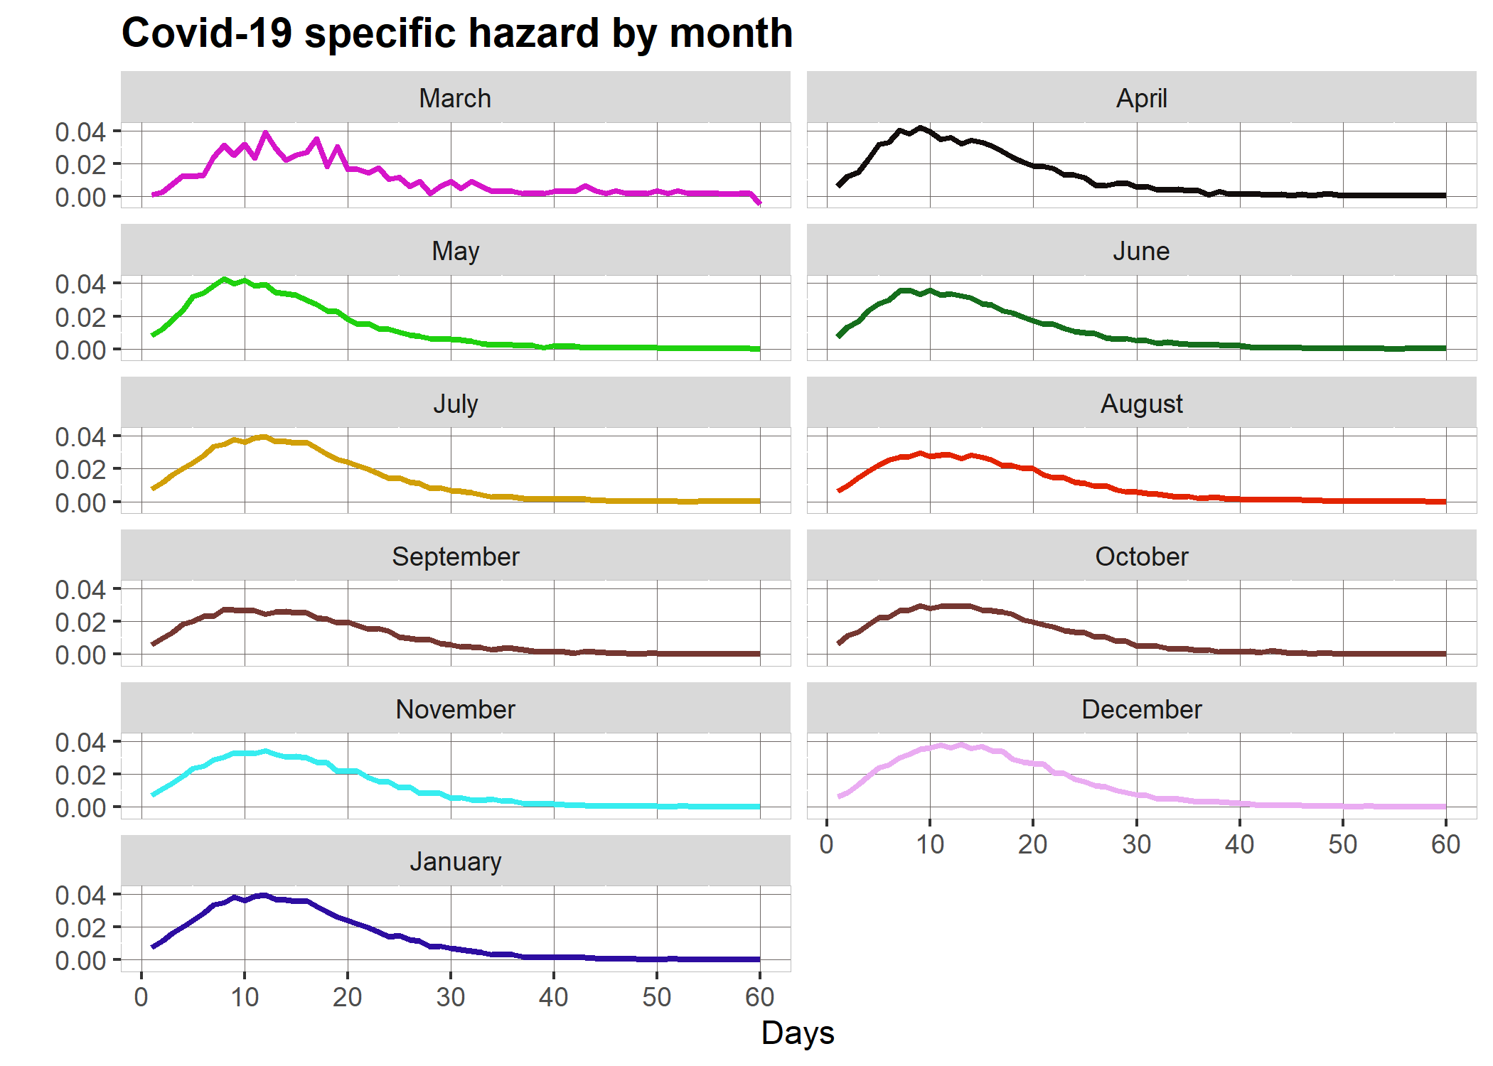

Figure 6: COVID-19 mortality rates by month.

## 2. Parameter distributions plots

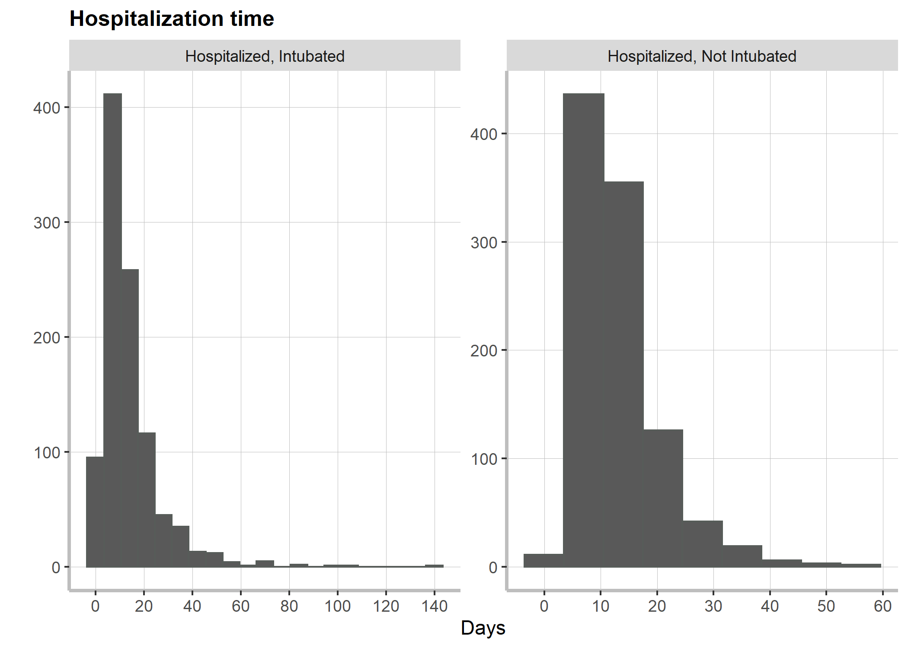

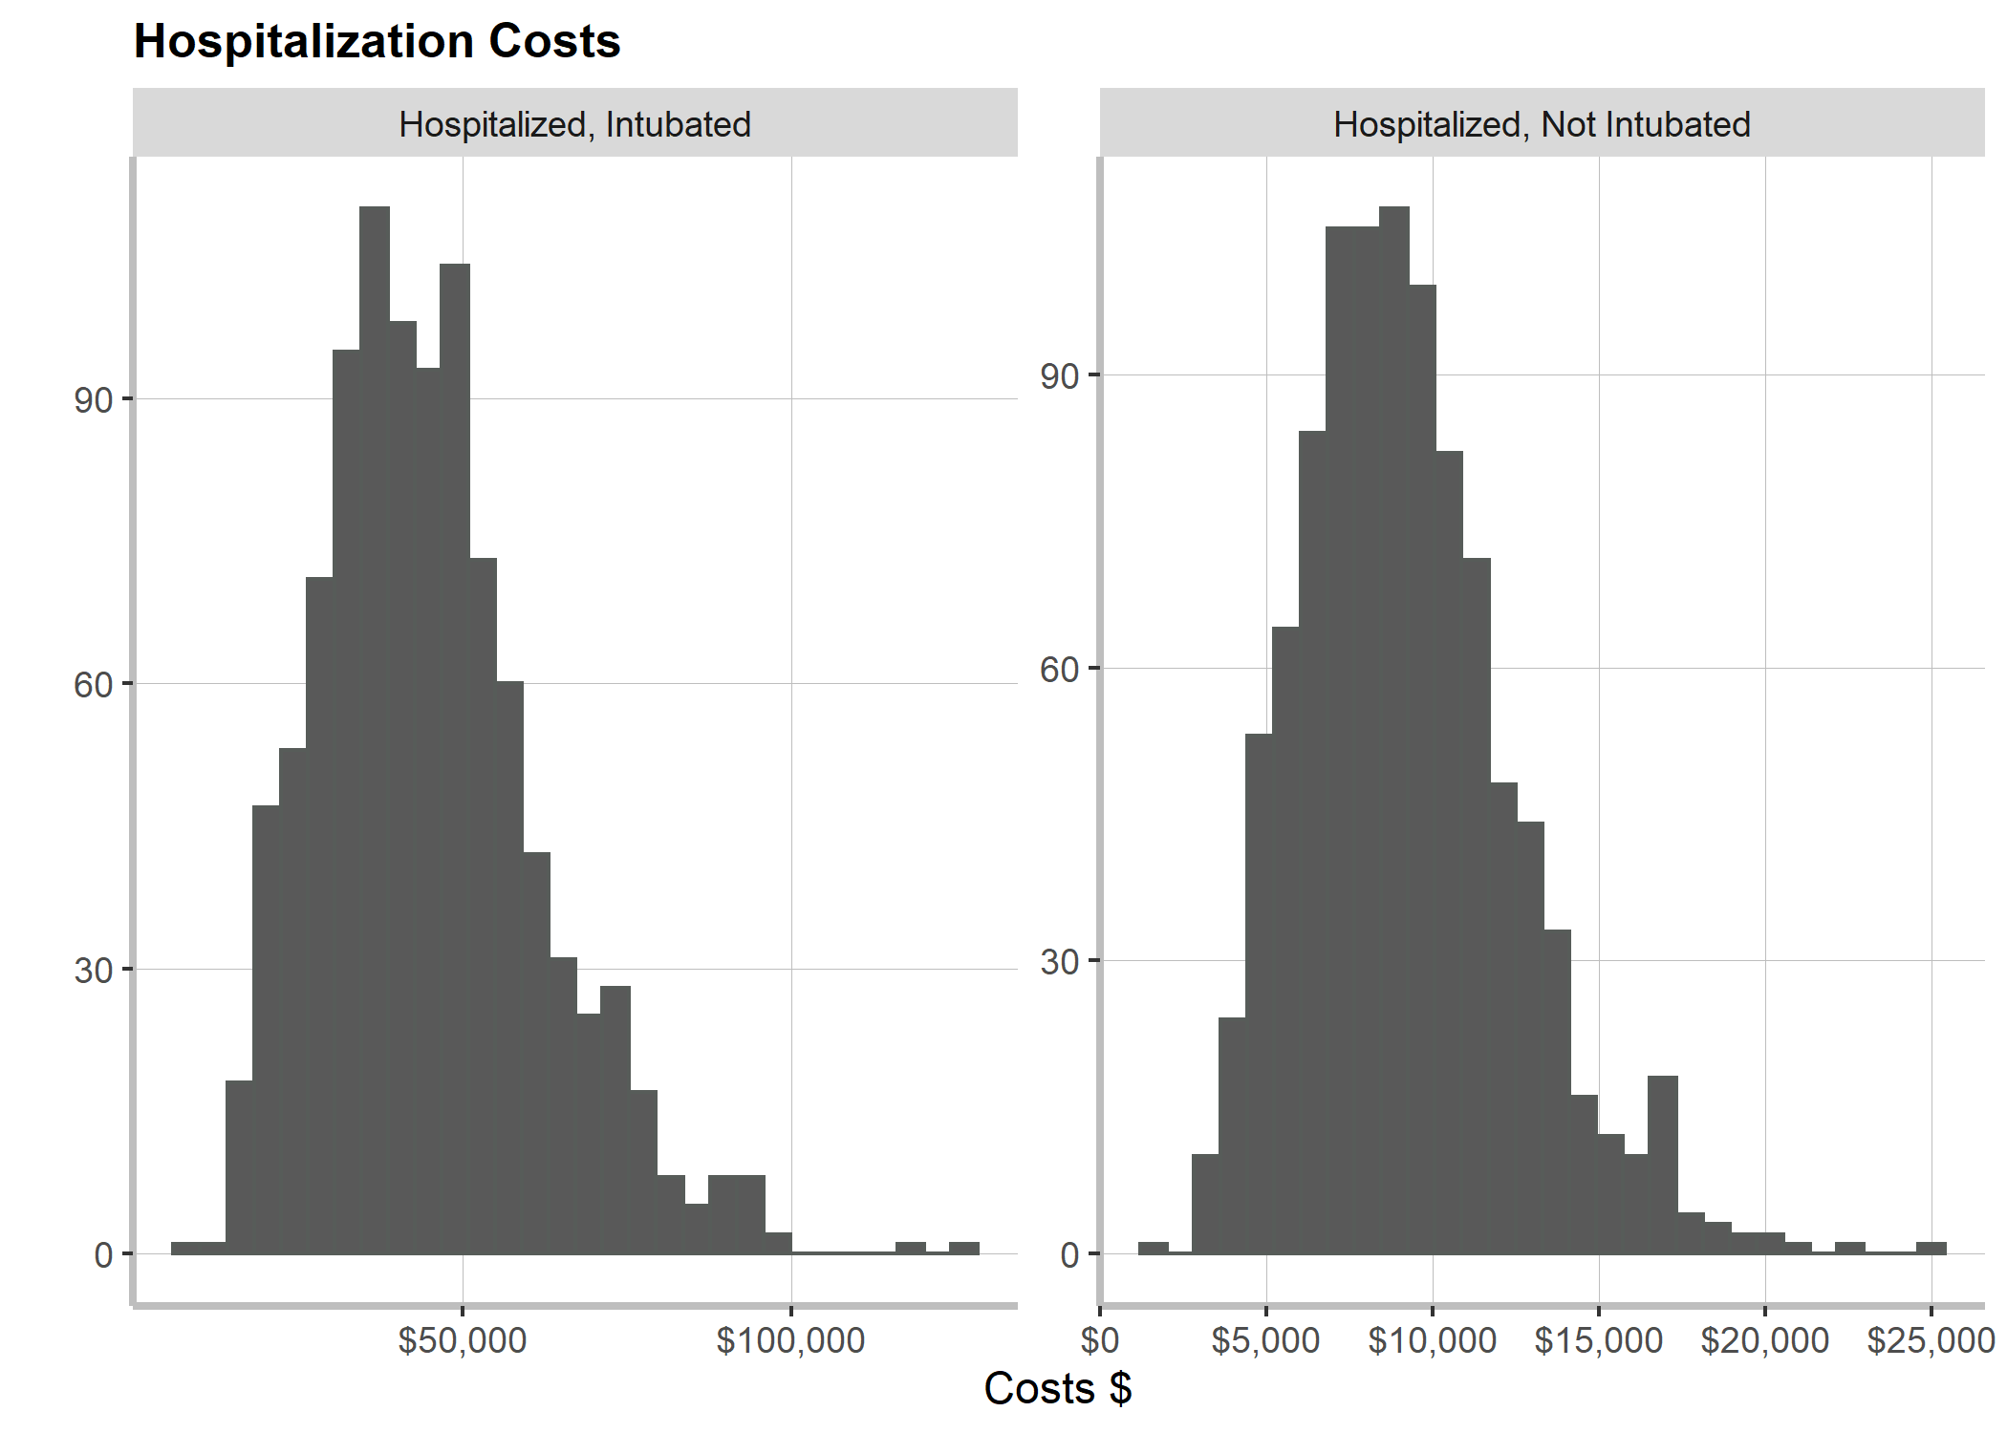

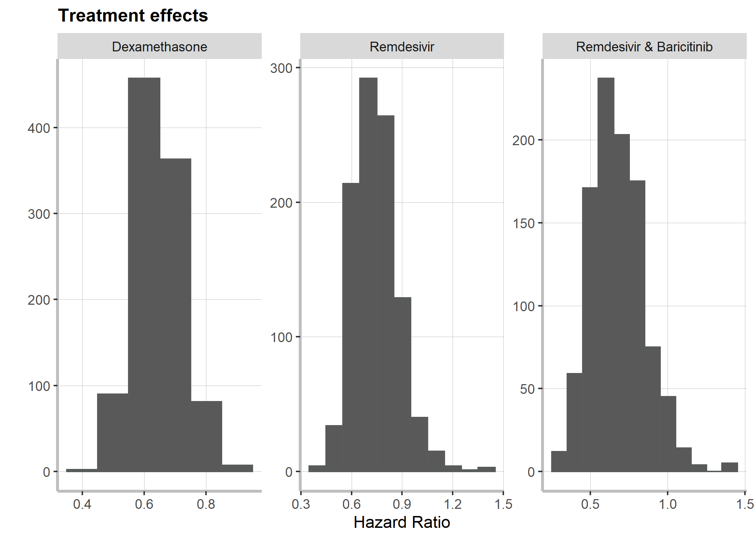

Figure 7: Parameter distribution

## 3. QALEs Table

|  |  |  |  |  |  |
| --- | --- | --- | --- | --- | --- |
| **Age** | **Sex** | **Discounted Costs** | **Quality-Adjusted Life Years** | **Costs** | **Life Years Expected** |
| 45 | male | 224382 | 12.56 | 572265 | 32.31 |
| 46 | male | 225825 | 12.37 | 564111 | 31.46 |
| 47 | male | 227425 | 12.17 | 556105 | 30.62 |
| 48 | male | 229204 | 11.96 | 548264 | 29.78 |
| 49 | male | 231180 | 11.74 | 540606 | 28.95 |
| 50 | male | 233377 | 11.52 | 533146 | 28.13 |
| 51 | male | 235818 | 11.32 | 525897 | 27.32 |
| 52 | male | 238530 | 11.12 | 518880 | 26.51 |
| 53 | male | 241544 | 10.90 | 512110 | 25.72 |
| 54 | male | 244893 | 10.69 | 505607 | 24.93 |
| 55 | male | 248615 | 10.46 | 499394 | 24.15 |
| 56 | male | 252754 | 10.24 | 493494 | 23.39 |
| 57 | male | 257359 | 10.00 | 487936 | 22.63 |
| 58 | male | 262485 | 9.77 | 482749 | 21.88 |
| 59 | male | 268197 | 9.52 | 477967 | 21.15 |
| 60 | male | 274566 | 9.28 | 473626 | 20.42 |
| 61 | male | 268205 | 9.04 | 456296 | 19.71 |
| 62 | male | 261777 | 8.81 | 439276 | 19.02 |
| 63 | male | 255288 | 8.57 | 422574 | 18.33 |
| 64 | male | 248748 | 8.33 | 406196 | 17.66 |
| 65 | male | 242162 | 8.09 | 390148 | 17.00 |
| 66 | male | 235536 | 7.84 | 374434 | 16.36 |
| 67 | male | 228888 | 7.59 | 359071 | 15.73 |
| 68 | male | 222210 | 7.34 | 344042 | 15.11 |
| 69 | male | 215529 | 7.08 | 329378 | 14.51 |
| 70 | male | 208848 | 6.82 | 315075 | 13.92 |
| 71 | male | 202118 | 6.60 | 301052 | 13.35 |
| 72 | male | 195422 | 6.37 | 287423 | 12.79 |
| 73 | male | 188744 | 6.15 | 274153 | 12.24 |
| 74 | male | 182091 | 5.93 | 261242 | 11.71 |
| 75 | male | 175472 | 5.70 | 248692 | 11.20 |
| 76 | male | 168893 | 5.48 | 236497 | 10.70 |
| 77 | male | 162369 | 5.26 | 224669 | 10.21 |
| 78 | male | 155896 | 5.03 | 213189 | 9.74 |
| 79 | male | 149463 | 4.81 | 202033 | 9.29 |
| 80 | male | 143118 | 4.59 | 191251 | 8.84 |
| 81 | male | 136854 | 4.39 | 180819 | 8.42 |
| 82 | male | 130661 | 4.19 | 170716 | 8.00 |
| 83 | male | 124534 | 3.99 | 160920 | 7.60 |
| 84 | male | 118470 | 3.80 | 151419 | 7.21 |
| 85 | male | 112464 | 3.61 | 142195 | 6.83 |
| 86 | male | 106513 | 3.41 | 133235 | 6.46 |
| 87 | male | 100623 | 3.23 | 124539 | 6.11 |
| 88 | male | 94803 | 3.04 | 116107 | 5.76 |
| 89 | male | 89048 | 2.85 | 107921 | 5.43 |
| 90 | male | 83374 | 2.67 | 99994 | 5.10 |
| 91 | male | 77783 | 2.49 | 92314 | 4.79 |
| 92 | male | 72280 | 2.31 | 84875 | 4.48 |
| 93 | male | 66732 | 2.14 | 77514 | 4.18 |
| 94 | male | 61226 | 1.96 | 70323 | 3.88 |
| 95 | male | 55533 | 1.77 | 63037 | 3.59 |
| 96 | male | 49575 | 1.58 | 55571 | 3.28 |
| 97 | male | 43151 | 1.37 | 47714 | 2.96 |
| 98 | male | 35894 | 1.13 | 39093 | 2.60 |
| 99 | male | 27187 | 0.85 | 29109 | 2.19 |
| 100 | male | 15896 | 0.47 | 16690 | 1.68 |
| 45 | female | 270117 | 12.89 | 692372 | 35.88 |
| 46 | female | 270765 | 12.71 | 680469 | 34.96 |
| 47 | female | 271512 | 12.51 | 668690 | 34.05 |
| 48 | female | 272368 | 12.31 | 657047 | 33.14 |
| 49 | female | 273347 | 12.11 | 645550 | 32.24 |
| 50 | female | 274464 | 11.89 | 634209 | 31.35 |
| 51 | female | 275735 | 11.70 | 623038 | 30.46 |
| 52 | female | 277178 | 11.49 | 612048 | 29.58 |
| 53 | female | 278814 | 11.28 | 601253 | 28.70 |
| 54 | female | 280664 | 11.07 | 590668 | 27.84 |
| 55 | female | 282754 | 10.85 | 580308 | 26.98 |
| 56 | female | 285114 | 10.62 | 570192 | 26.14 |
| 57 | female | 287775 | 10.39 | 560339 | 25.30 |
| 58 | female | 290776 | 10.15 | 550772 | 24.47 |
| 59 | female | 294158 | 9.90 | 541514 | 23.65 |
| 60 | female | 297970 | 9.64 | 532594 | 22.84 |
| 61 | female | 291403 | 9.41 | 513177 | 22.05 |
| 62 | female | 284722 | 9.17 | 494046 | 21.26 |
| 63 | female | 277934 | 8.93 | 475215 | 20.49 |
| 64 | female | 271047 | 8.68 | 456692 | 19.73 |
| 65 | female | 264066 | 8.42 | 438487 | 18.98 |
| 66 | female | 257000 | 8.16 | 420610 | 18.25 |
| 67 | female | 249859 | 7.90 | 403072 | 17.53 |
| 68 | female | 242653 | 7.63 | 385887 | 16.83 |
| 69 | female | 235394 | 7.36 | 369062 | 16.14 |
| 70 | female | 228090 | 7.08 | 352608 | 15.46 |
| 71 | female | 220710 | 6.84 | 336467 | 14.80 |
| 72 | female | 213326 | 6.60 | 320742 | 14.15 |
| 73 | female | 205925 | 6.35 | 305404 | 13.53 |
| 74 | female | 198519 | 6.10 | 290456 | 12.91 |
| 75 | female | 191119 | 5.86 | 275908 | 12.32 |
| 76 | female | 183735 | 5.61 | 261758 | 11.74 |
| 77 | female | 176385 | 5.35 | 248021 | 11.17 |
| 78 | female | 169072 | 5.10 | 234686 | 10.62 |
| 79 | female | 161793 | 4.85 | 221739 | 10.09 |
| 80 | female | 154594 | 4.59 | 209226 | 9.58 |
| 81 | female | 147476 | 4.38 | 197134 | 9.08 |
| 82 | female | 140439 | 4.17 | 185446 | 8.61 |
| 83 | female | 133483 | 3.96 | 174148 | 8.14 |
| 84 | female | 126612 | 3.76 | 163233 | 7.69 |
| 85 | female | 119831 | 3.56 | 152689 | 7.26 |
| 86 | female | 113142 | 3.36 | 142506 | 6.84 |
| 87 | female | 106554 | 3.16 | 132683 | 6.44 |
| 88 | female | 100072 | 2.97 | 123212 | 6.05 |
| 89 | female | 93697 | 2.78 | 114078 | 5.68 |
| 90 | female | 87438 | 2.60 | 105279 | 5.32 |
| 91 | female | 81300 | 2.41 | 96803 | 4.97 |
| 92 | female | 75276 | 2.24 | 88630 | 4.63 |
| 93 | female | 69246 | 2.06 | 80606 | 4.31 |
| 94 | female | 63288 | 1.88 | 72811 | 3.99 |
| 95 | female | 57178 | 1.70 | 64982 | 3.67 |
| 96 | female | 50842 | 1.51 | 57038 | 3.34 |
| 97 | female | 44078 | 1.31 | 48764 | 3.00 |
| 98 | female | 36515 | 1.08 | 39781 | 2.63 |
| 99 | female | 27532 | 0.82 | 29482 | 2.21 |
| 100 | female | 16033 | 0.48 | 16834 | 1.69 |

Table 4: Table with discounted costs, quality adjusted life years, costs and life years expected.