**Industrial Internship Report on**

**”Password Manager”**

**Prepared by**

**Hirvita Mandaviya**

|  |
| --- |
| *Executive Summary* |
| This report provides details of the Industrial Internship provided by upskill Campus and The IoT Academy in collaboration with Industrial Partner UniConverge Technologies Pvt Ltd (UCT).  This internship was focused on a project/problem statement provided by UCT. We had to finish the project including the report in 6 weeks’ time.  My project was a Password Manager, a Python application that securely stores and manages passwords using encryption, generates strong passwords, and offers a user-friendly interface for easy input and retrieval.  This internship gave me a very good opportunity to get exposure to Industrial problems and design/implement solution for that. It was an overall great experience to have this internship. |

**TABLE OF CONTENTS**

1 Preface 3

2 Introduction 4

2.1 About UniConverge Technologies Pvt Ltd 4

2.2 About upskill Campus 8

2.3 Objective 9

2.4 Reference 9

2.5 Glossary 10

3 Problem Statement 11

4 Existing and Proposed solution 12

5 Proposed Design/ Model 13

5.1 High Level Diagram (if applicable) 13

5.2 Low Level Diagram (if applicable) 13

5.3 Interfaces (if applicable) 13

6 Performance Test 14

6.1 Test Plan/ Test Cases 14

6.2 Test Procedure 14

6.3 Performance Outcome 14

7 My learnings 15

8 Future work scope 16

# Preface

* The rise in online accounts has made password management challenging, with many users reusing weak passwords, increasing security risks. The Password Manager project was developed to securely store, manage, and generate strong passwords.
* A relevant internship is crucial for career development as it provides practical experience, industry insights, and professional networking opportunities, enhancing skills and increasing employability in the chosen field.
* Users struggle to maintain strong, unique passwords for multiple accounts, often leading to poor password practices. The Password Manager addresses this by offering a secure, efficient solution for password storage and management, enhancing overall security.
* Opportunity given by USC/UCT.
* How Program was planned

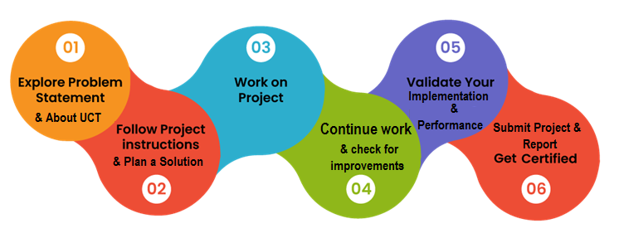

* During the internship, I gained hands-on experience in Python programming, particularly in developing secure applications like the Password Manager. I learned to implement encryption algorithms, manage databases using `sqlite3`, and create user-friendly interfaces. The weekly quizzes enhanced my problem-solving skills and solidified my understanding of key concepts. Overall, this internship has significantly boosted my technical skills, provided valuable industry insights, and prepared me for future career opportunities in the tech field.

# Introduction

## About UniConverge Technologies Pvt Ltd

A company established in 2013 and working in Digital Transformation domain and providing Industrial solutions with prime focus on sustainability and RoI.

For developing its products and solutions it is leveraging various**Cutting Edge Technologies e.g. Internet of Things (IoT), Cyber Security, Cloud computing (AWS, Azure), Machine Learning, Communication Technologies (4G/5G/LoRaWAN), Java Full Stack, Python, Front end**etc.

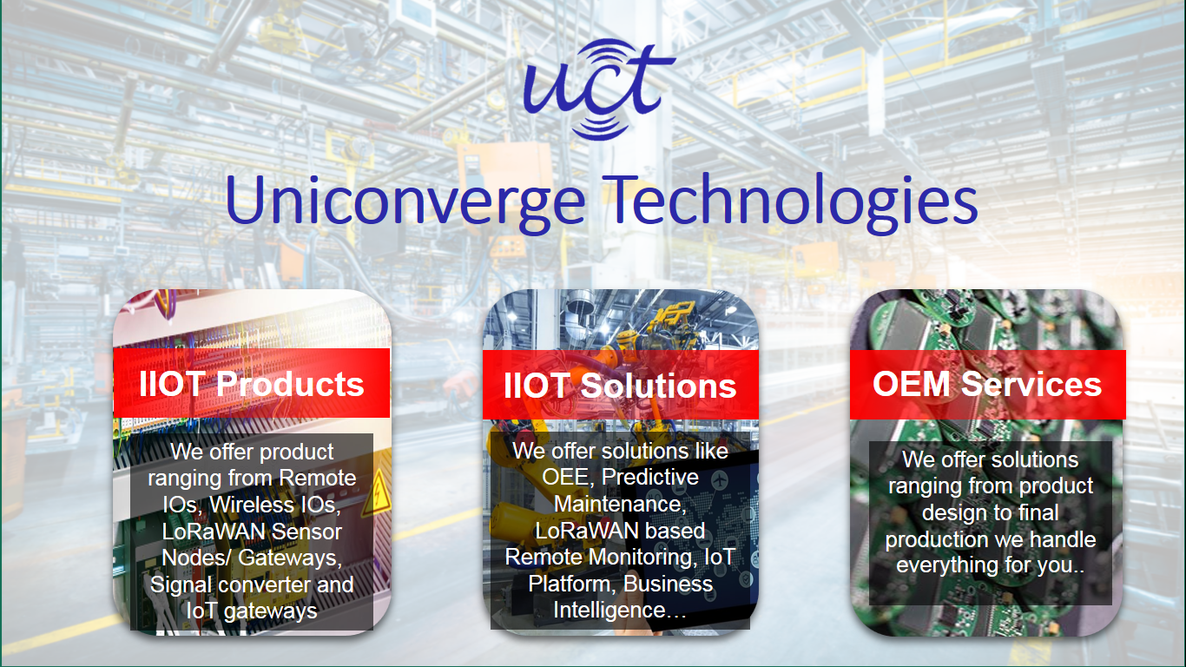

1. UCT IoT Platform **(****)**

**UCT Insight** is an IOT platform designed for quick deployment of IOT applications on the same time providing valuable “insight” for your process/business. It has been built in Java for backend and ReactJS for Front end. It has support for MySQL and various NoSql Databases.

* It enables device connectivity via industry standard IoT protocols - MQTT, CoAP, HTTP, Modbus TCP, OPC UA
* It supports both cloud and on-premises deployments.

It has features to  
• Build Your own dashboard  
• Analytics and Reporting  
• Alert and Notification  
• Integration with third party application(Power BI, SAP, ERP)  
• Rule Engine

 

1. **Smart Factory Platform (****)**

Factory watch is a platform for smart factory needs.

It provides Users/ Factory

* with a scalable solution for their Production and asset monitoring
* OEE and predictive maintenance solution scaling up to digital twin for your assets.
* to unleased the true potential of the data that their machines are generating and helps to identify the KPIs and also improve them.
* A modular architecture that allows users to choose the service that they what to start and then can scale to more complex solutions as per their demands.

Its unique SaaS model helps users to save time, cost and money.

 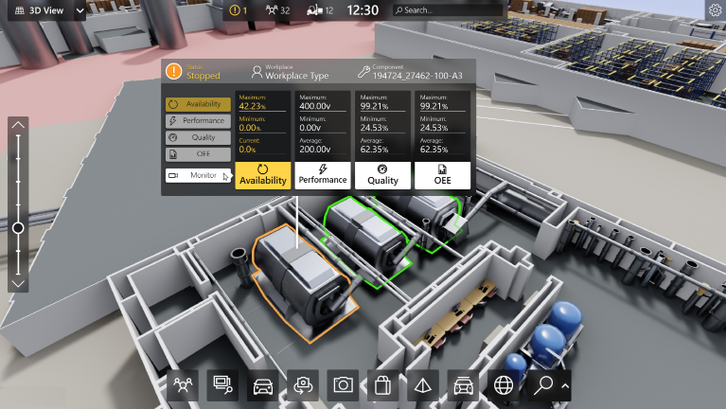

1. 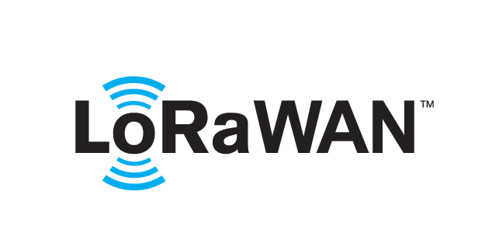 based Solution

UCT is one of the early adopters of LoRAWAN teschnology and providing solution in Agritech, Smart cities, Industrial Monitoring, Smart Street Light, Smart Water/ Gas/ Electricity metering solutions etc.

1. Predictive Maintenance

UCT is providing Industrial Machine health monitoring and Predictive maintenance solution leveraging Embedded system, Industrial IoT and Machine Learning Technologies by finding Remaining useful life time of various Machines used in production process.



## About upskill Campus (USC)

upskill Campus along with The IoT Academy and in association with Uniconverge technologies has facilitated the smooth execution of the complete internship process.

USC is a career development platform that delivers **personalized executive coaching** in a more affordable, scalable and measurable way.



Seeing need of upskilling in self paced manner along-with additional support services e.g. Internship, projects, interaction with Industry experts, Career growth Services

<https://www.upskillcampus.com/>

upSkill Campus aiming to upskill 1 million learners in next 5 year

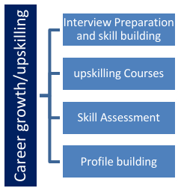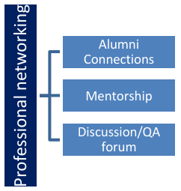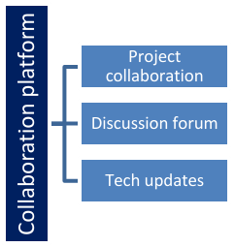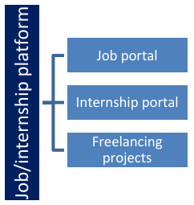

## The IoT Academy

The IoT academy is EdTech Division of UCT that is running long executive certification programs in collaboration with EICT Academy, IITK, IITR and IITG in multiple domains.

## Objectives of this Internship program

The objective for this internship program was to

 ☛ get practical experience of working in the industry.

 ☛ to solve real world problems.

 ☛ to have improved job prospects.

 ☛ to have Improved understanding of our field and its applications.

 ☛ to have Personal growth like better communication and problem solving.

## Reference

[1] Python Documentation

[2] Python E-book

[3] Upskill videos

## Glossary

|  |  |
| --- | --- |
| Terms | Acronym |
| Structured Query Language | SQL |
| Graphical User Interface | GUI |
| Command Line Interface | CLI |
| Encryption | Encoding |
| Decryption | Decoding |

# Problem Statement

The primary problem addressed by this project is the difficulty users face in maintaining strong, unique passwords for multiple online accounts. This issue often leads to poor password practices, such as using weak or repeated passwords, which are vulnerable to cyber attacks. The Password Manager project aims to solve this problem by providing a secure and efficient way to store and manage passwords, ensuring that users can easily access their accounts without compromising security.

# Existing and Proposed solution

* Existing password managers like LastPass, 1Password, Dashlane, and Bitwarden offer various features but have drawbacks like security breaches or cost. Proposed improvements include enhanced MFA, biometric access, better encryption, seamless cross-platform use, and advanced integration. Additionally, customizability, cost-effective pricing, and user education can further enhance these tools.
* My proposed password manager solution includes enhanced security with MFA and biometric access, end-to-end encryption, and a user-friendly interface. It also supports modern authentication methods, provides customizable settings and secure backups, offers cost-effective pricing, considers an open-source model, and includes resources for user education on best practices.

## Code submission (GitHub link)

**Repository Link:** <https://github.com/Hirvita6/upskillcampus>

<https://github.com/Hirvita6/upskillcampus/blob/main/PasswordManager.py>

## Report submission (GitHub link): first make placeholder, copy the link.

# Proposed Design/ Model

The proposed password manager design features enhanced security with MFA and biometric access, end-to-end encryption, a user-friendly interface, modern authentication support, customizable settings, secure backups, and user education resources.

## High Level Diagram (if applicable)

Figure 1: HIGH LEVEL DIAGRAM OF THE SYSTEM

## Low Level Diagram (if applicable)

## Interfaces (if applicable)

Update with Block Diagrams, Data flow, protocols, FLOW Charts, State Machines, Memory Buffer Management.

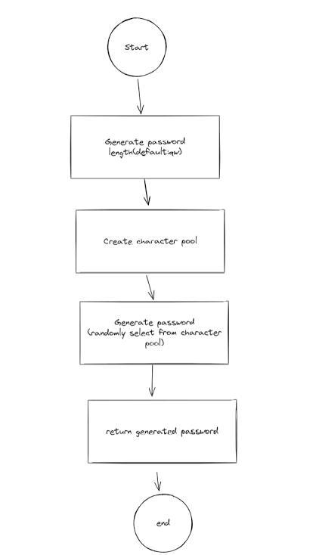

# Performance Test

To test performance, measure speed for login and access, simulate multiple users (load test), stress under extreme conditions, evaluate scalability, perform security assessments, monitor resource use, and test backup recovery.

## Test Plan/ Test Cases

Test plan includes:

* Load/Stress: Simulate users/data load.
* 4. Scalability: Evaluate performance with growth.
* 5. Security: Conduct vulnerability tests.
* 6. Resource Usage: Monitor CPU/memory usage.
* 7. Backup/Recovery: Test backup and restoration.

## Test Procedure

To test performance, measure login speed, simulate user load, conduct stress tests, evaluate scalability, perform security assessments, monitor resource usage, and verify backup and recovery processes

## Performance Outcome

Ensures fast stable high-load handling, efficient scalability, robust security, optimal resource use, and effective data backup and recovery, confirming system efficiency and reliability.

# My learnings

To build a console-based password manager in Python, focus on learning syntax, OOP principles, and file handling. Incorporate encryption for security and handle user input with validation. Structure your project using modules and version control, create a user-friendly CLI, and ensure performance through testing and adherence to coding best practices.

# Future work scope

Future work on the password manager could include developing a graphical user interface (GUI) for better usability, integrating cloud storage for secure backups, and implementing advanced encryption algorithms. Adding features like password strength analysis, breach detection, and auto-update capabilities for stored passwords would enhance security. Additionally, expanding the project to support mobile platforms and browser extensions could significantly increase its accessibility and user base.