AccuPrompt
Testing Report
An accuracy-prompt browser extension for the moment of sharing
Hirwa Armstrong Brian
Supervisor: Kevin Sebineza

1. Overview
This report documents the testing of AccuPrompt, a Manifest V3 browser extension that shows a brief accuracy prompt at the moment a user shares content, on WhatsApp Web, Facebook Messenger, X, and Facebook. It records the testing strategies used, the behaviour observed across different input values, and how the product performs across different software environments. Because AccuPrompt operates by intercepting share actions inside third-party web applications and by talking to a local retrieval service, testing combined automated checks (unit and integration-level logic tests, type checking, and build verification) with manual live verification on each target platform.
What is being tested. The product has four functional pillars: (1) share interception across four platforms; (2) the accuracy prompt itself, with four message formulations selected by a multi-armed bandit; (3) a content-blind triggering gate that suppresses prompts on trivial messages; and (4) an optional retrieval-only evidence panel (RAG) that surfaces related human-written fact-checks, in English and draft Kinyarwanda. Each pillar is exercised below.

2. Testing strategies
Four complementary strategies were used. Each targets a different class of defect, and together they cover the logic, the type safety, the build integrity, and the real-world behaviour of the extension.

2.1 Unit testing (decision logic)
The triggering gate is the component with the most decision logic, so it carries a dedicated unit-test suite (src/content/gate.test.ts). The suite feeds the gate a range of representative messages and asserts the prompt/no-prompt decision for each, exercising the conservative “only prompt when claim-like” posture: trivial acknowledgements are suppressed, while messages carrying a link, numerals, or sufficient length trip the gate.
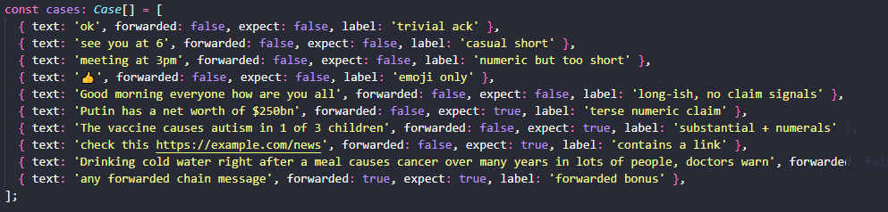
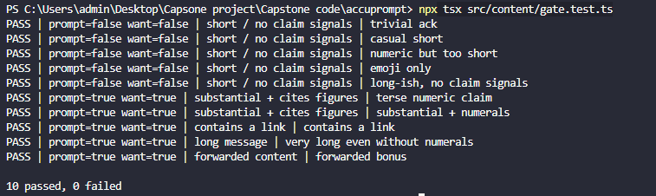
Representative cases and expected decisions:
Input message | Signal | Expected
“ok” | short, no signals | No prompt
“see you at 6” | short, no signals | No prompt
“meeting at 3pm” | numeric but too short | No prompt
“Putin has a net worth of $250bn” | substantial + numerals | Prompt
“The vaccine causes autism in 1 of 3 children” | substantial + numerals | Prompt
“check this https://example.com/news” | contains a link | Prompt
(a long claim > 120 chars, no numerals) | long message | Prompt

2.2 Integration-level logic testing (platform adapters)
Share interception is factored into per-platform adapters behind a common interface, so the platform-selection and send-detection logic can be exercised without a live browser. Automated checks confirmed that each hostname resolves to the correct adapter (WhatsApp, Messenger, X, Facebook, and “none” for unrelated sites), and that the platform-specific send semantics behave correctly most notably that plain Enter sends on WhatsApp/Messenger but is treated as a newline on X, where the keyboard send is Ctrl/Cmd+Enter.
Examples:
1. For messenger:
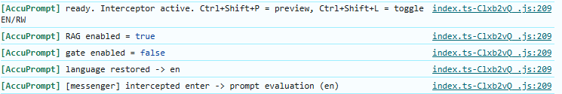

2.3 Manual live verification (target environment)
Because the extension operates inside live, obfuscated third-party web applications, the decisive test is manual verification on each real platform. With the extension loaded unpacked and the developer console open, a share/send action was performed on each platform and the console was checked for the interception log line and the appearance of the prompt. The local retrieval backend was started so the evidence panel could be exercised end-to-end.

3. Testing with different data values
AccuPrompt’s behaviour is data-dependent in three places: the gate reacts to the structure of the message, the evidence panel reacts to whether a claim exists in the corpus, and the interface reacts to the selected language. Each was tested with contrasting inputs.

3.1 Gate: trivial vs. claim-like messages
With the gate enabled, trivial messages (“hell”, “Hello) produced no prompt the console logged a gate-skip with the reason “short / no claim signals” while claim-like messages (a statement with figures, or one carrying a link) produced the prompt. This confirms the gate discriminates on structure as designed.
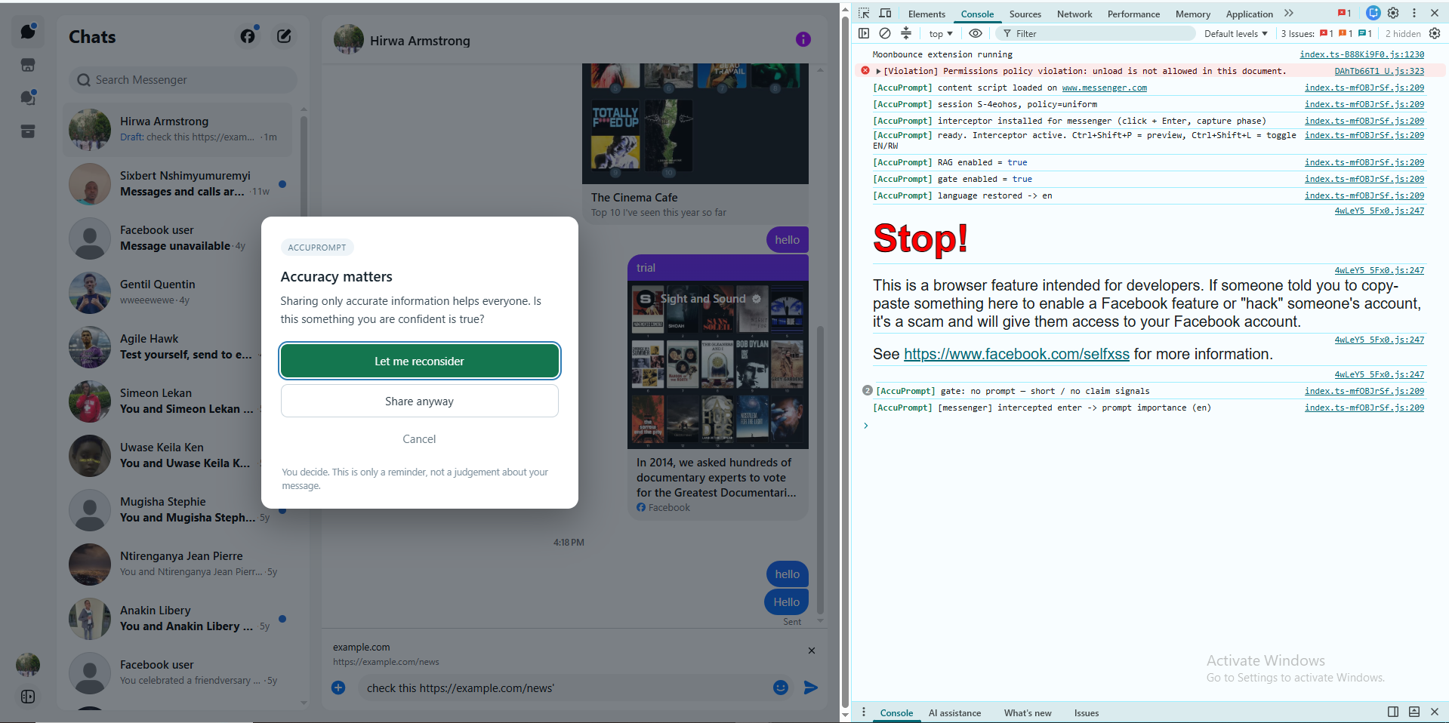

3.2 Evidence panel: in-corpus vs. out-of-corpus claims
The retrieval panel is deliberately silent for messages with no close match in the fact-check corpus (similarity threshold 0.5), and appears only for known claims. Tested with an in-corpus claim (“vaccines cause autism”) the panel returned related fact-checks with their verdict labels and human-written justifications; tested with an everyday out-of-corpus message the panel correctly showed nothing. This threshold behaviour was tuned empirically: a genuine match scored ~0.69–0.76, a vague query ~0.40–0.43, and unrelated text ~0.28, giving a clean separation at 0.5.
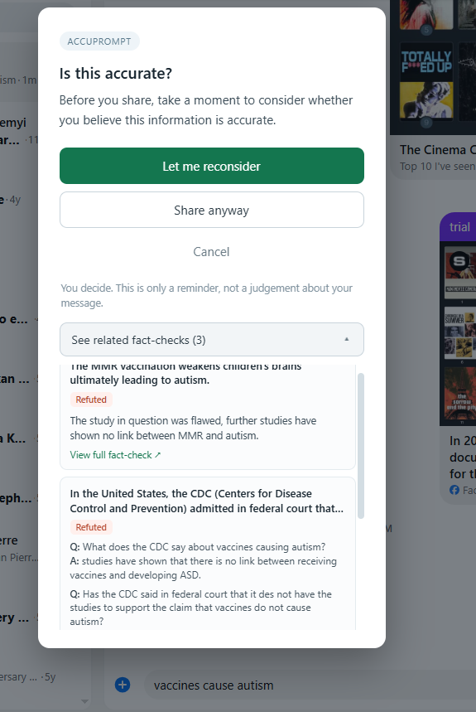
Different verdict values. The corpus carries four verdict categories, and the panel colour-codes each: Refuted (red tone), Supported (green tone), and the neutral Not Enough Evidence and Conflicting Evidence/Cherrypicking. Testing with claims of different verdicts confirmed the correct label and tone were shown for each.

3.3 Language: English vs. Kinyarwanda
Switching to Kinyarwanda (via the popup or the keyboard toggle) re-rendered the prompt and the evidence panel in Kinyarwanda. Where a translated justification existed it was shown with an amber “auto-translated, not yet reviewed” notice; where none existed the panel fell back to the English text with a note; and draft verdict labels appeared with a provisional “(agateganyo)” marker while the colour stayed keyed to the English verdict. This confirms the honesty safeguards behave correctly under both languages.
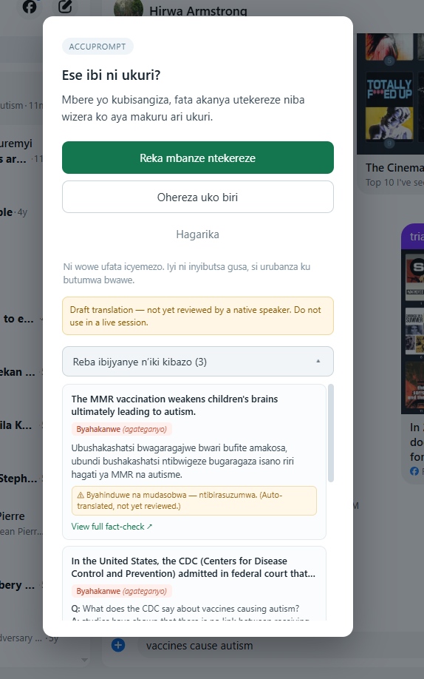

4. Performance across software environments
AccuPrompt has two runtime parts with different environment sensitivities: the extension (runs in the browser) and the local retrieval backend (runs on the workstation). Both were exercised across the environments below.
Environment / condition | What was tested | Result
Chrome / Chromium (MV3) | Extension load, injection, interception | Loads and intercepts as expected
Four platforms (WhatsApp, Messenger, X, Facebook) | Share/send detection on each live site | Interception verified on each
Backend running vs. not running | Evidence-panel behaviour under backend failure | Prompt still works; panel degrades gracefully
Backend first run vs. warm | Embedding-model download on first start | One-time ~90MB download, then fast
Gate on vs. gate off | Prompt frequency (A/B arms) | Off = every send; On = claim-like only
Evidence on vs. off | Retrieval presence (A/B arms) | Independently switchable from popup
Graceful degradation (a key resilience result). When the backend was deliberately not running, a share still produced the accuracy prompt and the user could still choose an outcome; only the optional evidence panel was absent, and it failed silently rather than blocking the core function. This was observed directly in testing (a connection-refused entry appeared in the console while the prompt continued to work), confirming that retrieval failure never prevents the intervention.
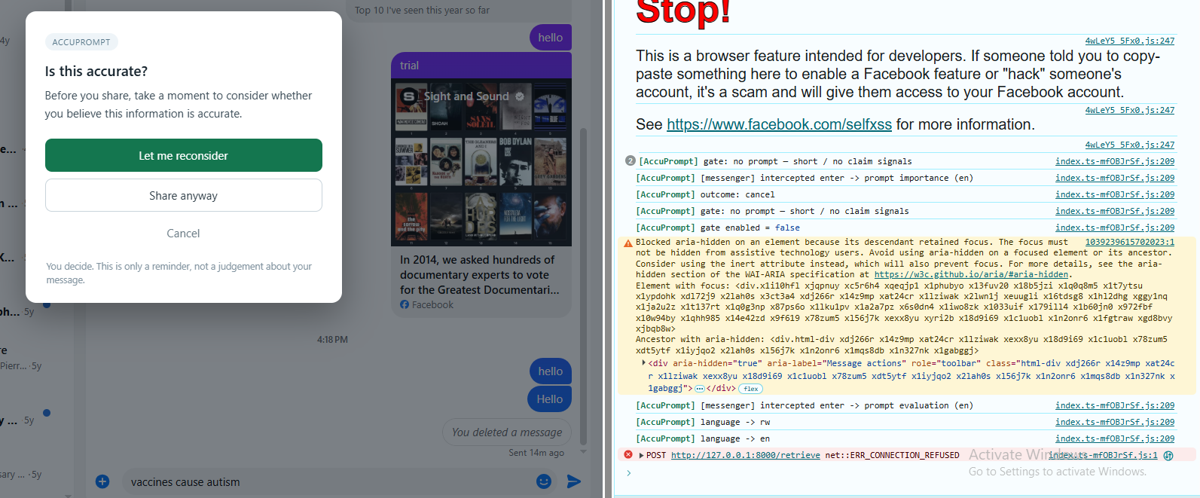

5. Summary of testing
Across the four strategies, the core functionalities behaved as designed: interception fired on all four platforms; the gate discriminated trivial from claim-like messages; the evidence panel appeared only for in-corpus claims and degraded gracefully when the backend was down; and the bilingual interface applied its honesty safeguards under both languages. The automated logic tests, type checking, and build verification passed on every accepted change, and the manual live checks confirmed the behaviour in the real target environment.
Known limitations surfaced by testing. Interception depends on platform-specific selectors in obfuscated, frequently-changing web interfaces; the Facebook share hook in particular relies on an English interface string and is language-dependent. These are documented so that a future maintainer knows where behaviour is most likely to break, and are discussed further in the accompanying Analysis, Discussion and Recommendations report.

