* **Creating a database:**

create database healthcare_db;

use healthcare_db;

* **creating two tables called diabetic_data and demographic out of the same data:**

show tables;

select *from diabetic_data;

select count(*) from diabetic_data;

describe diabetic_data;

* **updating age column in demographic table**

update demographic

set age=replace(age, '[', '(');

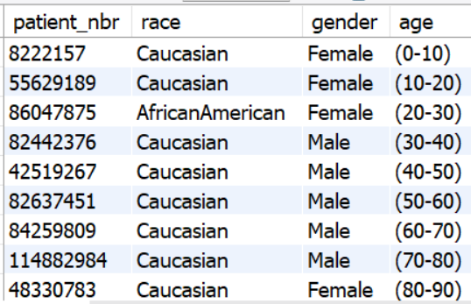

* **Just wanted to find the max and min of patient number:**

select max(patient_nbr) from demographic;

select min(patient_nbr) from demographic;

* **finding duplicates using row number windows function**

select *

from (

select *,

row_number() over(partition by patient_nbr order by patient_nbr) as RowNum

from demographic

)d

where d.RowNum>1;

* **Another way of finding duplicates in the dataset:**

select count(*)

from(

select *

from (

select *,

row_number() over(partition by patient_nbr order by patient_nbr) as RowNum

from demographic

)d

where d.RowNum>1

)as dup;

* **Finding duplicates in the table diabetic_data:**

select *

from (

select *,

row_number() over(partition by patient_nbr order by patient_nbr) as RowNum

from diabetic_data

)d

where d.RowNum >1;

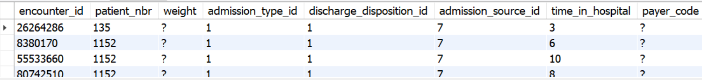

* **Finding duration of stay in hospital**

select time_in_hospital, count(*) as counts

from diabetic_data

group by time_in_hospital

order by time_in_hospital;

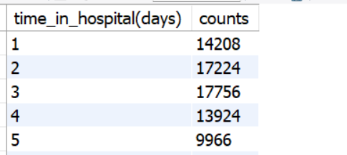

* **SQL command creating Histogram**

select

round(time_in_hospital, 1) as bins,

count(*) as counts,

rpad('', count(*)/100, '*') as bar

from diabetic_data

group by bins

order by bins;

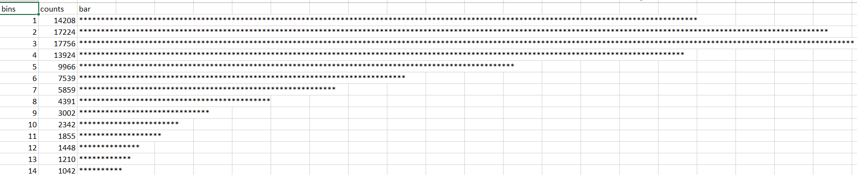

* **Just to find out how many medical specialties in the hospital**

select distinct(medical_specialty),

dense_rank() over (order by medical_specialty) as serial_no

from diabetic_data

order by medical_specialty;

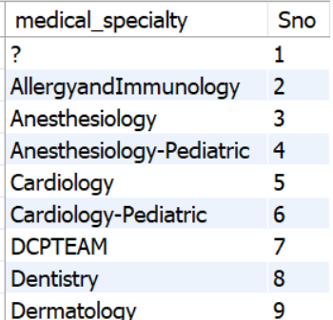

* **Finding the average number of procedures done in each speciality:**

select medical_specialty,

round(avg(num_procedures),1)avg_procedures

from diabetic_data

group by medical_specialty

order by avg_procedures desc;

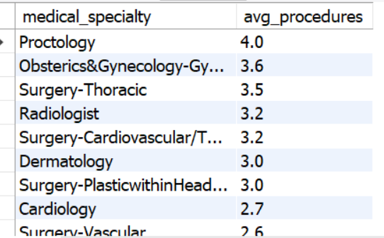

select medical_specialty,

round(avg(num_procedures),1)avg_procedures,

count(*) total_number_procedures_done

from diabetic_data

group by medical_specialty

having count(*) > 50

and avg_procedures >2.5

order by avg_procedures desc;

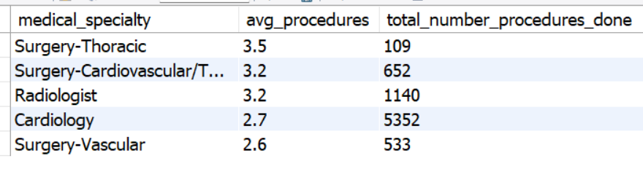

select * from diabetic_data

join demographic on diabetic_data.patient_nbr = demographic.patient_nbr;

select race, round(avg(num_lab_procedures),1) num_avg_lab_procedures

from diabetic_data

join demographic on diabetic_data.patient_nbr = demographic.patient_nbr

group by race

order by num_avg_lab_procedures desc;

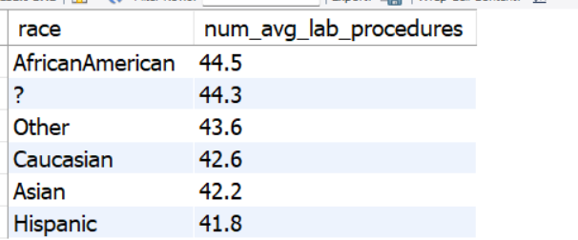

* **Finding average stay in the hospital and the number of procedure carried out.**

select round(avg(time_in_hospital),1) avg_stay_hospital,

case

when num_lab_procedures >= 0 and num_lab_procedures < 25 then "few"

when num_lab_procedures >= 25 and num_lab_procedures < 55 then "average"

else "many"

end as procedure_frequency

from diabetic_data

group by procedure_frequency

Order by avg_stay_hospital desc;

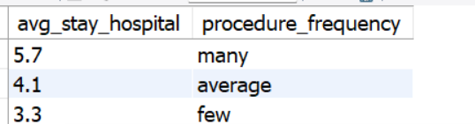

Select count(*) as total_count

From

(

select patient_nbr from demographic where race = "Asian"

union

select patient_nbr from diabetic_data where metformin = "up"

) as combined_total;

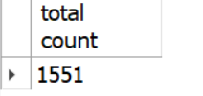

select concat('Patient',' ', diabetic_data.patient_nbr,' ', 'was',' ', race,' ', 'and',

(case

when readmitted like '%<30%' Then "was readmitted <30 days after discharge"

-- when readmitted = 'no' Then "was not"

-- when readmitted = 'No' Then "was not"

else ' was not readmitted.'

end),' ',

'and had',' ', num_medications,' ', 'medications and ', num_lab_procedures,' ', 'lab procedures.') summary

from diabetic_data

join demographic on diabetic_data.patient_nbr = demographic.patient_nbr

order by diabetic_data.patient_nbr desc;

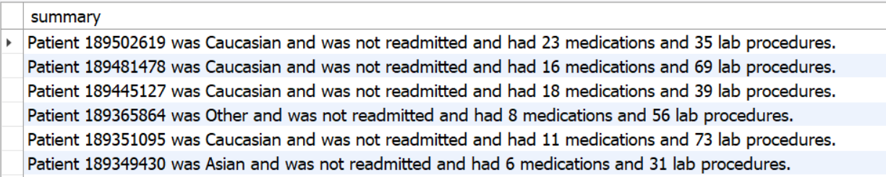

with cte as

(

select concat('Patient',' ', diabetic_data.patient_nbr,' ', 'was',' ', race,' ', 'and',' ',

(case

when readmitted like '%<30%' Then "was readmitted <30 days after discharge"

when readmitted like '%>30%' Then "was readmitted >30 days after discharge"

when not readmitted like "%NO%" then "was readmitted"

when readmitted like "%NO%" then "was not readmitted"

end),' ',

'and had',' ', num_medications,' ', 'medications and ', num_lab_procedures,' ', 'lab procedures.') summary

from diabetic_data

join demographic on diabetic_data.patient_nbr = demographic.patient_nbr

)

select *from cte where summary like "%<30%";

