

PROPOSAL FOR STRATEGIC PARTNERSHIP AND YOUTH FOOTBALL DEVELOPMENT SUPPORT BETWEEN RAYS OF GRACE ACADEMY & NILE BREWERIES LIMITED
1. Introduction
Rays of Grace Academy is a youth football development academy based in Njeru Municipality, Buikwe District, Uganda, dedicated to identifying, nurturing, and transforming talented young players into disciplined athletes and responsible future leaders. Established with a vision of using sports as a tool for social transformation, the academy provides talented children with an opportunity to access professional football training, education, mentorship, and life-skills development.
However, our ambition to reach national stages and produce Uganda's next football heroes requires strategic partnerships. We therefore invite Nile Breweries Limited to join us in building champions, empowering communities, and shaping a brighter future through the beautiful game.
2. Background of the Academy
Rays of Grace Academy was founded in 2016 by Mr. Roberts Kiwanuka with the mission to educate and prepare players for excellence in football through a well-structured coaching and education program that develops their skills, discipline, and overall performance both on and off the pitch. The academy was established after recognizing the lack of structured opportunities available to many talented young footballers in Uganda who had the potential to succeed but lacked access to proper training facilities, mentorship, education, and exposure.
Starting as a small initiative aimed at nurturing football talent in the community, the academy has grown into a respected youth sports institution serving hundreds of young players aged between 6 and 18 years. The academy operates throughout the year and offers professional coaching programs designed to develop players technically, physically, mentally, and socially.
The academy has steadily grown into one of Uganda’s recognized youth football institutions, offering structured sports programs that emphasize honesty, discipline, teamwork, integrity, and holistic child development. Rays of Grace Academy is officially registered with the Uganda Youth Football Association (UYFA) and has participated in several national and regional competitions, producing young players who continue to excel at different levels of football.
Rays of Grace Academy has achieved significant success in youth football competitions both nationally and regionally. Has gained national recognition after winning the inaugural FUFA Primary Schools Championship (Odilo) in 2019 and successfully defending the title in 2022. The academy has also competed in tournaments such as the Airtel Rising Stars Championship, Kabaka Cup, UYFA competitions, FEASSSA Games, FUFA Academies League, and several other youth football tournaments across East Africa.
The academy’s development approach goes beyond football by focusing on holistic child development through education, discipline, leadership, moral values, and mentorship. Rays of Grace Academy works closely with guardians, coaches, and development partners to ensure that children receive support both academically and socially while pursuing their sporting careers.
Despite its achievements, the academy continues to face challenges including limited financial resources, inadequate training equipment, transportation difficulties, and the need for improved sports facilities and player welfare support. To continue transforming the lives of young athletes and expanding opportunities for youth development, Rays of Grace Academy seeks sponsorship and strategic partnership Nile Breweries Limited to empower communities and support the future of Ugandan youth through sports.
Mission
To nurture young talent holistically by integrating elite football training with academic support, character development, and life-skills education.
Vision
To become a leading football academy in Uganda that produces disciplined, skilled, and empowered youth who excel both on and off the pitch.
Objectives
- To identify, nurture, and develop football talent at grassroots level.
- To produce players capable of competing at district, national, and international levels.
- To create opportunities for players to progress through the academy ranks and represent Uganda at various levels.
- To provide high-quality football training through experienced coaches while promoting sportsmanship and discipline.
- To integrate sports psychology into player and team development for improved performance and mental strength.
- To provide leadership, mentorship, and positive role models for young athletes.
- To promote personality development, confidence, and life skills among players.
- To contribute to the growth and development of sports in Uganda.
Core Values
- Honesty
- Fairness
- Friendliness
- Discipline
- Integrity
At Rays of Grace Academy, every child is seen, valued, and guided not only to succeed in football, but also to succeed in life.
2. Achievements of the Academy
Since its inception, Rays of Grace Academy has recorded significant milestones that speak to our credibility, visibility, and measurable impact within the community and beyond. What we started as a small group of passionate young players has grown into a recognized incredible football institution.
Major Tournaments Won
Our teams have consistently competed and excelled against established academies. Key honors include:

Players Developed
Arafat Nkoola who is known as Uganda U17 World Cup Hero, Arafat Nkoola arrived at Rays of Grace Academy in 2017 as a quiet boy from a humble background. Today, he stands as one of Uganda's most promising young footballers as he showcased in the U17 World Cup in 2025 where his goal gave cranes a lead against Burkina Faso in the round of 16 though it was equalised later and ended in 5-3 loss in penalty shoot out against Burkina Faso that ended their campaign.
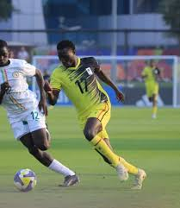
Simon Wanyama is also another key player who has been raised here, Simon is a consistent performer for both academy and country, developing alongside Nkoola through the Rays of Grace system. He was part of the Uganda Cubs squad that made history by qualifying for the U17 World Cup, the first Uganda football team ever to reach a global World Cup stage. Selected for the U15 National Team squad for the CECAFA U15 tournament in 2023, to mention but a few.
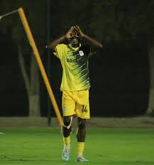

Talent Progression & Success Stories
Rays of Grace Academy has a proven track record of nurturing talent, leading players to national youth teams (Uganda U15, U17, U20), top-tier club contracts, and premier secondary school sports scholarships. The academy couples sports development with education, ensuring 100% transitions into secondary education. Below are some of the success stories at Rays of Grace Academy.
Travis Mutyaba: One of the most prominent academy graduates, Mutyaba rose through the youth ranks at Rays of Grace, starred in the Airtel Rising Stars tournaments (2018 & 2019) that Rays of Grace Academy Crowned, and has since established himself on the international stage with the Uganda Cranes and overseas clubs.
Vincent Mulema: A highly successful product of the academy's junior setup. Mulema served as the team captain and successfully progressed to the Uganda U-15 and U-17 national teams, including representing the country at the 2021 U-17 AFCON in Morocco.
Leonard Kasanya: Another academy standout who won the Most Valuable Player (MVP) award at the FUFA Odilo Primary Schools Championship (2019). He later played for the Uganda U-15 national team.
Enock Luyima: Progressed from Rays of Grace to the Uganda U-20 national squad, as well as being named in the final traveling squad for the 2021 U-17 AFCON in Morocco.
Lawrence Kambugu: Demonstrated the academy's path to professional club football by signing a two-year contract with Uganda Premier League side BUL Football Club.
Simon Wanyama: Discovered during scouting missions in Busia, Wanyama overcame a challenging background to star for the academy, helping the institution secure both national youth trophies and the FEASSSA East African Championship

Key Honors
These are some of the key honors for the success stories;
A goal from Hamis Nalapa secured a 1–0 victory for Rays of Grace Academy against Namagabi UMEA in the UPSSA 2025 competition. The match was played at Ndeba C/U Playground, with both teams displaying determination and impressive football talent
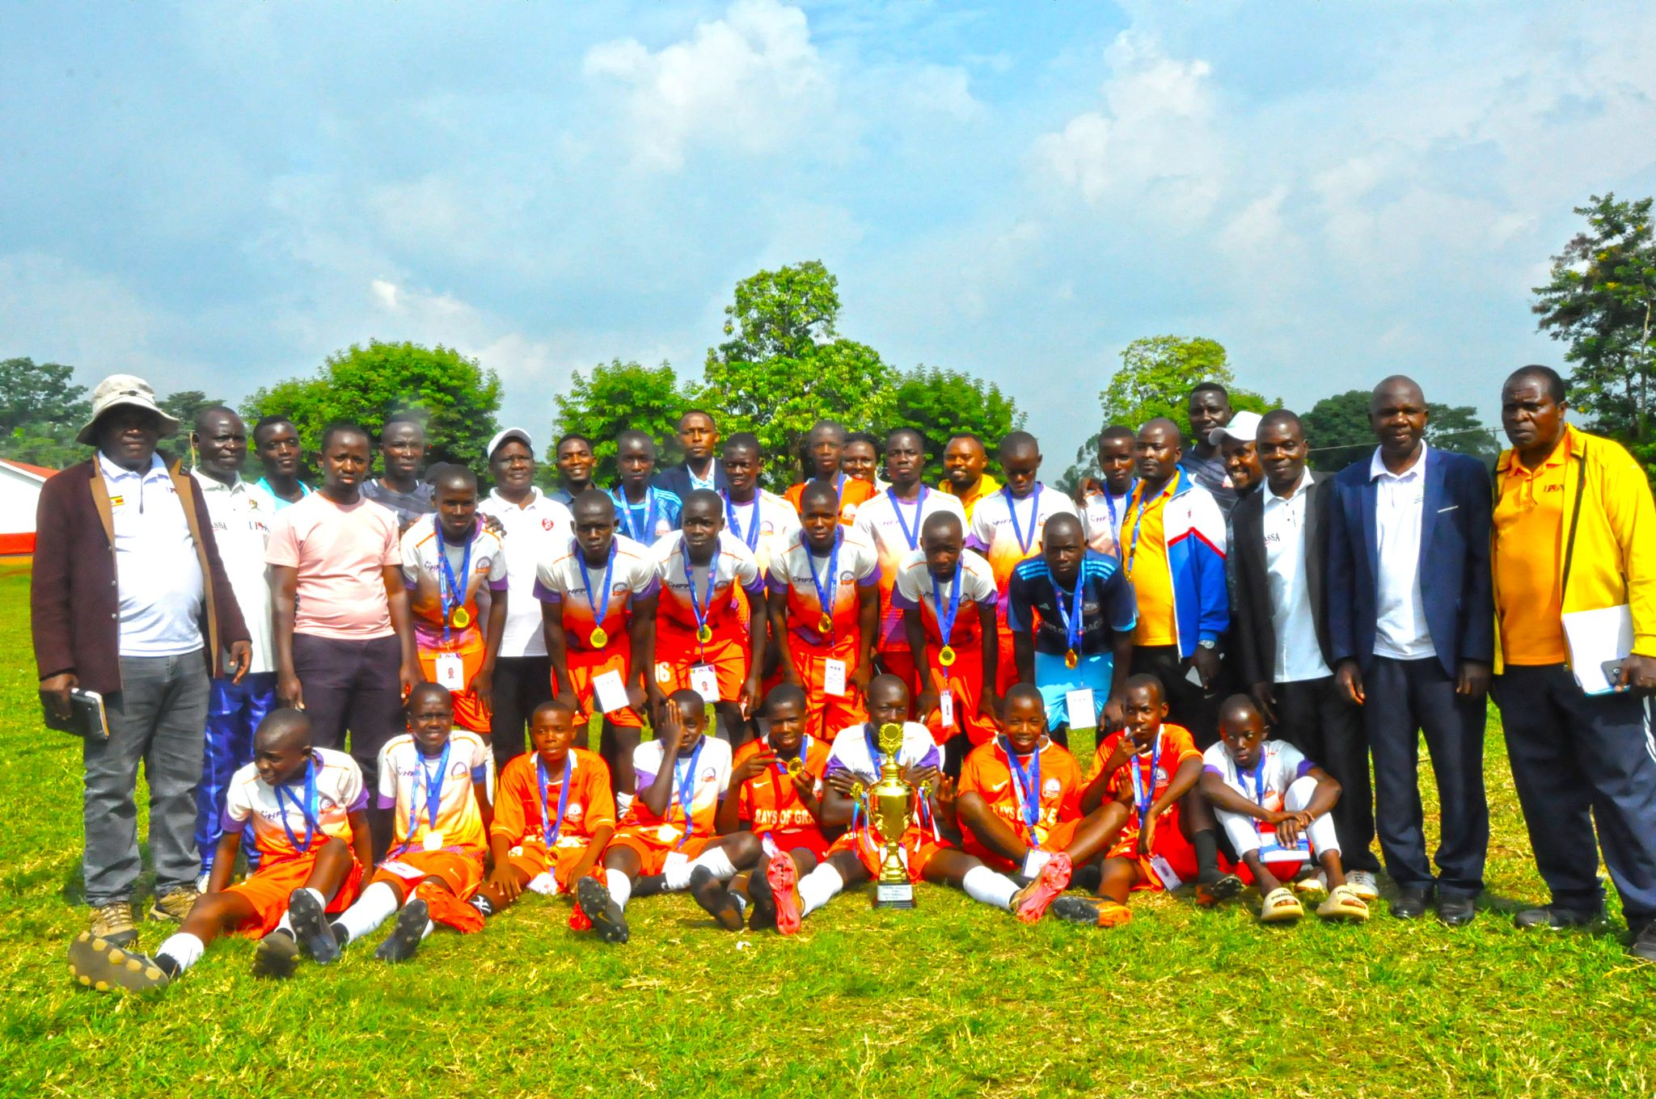
The Academy retained their Buganda region FUFA Odilo championship title after a sound 4-0 win over Masaka-based Becker Infant School in the final played at Latifah Mixed secondary school playgrounds in Kabimbiri-Mukono.
Amos Molu had a brace while Nicholas Kawooya and Steven Sseruwagi scored one each as Rays of Grace won the title for the third straight time.
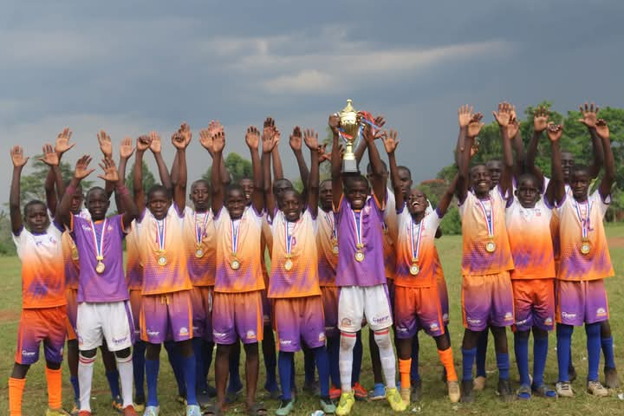
On a busy Saturday morning at the Panamera sports grounds in December 2022. Hundreds of kids aged under 10, 12 and 14 from seven academies including hosts Joe Kigozi academy, Rays of Grace, Excel academy, Proline, Aliguma, Teletubies and Discovery exhibited their skills in the inaugural JKA Juniors tournament where Rays of Grace Academy Emerged as Champions.
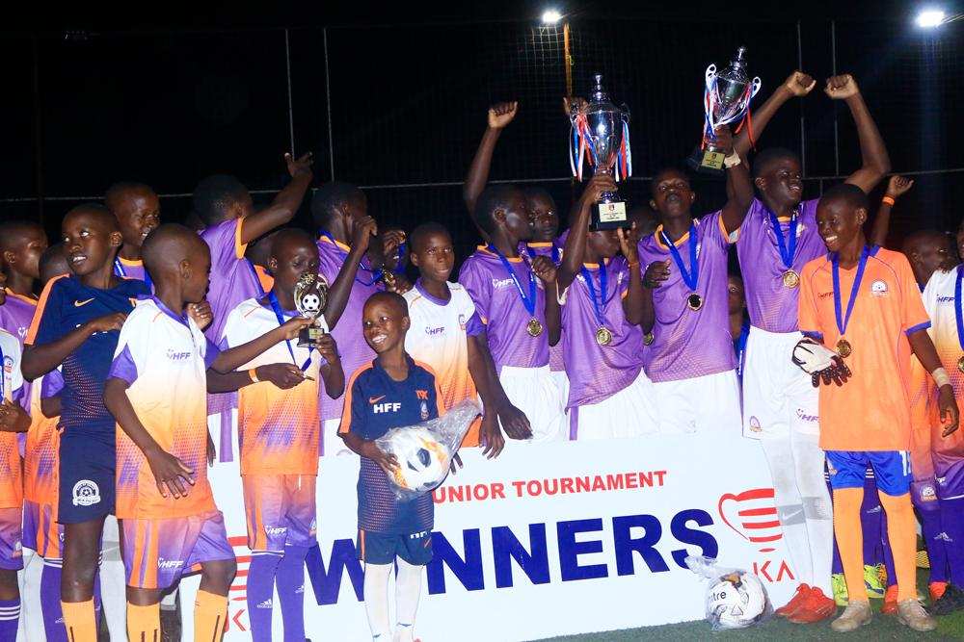

Rays of Grace Academy won the Sports for Climate Change Mitigation Tournament after a hard-fought 1–0 victory over Brentford Soccer Academy. The winning goal was scored by Musika Sowed during the match played at Twin Brook Soccer Ground. The tournament brought together young players to promote environmental awareness through sports while showcasing their football talents.
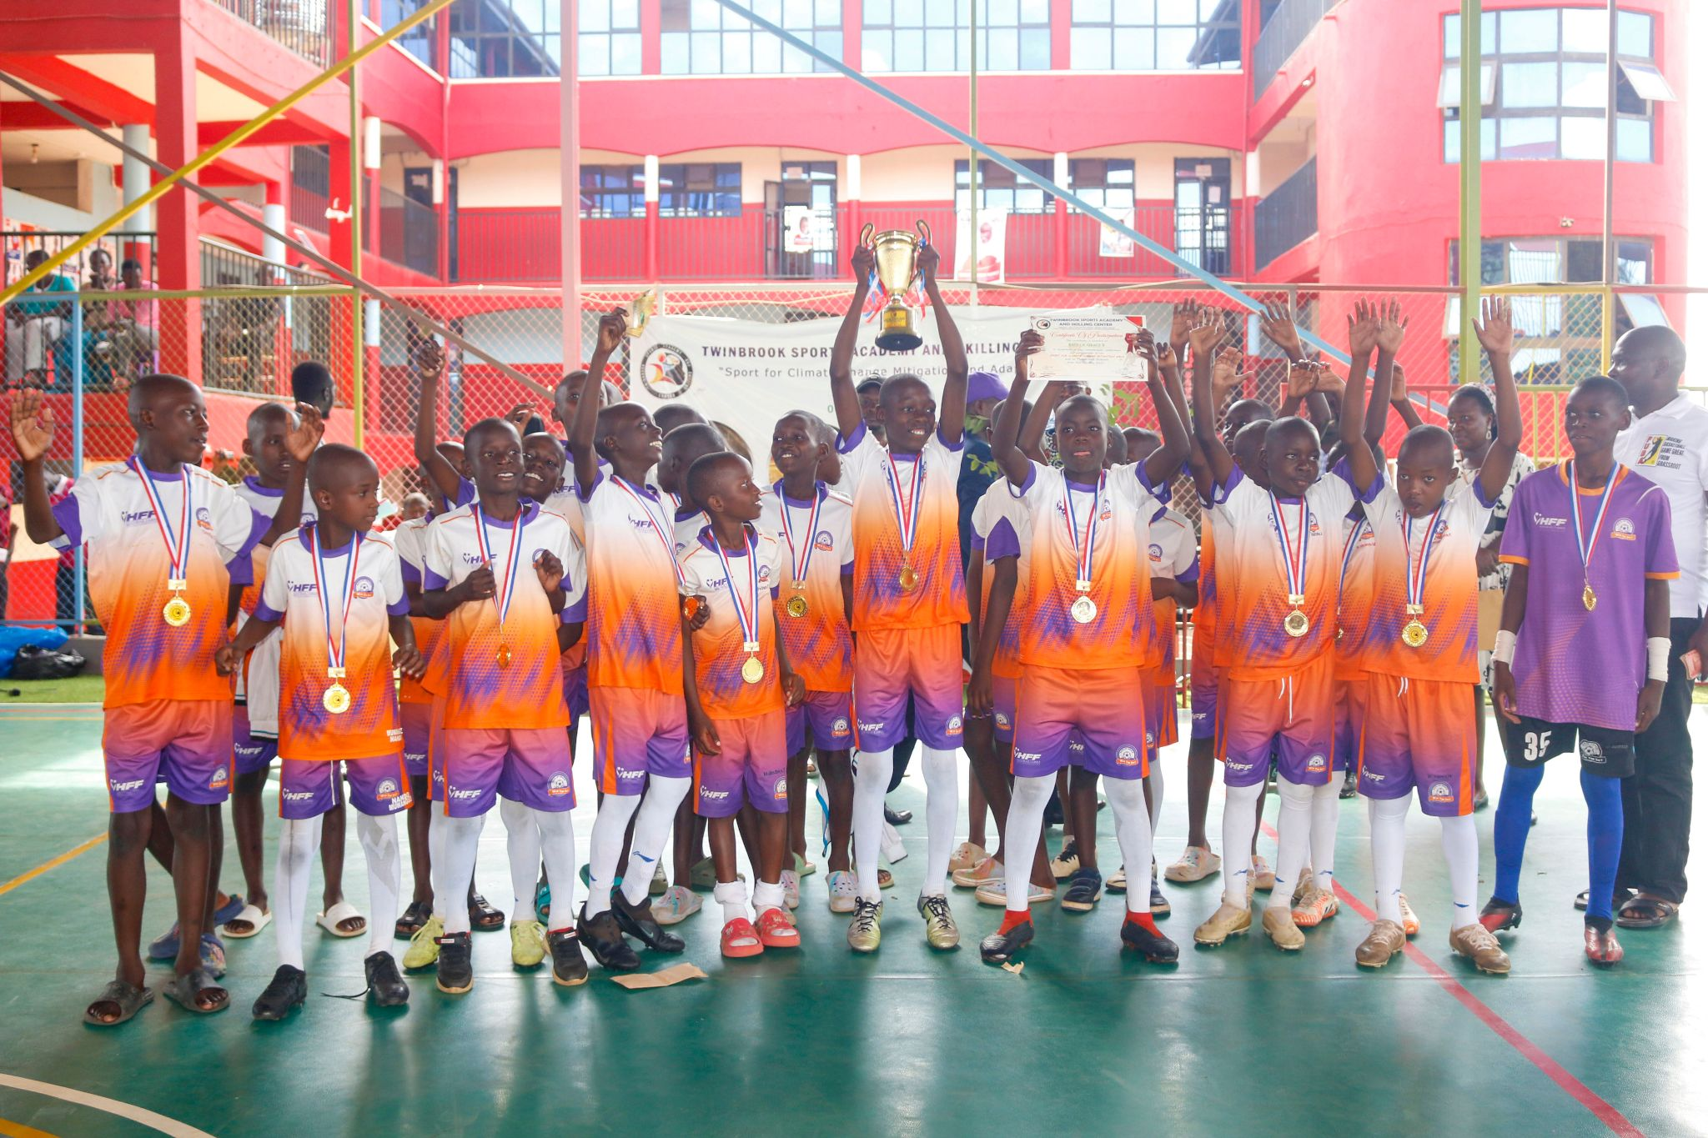
In 2019, Rays of Grace Academy emerged victorious in the FUFA Primary Schools Champions competition after securing a 1–0 win over Oasis Primary School. The match was played at Njeru Technical Center, with Leonard scoring the decisive goal to seal the victory for Rays of Grace Academy. The game showcased determination, teamwork, and outstanding young football talent.
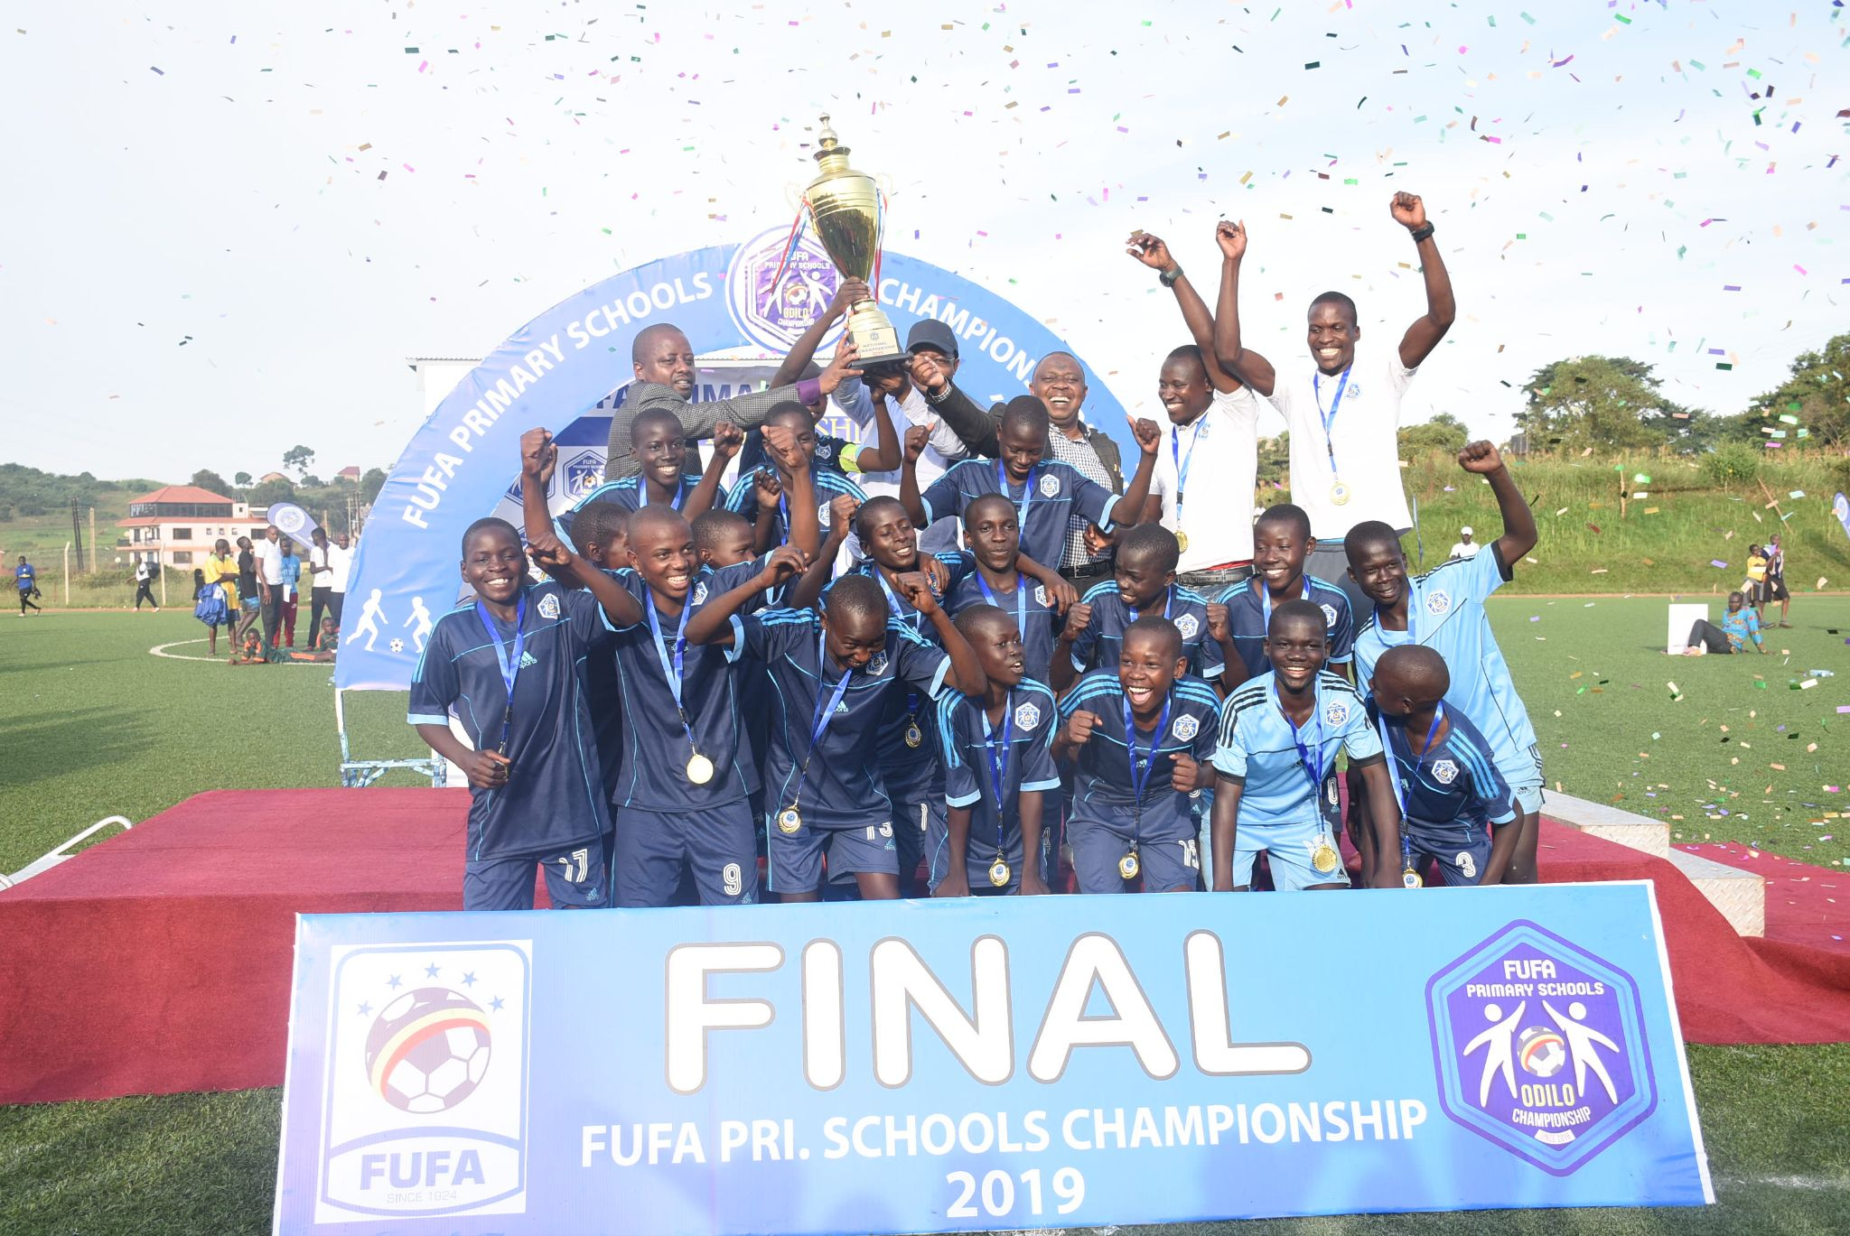

3. National Engagement and Impact
Rays of Grace Academy actively participates in national football structures and youth transformation initiatives across Uganda:
- National Competitions: Registered and competing in FUFA Juniors League, Regional Zonal Qualifiers, Uganda Youth Football Association tournaments.
- Talent Identification: Our players have been scouted by Jinja SSS, Vipers Youth, KCCA Academy, Uganda Cubs scouts during national tourneys.
- Community Development: We use football matches as platforms to promote malaria prevention, alcohol awareness (responsibly), and school retention.
- Youth Transformation: By keeping youth engaged in daily training and mentorship, our catchment area has reported reduced street idleness and improved school attendance.
We are proud to contribute to Uganda’s National Sports Policy and the broader goal of using football for social good, not just trophies.

4. Why Rays of Grace Academy Should Partner with Nile Breweries
Nile Breweries is more than a beverage company it is a household name deeply rooted in Ugandan communities. Partnering with Rays of Grace offers strategic value:
- Brand Visibility at Community & Regional Level: Our matches, tournaments, and events attract hundreds of families, schools, and local leaders. Your logo on kits, banners, and social media posts will generate grassroots brand love.
- CSR Alignment with Youth & Sports: Nile Breweries’ commitment to responsible drinking, community development, and youth empowerment aligns perfectly with our discipline-focused football model.
- Positive Public Image: Sponsoring a talent academy transforms Nile Breweries from a corporate entity to a community enabler especially among parents, educators, and local government.
- Access to Uganda’s Football Ecosystem: Through us, you gain a direct pipeline into FUFA structures, youth tournaments, and scouting networks ideal for long-term sports marketing.
- Grassroots Legacy: While many sponsors chase elite leagues, supporting grassroots football builds authentic, lasting emotional connection with future consumers.
“Rays of Grace is where future stars are shaped and we invite Nile Breweries to write that story with us.”

5. Benefits the Academy Seeks from the Partnership
To scale our impact, we respectfully seek the following support from Nile Breweries:
- Sponsorship Funding: This will cover registration fees, coach stipends, and medical insurance.
- Training Equipment: Footballs, cones, bibs, goalkeeper gloves, and first-aid kits.
- Playing & Training Kits: 3 full sets (home, away and training) with Nile Breweries branding.
- Transport Support: Bus/taxi hire or even fuel for away matches and national tournaments.
- Tournament Sponsorship: Title sponsorship for our annual “Rays of Grace Community Cup” we think of it to have over 20 teams.
- Infrastructure: Pitch maintenance, changing rooms, and simple floodlights for evening training.
- Scholarships for Top Talent: Support for outstanding players to attend football & academics.
- Media Exposure: Feature academy progress on Nile Breweries digital platforms.
- Mentorship: Staff engagement sessions on leadership, career guidance, and responsible life choices.

6. Mutual Benefits of the Partnership
For Rays of Grace Academy | For Nile Breweries Limited
Sustained football operations | High impact visibility
Better equipment and safety | Positive brand association with youth & sports
Access to national tournaments | Grassroots marketing reach which will reach parents, schools, and local leaders
Talent exposure & player development | Opportunity for employee volunteering & teambuilding
Long-term planning ability | Media coverage on our platforms & partner networks

This is not a donation, it is a strategic alliance that builds community goodwill while elevating Nile Breweries’ brand among Uganda’s next generation.

7. Conclusion and Call to Action
Rays of Grace Academy is not waiting for permission to change lives; we are doing it every day with the resources that we currently have. But with Nile Breweries by our side, we could reach ten times more young people, produce national-level players, and set a new standard for grassroots sports in Uganda.
We respectfully request a meeting with your Sponsorship Committee to present our vision in person, share testimonials and photos then discuss a tailored sponsorship package.
Draft Sponsorship Package for Discussion:

Final budget will be shared upon acceptance of partnership discussions.
Together, we can turn raw talent into national pride. Together, we can keep youth focused, fit, and hopeful one match at a time.
We eagerly await your positive response and the opportunity to discuss how Rays of Grace Academy and Nile Breweries can score a goal for Uganda’s future.

