4MP Outdoor IP65 Waterproof AI Intrusion Detection Battery-Powered Wireless WiFi Camera
C90
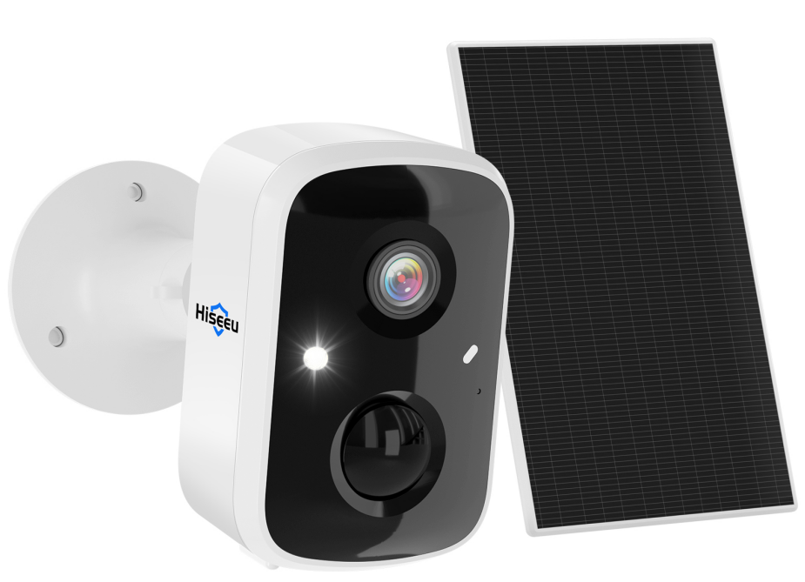

Features
- Installation is simple, usage is convenient, fully wireless, no need to run wires
- The image is clear and smooth, and intelligent transmission reaches the network's full potential
- Online firmware upgrade, synchronized update function and health check
- Supports two-way voice communication, echo cancellation, and noise suppression
- Supports Android and iOS smart terminals for remote real-time monitoring
- 400W high-definition pixels (2560*1440), with clear picture quality
- 7-meter infrared night vision lighting; optional white light illumination for supplementary light, enabling night vision of color images
- Built-in rechargeable lithium battery, with long battery life. Normal operation lasts up to 6 months, and standby time is up to 12 months
- Supports 2.4G Wi-Fi (IEEE 802.11b/g/n)
- Supports cloud storage technology, with micro SD card (up to 128GB) for storage, and mobile phone video recording
- Support intelligent connection of QR codes for power distribution networks
- Supports human shape detection, vehicle detection, pet capture, and package detection (requires activation of premium services)
- IP65 dustproof and waterproof design, easy to install. Both the back and bottom support 1/4 universal screw brackets

Specifications
Model | C90
Host processor | SOC:ARM
Imaging sensor
Max Resolution | 4 MP
Sensor | 1/2.8" color CMOS sensor
Lens | M12, f: 3.0mm, F1.6, 4 million pixels
Viewing angle | H (horizontal) 115 degrees; V (vertical) 62 degrees; D (diagonal) 138 degrees
Minimum illumination | 0.01 Lux
Audio
Input/Output | Enable two-way voice communication (built-in microphone and speaker)
Audio compression method | AAC
Video
Video compression method | H.264/H.265
Lighting frequency | 50Hz, 60Hz
Image frame rate | 15fps
Maximum image resolution | 2560*1440
Night vision light source | Infrared lamp or white light lamp (1.5W 200Lux)
Internet
Wireless Network | 2.4G Wi-Fi (IEEE802.11b/g/n), built-in antenna, external antenna support (2.4G)
Supported Protocols | TCP/IP, UDP/IP, DHCP, RTMP, MUTP
Supported IP Address | Dynamic IP Address
AI
Smart Features | Human Detection, Vehicle Detection, Pet Capture, Package Detection
Alarm Method
Alarm Notification | Mobile app push notifications, device white light flashing, and audible alarm
Wake-Up
Wake-Up Method | PIR motion detection wake-up, remote active wake-up
Recording
Recording Method | Alarm-triggered recording, manual recording
Recording Storage | Cloud storage, local Micro SD card, mobile device memory
Indicator Lights
LED Indicators | Red and blue lights indicating power/network signal/function status
Power Consumption
Power Off | 0.32mW (4V 80μA)
Standby | 1.68mW (4V 0.35mA)
Daytime Operating Power Consumption | 0.98W (4V 246mA)
Network
Open-Air Range | 100 meters
Interfaces
Power | Micro USB port
SD Card | Supports up to 128GB
Antenna | Supports external antenna
Buttons | 1 Power Button, 1 Reset Hole
Mounting
Mounting Method | Rear 1/4" Universal Screw Hole
Environment
Dustproof & Waterproof | IP65
Operating Environment | Digital Defog
Storage Environment | -20°C ~ 60°C / 0% ~ 90% RH (non-condensing)
Specifications
Dimensions (LxWxH) | 59mm x 60mm x 91mm (excluding bracket)
Unit Weight | Approx. 235g
Material, Color, Finish | PC, White High Gloss
Certificates
Certificates | CE, FCC, RoHS, MSDS, UN38.3
Built-in Speaker | Support
WIFI | N/A
Network | 1 × RJ45 10 M/100 M Base-TX Ethernet
General
Protection | IP66
Power | DC 12V±25%, PoE (IEEE 802.3af)
Power Interface | Ø5.5 mm coaxial power plug
Dimensions | Φ110mm*110mm*151mm (Φ4.3”x 4.3”x 6.0”)
Weight | 0.38kg (0.84lb)
Material | Plastic
Working Environment | -30 ℃ to 60 ℃ (-22 ℉ to 140 ℉), Humidity: ≤ 95% RH (non-condensing)
Storage Environment | -30 ℃ to 60 ℃ (-22 ℉ to 140 ℉), Humidity: ≤ 95% RH (non-condensing)
Surge Protection | 4 KV
Reset Button | Support
LED Indicator | 1, red/blue

