TZ-HBY08
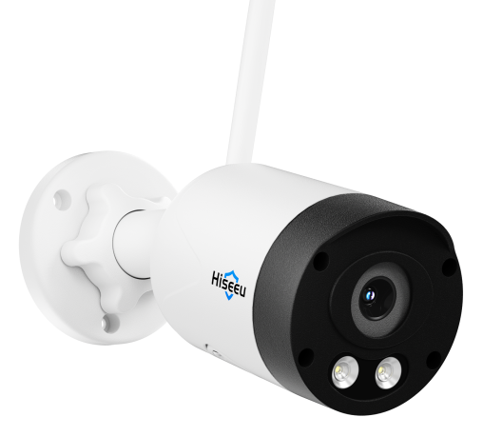

Features
4K HD resolution delivers crisp, detailed images
Dual-band 2.4GHz/5.8GHz operation minimizes co-channel interference
Supports wireless pairing with dual-band wireless NVRs and is compatible with WiFi 4 wireless NVRs
Can be used as a standalone device with Bluetooth one-touch network setup for effortless configuration
Supports automatic/manual wireless cascading for complex scenarios, ensuring stable image transmission
Two-way audio intercom
Dual-light design with infrared/white light, supports IR/full-color modes for true night vision
Motion detection with real-time alert notifications
Intelligent human-shaped detection filters false alarms for precise security protection
Supports remote monitoring via mobile devices

Specifications
Module
Model | TZ-HBY08
Iamge
Sensor | 1/2.7” CMOS Sensor
Lens Focal Length | 2.8mm Lens
Lens Aperture | F1.6
Field of View | Diagonal 126°, Horizontal 105°, Vertical 57.9°
Minimum Illumination | 0.01 lux
Pan/Tilt Range | Horizontal 270°, Vertical 90°
Night Vision Range | 15 meters
Audio
Input | Built-in microphone
Output | Built-in speaker
Two-way communication mode | Full-duplex
Compression format | AAC
Video
Compression Format | H.265/H.265+
Illumination Frequency | 50 Hz，60 Hz
Frame Rate | 15 fps
Maximum Resolution | 3840*2160
Night Vision Light Source | Dual Light Source: Infrared and White Light
Recording
Recording Modes | Alarm Trigger, Manual Recording, 24-Hour Continuous Recording
Recording Storage | Supports up to 256GB TF cards Combined with NVR local storage for recordings
Features
Smart Functions | Motion Detection, Human Detection
Alarm Notification | Mobile App Push Notifications
TFcard | Supports TF card expansion
Pairing | Supports wireless pairing, wired pairing
Supported Protocols | Supports N1 protocol
Network
Wide Dynamic Range | Supports Digital Wide Dynamic Range
Protocol | Supports ONVIF
Network Protocol | Supports RTSP/DHCP and other network protocols
Wired Network | 1 RJ45 Ethernet port, 10/100M auto-negotiation
Wireless Network | Dual-band 2.4GHz & 5.8GHz, compatible with IEEE 802.11b/g/a/n/ac/ax protocols
Power
Charging Voltage | DC12V
Current Consumption | ≤3W
Interfaces
Power | DC12V
Button | Reset button
Network Port | 1 RJ45 Ethernet port, 10/100 Mbps auto-negotiation
Installation
Mounting Method | Wall-mounted, Ceiling-mounted
Bracket Specifications | 1/3'' universal screw holes
Environment
Dust and Water Resistance | IP65
Operating Temperature | -10°C ~ 60°C
Storage Temperature | -20°C ~ 60°C
Specifications
Material | Aluminum alloy
Color | Black
Accessories | Single item: Instruction manual*1 Screw pack*1 5dB antenna

