TZ-NVR10VN
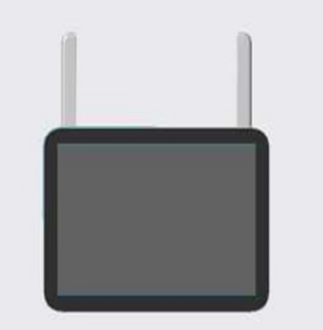

Features
Supports MIPI display interface, 6-pin capacitive touch interface
Supports dual storage via SD card and hard drive
Supports external speaker output with audio-visual synchronization
Supports external microphone input for intercom communication with cameras
Supports online upgrades for NVR and cameras
Supports multi-channel remote monitoring via mobile and PC clients for anytime, anywhere viewing

Specifications
Module
Model | TZ-NVR10VN
Video/Audio Input
IP Video Input | 10-ch
Video/Audio Output
HDMI/RGB Output | 1 channel, Resolution: 1024x768, 1280x1024, 1440x900, 1920x1080, 4K@30Hz with audio output support
Recording Resolution | 8MP/5MP/3MP/1080P/720P
Audio/Video Decoding Format | G.711A
Decoding
Video Processing | H.265/H.264
Synchronous Playback | 1080P: 4 channels @4MP / 2 channels @5MP / 1 channel @8MP  4K: 4 channels @ 3MP / 2 channels @ 5MP / 1 channel @ 8MP
Recording Management
Recording Mode | Scheduled Recording, Motion Detection Recording
Playback Mode | Motion Recording, Scheduled Recording, Human Detection Recording
Backup | USB Flash Drive Backup / App Playback Point Backup
Storage
SD Card | 1 MicroSD Slot, Supports up to 256GB SD Card / Cloud Storage
Hard Drive | 1 hard drive interface, supports up to 8TB capacity / Cloud storage
Power
Charging Voltage | DC 12V 2A
Interfaces
Internal WIFI Antenna | 2 x 2.4GHz/5.8GHz paired WIFI antenna ports
Internet WIFI Antenna | 1 x 2.4GHz/5.8GHz internet WIFI antenna port
Network Interface | 1 x RJ45 10M/100M auto-negotiating Ethernet port
USB Ports | 1 USB 2.0 port
Operating Environment
Operating Temperature | -20°C to 50°C
Indicator Lights
Power Light | Steady blue light when powered on
Recording Light HDD | Slow flash: Recording in progress, 1 flash per second  Steady blue: Storage device normal, waiting for recording  Off: No storage device detected (SD card or HDD)
Operation LED | Slow blue flash: Device operating normally  Off: Device malfunction
Specifications
Dimensions (with packaging) | 32 × 27.7 × 6 cm
Color | White

