TZ-NVR16A
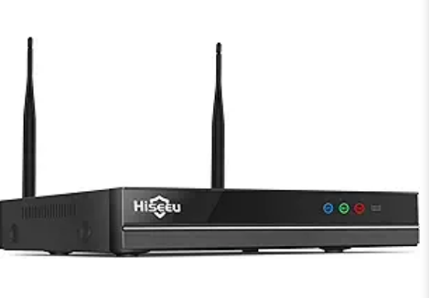

Features
- 16-channel HD wireless surveillance deployment
- Supports dual-band WiFi 4 and 6 with concurrent operation to reduce co-channel interference
- Automatic wireless pairing and device addition; supports up to 8MP cameras
- Mixed-model compatibility for diverse surveillance angle requirements
- One-click auto-cascading eliminates manual setup, enabling effortless wireless relay to extend coverage range
- H.265 high compression ratio reduces storage space and transmission bandwidth
- Built-in wireless network card eliminates cable constraints
- Integrated high-sensitivity microphone ensures audio-visual synchronization
- Zone motion detection with real-time alert notifications
- Supports multi-channel remote monitoring via mobile/PC clients for anytime, anywhere access

Specifications
Module
Model | TZ-NVR16A
Video/Audio Input
Network Video/Audio Input | 16 channels, 8MP
Video/Audio Output
HDMI Output | 1 channel, Resolution: 1024x768, 1280x1024, 1440x900, 1920x1080, 4K@30Hz with audio output support
VGA Output | 1 channel, Resolution: 1024x768, 1280x1024, 1440x900, 1920x1080p
Video Decoding Standard
Video Decoding | H.264/H.265
Audio Decoding Format
Audio Decoding | G711A / AAC
Video/Audio Codec Parameters
Recording Resolution | 8MP/5MP/3MP/1080P/720P
Simultaneous Playback | 4 channels @ 5MP; 2 channels @ 8MP
Recording Management
Recording Mode | Scheduled Recording, Motion Detection Recording
Playback Mode | Smart Playback, Standard Playback, Event Playback
Backup | USB Flash Drive Backup
Hard Drive
Type | 1 SATA Interface
Maximum Capacity | Supports cloud storage or hard drives up to 8TB capacity
External Interfaces
Network Port | 1 RJ45 10M/100M auto-negotiating Ethernet port, built-in wireless functionality
Antenna Ports | 3 total: 2 external 2.4G/5.8G antennas, 1 internal 2.4G antenna
Network Port | 1 RJ45 10M/100M auto-negotiating Ethernet port, built-in wireless functionality
USB Ports | 1 USB 2.0 port
Audio Ports | 1x 3.5mm headphone jack (optional speaker amplifier output)
General Specifications
Power Supply | DC: 12V 2A
Device Power Consumption (excluding hard drive) | ≤5W
Operating Temperature | -20°C to 50°C, humidity <95% (non-condensing)
Startup Temperature | -20°C to 50°C, humidity <95% (non-condensing)
Storage Temperature | -40°C to 80°C, humidity <95% (non-condensing)
Interface Type
Power Supply | DC12V2A
Light Board Interface | 5-pin 2.54mm (1 port) for light board (NET network light, REC recording light, ground, 3.3V power, coding key)
Reset Button | 1 reset button. Press and hold for 3 seconds to perform a simple factory reset (clear password). Press and hold for 10 seconds to perform a full factory reset (delete all camera channels)
Internal WiFi Antenna | 2 paired WiFi antenna ports
External WiFi Antenna | 1 Internet WiFi antenna port
VGA Port | 1 VGA port
HDMI Port | 1 HDMI port
USB Port | 1 USB 2.0 port
MIC Port | 1 x 2-pin MIC jack
Speaker jack | 1 x 2-pin speaker jack

Function Module Block Diagram
