2.5-inch Full-Metal Ultra-Compact Ball Camera Ultra-Clear Video Quality Omnidirectional Rotation with Remote Control Explosion-Proof and Waterproof 5x Zoom TF Card Storage
WHC905
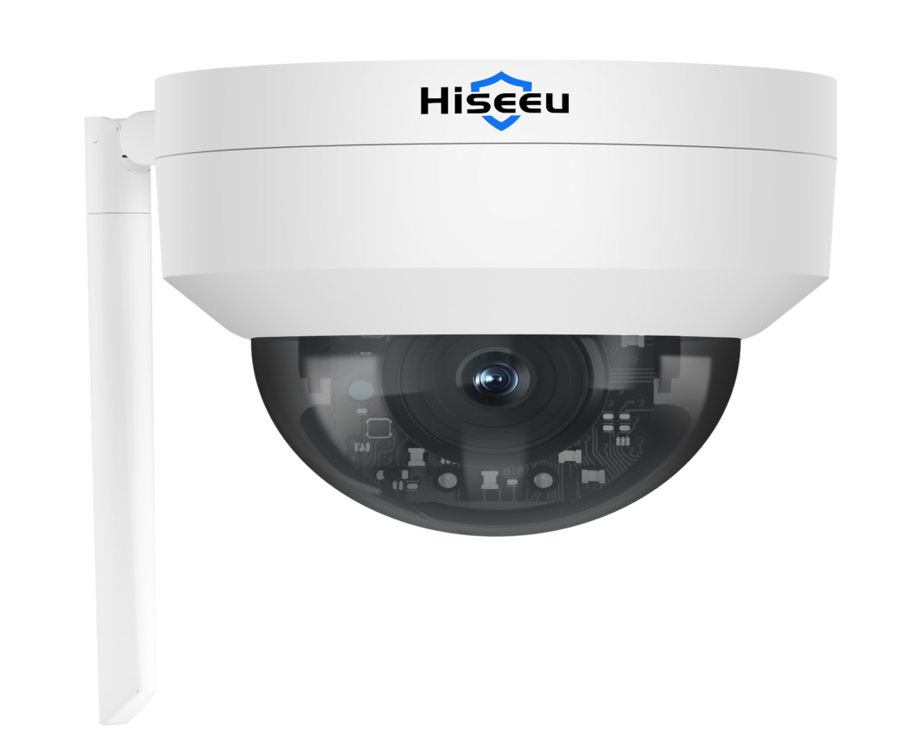

Features
5MP high-definition resolution for crisp, detailed images
Dual-band 2.4GHz/5.8GHz concurrent operation reduces co-channel interference
Supports wireless pairing with dual-band wireless NVRs and is compatible with WiFi 4 wireless NVRs
Can be used as a standalone device with Bluetooth one-touch network setup for effortless configuration
Supports automatic wireless cascading for complex scenarios, ensuring stable image transmission
Supports MIC input and two-way audio intercom
Zone motion detection with real-time alert notifications
Intelligent human-shaped detection filters false alarms for precise security protection
Remote monitoring via mobile and PC clients

Specifications
Module
Model | WHC905
Iamge
Sensor | 1/2.8” CMOS Sensor
Lens Focal Length | 3.6mm Lens
Lens Aperture | F1.6
Field of View | Diagonal 101.1°, Horizontal 84.8°, Vertical 46.5°
Minimum Illumination | 0.01 lux
Pan/Tilt Range | Horizontal 300°, Vertical 90°
Night Vision Range | 10 meters
Audio
Input | Built-in microphone
Output | Built-in speaker
Two-way communication mode | Full-duplex
Compression method | G.711
Video
Compression Format | H.264/H.265
Illumination Frequency | 50 Hz，60 Hz
Frame Rate | 15 fps
Maximum Resolution | 2880*1620
Night Vision Light Source | Dual-beam 2 infrared lights
Recording
Recording Modes | Alarm Trigger, Manual Recording, 24-Hour Continuous Recording
Recording Storage | Supports TF Card Local Storage via NVR
Features
Smart Functions | Motion Detection, Human Detection
Alarm Notification | Mobile App Push Notifications
Network
Wide Dynamic Range | Supports Digital Wide Dynamic Range
Protocol | Supports N1 Protocol
Network Port | Supports RTSP/DHCP and other network protocols
Power
Charging Voltage | DC12V
Current Consumption | ≤3W
Interfaces
Power | DC12V
Button | Reset button
Installation
Mounting Method | Wall-mounted
Bracket Specifications | 1/4'' universal screw holes
Environment
Dust and Water Resistance | IP66
Operating Temperature | -10°C ~ 60°C
Storage Temperature | -20°C ~ 60°C
Specifications
Material | Metal
Color | White
Accessories | Single unit: Manual*1 Screw pack*1 Waterproof cap*1

Dimensions

