WS03
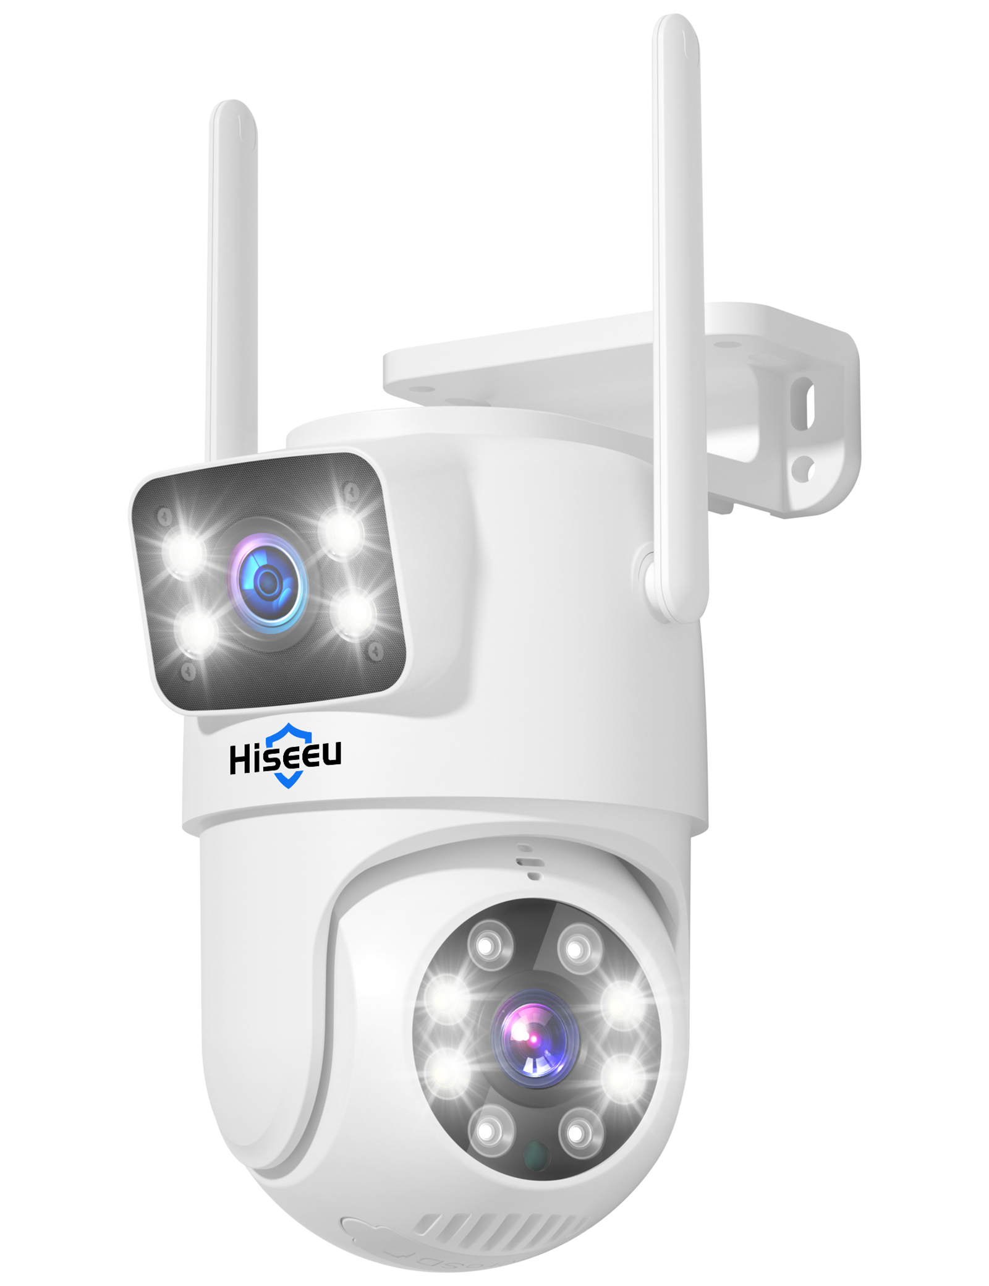

Specifications
Module
Model | WS03
Iamge
Sensor | 1/3" CMOS Sensor*2
Lens Focal Length | 3.6mm Lens
Lens Aperture | F1.6
Field of View | Diagonal 88°, Horizontal 67°, Vertical 50°
Minimum Illumination | 0.01 lux
Pan/Tilt Range | Horizontal 270°, Vertical 90°
Night Vision Range | 10 meters
Audio
Input | Built-in microphone
Output | Built-in speaker
Two-way communication mode | Full-duplex
Compression format | AAC
Video
Compression Format | H.264/H.265
Illumination Frequency | 50 Hz，60 Hz
Frame Rate | 12.5 fps
Maximum Resolution | 1920*2160
Night Vision Light Source | Dual-light: 4 IR LEDs + 4 white LEDs (Dome Camera)/4 IR LEDs + 4 white LEDs (Bullet Camera)
Recording
Recording Modes | Alarm Trigger, Manual Recording, 24-Hour Continuous Recording
Recording Storage | Supports TF Card Local Storage via NVR
Features
Smart Functions | Motion Detection, Human Detection
Alarm Notification | Mobile App Push Notifications
Network
Wide Dynamic Range | Supports Digital Wide Dynamic Range
Protocol | Supports N1 Protocol
Network Port | Supports RTSP/DHCP and other network protocols
Power
Charging Voltage | DC12V
Current Consumption | ≤3W
Interfaces
Power | DC12V
Button | Reset button
Installation
Mounting Method | Wall-mounted
Bracket Specifications | 1/4'' universal screw holes
Environment
Dust and Water Resistance | IP65
Operating Temperature | -10°C ~ 60°C
Storage Temperature | -20°C ~ 60°C
Specifications
Dimensions (with packaging) | 22.7 × 15 × 12 cm
Weight (with packaging) | 0.975 kg
Material | Plastic
Color | White
Accessories | Single unit: Manual*1 Screw pack*1 Waterproof cap*1

