WTD504

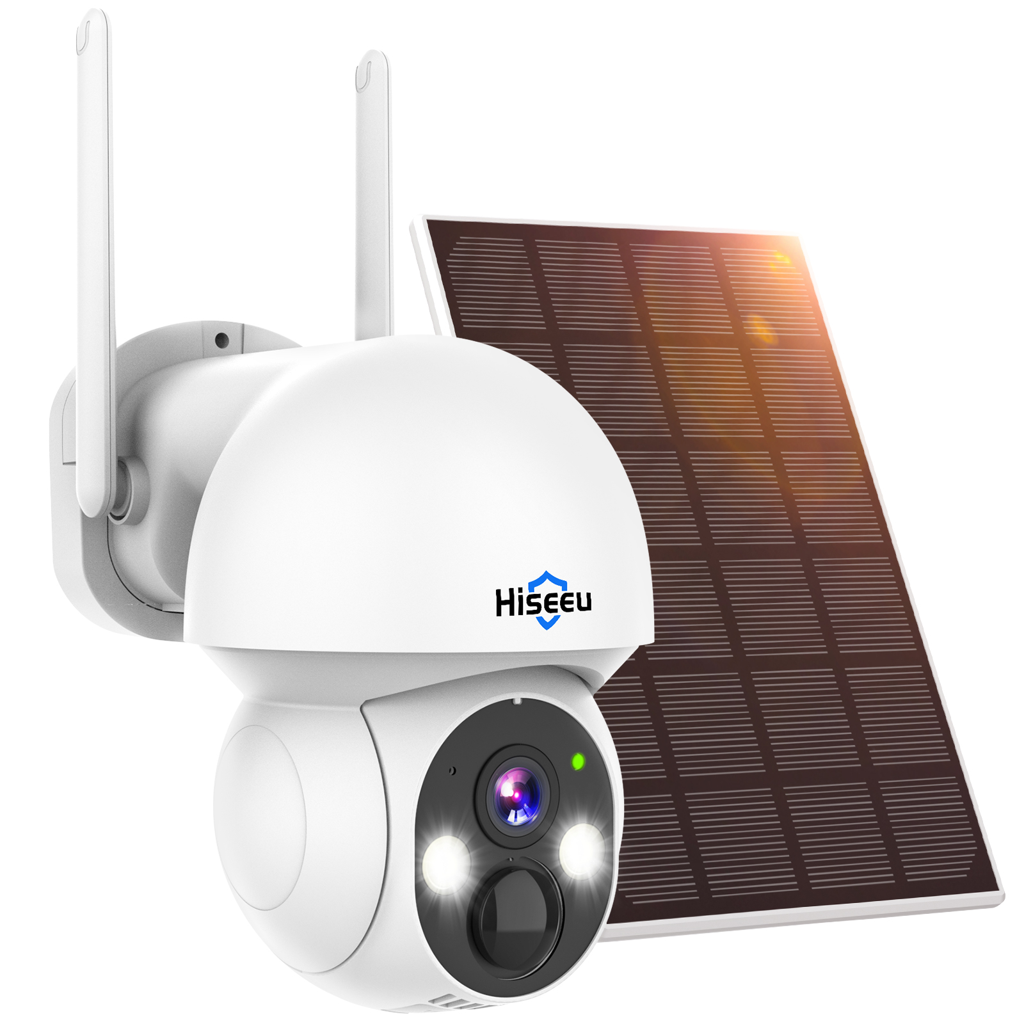

Features
- Supports Bluetooth and QR code network pairing
- 4MP resolution for high-definition imaging
- PIR + human-shaped detection for instant recording activation
- Built-in microphone and speaker with two-way audio intercom via mobile app
- 350° horizontal rotation, 90° vertical rotation
- Supports one-touch wireless pairing with base stations, 7-inch displays, and wireless NVRs
- Powered by two built-in 21700 lithium batteries, Wi-Fi connectivity, 100% wireless operation, ultra-low standby power consumption, extended standby time

Specifications
Model | WTD504
Pixel Resolution | Main Stream: 2560x1440, Sub Stream: 800x44
Image Sensor | 1/3.2" CMOS Sensor
Lens | 4mm Fixed Focus Lens
Frame Rate | 15fps
Audio | Supported
Speaker | Supported
PIR Range | 8m distance, 120°
Smart Alarm | PIR + Human-shaped, Motion Detection Alarm
Storage | Supported (Maximum Support: 128G)
Audio Function | Two-way Audio (Built-in Speaker, Microphone)
WIFI | 802.11b/g/n; Wireless Frequency: 2.4 GHz ~ 2.4835 GHz
Antenna | 3dB
ONVIF | Not supported
Minimum Illumination | Color: 0.1Lux, Monochrome: 0.01Lux
IR LED | 2 dual-color dual-core LEDs (2 infrared LEDs, 2 white LEDs)
IR Illumination Range | 20 meters
Solar Panel Power | Monocrystalline silicon 3W
Battery Capacity | 9000mAh (4500mAh*2)
Input Voltage | DC 5V
Pan/Tilt Function | Horizontal 350°, Vertical 90°
Operating Temp/Humidity | -20°C to +55°C / 30% to 80% RH
Storage Temp/Humidity | -40°C to +85°C / 20% to 90% RH

