SP1 Low Power Consumption - 4MP (WIFI Version)
WTD904
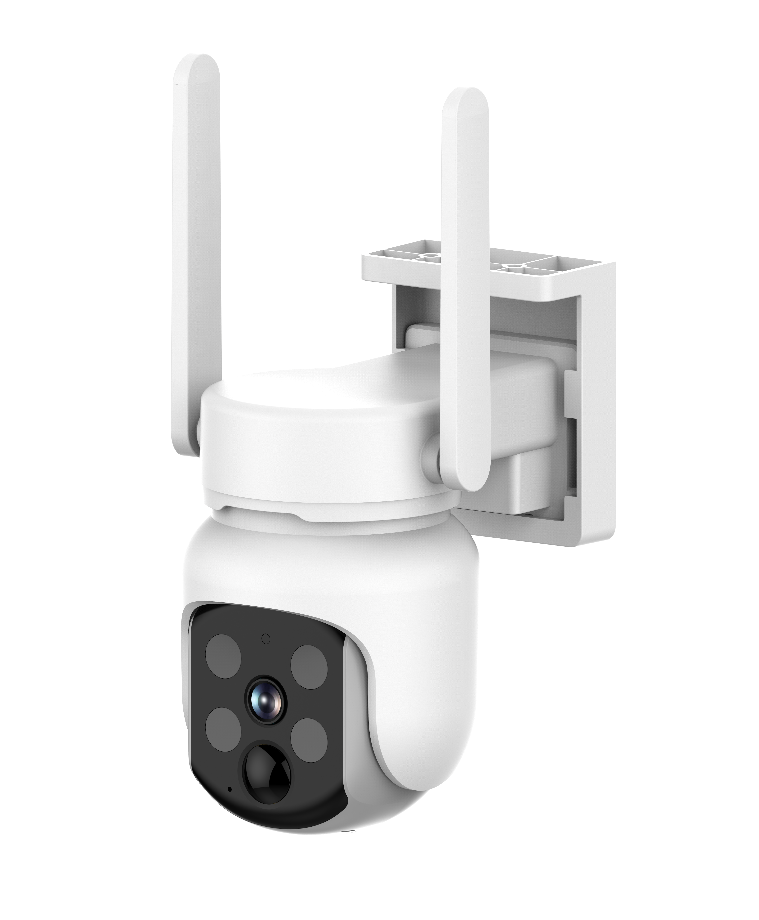

Features
Smart Features, Human-shaped detection
Wake-up Methods, PIR motion detection wake-up, Remote active wake-up
Alarm Notification, Mobile app push notifications, device white light flashing, and audible alarm
Pan/Tilt Range, Horizontal 350°, Vertical 90°

Specifications
Model | WTD904
Image
Sensor | 1/3" CMOS, 4 megapixels
Lens Focal Length | 3 mm
Lens Aperture | F1.6
Field of View | Diagonal 135°, Horizontal 112°, Vertical 60°
Minimum Illumination | Color: 0.1Lux@F2.3, Monochrome: 0.01Lux@F2.3
Compression | AAC/G711
Audio
Input | Built-in microphone
Output | Built-in speaker
Two-Way Intercom | Full-duplex
Compression | AAC/G711
Video
Compression | H.264/H.265
Frame Rate | 15fps
Maximum image resolution | 2560*1440
Night vision light source | Infrared lamp or white light lamp
Network
Wireless Standard | IEEE 802.11 b/g/n/a/ac/ax
Wireless WiFi | Supports 2.4 GHz & 5.8 GHz (Dual-Band)
Wired Network | Not supported
Recording
Recording Method | Alarm-triggered recording, manual recording
Recording Storage | Cloud storage, Local Micro SD card (supports up to 128 GB)
Indicator Lights
LED Indicators | Red and blue lights indicating power/network signal/function status
APP
APP | Eseecloud
Battery
Capacity | 5200 mAh
Removability | Non-removable
Operating Time | 3 months (recording 20 x 10-second videos daily) Note: Actual battery life may vary
Standby Time | 10 months Note: Actual battery performance may vary
Charging Voltage | 5 V ±5%
Charging Current | 1.5 A
Charging Time | 8 hours Note: Actual battery performance may vary
Protection Mechanisms | Overcharge, over-discharge, overcurrent, short circuit, and high/low temperature charging protection
Power Consumption
Standby | 200uA/0.76 mW
Daytime Operation | 0.76W
Nighttime Operation | 1.6W
Buttons | 1 Power Button, 1 Reset Hole
Interfaces
Power | TYPE-C
Storage | Micro SD Card
Button | Reset Button
Installation
Mounting | Wall-mounted, Ceiling-mounted
Bracket Specifications | 1/4'' Universal Screw Holes
Environment
Dust and Water Resistance | IP65
Operating Temperature | -10 ℃ ~ 45 ℃
Storage Temperature | -20°C ~ 60°C
Specifications
Dimensions | 140 mm × 95 mm × 140 mm (with bracket)
Unit Weight | Approx. 470 g
Material | ABS+PC
Color | White
Certifications
Certifications | CE, FCC, RoHS, WEEE, MSDS, UN38.3

