WTDS803

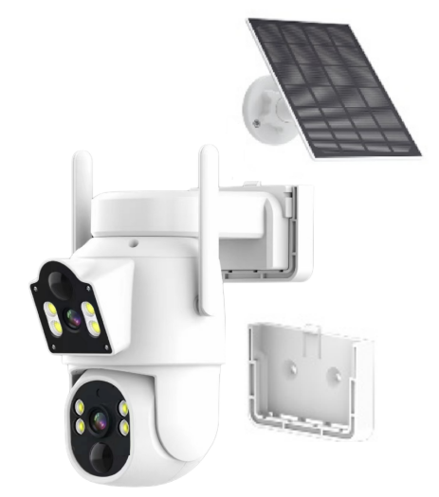

Features
- Features a high-precision motor with a dual-axis pan-tilt mechanism, offering 345-degree horizontal rotation and 90-degree vertical rotation;
- 3MP bullet camera + 3MP dome camera deliver crisp, detailed imagery;
- Bluetooth network pairing enables effortless setup with three-step configuration;
- Built-in hotspot connectivity allows viewing and playback even without network access;
- Multi-camera functionality enables simultaneous monitoring of two distinct areas, expanding surveillance coverage;
- PIR + intelligent detection triggers instant recording;
- Intelligent human-shaped detection filters false alarms for precise security protection;
- Supports cloud storage and local TF card recording for secure video archiving;
- Operates in ultra-low power consumption mode;
- Supports lithium battery power supply and direct charging;
- Features PWM dimming to extend battery life;
- Pan-tilt unit supports motion tracking and preset positions;
- Mobile app access enables real-time viewing anytime, anywhere

Specifications
Model | WTDS803
Iamge
Pixels | 300W+300W
Resolution | 2304 x 2592
Shutter Speed | 1/50(1/60) sec to 1/10000 sec
Sensor | 1/2.9”CMOS *2
Lens focal length | 4mm fixed focal length
Audio
Input | Built-in microphone
Output | Built-in speaker
Two-way intercom | Supported
Compression format | AAC/G711A
Video
Compression Format | H.265
Frame Rate | 12.5fps
Lighting Frequency | 50 Hz, 60 Hz
Night Vision Light Source | Dual-Light
Recording
Recording Method | Alarm Triggering, Manual Recording
Recording Storage | TF Card, Cloud Storage Paired with NVR Local Storage Recording
Features
Smart Functions | Motion Detection, Human Detection, Pedestrian Tracking
Alarm Notification | Mobile App Notifications, Device Audible Alarms, Light Alarms
Network
ONVIF | Supported
Wide Dynamic Range | Supports Digital Wide Dynamic Range
Network Protocols | Supports network protocols such as RTSP and DHCP
Power
Charging Voltage | DC5V1A / Solar Panel Powered
Power Consumption | ≤3W
Interfaces
Power Port | DC5V Type-C Port
Button | Reset Button
Installation
Mounting Methods | Wall-mount
Environment
Dust/Water Resistance | IP65
Operating Temperature and Humidity | -10°C to +50°C / 30% to 80% RH
Storage Temperature and Humidity | -20°C to +60°C / 20% to 90% RH
Specifications
Material | Plastic
Color | White
Accessories | Single item: Instruction manual*1, Screw pack*1, 3W solar panel*1, Solar panel mount*1, Camera mount*1

