Gunball Low Power - Dual-Band WiFi 6 - 400MP + 400MP - 9000mAh Battery - 5W Solar Panel
WTS804
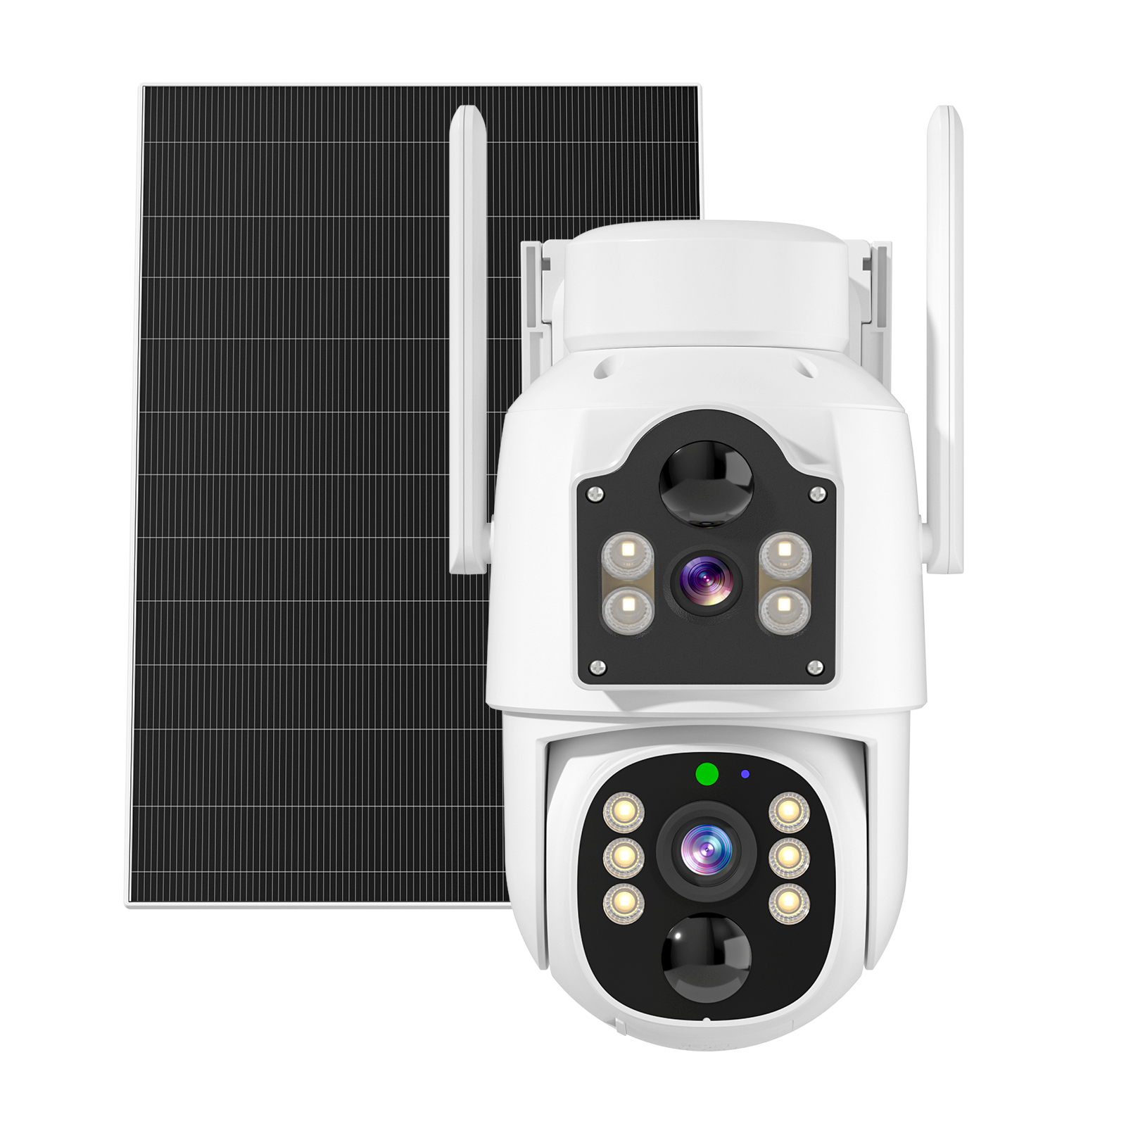

Features
- Supports Bluetooth mesh networking, Wi-Fi connectivity, and 100% complete wireless operation
- Supports Wi-Fi 6 dual-band (2.4 GHz-5.8 GHz) and high-speed transmission
- Stable battery life with ultra-low power consumption, extended standby time, and support for solar charging panels
- Supports microphone and speaker for two-way audio communication
- Intelligent PIR motion detection accurately captures instantaneous movements
- 2MP ultra-clear resolution with infrared night vision and full-color white light mode

Specifications
Module
Model | B4-Q-L2-A6
Image
Pixel Count | 4 MP*4MP
Resolution | Main Stream: 2560 x 1440 / Sub Stream: 800 x 448
Sensor | 1/3" CMOS Sensor
Lens | 4mm
Lens Aperture | F2.0
Field of View | Dome Lens: Diagonal 110°, Horizontal 90°, Vertical 57.9°  Bullet Lens: Diagonal 110°, Horizontal 100°, Vertical 57.9°
Minimum Illumination | Color: 1 Lux B/W: 0.01 Lux
Pan/Tilt Range | Horizontal 350°, Vertical 90°
Audio
Input/Output | Enable two-way voice communication (built-in microphone and speaker)
Two-way Intercom | Supported
Audio compression method | AAC/G711A
Video
Video compression method | H.265/H.265+
Lighting frequency | 50Hz, 60Hz
Night vision light source | Dual-light Full-color Night Vision/Infrared Night Vision/Smart Full-color
Recording
Recording Method | Alarm Trigger, Manual Recording, 24-Hour Continuous Recording
Recording Storage | Supports Micro SD Card Storage (Max 256GB) and Cloud Storage
Features
PIR Range | 10m Distance / 120°
Smart Functions | Motion Detection, Human Detection
Alarm Notifications | Mobile App Push Notifications
Network
WiFi | Supports WiFi 6 dual-band (2.4 GHz & 5.8 GHz)
Wide Dynamic Range | Supports digital wide dynamic range
Protocol | Supports NI protocol
Network Protocols | Supports RTSP/DHCP and other network protocols
Power
Battery | SC-18650-2600-3P-3.7V-9000mAh-28.86Wh
Charging Voltage | DC5V 1A
Current | ≤3W
Solar Panel | 5W solar panel, ETFE material
Interface/Buttons
Charging Port | TYPE-C
Power | DC5V
Buttons | ON/OFF Switch: Toggle ON-Power On, Toggle OFF-Power Off  Press and hold Reset button for 3 seconds: Reset
Installation
Mounting Method | Wall Mount
Mounting Specifications | 1/4'' universal screw hole
Indicator Lights
Indicator Light Descriptions | Green light on for 2 seconds, then off: Initiating network connection.  Green and red lights steady on: Remote camera preview in progress (privacy light).  Green light steady on: Device connected to network or awakened.  Green light continuously flashing: Firmware upgrade in progress.  Green light continuously slow flashing: Standby charging.  Red light flashes 3 times: Power off.  Red light steady: Low battery  Green/red light steady: Standby
Environment
Dustproof & Waterproof | IP65
Operating Environment | -20℃ to 50℃ / 15%～85%RH non-condensing
Storage Environment | -20°C ~ 60°C
Specifications
Material | ABS+PC
Color | White
Accessories | Single Unit: Manual*1 Screw Pack*2 Solar Panel*1 Data Cable*1 Solar Panel Mount*1

