Evaluating Quality Conditioning for MRI Segmentation with Missing Modalities
Working manuscript draft for author revision. Venue, authorship and institutional declarations are not yet supplied. This document reports completed internal experiments and retains their limitations. Gallery figure numbers refer to the stable repository catalog and can be renumbered for the selected venue.

Abstract
Quality descriptors may appear useful for fusing incomplete MRI inputs, but their contribution requires controls that preserve the surrounding training system. We evaluated an implemented quality-conditioned moment-fusion model after auditing its preprocessing, inference and data partitions. An audit of 484 canonical segmentation case IDs identified 262 conservative image-similarity groups. Nine variants were trained on one grouped development fold with three fixed seeds, followed by evaluation of four prespecified model families on 66 reserved cases in 51 groups. All 15 nonempty modality subsets were evaluated on one fixed representative per reserved group. QMMF achieved full-modality group macro Dice of 0.7689 +/- 0.0055 across seeds, compared with 0.7769 +/- 0.0007 without quality features. The QMMF-minus-control difference was -0.0080 with an adjusted paired group-bootstrap interval of [-0.0133, -0.0028]; mean- and worst-subset comparisons also favored removing quality. An exploratory 15-group sensitivity addressing historical exposure left the full-modality difference uncertain. These results do not support the implemented quality-conditioning advantage. Unknown patient identities, earlier validation exposure, differences in cross-family objectives and simulated missingness after complete-modality preprocessing limit generalization.

1. Introduction
MRI segmentation with incomplete modality availability requires an evaluation that distinguishes the contribution of a proposed component from the surrounding model and training choices. Modality aggregation is established prior work: HeMIS learns modality-specific representations that can be combined when inputs are missing. More recent work, including SimMLM, studies dynamic modality weighting and objectives designed around differing input availability. These precedents motivate a focused empirical question about the additional value of the implemented quality descriptors.
This study evaluates that question within a repaired implementation derived from the supplied research notebook. The work includes a conservative similarity audit, explicit role boundaries, same-family ablations, repeated training seeds and a reserved-cohort evaluation. It reports a negative finding: the quality-conditioned variant did not improve the declared reserved endpoints over its no-quality control. The contribution is the bounded empirical evaluation and its auditable evidence, rather than a claim of architectural novelty or superiority over current published methods.

2. Data, provenance and cohort construction
The segmentation source is the Brain Tumour task mirrored from the Medical Segmentation Decathlon. Source and mirror information, label mapping and terms are documented in the dataset report. Auditing identified rescaled image copies that crossed the original case-ID partitions. Repaired partitions contain 484 canonical case IDs in 262 conservative similarity groups. Group identities describe observed image similarity; patient identities are not independently established.
The executed main study uses development fold 0 with 294 training cases in 132 groups, 33 inner-selection cases in 24 groups, and 91 outer-development cases in 55 groups. A reserved set contains 66 cases in 51 groups. Three seeds repeat this fixed partition. Although four-fold split metadata is retained, the completed main results are not four-fold cross-validation.
Role | Cases | Groups
train | 294 | 132
inner_val | 33 | 24
outer_val | 91 | 55
reserved | 66 | 51

Only fold 0 was executed in the main study. The 15-group historical sensitivity is a nested subset of the reserved cohort.
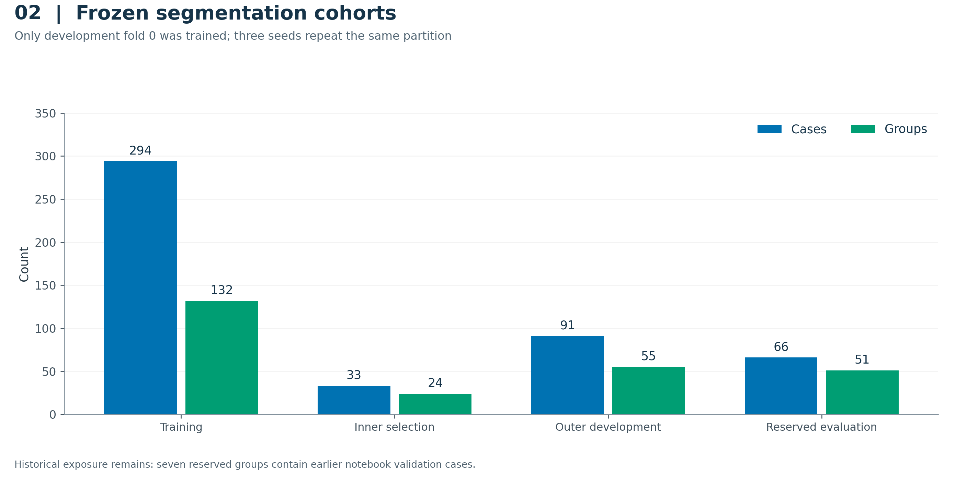
A retrospective provenance audit identified seven reserved groups containing cases from the original notebook's recorded validation subset. The word reserved therefore refers to the revised fitting and selection boundary, not a historically untouched dataset. A separate sensitivity includes 15 groups/18 cases entirely outside the original development partition. Its rule was frozen before reserved outcomes but after some main development outcomes were available; it is exploratory and does not replace the full report.

3. Models and implementation controls
The QMMF implementation uses available-modality feature aggregation with quality-conditioned components. The study repairs verified channel order, inference geometry and normalization, training-fitted quality scaling, complete-modality teacher inputs and the shuffled-quality control. Exact implementation details are preserved in the submitted source snapshots and resolved configurations rather than inferred from the names of the original notebook variants.
The main matrix comprises QMMF, no quality, shuffled quality, matched moment fusion, no variance, no max, no consistency, a HeMIS-style 2.5D model and a U-Net 2.5D model. The last two are local comparator implementations; the U-Net naming acknowledges the encoder-decoder family introduced by Ronneberger and colleagues. They must not be represented as exact modern benchmark reproductions. QMMF and its same-family controls use two auxiliary supervision heads with weights 0.5 and 0.25; the HeMIS-style and U-Net implementations do not. Cross-family differences consequently combine architecture and effective objective changes.
All 27 main fits use five-slice 2.5D context and 192-by-192 in-plane crops, seeds 42, 43 and 44, and a budget of 120 epochs with 100 microbatches per epoch. Resolved configurations use AdamW with learning rate 0.0003, weight decay 0.001, batch size four and accumulation two. This gives 6,000 scheduled optimizer-step opportunities per fit. Inner validation occurs every ten epochs. Checkpoints are selected by the declared inner-selection score, without using reserved outcomes. Full resolved settings, effective-objective checks and training histories remain in the repository.

4. Evaluation and uncertainty
WT, TC and ET Dice are evaluated with the frozen nonempty-reference rule. The headline full-modality score first forms each case's regional macro, averages cases within conservative groups, then weights groups equally. Repeated-seed tables summarize the three fixed seed estimates with their mean and sample standard deviation. Regional tables have their own nonempty-reference denominators; averaging regional means would not reconstruct the case-first headline metric.
Missing-modality evaluation masks channels after complete four-channel preprocessing, including support/crop construction. All 15 nonempty subsets are retained. Development subset evaluation uses 16 fixed group representatives; reserved subset evaluation uses 51 representatives. Mean-subset Dice averages each representative's subset scores before averaging groups. Worst-subset Dice takes each representative's minimum before averaging groups. The all-four-subset result uses one representative per group and is not identical to the headline full-modality score using all 66 reserved cases.
Paired uncertainty uses 10,000 bootstrap draws of conservative image groups, retaining all three fixed seeds within each draw. Seed SD is reported separately. Main ablation intervals adjust for eight QMMF-control contrasts separately per endpoint; reserved intervals adjust for three controls separately per endpoint. The adjustment is not a global guarantee across all endpoints and exploratory analyses. Neither slices nor repeated seed/group records are treated as independent patients.

5. Results

5.1 Main development ablations
All nine variants completed all three scheduled fits. QMMF achieved full-modality outer group Dice of 0.8052 +/- 0.0028, compared with 0.8106 +/- 0.0042 for no quality. The adjusted same-family no-quality comparisons did not establish a QMMF advantage. The matched moment-fusion control had a better mean worst-subset result under the declared paired adjustment. Every variant remains in the comparison, including controls with higher scores.
Model | Full Dice | Mean-subset Dice | Worst-subset Dice
QMMF | 0.8052 +/- 0.0028 | 0.6492 +/- 0.0059 | 0.3407 +/- 0.0184
No quality | 0.8106 +/- 0.0042 | 0.6551 +/- 0.0081 | 0.3537 +/- 0.0197
Shuffled quality | 0.8044 +/- 0.0008 | 0.6455 +/- 0.0060 | 0.3246 +/- 0.0323
Matched moment fusion | 0.8098 +/- 0.0032 | 0.6548 +/- 0.0023 | 0.3591 +/- 0.0107
No variance | 0.8073 +/- 0.0011 | 0.6512 +/- 0.0068 | 0.3462 +/- 0.0042
No max | 0.8066 +/- 0.0032 | 0.6528 +/- 0.0077 | 0.3423 +/- 0.0135
No consistency | 0.8043 +/- 0.0038 | 0.6441 +/- 0.0052 | 0.3394 +/- 0.0082
HeMIS-style | 0.7072 +/- 0.0060 | 0.5403 +/- 0.0039 | 0.2338 +/- 0.0249
U-Net 2.5D | 0.7865 +/- 0.0105 | 0.6107 +/- 0.0093 | 0.2912 +/- 0.0196

Entries are means +/- sample SD over three fixed training seeds. Group-bootstrap intervals and cohort denominators are in the source CSV and results report.
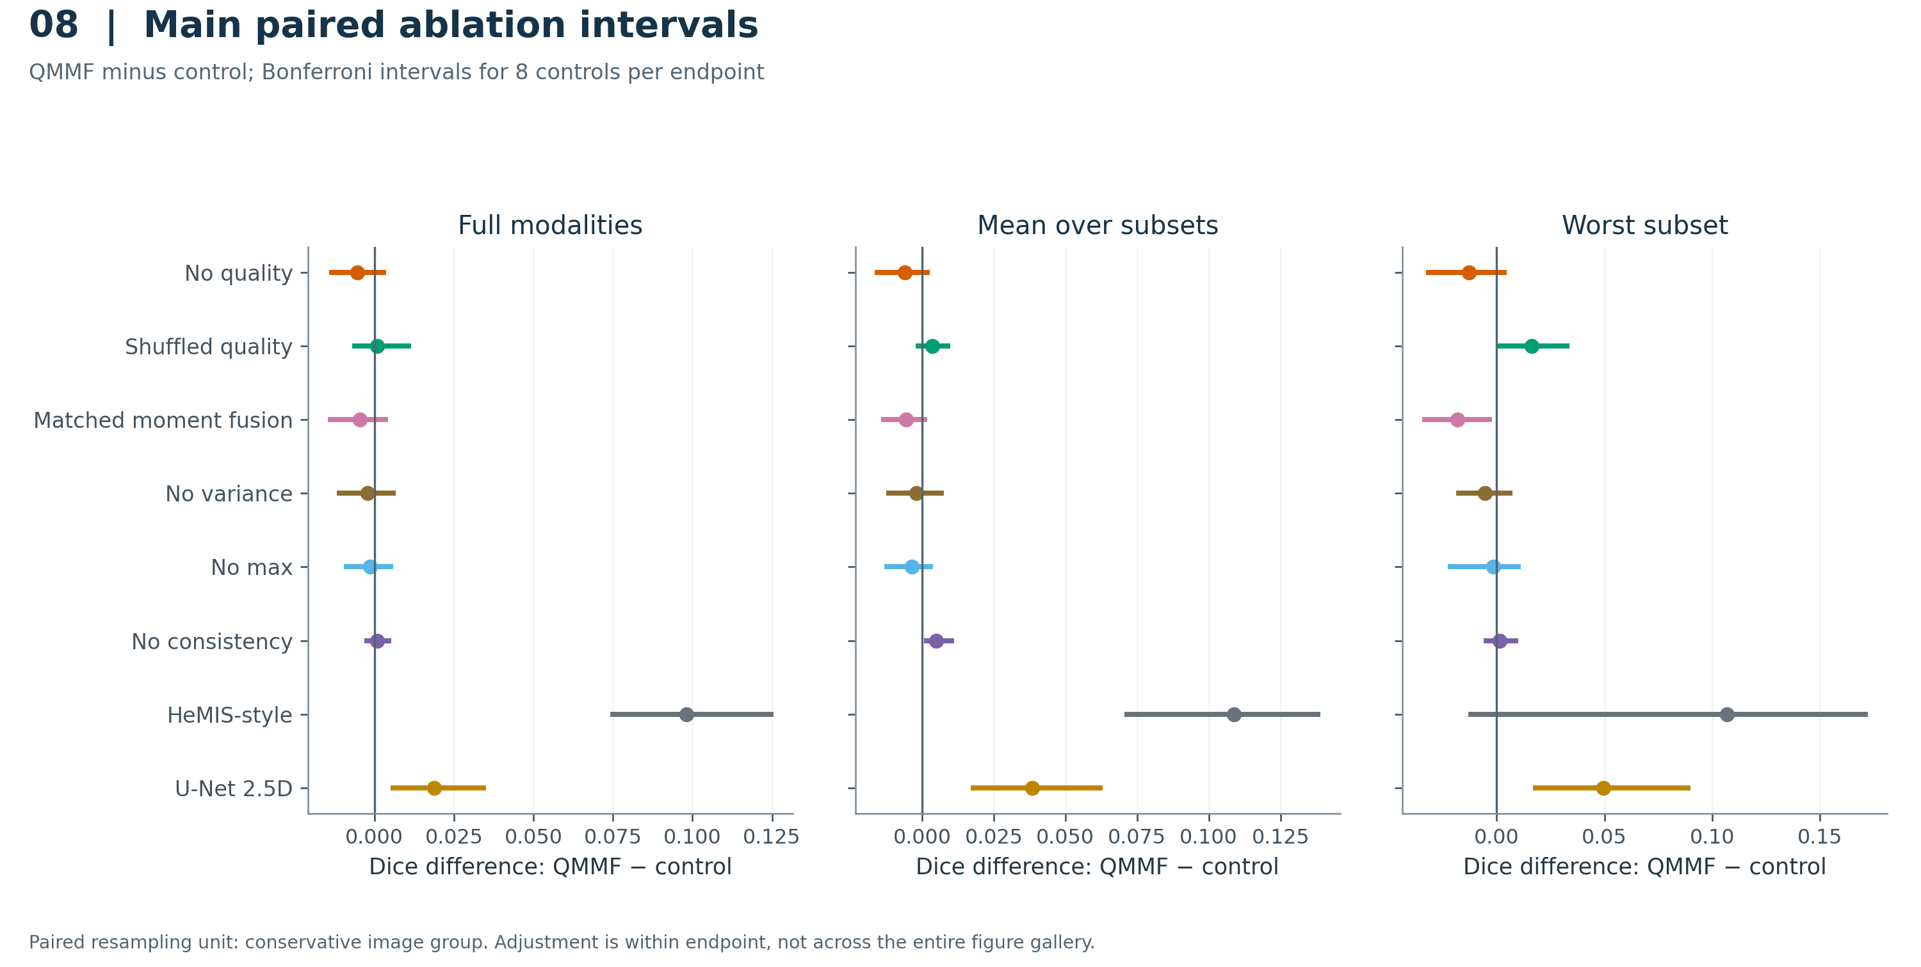

5.2 Reserved evaluation
The four prespecified families were evaluated using their three selected checkpoints, producing 12 completed reserved evaluations. The cohort includes all 66 reserved cases and 51 groups. QMMF full-modality Dice was 0.7689 +/- 0.0055; no quality achieved 0.7769 +/- 0.0007. Their difference was -0.0080 with adjusted interval [-0.0133, -0.0028]. QMMF-minus-no-quality differences for mean-subset and worst-subset Dice were -0.0083 and -0.0214, respectively, with both adjusted intervals below zero. These observations support a negative finding for the implemented quality descriptors under the recorded training protocol.
Model | Full Dice | Mean-subset Dice | Worst-subset Dice
QMMF | 0.7689 +/- 0.0055 | 0.6322 +/- 0.0080 | 0.3672 +/- 0.0120
No quality | 0.7769 +/- 0.0007 | 0.6405 +/- 0.0075 | 0.3886 +/- 0.0137
HeMIS-style | 0.6837 +/- 0.0007 | 0.5462 +/- 0.0080 | 0.2748 +/- 0.0286
U-Net 2.5D | 0.7621 +/- 0.0074 | 0.6034 +/- 0.0078 | 0.3140 +/- 0.0115

Entries are means +/- sample SD over three fixed training seeds. Group-bootstrap intervals and cohort denominators are in the source CSV and results report.
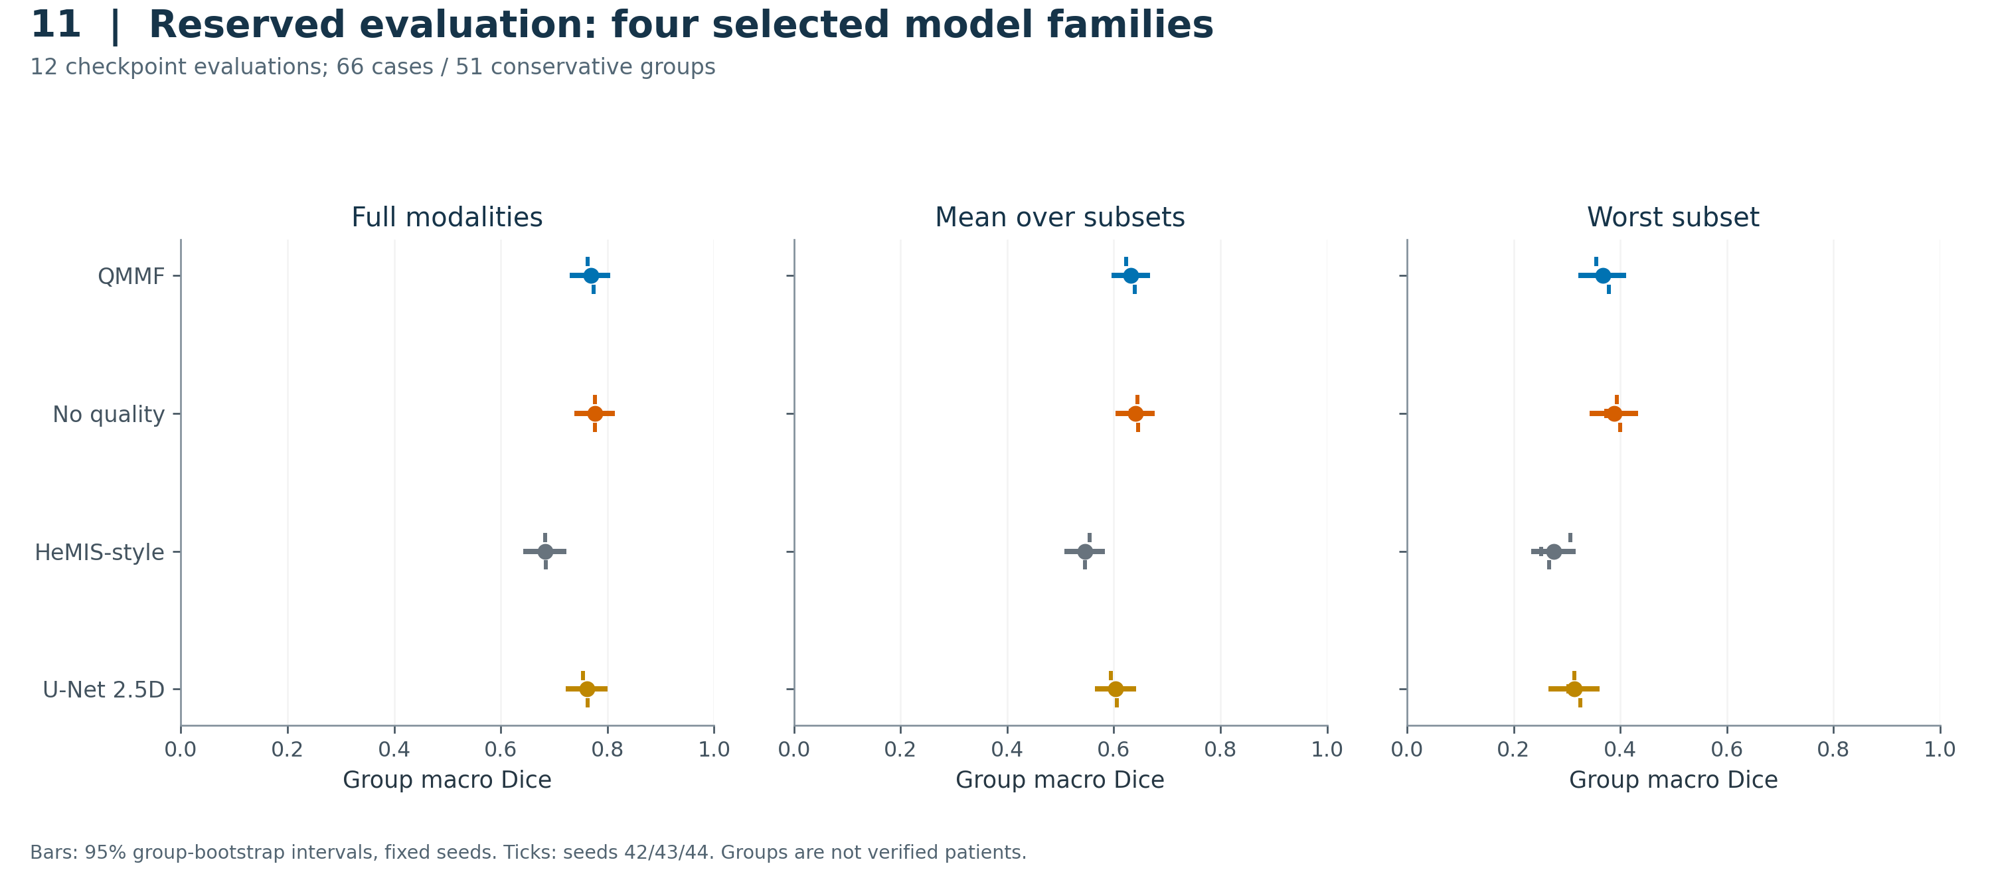
Control | Endpoint | QMMF - control | Adjusted interval
No quality | Full | -0.0080 | [-0.0133, -0.0028]
No quality | Mean subset | -0.0083 | [-0.0124, -0.0042]
No quality | Worst subset | -0.0214 | [-0.0322, -0.0119]
HeMIS-style | Full | +0.0853 | [+0.0712, +0.0993]
HeMIS-style | Mean subset | +0.0861 | [+0.0734, +0.1003]
HeMIS-style | Worst subset | +0.0923 | [+0.0617, +0.1258]
U-Net 2.5D | Full | +0.0068 | [-0.0045, +0.0189]
U-Net 2.5D | Mean subset | +0.0289 | [+0.0210, +0.0375]
U-Net 2.5D | Worst subset | +0.0532 | [+0.0355, +0.0738]

10,000 paired group-bootstrap draws retain all three training seeds. Bonferroni adjustment uses three controls separately per endpoint; negative values favor the control.
QMMF exceeded the HeMIS-style comparator on all three reserved endpoints under the declared adjustment. Its full-modality comparison with U-Net was uncertain, while mean- and worst-subset comparisons favored QMMF. These cross-family findings cannot isolate the quality module because the models and auxiliary objectives differ. The reserved comparison set was not expanded after development outcomes to include whichever variant ranked first.

5.3 Missing modalities and failure analysis
The no-quality control had the higher descriptive three-seed mean in all 15 modality combinations. These cell-wise comparisons are not additional adjusted hypothesis tests. QMMF obtained approximately 0.3921 with T1 alone, while its average case-specific worst-subset score was 0.3672. A worst-subset mean can be below every column mean because different cases have different worst combinations.
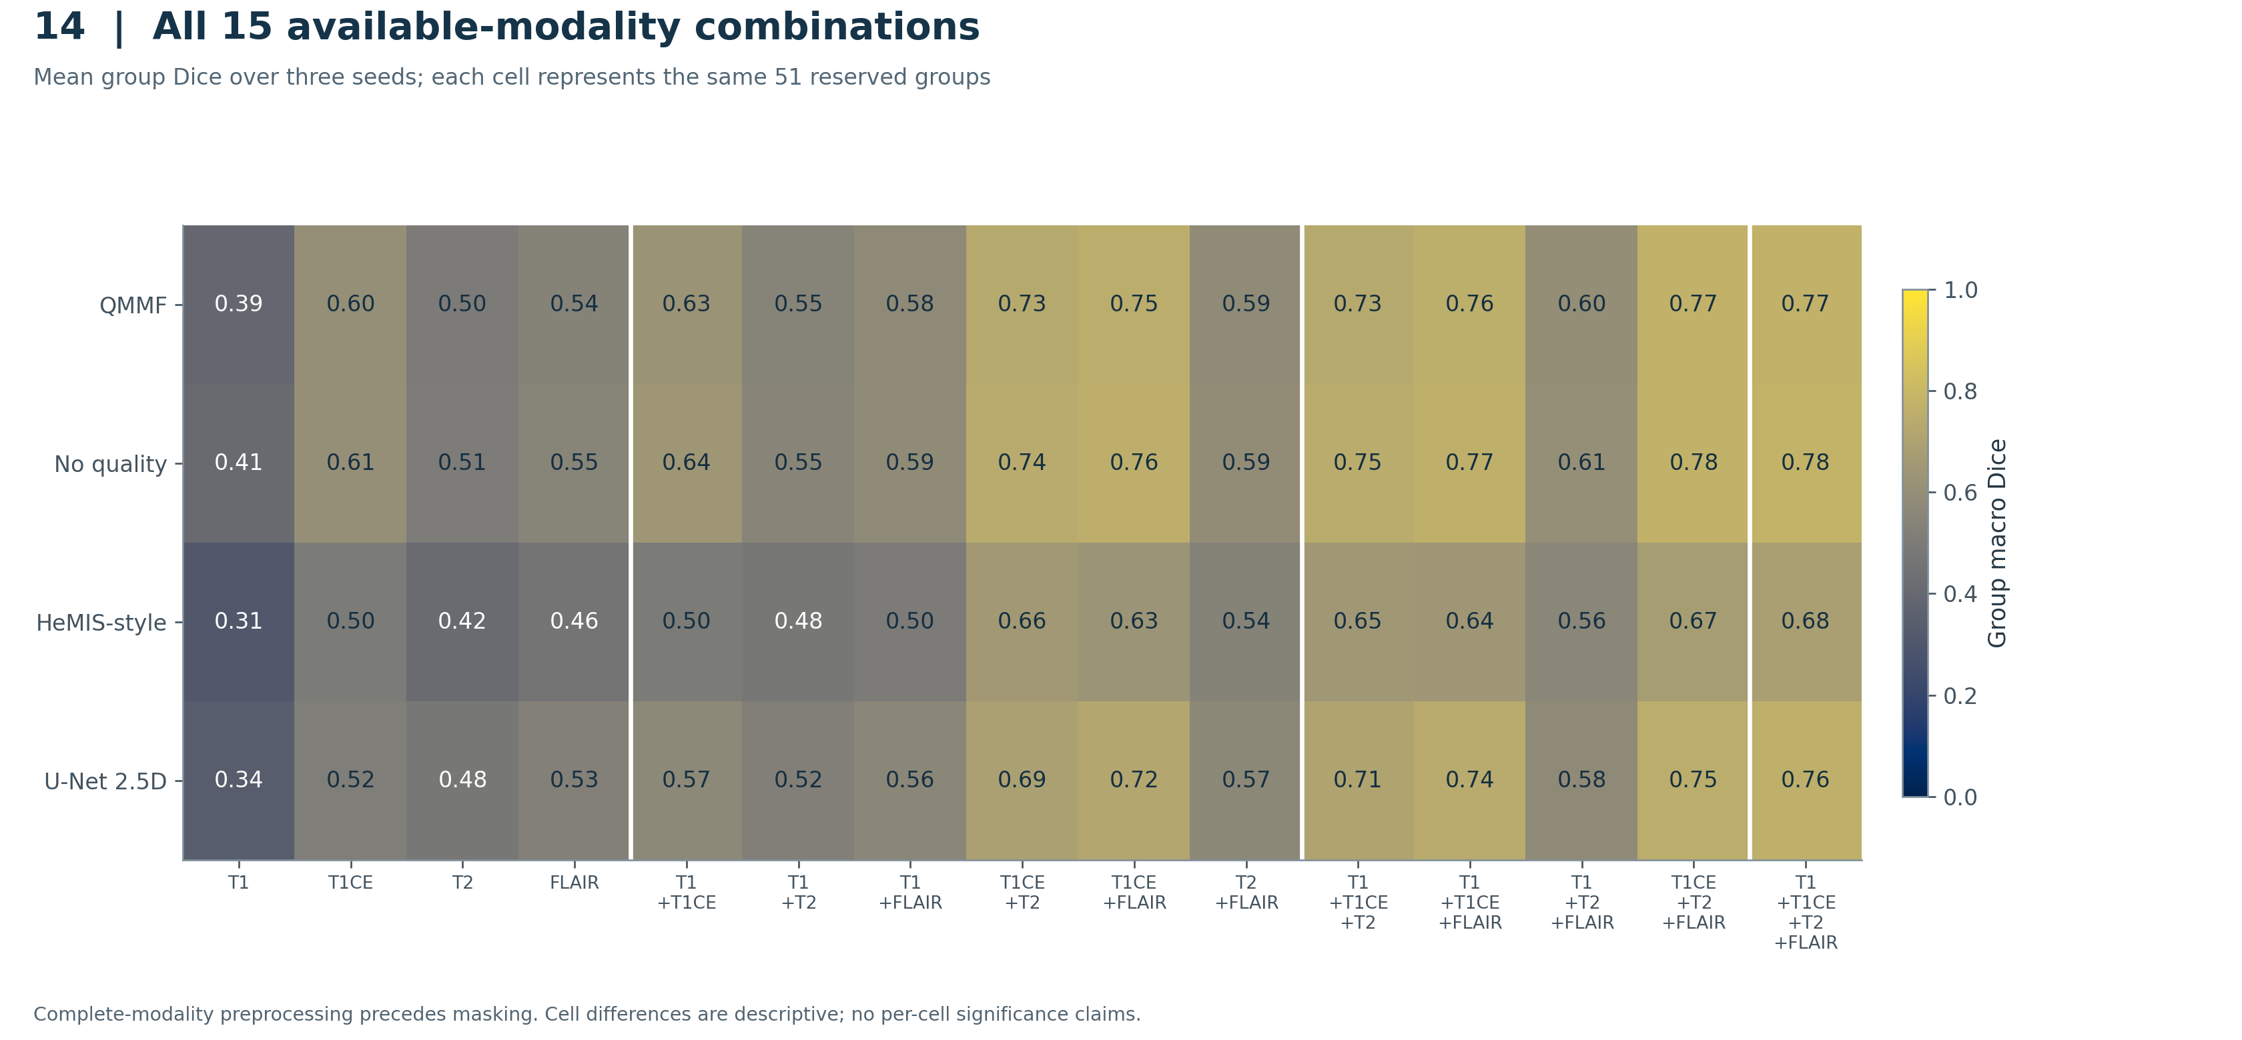
The frozen rule excludes empty-reference regions from primary Dice. Both ET-empty reserved cases, BRATS_023 and BRATS_027, nevertheless received false-positive ET predictions from every model and seed. Their 24 measured predicted volumes are retained in Figure 17. Nonempty-reference ET averages must be read together with this failure mode. The prespecified qualitative montage retains all four models on BRATS_143, BRATS_119 and BRATS_023 at seed 42; displayed scores are whole-volume scores. BRATS_143 has recorded historical validation exposure.
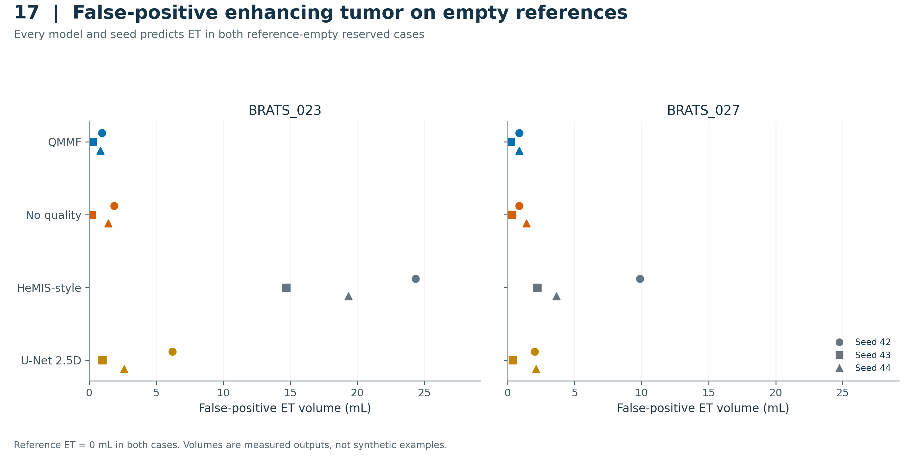

5.4 Historical sensitivity and computation
The exploratory 15-group sensitivity retained all four model families and all three seeds. QMMF-minus-no-quality adjusted intervals crossed zero for full-modality and mean-subset Dice. The worst-subset difference was -0.0178 with adjusted interval [-0.0437, -0.0016], still favoring no quality. Because these groups are a subset of the complete reserved cohort, the sensitivity is not an independent replication.
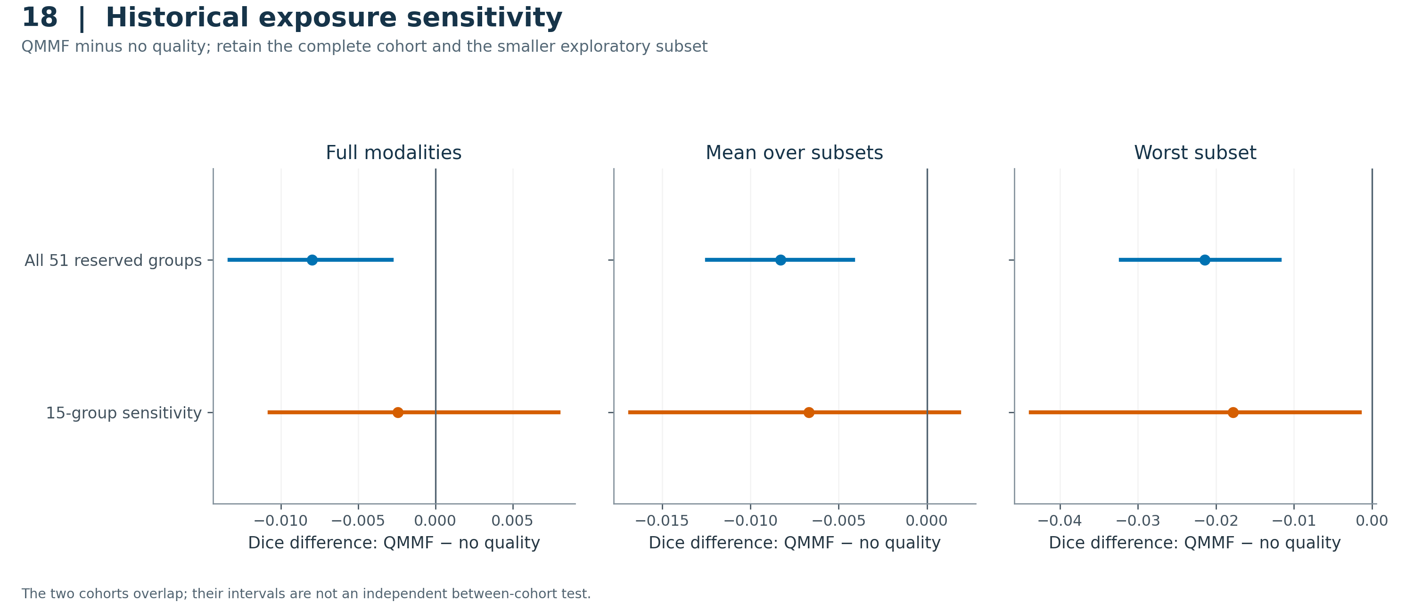
Lossless cache changes measured approximately 4.02-fold QMMF and 3.51-fold HeMIS-style training-segment throughput improvements on Kaggle. These bounded measurements used 10 warmup and 100 timed microbatches per model/format. They do not estimate end-to-end experiment speedup or repeated-run timing uncertainty. All main fits reached the epoch budget; the learning trajectories do not establish universal convergence.

6. Discussion and limitations
The closest controls provide the clearest interpretation: quality conditioning did not improve the recorded reserved endpoints over an otherwise comparable no-quality configuration. The result applies to this descriptor implementation, data partition and optimization schedule. It does not establish that every possible quality-aware fusion method is inferior. Architectural differences from more distant baselines should not obscure the same-family negative finding.
Several factors bound the evidence. Conservative similarity groups are not verified patients, and the data audit cannot prove removal of all patient overlap. Historical validation exposure prevents describing the revised reserved set as historically untouched. The main training study covers one development fold and three fixed seeds, not several independent cohorts. Cross-family objectives differ. Missingness is simulated after complete-modality preprocessing, and the subset evaluation uses one representative per group. No independent external clinical cohort or contemporary author-implementation comparator has been evaluated here. The smaller historical sensitivity is exploratory and has limited sample size.
The practical value of the release is its traceability: complete rather than favorable-only model tables, preserved failure provenance, fixed qualitative examples, source hashes and a separately executed 20-figure Kaggle report. The accompanying classification experiment is a separate image-level benchmark and should be described in supplementary material or a different manuscript. Its results should not be combined with segmentation into a headline accuracy measure.

7. Conclusion
An audited repeated-seed evaluation did not support the implemented quality-conditioning advantage for MRI segmentation under simulated missing modalities. The complete reserved comparisons favored removing quality features, while the smaller historical sensitivity retained uncertainty on some endpoints. The evidence supports a bounded negative-result report and an auditable reproduction package; broader generalization and novelty claims require additional evidence.

Reproducibility and author declarations
The private GitHub repository contains the two research notebooks, the supporting visualization notebook, executed figure outputs, plotted-data CSVs, result tables and exact Kaggle version/source records. Full data and checkpoints remain accessible through their documented Kaggle sources. The original v1.0.0 experiment release is preserved, and the writing package is a subsequent version. Figure 19 and its source montage retain the required attribution.
Authors must supply their identities, affiliations, contributions, funding/conflicts, source-code licensing decision and institutional determination for secondary-data use. No ethics approval, consent status, exemption or submission acceptance is inferred from the supplied notebooks. The writing guide lists the remaining author decisions. These are draft declarations, not completed submission statements.

