Blood Donor Eligibility Reminder Console — CA1 Proposal

Nov 5, 2026
Lovely Professional University
School of Computer Applications · Master of Computer Applications (MCA)
CAP455 · Object-Oriented Programming using C++
Minor Project · CA1: Design & Create · Session 2026–27
Field | Details
Student name | Hisham P P
Registration / roll no. | 12604325 / 69
Section | D1P2635
Faculty | Adarsh Singh
Allocated project | Blood Donor Eligibility Reminder Console
Submission file name | 12604325_CAP455_CA1_BloodDonorReminder

1. Problem statement
Regular blood donors must wait a minimum gap between two whole blood donations, but most blood banks and donation camps do not track when each donor becomes eligible again. Under the NBTC 2017 guidelines this gap is 90 days for male donors and 120 days for female donors.
In practice, donor lists are kept in registers or spreadsheets. When there is a shortage, volunteers call donors who donated recently and are turned away, while donors who are already eligible are never contacted. Donors themselves also forget their last donation date.
The Blood Donor Eligibility Reminder Console stores donor records, checks each donor against the basic NBTC eligibility rules, and shows who is eligible to donate today and who becomes eligible in the next 7 days. Because a console program cannot send notifications, the reminder is produced when the program is opened and the user asks for the reminder list.

2. Existing Systems
I worked in this project i understand one thing that is the actually a real problem in india i used to research like whether any app or web done this solution or not ... still now e-RaktKosh is a governments app trying to solve but it still fragmented. My project is a small model of the eligibility logic for donor group’s own list, So the group always knows who is eligible today. But i like to work with project more, Like in india there are several patients are getting late to get their blood. I know it’s too complicated problem but still I’m researching it towards and let me know if there is any way to try to solve.

3. Objectives and scope
CA1 delivers an in-memory donor register with validated Create and Read operations; storage, inheritance and the full CRUD menu follow in later phases.
Objectives
- Register donors with complete, validated details and a unique Donor ID.
- Reject duplicate Donor IDs and invalid input at the point of entry.
- Display all donors, or one donor searched by ID, with their next eligible date.
- Show a reminder list: donors eligible today and donors due in the next 7 days.
- Keep the code readable and modular so later phases can build on it.
In scope for CA1
- Donor entity class, array of objects (maximum 100 donors), pointers, this, std::string
- Create (add donor) and Read (display all, search by ID, reminder list, find by blood group)
- Input validation for every field; no duplicate keys
Out of scope for CA1 (planned for later phases)
- Saving records to a file (CA2)
- Update and Delete (basic update in CA2, safe update and delete in CA3)
- Donation types such as platelet or plasma donors (CA3)
- Medical checks done at the camp (haemoglobin, blood pressure, medical history). The system records only details a donor can declare; the final decision is always the medical officer's.

4. Entities and unique key
The system has one main entity, Donor, identified by a unique Donor ID in the format D followed by 4 digits (for example D1001).
Entity | Role in CA1 | Key
Donor (class) | One registered blood donor and their last donation | Donor ID, e.g. D1001
Date (struct) | A calendar date used for the last donation and today's date | Not a stored entity
Why Donor ID and not the phone number? A phone number can change, and family members often share one number. A Donor ID never changes once issued, so it is a safer unique key. The system rejects a new donor whose ID already exists, and IDs are matched case-insensitively (d1001 is treated as D1001).
Values that are calculated, not stored: the next eligible date, the number of days left, and the status text (Eligible now / Due in N days / Wait N days). They depend on today's date, so storing them would make them wrong the next day.
5. Main class design
The Donor class keeps all ten data members private and exposes only the functions below; the eligibility rule values are public static constants so every part of the program uses the same numbers.
Member function | Kind | What it does
setDetails(...) | Public | Stores all details in the object; uses this-> because parameter names match member names
getId(), getName(), getBloodGroup() | Inline (defined inside class) | Return private values for searching and display
isFirstTimeDonor() | Inline (keyword inline) | True if the donor has never donated
getGapDays() | Inline (keyword inline) | Returns 90 for male, 120 for female donors
hasSameId(id) | Public | Compares this->donorId with an ID; used for duplicate checking and search
getNextEligibleDate() | Public | Last donation date plus the gap
display(today) | Public | Prints the full record of one donor
displayRow(today) | Public | Prints one row of the donor table
getDonorCount(), increaseDonorCount() | Static | Read and update the shared count of registered donors
statusText(daysLeft) | Static | Converts days left into "Eligible now", "Due in N days" or "Wait N days"
daysUntilEligible(donor, today) | Friend | Reads private hasDonatedBefore and lastDonation; 0 or less means eligible today
Static constants (shared rule values): MIN_AGE = 18, MAX_AGE = 65, MAX_FIRST_TIME_AGE = 60, MIN_WEIGHT = 45, MAX_WEIGHT = 200, MALE_GAP_DAYS = 90, FEMALE_GAP_DAYS = 120, REMINDER_DAYS = 7.
Program files
File | Contents
src/Donor.h, src/Donor.cpp | Donor class, static members, friend function
src/Utils.h, src/Utils.cpp | Date struct, date maths, string helpers, validators, safe input functions
src/main.cpp | Array of donors, menu, add / show / search / reminder operations

6. Data dictionary
Every stored field of a donor, its C++ type and the rule it must pass before it is saved.
Field | C++ type | Size / range | Validation rule | Example
donorId | std::string | 5 characters | D + 4 digits; must not already exist; input converted to uppercase | D1001
name | std::string | 2–30 characters | Letters, spaces and dots only; must start with a letter | Rahul Sharma
gender | char | 1 character | M or F (lowercase accepted) | M
age | int | 18–65 years | Whole number; a first-time donor must be 60 or younger | 25
hasDonatedBefore | bool | true / false | Entered as Y or N | true
lastDonation | Date (struct) | DD-MM-YYYY | Real calendar date (leap years checked); not in the future; asked only if the donor has donated before | 01-08-2026
weight | int | 45–200 kg | Whole number; 45 kg is the NBTC minimum | 68
bloodGroup | std::string | 2–3 characters | One of A+, A-, B+, B-, AB+, AB-, O+, O-; input converted to uppercase | B+
phone | std::string | 10 digits | Digits only; first digit 6, 7, 8 or 9 (Indian mobile) | 9876543210
city | std::string | 2–25 characters | Letters and spaces; must start with a letter | Phagwara
donorCount | static int | 0–100 | Shared by the class; registration stops at MAX_DONORS (100) | 4
Date struct: day (int, 1–31), month (int, 1–12), year (int, 1900–2100).
Known limitation: age is recorded at registration and does not increase on its own. Storing a date of birth instead is planned for CA2, when records are saved to a file and kept for longer.

7. UML class diagram
The main program owns an array of up to 100 Donor objects, each Donor contains one Date, and both use the Utils helper functions.
Notation: - private, + public, underlined members are static, a filled diamond is composition (the part cannot exist without its owner), and a dashed arrow is a «uses» dependency.
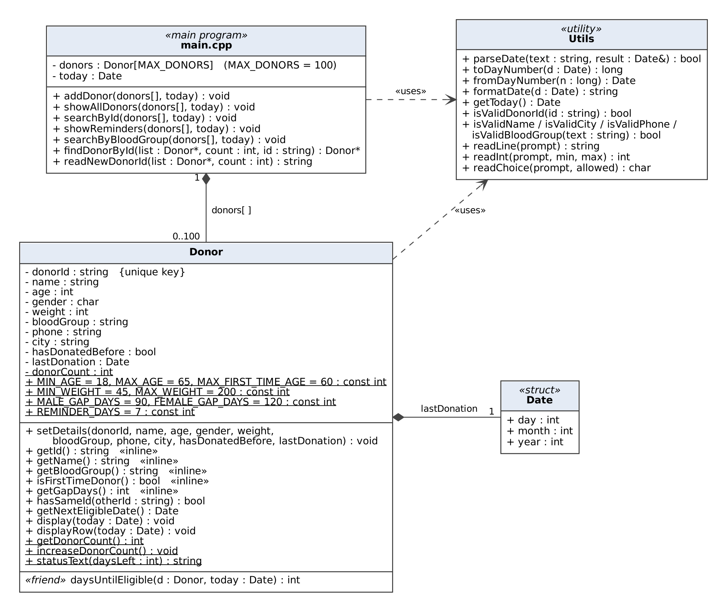
Figure 1: UML class diagram (source: docs/uml_class_diagram.dot)
8. Flowcharts
The program loops on a menu until the user chooses 0; adding a donor is the only operation that changes data, so it has its own flowchart showing every validation branch.
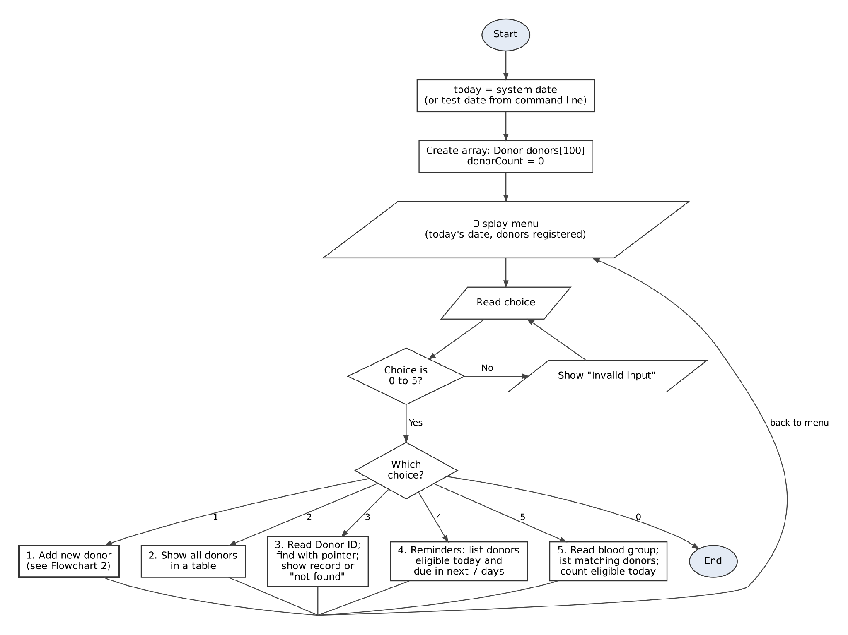
Figure 2: Main menu flow (source: docs/flowchart_main_menu.dot)
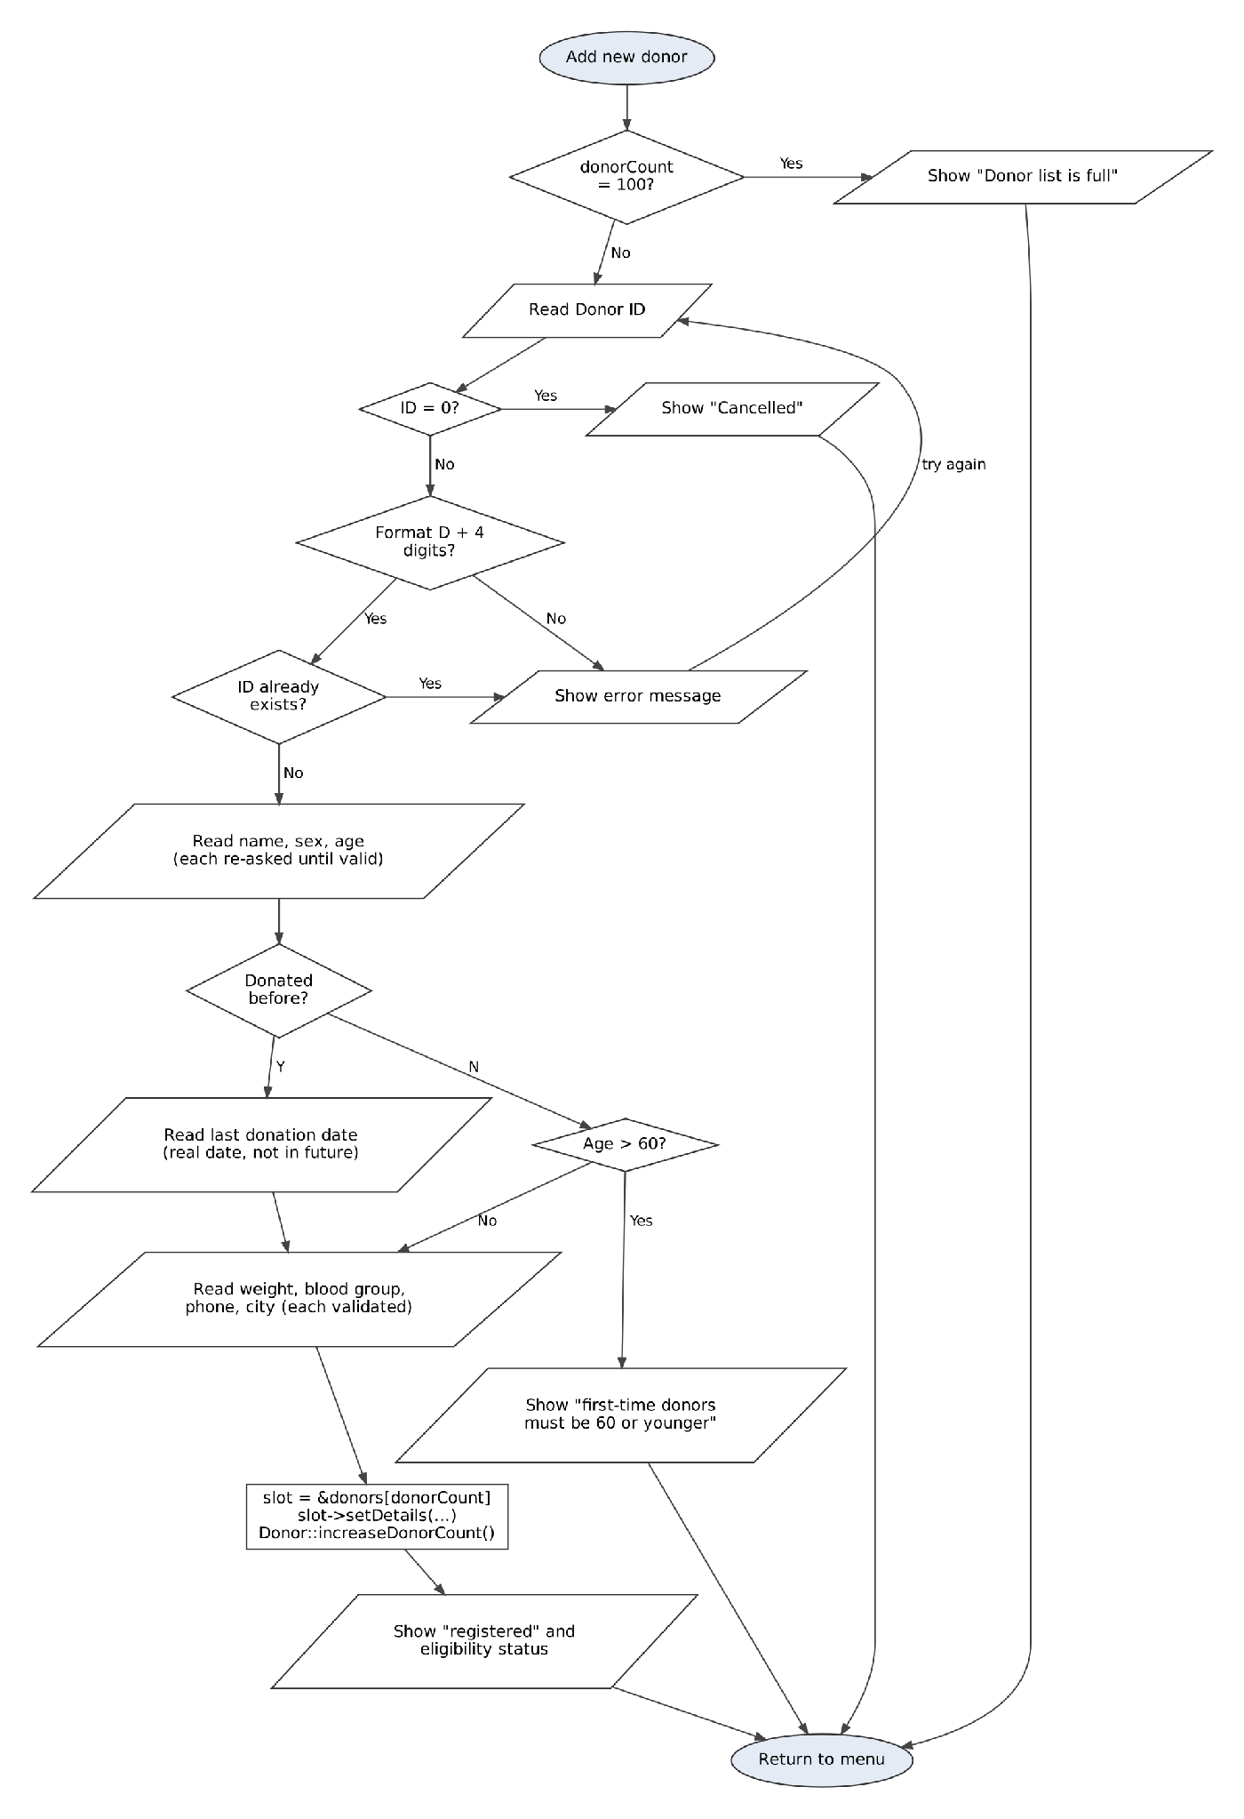
Figure 3: Add new donor, the Create operation with validation and duplicate-key check (source: docs/flowchart_add_donor.dot)
9. Eligibility rules used
The program applies the NBTC 2017 donor-selection rules that can be checked from details a donor declares; checks that need a medical examination are left to the blood bank.
Rule (NBTC 2017) | Value | How the program applies it
Age | 18–65 years | Age input accepts only 18 to 65
First-time donor age | Not more than 60 years | A first-time donor older than 60 is not registered
Minimum weight | 45 kg (350 ml collection) | Weight input accepts only 45 kg and above
Gap between whole blood donations, male | 90 days | getGapDays() returns 90 for M
Gap between whole blood donations, female | 120 days | getGapDays() returns 120 for F
Haemoglobin | At least 12.5 g/dL | Not checked: needs a test at the camp
How eligibility is calculated
- Convert the last donation date to a day number (days counted from 01-01-1900).
- Add the gap (90 or 120 days) to get the next eligible day, and convert it back to a date for display.
- Days left = next eligible day − today's day number.
- Days left ≤ 0 → Eligible now; 1 to 7 → Due in N days (shown in the reminder list); more than 7 → Wait N days.
- A first-time donor has no waiting period and is always Eligible now.
Counting days from a fixed starting date makes month lengths and leap years simple: the program only adds and subtracts whole numbers.
Sources: Revised NBTC Guidelines for Blood Donor Selection and Blood Donor Deferral, June 2017 (Dr Akshaya Tomar, AFMC Pune) · Blood transfusion: Guidelines by MoHFW, M3 India

10. Validation behaviour
No invalid value is ever stored: each field is re-asked until it is valid, with a message that says exactly what is expected.
- All input is read with getline, never cin >>. A stray newline can then never skip the next prompt, and typing letters where a number is expected cannot break the program.
- Duplicate check comes first. The Donor ID is checked against existing donors before any other field is asked, so the user does not type a full record only to have it rejected.
- Cancel option. Entering 0 as the Donor ID cancels the registration.
- Rule check during entry. If a first-time donor is older than 60, registration stops right after the "donated before?" question.
- Full list. When 100 donors are registered, Add is refused with a message instead of writing past the end of the array.
- End of input. If input ends unexpectedly (for example a test file runs out), the program exits cleanly instead of looping forever.

11. CA1 requirements and where they are in the code
Every CA1 item in the project guide is used for a real purpose in the program, not added only to tick a box.
CA1 requirement | Where | How it is used
Entity class | Donor in Donor.h | 10 private data members, public member functions
Static members | donorCount, getDonorCount(), increaseDonorCount(), statusText(), rule constants | One shared donor count for the whole class; rule values defined once
Inline functions | Getters inside the class; isFirstTimeDonor(), getGapDays() with inline | Small functions called often while displaying tables
Friend function | daysUntilEligible() | Reads private hasDonatedBefore and lastDonation to compute days left
Array of objects | Donor donors[MAX_DONORS] in main() | In-memory storage for up to 100 donors
Pointers | findDonorById(), Donor* slot, for (Donor* p = donors; ...) loops | Search returns the address of the match or nullptr; loops walk the array with pointer arithmetic
this pointer | setDetails(), hasSameId(), display() | Separates members from same-named parameters; passes the current object to the friend function
std::string | All text fields and helpers | substr, length, find, find_first_not_of; uppercase conversion
Create with validation | addDonor() and the read...() functions | Every field re-asked until valid
Read | Show all, search by ID, reminders, find by blood group | Four read views over the same array
No duplicate keys | readNewDonorId() | Calls findDonorById() before accepting an ID
Friend function (Donor.cpp)
int daysUntilEligible(const Donor& d, const Date& today) {
if (!d.hasDonatedBefore) {
return 0; // first-time donors have no waiting period
}
long nextDay = toDayNumber(d.lastDonation) + d.getGapDays();
return (int)(nextDay - toDayNumber(today));
}
Search with a pointer (main.cpp)
Donor* findDonorById(Donor* list, int count, const string& id) {
for (Donor* p = list; p < list + count; p++) {
if (p->hasSameId(id)) {
return p;
}
}
return nullptr;
}

12. Test cases and results
All 33 console test cases (8 normal, 18 invalid, 7 boundary) and all 27 automated checks passed. Every console run used the fixed test date 05-11-2026 (donor_app 05-11-2026), so the results are the same on any day; full transcripts are in the tests folder.
Normal cases (tests/test1_normal_output.txt)
ID | Input | Expected | Actual | Result
N1 | Add D1001, male, last donation 01-08-2026 | Registered; next eligible 30-10-2026; Eligible now | Same | Pass
N2 | Add D1002, female, last donation 10-07-2026 | Next eligible 07-11-2026; Due in 2 days | Same | Pass
N3 | Add D1003, male, last donation 01-10-2026 | Next eligible 30-12-2026; Wait 55 days | Same | Pass
N4 | Add D1004, first-time donor | Last donated "Never"; Eligible now | Same | Pass
N5 | Menu 2: show all | Table of 4 donors | Same | Pass
N6 | Menu 3: search D1002 | Full record of Priya Verma | Same | Pass
N7 | Menu 4: reminders | 2 eligible today (D1001, D1004); 1 due soon (D1002) | Same | Pass
N8 | Menu 5: blood group B+ | 2 donors listed; "1 of 2 can donate today" | Same | Pass
Invalid cases (tests/test2_invalid_output.txt)
ID | Input | Expected | Actual | Result
I1 | Menu choice 9, then x | Error; asked again | Same | Pass
I2 | Search by ID with no donors | "No donors registered yet" | Same | Pass
I3 | Donor ID 1001, then D10 | Format error each time | Same | Pass
I4 | Donor ID d1001 when D1001 exists | Duplicate rejected | Same | Pass
I5 | Name A, then R@hul | Rejected | Same | Pass
I6 | Sex X | Rejected | Same | Pass
I7 | Age 17, 66, abc | Rejected | Same | Pass
I8 | "Donated before?" maybe | Rejected | Same | Pass
I9 | Date 2026-08-01, then 31-02-2026 | Invalid date | Same | Pass
I10 | Date 10-12-2026 (future) | "Cannot be in the future" | Same | Pass
I11 | Weight 44, then 201 | Rejected | Same | Pass
I12 | Blood group C+, then ab+ | C+ rejected; ab+ stored as AB+ | Same | Pass
I13 | Phone 12345, 5876543210, 98765abc10 | Rejected | Same | Pass
I14 | City Ph4gwara | Rejected | Same | Pass
I15 | Donor ID 0 | Cancelled; no donor added | Same | Pass
I16 | First-time donor aged 61 | Not registered | Same | Pass
I17 | Search ID D9999 | "No donor found" | Same | Pass
I18 | Blood group A+ with no A+ donors | "No donors with blood group A+" | Same | Pass
Boundary cases (tests/test3_boundary_output.txt)
ID | Input | Expected | Actual | Result
B1 | Male, age 65, weight 45, donated exactly 90 days ago | Accepted; Eligible now | Same | Pass
B2 | Female, age 18, weight 200, donated 119 days ago | Accepted; Due in 1 day | Same | Pass
B3 | First-time donor aged 60 | Accepted; Eligible now | Same | Pass
B4 | Date 29-02-2026, then 29-02-2024 | 2026 rejected (not a leap year); 2024 accepted | Same | Pass
B5 | Male, 7 days left | In reminder list: Due in 7 days | Same | Pass
B6 | Male, 8 days left | Not in reminder list: Wait 8 days | Same | Pass
B7 | Last donation = today (05-11-2026), female | Accepted; next eligible 05-03-2027; Wait 120 days | Same | Pass
Automated checks (tests/test_validators.cpp): 27 checks on the validators, date maths (including a year change) and the friend function. Result: 27 passed, 0 failed.
Sample output: reminder list (test N7)
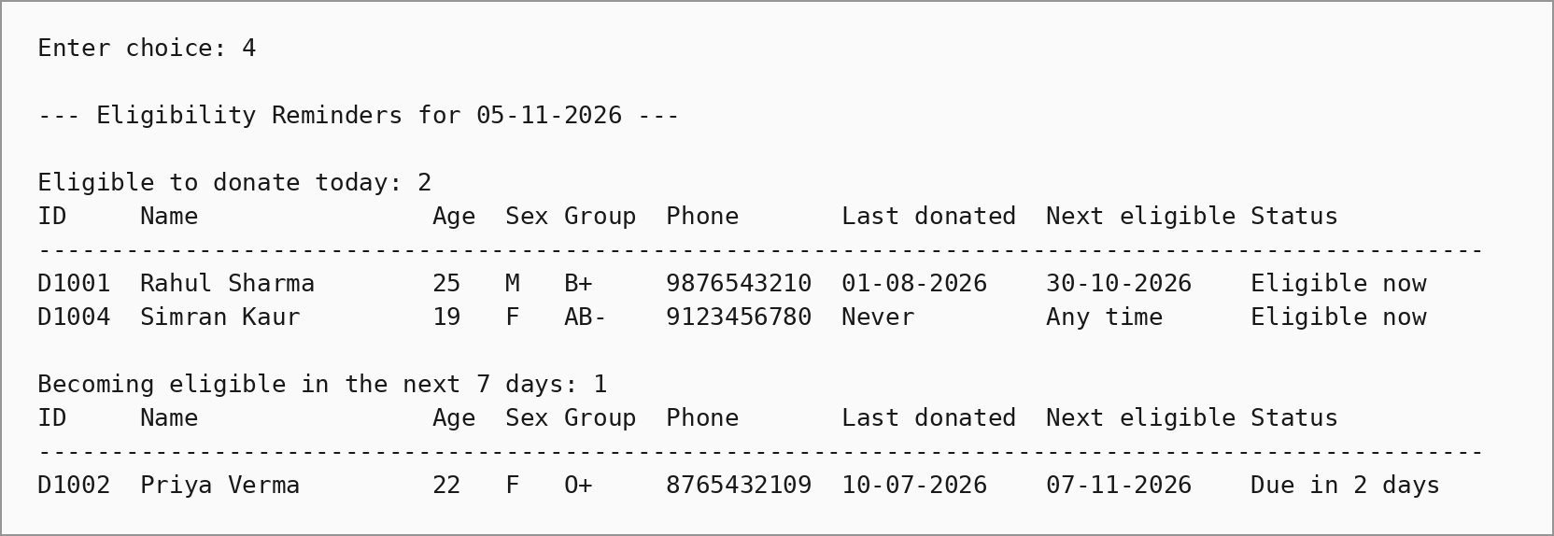
Rendered from tests/test1_normal_output.txt.

13. Plan for later phases
Each phase extends the CA1 design without rewriting it; the one planned structural change is a fixed-size record for file storage in CA2.
Phase | Due (from allocation) | What will be added to this project
CA2 · Persist & Search | Day 14 | Default, parameterised and copy constructors and a destructor for Donor; records saved to data/donors.dat as fixed-size binary records; search with seekg; basic update with seekp; data survives a restart; date of birth replaces age
CA3 · Reuse & Delete | Day 28 | Base class Donor with derived classes for whole blood and apheresis (platelet/plasma) donors, each overriding a virtual getGapDays() (apheresis gap: 48 hours under NBTC 2017); overloaded <<, >>, ==, < and one more operator; a type conversion; new/delete with a virtual destructor; safe update and delete with confirmation
CA4 · Integrate & Defend | Day 42 | Full CRUD menu; custom exception class with try/catch/throw; function and class templates; std::vector with sort (by next eligible date), find_if and count_if; advanced feature: CSV export of the reminder list for camp volunteers, plus backup and restore
Design decision for CA2: a std::string member stores its text elsewhere in memory, so writing a Donor object straight to a binary file with write() would save memory addresses, not names. After a restart those addresses are meaningless. CA2 will therefore copy each donor into a separate fixed-size record struct (character arrays of known length) before writing, and back again after reading. Keeping Donor and the file record separate means the CA1 class does not need to change.

14. Repository layout, build and run
The repository follows the /docs, /src, /data, /tests layout from the project guide, with a README at the top level. Submission files are named 12604325_CAP455_<Phase>_<Title>, for example 12604325_CAP455_CA1_BloodDonorReminder.zip. Testing covers normal, invalid and boundary cases, including strict rejection of duplicate Donor IDs.
Repository link: [paste your GitHub link here]
I. /docs (documentation): This proposal (Word and PDF), the UML class diagram and the two flowcharts, saved as PNG images with their Graphviz .dot source files. The edge-case test table (CA3) and the final project report (CA4) will be added here in later phases.
II. /src (source code): main.cpp (menu and operations), Donor.h and Donor.cpp (the Donor class), and Utils.h and Utils.cpp (dates, validators and safe input). The code compiles on any standard C++11-or-later compiler; it was compiled with g++ 13 using -Wall -Wextra with no warnings.
III. /data (data storage): In CA1 donor records are kept in memory, so this folder holds a sample data file, sample_donors_input.txt, which registers six sample donors when it is given to the program as input. From CA2, when file persistence with fstream is added, the binary file donors.dat that saves the donor records will be stored here.
IV. /tests (testing): Input files and output transcripts for the normal, invalid and boundary test runs, and test_validators.cpp, which runs 27 automated checks on the validators, date calculations and eligibility rule.
V. README.md: Build and run steps and the features completed in each phase.
Build (g++ / MinGW, from the project folder)
g++ -std=c++17 -Wall src/main.cpp src/Donor.cpp src/Utils.cpp -o donor_app
Run
donor_app uses today's date
donor_app 05-11-2026 test mode: treats 05-11-2026 as today
Code::Blocks: create a new Console Application project and add all five files from src, then Build and Run.
Re-run a test: donor_app 05-11-2026 < tests/test1_normal_input.txt
Load the sample donors: donor_app < data/sample_donors_input.txt
Automated checks: g++ -std=c++17 tests/test_validators.cpp src/Donor.cpp src/Utils.cpp -Isrc -o run_tests, then run run_tests.
15. References
- National Blood Transfusion Council (NBTC), MoHFW. Guidelines for Blood Donor Selection & Blood Donor Referral, 2017, as summarised in: Tomar, A. Revised NBTC Guidelines for Blood Donor Selection and Blood Donor Deferral, Dept. of Immunohematology and Blood Transfusion, AFMC Pune.
- M3 India Newsdesk. Blood transfusion: Guidelines by MoHFW, 14 June 2022.
- Lovely Professional University. CAP455 Minor Project Quick Guide, Session 2026–27.
- cppreference.com: std::basic_string — reference for the string functions used.

