ONLINE APPENDIX
How do indirect taxes reshape tax-benefit-revealed social preferences for redistribution?

A. Imputation of consumption from HBS to EU-SILC and simulation of indirect taxes
A.1. Survey-to-survey imputation of consumption
A.1.1. Estimation of Engel curves on HBS data
A.1.2. Imputation of consumption into EU-SILC
A.1.3. Explanatory variables in models A1 through A6
A.1.4. Comparison of expenditures imputed into EU-SILC to those observed in HBS
A.2. Simulation of indirect taxes
A.2.1. Simulation framework
A.2.2. Comparison of simulated indirect taxes between EU-SILC and HBS

B. Labour supply model and elasticities
B.1. Model description and specification, discretisation of work hours, and hourly wages
B.1.1. Model description
B.1.2. Specification of utility function, opportunity measure, and opportunity density
B.1.3. Discretisation of work hours
B.1.4. Hourly wages
B.2. Model estimation and fit
B.3. Calibration of model’s baseline predictions

References for Online Appendix

A. Imputation of consumption from HBS into EU-SILC and simulation of indirect taxes
In this section, we describe how we augmented the EU-SILC data with information about household consumption expenditures from the HBS and how we then simulate indirect taxes. We use the method by de Agostini et al. (2017). We first present the consumption imputation part and then turn to the tax simulation part.

A.1. Survey-to-survey imputation of consumption
We first explain how consumption data is imputed into the EU-SILC, drawing on de Agostini et al. (2017: sections 3.2 and 3.3), with some minor changes in notation. Then we compare the expenditures imputed into the EU-SILC to those observed in the HBS.

A.1.1. Estimation of Engel curves on HBS data
We first classify all expenditure items in the HBS into durable and non-durable expenditures. The total expenditure of a household $h$ is the sum of the durable expenditures $D^{h}$ and non-durable expenditures $E^{h}$. Not all households had durable expenditures in the reference period (12 months before the survey), and the probability of positive durable expenditures for a household $h$, $\operatorname{Pr}\left(D^{h}>0\right)=\operatorname{Pr}\left(d_{D}^{h}=1\right)$, is first modelled using a probit model:
$$\operatorname{Pr}\left(d_{D}^{h}=1\right)=ϕ\left(α_{D,0}+\sum_{m=1,2,3}{β_{D,0,m}{\left({\ln{y}}^{h}\right)}^{m}}+z^{h}γ_{D,0}+ε_{D,0}^{h}\right){ ,}$$ | (A1)
where $ϕ(⋅)$ is the probit link function, $\sum_{m=1,2,3}{β_{D,0,m}{\left({\ln{y}}^{h}\right)}^{m}}$ is a third-degree polynomial of the logarithm of disposable income simulated by EUROMOD, and $z^{h}$ is a set of additional explanatory variables. All explanatory variables must be available and defined in the same way in both the HBS and EU-SILC data. These variables are described at the end of this section. Households with a very low disposable income ($y^{h}<1$) are excluded from the estimation sample because the natural logarithm of low values are very high or undefined (if $y^{h}≤0$). This sample restriction is applied in the estimation of models A2 and A3 (see below) as well. Conditional on positive durable expenditures, the following Engel-curve model is then estimated for durable expenditures:
$$\ln{D^{h}}=α_{D}+\sum_{m=1,2,3}{β_{D,m}{\left({\ln{y}}^{h}\right)}^{m}}+z^{h}γ_{D}+ε_{D}^{h} \text{if} d_{D}^{h}=1 .$$ | (A2)
Also, for non-durable expenditures, the following unconditional Engel-curve model is estimated:
$$\ln{E^{h}}=α_{E}+\sum_{m=1,2,3}{β_{E,m}{\left({\ln{y}}^{h}\right)}^{m}}+z^{h}γ_{E}+ε_{E}^{h} .$$ | (A3)
Total non-durable expenditures are then further divided into the following 15 categories of goods, indexed by $G$ = 1, 2, …, 15: food and non-alcoholic beverages; alcoholic beverages; tobacco products; clothing and footwear; home fuels, electricity and water; housing and rents; household goods and services; health; private transport; public transport; communications; recreation and culture; education; restaurants and hotels; other goods and services. For some of these categories many households do not have positive expenditures, and as in the case of durables, for each such category we estimate a probit model of the probability of positive expenditures, $Pr\left(e_{G}^{h}>0\right)≡\operatorname{Pr}\left(d_{G}^{h}=1\right)$:
$$\operatorname{Pr}{(d_{G}^{h}=1)}=ϕ\left(α_{G,0}+\sum_{m=1,2,3}{β_{G,0,m}{\left({\ln{E}}^{h}\right)}^{m}}+z^{h}γ_{G,0}+ε_{G,0}^{h}\right)\text{if} G∈Z ,$$ | (A4)
where $Z$ is the set of categories for which many households have zero consumption. These categories are: alcoholic beverages; tobacco products; clothing and footwear; health; private transport; public transport; education; restaurants and hotels; housing and rents. For each of these, we then estimate the following conditional Engel-curve model:
$$w_{G}^{h}=α_{G,Z}+\sum_{m=1,2,3}{β_{G,Z,m}{\left({\ln{E}}^{h}\right)}^{m}}+z^{h}γ_{G,Z}+ε_{G,Z}^{h} \text{if} d_{G}^{h}=1 \text{and} G∈Z ,$$ | (A5)
where $w_{G}^{h}≡e_{G}^{h}/E^{h}$ is the share of expenditures on a $G∈Z$ in the total non-durable expenditures.
For the other categories (i.e., $G∉Z$) called the ‘remaining’ goods, $G∈R$, we estimate the following unconditional Engel-curve model:
$$r_{G}^{h}=α_{G,R}+\sum_{m=1,2,3}{β_{G,R,m}{\left(\ln{E_{R}^{h}}\right)}^{m}}+z^{h}γ_{G,R}+ε_{G,R}^{h} \text{if} G∈R ,$$ | (A6)
where $r_{G}^{h}≡e_{G}^{h}/E_{R}^{h}$ is the share of expenditures on a $G∈R$ in the total expenditures on categories $G∈R$. The total expenditures on categories $G∈R$ are obtained as $E_{R}^{h}=E^{h}⋅\left(1-\sum_{G∈Z}{w_{G}^{h}}\right)$.

A.1.2. Imputation of consumption into EU-SILC
Once the parameters of the models A1 through A6 are estimated, we use them in the EU-SILC to impute expenditures into it. All the explanatory variables that appear on the right-hand sides of equations A1-A6 are created in the same way in the EU-SILC, and the estimated parameters are used to impute the dependent variables. The imputation results in the EU-SILC data augmented with data on expenditures $e_{G}^{h}$ for every category $G$ and expenditures on durable goods $D^{h}$. The imputed values ${\hat{e}}_{G}^{h}$ are calculated as
$${\hat{e}}_{G}^{h}=\left\{\begin{matrix}{\hat{w}}_{G}^{h} & \text{for any} & G∈Z , \\ {\hat{r}}_{G}^{h} & \text{for any} & G∈R .\end{matrix}\right.$$ | (A7)
At this point, two things are important.
First, before performing imputations using models A1 through A3, we make sure that that the distribution of disposable income in the EU-SILC does not differ substantially from the one in the HBS. To this end, we align the means and standard deviations in the two datasets as follows. For every household in the EU-SILC, the disposable income $y^{h}$ is transformed into ${\tilde{y}}^{h}$ using the formula:
$${\tilde{y}}^{h}=\frac{y^{h}-\overline{y}}{σ}σ_{HBS}+{\overline{y}}_{HBS} ,$$ | (A8)
where $\overline{y}$ and $σ$ are the mean and standard deviation of disposable income in the EU-SILC, and ${\overline{y}}_{HBS}$ and $σ_{HBS}$ are the respective statistics in the HBS. In both datasets, the mean and standard deviation are calculated after excluding observations with a very low disposable income ($y^{h}<1$) and outliers by disposable income. An outlier is any observation with disposable income $y^{h}$ for which the following holds:
$$ϕ\left(\frac{\ln{y}-μ_{\ln{y}}}{σ_{\ln{y}}}\right)<\frac{1}{2N} ,$$ | (A9)
where $ϕ(⋅)$ is the density function for the normal distribution, $μ_{\ln{y}}$ and $σ_{\ln{y}}$ are the mean and standard deviation of $\ln{y^{h}}$, and $N$ is the number of observations. What is said here for doing imputations using models A1 to A3, should be applied when doing imputations using models A4 to A6 as well, where the alignment of means and standard deviations between the datasets concern the variables ${\ln{E}}^{h}$ and ${\ln{E}}_{R}^{h}$.
Second, after imputing $\ln{D^{h}}$ and $\ln{E^{h}}$ using models A3 and A4, respectively, $D^{h}$ and $E^{h}$ are calculated in the following way. In the case of $D^{h}$, the prediction ${\hat{D}}^{h}$ is obtained as
$${\hat{D}}^{h}=\ln\left(\frac{Ε\left[\exp{({\hat{α}}_{D}+\sum_{m=1,2,3}{{\hat{β}}_{D,m}{\left({\ln{y}}^{h}\right)}^{m}}+z^{h}{\hat{γ}}_{D}+{\hat{ε}}_{D}^{h})}\right]}{Ε\left[\exp{({\hat{ε}}_{D}^{h})}\right]}\right) ,$$ | (A10)
where ${\hat{ε}}_{D}^{h}$ is the predicted regression residual the expected values are estimated as sample means. Similarly, ${\hat{E}}^{h}$ is calculated as
$${\hat{E}}^{h}=\ln\left(\frac{Ε\left[\exp{({\hat{α}}_{E}+\sum_{m=1,2,3}{{\hat{β}}_{E,m}{\left({\ln{y}}^{h}\right)}^{m}}+z^{h}{\hat{γ}}_{E}+{\hat{ε}}_{E}^{h})}\right]}{Ε\left[\exp{({\hat{ε}}_{E}^{h})}\right]}\right) .$$ | (A11)
Simply taking anti-logs to obtain the imputed values ${\hat{D}}^{h}$ and ${\hat{E}}^{h}$, instead of using formulas A10 and A11, would render the imputed values biased.

A.1.3. Explanatory variables in models A1 through A6
The explanatory variables described below are not the same as in de Agostini et al. (2017), but rather chosen to ensure good imputation performance, judged by comparing the quantities imputed into the EU-SILC with those observed in the HBS.
- Natural log of disposable income: Disposable is simulated by EUROMOD, and equivalised using the OECD equivalence scale (weights: 1 for one adult, 0.5 for every additional adult, 0.3 for every child). We use the natural log and its square, where the two are orthogonalized to remove the correlation between them. Concretely, ${\left(\ln{y}\right)}^{2}$ is regressed on $\ln{y}$ and the residuals are saved. Then, $\ln{y}$ and the residuals are used as explanatory variables in models A1, A2, and A3.
- Natural log of total expenditures: We use two variables: the natural log and its square. The same orthogonalization as in the case of disposable income is applied $\ln{E^{h}}$ and ${\left(\ln{E^{h}}\right)}^{2}$in models A4 and A5.
- Natural log of total expenditures on ‘remaining’ goods: The ‘remaining’ goods are those that are consumed by all households in the HBS sample. These goods are denoted $G∈R$ above. We use two variables: the natural log and its square. The same orthogonalization as in the case of disposable income is applied to$\ln{E_{R}^{h}} and {\left(\ln{E_{R}^{h}}\right)}^{2}$ in model A6.
- Natural log of household size: Household size equals the number of members. We use two variables: the natural log and its square. The same orthogonalization as in the case of disposable income is applied.
- Share of economically active and share of retired household members: Economically active are those whose self-defined activity status is employed, self-employed, or farmer/fisherman. The residual share is the share of economically inactive persons who are not retired, including children. The denominator in the calculation of the shares is the household size.
- Shares of age groups within household: We use the groups 0–9, 10–19, …, and 70–79 years, leaving out the residual share (age 80 or more). The denominator in the calculation of the shares is the household size.
- Number of rooms in house/apartment
- Indicator for car possession: A binary variable equal to one if the household has a car, and zero otherwise.

A.1.4. Comparison of expenditures imputed into EU-SILC to those observed in HBS
Table A1 displays the average imputed (into EU-SILC) and observed (in HBS) expenditures, and the percentage difference between them. The average shares of non-durable commodity types in the total non-durable expenditures are also compared. Fig. A1 compares the imputed and observed amounts of total, non-durable and durable expenditures across 20 ventile groups of the distribution of equivalised disposable income. Fig. A2 compares the imputed and observed shares of expenditures for 15 non-durable commodity types in the total non-durable expenditures.

A.2. Simulation of indirect taxes

A.2.1. Simulation framework
This section briefly describes how indirect taxes on the durable and non-durable commodity categories are simulated in the EU-SILC after imputing consumption information. Here we draw on section 3.4 and 3.5 in de Agostini et al. (2017).
For any commodity $k$ within a non-durable commodity category $G$ = 1, 2, …, 15 or within the category of durable goods, the consumer price $p_{k}$ and producer (or seller) price $q_{k}$ are related as
$$q_{k}=\left(1+t_{k}\right)\left(p_{k}+a_{k}+v_{k}q_{k}\right) ,$$ | (A12)
where $t_{k}$ is the value-added tax (VAT) rate, $a_{k}$ is the specific (i.e., per unit) excise, and $v_{k}$ is the ad valorem excise rate. The implicit tax rate on a commodity $k$, denoted $τ_{k}$, is defined implicitly by the identity
$$q_{k}≡\left(1+τ_{k}\right)p_{k} .$$ | (A13)
A12 and A13 together give
$$\frac{τ_{k}}{1+τ_{k}}=\frac{t_{k}}{1+t_{k}}+\frac{a_{k}}{q_{k}}+v_{k} .$$ | (A14)
Then, for a household $h$ that consumes $x_{k}^{h}$ units of a commodity $k$ at a consumer price of $p_{k}$ per unit, the total tax liability for the commodity is
$$T_{k}^{h}≡τ_{k}p_{k}x_{k}^{h}=\frac{τ_{k}}{1+τ_{k}}e_{k}^{h} ,$$ | (A15)
where $e_{k}^{h}$ is the expenditure (tax-inclusive) for the commodity $k$. The total liability $T_{k}^{h}$ can be decomposed into the VAT liability $T_{k}^{h,t}$, specific excise liability $T_{k}^{h,a}$, and ad valorem excise liability $T_{k}^{h,v}$:
$$T_{k}^{h}=T_{k}^{h,t}+T_{k}^{h,a}+T_{k}^{h,v} ,$$ | (A16)
$$T_{k}^{h,t}≡\frac{t_{k}}{1+t_{k}}e_{k}^{h} ,$$ | (A17)
$$T_{k}^{h,a}≡a_{k}x_{k}^{h}=\frac{a_{k}}{q_{k}}e_{k}^{h} ,$$ | (A18)
$$T_{k}^{h,v}≡v_{k}e_{k}^{h} .$$ | (A19)
However, these quantities can be computed in the HBS only, because only this dataset contains $e_{k}^{h}$ for all $k$. In the EU-SILC, we have only the imputed expenditures for the 15 commodity types $G$ = 1, 2, …, 15 and for durables.
Tax liabilities for households in the EU-SILC are obtained using these formulas:
$${\hat{T}}_{G}^{h}=\left(\sum_{k∈G}{\frac{τ_{k}}{1+τ_{k}}}ω_{k,HBS}\right){\hat{e}}_{G}^{h} ,$$ | (A20)
$${\hat{T}}_{G}^{h,t}=\left(\sum_{k∈G}{\frac{t_{k}}{1+t_{k}}}ω_{k,HBS}\right){\hat{e}}_{G}^{h} ,$$ | (A21)
$${\hat{T}}_{G}^{h,a}=\left(\sum_{k∈G}{\frac{a_{k}}{q_{k}}}ω_{k,HBS}\right){\hat{e}}_{G}^{h} ,$$ | (A22)
$${\hat{T}}_{G}^{h,v}=\left(\sum_{k∈G}{v_{k}}ω_{k,HBS}\right){\hat{e}}_{G}^{h} .$$ | (A23)
In these formulas, the weight $ω_{k,HBS}$ is the aggregate share of the expenditure for a commodity $k$ in the total expenditure for the commodity type $G$ to which $k$ belongs, computed with the HBS data,
$$ω_{k,HBS}≡\frac{e_{k,HBS}}{e_{G,HBS}}\text{ for any }k∈G ,$$ | (A24)
where $e_{k,HBS}=\sum_{h}{e_{k}^{h}}$ is the aggregate expenditure for the commodity $k$, and $e_{G,HBS}=\sum_{k∈G}{\sum_{h}{e_{k}^{h}}}=\sum_{k∈G}{e_{k,HBS}}$ is the aggregate expenditure for the commodity type $G$ that $k$ belongs to.
In A20 through A24, we refer to a commodity type $G$ = 1, 2, …, 15 and individual commodities within it, but the same formulas hold for durables. We only must replace the subscript $G$ with $D$, and ${\hat{e}}_{G}^{h}$ with ${\hat{D}}^{h}$.

A.2.2. Comparison of simulated indirect taxes between EU-SILC and HBS
Table A2 compares the average indirect taxes (VAT + excises), VAT, and excises simulated in the HBS and EU-SILC. The total is given and broken down by commodity types (durables and the 15 non-durable commodity types. Fig. A3 compares the total indirect taxes (VAT + excises), VAT, and excises simulated in the HBS and EU-SILC across 20 ventile groups of the equivalised disposable income distribution.

B. Labour supply model and elasticities
In this section, we describe the structural labour supply model and how it is estimated, present the estimates of its parameters, assess its fit to the data, and explain how we simulate the intensive- and extensive-margin elasticities of labour supply based on the parameter estimates.

B.1. Model description and specification, discretisation of work hours, and hourly wages

B.1.1. Model description
Individuals have preferences over consumption (after-tax income) $C$, hours of work $h$, and other job characteristics $z$. The latter are observed by individuals but are latent to us. $z$ is used to index jobs, with $z=0$ representing “not working”, which is here understood as just a “job” outside the formal labour market. The preferences are represented by a utility function
$$U\left(C,h,z\right)=V\left(C,h\right)+ε\left(z\right) ,$$ | (B1)
where $V(C,h)$ is its deterministic part, and $ε(z)$ is a random term following the Extreme Value Type I distribution with the cumulative distribution function $F\left(ε\right)=\exp\left(-exp\left(-ε\right)\right)$. Individuals choose jobs by maximising the utility function under the household budget constraint
$$C\left(h,w\right)=wh+N-T\left(wh,N\right) ,$$ | (B2)
where $w$ denotes individual-specific gross hourly wage rate which, by assumption, does not vary with $h$, and $N$ is non-labour income (e.g., capital or property income). The function $T(.)$ is a tax-benefit function that transforms the total before-tax income into the total after-tax income (in our case, disposable or consumable).
Let $H(z)$ denote a fixed number of work hours associated with a job $z$. Plugging it into B1 gives
$$\tilde{U}\left(z\right)≡U\left(C\left(H\left(z\right),w\right),H\left(z\right),z\right)=V\left(C\left(H\left(z\right),w\right),H\left(z\right)\right)+ε\left(z\right) ,$$ | (B3)
where $z∈B$, and $B$ is the set of jobs available to the individual. Let $B(h)$ be the subset of $B$ that contains all the jobs for which $H\left(z\right)=h$ and let $m(h)$ the number of jobs in $B(h)$. The latter number is unknown to us. Furthermore, let $D$ be the set of all possible work hours, including zero hours. Then, denoting $ψ\left(h;w\right)≡V\left(C\left(h,w\right),h\right)$ the probability that the individual chooses a job with hours $h$ can be written as (Dagsvik et al., 2014):
$$φ\left(h\right)=\operatorname{Pr}\left(\max_{z∈B(h)}{\tilde{U}(z)}=\max_{z∈B}{\tilde{U}(z)}\right)=\frac{\exp\left(ψ\left(h;w\right)\right)m(h)}{\exp\left(ψ\left(0\right)\right)+\sum_{x∈D,x>0}{\exp\left(ψ\left(x;w\right)\right)m(x)}} .$$ | (B4)
Dagsvik and Strøm (2006) express $m(x)$ as a product of the ‘opportunity measure’ $θ=\sum_{x∈D,x>0}{m(x)}$, which is a measure of jobs available to the individual, and the ‘opportunity density’ $g(h)$, the fraction of available jobs with hours $h$: $m\left(h\right)=θg(h)$. $φ(h)$ then becomes:
$$φ\left(h\right)=\left\{\begin{matrix}\frac{\exp\left(ψ\left(h;w\right)\right)θg(h)}{\exp\left(ψ\left(0\right)\right)+\sum_{x∈D,x>0}{\exp\left(ψ\left(x;w\right)\right)θg(h)}} & \text{if} & h>0 , \\ \frac{\exp\left(ψ\left(0\right)\right)}{\exp\left(ψ\left(0\right)\right)+\sum_{x∈D,x>0}{\exp\left(ψ\left(x;w\right)\right)θg(h)}} & \text{if} & h=0 .\end{matrix}\right.$$ | (B5)

B.1.2. Specification of utility function, opportunity measure, and opportunity density
To estimate these choice probabilities using data, we specify the deterministic part of the utility function parametrically as follows:
$$V\left(C,H\right)=β_{C}C+β_{CC}C^{2}+β_{L}L+β_{LL}L^{2}+β_{CL}(C×L) .$$ | (B6)
$L$ denotes the annual leisure hours, given as the total annual time endowment of 8760 hours (365 days times 24 hours) minus the annual work hours $h$: $L$ = 8760 – $h$. Preference heterogeneity is allowed for by specifying:
- $β_{C}=β_{C0}$
$$+ β_{C1}×1\left[\text{woman}\right]$$
$$+ β_{C2}×\text{household size}$$
$$+ β_{C3}×\text{household size}×1\left[\text{woman}\right]$$
- $β_{CC}=β_{CC0}+β_{CC1}×1[\text{woman}]$
- $β_{L}=β_{L0}$
$$+{ β}_{L1}×1\left[\text{woman}\right]$$
$$+{ β}_{L2}×\text{years of} \text{age}$$
$$+{ β}_{L3}×\text{years of }\text{age}×1\left[\text{woman}\right]$$
$$+ β_{L4}×{\text{years of }\text{age}}^{2}$$
$$+ β_{L5}×{\text{years of }\text{age}}^{2}×1\left[\text{woman}\right]$$
$$+ β_{L6}×1\left[\text{suffers moderate health limitation}\right]$$
$$+ β_{L7}×1\left[\text{suffers moderate health limitation}\right]×1\left[\text{woman}\right]$$
$$+ β_{L6}×1\left[\text{suffers severe health limitation}\right]$$
$$+ β_{L9}×1\left[\text{suffers severe health limitation}\right]×1\left[\text{woman}\right]$$
- $β_{LL}=β_{LL0}+β_{LL1}×1[\text{woman}]$
- $β_{CL}=β_{CL0}+β_{CL1}×1[\text{woman}]$
where 1[.] denotes an indicator variable that equals one if the bracketed condition is true, and zero otherwise. The reference category for suffering moderate/severe health limitation is suffering no health limitation.
When it comes to the specifications of the opportunity measure and density, we follow Dagsvik and Jia (2016). They specify the opportunity measure as $θ=\exp\left(X^{'}γ\right)$, that is, $\ln{θ}=X^{'}γ$. Specifically, we have:
- $\ln{θ}=γ_{0}×1[h>0]$
$$+ γ_{1}×1\left[h>0\right]×1\left[\text{woman}\right]$$
$$+{ γ}_{2}×1\left[h>0\right]×\text{age}$$
$$+ γ_{3}×1\left[h>0\right]×\text{age}×1\left[\text{woman}\right]$$
$$+ γ_{4}×\text{years of work experience}$$
$$+ γ_{5}×\text{years of work experience}×1\left[\text{woman}\right]$$
$$+ γ_{6}×1[\text{resides in high-population-density area]}$$
$$+ γ_{7}×1[\text{resides in high-population-density area]}×1\left[\text{woman}\right]$$
$$+ γ_{6}×1[\text{resides in moderate-population-density area]}$$
$$+ γ_{7}×1[\text{resides in moderate-population-density area]}×1\left[\text{woman}\right]$$
where the reference category for residing in a high/moderate-population-density area is residing in a low-population-density area.
Concerning the opportunity density, Dagsvik and Jia (2016) model it as uniform for all positive work hours, except for peaks at hours carrying a significant mass. In our data, the only substantial peak for positive hours is at the hours associated with annual full-time work, which is 2080 hours (see Fig. A4 below). Thus, we model $g(h)$ as a constant specific to full-time work: $g\left(h\right)=\exp{(δ×1[h=2080])}$, that is, $\ln{g(h)}=δ×1[h=2080]$.

B.1.3. Discretisation of work hours
Based on the EU-SILC data, we obtain for everyone the annual number of work hours using the following formula:
$$h=\text{Months_Full_Time_Job}×40 \\ + \text{Months_Part_Time_Job}×20 \\ + \text{Months_Additional_Job}×10 ,$$ | (B7)
where $\text{Months_Full_Time_Job}$ is the number of months (over the income reference year) spent in full-time employment, $\text{Months_Part_Time_Job}$ is the number of months (over the income reference year) spent in part-time employment, and $\text{Months_Additional_Job}$ is the number of months (over the income reference year) that the individual had an additional job besides the main one. These numbers are obtained from individuals’ self-reported labour market status and a question of whether they have an additional job. The numbers 40, 20, and 10 in the above formula are the median (also modal) work hours in full-time, part-time, and additional jobs, respectively, determined from individuals’ self-reported usual weekly work hours.
For usage in the labour supply model, we discretise the distribution of work hours (calculated using formula B7) by reducing it to six discrete hours points. The discretisation is shown in Table A3. Each individual falls into an interval of annual hours, and depending on the interval, we assign him/her the median hours within the interval. The rightmost two columns show the weekly equivalents of the annual figures. Fig. A4 displays the discretised distribution of work hours.

B.1.4. Hourly wages
The gross hourly wages $w$ for individuals with positive work hours are computed by dividing individuals’ annual gross employment incomes (gross salaries) by the annual work hours. Here, the annual hours refer to those after the discretisation explained above (see Table A3). For individuals out of work, gross hourly wages are missing information by construction. Following a standard practice, we obtain the missing wages by estimating a selection model à la Heckman (1979). We estimate a version of the model where the wage regression equation and the selection (into work, i.e., into $H$ > 0) equation are estimated jointly by the maximum likelihood estimation. The wage regression and selection equations for observation $j$ read:
$$w_{j}=X_{j}ζ+u_{1j} ,$$ | (B8)
$$d_{j}^{*}=Z_{j}ξ+u_{2j}>0 ,$$ | (B9)
respectively, where $w$ is the log of gross hourly wage, $d^{*}$is a continuous latent variable representing the propensity to be selected, $X$ and $Z$ are sets of observable characteristics, $ζ$ and $ξ$ are parameters to be estimated, $u_{1}\sim Normal\left(0,σ^{2}\right)$, $u_{2}\sim Normal(0,1)$, and $corr\left(u_{1},u_{2}\right)=ρ$. $X$ contains age (in years) and its square, education (in years) and its square, experience (in years) and its square, and a dummy for residing in an area with a high population density (reference category: residing in an area with a moderate or low population density). $Z$ contains $X$ and the following additional characteristics: dummies for moderate and severe health limitations (reference category: no health limitation), a dummy for being married or in cohabitation (reference category: neither married nor in cohabitation), the numbers of children aged 0–6 and 7–14, and the income of other household members. The vectors of parameters $ζ$ and $ξ$ both contain a constant. The log likelihood for observation $j$, $l_{j}≡\ln{L_{j}}$, reads
$$l_{j}=\left\{\begin{matrix}s_{j}\left[\ln{Φ\left(\frac{Z_{j}ξ+\frac{\left(w_{j}-X_{j}ζ\right)ρ}{σ}}{\sqrt{1-ρ^{2}}}\right)}-{\left(\frac{w_{j}-X_{j}ζ}{σ\sqrt{2}}\right)}^{2}-\ln\left(σ\sqrt{2π}\right)\right] & \text{if} w_{j} \text{missing}, \\ s_{j}\ln{Φ(-Z_{j}ξ)} & \text{if} w_{j} \text{observed.}\end{matrix}\right.$$ | (B10)
where $Φ(.)$ is the c.d.f. of the normal distribution and $s_{j}$ is the observation’s population weight. For a sample of $N$ individuals, the log likelihood function is
$$l=\sum_{j|w_{j} \text{missing}}{s_{j}\left[\ln{Φ\left(\frac{Z_{j}ξ+\frac{\left(w_{j}-X_{j}ζ\right)ρ}{σ}}{\sqrt{1-ρ^{2}}}\right)}-{\left(\frac{w_{j}-X_{j}ζ}{σ\sqrt{2}}\right)}^{2}-\ln\left(σ\sqrt{2π}\right)\right]}+\sum_{j|w_{j} \text{observed}}{s_{j}\ln{Φ(-Z_{j}ξ)}} .$$ | (B11)
The estimation results are shown in Table A3.
Using the estimates of the wage equation parameters, $\hat{ζ}$, and the standard error of the wage equation residuals, $\hat{σ}=\sqrt{{\hat{σ}}^{2}}$, we predict the missing wage of the person $j$ according to
$${\hat{w}}_{j}={\overline{w}}_{j}+\hat{σ}⋅η_{j} ,$$ | (B12)
where ${\overline{w}}_{j}≡X_{j}\hat{ζ}$ and $η_{j}$ is a draw from the standard normal distribution. For each $j$, we make 50 predictions, ${\left\{{\hat{w}}_{j}^{r}\right\}}_{r=1,…,50}$ by taking 50 draws from the standard normal distribution, ${\left\{η_{j}^{r}\right\}}_{r=1,…,50}$. We use these 50 wage predictions in the estimation of the labour supply model to take account of the wage prediction error (see section B.2 below).
The Heckman model estimation is done separately for men and women, and on samples before the restrictions applied to obtain the analysed population (see Section 4.1 in the main text). The estimates are shown in Table A4.

B.2. Model estimation and fit to data
The labour supply model is estimated by the simulated maximum likelihood method. For an individual $j$ = 1, 2, …, $N$ the contribution to the log likelihood is
$$l_{j}=\left\{\begin{matrix}\ln\left(\frac{\exp\left[ψ_{j}\left(h_{j};w_{j}\right)+\ln{θ_{j}}+\ln{g(h_{j})}\right]}{\exp\left[ψ_{j}\left(0\right)\right]+\sum_{h∈D,h>0}{exp⁡[ψ_{j}\left(h;w_{j}\right)+\ln{θ_{j}}+\ln{g(h)]}}}\right) & \text{if }h_{j}>0 , \\ \ln\left(Ε\left\{\frac{\exp\left[ψ_{j}\left(0\right)\right]}{\exp\left[ψ_{j}\left(0\right)\right]+\sum_{h∈D,h>0}{{exp⁡[ψ}_{j}\left(H;{\hat{w}}_{j}\right)+\ln{θ_{j}}+\ln{g(h)]}}}\right\}\right) & \text{if }h_{j}=0 ,\end{matrix}\right.$$ | (B13)
where ${\hat{w}}_{j}={\overline{w}}_{j}+\hat{σ}⋅η_{j}$ and $Ε$ is the expected value operator over $η_{j}$. This expectation is approximated by
$$Ε\left\{\frac{\exp\left[ψ_{j}\left(0\right)\right]}{\exp\left[ψ_{j}\left(0\right)\right]+\sum_{\begin{aligned}H∈D \\ h>0\end{aligned}}{{exp⁡[ψ}_{j}\left(H;{\hat{w}}_{j}\right)+\ln{θ_{j}}+\ln{g(h)]}}}\right\}≈\frac{1}{50}\sum_{r=1}^{50}{\frac{\exp\left[ψ_{j}\left(0\right)\right]}{\exp\left[ψ_{j}\left(0\right)\right]+\sum_{\begin{aligned}h∈D \\ h>0\end{aligned}}{{exp⁡[ψ}_{j}\left(h;{\hat{w}}_{j}^{r}\right)+\ln{θ_{j}}+\ln{g\left(h\right)]}}}} ,$$ | (B14)
where ${\hat{w}}_{j}^{r}={\overline{w}}_{j}+\hat{σ}⋅η_{j}^{r}$ are the 50 wage predictions from Section B.1.4.
Then, for a sample of $N$ individuals, the log likelihood function is
$$l\left(Ω\right)=\sum_{j|h_{j}>0}{\ln\left(\frac{\exp\left[ψ_{j}\left(h_{j};w_{j}\right)+\ln{θ_{j}}+\ln{g\left(h_{j}\right)}\right]}{\exp\left[ψ_{j}\left(0\right)\right]+\sum_{\begin{aligned}h∈D \\ h>0\end{aligned}}{exp⁡[ψ_{j}\left(h;w_{j}\right)+\ln{θ_{j}}+\ln{g\left(h\right)]}}}\right)}+\sum_{j|h_{j}=0}{\ln\left(\frac{1}{50}\sum_{r=1}^{50}{\frac{\exp\left[ψ_{j}\left(0\right)\right]}{\exp\left[ψ_{j}\left(0\right)\right]+\sum_{\begin{aligned}h∈D \\ h>0\end{aligned}}{exp⁡[ψ_{j}\left(h;{\hat{w}}_{j}^{r}\right)+\ln{θ_{j}}+\ln{g\left(h\right)]}}}}\right)} ,$$ | (B15)
where $\ln{θ}=γ_{0}+\sum_{j=1}^{J}{γ_{j}X_{θj}}$ and $\ln{g(h)}=δ$ (as specified in Sect. B.1.2) and $Ω=(β,γ,δ)$ are the parameters of the labour supply model (as specified in Sect. B.1.2) to be estimated.
The model is estimated separately for men and women, and for each gender, there are two versions of the model: with disposable income and with consumable income. The estimates are shown in Tables A5 for men and in Table A6 for women. Due to relatively small samples, the estimates are imprecise. However, for both genders, both versions of the model fit the data very well, as shown in Fig. A5 which compares the discretised distribution of annual work hours observed in the data with those predicted by the two model versions.

B.3. Calibration of model’s baseline predictions
As explained in Sect. 4.4 of the main text, we obtain the labour supply elasticities at the intensive margin ($ζ_{i}^{D}$ and $ζ_{i}^{DI}$ for $i$ = 1, …, 5) and the extensive margin ($η_{i}^{D}$ and $η_{i}^{DI}$ for $i$ = 1, …, 5) by simulation. Before the simulation, we first ensure that the model accurately predicts everyone’s labour supply, that is, the annual number of work hours.
We do that using the calibration procedure described in Creedy and Kalb (2005). The calibration proceeds by drawing for every individual a large number of random utility terms $ε$ from the Extreme Value Type I distribution. A draw is accepted (i.e., kept) only if, when the random term drawn is added to the deterministic part of the utility $V(C,H)$, the discrete hours point with the highest choice probability $φ\left(H\right)$ is the point actually chosen by the individual. For every individual, we generate 100 such sets of random terms.
These 100 sets are added to the deterministic part of the utility when simulating the elasticities. This gives 100 values of every elasticity that we simulate. The elasticities that we use to calculate the MSWWs are obtained as averages over the 100 values of the respective elasticity.

References
Heckman, JJ (1979) Sample selection bias as a specification error. Econometrica, 47(1):153–161.
Creedy J, Kalb G (2005) Discrete hours labour supply modelling: specification, estimation and simulation. J Econ Surv 19:697–734.

Tables and figures referred to in Online Appendix

Table A1 Observed (in HBS) and imputed (into EU-SILC) averages of expenditures and shares
 | Observed in HBS | Imputed into EU-SILC | Difference (%)
Total expenditures (HRK/year) | 98,129 | 100,691 | 2.6
Durable expenditures (HRK/year) | 9,689 | 9,732 | 0.4
Non-durable expenditures (HRK/year) | 88,441 | 90,960 | 2.8
Expenditures for non-durable commodity types (HRK/year)
Food and non-alcoholic beverages | 27,276 | 27,496 | 0.8
Alcoholic beverages | 1,149 | 1,184 | 3.0
Tobacco products | 1,535 | 1,504 | −2.0
Clothing and footwear | 7,779 | 7,647 | −1.7
Home fuels, electricity, and water | 9,292 | 10,149 | 9.2
Household goods and services | 6,716 | 7,044 | 4.9
Health | 3,377 | 3,371 | −0.2
Private transport | 12,250 | 12,935 | 5.6
Public transport | 723 | 728 | 0.7
Communications | 5,015 | 5,479 | 9.3
Recreation and culture | 4,254 | 4,352 | 2.3
Education | 1,014 | 971 | −4.2
Restaurants and hotels | 2,816 | 2,702 | −4.0
Housing and rents | 706 | 904 | 28.0
Other goods and services | 4,541 | 4,494 | −1.0
Share in non-durable expenditures (%)
Food and non-alcoholic beverages | 31.9 | 31.4 | −1.6
Alcoholic beverages | 1.3 | 1.4 | 3.7
Tobacco products | 1.7 | 1.8 | 3.0
Clothing and footwear | 7.7 | 7.7 | −0.2
Home fuels, electricity, and water | 12.1 | 11.8 | −2.0
Household goods and services | 8.1 | 8.1 | 0.0
Health | 3.9 | 4.0 | 2.3
Private transport | 12.7 | 12.8 | 1.5
Public transport | 0.8 | 0.8 | 1.2
Communications | 5.8 | 5.9 | 1.6
Recreation and culture | 4.7 | 4.7 | 0.7
Education | 0.9 | 0.9 | 0.4
Restaurants and hotels | 2.6 | 2.6 | 0.9
Housing and rents | 0.8 | 1.0 | 24.4
Other goods and services | 4.9 | 4.9 | 0.4
Notes: Population expansion factors used.

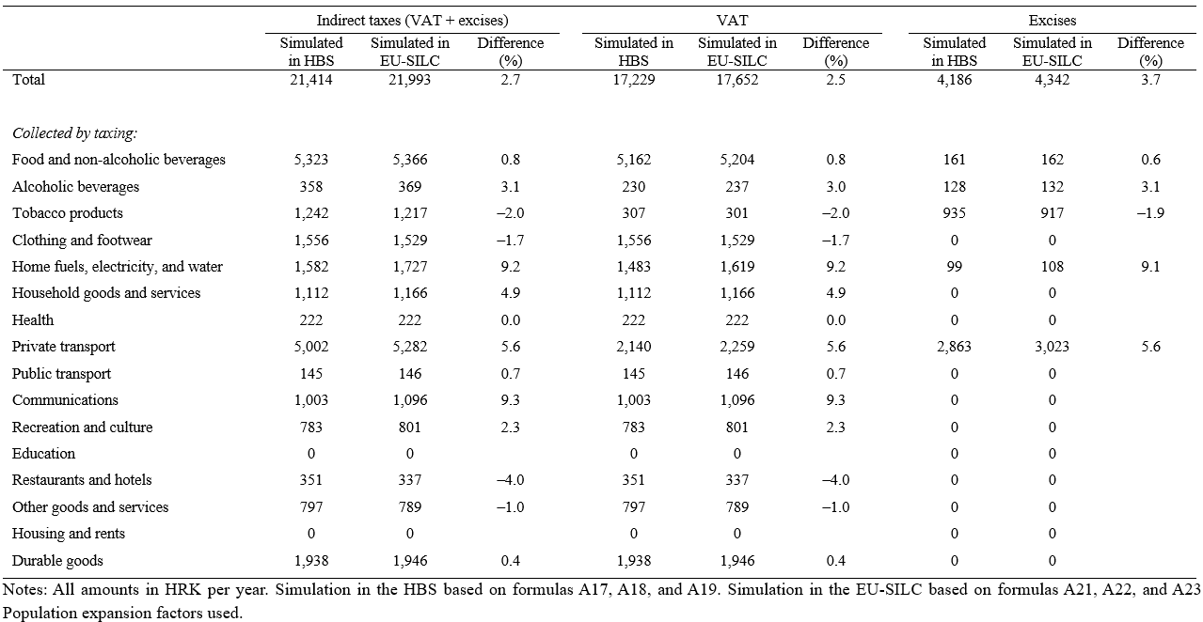 | Table A2 Average amount of indirect taxes simulated in HBS and EU-SILC
Table A3 Discretisation of work hours distribution
Discrete hours point | Annual hours |  |  | Weekly equivalent of annual hours
 | Interval | Median within interval |  | Interval | Median within interval
1 | 0 ≤ H < 260 | 0 |  | 0 ≤ H < 5 | 0
2 | 260 ≤ H < 780 | 520 |  | 5 ≤ H < 15 | 10
3 | 780 ≤ H < 1300 | 1040 |  | 15 ≤ H < 25 | 20
4 | 1300 ≤ H < 1820 | 1560 |  | 25 ≤ H < 35 | 30
5 | 1820 ≤ H < 2600 | 2080 |  | 35 ≤ H < 50 | 40
6 | 2600 ≤ H | 2600 |  | 50 ≤ H | 50
Notes: Annual hours calculated using formula B7. The weekly equivalents calculated by dividing the annual hours by 52 (i.e., the number of weeks in a year).

Table A4 Estimation of Heckman selection model
 | Men |  |  | Women
 | Estimate | SE |  | Estimate | SE
Wage regression equation
age | –0.004 | (0.011) |  | –0.014 | (0.012)
age squared | –0.002 | (0.013) |  | 0.000 | (0.012)
education | 0.092 | (0.005) |  | 0.095 | (0.006)
experience | 0.029 | (0.005) |  | 0.039 | (0.011)
experience squared | –0.040 | (0.012) |  | –0.043 | (0.016)
1[resides in high-population-density area] | 0.119 | (0.022) |  | 0.157 | (0.020)
constant | 2.361 | (0.201) |  | 2.281 | (0.180)
Selection equation
age | –0.096 | (0.035) |  | –0.008 | (0.035)
age squared | –0.026 | (0.042) |  | –0.107 | (0.045)
education | 0.143 | (0.019) |  | 0.121 | (0.018)
experience | 0.193 | (0.016) |  | 0.198 | (0.013)
experience squared | –0.184 | (0.036) |  | –0.251 | (0.029)
1[resides in high-population-density area] | 0.039 | (0.088) |  | 0.179 | (0.082)
1[suffers moderate health limitation] | –0.512 | (0.097) |  | –0.251 | (0.125)
1[suffers severe health limitation] | –1.249 | (0.168) |  | –0.903 | (0.221)
1[married or in cohabitation] | 0.223 | (0.099) |  | –0.093 | (0.097)
number of children 0–6 | 0.005 | (0.077) |  | –0.497 | (0.092)
number of children 7– 4 | –0.086 | (0.061) |  | –0.247 | (0.062)
income of other household members | 0.011 | (0.017) |  | –0.035 | (0.012)
constant | 1.328 | (0.674) |  | –0.067 | (0.583)
atanh $ρ$ | –0.212 | (0.047) |  | 0.61 | (0.428)
ln $σ$ | –0.851 | (0.021) |  | –0.953 | (0.051)
Log-likelihood | –569.671 |  |  | –547.936
Chi-squared | 564.193 |  |  | 551.143
Observations | 3682 |  |  | 3990
Notes: Estimated by maximum likelihood. Population expansion factors used. Estimation samples include individuals before the restrictions applied to obtain the analysed population. 1[.] denotes an indicator variable that equals one if the bracketed condition is true, and zero otherwise.

Table A5 Estimates of labour supply model parameters
 | Parameter symbol | Model with disposable income |  |  | Model with consumable income
 |  | Estimate | SE |  | Estimate | SE
Utility function parameters
C | $$β_{C0}$$ | 1.301 | (1.896) |  | 2.091 | (2.148)
C × 1[woman] | $$β_{C1}$$ | 4.066 | (3.101) |  | 0.843 | (2.914)
C × household size | $$β_{C2}$$ | –0.119 | (0.119) |  | –0.05 | (0.239)
C × household size × 1[woman] | $$β_{C3}$$ | 0.002 | (0.162) |  | –0.058 | (0.300)
C × C | $$β_{CC0}$$ | –0.036 | (0.031) |  | –0.078 | (0.039)
C × C × 1[woman] | $$β_{CC1}$$ | –0.077 | (0.049) |  | 0.006 | (0.047)
L | $$β_{L0}$$ | 13.36 | (11.676) |  | 15.726 | (11.924)
L × 1[woman] | $$β_{L1}$$ | –4.471 | (17.655) |  | –12.758 | (16.946)
L × age | $$β_{L2}$$ | –0.213 | (0.169) |  | –0.256 | (0.184)
L × age × 1[woman] | $$β_{L3}$$ | 0.156 | (0.234) |  | 0.189 | (0.248)
L × age × age | $$β_{L4}$$ | 0.293 | (0.189) |  | 0.336 | (0.207)
L × age × age × 1[woman] | $$β_{L5}$$ | –0.203 | (0.265) |  | –0.230 | (0.282)
L × 1[moderate health limitation] | $$β_{L6}$$ | 0.744 | (0.469) |  | 0.808 | (0.528)
L × 1[moderate health limitation] × 1[woman] | $$β_{L7}$$ | 0.142 | (0.650) |  | –0.018 | (0.709)
L × 1[severe health limitation] | $$β_{L8}$$ | 1.042 | (0.550) |  | 1.022 | (0.638)
L × 1[severe health limitation] × 1[woman] | $$β_{L9}$$ | 0.390 | (0.952) |  | 0.319 | (1.058)
L × L | $$β_{LL0}$$ | –0.554 | (0.707) |  | –0.595 | (0.733)
L × L × 1[woman] | $$β_{LL1}$$ | 0.197 | (1.072) |  | 0.588 | (1.054)
C × L | $$β_{CL0}$$ | 0.011 | (0.222) |  | 0.033 | (0.267)
C × L × 1[woman] | $$β_{CL1}$$ | –0.486 | (0.366) |  | –0.172 | (0.373)
Opportunity measure parameters
1[h > 0] | $$γ_{0}$$ | –1.462 | (3.533) |  | –0.706 | (3.591)
1[h > 0] × 1[woman] | $$γ_{1}$$ | 2.684 | (5.474) |  | 1.459 | (5.513)
1[h > 0] × age | $$γ_{2}$$ | –0.073 | (0.081) |  | –0.065 | (0.082)
1[h > 0] × age × 1[woman] | $$γ_{3}$$ | 0.020 | (0.116) |  | 0.031 | (0.116)
1[h > 0] × experience | $$γ_{4}$$ | 0.173 | (0.066) |  | 0.154 | (0.068)
1[h > 0] × experience × 1[woman] | $$γ_{5}$$ | –0.112 | (0.080) |  | –0.101 | (0.080)
1[h > 0] × 1[high population density] | $$γ_{6}$$ | 0.434 | (0.955) |  | 0.215 | (1.048)
1[h > 0] × 1[high population density] × 1[woman] | $$γ_{7}$$ | –1.000 | (1.402) |  | –0.784 | (1.467)
1[h > 0] × 1[moderate population density] | $$γ_{8}$$ | 0.129 | (1.029) |  | –0.334 | (1.093)
1[h > 0] × 1[moderate population density] × 1[woman] | $$γ_{9}$$ | –0.745 | (1.488) |  | –0.113 | (1.544)
Opportunity density parameter
1[h = 2080] | $$δ$$ | 3.044 | (0.281) |  | 2.996 | (0.282)
log-likelihood |  | –173.812 |  |  | –165.412
number of households |  | 280 |  |  | 280
number of observations (number of households × 6) |  | 1680 |  |  | 1680
Notes: C, L, and h denote income, leisure hours, and work hours, respectively. Estimated by simulated maximum likelihood. SE denotes the standard error of the estimate. 1[.] denotes an indicator variable equal to one if the bracketed condition is true, and zero otherwise.

Fig. A1 Imputed (into HBS) and observed (in HBS) total, non-durable, and durable expenditures, by ventile group of equivalised disposable income distribution
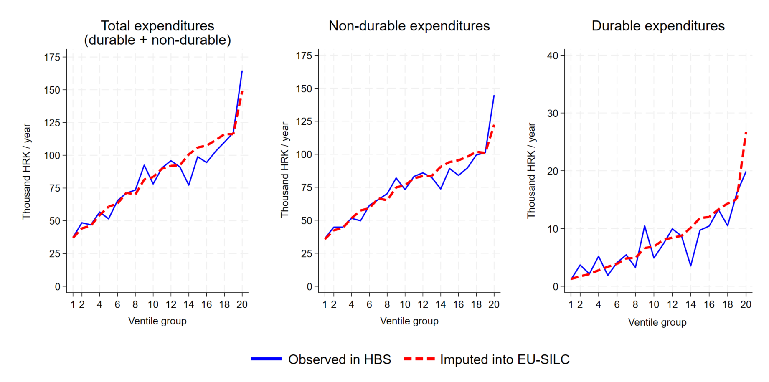
Notes: Population expansion factors used.

Notes: The vertical axis measures the percentage of total non-durable expenditures. Population expansion factors used. |  | Fig. A2 Imputed (into HBS) and observed (in HBS) shares of expenditures for 15 non-durable commodity types in total non-durable expenditures, by ventile group of equivalised disposable income distribution

Fig. A3 Indirect taxes simulated in EU-SILC and HBS, by ventile group of equivalised disposable income distribution.
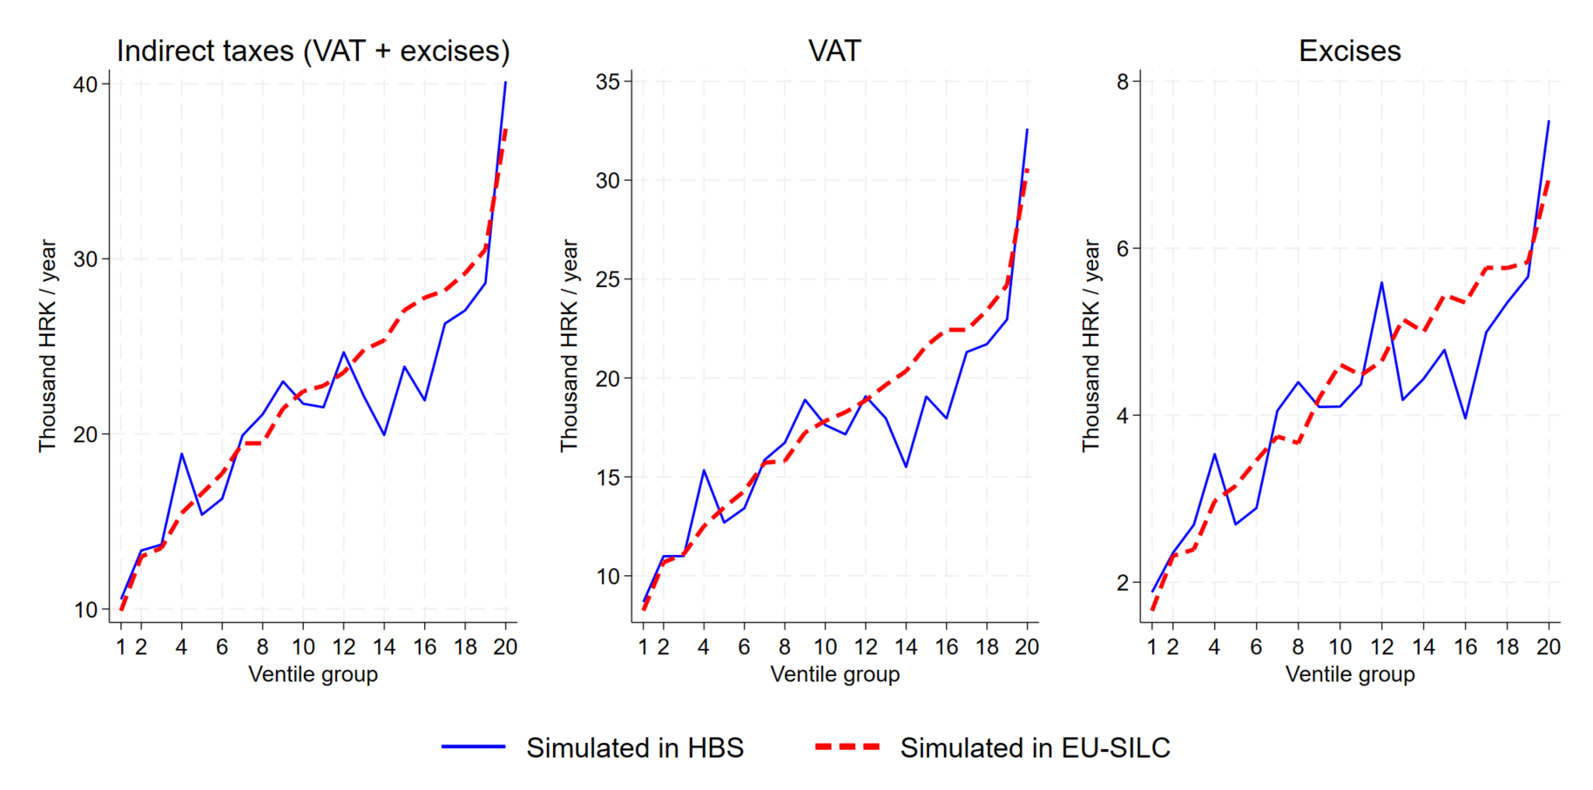
Notes: Population expansion factors used. Simulation in the HBS based on formulas A17, A18, and A19. Simulation in the EU-SILC based on formulas A21, A22, and A23. Population expansion weights used.

Fig. A4 Discretised distribution of work hours
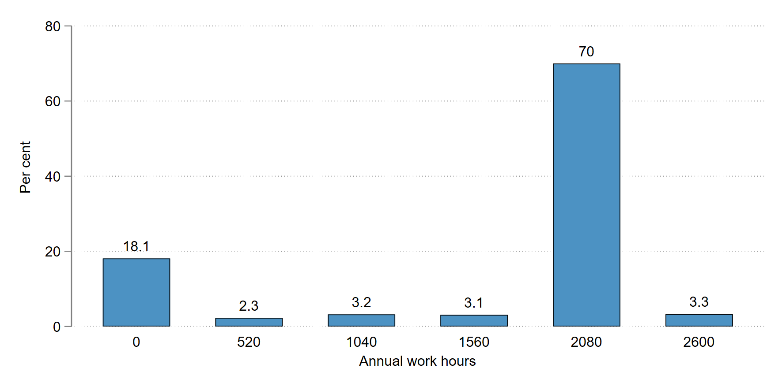
Notes: The discretisation is described in Table A3. Population expansion factors used. The vertical axis measures the share of analysed population (represented by the sample) in each of the six discrete hours points.

Fig. A5 Labour supply model fit
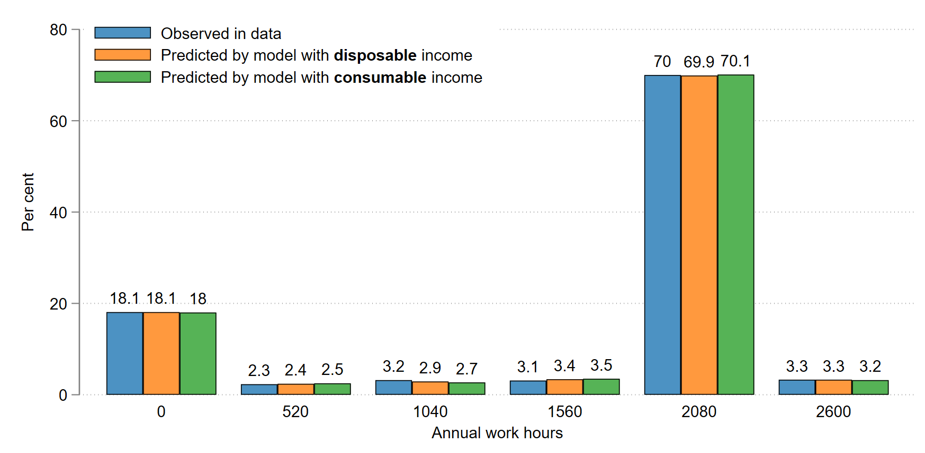
Notes: Population expansion factors used. The vertical axis measures the share of analysed population (represented by the sample) in each of the six discrete hours points. The predicted shares are based on the parameter estimates shown in Table A5.

The comparison is presented in Sect. A.3 below.
All tables and figures are placed at the end.
The actual selection indicator $d_{j}$ is an indicator equal to one$if d_{j}^{*}>0$ and zero otherwise.

