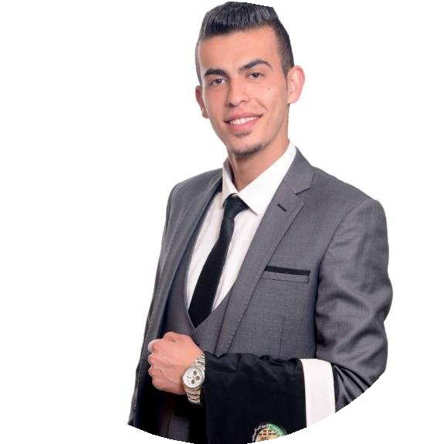

HISHAM Al -BARGHOUTHI

Objective

I’m a fresh graduate
who is seeking for a full-time position across reputed organizations. Demanding high standard of quality providing opportunity utilizes my skills gained in the best possible way to achieve to organizational goals. I would like to work with other professionals to improve my skills.

CONTACT
hishambrg22@gmail.com
 +962772000654
https://github.com/HishamAlbarghouthi.

https:/www.linkedin.com/in/hisham-albarghouthi-88a481198.

SKILLS

Frontend Development.

HTML5, CSS, CSS3, Bootstrap4, Javascript , Jquery , Nodejs.

Hard Worker.

Work under pressure.

Learning new concepts quickly.

Sense of humour.

Handle customer.

EDUCATION

Al Balqa’a Applied University 2015 – 2019.

B.Sc in software engineering.

Frontend Upskilling program in HTU. 15/10/2019 – 15/1/2020.
LANGUAGES

- Arabic.
- English: Very good writing, good speaking.

GRADUATION PROJECT

An arabic word stemmer built with python that takes single words or complete sentences and runs them through a custom normalization technique and outputs the 3 letter stem of each word into a GUI.

