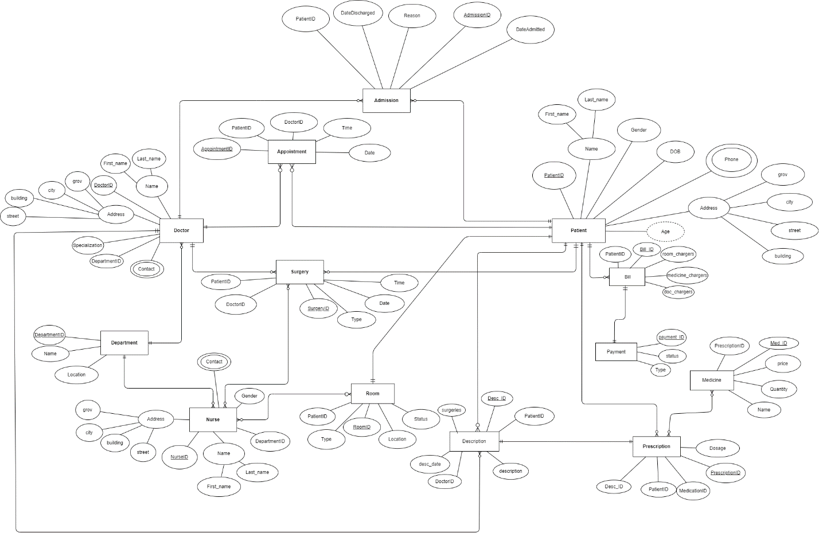  
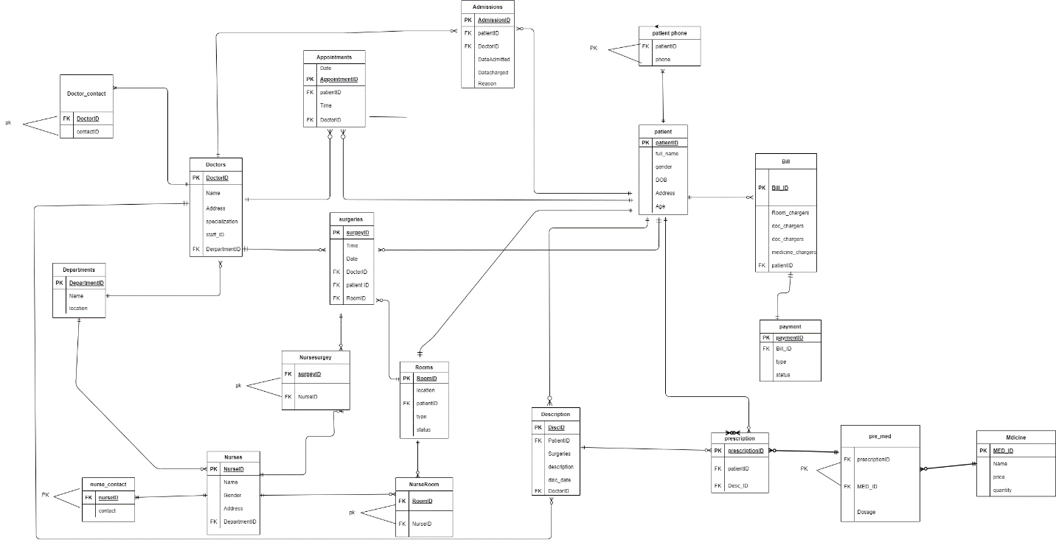

Tables:

Patient:

PatientID: Unique identifier for each patient.

full_name: Full name of the patient.

Gender: Gender of the patient.

DOB: Date of birth of the patient.

Address: Address of the patient.

Age: Age of the patient.

Departments:

DepartmentID: Unique identifier for each department.

Name: Name of the department.

Location: Location of the department.

Doctors:

DoctorID: Unique identifier for each doctor.

Name: Name of the doctor.

Specialization: Specialization of the doctor.

Address: Address of the doctor.

DepartmentID: Identifier of the department the doctor belongs to (foreign key).

Nurses:

NurselD: Unique identifier for each nurse.

Name: Name of the nurse.

Gender: Gender of the nurse.

Address: Address of the nurse.

DepartmentID: Identifier of the department the nurse belongs to (foreign key).

Rooms:

RoomID: Unique identifier for each room.

Location: Location of the room.

PatientID: Identifier of the patient assigned to the room (foreign key).

Type: Type of the room.

Status: Current status of the room.

Nurse_Room:

RoomID: Identifier of the room (foreign key).

NurselD: Identifier of the nurse assigned to the room (foreign key).

PRIMARY KEY: Combination of NurseID and RoomID.

Medicine:

Med_ID: Unique identifier for each medicine.

Name: Name of the medicine.

Price: Price of the medicine.

Quantity: Quantity available.

Prescription:

PrescriptionID: Unique identifier for each prescription.

PatientID: Identifier of the patient (foreign key).

Desc_ID: Identifier of the description (foreign key).

Bill:

Bill_ID: Unique identifier for each bill.

PatientID: Identifier of the patient (foreign key).

room_chargers: Charges for room.

doc_chargers: Charges for doctor's services.

medicine_chargers: Charges for medicines.

Payment:

payment_ID: Unique identifier for each payment.

Bill_ID: Identifier of the bill (foreign key).

Type: Type of payment.

Status: Payment status.

Admissions:

AdmissionID: Unique identifier for each admission.

PatientID: Identifier of the patient (foreign key).

DoctorID: Identifier of the doctor (foreign key).

DateAdmitted: Date of admission.

DateDischarged: Date of discharge.

Reason: Reason for admission.

Appointments:

AppointmentID: Unique identifier for each appointment.

PatientID: Identifier of the patient (foreign key).

DoctorID: Identifier of the doctor (foreign key).

Date: Date of appointment.

Time: Time of appointment.

Surgeries:

SurgeryID: Unique identifier for each surgery.

DoctorID: Identifier of the doctor (foreign key).

PatientID: Identifier of the patient (foreign key).

Date: Date of surgery.

Time: Time of surgery.

Type: Type of surgery.

RoomID: Identifier of the room (foreign key).

Patient_Phone:

PatientID: Identifier of the patient (foreign key).

Phone: Phone number of the patient.

PRIMARY KEY: Combination of PatientID and Phone.

Doctor_cont:

DoctorID: Identifier of the doctor (foreign key).

contact: Contact information of the doctor.

PRIMARY KEY: Combination of DoctorID and contact.

Nurse_cont:

NurselD: Identifier of the nurse (foreign key).

contact: Contact information of the nurse.

PRIMARY KEY: Combination of NurselD and contact.

Description:

Desc_ID: Unique identifier for each description.

PatientID: Identifier of the patient (foreign key).

DoctorID: Identifier of the doctor (foreign key).

surgeries: Indicator for surgeries.

description: Description of the patient.

desc_date: Date of description.

pre_med:

MED_ID: Identifier of the medicine (foreign key).

Pre_ID: Identifier of the prescription (foreign key).

Dosage: Dosage of the medicine.

PRIMARY KEY: Combination of MED_ID and Pre_ID.

Nursesurgey:

NurseID: Identifier of the nurse (foreign key).

surgeryID: Identifier of the surgery (foreign key).

PRIMARY KEY: Combination of NurseID and surgeryID.

SP_selectAllPatient: This procedure retrieves all information about every patient from the Patient table.

SP_selectPatientByID: This procedure retrieves information about a patient based on their PatientID.

SP_insertIntoPatient: This procedure inserts a new patient into the Patient table along with their phone number into the Patient_Phone table.

SP_UpdateAgeByID: This procedure updates the age of a patient based on their PatientID.

SP_addPatientPhone: This procedure adds a new phone number for a patient.

SP_showAllPatientPhone: This procedure retrieves all phone numbers associated with a particular patient.

SP_assignNurseToRoom: This procedure assigns a nurse to a specific room.

SP_cancelNurseFromRoom: This procedure cancels the assignment of a nurse from a room.

SP_BookNewAppointment: This procedure books a new appointment for a patient with a specific doctor.

SP_showAppointmentInDay: This procedure shows all appointments scheduled for a particular day.

SP_showAppointmentByDoctor: This procedure shows all appointments scheduled with a specific doctor.

SP_changeAppointmentDate: This procedure changes the date of a specific appointment.

SP_showTotalPatient: This procedure calculates and shows the total number of patients in the Patient table.

SP_totalBenfits: This procedure calculates and shows the total charges for rooms, doctors, and medicines from the Bill table.

SP_causeDescription: This procedure retrieves the names of doctors, their IDs, associated patient IDs, and descriptions of patients' conditions from the Doctors and Description tables.