**Elicitation Execution**

**for**

**COMSYS**

University Communication and Services Portal

**Section: TT4L**

**Group: 4**

|  |  |
| --- | --- |
| **NAME** | **STUDENT ID** |
| HESHAM NADER DEYAAEDEEN EISA | 1221101049 |
| NICKLEIRSCH JAYA RAJ | 1231303114 |
| DANESH VERAN A/L BALASUBRAMANIAM | 1211109158 |
| LIM XIN YEE | 1211109469 |

***One drive link containing proof of execution:*** [***SRE Items***](https://mmuedumy-my.sharepoint.com/:f:/g/personal/1221101049_student_mmu_edu_my/Ek_hYQuewOxHtjGwTXkIocwBFJmRQXxLP-XgA9Wkxvp0hA?e=8tjtHb)

**Table of Contents**

1. Results of Interview 3

1.1 Interview 1 3

1.2 Interview 2 6

1.3 Interview 3 9

1.4 Interview 4 12

2. Analysis on Results of Interview 15

2.1 Students’ Interview 15

2.1.1 Interview Minutes 15

2.1.2 Key Themes 17

2.1.3 Summary of Findings 18

2.1.4 Elicited Requirements 19

2.2 Parent’s Interview 22

2.2.1 Interview Minutes 22

2.2.2 Key Themes 23

2.2.3 Summary of Findings 23

2.2.4 Elicited Requirements 24

2.3 Lecturer’s Interview 26

2.3.1 Interview Minutes 26

2.3.2 Key Themes 27

2.3.3 Summary of Findings 27

2.3.4 Elicited Requirements 28

3. Results of Observation 31

3.1 Observation 1 31

3.2 Observation 2 33

3.3 Observation 3 35

Checking Calendar 35

3.3 Summary of Findings 37

3.4 Elicited Requirements 38

4. Results of Questionnaire 40

4.1 Students’ Questionnaire 40

4.1.1 Quantitative Analysis 40

4.1.2 Qualitative Insights 46

4.1.3 Elicited Requirements 48

4.2 Parents’ Questionnaire 50

4.2.1 Quantitative Analysis 50

4.2.2 Qualitative Insights 54

4.2.3 Elicited Requirements 55

4.3 Lecturers’ Questionnaire 57

4.3.1 Quantitative Analysis 57

4.3.2 Qualitative Insights 67

4.3.3 Elicited Requirements 68

4.4 Admin’s Questionnaire 70

4.4.1 Quantitative Analysis 70

4.4.2 Summary of Findings 77

4.4.3 Elicited Requirements 78

5. Kano Model 80

5.1 Glossary 80

5.2 Finalised Set of Requirements 81

5.2.1 Notification System 81

5.2.2 Authentication & Access Control 82

5.2.3 Dashboard & Interface 83

5.2.4 Communication 84

5.2.5 Academic & Course Management 85

5.2.6 Calendar & Scheduling 85

5.2.7 Performance & Reliability 85

5.2.8 Usability, Accessibility & Availability 86

5.3 Applying Kano to Elicited Requirements 87

5.3.1 Dissatisfiers 87

5.3.2 Satisfiers 90

5.3.3 Delighters 93

5.4 Graph 95

6. Justification: Accuracy of Brainstormed Kano Classification 98

# **Results of Interview**

*Note: All further proof of execution is available in the drive folder path: /Interview*

## **Interview 1**

**Interviewer:** Nickleirsch Jaya Raj

**Interviewee:** Meeraa Dharsini Veramani

Stakeholder: Student

**Date:** 12/05/2025

**Location:** Online (Microsoft Teams)

Proof of execution:

**Interview Transcript:**

**Interviewer:**

Hi Meeraa, thank you for taking the time to speak with me. I'm working on a project to develop an academic communication and management system for students like you. Your feedback will help us understand what's currently working, what's not, and what improvements would be most helpful.

First question: How do you currently keep track of your academic information—your grades, bills, and your deadlines?

**Meeraa:**

I check my academic information through Clic for billing updates and stuff, and I use a portal called Ebwise to track my courses and deadlines.

**Interviewer:**

I see.

What frustrates you the most about how the university currently communicates important information to you?

**Meeraa:**

I don’t really get frustrated with the current system. Sometimes I receive some [spam] emails, but I don’t really mind.

**Interviewer:**

So, other than receiving some irrelevant emails, there’s nothing else that bothers you?

**Meeraa:**

No, not really.

**Interviewer:**

Got it.

Can you recall a time when you missed an important update from the university?

**Meeraa:**

Oh, yeah. It happened to me this semester. I missed an important update about a quiz for one of my subjects where I didn’t receive any notification about it.

**Interviewer:**

I see.

Next question: What is your preferred method for receiving updates from the university?

**Meeraa:**

I think receiving emails, it’s easy to check.

**Interviewer:**

How about SMS? Would receiving notifications through SMS be useful?

**Meeraa:**

Yeah, I think that would be okay too

**Interviewer:**

Which types of notifications do you usually pay attention to, and which ones do you tend to ignore? For example—class cancellations, billing, event reminders?

**Meeraa:**

I usually ignore general updates. But I do pay attention to class cancellations and billing.

**Interviewer:**

Do you usually share university-related information with your parents? And if so, how?

**Meeraa:**

Not really. It’s more like I just talk to them about it. I don’t forward emails or anything like that.

**Interviewer:**

Would having a centralized platform for all university services and updates be useful to you?

**Meeraa:**

Yes, definitely. Having different systems is kind of redundant and can get a bit confusing.

**Interviewer:**

Have you seen any features on other apps or platforms that you wish our university system had?

**Meeraa:**

I think having a better calender system will make it easier for me to understand, because the current one is difficult. Sometimes it's hard to understand things like subject codes. I wish it was clearer, like showing the course name properly.

**Interviewer:**

Do you have any other suggestions, concerns, or expectations for the new university system that you’d like to share?

**Meeraa:**

I would just like to receive my notifications about course changes and deadlines on time, so I’m not left behind, that’s the most important.

**Interviewer:**

Alright, thank you again, Meeraa, for your valuable input. Your responses will help design a system that truly supports the needs of students. If you think of anything else later, feel free to reach out.

## **Interview 2**

**Interviewer:** Lim Xin Yee

**Interviewee:** Ryan Lai Ting Hong

Stakeholder: Student

**Date:** 14/05/2025

**Location:** Online (Microsoft Teams)

Proof of execution:

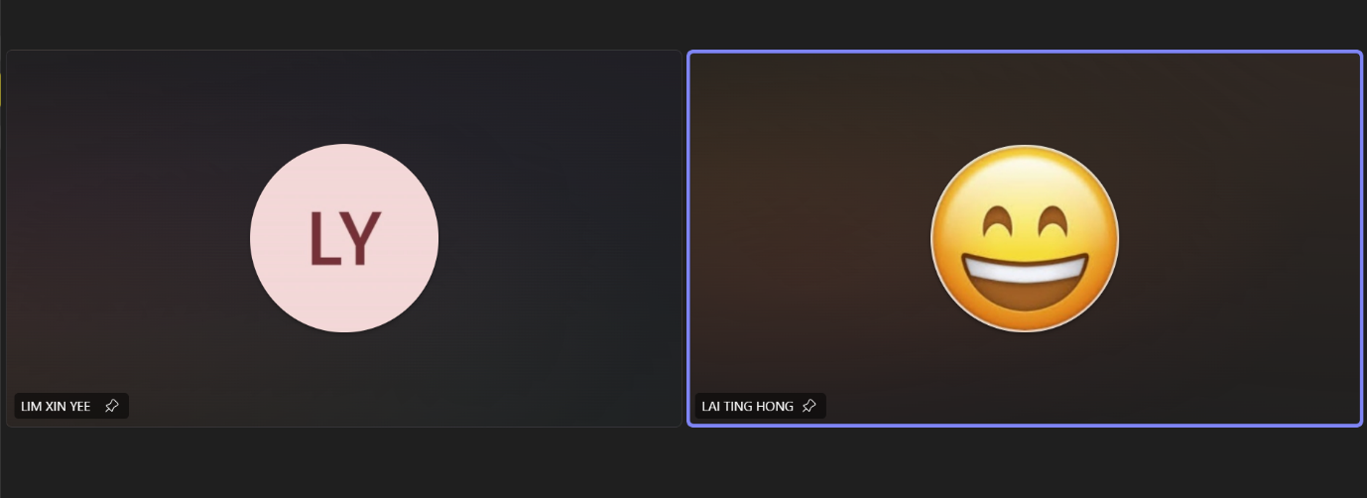

**Interview Transcript:**

**Interviewer:**

Hi Ryan, thanks so much for taking the time to chat with me today. This interview is part of a brainstorming and research session we’re doing to understand how students interact with the current university systems, especially when it comes to communication, academic tracking, and notifications. Your feedback will really help us improve the design of a new portal that could benefit students like you. Feel free to be as honest as you like — there are no right or wrong answers. Let’s start with something basic —

How do you currently keep track of your academic information (grades, billing, deadlines)?

**Ryan**:

Honestly, it’s kind of all over the place. I check grades and billing through the university portal, but for deadlines, I mostly rely on announcements in Microsoft Teams or reminders from classmates. Sometimes I use my phone calendar or even just jot things down on sticky notes. There’s no single system I depend on.

**Interviewer:**

Got it.

What frustrates you the most about the current university communication system?

**Ryan:**

The biggest issue for me is how inconsistent everything is. Some lecturers use Teams, others post on the university portal, and a few still send out emails. So, I’m constantly switching between platforms just to stay updated. It’s easy to miss something important when the info isn’t centralized.

**Interviewer:**

Can you recall a time when you missed an important university update? What happened?

**Ryan:**

Yeah, there was one time when I missed the announcement for the quiz venue change. It was posted in a section of the portal I rarely check, and no one mentioned it in class or on Teams. I showed up at the wrong hall and lost about 15 minutes trying to figure out where to go. I still managed to take the quiz, but I was flustered and could’ve used that time to settle in and plan my answers.

**Interviewer:**

That's indeed frustrating.

So what is your preferred method of receiving university notifications? (Email, SMS, app notifications)

**Ryan:**

Definitely, app notifications. I always have my phone with me, and I usually see those right away. I tend to ignore emails unless I’m specifically expecting something. SMS is okay too, but it feels a bit outdated—app alerts are just quicker and more convenient.

**Interviewer:**

Which notifications do you tend to pay attention to, and which do you tend to ignore?

**Ryan:**

I always pay attention to things like exam schedules, assignment deadlines, and fee payment reminders. But I usually ignore general announcements, like event promos or faculty-wide updates that don’t really apply to me.

**Interviewer:**

How do you share university related stuff with your parents?

**Ryan:**

Mostly I just tell them directly or send them a quick message. If it’s something like fees or grades, I’ll show them a screenshot. But yeah, there’s no formal way for them to check that stuff unless I log in and show it myself.

**Interviewer:**

How important is having one centralised system instead of multiple different ones be to you?

**Ryan:**

Honestly, that would make a huge difference. Right now, it’s time-consuming and easy to miss things. If everything was in one place-grades, announcements, schedules, it would save a lot of hassle and help us stay more organized.

**Interviewer:**

Is there any feature you’ve seen in other educational platforms that you wish our university had?

**Ryan:**

Yeah, I saw a portal in another university where students could set personal reminders and sync academic calendars with their phone. That would be really helpful.

**Interviewer:**

Do you have any other suggestions or concerns you’d like to share?

**Ryan:**

Maybe allow a bit of customization, like letting us choose which types of alerts we want to get or hiding the stuff we don’t use. That way, it doesn’t feel overwhelming and it’s more tailored to each student.

**Interviewer:**

That wraps up our chat today. Thanks again, Ryan. You've given us a lot of helpful insight.

## **Interview 3**

Interviewer: Danesh Veran A/L Balasubramaniam

Interviewee: Mr. Balasubramaniam A/L C.Krishnan

Stakeholder: Parent

**Date:** 13/5/2025

**Location:** Online (Microsoft Teams)

Proof of execution:

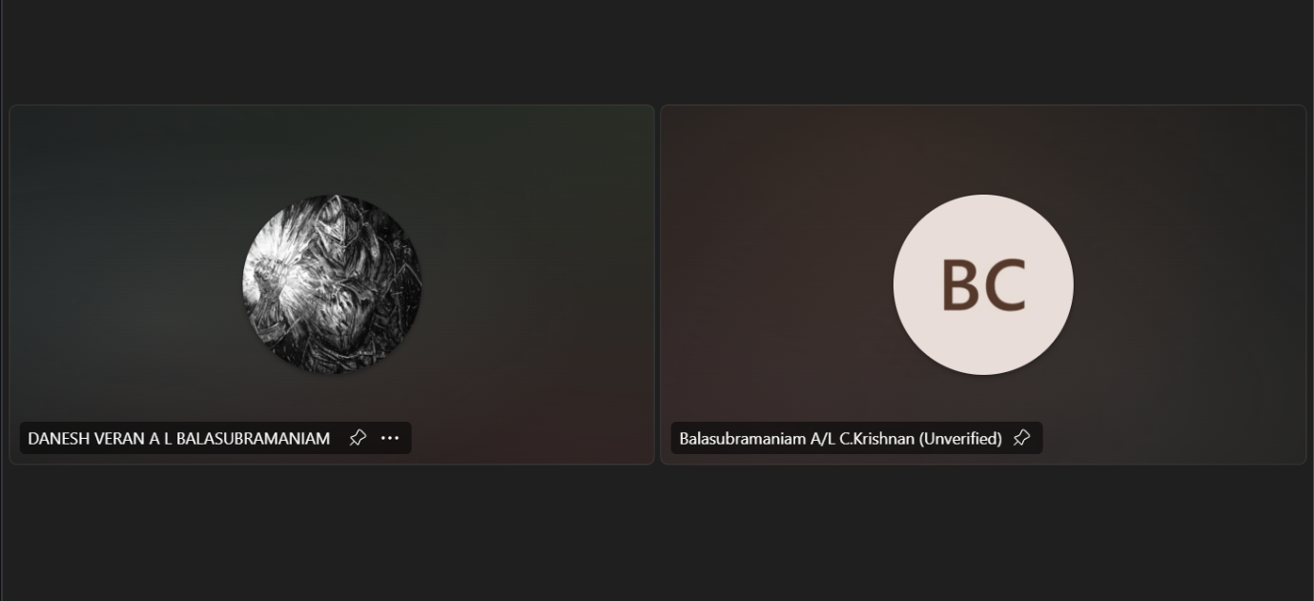

**Interview Transcript:**

**Interviewer:**

Hello Mr. Balasubramaniam, thank you for taking some time to have this interview with me today. I'm conducting this interview to better understand how parents currently access with the university's systems, particularly on communication, billing and academic tracking, for a project I'm currently developing. Your feedback will really help us know better on what's working, what's not working and what improvements could be carried out to make the experience better. Feel free to be as honest as you like as there are no right or wrong answers for this interview.

Firstly, how do you currently receive information about your child's academic progress?

**Mr. Balasubramaniam:**

No problem, Danesh. Firstly, I want to address the fact that at current, parents like me are unable to access the university’s systems on ourselves. Every time I want to see my child’s academic progress, I require my child to login into the university’s systems using their student account and then share (or show) the academic report. This method is quite the hassle.

**Interviewer:**

I can feel your frustrations.

Moving on, can you recall a time when you missed important university information? What happened?

**Mr. Balasubramaniam:**

Often, I am unaware of the university’s billing due dates as they’re not addressed to me. I always must rely on my child to either check for the due dates on the university’s systems or forward the billing email they receive to me.

**Interviewer:**

How do you currently manage and track university fee payments?

**Mr. Balasubramaniam:**

As I previously mentioned for the last question, parents are unable to access the university’s portal by themselves. Hence, all university fee payments management and tracking are performed based on the information my child gives me.

**Interviewer:**

What kind of financial notifications would be most helpful to receive?

**Mr. Balasubramaniam:**

I would say that it would be great if billing information and the due date is sent to our email and any critical overdue are sent via WhatsApp or SMS.

**Interviewer:**

How would you prefer to be notified about upcoming payment deadlines?

**Mr. Balasubramaniam:**

As previously mentioned, email would be the best method as it’s easier for me to track and manage.

**Interviewer:**

What types of emergency notifications would you consider critical?

**Mr. Balasubramaniam:**

As previously mentioned, overdue on fees payment should be considered critical. On top of that, it would be good to receive emergency notifications regarding low attendance and any disciplinary issues that may have occurred.

**Interviewer:**

If you could design a parent portal, what three features would be most important to you?

**Mr. Balasubramaniam:**

A dedicated parent portal really would fix a lot of the issues I’m currently facing. I would suggest adding financial statement, attendance and academic progress as the priority features first.

**Interviewer:**

Lastly, is there anything else you'd like to share about improving parent-university communication?

**Mr. Balasubramaniam:**

Nothing much. Just that, it would be great if there was a channel for parents to receive general information regarding the university like say a chatgroup between university administrators and parents.

**Interviewer:**

That concludes our interview here. Thank you again, Mr Balasubramaniam for giving some of your time today and sharing helpful insights. This helps us a lot in designing a system that fulfills the issues currently faced by parents.

## **Interview 4**

Interviewer: Hesham Nader

Interviewee: Dr. Nur Haifa binti Mohd Fathil

Stakeholder: Lecturer

**Date:** 14/05/2025

**Location:** Online (Microsoft Teams)

Proof of execution:

**Interview Transcript**

**Interviewer:**

What are the main challenges you face when communicating with students and managing your courses with the current system?

**Dr Nur Haifa:**

I'm not getting feedback from students. When I send a notification or something, I don't really get the feedback that they actually read it or not.

**Interviewer:**

How do you currently communicate important course updates to your students?

**Dr Nur Haifa:**

Through student portals, and then through created MS teams, and I used to have Telegram as well.

**Interviewer:**

Do you think using multiple platforms makes it confusing and that announcements could go unseen by students when using multiple platforms?

**Dr Nur Haifa:**

Yes, that's the first assumption, but actually with multiple platforms, I think the message is being sent out effectively. The objective is to send out and get everybody to see it. So I think through sending it through multiple platforms, I can achieve the objective to get everybody to read or get a notification or communication.

**Interviewer:**

What types of notifications would you want to send to students automatically?

**Dr Nur Haifa:**

Reminders.

**Interviewer:**

What about for parents? What type of information would you want to automatically share with parents?

**Dr Nur Haifa:**

For attendance... though I think we are legally bounded with situations where we cannot just expose any information even to parents, except for emergency situations.

**Interviewer:**

How do you currently handle grade submission and academic performance tracking with students?

**Dr Nur Haifa:**

We use other systems. We cannot use other systems than that system, except for posting current credits. The actual uploading of the marks all happens on that system.

**Interviewer:**

What challenges do you face when sharing course material with students?

**Dr Nur Haifa:**

The challenges are to update it. If I want to have updates, that's the common challenge. If there is an update or I want to revise the course material, especially for tutoring, if I found something new. Because I've loaded it upfront, and because of the few places that I actually put it like in MS teams and in the system, I think the duplication of actions to upload new revision is the challenge. We need to have like a shared folder and then I just share the link at whatever platforms that I'm sharing.

**Interviewer:**

What features added to the system would make your daily teaching and administrative tasks easier?

**Dr Nur Haifa:**

I use Microsoft To Do list. It would be easier if it can include the calendar and then include the to-do list along so that I can see the whole list of the day, what to do at least for the week.

**Interviewer:**

Do you have any questions for us?

**Dr Nur Haifa:**

No questions for you

# **Analysis on Results of Interview**

## **Students’ Interview**

### **Interview Minutes**

|  |  |
| --- | --- |
| **Identifier** | INT-1 |
| **Date** | 12/05/2025 |
| **Goal of the interview** | Elicit requirements for the University Portal by gaining detailed insights into student expectations, current challenges, and workflows. |
| **Interviewer** | Nickleirsch Jaya Raj |
| **Interviewee** | Meeraa Dharsini (Student, Multimeda University) |
| **Notes** | * Uses Clic for billing and Ebwise for course deadlines. * Receives some irrelevant (spam) emails but finds them tolerable. * Missed a quiz update due to lack of notification. * Prefers email for updates; open to SMS notifications as well. * Pays close attention to class cancellations and billing; tends to ignore general updates. * Shares university information with parents verbally, not digitally. * Finds multiple systems redundant; prefers a centralized platform. * Suggests an improved calendar system with clearer course names. * Most important: receiving timely notifications about course changes and deadlines. |

|  |  |
| --- | --- |
| **Identifier** | INT-2 |
| **Date** | 14/05/2025 |
| **Goal of the interview** | Elicit requirements for the University Portal by gaining detailed insights into user expectations, current challenges, and workflows. |
| **Interviewer** | Lim Xin Yee |
| **Interviewee** | Ryan Lai Ting Hong (Student, Multimeda University) |
| **Notes** | * Tracks grades and billing through the university portal; deadlines via Teams, classmates, phone calendar, or sticky notes. * Finds communication inconsistent due to multiple platforms (Teams, portal, email); easy to miss updates. * Missed a quiz venue change because the update was buried in the portal; this caused stress and lost time. * Prefers app notifications for immediacy and convenience; tends to ignore emails unless expecting one; SMS feels outdated but acceptable. * Pays attention to exam schedules, deadlines, fee reminders; ignores general or irrelevant announcements. * Shares important info with parents via direct message or screenshot, with no formal parental access. * Strongly prefers a centralized system for all academic info to avoid missing updates and reduce hassle. * Wishes for features like personal reminders and calendar sync with phone, as seen in other platforms. * Suggests allowing customization of alerts and hiding irrelevant features to avoid overwhelm and improve user experience. |

### **Key Themes**

1. **Fragmentation of Systems**

Both students rely on multiple platforms (e.g., Clic, Ebwise, Microsoft Teams, Email). They find it inconvenient and sometimes confusing to manage academic information across these disconnected systems.

1. **Missed or Inconsistent Communication**

Both have missed important updates (quiz notifications, venue changes). Communication is described as inconsistent and not centralized. Students often rely on peers or random checks to stay updated.

1. **Preferred Notification Channels**

There is mixed preference with app notifications and emails as the most immediate but there is willingness to open to SMS. Both agree that timely and relevant notifications are critical.

1. **Information Filtering**

Students tend to ignore general announcements (e.g., events or faculty-wide promos). They focus more on academic and billing updates, class changes, and deadlines.

1. **Parental Communication**

Both students communicate updates to parents informally (e.g., through verbal conversations or screenshots). There is no formal parental access or sharing mechanism in place.

1. **Desire for a Centralized Platform**

Strong desire for a single platform to manage grades, billing, schedules, and announcements. Redundancy and switching between systems is a major pain point.

1. **Calendar and Reminder Enhancements**

There is a desire for better-organized, clearer calendar and schedule systems (e.g., using course names instead of codes) and for more intuitive interfaces.

1. **Customization and User Control**

Interest in customizable alerts, allowing students to filter the types of notifications they receive.

### **Summary of Findings**

Interviewees struggle with the current fragmented university communication ecosystem, leading to missed deadlines and important updates. Both value the idea of a centralized portal that aggregates grades, billing, announcements, and deadlines in a user-friendly, accessible manner. Timely, relevant, and customizable notifications are critical, with a preference for real-time delivery (app notifications or SMS). There is also a need for better calendar integration and clearer presentation of academic information. Students want to filter out non-essential information and tailor the system to their needs. Methods for sharing academic information with parents are informal and could be improved.

### **Elicited Requirements**

Notes:   
‘I’ stands for Interview here

Numbering pattern: 1xx : Student, 2xx : Parent : 3xx, Lecturer : 4xx, Admin

**Function*al Requirements***

1. **Centralized Academic Portal**

**I_101**: The system shall consolidate grades, billing, deadlines, course updates, and announcements into a single portal.

1. **Notification System**

**I_102**: The system shall support multiple notification methods: in-portal notifications, email and SMS

**I_103**: Users shall be able to select their preferred notification channels.

1. **Notification Customization**

**I_104**: Users shall be able to filter and view notifications by category (e.g., academic, billing, general).

**I_105**: Users shall be able to mute or hide irrelevant notification types or sections.

1. **Calendar Integration**

**I_106**: The calendar shall support syncing with external personal calendars (e.g., Google Calendar, Apple Calendar).

1. **Parent Access**

**I_107**: The system shall provide secure, parent/guardian access to academic and billing data.

**I_108**: Parent access shall be controlled by student consent and include view-only reports.

1. **User Customization**

**I_109**: Users shall be able to customize their dashboard layout by moving around widgets

**Performance Requirements**

1. **Notification Timeliness**

**I_110**: Critical notifications (e.g., class cancellations, deadline changes) shall be delivered within 1 minute of their creation.

1. **System Reliability**

**I_111**: The system shall achieve 99.9% uptime availability.

**I_112**: Notifications shall be guaranteed to reach all selected channels without duplication or loss.

1. **Synchronization Speed**

**I_113**: Calendar synchronization with external services shall occur within 2 minutes of changes being made.

**Usability *Requirements***

1. **Clear Language and Labels**

**I_114**: The interface shall use descriptive course and event names rather than alphanumeric codes.

**I_115**: Notifications and messages shall be presented in plain, concise, and user-friendly language.

1. **Reduced Information Overload**

**I_116**: The system shall prioritize important academic alerts over general announcements by default.

**I_117**: The default notification setup shall exclude low-priority categories unless enabled by the user.

**Interface Requirements**

1. **Platform Accessibility**

**I_117**: The system shall be accessible via a responsive web portal.

**I_118**: The system shall include a mobile application for Android and iOS.

1. **Cross-Platform Compatibility**

**I_119**: The parent portal shall be accessible via modern web browsers on desktops and mobile devices.

**I_120**: The interface shall be responsive and adapt to different screen sizes without loss of functionality.

**I_121**: Visual components shall be optimized for readability and clarity across devices.

1. **Customizable Interface**

**I_122**: Users shall be able to rearrange dashboard widgets and sections based on personal preferences.

**I_123**: The system shall offer theme options (e.g., light/dark mode).

## **Parent’s Interview**

### **Interview Minutes**

|  |  |
| --- | --- |
| **Identifier** | INT-3 |
| **Date** | 12/05/2025 |
| **Goal of the interview** | Elicit requirements for the University Portal by gaining detailed insights into parent expectations, current challenges, and workflows. |
| **Interviewer** | Danesh Veran A/L Balasubramaniam |
| **Interviewee** | Mr. Balasubramaniam A/L C.Krishnan (Parent, University Student's Guardian) |
| **Notes** | * Parents currently have no direct access to the university’s academic or billing systems; must rely on their child to log in and share reports. * Managing and tracking fee payments depends on information relayed by the student. * Frequently unaware of billing due dates; would prefer to receive billing information and due dates directly via email. * Critical notifications (e.g., fee overdue) should be sent via WhatsApp or SMS for urgency. * Prefers email for regular payment deadline reminders. * Wants to receive emergency notifications about low attendance and disciplinary issues. * Suggests a dedicated parent portal prioritizing financial statements, attendance, and academic progress visibility. * Recommends a general information channel for parents (e.g., chat group with university administrators). |

### **Key Themes**

1. **Lack of Direct Parental Access**

Parents currently do not have direct access to the university’s system. They depend on their children to access academic and financial information, which may lead to delays, inconvenience, and missed updates.

1. **Information Gaps in Communication**

Important updates (e.g. billing due dates) are not communicated directly to parents. Parents often miss critical information unless forwarded by the student.

1. **Preferred Communication Channels**

Email is preferred for billing and academic reports, whereas WhatsApp/SMS are preferred for urgent or overdue notifications.

1. **Concerns Over Student Progress & Behaviour**

Parents are concerned about missing notifications related to academic performance, attendance, or disciplinary issues.

1. **Critical Alerts**

Overdue payments, low attendance, and disciplinary actions are seen as critical information for parents.

1. **Desire for a Dedicated Parent Portal**

Parents have a strong preference for a centralized portal tailored for them. Suggested key features include access to financial information, academic progress, and attendance records.

1. **Interest in Community & Information Sharing**

Parents suggest for a communication channel (e.g., chatgroup or broadcast) where general university updates can be shared with parents.

### **Summary of Findings**

Parents face significant obstacles accessing timely and relevant information about their child’s university progress and finances, leading to dependency on their children for updates. This indirect access causes frustration and increases the risk of missing important deadlines, especially for billing and emergencies. Parents want a dedicated portal that provides them with direct access to academic progress, attendance, and financial information, along with reliable channels for urgent notifications and general university updates.

### **Elicited Requirements**

**Functional Requirements**

Notes:   
‘I’ stands for Interview here

Numbering pattern: 1xx : Student, 2xx : Parent : 3xx, Lecturer : 4xx, Admin

1. **Dedicated Parent Portal Access**

**I_201**: The system shall provide a separate portal for parents to access their child’s academic records, attendance, and financial information.

**I_202**: Access shall be restricted to authorized parents/guardians via secure authentication mechanisms.

1. **Notification System**

**I_203**: The system shall send urgent or critical financial alerts (e.g., overdue fees, low attendance, disciplinary actions) via SMS.

1. **Financial Tracking and Transparency**

**I_204**: Parents shall be able to view their child’s current fee payment status and view upcoming payment deadlines.

1. **Communication Channel**

**I_205**: The system shall enable communication between university administrators and parents via a designated live chat

**Performance Requirements**

1. **Notification Timeliness**

**I_206**: Emergency and critical alerts (e.g., low attendance, overdue fees) shall be delivered to parents within 1 minute of being triggered.

**Usability *Requirements***

1. **Ease of Use**

**I_207**: The portal shall be designed for non-technical users, with clear labels, icons, and navigation aids.

**I_208**: All key information (academic performance, attendance, billing) shall be accessible within 2–3 clicks from the parent dashboard.

1. **Visual Clarity**

**I_209**: Academic, financial, and attendance data shall be presented using charts, tables, and summaries for quick understanding.

**I_210**: Alerts and warnings shall be clearly distinguishable using visual cues (e.g., color-coded statuses, alert banners).

**Interface *Requirements***

1. **Secure Access**

**I_211**: The portal shall require secure login credentials for parent access.

**I_212**: The system shall implement encryptions for all sensitive data in transit and at rest.

1. **Cross-Platform Compatibility**

**I_213**: The parent portal shall be accessible via modern web browsers on desktops and mobile devices.

**I_214**: The interface shall be responsive and adapt to different screen sizes without loss of functionality.

**I_215**: Visual components shall be optimized for readability and clarity across devices.

1. **Multilingual Support**

**I_216**: The portal may provide multilingual support to accommodate parents from diverse linguistic backgrounds.

## **Lecturer’s Interview**

### **Interview Minutes**

|  |  |
| --- | --- |
| **Identifier** | INT-4 |
| **Date** | 14/05/2025 |
| **Goal of the interview** | Elicit requirements for the University Portal by gaining detailed insights into lecturer expectations, current challenges, and workflows. |
| **Interviewer** | Hesham Nader |
| **Interviewee** | Dr. Nur Haifa binti Mohd Fathil (Lecturer, Multimedia University) |
| **Notes** | * Main challenge: Lack of feedback/confirmation from students when notifications are sent. * Uses multiple platforms (student portal, MS Teams, Telegram) for communication; sees redundancy as beneficial for reaching all students. * Would like to automate reminders to students. * For parents, would only share attendance info and only in emergencies due to legal restrictions. * Grade submission and performance tracking must use the official system; other systems not allowed for this. * Challenge in sharing and revising course materials due to duplication of effort across platforms; wishes for a shared folder link to reduce redundancy. * Would benefit from integrated features like a calendar and to-do list for teaching/admin tasks. |

### **Key Themes**

1. **Lack of Feedback on Student Engagement**

There is no way to confirm whether students have received or read the announcements, which may lead to uncertainty and affects the effectiveness of communication efforts.

1. **Reliance on Multiple Platforms**

Although multiple platforms (University Portal, Microsoft Teams, and Telegram) are used for communication to ensure message visibility, this also introduces inefficiencies, especially when managing or updating content across platforms.

1. **Automated Notifications and Parental Communication**

The lecturer would benefit from a system that can send automated reminders to students. For parents, she suggested limited communication, constrained by legal considerations, with attendance being the most appropriate information to share in emergency or special situations.

1. **Material Management Complexity**

Difficulty in updating and distributing revised teaching materials due to the need to upload revised content on multiple platforms, which causes inefficiencies.

1. **Personal Productivity Integration**

The lecturer desires a teaching system that incorporates a calendar view alongside a to-do/task list, enabling to visualize and manage daily or weekly responsibilities more efficiently.

### **Summary of Findings**

Lecturers face inefficiencies caused by a lack of acknowledgment from students, redundant communication across multiple channels, and the need to repeatedly update materials in different systems. Legal constraints limit information sharing with parents. There is an expressed need for automation in reminders and for integrated tools combining calendar and task management to streamline teaching and administrative duties.

### **Elicited Requirements**

Notes:   
‘I’ stands for Interview here

Numbering pattern: 1xx : Student, 2xx : Parent : 3xx, Lecturer : 4xx, Admin

**Functional Requirements**

1. **Notification Acknowledgment**

**I_301**: The system shall provide lecturers with a read receipt status when students view an announcement.

1. **Automated Notification Scheduling**

**I_302**: Lecturers shall be able to schedule automated notifications for academic events such as assignment deadlines, exams, and class updates.

1. **Multi-Platform Resource Sharing**

**I_303**: The system shall allow lecturers to upload teaching materials to a centralized location (shared folder) allowing the use of a single link to materials across various communication platforms (portal, email, chat).

1. **Calendar and Task Management**

**I_304**: The system shall include a built-in calendar for lecturers to schedule academic and administrative tasks.

**I_305**: The system shall support a to-do list feature with task creation, deadlines, and reminders.

1. **Compliance with Official Systems**

**I_306**: The system shall integrate with or align to university-mandated systems for grade submission and student performance tracking.

**I_307**: Changes to grades or student performance data shall be recorded and logged.

1. **Controlled Parent Communication**

**I_308**: The system shall only permit access to parents regarding attendance or emergencies in compliance with university privacy policies and legal requirements.

**I_309**: Parental communication features shall require explicit consent or configuration at the university level.

**Performance Requirements**

1. **Notification Reliability**

**I_310**: Scheduled and automated notifications shall be delivered at the specified time with 99% reliability.

**I_311**: Read receipts shall be updated within 1 minute of student interaction with a notification.

1. **Sync Efficiency**

**I_312**: Updates to shared teaching materials shall propagate to all platforms and links within 5 seconds of modification.

**Usability *Requirements***

1. **Simplified Workflow**

**I_313**: Scheduling a notification or uploading a resource shall not require more than 3 input steps.

**I_314**: The system shall allow drag-and-drop uploading and batch resource management for convenience.

1. **Transparency and Tracking**

**I_315**: Lecturers shall be able to track student engagement with posted resources (e.g., who accessed what and when).

**I_316**: A summary dashboard shall show pending tasks, unread notifications, and upcoming events.

1. **Legal Clarity**

**I_317**: Features related to parent communication shall include disclaimers and configuration screens outlining permitted usage boundaries.

**Interface Requirements**

1. **Integrated Calendar and Task View**

**I_318**: The lecturer interface shall include a combined calendar and to-do list view for academic planning.

**I_319**: Events and tasks shall be color-coded and filterable by category or course.

1. **Material Management UI**

**I_320**: Course materials shall be displayed in an organized folder structure with version control indicators.

**I_321**: The UI shall allow one-click generation of shareable links with customizable access permissions (e.g., view-only, download).

1. **Cross-Platform Accessibility**

**I_322**: The lecturer portal shall be accessible via web and mobile platforms.

**I_323**: All uploaded content and schedules shall be synced across platforms for consistent experience.

# **Results of Observation**

*Note: All further proof of execution is available in the drive folder path: /Observation*

## **Observation 1**

**Observer:** Hesham

**Observee:** Nickleirsch

Stakeholder: Student

**Date:** 12/05/2025

**Location:** Online

**Checking Attendance**

|  |  |  |  |
| --- | --- | --- | --- |
| Issue Type | Description | Impact Level | Points |
| Navigation | Multiple submenus, unclear paths | Severe | 3 |
| Display | Cluttered view, unnecessary  columns | Severe | 2 |
| Performance | Linear navigation issues | Minor | 1 |
| Total Pain Points: |  |  | 6/9 |

**Checking Billing Information**

|  |  |  |  |
| --- | --- | --- | --- |
| Issue Type | Description | Impact Level | Points |
| Navigation | Complex navigation structure | Moderate | 2 |
| Display | Overly complex information presentation | Severe | 2 |
| Performance | No significant issues | Minor | 1 |
| Total Pain Points: |  |  | 5/9 |

**Checking Calendar**

|  |  |  |  |
| --- | --- | --- | --- |
| Issue Type | Description | Impact Level | Points |
| Navigation | Standard navigation | Minor | 1 |
| Display | Missing critical class information | Severe | 2 |
| Performance | No syncing capabilities | Moderate | 2 |
| Total Pain Points: |  |  | 5/9 |

**Enrolling Courses**

|  |  |  |  |
| --- | --- | --- | --- |
| Issue Type | Description | Impact Level | Points |
| Navigation | Unintuitive flow, redundant steps | Severe | 3 |
| Display | Complex prerequisites display | Minor | 1 |
| Performance | Multiple window operations | Moderate | 2 |
| Total Pain Points: |  |  | 6/9 |

**Checking Academic Records**

|  |  |  |  |
| --- | --- | --- | --- |
| Issue Type | Description | Impact Level | Points |
| Navigation | Redundant tabs | Moderate | 2 |
| Display | Inconsistent headers, poor visualization | Severe | 2 |
| Performance | Standard performance | Minor | 1 |
| Total Pain Points: |  |  | 5/9 |

**Observer 1 Recommendations:**

|  |  |
| --- | --- |
| Category | Recommendation |
| User Interface | * Implement clean, minimalist design * Add visual indicators for navigation * Standardize table headers across system and highlight important information only |
| Navigation | * Reduce number of clicks to reach features * Add search functionality |
| Functionality | * Add data visualization features * Implement parent access portal * Add automated notifications system |

## **Observation 2**

**Observer:** Lim Xin Yee

**Observee:** Ryan Lai Ting Hong

Stakeholder: Student

**Date:** 12/05/2025

**Location:** Physical

**Checking Attendance**

|  |  |  |  |
| --- | --- | --- | --- |
| Issue Type | Description | Impact Level | Points |
| Navigation | Multiple submenu navigation and confusing tab locations | Severe | 3 |
| Display | Unclear labelling and confusing UI | Severe | 2 |
| Performance | Standard performance | Minor | 1 |
| Total Pain Points: |  |  | 6/9 |

**Checking Billing Information**

|  |  |  |  |
| --- | --- | --- | --- |
| Issue Type | Description | Impact Level | Points |
| Navigation | Need to access external apps for  sharing | Moderate | 2 |
| Display | No parent-friendly view available | Severe | 2 |
| Performance | Manual screenshot and sharing  process | Moderate | 2 |
| Total Pain Points: | | | 7/9 |

**Checking Calendar**

|  |  |  |  |
| --- | --- | --- | --- |
| Issue Type | Description | Impact Level | **Points** |
| Navigation | Standard navigation | Minor | 1 |
| Display | Missing lecturer and class  information | Severe | 2 |
| Performance | No sync capability, lack of  automated updates | Moderate | 2 |
| Total Pain Points: | | | 6/9 |

**Enrolling Courses**

|  |  |  |  |
| --- | --- | --- | --- |
| Issue Type | Description | Impact Level | Points |
| Navigation | Multiple window navigation for  prerequisites | Severe | 3 |
| Display | Unintuitive UI for enrollment | Severe | 2 |
| Performance | Multiple window operations causing delays | Moderate | 2 |
| Total Pain Points: | | | 7/9 |

**Checking Academic Records**

|  |  |  |  |
| --- | --- | --- | --- |
| Issue Type | Description | Impact Level | Points |
| Navigation | Standard navigation | Minor | 1 |
| Display | No visualization tools, inconsistent  headers | Severe | 2 |
| Performance | Basic functionality only | Moderate | 2 |
| Total Pain Points: | | | 5/9 |

**Observer 2 Recommendations:**

|  |  |
| --- | --- |
| **Category** | **Recommendation** |
| User Interface | * Redesign with intuitive layout * Add tooltips and help guides * Implement consistent formatting |
| Navigation | * Streamline course enrollment process * Add quick access shortcuts * Implement smart search |
| Performance | * Add third-party calendar integration * Optimize page load times |
| Functionality | * Add performance analytics * Implement parent communication system * Add automated reminder system |

## **3.3 Observation 3**

**Observer:** Danesh Veran A/L Balasubramaniam

**Observee:** Balasubramaniam A/L C.Krishnan

Stakeholder: Parent

**Date:** 13/05/2025

**Location:** Physical

**Checking Attendance**

|  |  |  |  |
| --- | --- | --- | --- |
| Issue Type | Description | Impact Level | Points |
| Navigation | Standard navigation | Minor | 1 |
| Display | Unfriendly format, redundant information displayed in attendance view. | Severe | 3 |
| Performance | Standard performance | Minor | 1 |
| Total Pain Points: 5/9 |  |  |  |

**Checking Billing Information**

|  |  |  |  |
| --- | --- | --- | --- |
| Issue Type | Description | Impact Level | Points |
| Navigation | Billing information page not appropriately named, making it easy to miss. | Severe | 3 |
| Display | Unfriendly user interface used to portray billing information. | Moderate | 2 |
| Performance | Standard performance | Minor | 1 |
| Total Pain Points: 6/9 |  |  |  |

**Checking Calendar**

|  |  |  |  |
| --- | --- | --- | --- |
| Issue Type | Description | Impact Level | Points |
| Navigation | Calendar not directly accessible from main page, requires too many submenus. | Severe | 3 |
| Display | Unfriendly user interface used to portray calendar view. | Moderate | 2 |
| Performance | Standard performance | Minor | 1 |
| Total Pain Points: 6/9 |  |  |  |

**Enrolling Course**

|  |  |  |  |
| --- | --- | --- | --- |
| Issue Type | Description | Impact Level | Points |
| Navigation | Current process requires too many complicated steps. | Severe | 3 |
| Display | Unfriendly user interface implemented for course enrolment. | Severe | 3 |
| Performance | No significant issues. | Minor | 1 |
| Total Pain Points: 7/9 |  |  |  |

**Checking Academic Records**

|  |  |  |  |
| --- | --- | --- | --- |
| Issue Type | Description | Impact Level | Points |
| Navigation | Too many irrelevant submenus added in current page. | Moderate | 2 |
| Display | Inconsistent table headers. | Severe | 3 |
| Performance | No significant issues. | Minor | 1 |
| Total Pain Points: 6/9 |  |  |  |

**Observer 3 Recommendations:**

|  |  |
| --- | --- |
| **Category** | **Recommendation** |
| User Interface | * Simplify attendance display: Remove redundant information and use a clear, user-friendly format. |
| Navigation | * Redesign course enrollment interface for user-friendliness. * Standardize academic records display: Ensure consistent table headers across all views. * Improve discoverability of billing information: Ensure the page is clearly and intuitively named/labeled. * Enhance calendar accessibility: Provide direct access from the main page and reduce submenu navigation depth. * Streamline the course enrollment process: Reduce the number of steps and simplify the workflow. * Simplify academic records navigation: Remove or consolidate irrelevant submenus. |
| Functionality | * Implement parent access portal |

## **Summary of Findings**

The observation sessions, conducted across three different stakeholders (two students and one parent), revealed significant usability and functionality challenges in the current university portal system. Navigation seemed as the most critical issue, with users consistently struggling through complex menu structures and unclear pathways, resulting in an average pain point score of 6.7/9. This was particularly evident in core functions such as attendance checking and course enrolment, where users were forced to navigate through multiple submenus to accomplish basic tasks.

Display and interface issues formed the second major concern, scoring an average of 6.2/9 pain points. Users encountered inconsistent header formatting, cluttered information displays, and a notable lack of data visualization tools, especially in academic records. The calendar function was particularly problematic, missing critical information such as lecturer details and room assignments, while billing information was presented in a format that was difficult for parents to interpret and share.

Cross-cutting issues were identified across all functions, with parent accessibility being severely limited by the current system design.

## **Elicited Requirements**

**Functional Requirements**

Notes:   
‘O’ stands for Observation here

Numbering pattern: 1xx : Student, 2xx : Parent : 3xx, Lecturer : 4xx, Admin

1. **Navigation and Access**

**O_101**: The system shall implement a search functionality across all system features.

1. **Display and Visualization**

**O_102**: The system shall implement data visualization tools for academic performance tracking.

**O_103**: The system shall display only relevant information based on user role and context.

1. **Calendar Management**

**O_104**: The system shall display complete class information including lecturer, venue, and section in the calendar.

**O_105**: The system shall provide automated updates to the calendar for schedule changes.

1. **Parent Access**

**O_106**: The system shall provide a dedicated parent portal for accessing student information.

**O_107**: The system shall enable direct sharing of billing information with registered parent accounts.

**O_108**: The system shall support automated notifications to parents for critical updates.

**Performance Requirements**

1. **Response Time**

**O_109**: The system shall load any page within 3 seconds under normal conditions.

**O_110**: *Acceptance Criterion: “At an average load of 50 user requests per second, the system shall load 98% of all requests within 3 seconds and to the remaining 2% withing 4 seconds”*

**O_111**: The system shall process course enrolment requests within 5 seconds.

1. **Synchronization**

**O_112**: The system shall update calendar changes across all platforms within 1 minute.

**O_113**: The system shall maintain data consistency across all views and interfaces.

**Usability Requirements**

1. **Accessibility**

**O_114**: The system shall support multiple languages for interface elements.

**O_115**: The system shall implement responsive design for mobile access.

**O_116**: The system shall provide clear error messages and recovery options.

**O_117**: The system shall limit navigation depth to maximum five levels for any feature.

**Interface Requirements**

1. **Interface Design**

**O_118**: The system shall implement a clean, minimalist design across all pages.

**O_119**: The system shall provide visual indicators for navigation paths.

**O_120**: The system shall support tooltips, and help guides for complex features.

**O_121**: The system shall provide a single-window course enrolment process.

# **Results of Questionnaire**

*Note: All further proof of execution is available in the drive folder path: /Questionnaire*

## **Students’ Questionnaire**

The student questionnaire was distributed digitally through Microsoft Forms, targeting a minimum of 25 responses. The final collection yielded 26 complete responses, exceeding the target response rate. The questionnaire was structured to gather insights about current communication systems, desired features, and future expectations.

### **Quantitative Analysis**

1. Communication channels used for Academic/Administrative updates

*Note: Multiple channels were sometimes answered by stakeholder; hence why frequency could be > responses.*

|  |  |  |
| --- | --- | --- |
| Channel | Frequency | Percentage |
| Email | 16 | 48% |
| Social Media/Chatrooms | 5 | 15% |
| University Portal | 12 | 36% |

**Insight**: Currently, almost half of the respondents answered email for the current channel method. Though, many students receive information through multiple channels, indicating a fragmented communication landscape. Furthermore, these figures will be useful in correspondence with other preference towards these channels to analyze and elicit satisfaction.

1. Satisfaction levels with the current system

|  |  |  |
| --- | --- | --- |
| Rating | Frequency | Percentage |
| 5 | 1 | 4% |
| 4 | 8 | 31% |
| 3 | 15 | 58% |
| 2 | 2 | 8% |
| 1 | - | - |

**Insight**: The survey revealed an average satisfaction rating of 3.31 out of 5 for the current system. This moderate satisfaction level suggests that while the system meets basic functional requirements, there is substantial room for improvement. The rating being above the median (2.5) indicates that the current system successfully implements fundamental features (dissatisfiers) but lacks enhanced functionality (satisfiers) and innovative elements (delighters) that could elevate user satisfaction. This presents a clear opportunity for system enhancement through the introduction of new features and improvements to existing functionality.

1. **Services that should be accessible through a single university portal**

|  |  |  |
| --- | --- | --- |
| Service | Frequency | Percentage |
| Grades | 25 | 15% |
| Class Schedule | 25 | 15% |
| Attendance | 24 | 14% |
| Announcements | 23 | 14% |
| Billing | 20 | 12% |
| Exam Timetables | 25 | 15% |
| Course Registration | 25 | 15% |

**Insight**: This data demonstrates an overwhelming demand for comprehensive service integration, with four core academic services (Grades, Class Schedules, Course Registration, and Exam Timetables) being requested by 96% of respondents. The high request rate across all major services (77-96%) strongly indicates users’ preference for a centralized system. This trend is supported by the fragmentation of current communication throughout the system and suggests that centralization is a must-be requirement. Furthermore, the particularly high demand for academic-related services (>90%) compared to administrative services like billing (77%) could be either due to students not being too concerned with that category of services; or a proposal of an administrative system with billing services and so on.

1. **SMS preferential use for urgent matters**

|  |  |  |
| --- | --- | --- |
| Option | Frequency | Percentage |
| Yes | 21 | 81% |
| No | 5 | 19% |

**Insight**: Strong preference for SMS notifications suggests that this requirement is very important to a large number of students. The 19% figure will be further analyzed during the qualitative section as it could propose customizable notification options as a requirement.

1. **Preferred notification channel per type of communication**

**Insight**: The data reveals distinct user preferences for different types of communication, demonstrating a clear channel-content relationship with a personal preference variety.

1. Announcements: Strong preference for email (61%), suggesting students prefer a documented, searchable format for general communications. The lower preference for SMS (15%) indicates users do not consider most announcements urgent enough for immediate notification. This is further supported by the analysis done in “**SMS preferential use for urgent matters**”.
2. Attendance: University portal dominates (50%), likely because attendance tracking by default requires system integration and real-time updates. A significant (34%) choosing email also suggests that users want a record of their attendance status to be sent out.
3. Billing: More evenly distributed preferences with email leading (38%), followed closely by SMS (34%). This split indicates user preference and further supports the need of customizable notifications. The aforementioned “urgent matters SMS” analysis supports this too.

This distribution pattern suggests a hybrid notification system with customizable settings and flexibility to include all preferences and increase satisfaction.

1. **Importance of a customizable session timeout feature**

|  |  |  |
| --- | --- | --- |
| Rating | Frequency | Percentage |
| 5 | 3 | 12 |
| 4 | 11 | 42 |
| 3 | 7 | 27 |
| 2 | 3 | 12 |
| 1 | 2 | 8 |

**Insight**: The data reveals a clear pattern of moderate to high importance with an average rating of 3.38 out of 5. Most notable, 53.8% of respondents rated this feature as important or very important (levels 4 and 5), while only 19.2% considered it low priority. This distribution suggests that this feature is important for a lot of user and would enhance user experience.

1. **Importance of customizable interface features**

|  |  |  |
| --- | --- | --- |
| Rating | Frequency | Percentage |
| 5 | 8 | 31% |
| 4 | 8 | 31% |
| 3 | 9 | 35% |
| 2 | 1 | 4% |
| 1 | - | - |

**Insight**: The data reveals a strong preference for customizable interface features, with a high average rating of 3.88 out of 5, with 61.6% of respondents rating it as important or very important. There is minimal resistance to this feature, as expected, since a customizable interface allows for freedom. This suggests that this feature and other User Experience/User Interface features would significantly increase satisfaction.

1. **Importance of calendar integration features**

|  |  |  |
| --- | --- | --- |
| Rating | Frequency | Percentage |
| 5 | 8 | 31% |
| 4 | 13 | 50% |
| 3 | 3 | 12% |
| 2 | 1 | 4% |
| 1 | 1 | 4% |

**Insight**: Calendar integration emerges as one of the highly valued features with a significant average rating of 4 out of 5, the highest among all surveyed features/requirements. An overwhelming 80.8% of respondents rated this feature as important or very important with half of the respondents giving it a rating of 4. This strong preference reflects the students’ desire for seamless scheduling management and also could suggest current problems with the scheduling and calendar features in the system. This is discussed in the analysis of the observation sessions.

1. **Importance of “quiet hour” feature**

|  |  |  |
| --- | --- | --- |
| Rating | Frequency | Percentage |
| 5 | 4 | 15% |
| 4 | 7 | 27% |
| 3 | 10 | 38% |
| 2 | 4 | 15% |
| 1 | 1 | 4% |

**Insight**: The data shows a moderate average of 3.35 rating out of 5, with the largest segment (38.5%) giving it a neutral rating of 3. While 42.3% of respondents considered it important of very important, there’s a notable spread across all ratings levels, suggesting varied personal preferences regarding notification management. This distribution indicates a problem to be solved in the current system somewhere else and a probable demand for this feature.

1. **Importance of “quiet hour” feature**

|  |  |  |
| --- | --- | --- |
| Rating | Frequency | Percentage |
| 5 | 6 | 23% |
| 4 | 5 | 19% |
| 3 | 10 | 38% |
| 2 | 5 | 19% |
| 1 | - | - |

**Insight**: The data shows a moderate to positive inclination towards multilingual support, with an average rating of 3.46 out of 5. Notable, 42.3% of respondents rated this feature as important or very important, while 38.5% remained neutral. This pattern likely reflects the diverse student population and their comfort levels with different languages. It will be important to analyze the parent’s thoughts on this feature during the analysis of parent’s questionnaire in section 3.2.

### **Qualitative Insights**

1. **Biggest challenge staying updated with university information**

|  |  |  |
| --- | --- | --- |
| **Category** | **Frequency** | **Key Issues** |
| Communication Fragmentation | 8 | Multiple platforms (Teams, WhatsApp, Telegram), scattered information, multiple accounts needed |
| Notification Issues | 7 | Missed updates, delayed notifications, manual notification settings |
| Email Management | 6 | Spam issues, important emails getting lost, excessive unimportant emails |
| System Usability | 3 | Confusing interface, slow system, difficult login process |
| Information Quality | 2 | Dense information chunks, lack of information |

**Insight**: The qualitative responses reveal that communication fragmentation and notification management are the most significant challenges, with 30.8% of respondents highlighting issues with dispersed information across multiple platforms, and 26.9% reporting problems with notifications. This is heavily supported by several sections in the quantitative analysis. A recurring theme emerges around information overload and poor signal-to-noise ratio, whether through email spam or excessive unimportant messages. These responses strongly suggest that students would benefit from a centralized, well-organized communication system with smart notification management that can effectively filter and prioritize important information while maintaining accessibility across different preferred communication channels.

1. **Justification of whether SMS should be used for urgent matters**

Based on the quantitative analysis, 19% of students do not want SMS to be used for urgent matters. The reasoning given by the students ranged from concerns on security and accessibility issues. This proposes and supports customizable notifications as an important and crucial requirement.

1. **Features deemed necessary**

|  |  |  |
| --- | --- | --- |
| Category | Frequency | Key Features/Requirements |
| Unified System & Navigation | 7 | Centralized platform, clear navigation, simplified interface, all-in-one portal |
| Notification Management | 6 | Customizable notifications, priority-based alerts, effective delivery system |
| Performance & Accessibility | 4 | Fast loading times, reliable server, consistent accessibility |
| User Interface | 4 | Clear UI, less clutter, intuitive design, better organization |
| Feature Integration | 3 | Calendar integration, submission capabilities, billing features |
| Platform Adoption | 2 | Universal adoption by lecturers, active usage |

**Insight**: The responses strongly emphasize the need for a unified, well-organized system with clear navigation as the primary requirement for success, mentioned by 26.9% of respondents. The second most crucial feature is intelligent notification management (23.1%), with users specifically requesting customizable and priority-based alerts. The recurring theme across responses suggests that simplicity and consolidation of features are more valued than complex functionality, with users consistently expressing desire for a streamlined, efficient, and intuitive platform that can serve as a single point of access for all university-related communications and tasks.

### **Elicited Requirements**

**Functional Requirements**

Notes:   
‘Q’ stands for Questionnaire here

Numbering pattern: 1xx : Student, 2xx : Parent : 3xx, Lecturer : 4xx, Admin

1. **Notification System**

**Q_101**: The system shall send notifications through email, SMS, and portal channels based on the type of communication.

**Q_102**: The system shall implement a single sign-on authentication mechanism for accessing all university services.

**Q_103**: The system shall allow users to customize their notification preferences for different types of communications.

**Q_104**: The system shall support integration with common calendar applications (Google Calendar, Apple Calendar) for academic schedules.

**Q_105**: The system shall provide real-time tracking and display of attendance records.

1. **Enhanced Communication Features**

**Q_106**: The system should implement priority-based notification filtering to distinguish between urgent and non-urgent communications.

**Q_107**: The system should send automated email digests of attendance status on a bi-weekly basis.

**Q_108**: The system should provide a search functionality for past announcements and communications.

**Interface Requirements**

1. **Dashboard Display**

**Q_109**: The system shall provide students with a centralized dashboard displaying academic records, class schedules, attendance, announcements, billing information, exam timetables, and course registration.

1. **Interface Customization**

**Q_110**: The system should implement a customizable interface with light/dark mode options.

**Q_111**: The system should support multilingual interface options with at least English and one additional language.

**Usability requirements**

1. **User Convenience Features**

**Q_112**: The system should provide a "quiet hours" feature allowing users to temporarily suspend non-urgent notifications.

**Q_113**: The system should provide customizable session timeout settings for security purposes.

## **Parents’ Questionnaire**

This section analyses responses from 10 parents regarding university communication about their child's academic progress. The results inform prioritized requirements for a parent-facing module in the new University Portal.

### **Quantitative Analysis**

1. **Regularity of being informed**

|  |  |
| --- | --- |
| **Response** | **Frequency** |
| Yes | 4 |
| No | 4 |
| Sometimes | 2 |

**Visualization:**

**Insight**: A significant proportion of parents (40%) report not being regularly informed, while only 40% feel adequately updated. This indicates a substantial communication gap: parents do not consistently receive timely or reliable information about their child’s progress. For a university portal, this reveals an essential need for direct, systematic, and reliable communication channels between the university and parents, reducing overreliance on the student as an intermediary.

1. **Channels for receiving updates**

|  |  |
| --- | --- |
| **Channel** | **Frequency** |
| My child tells me | 9 |
| I don't usually receive updates | 3 |
| Family ortal | 1 |
| SMS | 1 |
| Email | 1 |

**Visualization:**

**Insight**: Parents overwhelmingly rely on their child as the messenger; direct contact from the university is rare. This indirect method is unreliable due to forgetfulness, miscommunication, or selective sharing by students. The portal should explicitly remedy this by enabling direct, automated, and consistent updates from the university to parents through preferred channels (portal, email, SMS).

1. **Types of alerts desired**

|  |  |
| --- | --- |
| **Alert Type** | **Frequency** |
| Low Attendance | 8 |
| Paymen/Fee Reminders | 9 |
| Disciplinary Actions/Warnings | 6 |
| Grade Drops | 7 |
| Academic Milestones (e.g. Results) | 5 |
| General Announcements | 4 |

**Visualization:**

**Insight:**Parents are most concerned about timely awareness of financial obligations, attendance issues, and academic performance declines. These are critical intervention points and missing them can have serious consequences for both the student and family. The portal must prioritize configurable, real-time alerts for these high-impact events, with options for parents to choose which alerts matter most to them.

1. **Feature importance rating (1 = Not Important, 5 = Very Important)**

|  |  |
| --- | --- |
| **Feature** | **Mean Rating** |
| Urgent SMS Alerts | 4.1 |
| Parent Portal Access | 4.3 |
| Multilingual Support | 3.7 |
| Scheduling 1-on-1 Meetings | 3.5 |

**Visualization:**

**Insight:**Access to a parent portal and urgent SMS alerts are top-rated features. There is strong demand for urgent SMS alerts, reflecting the importance of immediacy and reliability for critical communications. Parents value being able to respond quickly to important issues, so the portal should offer robust, fail-safe notification mechanisms—especially for urgent matters. High ratings for parent portal access also underscores the need for a dedicated parent access point. Parents want independent, on-demand visibility into their child’s academic and financial status. The portal should provide a secure, user-friendly dashboard aggregating all relevant information in real time.

While not as critical as direct communication, multilingual support is valuable—especially for parents more comfortable in languages other than English. This enhances inclusivity and understanding, reducing the risk of miscommunication.

Many parents see value in having an option to request meetings with staff, which supports more personalized engagement and problem resolution. The portal should make it easy to initiate direct conversations or book appointments with relevant personnel.

### **Qualitative Insights**

**Common Concerns:**

1. Risk of missing timely updates unless child informs them directly
2. Lack of transparency and real-time access to grades/attendance
3. No direct communication channel with university
4. Desire for more detailed, clear academic information

**Insight:**  
Concerns highlight the risks and frustrations of indirect, inconsistent communication. There’s a clear call for transparent, real-time, and direct channels that empower parents to stay informed without relying solely on their children.

**Common Suggestions:**

1. Regular, timely updates from the university (not via the child)
2. Direct parent access to academic info (portal/account)
3. Timely alerts and announcements
4. Option for designated university contact or support channel

**Insight:**  
Parents are asking for proactive, not reactive, communication. They want features that offer control, transparency, and direct interaction—making them true stakeholders in their children’s education. The portal design should reflect this by building in mechanisms for regular, structured updates, easy access to information, and avenues for direct contact with the university.

### **Elicited Requirements**

The survey reveals a clear gap in direct university-parent communication and highlights a strong demand for a dedicated parent portal with automated, real-time updates. Addressing these needs will significantly improve parent satisfaction and engagement with the university.

Notes:   
‘Q’ stands for Questionnaire here

Numbering pattern: 1xx : Student, 2xx : Parent : 3xx, Lecturer : 4xx, Admin

**Functional Requirements**

1. **Secure Parent Access**

**Q_201**: The system shall provide secure, authenticated access for parents to view their child’s attendance, academic grades, billing information, and alerts.

1. **Automated Urgent Notifications**

**Q_202**: The system shall automatically send urgent alerts to parents via SMS and/or email (e.g., fee due dates, low attendance, grade drops).

1. **Routine Academic Updates**

**Q_203**: The system shall send scheduled updates on academic performance to parents at defined intervals.

1. **Meeting Scheduling Functionality**

**Q_204**: The system should allow parents to schedule meetings with university staff through the portal interface.

1. **Custom Alert Preferences**

**Q_205**: The system may provide parents with options to customize which notifications they receive and through which channels.

1. **University Contact Directory**
   1. **Q_206**: The system may include a searchable directory of university staff and departments accessible to parents for communication.

**Performance *Requirements***

1. **Timely Alert Delivery**
   1. **Q_207**: The system shall ensure urgent alerts are delivered within 2 minutes of triggering events (e.g., attendance threshold breach, billing deadlines).
2. **Scheduled Updates Accuracy**

**Q_208**: Scheduled updates shall reflect the most recent data at the time of dispatch to ensure relevance.

**Usability Requirements**

1. **Multilingual Support**

**Q_209**: The system should support multilingual interfaces to allow parents to select their preferred language for dashboard and communications.

1. **Customizable Notifications Interface**

**Q_210**: Parents should be able to easily configure alert types and preferred communication channels via a user-friendly settings page.

**Interface *Requirements***

1. **Comprehensive Dashboard**

**Q_211**: The parent portal should present a unified dashboard view showing academic performance summary, attendance status, and billing/financial overview

1. **Directory Interface**

**Q_212**: The system may include a contact directory interface with filters for department, role, and communication options.

1. **Meeting Scheduler UI**

**Q_213**: The portal should offer an intuitive calendar or form-based UI to initiate and confirm meeting requests with staff.

## **Lecturers’ Questionnaire**

### **Quantitative Analysis**

The lecturer questionnaire was distributed digitally with the aim of collecting feedback on communication practices, system usage, and desired features. A total of five lecturers responded, providing a mixture of qualitative and quantitative insights.

1. **Effectiveness of Current Communication Methods**

|  |  |  |
| --- | --- | --- |
| Rating | Frequency | Percentage |
| 1 | 0 | 0.0% |
| 2 | 0 | 0.0% |
| 3 | 2 | 40.0% |
| 4 | 3 | 60.0% |
| 5 | 0 | 0.0% |

**Visualisation**:

**Insight**: The average satisfaction rating is 3.6 out of 5, indicating a generally positive perception of current communication methods among lecturers. While no respondents rated the system as very effective (5), a majority (60%) gave it a 4, suggesting the system is largely functional but could still benefit from targeted improvements to reach higher satisfaction levels.

1. **Visibility into Whether Messages Were Read**

|  |  |  |
| --- | --- | --- |
| Option | Frequency | Percentage |
| Yes | 0 | 0.0% |
| No | 5 | 100.0% |

**Visualisation**:

**Insight**: All respondent indicated they do not have visibility into whether students or parents have read their messages. This lack of feedback limits follow-up actions and suggests a strong need for read receipts or delivery confirmation features.

1. **Communication Channels Used**

|  |  |  |
| --- | --- | --- |
| Channels | Frequency | Percentage |
| University Portal | 2 | 25.0% |
| Email | 4 | 50.0% |
| Messaging Apps | 2 | 25.0% |

**Visualisation**:

**Insight**: Email is the most used communication channel (50%), followed by the university portal and messaging apps (25% each), leading to the same issue of fragmented communication seen in the student data. A unified platform is again strongly indicated.

1. **Preferred Method to Input/Manage Academic Data**

|  |  |  |
| --- | --- | --- |
| Method | Frequency | Percentage |
| University Portal | 4 | 66.67% |
| Upload Excel/CSV | 1 | 16.67% |
| Google Drive | 1 | 16.67% |

**Visualisation**:

**Insight**: Most lecturers (66.67%) prefer using the university portal to input and manage academic data, indicating strong reliance on the institutional system. However, 33.33% favour alternative methods like Excel or Google Drive, suggesting a need for flexible data entry options to accommodate diverse workflows.

1. **Importance of Real-Time Syncing**

|  |  |  |
| --- | --- | --- |
| Rating | Frequency | Percentage |
| 1 | 0 | 0.0% |
| 2 | 0 | 0.0% |
| 3 | 0 | 0.0% |
| 4 | 2 | 40.0% |
| 5 | 3 | 60.0% |

**Visualisation**:

**Insight**: All respondents rated real-time syncing as highly important, with 60% selecting the highest rating (5) and the remaining 40% selecting 4. This reflects a strong need for instant data updates to ensure accuracy and timeliness in student-facing systems. Real-time synchronization should be a core system feature.

1. **Most Frequently Interacted Data Types**

|  |  |  |
| --- | --- | --- |
| Data Type | Frequency | Percentage |
| Attendance | 4 | 33.33% |
| Grades | 2 | 16.67% |
| Assignment | 1 | 8.33% |
| Announcement | 5 | 41.67% |

**Visualisation**:

**Insight**: Announcements and attendance are the most frequently interacted data types, accounting for 41.67% and 33.33% respectively. This indicates that timely communication and tracking student presence are central to lecturers’ daily tasks. System design should prioritize quick access and efficient management of these two components.

1. **Required Access Control**

|  |  |  |
| --- | --- | --- |
| Access Type | Frequency | Percentage |
| Full Access | 4 | 50.0% |
| Messaging | 3 | 37.5% |
| View Only | 1 | 12.5% |
| Admin Only | 0 | 0.0% |

**Visualisation**:

**Insight**: Half of the lecturers (50%) prefer full access, highlighting a strong need for autonomy in managing academic data. Additionally, 37.5% desire messaging capabilities, suggesting the importance of direct communication features.

1. **Satisfaction with Current System Performance**

|  |  |  |
| --- | --- | --- |
| Rating | Frequency | Percentage |
| 1 | 0 | 0.0% |
| 2 | 0 | 0.0% |
| 3 | 0 | 0.0% |
| 4 | 5 | 100.0% |
| 5 | 0 | 0.0% |

**Visualisation**:

**Insight**: All respondents (100%) rated their satisfaction with the current system performance as a 4 out of 5, indicating a strong and unanimous perception that the system performs reliably and meets most expectations. However, the absence of any top-tier (5) ratings suggests that while performance is solid, there is still room for refinement to achieve optimal user satisfaction.

1. **Preferred Method to Manage/Respond to Queries**

|  |  |  |
| --- | --- | --- |
| Method | Frequency | Percentage |
| Ticketing System | 2 | 25.0% |
| Email | 3 | 37.5% |
| Dashboard (University portal) | 3 | 37.5% |

**Visualisation**:

**Insight**: Email and dashboard-based query management are equally preferred (37.5%), indicating a reliance on familiar, direct-response tools. However, 25% prefer a structured ticketing system, highlighting the need for more organized, trackable workflows. A flexible solution that supports both informal and formal query handling is essential.

1. **Concerns Regarding New System**

|  |  |  |
| --- | --- | --- |
| Concern | Frequency | Percentage |
| Privacy/Security | 1 | 11.11% |
| Workload | 3 | 33.33% |
| Training | 3 | 33.33% |
| Data Accuracy | 2 | 22.22% |

**Visualisation**:

**Insight**: The analysis shows that workload and training are the top user concerns, each at 33.33%, highlighting the need for adequate support and resources to help users adapt to the new system effectively. While data accuracy and privacy/security are less frequent, they remain important and must be addressed to ensure trust and compliance.

### **Qualitative Insights**

1. **Automatic Message Preferences**

Common suggested automated messages:

1. Updates/reminders
2. Class schedule changes
3. Deadlines

**Insight**: Lecturers commonly request automated messages for reminders, class schedule changes, and deadlines. This highlights the need for a built-in automated notification system to streamline routine communications and reduce manual effort.

1. **Challenges in Communication**

Key issues raised:

1. Students not checking LMS or emails
2. Lack of notification visibility
3. Fragmented communication platforms

**Insight**: Lecturers face challenges due to students not checking LMS or emails, limited visibility on message reach, and fragmented communication across platforms. This highlights the need for a centralized communication system with broadcast capabilities and delivery tracking.

1. **Features Desired from Other Systems**

Responses included:

1. Calendar integration
2. Read receipts
3. Longer storage period of course records (6-7 years)
4. Better Turnitin account support

**Insight**: Lecturers desire features such as calendar integration, read receipts, and longer storage period of course records. This suggests a need for a more organized, trackable, and long-term academic management system that enhances planning, visibility, and data retention.

### **Elicited Requirements**

Notes:   
‘Q’ stands for Questionnaire here

Numbering pattern: 1xx : Student, 2xx : Parent : 3xx, Lecturer : 4xx, Admin

**Functional Requirements**

1. **Read Receipts and Delivery Confirmation**

**Q_301**: The system shall track and display delivery and read status for each message sent to students and parents.

1. **Unified Communication System**

**Q_302**: The system shall centralize communications from email, portal, and apps into a single platform interface.

1. **Data Accuracy and Security Compliance**

**Q_303**: The system shall comply with applicable privacy and data security regulations, such as FERPA or GDPR.

1. **Real-Time Data Synchronization**

**Q_304**: The system might allow real-time synchronization of academic data (grades, schedules, announcements) between faculty inputs and student/parent views.

1. **Automated Messaging System**

**Q_305**: The system should support automated scheduling of notifications for events like deadlines, reminders, and class updates.

1. **Broadcast Messaging with Analytics**

**Q_306**: The system should support sending mass communications and provide analytics showing delivery and read rates.

**Performance Requirements**

1. **Synchronization Latency**

**Q_307**: Academic data updated by lecturers should synchronize across student and parent interfaces within 2 minutes.

**Usability Requirements**

1. **Streamlined Messaging Interface**

**Q_308**: The unified messaging platform shall allow switching between recipient groups (e.g., parents, students) with no more than two clicks.

**Interface *Requirements***

1. **Communication Dashboard**

**Q_309**: The platform shall feature display of all sent messages, delivery statuses, and read receipts, with filtering and search functionality for lecturers.

1. **Data Input Panel**

**Q_310**: The lecturer portal shall include options for direct grade entry and bulk upload (Excel, CSV, Google Drive).

## **Admin’s Questionnaire**

The admin questionnaire was distributed to key administrative staff to gather insights into their current communication practices, challenges with existing systems, and requirements for administrative functionalities in the new University Portal. This section analyses responses from 3 administrators.

### **Quantitative Analysis**

1. **Importance of the ability to create, manage, and reuse SMS templates for common communications\***

|  |  |  |
| --- | --- | --- |
| Rating | Frequency | Percentage |
| 5 | 0 | 0% |
| 4 | 1 | 33.3% |
| 3 | 0 | 0% |
| 2 | 0 | 0% |
| 1 | 1 | 33.3% |
| N/A | 1 | 33.3% |

**Visualisation:**

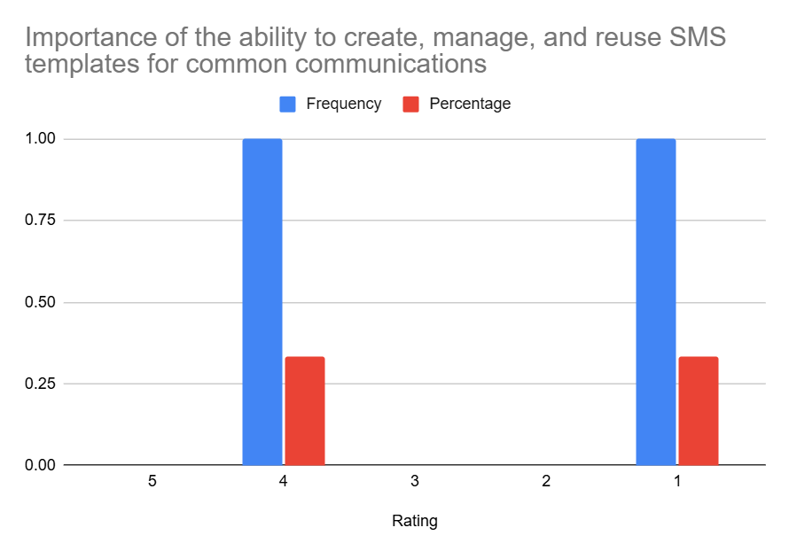

**Insight**: There’s a polarized view on the importance of managing reusable SMS templates. One administrator rated it as important (4), while another rated it as not important (1), and one did not respond to this question. The average rating of 2.5 (based on the two responses) suggests a moderate and divided opinion. This might indicate that the utility of this feature varies significantly depending on specific administrative roles or the types of communication they handle. Further exploration into the contexts where this is deemed important or unimportant would be beneficial.

2. **Preferred channel to handle system-wide announcements or notifications**

|  |  |  |
| --- | --- | --- |
| Channel | Frequency | Percentage |
| Mass email | 3 | 100% |
| SMS broadcast | 1 | 33.3% |
| Portal announcements | 3 | 100% |
| Through department heads | 0 | 0% |
| Other | 0 | 0% |

**Visualisation:**

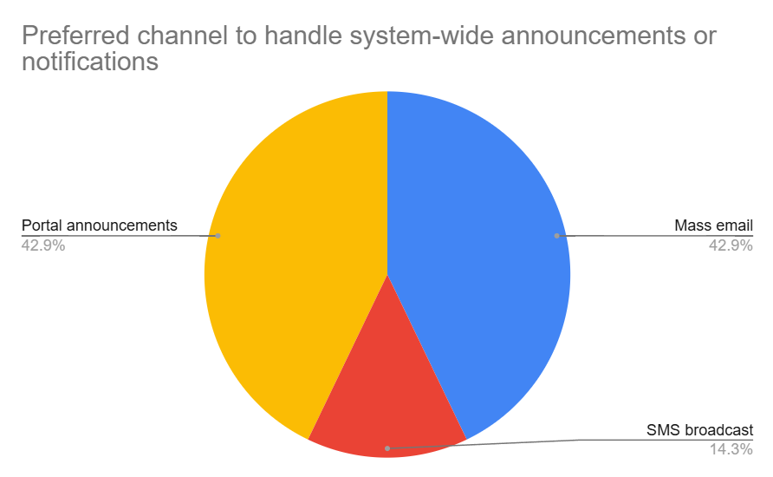

**Insight**: All responding administrators utilize Mass email and Portal announcements for system-wide communications, indicating these are core, established channels. SMS broadcast is used by one administrator, suggesting it’s a supplementary channel for specific situations or by certain roles. The non-use of “Through department heads” for system-wide announcements (as per this question) is noted, though this channel might be used for other types of communication.

3. **Importance of scheduling SMS or email notifications**

|  |  |  |
| --- | --- | --- |
| Rating | Frequency | Percentage |
| 5 | 3 | 100% |
| 4 | 0 | 0% |
| 3 | 0 | 0% |
| 2 | 0 | 0% |
| 1 | 0 | 0% |

**Visualisation:**

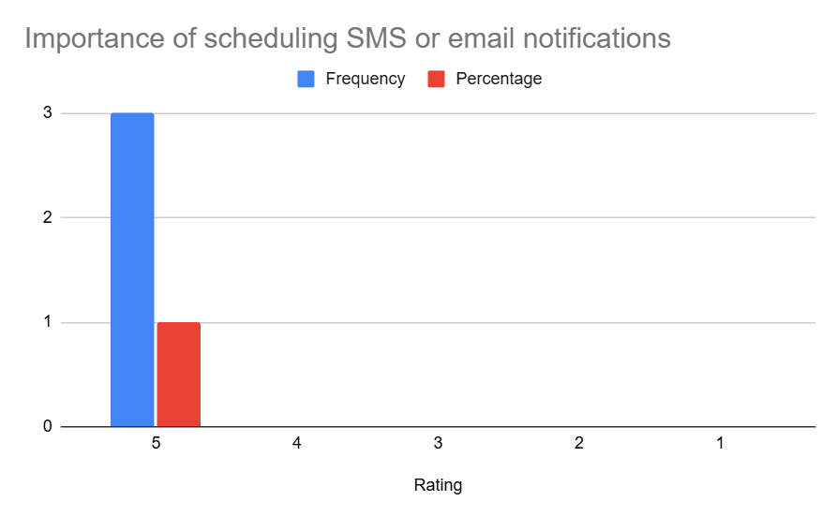

**Insight**: There is unanimous agreement (100%) among administrators that the ability to schedule SMS or email notifications is “Very Important.” This highlights a critical need for proactive communication planning and automation.

4. **Importance of tracking delivery and read status of messages**

|  |  |  |
| --- | --- | --- |
| Rating | Frequency | Percentage |
| 5 | 2 | 66.7% |
| 4 | 0 | 0% |
| 3 | 1 | 33.3% |
| 2 | 0 | 0% |
| 1 | 0 | 0% |

**Visualisation:**

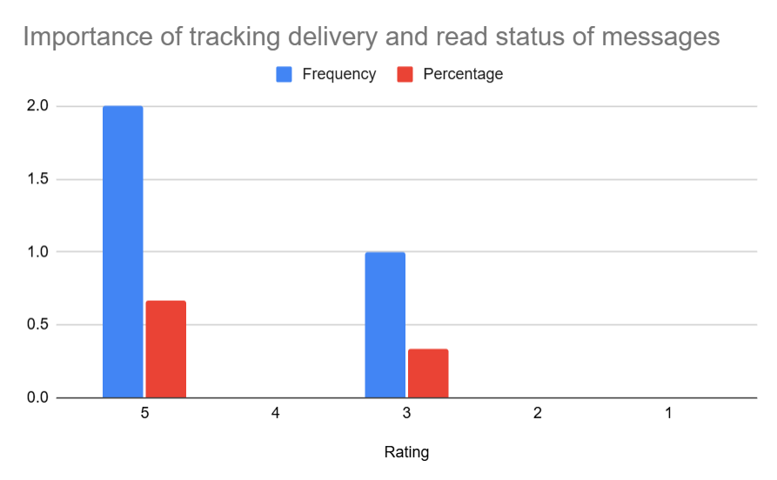

**Insight**: A strong majority (66.7%) rate tracking delivery and read status as “Very Important,” with the remaining administrator rating it as moderately important (3). The average rating of 4.33 underscores a significant desire for feedback on message reception, which can inform follow-up actions and assess communication effectiveness.

**5**. **Importance of sending messages to selected user groups**

|  |  |  |
| --- | --- | --- |
| Rating | Frequency | Percentage |
| 5 | 0 | 0% |
| 4 | 2 | 66.7% |
| 3 | 1 | 33.3% |
| 2 | 0 | 0% |
| 1 | 0 | 0% |

**Visualisation:**

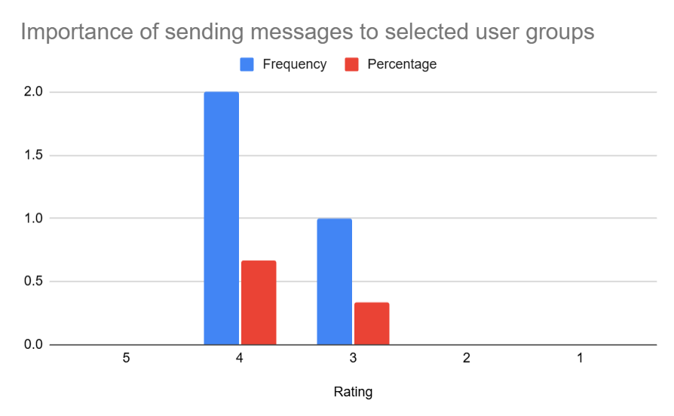

**Insight**: The ability to send messages to selected user groups is considered important, with an average rating of 3.67. Two-thirds of administrators rated this as important (4), indicating a need for targeted communication capabilities to avoid information overload and ensure relevance.

**6**. **Importance of customizing templates per department/event**

|  |  |  |
| --- | --- | --- |
| Rating | Frequency | Percentage |
| 5 | 0 | 0% |
| 4 | 2 | 66.7% |
| 3 | 1 | 33.3% |
| 2 | 0 | 0% |
| 1 | 0 | 0% |

**Visualisation:**

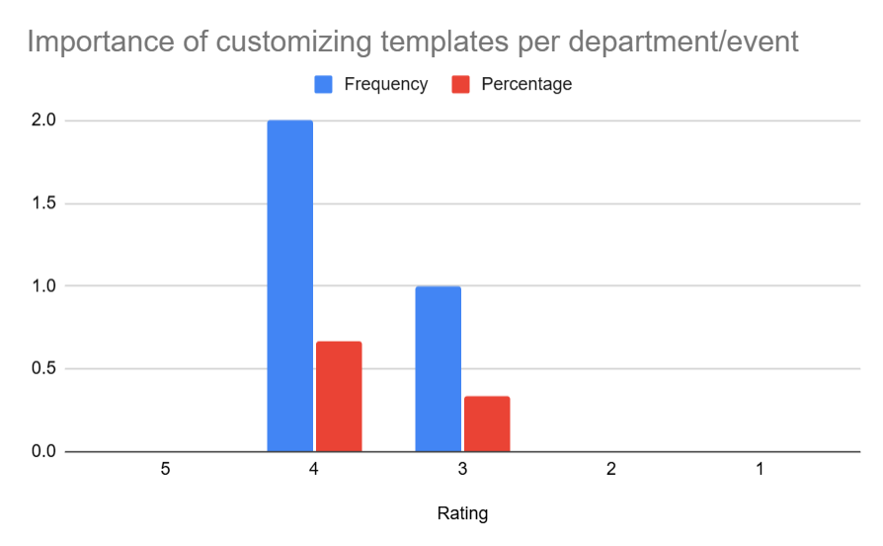

**Insight**: Similar to targeted messaging, customizing templates per department/event has an average importance rating of 3.67. This suggests a desire for flexibility in branding and content structuring to suit different communication contexts and departmental needs.

7. **Preferred method for managing and updating data**

|  |  |  |
| --- | --- | --- |
| Method | Frequency | Percentage |
| Manual entry via portal | 1 | 33.3% |
| Excel/CSV upload | 3 | 100% |
| Internal integrated system | 2 | 66.7% |
| Paper-based submission | 0 | 0% |
| Other | 0 | 0% |

**Visualisation:**

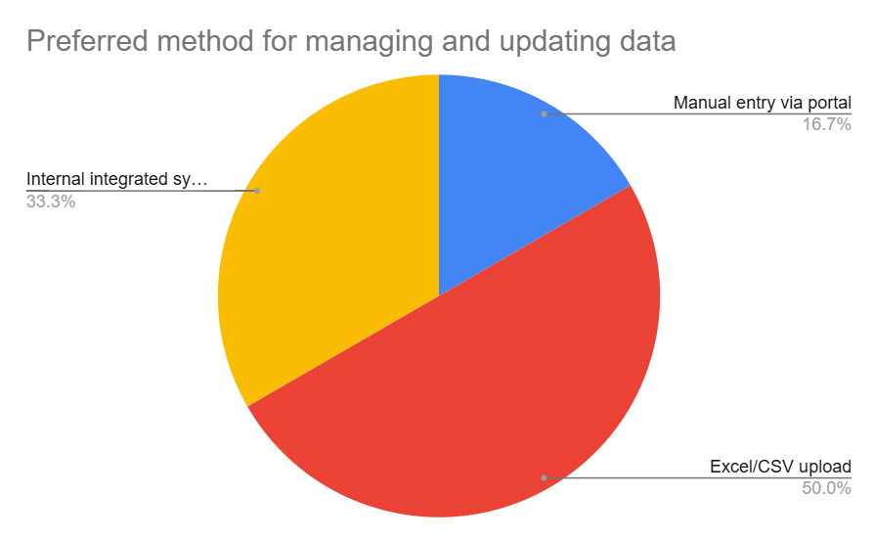

**Insight**: All surveyed administrators use Excel/CSV uploads for managing and updating data, highlighting it as a ubiquitous method. Internal integrated systems are also commonly used by two-thirds of respondents. Manual entry via a portal is less common, used by one administrator. This points to a need for robust import/export capabilities and seamless integration with existing backend systems.

8. **Frequency of encountering delays or errors when retrieving or submitting data through the system**

|  |  |  |
| --- | --- | --- |
| Frequency of Delays/Errors | Frequency | Percentage |
| Rarely | 0 | 0% |
| Occasionally | 3 | 100% |
| Frequently | 0 | 0% |
| Very frequently | 0 | 0% |

**Visualisation:**

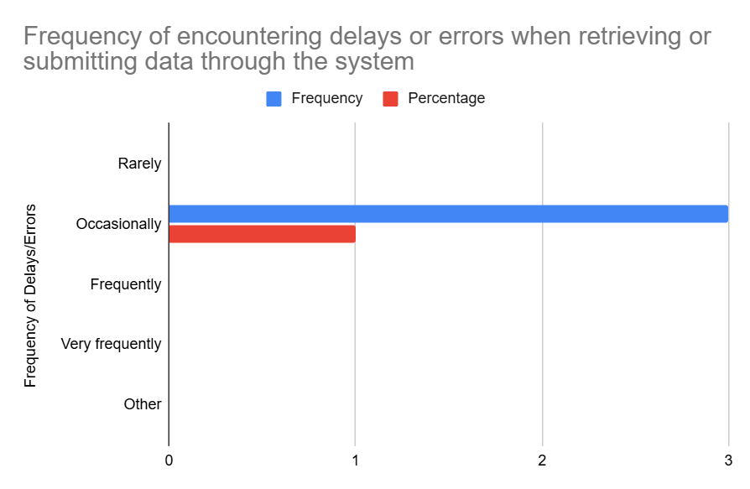

**Insight**: All responding administrators report “Occasionally” encountering delays or errors when retrieving or submitting data. While not “Frequently,” this consistent experience of occasional issues indicates room for improvement in system performance, reliability, and error handling to enhance administrative efficiency.

### **Summary of Findings**

The responses from the 3 administrators indicate that email and portal announcements are the primary channels for system-wide communication, with SMS being supplementary. There's a very high demand for scheduling notifications and a strong need for tracking message delivery/read status. Targeted messaging and customizable templates are also considered important. Excel/CSV uploads are a universal method for data management, alongside internal system integrations. While system delays/errors are only encountered "occasionally," it's a consistent experience. Qualitative feedback on specific system challenges or improvement suggestions was notably sparse, with one mention of slow internet.

### **Elicited Requirements**

Notes:   
‘Q’ stands for Questionnaire here

Numbering pattern: 1xx : Student, 2xx : Parent : 3xx, Lecturer : 4xx, Admin

**Functional Requirements**

1. **Scheduled Communication**

**Q_401**: The system shall allow administrators to schedule the sending of SMS and email notifications in advance.

1. **Delivery and Read Status Tracking**

**Q_402**: The system shall enable administrators to view the delivery status of all sent messages.

**Q_403**: Where technically feasible, the system shall provide read status indicators for messages.

1. **Data Management via Import/Export**

**Q_404**: The system shall support uploading user and communication data using Excel or CSV files.

**Q_405**: The system shall allow exporting system data (e.g., user lists, message logs) in Excel or CSV format.

1. **Targeted Messaging**

**Q_406**: The system shall enable sending communications to specifically filtered user groups based on predefined attributes (e.g., department, role, program).

1. **Communication Template Management**

**Q_407**: The system shall allow the creation, customization, and saving of communication templates for reuse across departments or event types.

**Q_408**: The system should support SMS template management with considerations for role-specific access or permissions, pending further evaluation of administrative needs.

1. **System Integration**

**Q_409**: The system should support integration with existing internal university systems (e.g., user databases, academic records) for synchronized data management.

**Performance Requirements**

1. **Data Handling Efficiency**

**Q_410**: The system shall perform data retrieval and submission operations (e.g., uploading CSVs, sending bulk messages) with minimal delay and high reliability.

1. **Message Dispatch Speed**

**Q_411**: Scheduled or immediate notifications shall be delivered to all selected recipients within 2 minutes of the intended dispatch time.

**Usability Requirements**

1. **Ease of Use for Admins**

**Q_412**: The communication scheduling interface shall allow users to set time, date, recipient group, and message content in no more than 3 steps.

**Q_413**: Uploaded Excel/CSV files shall be validated with clear success/failure feedback messages

1. **Role-Specific Tools**

**Q_414**: The system shall provide communication and template features that can be customized based on administrative roles or departments.

**Interface Requirements**

1. **Message Dashboard**

**Q_415**: Administrators shall have access to a dashboard that displays scheduled, sent, and failed messages along with delivery and read status indicators.

1. **Template Management**

**Q_416**: A template management interface shall allow creation and management of communication templates.

# **Kano Model**

The Kano Model is a proven framework for prioritizing and analyzing user requirements by evaluating how specific features and functions impact user satisfaction. Developed by Professor Noriaki Kano, the model categorizes requirements into dissatisfiers (basic needs), satisfiers (performance needs), and delighters (excitement needs), helping teams distinguish between essential system attributes and features that add extra value.

Applying the Kano Model to software requirements is especially helpful in complex systems, such as university portals, where different user groups have diverse expectations. By mapping requirements to Kano categories, stakeholders can ensure that baseline expectations are met, while also identifying opportunities to enhance user experience and deliver features that delight users. This approach leads to more effective prioritization, increased user satisfaction, and better alignment between the delivered system and stakeholder needs.

## **Glossary**

|  |  |
| --- | --- |
| Term | Definition |
| Real Time | System action occurs and is reflected to the user within 5 seconds of the triggering event, unless otherwise specified for specific features. |
| Critical | Events or notifications that, if delayed, may result in harm to student progress, compliance, or safety (e.g., low attendance, overdue fees). |
| Urgent | Requires user attention or action within 1 hour to avoid negative consequences; see also "Critical." |
| Consistently | The required action or state must occur in at least 99% of cases, measured monthly, with no unexplained exceptions. |
| Proper Termination (Logout) | All session tokens (local and SSO), cookies, and active logins are invalidated, and the user is redirected to the login page. |

## **Finalised Set of Requirements**

### **Notification System**

|  |  |  |  |  |
| --- | --- | --- | --- | --- |
| Notification System | |  | | |
| ID | Requirement | | Technique | ID in SRS |
| REQ-01 | The system shall support sending notifications to students and parents via email based on channel preference. | | Interview (I_102, I_303),  Questionnaire (Q_101, Q_ 107, Q_202, Q_305, Q_401) | REQ_F0901 |
| REQ-02 | The system shall deliver notifications via SMS to students and parents with registered mobile numbers, in accordance with their preferred communication channel. | | Interview (I_102, I_203),  Questionnaire (Q_101, Q_202, Q_ 401) | REQ_F3201 |
| REQ-03 | The system shall support in-portal notifications for students and parents | | Interview (I_102),  Questionnaire (Q_101) | REQ_F0601 |
| REQ-04 | The system shall provide urgent/critical alerts (low attendance, overdue fees) via SMS | | Interview (I_110, I_203), Questionnaire (Q_305, Q_401) | REQ_F3202 |
| REQ-05 | The system shall allow administrators and lecturers to schedule sending of notifications (SMS, email, portal) in advance. | | Interview (I_104), Questionnaire (Q_106, Q_202) | REQ_F0902 |
| REQ-06 | The system shall enable sending communications to filtered user groups based on predefined attributes (department, role, program). | | Interview (I_103), Questionnaire (Q_406) | REQ_F0903 |
| REQ-07 | The system shall allow student users to enable or disable notifications for specific communication types, such as academic alerts, billing updates, or general announcements. | | Interview (I_104, I_105) | REQ_F1901 |
| REQ-08 | The system shall allow users to customize their notification preferences and channels for different types of communications. | | Interview (I_103), Questionnaire (Q_103) | REQ_F1902 |
| REQ-09 | The system shall store and apply notification preferences per student in their user profile. | | Interview (I_117) | REQ_F1903 |
| REQ-10 | The system should provide a "quiet hours" feature allowing students to temporarily suspend non-urgent notifications. | | Questionnaire (Q_112) | REQ_F2001 |
| REQ-11 | The system shall allow lecturers to view the read status of announcements they have made | | Interview (I_301), Questionnaire (Q_301, Q_403) | REQ_F2501 |
| REQ-12 | The system shall allow lecturers and admins to use pre-made templates when creating notifications | | Questionnaire (Q_407, Q_408) | REQ_F0904 |
| REQ-13 | The system shall update read status of announcements in real time. | | Interview (I_311) | REQ_F0001 |

### **Authentication & Access Control**

|  |  |  |  |  |
| --- | --- | --- | --- | --- |
| Authentication & Access Control | |  |  | |
| ID | Requirement | | Technique | ID in SRS |
| REQ-14 | Access to information and features shall be based on user roles (student, parent, lecturer, admin). | | Observation (O_103) | REQ_F0009 |
| REQ-15 | The system shall support single sign-on authentication for accessing all university services | | Brainstorming, Questionnaire (Q_102) | REQ_F3101 |
| REQ-16 | The system shall provide proper termination of SSO sessions during logout | | Brainstorming, Questionnaire (Q_102) | REQ_F0201 |
| REQ-17 | The system shall implement features and controls necessary to comply with applicable data privacy and protection regulations, including but not limited to GDPR and FERPA. | | Questionnaire (Q_303) | REQ_F0002 |
| REQ-18 | Parental access and notifications shall comply with university privacy policies and require explicit student consent. | | Interview (I_108, I_309) | REQ_F3001 |
| REQ-19 | The system should provide customizable session timeout settings for students. | | Questionnaire (Q_113) | REQ_F0501 |
| REQ-20 | The session timeout duration shall be configurable within a secure range, with a minimum of 5 minutes and a maximum of 30 minutes | | Brainstorming | REQ_F0502 |
| REQ-21 | The system shall implement encryptions for all sensitive data in transit and at rest. | | Interview (I_212), Questionnaire (Q_303) | REQ_F0003 |

### **Dashboard & Interface**

|  |  |  |  |  |
| --- | --- | --- | --- | --- |
| Dashboard & Interface | |  |  | |
| ID | Requirement | | Technique | ID in SRS |
| REQ-22 | The system shall redirect users to role-specific dashboards after successful authentication | | Brainstorming | REQ_F0101 |
| REQ-23 | The student dashboard shall provide a section for managing course registration and enrolment. | | Brainstorming | REQ_F1701 |
| REQ-24 | The student dashboard shall display upcoming exam dates and times relevant to the student’s courses. | | Brainstorming | REQ_F1501 |
| REQ-25 | The student dashboard shall display university announcements relevant to the student. | | Questionnaire (Q_109) | REQ_F1801 |
| REQ-26 | The student dashboard shall display an overview of the student’s attendance records for each enrolled course. | | Questionnaire (Q_105) | REQ_F1201 |
| REQ-27 | The student dashboard shall display finance section with billing information, payment status, and fee breakdowns. | | Interview (I_107, I_204) | REQ_F1601 |
| REQ-28 | The student dashboard shall display a summary of the student’s academic records, including grades and completed courses. | | Interview (I_101), Questionnaire (Q_211) | REQ_F1301 |
| REQ-29 | The system shall present the student’s current class schedule with course names, times, and locations. | | Interview (I_106) | REQ_F1401 |
| REQ-30 | The system shall provide a dedicated portal for parents to access their child’s grades, attendance, and financial information. | | Interview (I_201),  Observation (O_106) | REQ_F2101 |
| REQ-31 | The system shall provide consistent header formatting across all tables and views. | | Observation (O_103) | REQ_I0001 |
| REQ-32 | The system shall provide students with the ability to switch between light and dark display modes | | Interview (I_123), Questionnaire (Q_110) | REQ_F0401 |
| REQ-33 | The system shall allow students to customize their dashboard layout by moving around widgets. | | Interview (I_109, I_122) | REQ_F0402 |
| REQ-34 | The interface shall be responsive and adapt to different screen sizes. | | Interview (I_120, I_214) | REQ_I0002 |
| REQ-35 | The system shall use descriptive course/event names, not codes, throughout the interface. | | Interview (I_114) | REQ_I0003 |
| REQ-36 | Academic, financial, and attendance data shall be presented with charts, tables, and summaries for quick understanding. | | Interview (I_209) | REQ_I0004 |

### **Communication**

|  |  |  |  |  |
| --- | --- | --- | --- | --- |
| Communication | |  |  | |
| ID | Requirement | | Technique | ID in SRS |
| REQ-37 | The system shall only permit notifications to parents regarding attendance or emergencies in compliance with privacy policies. *Consent described in [REQ-18].* | | Interview (I_308) | REQ_F0004 |
| REQ-38 | The system shall enable communication between university administrators and parents via chat or contact form. | | Interview (I_205) | REQ_F2301 |
| REQ-39 | Students, parents, lecturers and admins shall be able to use the live chat functionality to exchange messages in real time | | Brainstorming | REQ_F1101 |
| REQ-40 | The system shall provide a search functionality for past announcements and communications. | | Questionnaire (Q_108) | REQ_F1802 |
| REQ-41 | The system shall allow creation, customization, and management of communication templates by admins. | | Questionnaire (Q_407, Q_408, Q_414, Q_416) | REQ_F2701 |
| REQ-42 | The system shall include a contact directory interface, maintained by admins, for parents to access with filters for faculty and department | | Questionnaire (Q_206, Q_212) | REQ_F2201 |
| REQ-43 | The system shall maintain an audit log that records all user and system activities, including but not limited to logins, data modifications, access to sensitive records, and administrative actions. | | Brainstorming | REQ_F2901 |
| REQ-44 | Each audit log entry shall include the timestamp, user ID, action performed, and affected resources. | | Brainstorming | REQ_F2902 |

### **Academic & Course Management**

|  |  |  |  |  |
| --- | --- | --- | --- | --- |
| Academic & Course Management | |  |  | |
| Identifier | Requirement | | Technique |  |
| REQ-45 | The system shall provide a single-window course enrolment process | | Observation (O_121) | REQ_I0007 |
| REQ-46 | The system should send automated email digests of attendance status on a bi-weekly basis to students. | | Questionnaire (Q_107) | REQ_F0005 |
| REQ-47 | Lecturers shall be able to upload and update materials in a centralized location | | Interview (I_303),  Questionnaire (Q_310) | REQ_F2401 |
| REQ-48 | Lecturers shall be able to generate a single unique link to academic resources usable across platforms. | | Interview (I_303) | REQ_F2402 |
| REQ-49 | The system shall allow exporting and importing student academic data in Excel or CSV format. | | Questionnaire (Q_310, Q_404, Q_405) | REQ_F2601 |

### **Calendar & Scheduling**

|  |  |  |  |  |
| --- | --- | --- | --- | --- |
| Calendar and Scheduling | |  |  | |
| ID | Requirement | | Technique | ID in SRS |
| REQ-50 | The system shall support integration with common calendar applications (Google Calendar, Apple Calendar) for academic schedules. | | Interview (I_106), Questionnaire (Q_104) | REQ_F3301 |
| REQ-51 | Students and lecturers shall be able to set personal reminders and manage events or deadlines through the calendar. | | Interview (I_304, I_305) , Questionnaire (Q_305) | REQ_F1001 |

### **Performance & Reliability**

|  |  |  |  |  |
| --- | --- | --- | --- | --- |
| Performance & Reliability | |  |  | |
| ID | Requirement | | Technique | ID in SRS |
| REQ-52 | Calendar synchronization shall occur within 2 minutes of changes being made. | | Interview (I_113) | REQ_P0005 |
| REQ-53 | The system shall synchronize updated data across interfaces within 5 seconds of the change being committed. | | Interview (I_312) | REQ_P0003 |
| REQ-54 | Critical notifications shall be delivered within 1 minute of their creation. | | Interview (I_110, I_206) | REQ_P0004 |
| REQ-55 | The synchronization mechanism shall include academic records, financial transactions, attendance logs, and communication messages. | | Questionnaire (Q_304) | REQ_F0006 |
| REQ-56 | The system shall ensure that data changes are consistently reflected across all user-facing interfaces, including the web portal and mobile application. | | Brainstorming | REQ_F0010 |
| REQ-57 | The system shall load any page within 3 seconds under normal conditions. | | Observation (O_109) | REQ_P0001 |
| REQ-58 | The system shall process course enrolment requests within 5 seconds. | | Observation (O_111) | REQ_P0002 |
| REQ-59 | Notifications shall be guaranteed to reach all selected channels without loss, with 99% reliability for scheduled/automated notifications. | | Interview (I_112, I_310), Questionnaire (Q_306) | REQ_P0006 |
| REQ-60 | The system shall verify file type and size before accepting uploads and display a clear error if requirements are not met. | | Brainstorming | REQ_F0007 |
| REQ-61 | The system shall ensure that no user receives duplicate notifications for the same event across any communication channel. | | Brainstorming | REQ_F0008 |

### **Usability, Accessibility & Availability**

|  |  |  |  |  |
| --- | --- | --- | --- | --- |
| Usability & Accessibility | |  |  |  |
| ID | Requirement | | Technique | ID in SRS |
| REQ-62 | The system shall limit navigation depth to maximum five levels for any feature. | | Observation (O_117) | REQ_U0001 |
| REQ-63 | The system shall provide visual indicators for navigation paths. | | Observation (O_119) | REQ_I0005 |
| REQ-64 | The system shall support a multilingual interface for all student and parent facing pages and messages. | | Interview (I_216),  Questionnaire (Q_111, Q_209) | REQ_F0301 |
| REQ-65 | The system shall allow students and parents to select and save their preferred interface language via their user profile settings. | | Interview (I_216),  Observation (O_114)  Questionnaire (Q_111, Q_209) | REQ_F0302 |
| REQ-66 | The system shall provide contextual tooltips for students and parents for interface elements on hover | | Observation (O_120) | REQ_F0701 |
| REQ-67 | The system shall provide help guides accessible via a help section for students and parents, aimed at explaining system functionalities considered complex. | | Observation (O_120) | REQ_F0801 |
| REQ-68 | The system must meet WCAG 2.1 guidelines for accessibility, ensuring usability for all users, including those with disabilities. | | Brainstorming | REQ_U0002 |
| REQ-69 | The system shall maintain 99.9% uptime during academic terms and 99% during breaks and holidays. | | Interview (I_111) | REQ_P0007 |
| REQ-70 | The system shall provide context-sensitive help or tooltips for at least 90% of user interface elements. | | Brainstorming,  Observation (O_120) | REQ_U0003 |

## **Applying Kano to Elicited Requirements**

### **Dissatisfiers**

|  |  |  |
| --- | --- | --- |
| Identifier | Requirement | Justification |
| REQ-01 | The system shall support sending notifications to students and parents via email based on channel preference. | This is a fundamental expectation for a modern communication system; lacking any of these core channels would cause significant dissatisfaction. (Implied basic functionality) |
| REQ-02 | The system shall deliver notifications via SMS to students and parents with registered mobile numbers, in accordance with their preferred communication channel. |
| REQ-03 | The system shall support in-portal notifications for students and parents |
| REQ-04 | The system shall provide urgent/critical alerts (low attendance, overdue fees) via SMS | While notifications are basic, proactive, specific, urgent alerts for critical issues are a significant value-add, particularly for parents and for timely student intervention. (Parent & Student interviews). |
| REQ-08 | The system shall allow users to customize their notification preferences and channels for different types of communications. | Lack of control over notifications is a common complaint and basic expectation for user experience. (Implied from student questionnaire insights on notification overload). |
| REQ-09 | The system shall store and apply notification preferences per student in their user profile. |
| REQ-14 | Access to information and features shall be based on user roles (student, parent, lecturer, admin). | Fundamental security requirement to protect sensitive academic data and ensure appropriate access levels. |
| REQ-18 | Parental access and notifications shall comply with university privacy policies and require explicit student consent. | Legal issues as non-compliance is a fundamental problem that must be taken into account. |
| REQ-21 | The system shall implement encryptions for all sensitive data in transit and at rest. | Critical security requirement for protecting personal and academic data; absence would create significant security vulnerabilities. (Basic security requirement from brainstorming) |
| REQ-22 | The system shall redirect users to role-specific dashboards after successful authentication | Basic usability expectation for efficient system navigation; directly impacts user workflow efficiency. (Implied from brainstorming) |
| REQ-23 | The student dashboard shall provide a section for managing course registration and enrolment. | Core purpose of a student portal; its absence or poor implementation would render the system largely useless for students. (Implied basic functionality). |
| REQ-24 | The student dashboard shall display upcoming exam dates and times relevant to the student’s courses. |
| REQ-25 | The student dashboard shall display university announcements relevant to the student. |
| REQ-26 | The student dashboard shall display an overview of the student’s attendance records for each enrolled course. |
| REQ-27 | The student dashboard shall display finance section with billing information, payment status, and fee breakdowns. |
| REQ-28 | The student dashboard shall display a summary of the student’s academic records, including grades and completed courses. |
| REQ-29 | The system shall present the student’s current class schedule with course names, times, and locations. |
| REQ-30 | The system shall provide a dedicated portal for parents to access their child’s grades, attendance, and financial information. | A key demand from parents (as seen in Parent Questionnaire and Interview); lack of this is a major current pain point. |
| REQ-31 | The system shall provide consistent header formatting across all tables and views. | Problem in base system and complained about a lot. Inconsistent UI is a basic usability flaw causing frustration. |
| REQ-34 | The interface shall be responsive and adapt to different screen sizes. | Basic expectation for modern web applications; lack of responsiveness severely limits accessibility. (Implied from need for mobile access in questionnaire). |
| REQ-40 | The system shall provide a search functionality for past announcements and communications. | Essential for information retrieval; without it, users struggle to find past information, a basic usability need. (Student Questionnaire implies this need). |
| REQ-47 | Lecturers shall be able to upload and update materials in a centralized location | Addresses a core lecturer pain point of redundant work and material management complexity (Lecturer Interview). Basic efficiency expectation. |
| REQ-48 | Lecturers shall be able to generate a single unique link to academic resources usable across platforms. |
| REQ-49 | The system shall allow exporting and importing student academic data in Excel or CSV format. | Provides flexibility and interoperability, a convenience that improves workflow for users who prefer these formats (especially Admins). |
| REQ-62 | The system shall limit navigation depth to maximum five levels for any feature. | Deep, complex navigation is a common usability complaint (seen in Observations); limiting it is a basic expectation for ease of use. |
| REQ-63 | The system shall provide visual indicators for navigation paths. | Lack of clear navigation cues leads to user confusion and frustration, a basic usability expectation. (Seen in Observations as "unclear paths"). |
| REQ-66 | The system shall provide contextual tooltips for students and parents for interface elements on hover | Essential for usability, especially for diverse user skill levels; absence makes complex features inaccessible. (Addresses "confusing interface" from observations). |
| REQ-67 | The system shall provide help guides accessible via a help section for students and parents, aimed at explaining system functionalities considered complex. |
| REQ-70 | The system shall provide context-sensitive help or tooltips for at least 90% of user interface elements. |
| REQ-68 | The system must meet WCAG 2.1 guidelines for accessibility, ensuring usability for all users, including those with disabilities. | Essential requirement for equal access and legal compliance; failure to meet accessibility standards would exclude users and potentially violate regulations. (basic user need) |
| REQ-69 | The system shall maintain 99.9% uptime during academic terms and 99% during breaks and holidays. | Maintaining high availability is a fundamental expectation for a modern university portal; failure to meet this uptime requirement would result in severe user dissatisfaction and disruption of critical academic processes. During key periods such as registration, exams, and grading, system downtime would prevent users from accessing essential services, potentially causing missed deadlines and administrative issues. Lower availability would be perceived as a system failure rather than simply lacking a feature. |

### **Satisfiers**

|  |  |  |
| --- | --- | --- |
| Identifier | Requirement | Justification |
| REQ-05 | The system shall allow administrators and lecturers to schedule sending of notifications (SMS, email, portal) in advance. | This adds significant efficiency and planning capability, going beyond just sending messages manually. Highly valued by Admins & Lecturers (Questionnaires/Interviews). |
| REQ-17 | The system shall implement features and controls necessary to comply with applicable data privacy and protection regulations, including but not limited to GDPR and FERPA. | While compliance is a must (could be a dissatisfier if *not* met), actively ensuring and highlighting this builds trust and satisfaction, especially with sensitive data. Arguably borderline Dissatisfier. |
| REQ-32 | The system shall provide students with the ability to switch between light and dark display modes | Interface customization like themes (light/dark mode) is a common user preference that enhances visual comfort and personalization. (Student Questionnaire & Interviews). |
| REQ-33 | The system shall allow students to customize their dashboard layout by moving around widgets. |
| REQ-35 | The system shall use descriptive course/event names, not codes, throughout the interface. | Enhances user experience by improving readability and reducing confusion, particularly valued in student feedback. (Student questionnaire insights on interface preferences) |
| REQ-36 | Academic, financial, and attendance data shall be presented with charts, tables, and summaries for quick understanding. | Visual presentation of data improves user experience and information comprehension, going beyond basic functionality. |
| REQ-37 | The system shall only permit notifications to parents regarding attendance or emergencies in compliance with privacy policies. | Balances parental information needs with student privacy requirements, addressing concerns raised in stakeholder interviews. |
| REQ-38 | The system shall enable communication between university administrators and parents via chat or contact form. | Provides a direct, formal channel beyond student relay, addressing a key parent desire for better direct communication. (Parent Interview). |
| REQ-39 | Students, parents, lecturers and admins shall be able to use the live chat functionality to exchange messages in real time | This is implied from the analysis of interview as fragmentation in communication was identified. |
| REQ-42 | The system shall include a contact directory interface, maintained by admins, for parents to access with filters for faculty and department | Facilitates easier connection with relevant university personnel, improving communication efficiency for parents and potentially others. |
| REQ-43 | The system shall maintain an audit log that records all user and system activities, including but not limited to logins, data modifications, access to sensitive records, and administrative actions. | Essential for system security, troubleshooting, and accountability; standard requirement for academic systems. (Administrative requirements and security best practices) |
| REQ-44 | Each audit log entry shall include the timestamp, user ID, action performed, and affected resources. |
| REQ-45 | The system shall provide a single-window course enrolment process | Streamlines a critical student task, reducing frustration and improving efficiency. Student feedback indicated strong preference for simplified enrolment. (Student observation) |
| REQ-50 | The system shall support integration with common calendar applications (Google Calendar, Apple Calendar) for academic schedules. | Integration with popular calendar applications such as Google Calendar and Apple Calendar provides users with seamless access to their academic schedules across multiple devices and platforms. |
| REQ-51 | Students and lecturers shall be able to set personal reminders and manage events or deadlines through the calendar. | Personalization of reminders goes beyond basic calendar display; it empowers users to manage their own tasks effectively. (Student Interview desire). |
| REQ-52 | Calendar synchronization shall occur within 2 minutes of changes being made. | Timely sync enhances reliability and user trust, preventing missed events due to outdated info. Performance beyond basic functionality. |
| REQ-53 | The system shall synchronize updated data across interfaces within 5 seconds of the change being committed. | Performance requirement that enhances user satisfaction by ensuring timely data updates. |
| REQ-54 | Critical notifications shall be delivered within 1 minute of their creation. | Speed of delivery for critical items is a performance satisfier; basic notifications might tolerate slightly longer delays. |
| REQ-55 | The synchronization mechanism shall include academic records, financial transactions, attendance logs, and communication messages. | Timely data propagation ensures all stakeholders have current information, improving decision-making and trust. Performance satisfier. |
| REQ-56 | The system shall ensure that data changes are consistently reflected across all user-facing interfaces, including the web portal and mobile application. | The system shall ensure that data changes are consistently reflected across all user-facing interfaces, including the web portal and mobile application. |
| REQ-57 | The system shall load any page within 3 seconds under normal conditions. | Fast page load times significantly improve user experience and reduce frustration. Performance satisfier. (Addresses "slow system" complaints). |
| REQ-58 | The system shall process course enrolment requests within 5 seconds. | Quick processing of critical actions like enrollment enhances user satisfaction. Performance satisfier. |
| REQ-59 | Notifications shall be guaranteed to reach all selected channels without loss, with 99% reliability for scheduled/automated notifications. | High reliability and non-duplication go beyond basic sending; they ensure accuracy and prevent annoyance, enhancing satisfaction. |
| REQ-60 | The system shall verify file type and size before accepting uploads and display a clear error if requirements are not met. | Prevents user errors and system issues, improving overall system reliability and user experience. |
| REQ-61 | The system shall ensure that no user receives duplicate notifications for the same event across any communication channel. | Addresses a common user complaint about notification spam, improving communication efficiency. |

### **Delighters**

|  |  |  |
| --- | --- | --- |
| Identifier | Requirement | Justification |
| REQ-06 | The system shall enable sending communications to filtered user groups based on predefined attributes (department, role, program). | Advanced targeting beyond basic groups offers precise communication, which is powerful but perhaps not universally expected as a baseline. Enhances efficiency significantly. (Admin Questionnaire - rated important). |
| REQ-07 | The system shall allow student users to enable or disable notifications for specific communication types, such as academic alerts, billing updates, or general announcements. | Granular control over notifications (filtering, muting specific categories) is an advanced feature that significantly enhances user experience by reducing noise. (Student Interview - customization). |
| REQ-10 | The system should provide a "quiet hours" feature allowing students to temporarily suspend non-urgent notifications. | "Quiet hours" is a thoughtful feature addressing user well-being and focus, an unexpected but highly appreciated convenience. (Student Questionnaire & Interviews). |
| REQ-11 | The system shall allow lecturers to view the read status of announcements they have made | This feature goes beyond basic notification delivery, enabling lecturers to track engagement and ensure important messages are seen. While not always expected, providing read receipts empowers lecturers with actionable insights, supporting more effective communication. Its presence can pleasantly surprise users, increasing satisfaction and confidence in the system. |
| REQ-12 | The system shall allow lecturers and admins to use pre-made templates when creating notifications | Pre-made templates streamline the notification process, saving time and ensuring consistency in communication. Most systems require users to compose messages manually, so offering templates is an unexpected convenience. This feature boosts efficiency, reduces errors, and can delight users—especially those managing frequent or complex communications. |
| REQ-13 | The system shall update read status of announcements in real time. | Real-time updates on announcement read status represent advanced system responsiveness. While batch or delayed updates are common, instant feedback is rare and highly valued. This capability provides immediate assurance to lecturers and admins that their communications are reaching the audience, delivering a sense of control and modernity that delights users. |
| REQ-15 | The system shall support single sign-on authentication for accessing all university services | Since the system’s structure is meant to be centralized, logging-in to different platforms will not occur a lot within the scope of services covered by this new, unified portal. |
| REQ-16 | The system shall provide proper termination of SSO sessions during logout |
| REQ-19 | The system should provide customizable session timeout settings for students. | Offers users control over security aspects, enhancing their sense of safety and meeting individual preferences. (Student Questionnaire). |
| REQ-20 | The session timeout duration shall be configurable within a secure range, with a minimum of 5 minutes and a maximum of 30 minutes | This requirement has been raised by many and rated highly by students during the student questionnaire |
| REQ-41 | The system shall allow creation, customization, and management of communication templates by admins. | Advanced template management capabilities for admins provide significant efficiency gains and consistency in communications, an unexpected but powerful tool. (Admin Questionnaire - importance of template features). |
| REQ-46 | The system should send automated email digests of attendance status on a bi-weekly basis to students. | Proactive, summarized digests are a convenience feature that users (especially parents or students wanting an overview) might not expect but would find very useful. |
| REQ-64 | The system shall support a multilingual interface for all student and parent facing pages and messages. | Catering to multiple languages goes beyond basic accessibility for a diverse community, making the system far more inclusive and user-friendly for non-primary language speakers. (Parent Questionnaire importance). |
| REQ-65 | The system shall allow students and parents to select and save their preferred interface language via their user profile settings. |

## **Graph**

**Requirements mapped to features:**

|  |  |
| --- | --- |
| Feature | Associated Requirements |
| Multi-Channel Notification Delivery | REQ-01: The system shall support sending notifications to students and parents via email based on channel preference. |
| REQ-02: The system shall deliver notifications via SMS to students and parents with registered mobile numbers, in accordance with their preferred communication channel. |
| REQ-03: The system shall support in-portal notifications for students and parents |
| REQ-04: The system shall provide urgent/critical alerts (low attendance, overdue fees) via SMS |
| Advanced Notification Control | REQ-05: The system shall allow administrators and lecturers to schedule sending of notifications (SMS, email, portal) in advance. |
| REQ-06: The system shall enable sending communications to filtered user groups based on predefined attributes (department, role, program). |
| REQ-07: The system shall allow student users to enable or disable notifications for specific communication types, such as academic alerts, billing updates, or general announcements. |
| Role-Based Access Control | REQ-14: Access to information and features shall be based on user roles (student, parent, lecturer, admin). |
| REQ-17: The system shall implement features and controls necessary to comply with applicable data privacy and protection regulations, including but not limited to GDPR and FERPA. |
| Customize Session Timeout | REQ-19: The system should provide customizable session timeout settings for students. |
| REQ-20: The session timeout duration shall be configurable within a secure range, with a minimum of 5 minutes and a maximum of 30 minutes |
| Data Encryption | REQ-21: The system shall implement encryptions for all sensitive data in transit and at rest. |
| Centralized Dashboard | REQ-23: The student dashboard shall provide a section for managing course registration and enrolment. |
| REQ-24: The student dashboard shall display upcoming exam dates and times relevant to the student's courses. |
| REQ-25: The student dashboard shall display university announcements relevant to the student. |
| REQ-26: The student dashboard shall display an overview of the student's attendance records for each enrolled course. |
| REQ-27: The student dashboard shall display finance section with billing information, payment status, and fee breakdowns. |
| Parental Access Consent Management | REQ-30: The system shall provide a dedicated portal for parents to access their child's grades, attendance, and financial information. |
| Customizable Interface | REQ-32: The system shall provide students with the ability to switch between light and dark display modes |
| REQ-33: The system shall allow students to customize their dashboard layout by moving around widgets. |
| Real-Time Chat | REQ-39: Students, parents and lecturers shall be able to use the live chat functionality to exchange messages in real time |
| Search Through Announcements | REQ-40: The system shall provide a search functionality for past announcements and communications. |
| External Calendar Integration | REQ-50: The system shall support integration with common calendar applications (Google Calendar, Apple Calendar) for academic schedules. |
| REQ-52: Calendar synchronization shall occur within 2 minutes of changes being made. |
| Multi-Language Support | REQ-64: The system shall support a multilingual interface for all student and parent facing pages and messages. |
| REQ-65: The system shall allow students and parents to select and save their preferred interface language via their user profile settings. |
| Announcements Read Receipts | REQ-11: The system shall allow lecturers to view the read status of announcements they have made |
| Quiet Hours Feature | REQ-10: The system should provide a "quiet hours" feature allowing students to temporarily suspend non-urgent notifications. |
| Unified Learning Material Management | REQ-47: Lecturers shall be able to upload and update materials in a centralized location |
| REQ-48: Lecturers shall be able to generate a single unique link to academic resources usable across platforms. |
| Single Sign-On Implementation | REQ-15: The system shall support single sign-on authentication for accessing all university services |
| REQ-16: The system shall provide proper termination of SSO sessions during logout |

Figure 5.4 Kano Graph

# **Justification: Accuracy of Brainstormed Kano Classification**

The comparison between the student-led brainstorming exercise and the final executed Kano classification provides valuable insights into the effectiveness of the requirements gathering and classification process. This analysis examines the patterns, similarities, and differences between these two approaches to understand how well students grasped the Kano model concepts and their ability to identify user needs accurately. In addition to that, it also gives insight on areas of future improvement.

**Pattern Analysis and Similarities**

The brainstormed classification demonstrated significant alignment with the executed classification across all three Kano categories. In the dissatisfier category, students accurately identified fundamental requirements such as SMS emergency alerts, which corresponded to REQ-04's critical alerts implementation in the executed version. They also correctly recognized the importance of real-time data synchronization, which matched with REQ-53's academic data synchronization requirements. For satisfiers, the students' classification showed strong correlation with the executed version. Key examples include the classification of Single Sign-On (SSO) and customizable session timeout settings, which directly matched REQ-15 and REQ-19 respectively. The identification of grade update notifications as a satisfier aligned well with the broader notification requirements in the executed classification. In the delighters category, despite having fewer items, the brainstormed classification accurately identified innovative features such as customizable notification preferences and admin template management, corresponding to REQ-08 and REQ-41 in the executed version.

**Classification Insights**

Brainstorming proved particularly effective for identifying core functionality, as evidenced by the close alignment of dissatisfiers and satisfiers with the finalized requirements. This suggests that students have a solid grasp of baseline user needs and system expectations, especially regarding security, access, and communication features.