Sorting

## Selection Sort

* Select minimum and swap.
* 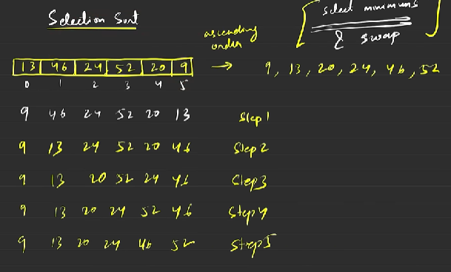
* O(n2)

## Bubble Sort

* Pushes the maximum to the last by adjacent swaps.
* O(n2)

## Insertion Sort

* Take an element and place it in its correct order.
* O(n2)

## Merge Sort

* Divide & Merge
* 