PURPOSE and SCOPE
The purpose of this study is to process time- or frequency-domain data obtained from multiple accelerometers placed on a structure to identify the system’s natural frequencies and visualize the corresponding mode shapes in 3D.
The interface developed using MATLAB App Designer allows the user to define sensor positions, upload data, perform frequency analyses, and export the results as both animations and GIF files. The application is designed to be flexible, supporting both time and frequency domain data. Users can specify which directions the sensors record data in, allowing even incomplete or single-axis measurements to be properly evaluated. Based on the validated sensor data, the system automatically determines the natural frequencies; the structure’s mode shape at the selected frequency is then animated and can be exported as a GIF.
This system aims to make the modal analysis process more visual and intuitive, supporting engineering analyses while providing the user with a flexible and controlled working environment.

Data Structure and Input Formats
The application expects two main types of input data:
- Accelerometer position information
- Measurement data (either time-domain or frequency-domain)
These two types of data are combined for each sensor to derive the system’s modal behavior. Figure 1 shows the interface design. On the left panel, the user can input accelerometer positions and upload measurement data.

Accelerometer Positions
For each sensor, 3D position information (X, Y, Z) can be entered manually or uploaded in bulk via a CSV, TXT, or XLSX file. This data is stored as SensorData{i}.Position within the application. Each sensor’s position is represented as a vector:
 | $$r_{i}=\left[\begin{matrix}x_{i} & y_{i} & z_{i}\end{matrix}\right]$$ | (1)

Measurement Data
User can provide data in either the time domain or frequency domain for each sensor.

Time Domain Data
File structure:
- Single-axis sensors: time and magnitude (2 columns), units: seconds and g.
- Three-axis sensors: time and magnitudes (4 columns), units: seconds and g.
These are later converted to the frequency domain for natural frequency detection.
 | $$Data_{time}=\left[\begin{matrix}t_{1} & x(t_{1}) & y(t_{1}) & z(t_{1}) \\ ⋮ & ⋮ & ⋮ & ⋮ \\ t_{T} & x\left(t_{T}\right) & y\left(t_{T}\right) & z\left(t_{T}\right)\end{matrix}\right]$$ | (2)
Where, $T$ is the time sampling.

Frequency Domain Data:
File structure:
- Single-axis sensors: frequency, magnitude, and phase (3 columns).
- Three-axis sensors: frequency, magnitudes, and phases (7 columns).
Units: Hz, g, and radians.
 | $$Data_{freq}=\left[\begin{matrix}f_{1} & A_{x}\left(f_{1}\right) & ϕ_{x}\left(f_{1}\right) & A_{y}\left(f_{1}\right) & ϕ_{y}\left(f_{1}\right) & A_{z}\left(f_{1}\right) & ϕ_{z}\left(f_{1}\right) \\ ⋮ & ⋮ & ⋮ & ⋮ & ⋮ & ⋮ & ⋮ \\ f_{K} & A_{x}\left(f_{K}\right) & ϕ_{x}\left(f_{K}\right) & A_{y}\left(f_{K}\right) & ϕ_{y}\left(f_{K}\right) & A_{z}\left(f_{K}\right) & ϕ_{z}\left(f_{K}\right)\end{matrix}\right]$$ | (3)
Where $K$, is the number of the frequency points.

Axis Selection
The user specifies one axis per sensor (X, Y, Z, or all axes as “3D”). If only one axis is selected, other axes’ amplitude and phase values are set to zero:
 | $$A_{j}\left(f_{1}\right)=0, ϕ_{j}\left(f_{1}\right)=0, for j ∈\left\{X,Y,Z\right\} \backslash \{selected axis\}$$ | (4)
This ensures matrix size and axis consistency.
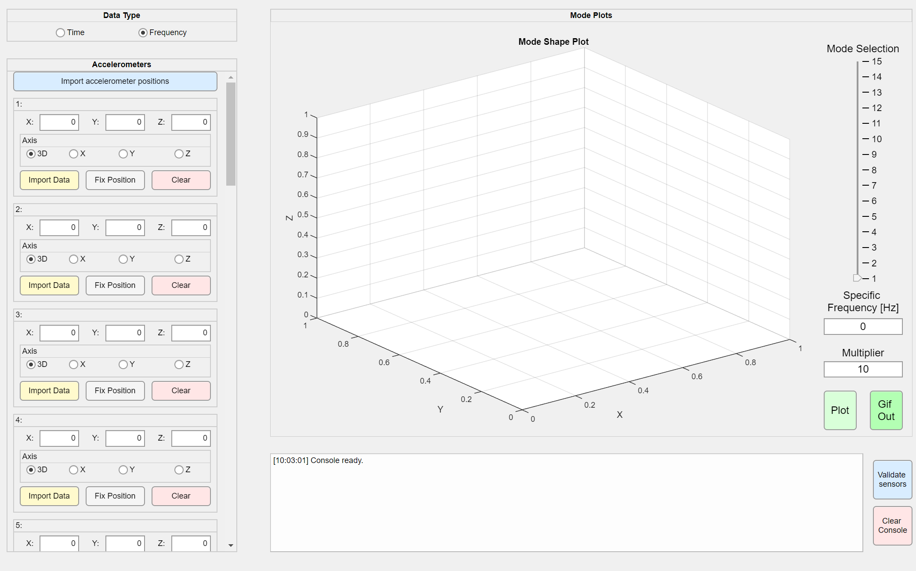
Figure 1 – The data type selection area is located at the top left, and the data upload panel is located at the middle left.

DATA VALIDATION and PREPROCESSING
To ensure data quality and prevent user errors, a validation and preprocessing step is executed when the “Validate Sensors” button is pressed. It consists of three parts:

Position and Axis Information Check
For each sensor:
- Position must be defined as a 3D vector.
- AxisType must be X, Y, Z, or 3D.
Sensors with missing or invalid data are reported to the console.

Measurement Data Check
For each sensor, the following structural checks are applied:
- Definition of the measurement vector in the time domain:
 | $$a\left(t\right)=\left[\begin{matrix}a_{X}(t) & a_{Y}(t) & a_{Z}(t)\end{matrix}\right], t∈[0,T]$$ | (5)
- Definition of the measurement vector in the frequency domain:
 | $$A\left(f\right)=\left[\begin{matrix}A_{X}\left(f\right) & ϕ_{X}\left(f_{1}\right) & A_{Y}\left(f\right) & ϕ_{Y}\left(f_{1}\right) & A_{Z}\left(f\right) & ϕ_{Z}\left(f_{1}\right)\end{matrix}\right]$$ | (6)
Axis consistency is checked; data fields corresponding to unselected axes must be zero or empty.If data is missing for all axes, the user is warned.

Time-to-Frequency Conversion
If time-domain data is provided, it is automatically converted to the frequency domain:
- Signals are zero-mean adjusted.
 | $$\tilde{a}\left(t\right)=a\left(t\right)-\frac{1}{T}\int_{0}^{T}{a\left(τ\right)}dτ$$ | (7)
- FFT is applied.
 | $$\hat{A}\left(f_{k}\right)=\sum_{n=0}^{N-1}{\tilde{a}\left(t_{n}\right)⋅e^{-j2πf_{k}t_{n}}}$$ | (8)
- Magnitude and phase are computed.
 | $$A\left(f_{k}\right)=\left|\hat{A}\left(f_{k}\right)\right|, ϕ(f_{k})=\arg\left(\hat{A}\left(f_{k}\right)\right)$$ | (9)
- Normalization is performed and stored in the data structure.
 | $$J_{amp}\left(f_{k}\right)=A_{J}\left(f_{k}\right), J_{phase}\left(f_{k}\right)=ϕ_{J}\left(f_{k}\right), J=X,Y,Z.$$ | (10)
If all sensors pass validation
 | app.allSensorsOK=true | (11)
otherwise, the user is warned and plotting is disabled. olarak işaretlenir.

NATURAL FREQUENCY IDENTIFICATION
Natural frequencies are critical resonance points of the structure. Their accurate detection is essential for modeling vibration behavior. The application determines these frequencies automatically using the following four steps:

Axis-Based Amplitude Spectrum Calculation
For each sensor and axis:
- If frequency-domain data exists: directly compute spectra.
- If time-domain data exists: perform FFT and compute spectra.

Averaging and Peak Detection
Normalized spectra from all sensors are averaged per axis:
 | $${\tilde{A}}_{i}\left(f_{k}\right)=\frac{A_{i}(f_{k})}{A_{i}\left(f_{1}\right)}, {\overline{A}}_{axis}(f_{k})=\frac{1}{N_{k}}\sum_{i=1}^{N_{k}}{{\tilde{A}}_{i}\left(f_{k}\right)}$$ | (12)
Where $N_{k}$ is the amount of sensor inputs. Peaks are detected by the sign change of the second derivative:
 | $$\frac{d^{2}}{df^{2} }\overline{A}\left(f_{k}\right)<0$$ | (13)
Only peaks with amplitude > 0.8 and prominence >10% of the global maximum are retained.
 | $\overline{A}\left(f_{k}\right)>0.8 \& \overline{A}\left(f_{k}\right)>0.1⋅\max\left(\overline{A}\right)$ | (14)

Mode Separation
Close frequencies are assumed to belong to the same mode and are merged:
 | $\left|f_{i}-f_{j}\right|>0.05⋅f_{i}$ | (15)
Future updates may use MAC (Modal Assurance Criterion) for better correlation.

User Interface Integration
Detected frequencies are stored in app.frequencyList.
- Up to 20 frequencies appear on a slider.
- The selected frequency updates the display and animation.

MODE SHAPE VISUALIZATION and ANIMATION
The application dynamically animates the vibration behavior of the structure in a 3D environment at the frequency specified by the user. This process is configured based on the positions of all sensors and the motion components corresponding to the selected frequency.

Generation of Motion Data
For each sensor, the vibration components in the X, Y, and Z axes are generated by means of a time-dependent motion model based on amplitude and phase information:
 | $$u_{i}\left(t\right)=\left[\begin{matrix}X_{i}(t) \\ Y_{i}(t) \\ Z_{i}(t)\end{matrix}\right]=\left[\begin{matrix}A_{x}\left(t\right)⋅\cos\left(ωt+ϕ_{x}\right) \\ A_{y}(t)⋅\cos\left(ωt+ϕ_{y}\right) \\ A_{z}(t)⋅\cos\left(ωt+ϕ_{z}\right)\end{matrix}\right]$$ | (16)
In this equation, $A_{x},A_{y},A_{z}$ ve $ϕ_{x},ϕ_{y},ϕ_{z}$ are the amplitude and phase values in the corresponding axes, obtained through linear interpolation with respect to frequency.
The absolute position of each sensor $p_{i}$ ​ is added to this oscillation vector and used in the animation:
 | $$r_{i}\left(t\right)=p_{i}+α⋅u_{i}\left(t\right)$$ | (17)
Here, $α$ is the scaling coefficient entered by the user.

Visualization and Axis Limits
Based on the trajectories $r_{i}\left(t\right)$ of all sensors, the minimum and maximum coordinates are calculated, and the axis limits are automatically defined. Connections between sensors are drawn for sensor pairs that satisfy the following condition:
 | $$\left|p_{i}-p_{j}\right|<d_{thresh}$$ | (18)
Before the drawing begins, the user can manually adjust the desired camera view angle; this angle is preserved throughout the animation.

Animation Loop
For each frame over time $t_{k}$:
- The positions $r_{i}\left(t_{k}\right)$ are calculated.
- The points are plotted in the three-dimensional environment.
- The lines between neighboring sensor pairs are updated.
- The animation is refreshed in real-time using the drawnow command.
he total number of frames $N$ corresponds to the length of the time vector.

Export as GIF (Optional)
If desired, the generated animation can be exported in GIF format:
- When the “Gif Out” button is pressed, the same animation is executed again in an invisible figure.
- Each frame is captured using the getframe command and sequentially written into a GIF file using the imwrite function.
- If the selected frequency matches one of the natural frequency values, the file is named: “Mode_Shape_k_fHz.gif”, otherwise, it is named as “Behavior-fHz.gif”.

GRAPHICAL USER INTERFACE (GUI)
The application, built in MATLAB App Designer, allows all actions via a graphical interface. Interface components are as follows:
- Sensor Panel: enter or clear position and axis data, upload files
- Data Type Selection: radio buttons for time/frequency domain
- Console: timestamped log of operations
- Frequency Input & Scale Factor: user-defined parameters
- Plot / GIF Buttons: visualize or export selected mode shape
Dynamic Elements are as follows:
- Mode Selection Slider: active after frequency detection
- Button Activation Logic: disabled until data validated
- Camera Angle: can be manually adjusted and remains fixed during animation

RESULTS and EVALUATION
The MATLAB-based system developed in this study successfully:
- Processes accelerometer data in both time and frequency domains
- Detects natural frequencies automatically
- Animates and exports 3D mode shapes

Key Achievements
- Natural Frequency Detection:
Average spectra and peak detection identified resonant frequencies.
- Mode Shape Visualization:
Sensor motion modeled as:
$$u_{i}(t)=A_{i}sin⁡(2πft+ϕ_{i})$$
and nearby sensors connected to show structure geometry.
- Animation and GIF Export:
View angle fixed during animation; exported with descriptive filenames: Behavior-10.3Hz.gif, Mode_Shape_2-14.7Hz.gif.
- Performance:
Efficient for medium datasets (<20 sensors, ~300 frequency points).
Table 1 – Challenges and Solutions
Missing or mismatched data | Zero vectors assigned to missing axes
NaN during averaging | Custom meanNoNaN function implemented
Camera angle drift | Fixed view maintained during animation

Proposed Improvements
- Add advanced analysis: Modal Assurance Criterion (MAC), damping ratio (ζ)
- Support new data formats (.mat, .json) and live sensor connections
- Validate results with experimental data
- Enhance UI with better error messages, keyboard shortcuts, and visual cues

