**What is TypeScript**

=>A strongly-typed superset of JavaScript

=> Adds Static typing to the language & other features too

=> Provides better error checking, enhanced tools, improved code readability

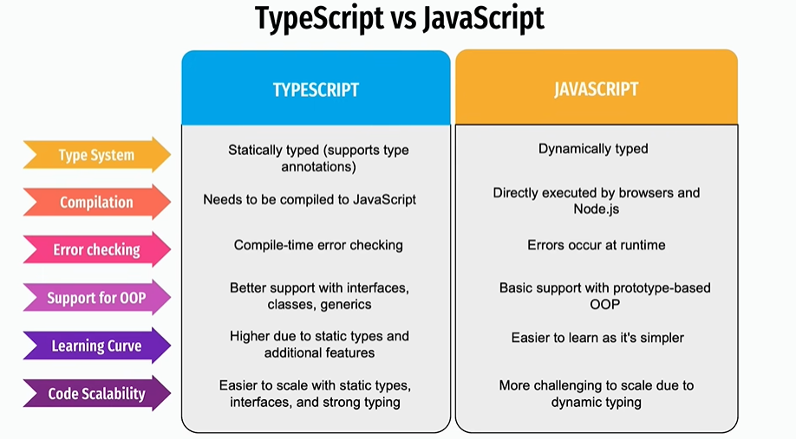

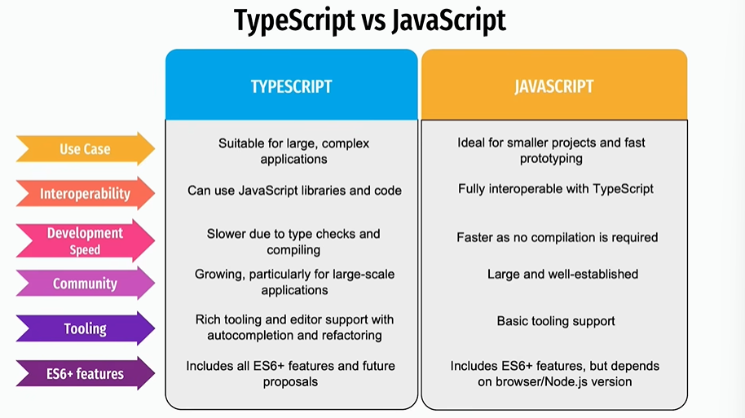

**How typescript works?**

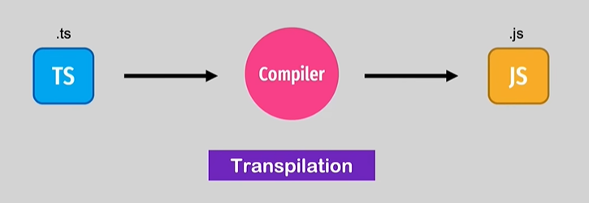

**Why TypeScript Compiles to JavaScript ?**

=>JavaScript is the language that browsers and Nodes.js understand natively

=>Browsers cannot directly execute TypeScript code. So it needs to be converted into JavaScript. This process is called Transpilation.

=>key Reasons:

JavaScript Compatibility

Cross-Platform Execution

Leveraging JavaScript Libraries

Backward Compatibility

Type Safety without Runtime Changes

**JavaScript Compatibility**

=>Why?:TypeScript is a superset of JavaScript, meaning it add extra­­ features(Like static typing) on top of JavaScript’s syntax. However, under the hood, it’s still JavaScript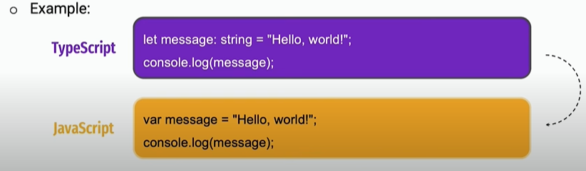

=>Here, the: string type annotation in Typescript is removed during compilation, leaving regular JavaScript.

**Cross-Platform Execution**

=>Why? JavaScript runs in every browser and on many platforms like Node.js So, converting TypeScript into JavaScript ensures the code will run on all these platforms without any extra dependencies

=>Example: A web application developed with typescript will be converted to JavaScript so that it can be run on all browers, no matter if they support TypeScript or not

Leveraging JavaScript Libraries

=>Why?: Many Libraries, like React, JQuery, or D3.js, are written in JavaScript. By compiling to JavaScript, TypeScript can easily integrate with these libraries without any special changes.

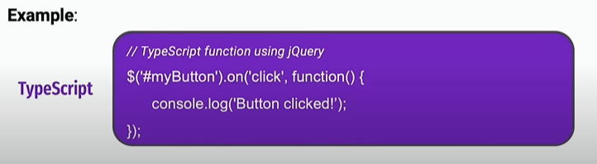

This will compile into JavaScript and work seamlessly with JQuery

**Backward Compatibility**

Why?: TypeScript supports modern JavaScript features (ES6+) even when older

Browsers might not. During compilation, TypeScript converts these modern features into a form that older browsers can understand

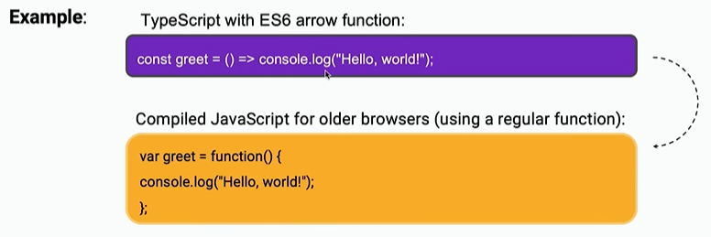

**Type Safety without Runtime Changes**

=>Why?: TypeScript’s static types help developers catch errors during development but don’t affect the performance of the running code. The types

are stripped away in the final JavaScript, so there’s no overhead when the program runs.



Conclusion

=>TypeScript compiles to JavaScript to ensure the code can run on any environment that supports JavaScript, maintain compatibility with existing JavaScript libraries, and leverage static typing and modern features without sacrificing runtime performance

