Лабораторная работа №6

Вариант 53

**Взвешенный граф:**

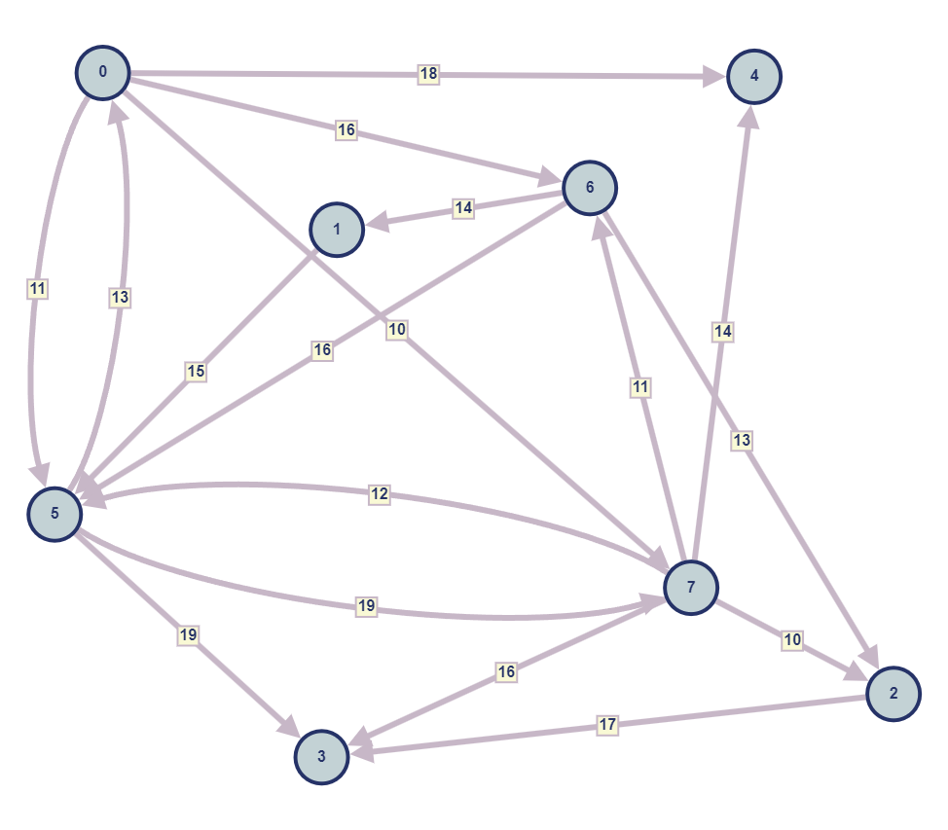



**Матрица инцидентности:**

|  |  |  |  |  |  |  |  |  |
| --- | --- | --- | --- | --- | --- | --- | --- | --- |
| вершина  ребро | 0 | 1 | 2 | 3 | 4 | 5 | 6 | 7 |
| 0 | 1 | 0 | 0 | 0 | -1 | 0 | 0 | 0 |
| 1 | 1 | 0 | 0 | 0 | 0 | -1 | 0 | 0 |
| 2 | -1 | 0 | 0 | 0 | 0 | 1 | 0 | 0 |
| 3 | 1 | 0 | 0 | 0 | 0 | 0 | 0 | 0 |
| 4 | 1 | 0 | 0 | 0 | 0 | 0 | -1 | 0 |
| 5 | 0 | 0 | 0 | 0 | -1 | 0 | 0 | 1 |
| 6 | 0 | -1 | 0 | 0 | 0 | 0 | 1 | 0 |
| 7 | 0 | 1 | 0 | 0 | 0 | -1 | 0 | 0 |
| 8 | 0 | 0 | 0 | 0 | 0 | -1 | 1 | 0 |
| 9 | 0 | 0 | 0 | 0 | 0 | 0 | -1 | 1 |
| 10 | 0 | 0 | -1 | 0 | 0 | 0 | 1 | 0 |
| 11 | 0 | 0 | 0 | 0 | 0 | -1 | 0 | 1 |
| 12 | 0 | 0 | 0 | 0 | 0 | 1 | 0 | -1 |
| 13 | 0 | 0 | 0 | -1 | 0 | 1 | 0 | 0 |
| 14 | 0 | 0 | 0 | -1 | 0 | 0 | 0 | 1 |
| 15 | 0 | 0 | -1 | 0 | 0 | 0 | 0 | 1 |
| 16 | 0 | 0 | 1 | -1 | 0 | 0 | 0 | 0 |

**Матрица смежности:**

в

из

|  |  |  |  |  |  |  |  |  |
| --- | --- | --- | --- | --- | --- | --- | --- | --- |
|  | 0 | 1 | 2 | 3 | 4 | 5 | 6 | 7 |
| 0 | 0 | 0 | 0 | 0 | 0 | 1 | 0 | 0 |
| 1 | 0 | 0 | 0 | 0 | 0 | 0 | 1 | 0 |
| 2 | 0 | 0 | 0 | 0 | 0 | 0 | 1 | 1 |
| 3 | 0 | 0 | 1 | 0 | 0 | 1 | 0 | 1 |
| 4 | 1 | 0 | 0 | 0 | 0 | 0 | 0 | 1 |
| 5 | 1 | 1 | 0 | 0 | 0 | 0 | 1 | 1 |
| 6 | 1 | 0 | 0 | 0 | 0 | 0 | 0 | 1 |
| 7 | 1 | 0 | 0 | 0 | 0 | 1 | 0 | 0 |

**Является ли граф Эйлеровым?**

Нет, не является.

Результат работы программы:

