**CSC 481 / 581, Assignment #1**

*Intro to Version Control, Build Systems, and Project Documentation*

**Intro**

In this assignment, we will explore UML for documenting an open source project. In order to do that, we will need to first clone a repository (create a developer workspace) and then use the code-base’s build system to produce a binary for execution.

Additionally, you will be introduced to an online tool for configuration management (bug-tracking, documentation, and code review) called Phabricator. You will also use Git, a version management application.

Importantly, in order to learn best practices from professional developers, you will attend developer meetings using *Internet Relay Chat* (IRC).

**Open Source**

The best way to learn the professional software engineering practice, is to participate via a well-funded open source project. The largest projects are essentially distributed companies, employing talented developers. Any contributions you make yourself to the project, will be recorded in its source control system, and therefore visible to potential employers. Thus, you can also begin a portfolio for your resume.

For the assignments in this course, we will use the open source project called Blender. Blender’s configuration management software (a customized instance of Phabricator), can be found at:

<https://developer.blender.org/>

**Deliverables / Tasks**

1. Proof that you have cloned the Blender repository with Git.

*You will need to clone the Blender repository. In your local copy (at the top-level), you will create a new directory named 481581DOCS/. You will commit all of the deliverables for* ***Assignment #1*** *in 481581DOCS/.*

*When submitting this assignment, you will submit your repository which contains all of your deliverables in 481581DOCS/.*

2. Proof that you have registered an account @ developer.blender.org.

*Create a plain text file called blender-account.txt. In it, list your Blender username.*

3. IRC log of at least one developer meeting.

*The best way to attend meetings, if you aren’t able to attend in real-time, is to keep IRC running on your machine, and then copy and paste the meeting into a text file. You need to attend at least one meeting for this assignment. Meeting times are listed on* [*developer.blender.org*](https://developer.blender.org)*.*

*Note, while using a standalone IRC program will provide the most flexibility,* <https://webchat.freenode.net/> provides a web-based interface for freenode. This is where the #blendercoders channel is located.

4. Proof of building a Blender executable on your computer.

*Submit a screen capture (and placed in 481581DOCS/) of the output of the compilation step, and the executable file in the proper bin directory.*

*Visit* [*https://wiki.blender.org/wiki/Main_Page*](https://wiki.blender.org/wiki/Main_Page)*. There, you will find information on installing dependencies and building the Blender source tree.* ***If you have questions, ask the developers on IRC, in the #blendercoders channel on freenode. Is it important that you start asking developers for help, as this is an integral part of being a software engineer, i.e. the effective use of communication with members of a software development team****.*

5. Find and submit the architectural structural diagram on the Blender modules.

*This will be found somewhere on the Blender wiki, which is linked from developer.blender.org. A partial recolored image of this document looks like this (original is black):*

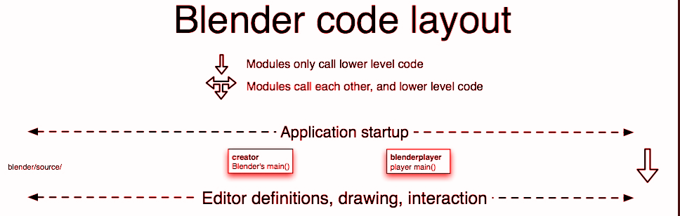

6. Join the mailing-list for blender developers. Submit proof (email response) from joining the mailing list.

*Information on how to join the mail-list will be found on the Blender wiki.*

7. Find a bug reported on the bug-tracker, and take a screen capture of the information found on the bug.