Bone stories - Educational kit

Activity 1
Find the astragalus
An investigation to identify the talus/astragalus in the foot, understand its place in the tarsus and transfer this landmark to other mammals.
Audience  8-12 years old | Duration  30-60 mins | Content  Guide, sheet, supports, correction | Length  To calculate

In this kit
- Facilitator guide
- Learner sheet
- Observation support
- Answer key and leads
- Sources and credits
Pilot version - content to be tested and proofread before final release.
Recommended printing: guide and correction for adults; student sheet in one copy per student; supports to be projected or printed in color. The kit also works in grayscale. Double-sided possible, long edge reversal.
Version: 1.0 pilot - July 20, 2026.

Bone Stories - Activity 1

Facilitator guide
Find the astragalus
Operational guide for conducting an observational survey in a classroom or museum.
Type  Facilitator guide | Audience  Supervising adults | Duration  30-60 mins | Version  Pilot 1.0
Pilot version - content to be tested and proofread before final release.

1. In brief
The students observe an isolated bone, describe its reliefs, look for its position in the foot then justify their location with at least two clues. The comparison with the sheep or the cow allows us to transfer the landmark without assuming that the members have the same shape.

2. Objectives
- Locate the talus/astragalus in the tarsus region.
- Describe a shape before naming it.
- Link position, joint surfaces and movement.
- Compare humans and other mammals with caution.

3. Expected success
Successful  The tarsus region is identified and two clues are explained. | In progress  The area is plausible, but only one clue is formulated. | To resume  The answer is based on name or chance, without observation.

4. Duration and material
Context | Duration | Material
Class | 45-60 mins | Learner sheet, pencils, printed or projected materials.
Museum | 30-45 mins | Display case, skeleton, photograph or authorized replica.

5. Quick preparation
Print one sheet per student. Keep the fix out of view. Prepare the vocabulary: foot, tarsus, talus/astragalus, joint, clue.
“Describe first. Then search. Justify with two clues. »

6. Detailed procedure
Time | Adult action | Student action | Purpose
5 mins | Present the bone without giving its location. | Formulate initial ideas. | Bring out representations.
10 mins | Request a description without a name. | Note bumps, hollows, surfaces and symmetry. | Install observation.
10-15 mins | Have the tarsus region searched. | Circle an area and write two clues. | Locate and justify.
10 mins | Distribute animal views. | Compare position and organization of the limb. | Transfer the landmark.
5-10 mins | Discuss the findings as a group. | Write a cautious conclusion. | Distinguish observation and hypothesis.

7. Questions and reminders
To observe  - What do you see without naming the bone?  - Where are the smooth surfaces?  - Which parts seem to fit together? | To justify  - What detail supports your proposition?  - What is missing to be sure?  - Does your second clue confirm the first?

8. Responses or expected elements
- The talus/astragalus is located in the tarsus, between the leg and the rest of the foot.
- Its smooth articular surfaces indicate contacts with other bones.
- In other mammals, a comparable bone exists, but the limb and proportions differ.
- A good answer describes the clues before announcing the location.

9. Differentiation
Need | Adaptation
Help | Limit the search to the area between leg and foot; provide the word bank.
Lighten the writing | Allow an oral or dictated response to a peer.
Go deeper | Compare three mammals and discuss differences in posture.

10. Museum adaptation
Use the sheet as a short station in front of a window, a photograph, a skeleton or a replica. Ask to locate a region of the limb rather than an isolated bone. An image or replica does not entirely replace the original. No heritage object is handled without authorization and protocol from the institution.

11. Quick assessment
Produce an output sentence: "I locate the talus/astragalus in... because I observe... and...". Check the presence of a location and two clues.

12. Common mistakes
Don't say that the talus is the visible heel. Do not use a simple silhouette likeness as proof of identification.
- Confuse the talus/astragalus with the calcaneus.
- Show an area without justification.
- Assume that all mammals have a foot identical to ours.

13. Sources and limits
The views of the talus come from BodyParts3D / DBCLS. Animal supports are anatomical images or historical plates credited in the support. The LeConte 1922 plate is old and does not replace a validated modern anatomical diagram. This activity introduces a method of observation; it does not train in expert anatomical identification.

14. Current status and remaining validations
Sheet and materials ready for a supervised test. Final scientific and educational proofreading, testing with students and physical printing still necessary. A modern anatomical diagram validated by the project remains recommended.

Print plan

Bone Stories - Activity 1

Learner sheet
Find the astragalus
Type  Learner sheet | Audience  8-12 years old | Duration  30-45 mins | Version  Pilot 1.0
Pilot version - content to be tested and proofread before final release.
Your missionFind where the talus/astragalus is hidden in the foot and explain your answer with visible clues.
Objective: learn to observe a bone, suggest a location and explain what makes you think that.
Material: this sheet, a pencil and the observation support.

1. Describe before guessing
- Look at the bone from several angles.
- Write at least three details: shape, bumps, hollows or smooth surfaces.

Word bank: rounded - hollow - bump - smooth surface - narrow - wide - joint.

2. Find your place
On the support, landmark the area between the leg and the rest of the foot. Circle where you would place the bone.
I observe  Write what is really visible. | I guess  Write where the bone might be.

3. Justify with two clues
clue 1:

clue 2:

4. Compare with another mammal
What is similar | What changes | What I still need to check

5. My final trace
Complete: “I locate the talus/astragalus in ____________. My two clues are ____________ and ____________. »

An observation describes what you see. A hypothesis offers an explanation or a location. The two are not the same thing.

Bone Stories - Activity 1

Observation support
Find the astragalus
To project or print. Captions and credits must remain associated with the images.
Type  Visual support | Audience  Learners and groups | Usage  Projection or printing | Version  Pilot 1.0
Pilot version - content to be tested and proofread before final release.

1. Observe the human talus
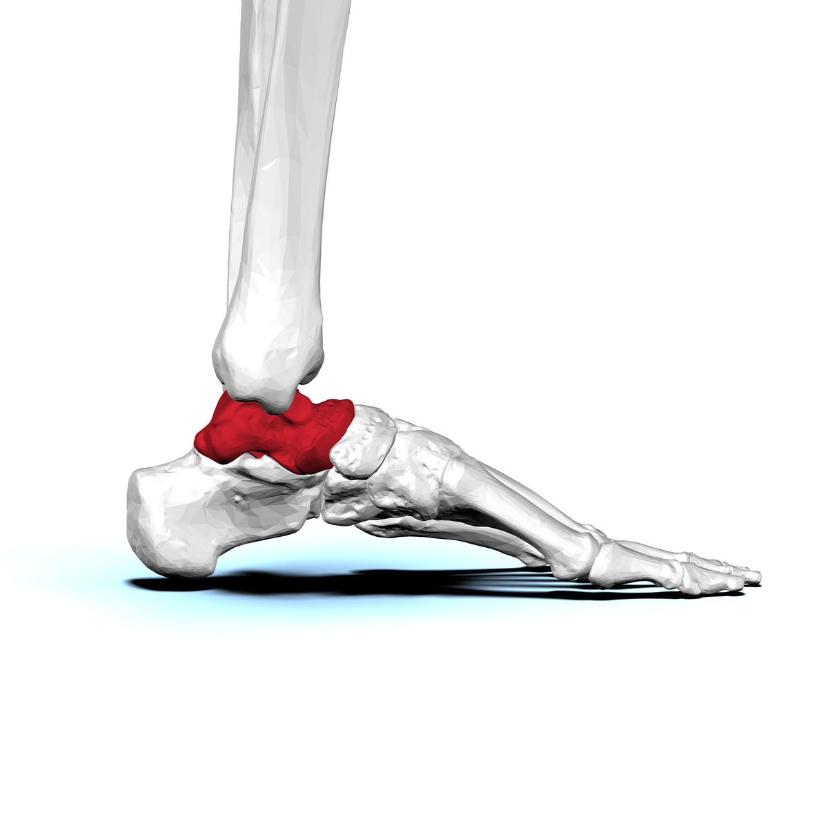
view side. The visible shape depends on the angle.BodyParts3D / DBCLS, CC BY-SA 2.1 JP, via Wikimedia Commons.
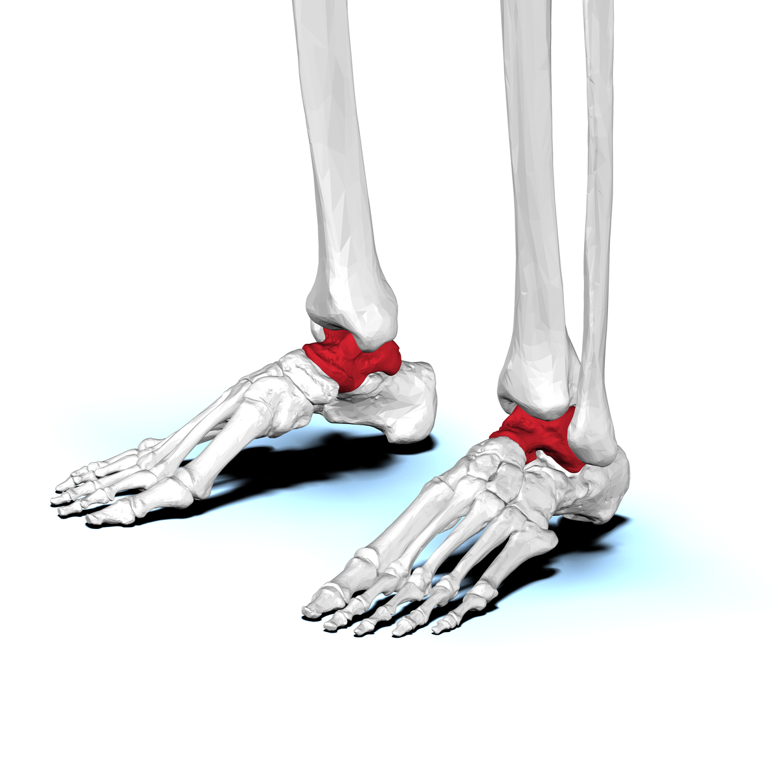
view anterolateral. Observe reliefs and joint surfaces.BodyParts3D / DBCLS, CC BY-SA 2.1 JP, via Wikimedia Commons.
Red is only used to identify the bone in these visualizations. Also rely on the legends: the information remains readable in grayscale.

2. Switch to sheep
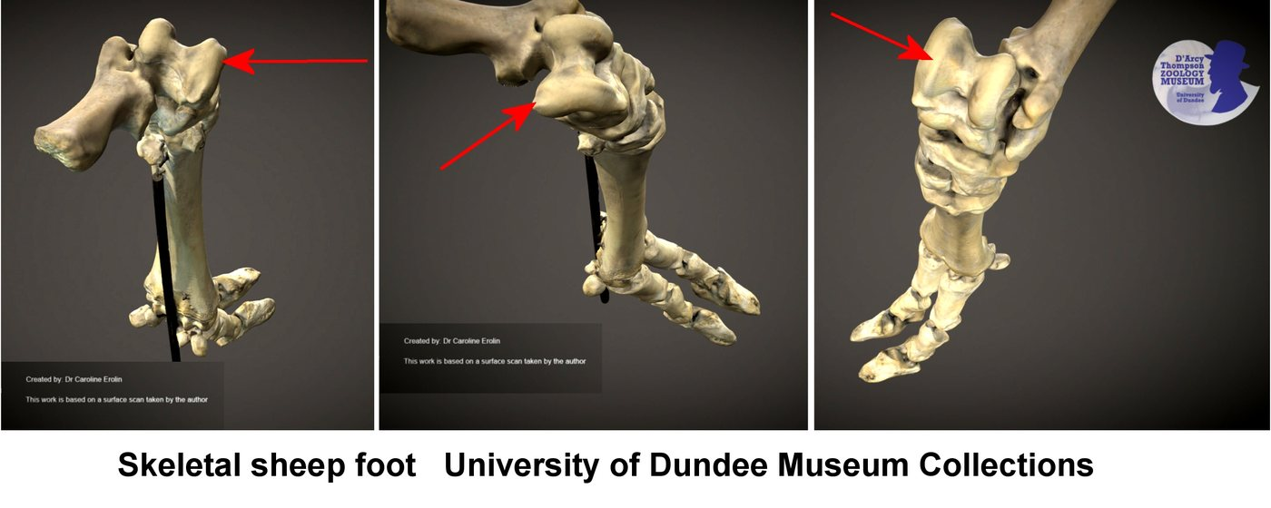
Annotated sheep's foot. Look for the tarsus region.Caroline Eroline, CC BY-SA 4.0, via Wikimedia Commons.
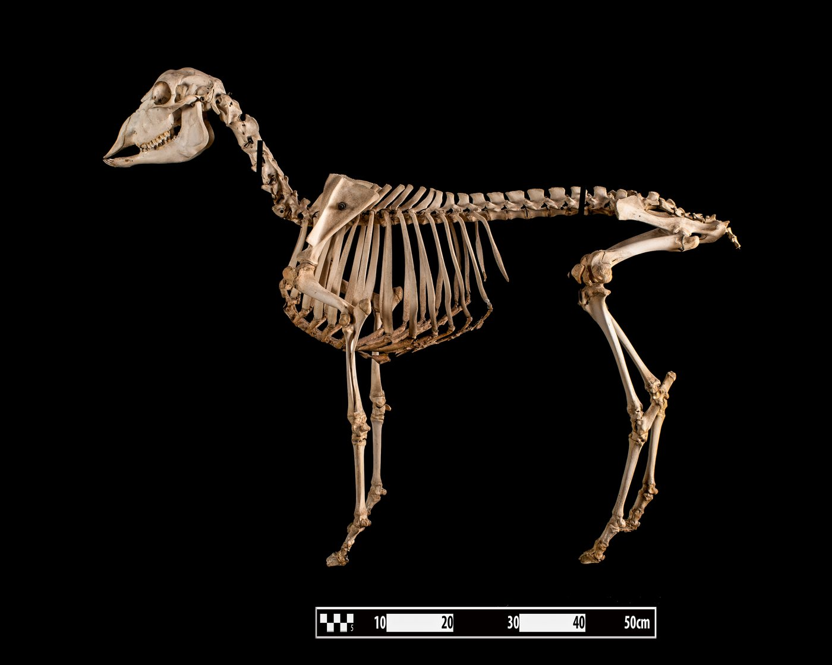
Sheep skeleton. Replace the foot in the hind limb.Museum of Veterinary Anatomy FMVZ USP / Wagner Souza e Silva, CC BY-SA 4.0.

3. Compare with caution
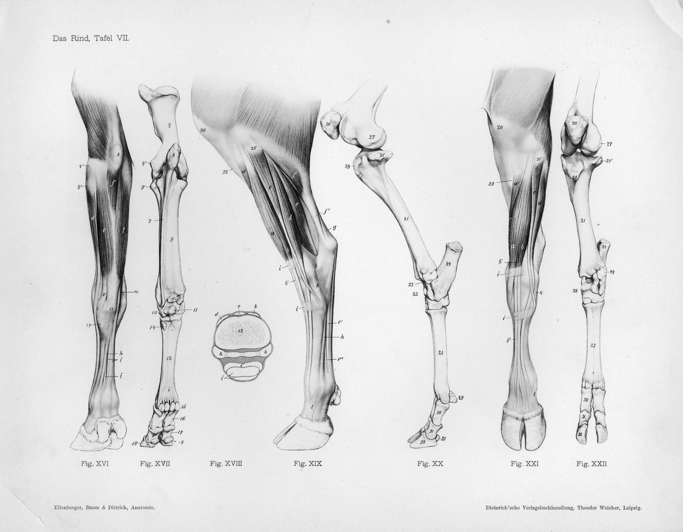
Old cow leg diagram. Comparison support, not modern project diagram.Ellenberger, Baum and Dittrich, public domain, via Wikimedia Commons.
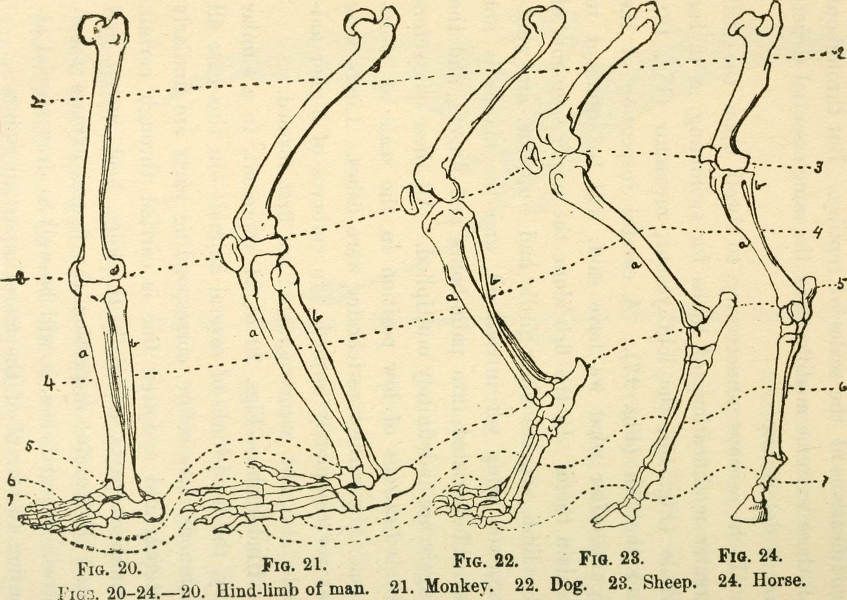
Comparative plate from 1922. Helps to observe; does not replace a validated modern anatomical reference.Internet Archive Book Images, no known restrictions, via Wikimedia Commons.

Bone Stories - Activity 1

Answer key and leads
Find the astragalus
Type  Adult answer key | Audience  Teachers and museum educators | Usage  Group review | Version  Pilot 1.0
Pilot version - content to be tested and proofread before final release.

landmarks fast
Form stage | Expected response | Possible answer | To resume
Describe | Three observable characteristics. | Rounded, smooth surfaces, hollows, reliefs. | “It’s a foot bone” without description.
Locate | Tarsus region, between leg and foot. | “Near the ankle, in the foot” if justified. | “In the visible heel” without nuance.
Justify | Two clues linked to the proposition. | Position and joint surfaces. | General resemblance only.
Compare | A similarity and a difference. | Comparable bone, different proportions. | “All feet are the same.”

Formulations adapted to students
Solid response  “I think the bone is in the tarsus because it is placed between the leg and foot and has several smooth surfaces that articulate with other bones. » | Cautious response  “This area is likely, but I would like to compare with a complete skeleton to verify. »

Common errors and correction
- talus = heel visible: remember that the talus is a deep tarsal bone.
- One image is enough: compare several views before concluding.
- Similarity = proof: request a second clue and a reference.

Scientific limits
The sheet allows an introductory anatomical identification. It does not replace either anatomical training or an osteological reference corpus. The talus/astragalus vocabulary is deliberately explained; the terminology depends on the anatomical, historical or archaeological context.
Have the final formulations reread, test comprehension by students and confirm the choice of the future anatomical diagram of the project.

Bone Stories - Activity 1

Sources and credits
This page belongs to the complete kit. It allows you to use the documents without consulting the site.

Pictures
- talus human, views fixed: BodyParts3D / DBCLS, CC BY-SA 2.1 JP, via Wikimedia Commons.
- Sheep's foot: Caroline Eroline, CC BY-SA 4.0, via Wikimedia Commons.
- Sheep skeleton: Museum of Veterinary Anatomy FMVZ USP / Wagner Souza e Silva, CC BY-SA 4.0.
- Old cow leg diagram: Ellenberger, Baum and Dittrich, public domain.
- Comparative plate LeConte 1922: Internet Archive Book Images, no known restrictions.

landmarks scientists
- NCBI Bookshelf, Anatomy, Bony Pelvis and Lower Limb: Foot talus, landmarks general anatomical.
- BodyParts3D / DBCLS, anatomical visualizations used as localization support.

Status
Pilot version. credits integrated; scientific, educational proofreading and physical printing test still necessary. The 1922 plate remains clearly presented as an old document.
Working translation: specialist scientific, educational and legal wording requires human review.
Traceability : https://histoire-d-os.github.io/Histoire-d-os/en/ressources/activite-01-trouver-astragale.html

