Bone Stories - Activity 1

Observation support
Find the astragalus
To project or print. Captions and credits must remain associated with the images.
Type  Visual support | Audience  Learners and groups | Usage  Projection or printing | Version  Pilot 1.0
Pilot version - content to be tested and proofread before final release.

1. Observe the human talus
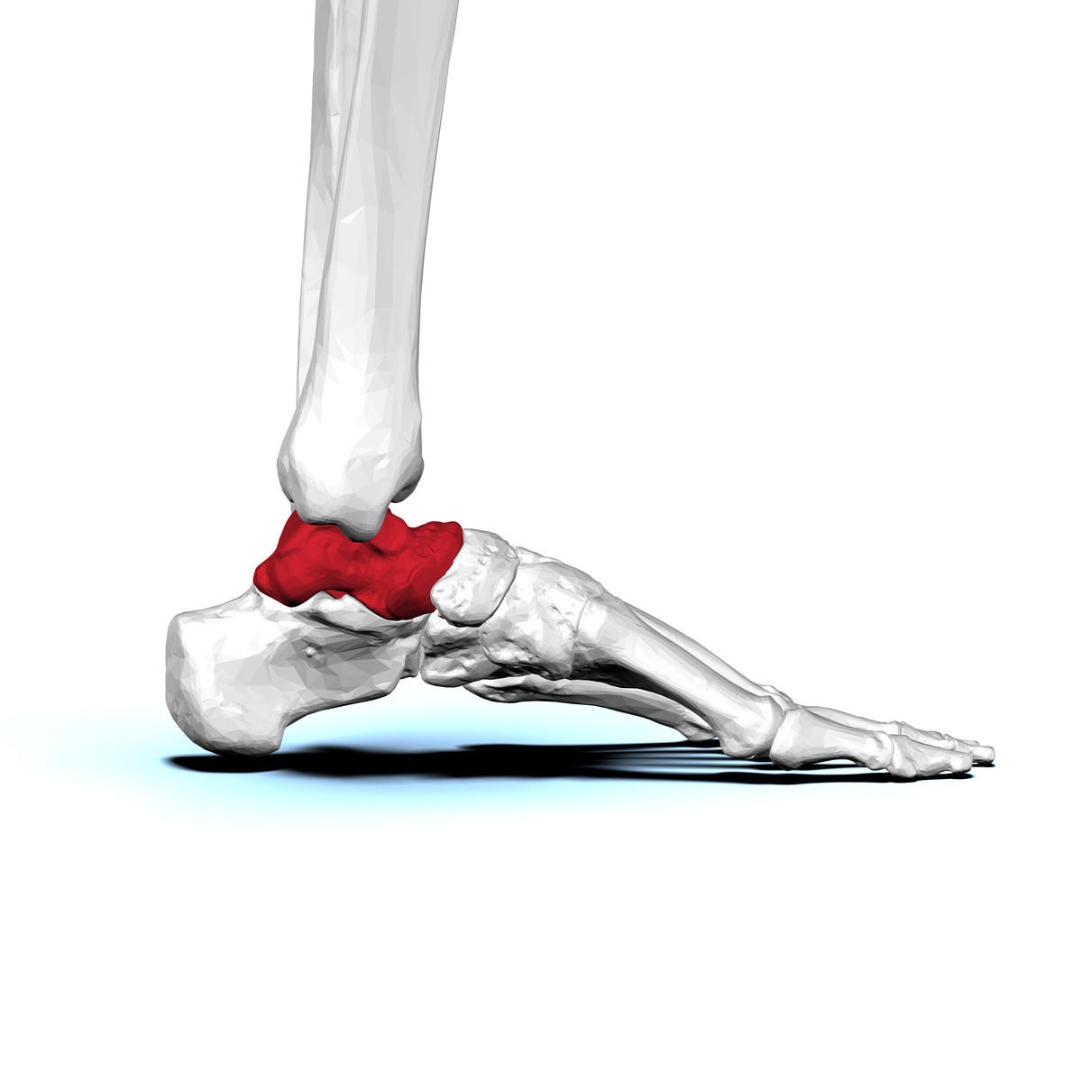
view side. The visible shape depends on the angle.BodyParts3D / DBCLS, CC BY-SA 2.1 JP, via Wikimedia Commons.
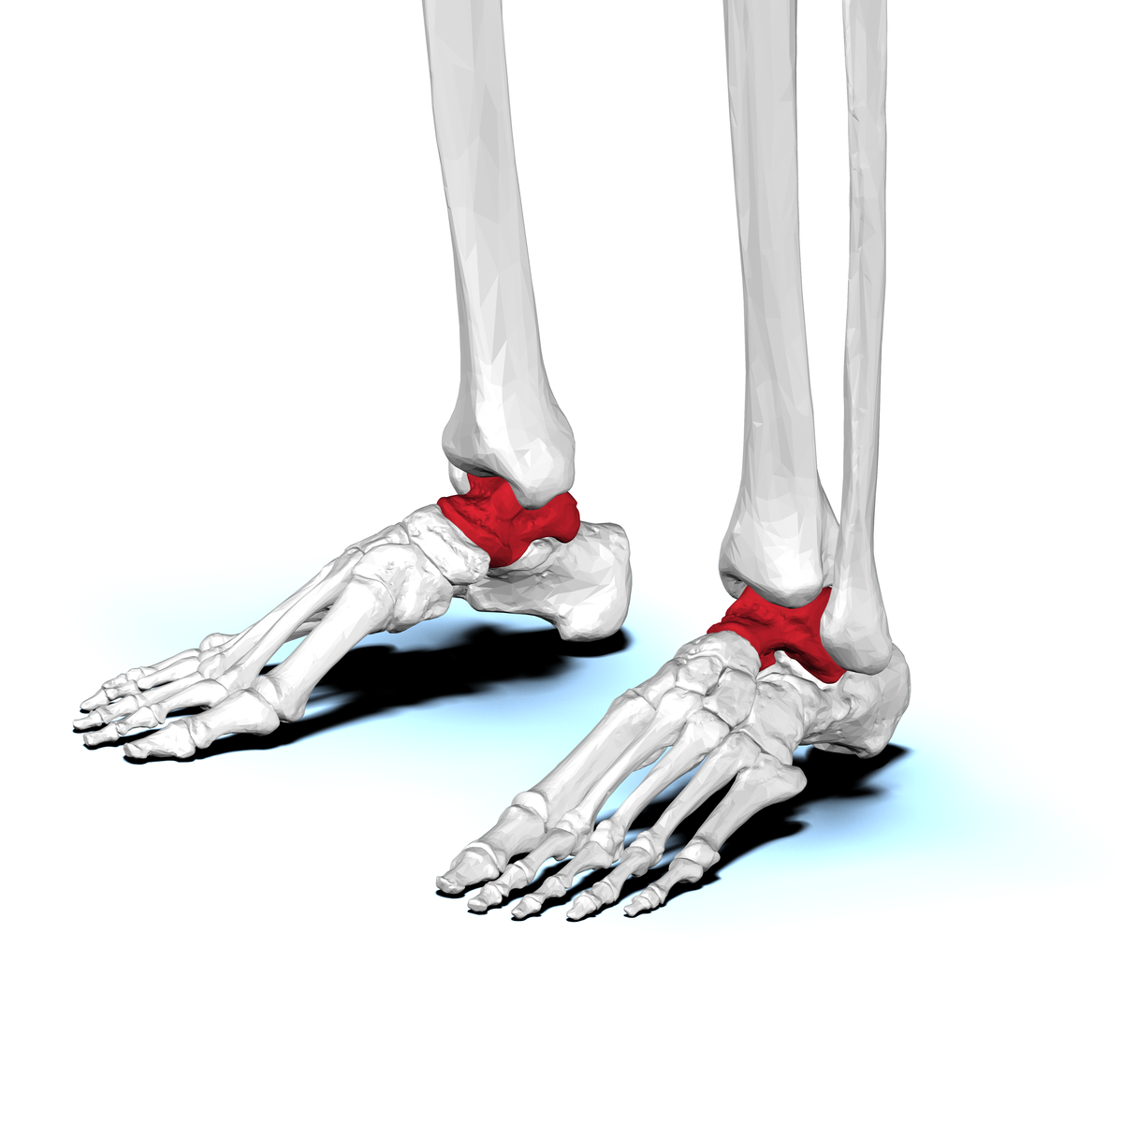
view anterolateral. Observe reliefs and joint surfaces.BodyParts3D / DBCLS, CC BY-SA 2.1 JP, via Wikimedia Commons.
Red is only used to identify the bone in these visualizations. Also rely on the legends: the information remains readable in grayscale.

2. Switch to sheep
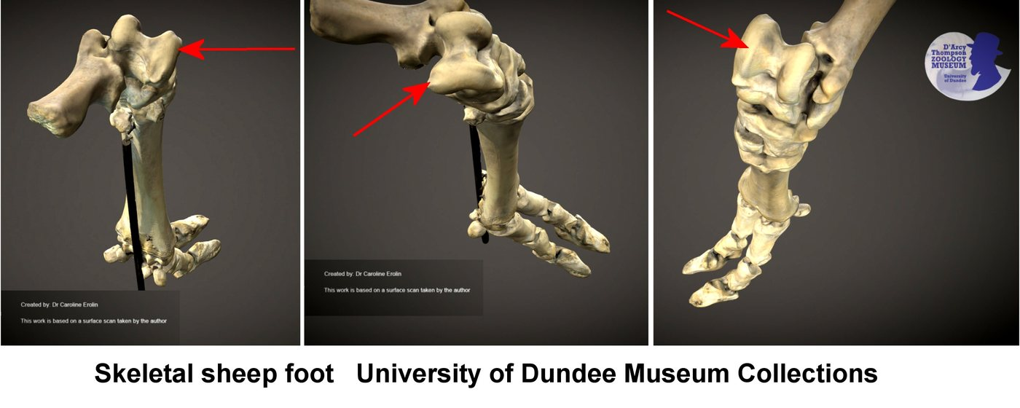
Annotated sheep's foot. Look for the tarsus region.Caroline Eroline, CC BY-SA 4.0, via Wikimedia Commons.
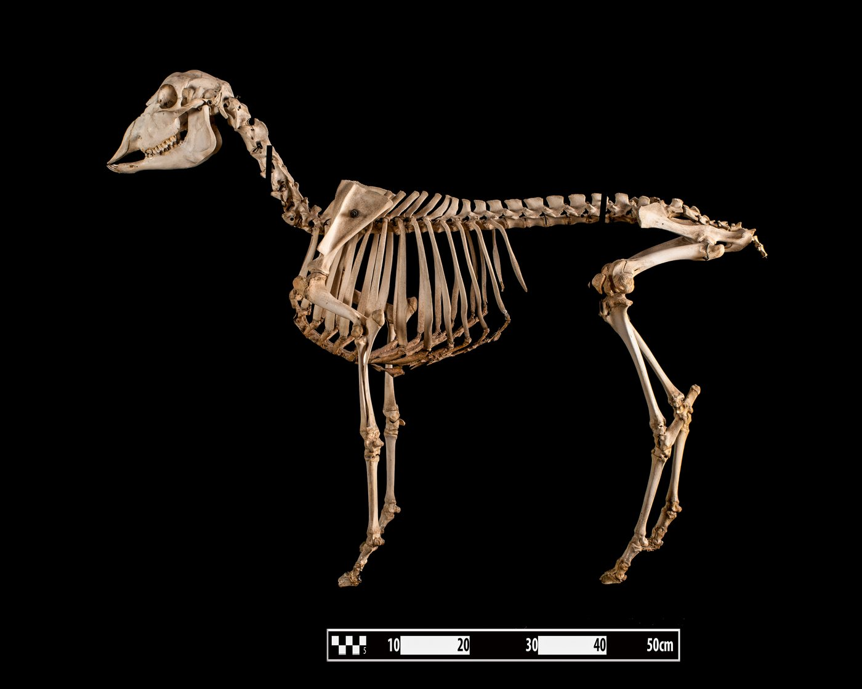
Sheep skeleton. Replace the foot in the hind limb.Museum of Veterinary Anatomy FMVZ USP / Wagner Souza e Silva, CC BY-SA 4.0.

3. Compare with caution
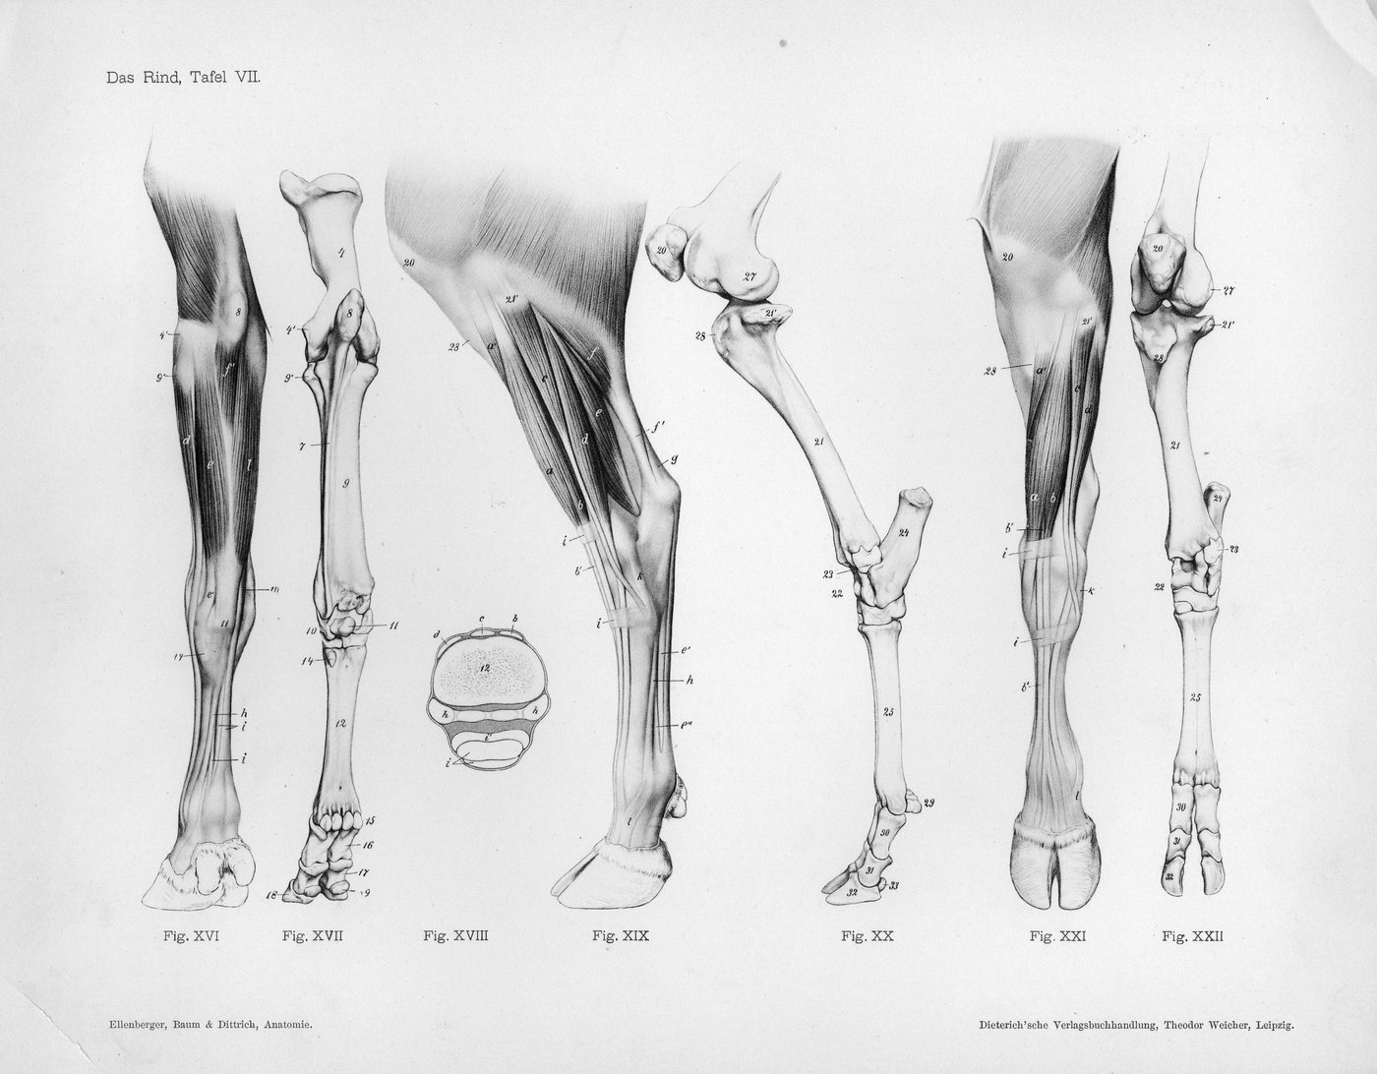
Old cow leg diagram. Comparison support, not modern project diagram.Ellenberger, Baum and Dittrich, public domain, via Wikimedia Commons.
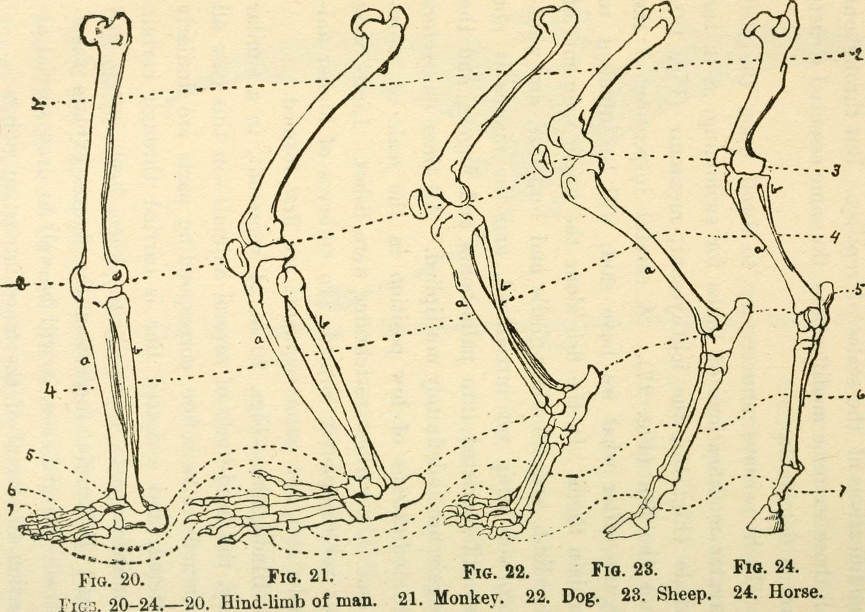
Comparative plate from 1922. Helps to observe; does not replace a validated modern anatomical reference.Internet Archive Book Images, no known restrictions, via Wikimedia Commons.
Traceability : https://histoire-d-os.github.io/Histoire-d-os/en/ressources/activite-01-trouver-astragale.html

