Bone stories - Educational kit

Activity 2
Associate an astragalus with an animal
A comparative investigation to describe a bone, bring together clues and defend a hypothesis without transforming a proposition into certainty.
Audience  8-12 years old | Duration  45-60 mins | Content  Guide, sheet, maps, trails | Length  To calculate

In this kit
- Facilitator guide
- Learner sheet
- Animal cards
- Neutral locations A-D
- Method correction
- Sources and credits
Pilot version - corpus of astragali A-D, identification and final correction to be validated.
Recommended printing: sheet for each student; animal cards and A-D cards for each group; guide and correction for adults. Cutting cards. Front side recommended for cards, double-sided long edge for the rest.
Color: recommended for animals, but the names and frames make the media usable in grayscale.
Version: 1.0 pilot - July 20, 2026.

Bone Stories - Activity 2

Facilitator guide
Associate an astragalus with an animal
Guide to learning how to argue a possible association, without requiring expert identification.
Type  Facilitator guide | Audience  Supervising adults | Duration  45-60 mins | Version  Pilot 1.0
Pilot version - corpus of astragali A-D, identification and final correction to be validated.

1. In brief
In groups, the students describe four bones A-D, compare them to possible animals then formulate a reasoned association. In this version, cards A-D are neutral locations: the session trains the method, not the identification of species.

2. Objectives
- Describe a shape without guessing.
- Compare multiple visible clues.
- Formulate a hypothesis with a degree of certainty.
- Name the references needed to verify.

3. Expected success
Successful  Two clues support the association and one uncertainty is named. | In progress  An association is proposed with a single clue. | To resume  The choice rests on the assumed size or chance.

4. Duration and material
Context | Duration | Material
Class | 45-60 mins | Sheet, animal cards, A-D cards, pencils.
Museum | 30-45 mins | Replicas, educational bones or validated photographs; animal cards.

5. Quick preparation
Cut out the animal cards. Use cards A-D only as templates until the scientific corpus is integrated. Do not prepare a specific response.
“Your job is not to guess. You must defend a hypothesis and say what is missing to verify it. »

6. Detailed procedure
Time | Adult action | Student action | Purpose
5 mins | Present the mission and caution vocabulary. | Read the degrees “possible”, “probable”, “to be verified”. | Lay down the rules of the game.
10 mins | Distribute an A-D card without an animal. | Describe shape, reliefs and surfaces. | Separate observation and attribution.
10 mins | Deal out the animal cards. | Compare locomotion, proportions and organization of the limb. | Build tracks.
15 mins | Request two clues and one limit. | Choose a possible association and argue it. | Explain the reasoning.
10 mins | Put the groups in debate. | Compare the propositions and the missing information. | Understand validation.

7. Questions and reminders
Observe  - What is wide or narrow?  - What surfaces appear articular?  - Which view should be added? | Argue  - Does your clue exclude an animal?  - What other explanation is possible?  - What measurement would help verify?

8. Responses or expected elements
No A-D attribution is expected in this release. The expected productions are verifiable descriptions, an association formulated as a hypothesis, at least two clues and a list of missing information: orientation, scale, species, provenance and comparison to a reference corpus.

9. Differentiation
Need | Adaptation
Help | Reduce to two animals and provide the word bank.
Lighten the writing | Have the argument recorded or dictated.
Go deeper | Have the clues classified from the weakest to the strongest.

10. Museum adaptation
Only use a manipulatable object if museum rules allow it. Otherwise, use an oriented photograph, showcase or replica. Adapt the species to the corpus actually available; never let people believe that a museum necessarily owns the collections mentioned.

11. Quick assessment
Request a sentence comprising four elements: possible association, clue 1, clue 2, information to be verified. Evaluate the quality of the reasoning rather than the name chosen.

12. Common mistakes
Do not present the size of the animal as a sufficient criterion. Do not announce cash for empty A-D cards. Do not confuse resemblance and identification.
- Choose your favorite animal.
- Deduce the species from a single curve.
- Forget orientation and scale.
- Use “certain” without reference.

13. Sources and limits
Zeder and Lapham (2010) show the limits of isolated morphological criteria for distinguishing certain postcranial bones of sheep and goats. A reliable attribution requires a reference corpus, an orientation, a scale and zooarchaeological validation. The bat remains an extension, outside the heart of the activity.

14. Current status and remaining validations
Corpus A-D not integrated. Species, photographs, metadata and final correction must be validated by a person competent in zooarchaeology. The interim scientific media documented in the redesign is explicitly excluded from these PDFs.

Print plan

Bone Stories - Activity 2

Learner sheet
Associate a bone with an animal
Type  Learner sheet | Audience  8-12 years old | Duration  45-60 mins | Version  Pilot 1.0
Pilot version - real bones A-D will be added after scientific validation.
Your missionCompare a bone A-D with several animals, propose a possible association and explain what still needs to be checked.
Objective: learn to argue without guessing and to say when an answer remains uncertain.
Material: an A-D card, the animal cards and a pencil.

1. Observe the bone without naming it
General form | Reliefs and hollows | Smooth surfaces | Question to ask

Word bank: wide - narrow - elongated - rounded - hollow - hump - articular surface - symmetrical.

2. Compare possible animals
Animal | clue which brings | clue which makes you hesitate
Horse
Sheep
Deer
Pork

3. Formulate your hypothesis
I suggest associating the ______ card with ____________________.
clue 1:

clue 2:

My level of confidence: ☐ possible ☐ probable ☐ to be verified

4. Say what is missing
To verify my hypothesis, I would need:

5. Final trace
Write a conclusion that contains the words “I observe”, “I suppose” and “I must check”.

An observation describes the bone. A hypothesis proposes an association. Identification requires references and validation.

Bone Stories - Activity 2

Supports and cards
Associate a bone with an animal
Animal cards to cut out and neutral locations for the future A-D corpus.
Type  Cards and media | Audience  Learner groups | Usage  Printing and cutting | Version  Pilot 1.0
Pilot version - scientific corpus A-D to be integrated after validation.

Animal cards
Horse 1  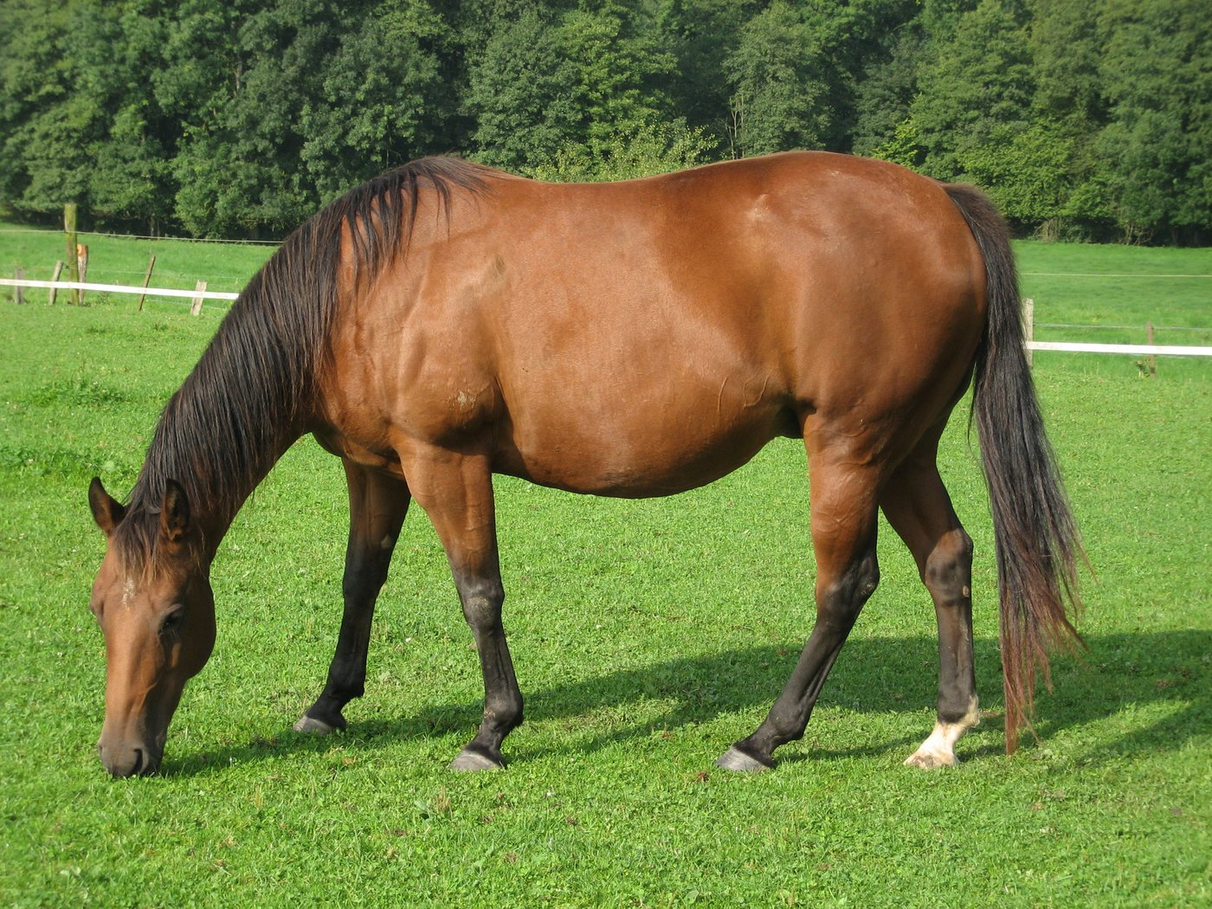  Observe the silhouette and the limb without deducing only the bone. | Sheep 2  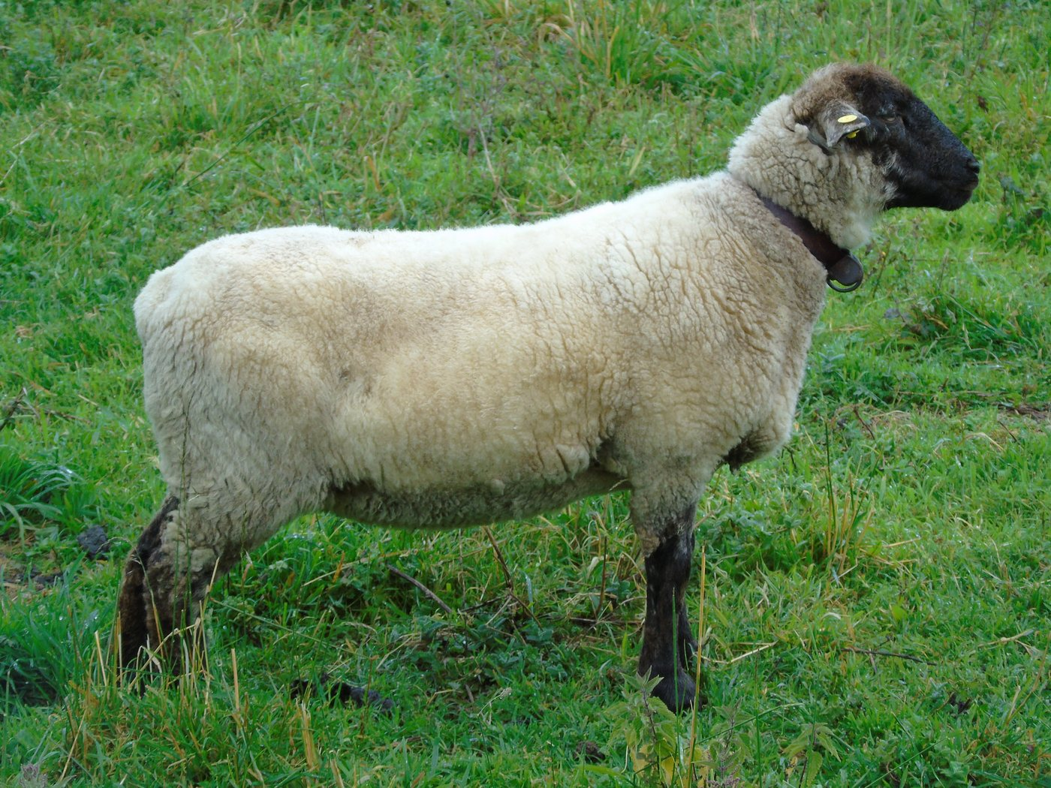  Small ruminant used as a possibility of comparison.
Deer 3  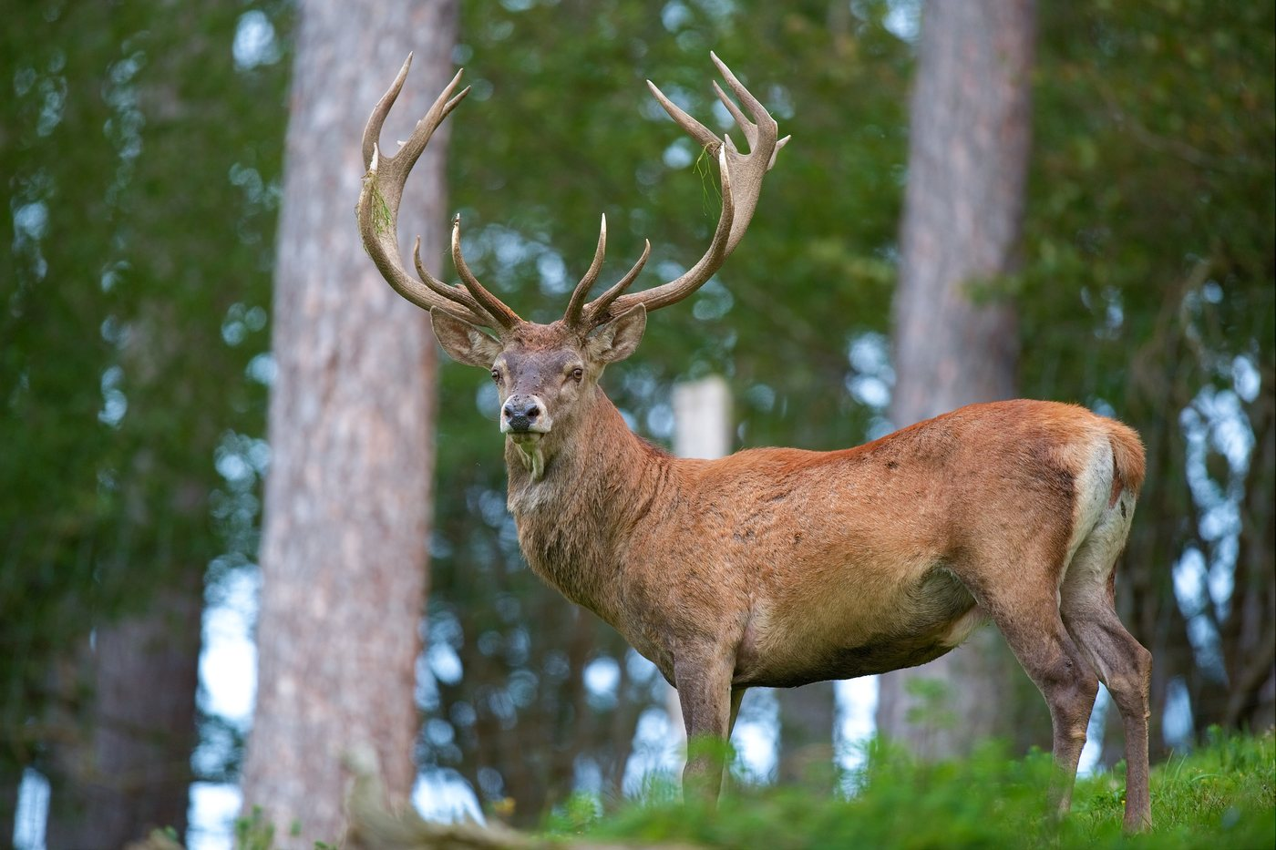  Deer presented without generalization to all species. | Pork 4  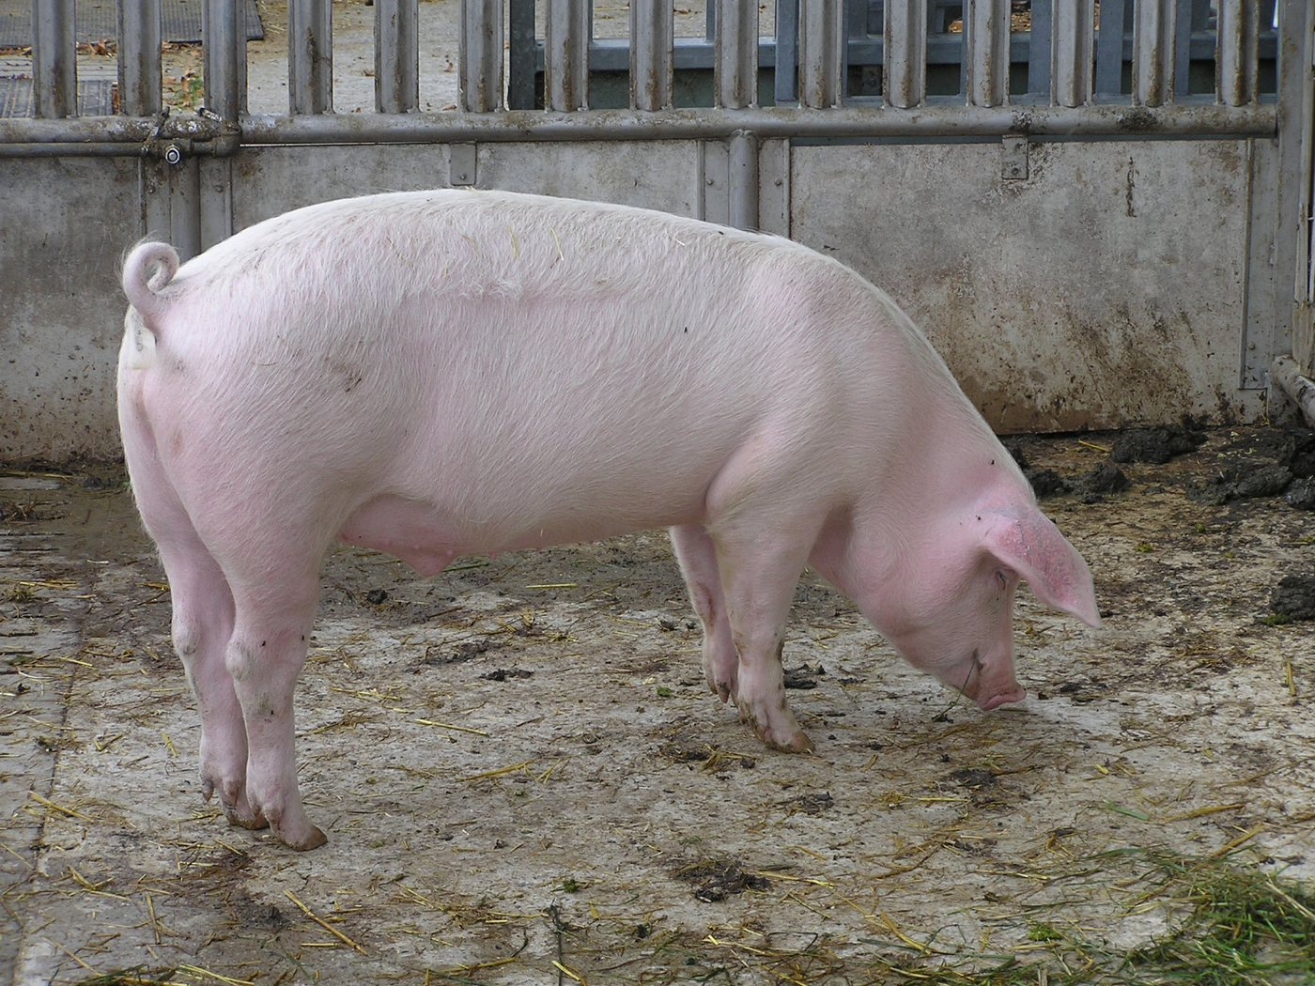  Whole animal: basis for comparison, not proof of identification.

Bone cards A-D - neutral templates
The photographs are not yet validated. Do not write species names on these cards before integration of the final corpus.
Bone A A | Bone B B
Bone C C | Bone D D
Scientific corpus to be integrated after validation.
Scientific corpus to be integrated after validation.
Scientific corpus to be integrated after validation.
Scientific corpus to be integrated after validation.

Bone Stories - Activity 2

Method correction
Associate a bone with an animal
Type  Adult guidance | Audience  Teachers and museum educators | Usage  Group review | Version  Pilot 1.0
Pilot version - no definitive A-D attribution before validation of the corpus.

Quick correction grid
Step | Expected response | Possible answer | Not to be validated alone
Observation | Several visible characteristics. | Width, reliefs, surfaces, proportions. | Animal name without description.
Comparison | clues linked to the cards. | Organization of the limb, locomotion, proportions. | General size of the animal.
Hypothesis | Association announced as possible. | “Probable according to these two clues”. | “It has to be…”.
Verification | At least one data missing. | orientation, scale, reference corpus. | New unsourced assumption.

Useful phrases
Expected response  “The association is possible because I observe two clues, but the species must be verified with a reference corpus. » | Possible answer  Two groups can propose different animals if their clues are explained and their limits recognized.

Common errors
- Confusing whole animal and shape of the bone.
- Forget scale or orientation.
- Taking a resemblance for identification.
- Transform the method answer key into a species key.

Scientific limits
Bones A-D are not present in this version. So there is no correct association to reveal. This answer only evaluates the approach: observe, compare, argue, verify.
Complete only after archaeozoological validation of the corpus, the notes on each bone and the criteria that can really be used with students.

Bone Stories - Activity 2

Sources, credits and limits
Keep with the complete kit.

Animal Pictures
- Horse: evelynbelgium, CC BY-SA 2.0, via Wikimedia Commons.
- Sheep: Fernando Losada Rodríguez, CC BY-SA 4.0, via Wikimedia Commons.
- Deer: Luc Viatour, CC BY-SA 3.0, via Wikimedia Commons.
- Pig: Joshua Lutz, public domain, via Wikimedia Commons.

Scientific references
- Melinda A. Zeder and Heather A. Lapham, “Assessing the reliability of criteria used to identify postcranial bones in sheep and goats,” Journal of Archaeological Science, 2010, DOI 10.1016/j.jas.2010.06.032.

Media excluded
The provisional comparative figure of Vuillien et al. is not integrated: its conditions of reuse have not been established. Cards A-D remain neutral until scientific and legal validation.

Status
Method support usable for a supervised test. Corpus, identification, final correction and physical printing test remain to be carried out.
Working translation: specialist scientific, educational and legal wording requires human review.
Traceability : https://histoire-d-os.github.io/Histoire-d-os/en/ressources/activite-02-associer-astragale-animal.html

