Bone Stories - Activity 2

Supports and cards
Associate a bone with an animal
Animal cards to cut out and neutral locations for the future A-D corpus.
Type  Cards and media | Audience  Learner groups | Usage  Printing and cutting | Version  Pilot 1.0
Pilot version - scientific corpus A-D to be integrated after validation.

Animal cards
Horse 1  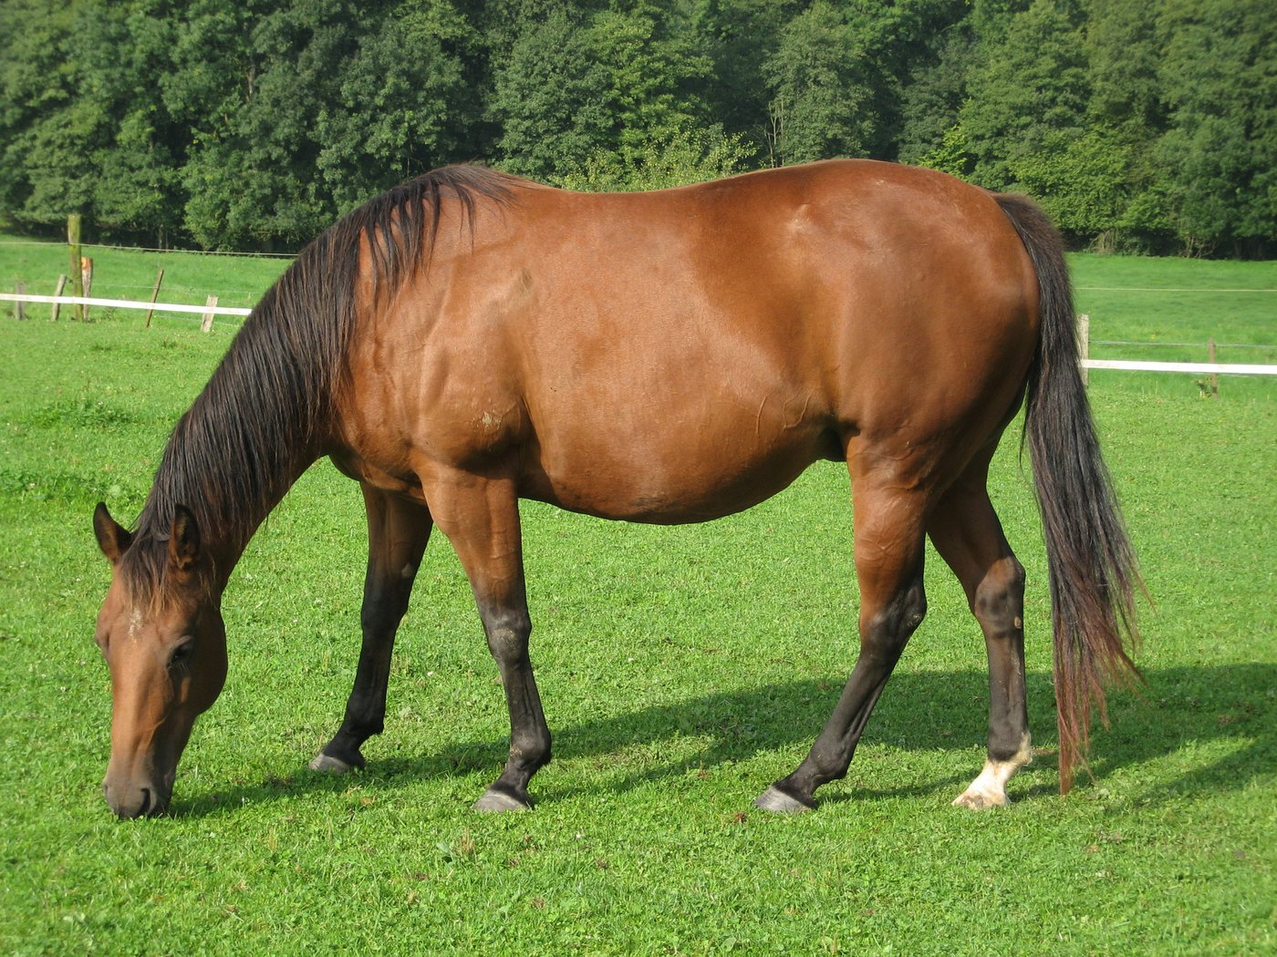  Observe the silhouette and the limb without deducing only the bone. | Sheep 2  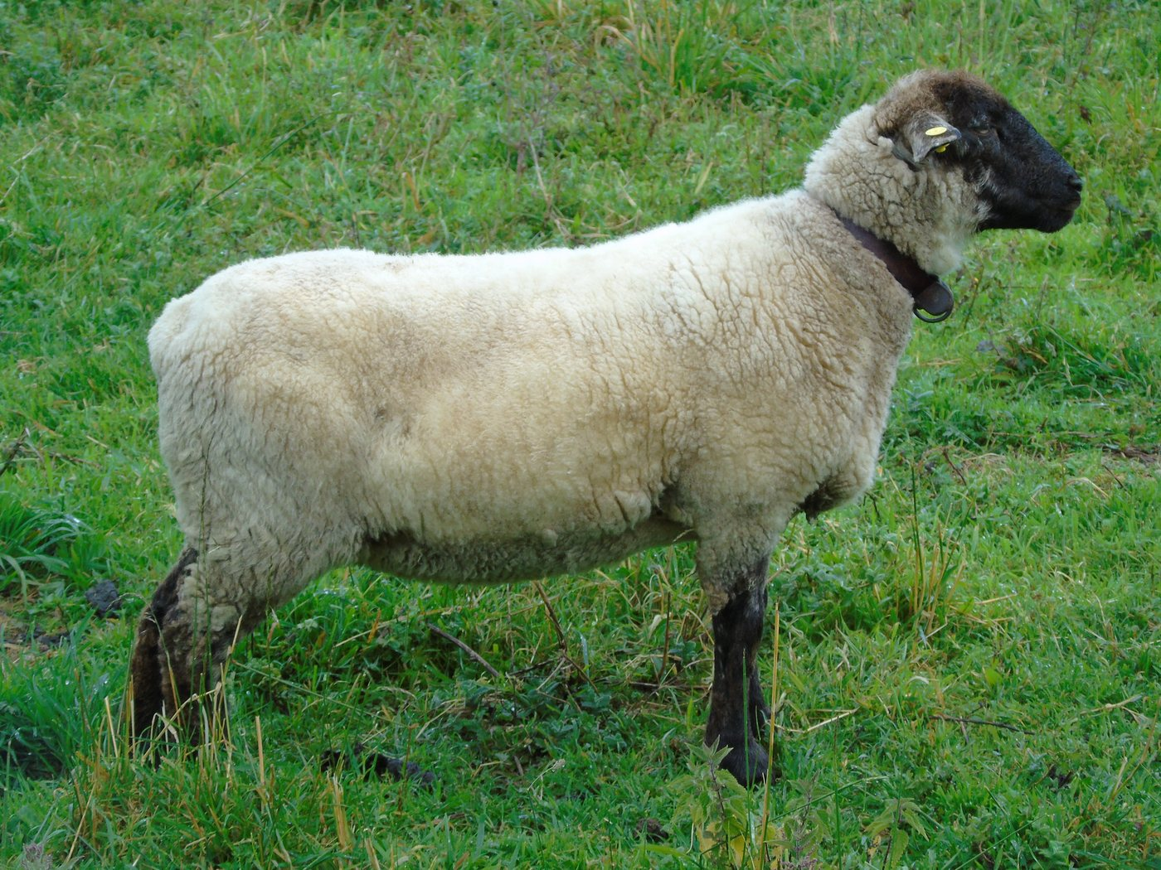  Small ruminant used as a possibility of comparison.
Deer 3  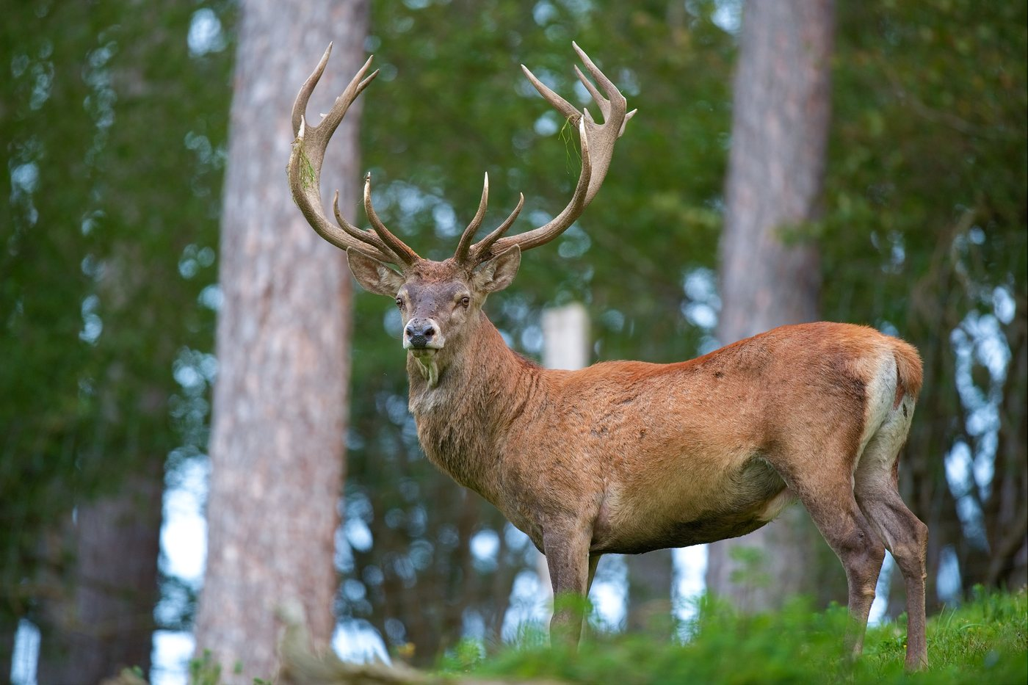  Deer presented without generalization to all species. | Pork 4  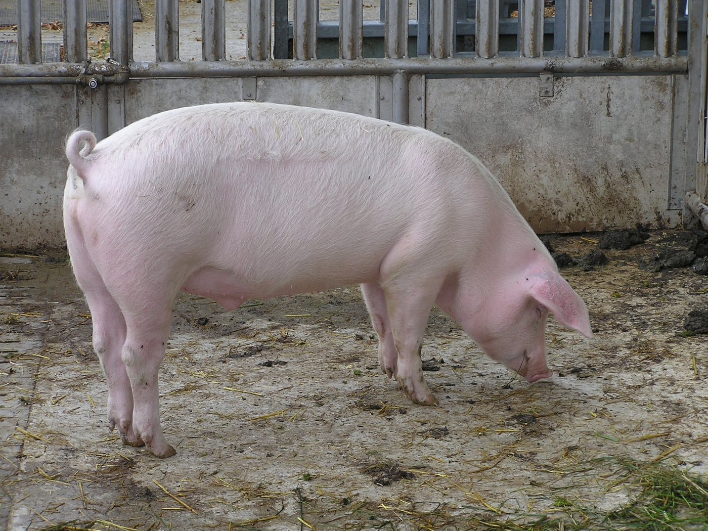  Whole animal: basis for comparison, not proof of identification.

Bone cards A-D - neutral templates
The photographs are not yet validated. Do not write species names on these cards before integration of the final corpus.
Bone A A | Bone B B
Bone C C | Bone D D
Scientific corpus to be integrated after validation.
Scientific corpus to be integrated after validation.
Scientific corpus to be integrated after validation.
Scientific corpus to be integrated after validation.

Traceability : https://histoire-d-os.github.io/Histoire-d-os/en/ressources/activite-02-associer-astragale-animal.html

