Bone stories - Educational kit

Activity 3
Achilles: a story that changes
An investigation of the sources to distinguish ancient stories, late tradition and modern images, then carefully link the Latin word talus to astragalus.
Audience  9-12 years old | Duration  45-60 mins | Content  Guide, sheet, supports, correction | Length  To calculate

In this kit
- Facilitator guide
- Learner sheet
- Timeline Materials and Cards
- Answer key and leads
- Sources, credits and limits
Pilot version - ancient corpus to be completed and formulations to be reread before final distribution.
Recommended printing: guide and correction for adults; student sheet in one copy per student; colored supports if possible. The classification remains readable in grayscale thanks to the titles and written statuses.
Version: 1.0 pilot - July 20, 2026.

Bone Stories - Activity 3

Facilitator guide
Achilles: a story that changes
Guide to comparing documents of different dates and status without confusing image, story and proof.
Type  Facilitator guide | Audience  Supervising adults | Duration  45-60 mins | Version  Pilot 1.0
Pilot version - a validated ancient document must still complete the corpus.

1. In brief
Students compare images produced well after Antiquity, identify their date and status, then carefully reconstruct the transformation of the story. The challenge is not to eliminate the familiar legend, but to learn to ask: who tells it, when, and from what source?

2. Objectives
- Distinguish ancient source, late tradition and modern creation.
- Understand that a late image testifies to its time of production.
- Identify what a document allows you to assert or not.
- Introduce talus/astragalus as an anatomical term without making it proof of the myth.

3. Expected success
Successful  The statuses are distinguished and two limits are explained. | In progress  The chronology is understood, but the evidence remains confused. | To resume  A modern image is used as proof of an ancient story.

4. Duration and material
Context | Duration | Material
Class | 45-60 mins | Sheet, cards, supports, scissors optional.
Museum | 30-45 mins | Reproductions and labels validated by the institution.

5. Quick preparation
Print one sheet per student and one set of cards per group. Keep the date of each image visible. Do not present the empty antique map as an oversight: it materializes the corpus which remains to be validated.
“An image shows what an artist has chosen to represent. Before using it as evidence, let's find out its date, author and source. »

6. Detailed procedure
Time | Adult action | Student action | Purpose
5 mins | Tell people the expression “heel of Achilles”. | Write down what they think they know. | Bring out the familiar story.
10 mins | Distribute images without classifying them. | Describe scene, date and caption. | Separate observation and memory.
15 mins | Request a chronological and documentary classification. | Distinguish between ancient, late, post-antique, contemporary. | Qualify the sources.
10 mins | Introduce the Latin word talus and the anatomical talus. | Compare vocabulary and body image. | Understand a possible shift in meaning.
10 mins | Organize the synthesis. | Write what is established, plausible and to be verified. | Construct a cautious conclusion.

7. Questions and reminders
On the document  - When was this image created?  - What does it really show?  - What era does it directly bear witness to? | On interpretation  - What source should you consult?  - Is this scene in the oldest Greek stories?  - What does “late tradition” mean?

8. Responses or expected elements
- Not all ancient Greek stories tell of the protective immersion familiar today.
- The version where Thetis makes Achilles invulnerable belongs to a later tradition, notably transmitted in Latin.
- Borel, Rubens and Rothaug are artists after Antiquity; their works show the reception of the story.
- Latin talus can designate the astragalus; this lexical point invites us to revisit the modern “heel”, without being enough to prove a mythical episode.

9. Differentiation
Need | Adaptation
Help | Limit to two images and provide the labels “old”, “late”, “modern”.
Lighten the writing | Have them classified orally and dictate a collective conclusion.
Go deeper | Compare text, image and production date; find the transmission chain.

10. Museum adaptation
Start from a work actually present in the institution, if it is relevant, then compare it to documented reproductions. Adapt the selection and the labels to the museum. A reproduction is a possible variant, but does not entirely replace the object, its materiality and its context.

11. Quick assessment
Ask for three sentences: “This document dates from…”, “It shows…”, “It does not, in itself, allow us to assert…”. Success relies on the distinction between date, visible content and scope of the proof.

12. Common mistakes
Do not call Borel, Rubens or Rothaug ancient sources. Do not use the BodyParts3D model to prove the story. Do not claim that the entire legend is an invention of a single Roman author.
- Confusing the date of the scene recounted with the date of the work.
- Deduce a complete story from a single visual detail.
- Transform a shift in vocabulary into historical certainty.

13. Sources and limits
The scientific framework is based in particular on Barbara Carè, “The astragalus of Achilles: around the vulnerability of the hero”, with consultation of the OpenEdition publication. Modern works are used to study reception. The definitive ancient corpus, its notices and the precise chain of texts must still be validated.

14. Current status and remaining validations
Support usable for a framed test, provided that the antique map is kept neutral. Scientific rereading of chronology, Latin talus, formulations on the late tradition and notices of works still necessary.

Print plan

Bone Stories - Activity 3

Learner sheet
Achilles: a story that changes
Type  Learner sheet | Audience  9-12 years old | Duration  45-60 mins | Version  Pilot 1.0
Pilot version - the ancient corpus still needs to be completed and validated.
Your missionClassify documents, identify what they really show and explain how the story of Achilles was transformed.
Objective: learn how to check the date and status of an image before using it as a source.
Material: this sheet and the timeline cards.

1. What I already know
In a few lines, tell the version of the story you know.

2. Look at a document
What I see | Date of work | Author / origin | Proposed status

Useful statuses: ancient source to be validated - late tradition - post-antique work - contemporary illustration - anatomical model.

3. Classify the cards
Place the cards from the oldest document to the most recent. For each card, write what it allows you to study.
Map | Place in the timeline | What it allows you to study | What it doesn't prove
1
2
3

4. From “heel” to talus
The Latin word talus can designate the astragalus, a tarsal bone. Why does this information suggest caution with the modern expression “heel of Achilles”?

5. My conclusion
Complete: “The colloquial version is a ____________ tradition. Modern images show ____________. To verify an ancient story, you must ____________. »

An image can be very useful without being an ancient source: it can teach us how a more recent era told history.

Bone Stories - Activity 3

Supports and cards
Achilles: a story that changes
Cut or project. The date and status of each document is part of the investigation.
Type  Visual supports | Audience  Learners and groups | Usage  Sequencing and discussion | Version  Pilot 1.0
Pilot version - no ancient images are published in this medium until the corpus is validated.

1. Map to complete: ancient source

Document A To be validated
Ancient source to be integrated after scientific, documentary and legal validation.
Questions: what date? what object or text? what scene? which institution? what does it really allow us to assert?

2. Late tradition and reception
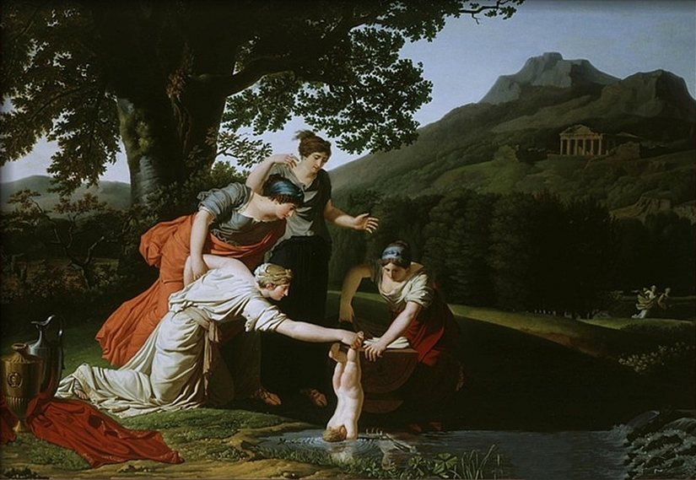
Antoine Borel, late 18th century. Modern image of the immersion episode, which belongs to a late tradition; it is not an ancient source.Antoine Borel, public domain, via Wikimedia Commons.
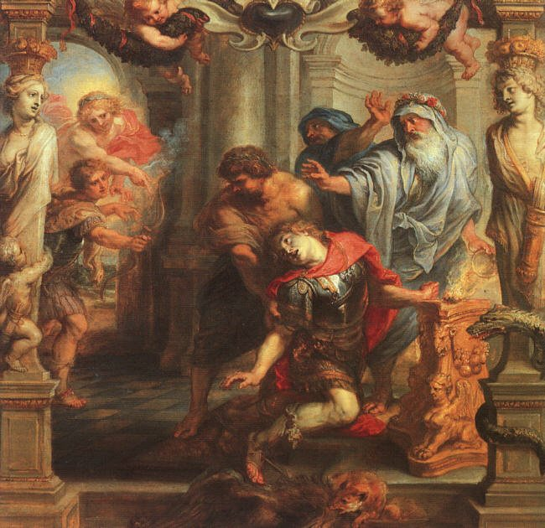
Peter Paul Rubens, 17th century. Post-antique reception of the death of Achilles; the work bears witness to its time of creation.Peter Paul Rubens, public domain, via Wikimedia Commons.
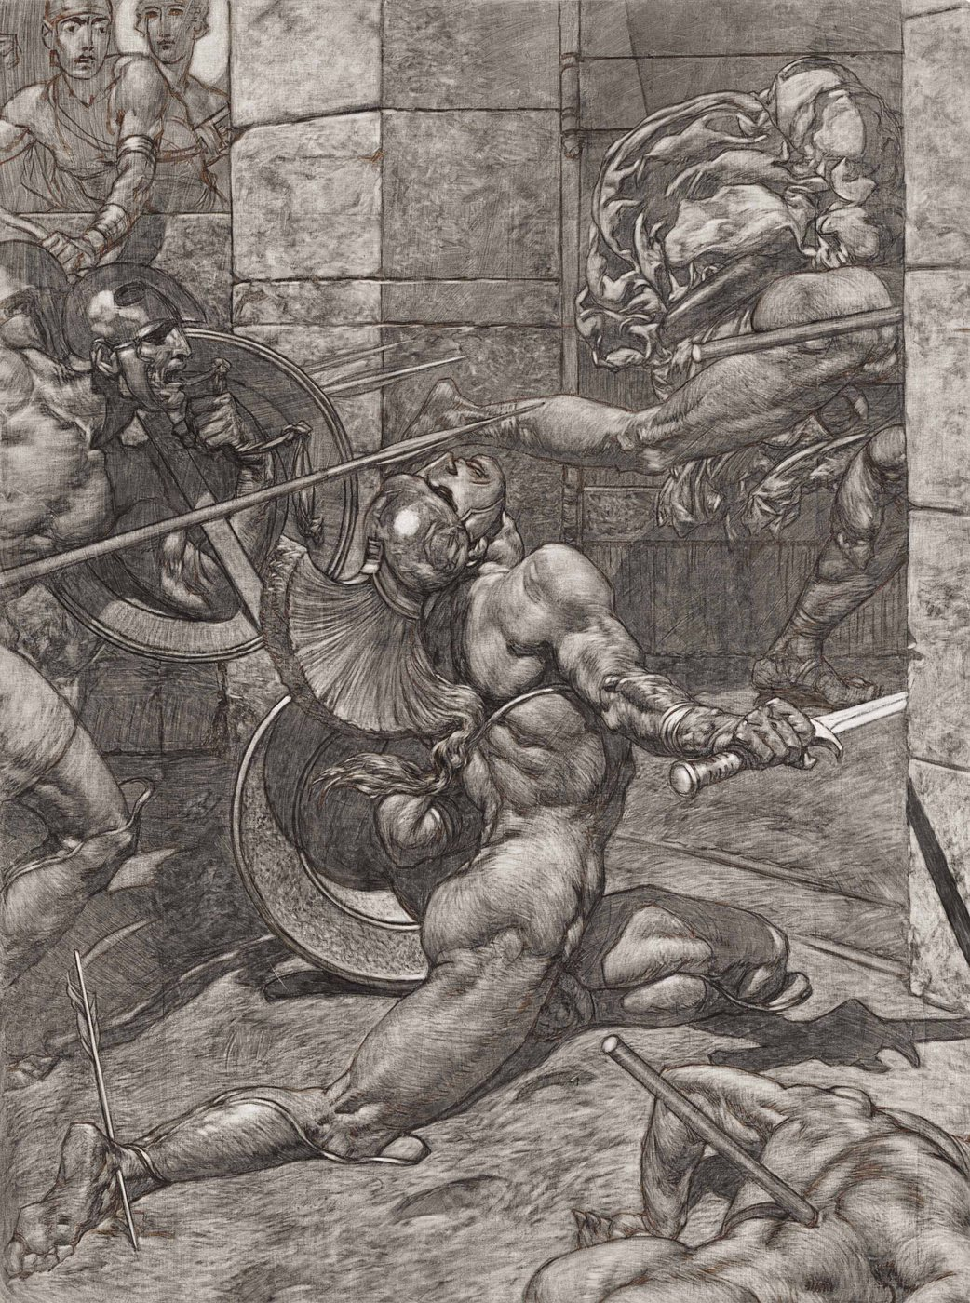
Alexander Rothaug, modern era. Post-antique artistic interpretation, not proof of an ancient story.Alexander Rothaug, public domain, via Wikimedia Commons.
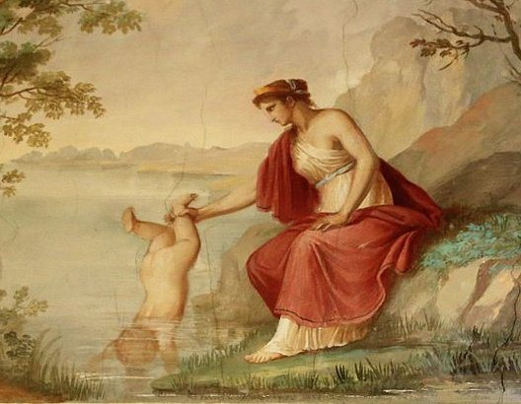
Contemporary illustration. A current creation around the late episode; it does not constitute an ancient source.Sasanian1111, CC BY-SA 4.0, via Wikimedia Commons.

3. An anatomical landmark, not proof of the story
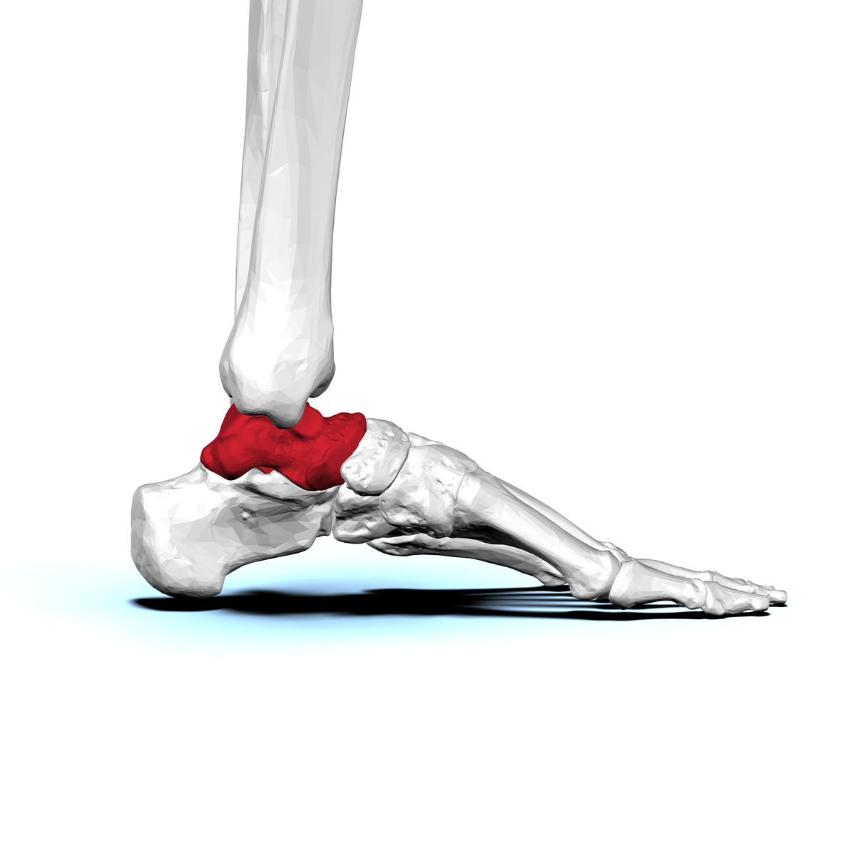
talus human, view lateral. This visualization is only used to locate and name the bone. It does not prove any episode in the story of Achilles.BodyParts3D / DBCLS, CC BY-SA 2.1 JP, via Wikimedia Commons.
The provisional photograph of the vase showing Achilles and Memnon is excluded from these PDFs. It will be replaced or integrated only after validation of the notice, relevance and rights.

Bone Stories - Activity 3

Answer key and leads
Achilles: a story that changes
Type  Adult answer key | Audience  Teachers and museum educators | Usage  Group discussion | Version  Pilot 1.0
Pilot version - method correction, to be adjusted with the future ancient corpus.

landmarks fix
Step | Expected response | Possible answer | To resume
Observe | Describe the scene and note the date of the work. | Characters, gestures, arrows, water, colored bones. | Tell the myth without looking at the document.
Classify | Distinguish between document to be validated, late tradition, post-antique works and contemporary illustration. | Specific dates can be grouped into broad periods. | Call all images “antique.”
Interpret | Say what the work teaches about its reception. | A modern artist takes up or transforms an episode. | Use the work as direct evidence of the archaic narrative.
talus | Understand that the vocabulary invites you to check the translation. | The modern “heel” does not exactly cover talus. | Make anatomy proof of the myth.

Model conclusion, to be adapted
“The expression “heel of Achilles” today sums up a weak point. The scene where Thetis protects her son by holding him by part of his foot belongs to a late tradition and is not told like this in the oldest Greek stories. The works of Borel, Rubens, Rothaug and contemporary illustration show how this story has continued to be represented. The Latin word talus, linked to astragalus, also invites to check the modern transition to “heel”. »

Cautious wording
To use  “late tradition”, “post-antique work”, “this image bears witness to…”, “the term invites us to verify…” | To avoid  “the Romans invented everything”, “this image proves the myth”, “Achilles was really injured in the talus”.

Scientific limits
The corpus does not yet contain a validated ancient document. The correction therefore concerns the documentary method and careful landmarks. Any more precise formulation on texts, translations and ancient iconography must be reread by the scientific manager.
Do not reveal a definitive ancient chronology from this version alone. Complete the correction after validation of the old corpus and the notices.

Bone Stories - Activity 3

Sources, credits and limits
Keep with the complete kit.

Main scientific reference
Barbara Carè, “The astragalus of Achilles: around the vulnerability of the hero”, in a publication by Presses universitaire de Caen, available on OpenEdition Books: books.openedition.org/puc/27266. Source used for scientific framing; no third party figures or long extracts are reproduced.

Pictures
- Antoine Borel, Thetis dives Achilles, public domain, via Wikimedia Commons.
- Peter Paul Rubens, The Death of Achilles, public domain, via Wikimedia Commons.
- Alexander Rothaug, The Death of Achilles, public domain, via Wikimedia Commons.
- Sasanian1111, contemporary illustration of Thetis and Achilles, CC BY-SA 4.0, via Wikimedia Commons.
- talus human: BodyParts3D / DBCLS, CC BY-SA 2.1 JP, via Wikimedia Commons.

Media excluded
The provisional photograph of the Achille-Memnon vase and the figures of articles without established publication authorization are not integrated. The “antique source” card remains deliberately neutral.

Status
Method support usable for a supervised test. Ancient corpus, notices, detailed chronology, lexical formulations and physical printing still need to be validated.
Working translation: specialist scientific, educational and legal wording requires human review.
Traceability : https://histoire-d-os.github.io/Histoire-d-os/en/ressources/activite-03-achille-histoire-transformee.html

