Bone Stories - Activity 3

Supports and cards
Achilles: a story that changes
Cut or project. The date and status of each document is part of the investigation.
Type  Visual supports | Audience  Learners and groups | Usage  Sequencing and discussion | Version  Pilot 1.0
Pilot version - no ancient images are published in this medium until the corpus is validated.

1. Map to complete: ancient source

Document A To be validated
Ancient source to be integrated after scientific, documentary and legal validation.
Questions: what date? what object or text? what scene? which institution? what does it really allow us to assert?

2. Late tradition and reception
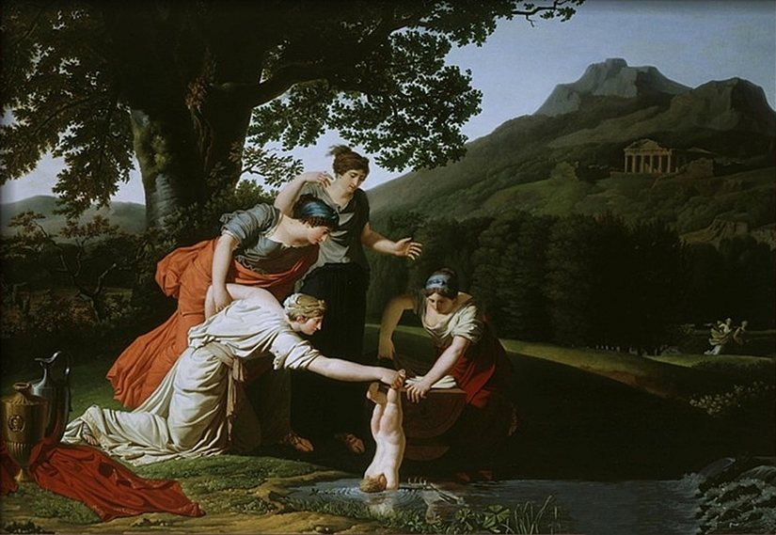
Antoine Borel, late 18th century. Modern image of the immersion episode, which belongs to a late tradition; it is not an ancient source.Antoine Borel, public domain, via Wikimedia Commons.
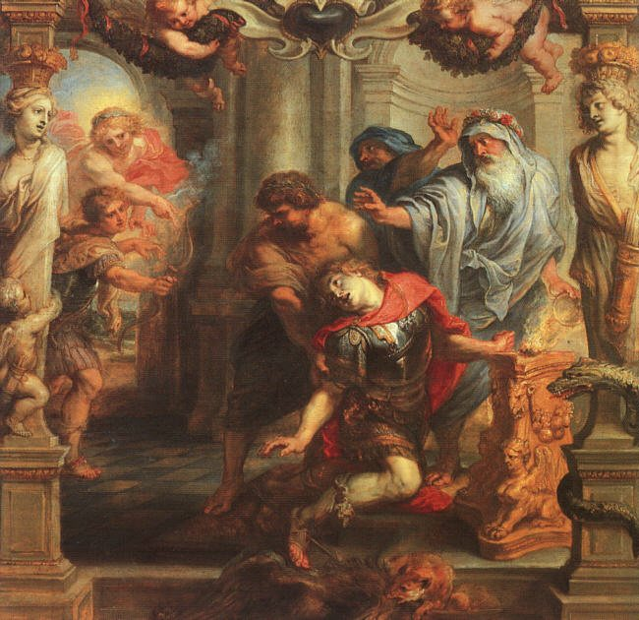
Peter Paul Rubens, 17th century. Post-antique reception of the death of Achilles; the work bears witness to its time of creation.Peter Paul Rubens, public domain, via Wikimedia Commons.
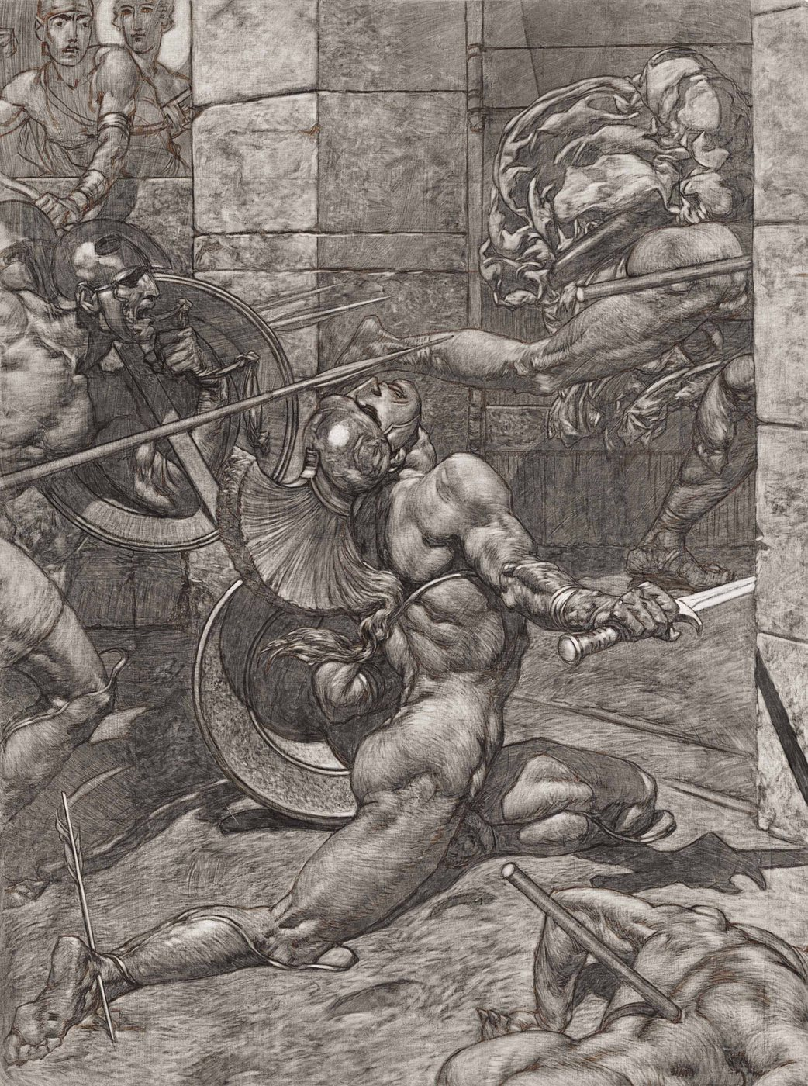
Alexander Rothaug, modern era. Post-antique artistic interpretation, not proof of an ancient story.Alexander Rothaug, public domain, via Wikimedia Commons.
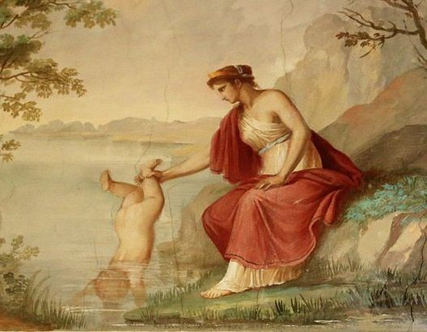
Contemporary illustration. A current creation around the late episode; it does not constitute an ancient source.Sasanian1111, CC BY-SA 4.0, via Wikimedia Commons.

3. An anatomical landmark, not proof of the story
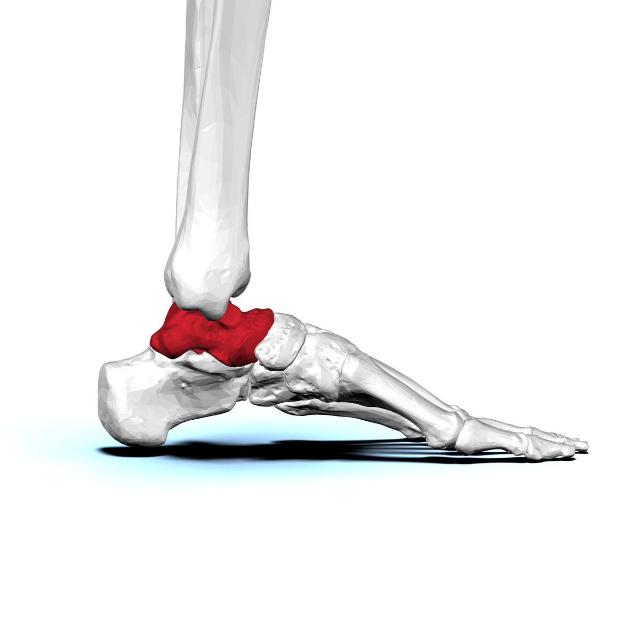
talus human, view lateral. This visualization is only used to locate and name the bone. It does not prove any episode in the story of Achilles.BodyParts3D / DBCLS, CC BY-SA 2.1 JP, via Wikimedia Commons.
The provisional photograph of the vase showing Achilles and Memnon is excluded from these PDFs. It will be replaced or integrated only after validation of the notice, relevance and rights.
Traceability : https://histoire-d-os.github.io/Histoire-d-os/en/ressources/activite-03-achille-histoire-transformee.html

