

Comparative Performance Analysis of VoyceMe Series vs. Competitors

Month of January 2023

**Introduction**

This report aims to evaluate the performance of VoyceMe series against its competitors by analyzing views and search counts from the provided datasets. The primary objective is to pinpoint high-performing and under-performing series, delve into genre-specific engagement trends, and offer data-driven strategies to bolster VoyceMe's market presence and viewer engagement. Through meticulous data analysis and visualization, this report intends to provide actionable insights to refine content strategy, marketing initiatives, and user engagement efforts.

**Objective:**

1. Analyze the performance of VoyceMe series compared to its competitors using provided datasets and identify well-performing and under-performing series based on views and search counts.
2. Provide data-driven recommendations to enhance the performance of VoyceMe series.
3. Ensure the report is concise, well-structured, and includes accurate visualizations to support findings and recommendations.

**Problem Statement:**

1. VoyceMe seeks to improve its market position and viewer engagement compared to its competitors by understanding the factors driving the performance of individual series and genres.
2. Identify series that are lagging and uncover reasons for their under-performance to optimize content strategy, marketing efforts, and user engagement initiatives.
3. Enhance overall performance, attract more viewers, and strengthen competitive edge.

**Total Views and Search for Each Platforms**

|  |  |  |
| --- | --- | --- |
| **Platforms** | **Total Views** | **Total Search Count** |
| VoyceMe | 50,6399 | 65,931 |
| Competitor1 | 23,5174 | 32,858 |
| Competitor2 | 24,1656 | 34,958 |

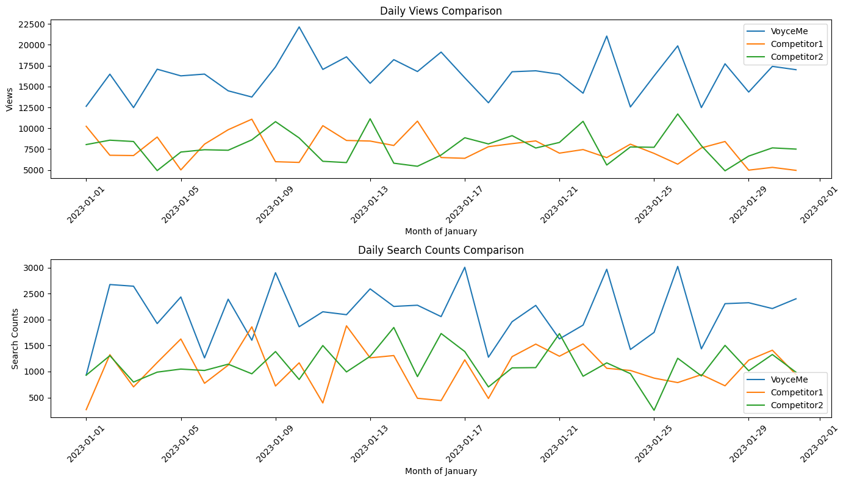

**Total views and search count for each series:**

|  |  |  |
| --- | --- | --- |
| **Title** | **Views** | **Search count** |
| series_1 | 114,216 | 15,647 |
| series_2 | 122,975 | 19,227 |
| series_3 | 112,299 | 17,123 |
| series_4 | 121,726 | 16,065 |
| series_5 | 122,875 | 15,735 |
| series_6 | 135,287 | 17,157 |
| series_7 | 119,930 | 18,893 |
| series_8 | 133,921 | 13,900 |

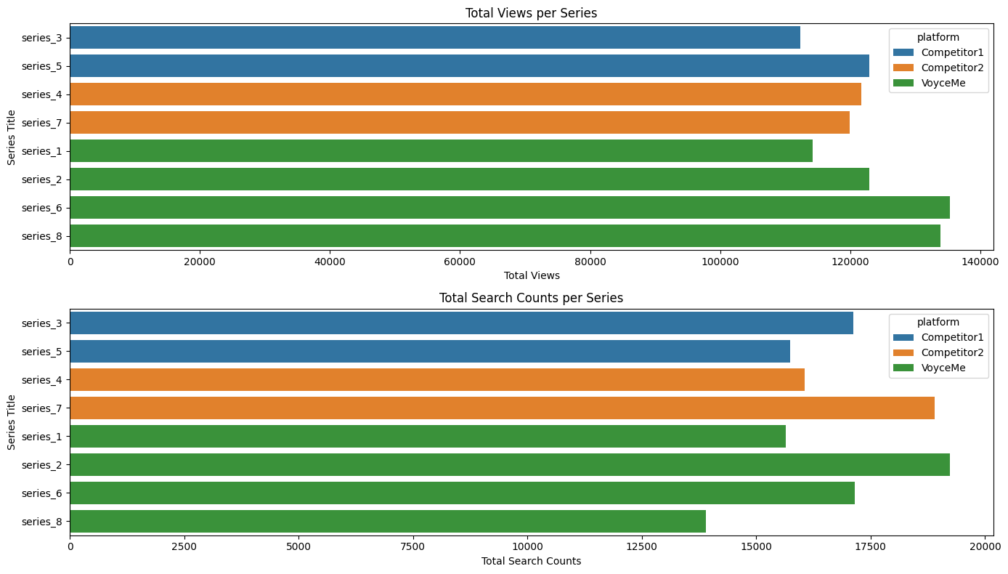

**Total views and search count for each genre:**

|  |  |  |
| --- | --- | --- |
| **Genre** | **Views** | **Search Count** |
| Adventure | 245,850 | 34,962 |
| Fantasy | 235,942 | 31,712 |
| Historical | 253,851 | 32,793 |
| Sci-Fi | 247,586 | 34,280 |

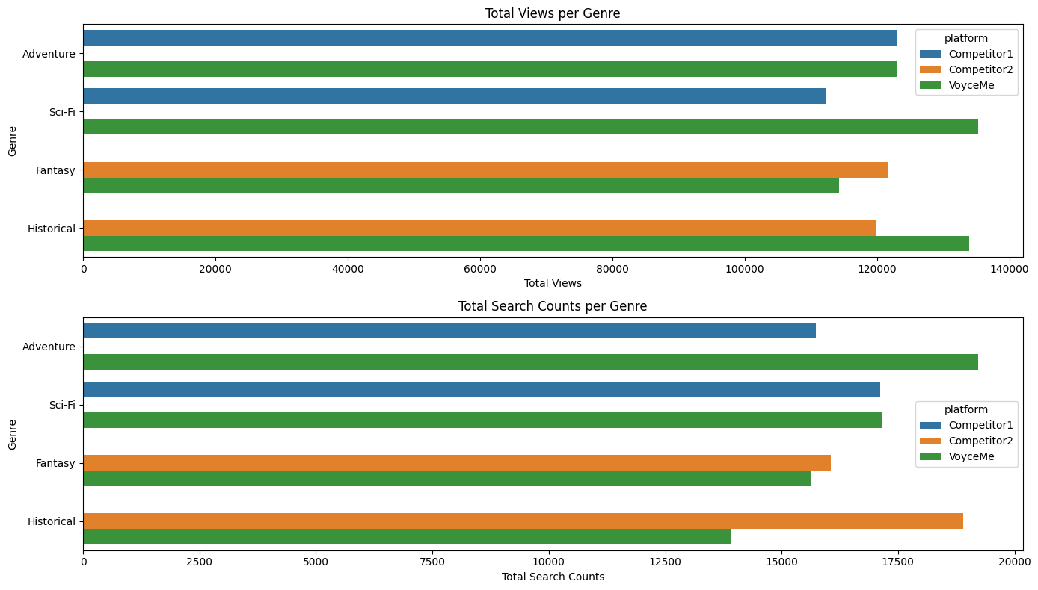

**Summary**

This report offers an in-depth analysis of VoyceMe series performance relative to its competitors, with a focus on metrics like views and search counts. Key findings include the identification of top-performing and lagging series, insights into genre preferences, and the overall engagement landscape. The report concludes with targeted recommendations designed to enhance content strategy, boost marketing effectiveness, and improve user engagement, thereby strengthening VoyceMe's competitive edge and expanding its viewer base.

**Insights**

* VoyceMe has significantly higher total views and search counts compared to both competitors, indicating better overall performance.
* Series 6 and Series 8 of VoyceMe series are the top-performing series in terms of both views and search counts.
* Series 1 of VoyceMe are the most underperforming series of the VoyceMe
* Adventure and Sci-Fi genres have the highest total views and search counts among all genres.

**Recommendations**

1. **Content Improvement:**

- Analyze the characteristics of top-performing series (Series 6 and Series 8) to understand what makes them successful. Promote similar series into new series or improve existing ones.

1. **Genre Targeting:**

- Invest more in Adventure and Sci-Fi genres as they seem to attract higher viewer engagement. Develop new series or promote existing ones in these genres.

1. **User Engagement:**

- Cultivate a vibrant community among VoyceMe users through the establishment of forums, discussion groups, or dedicated platforms for fan interaction. Encourage users to contribute their ideas, fan theories, and feedback on series.

- Introduce a feedback mechanism to gather user suggestions, preferences, and concerns. Utilize this valuable input to iteratively enhance series content and user satisfaction.

1. **Marketing Strategy:**

- Implement targeted marketing campaigns to increase visibility and attract more viewers to VoyceMe series.

-Utilize social media platforms and influencers to promote VoyceMe content and engage with the audience.