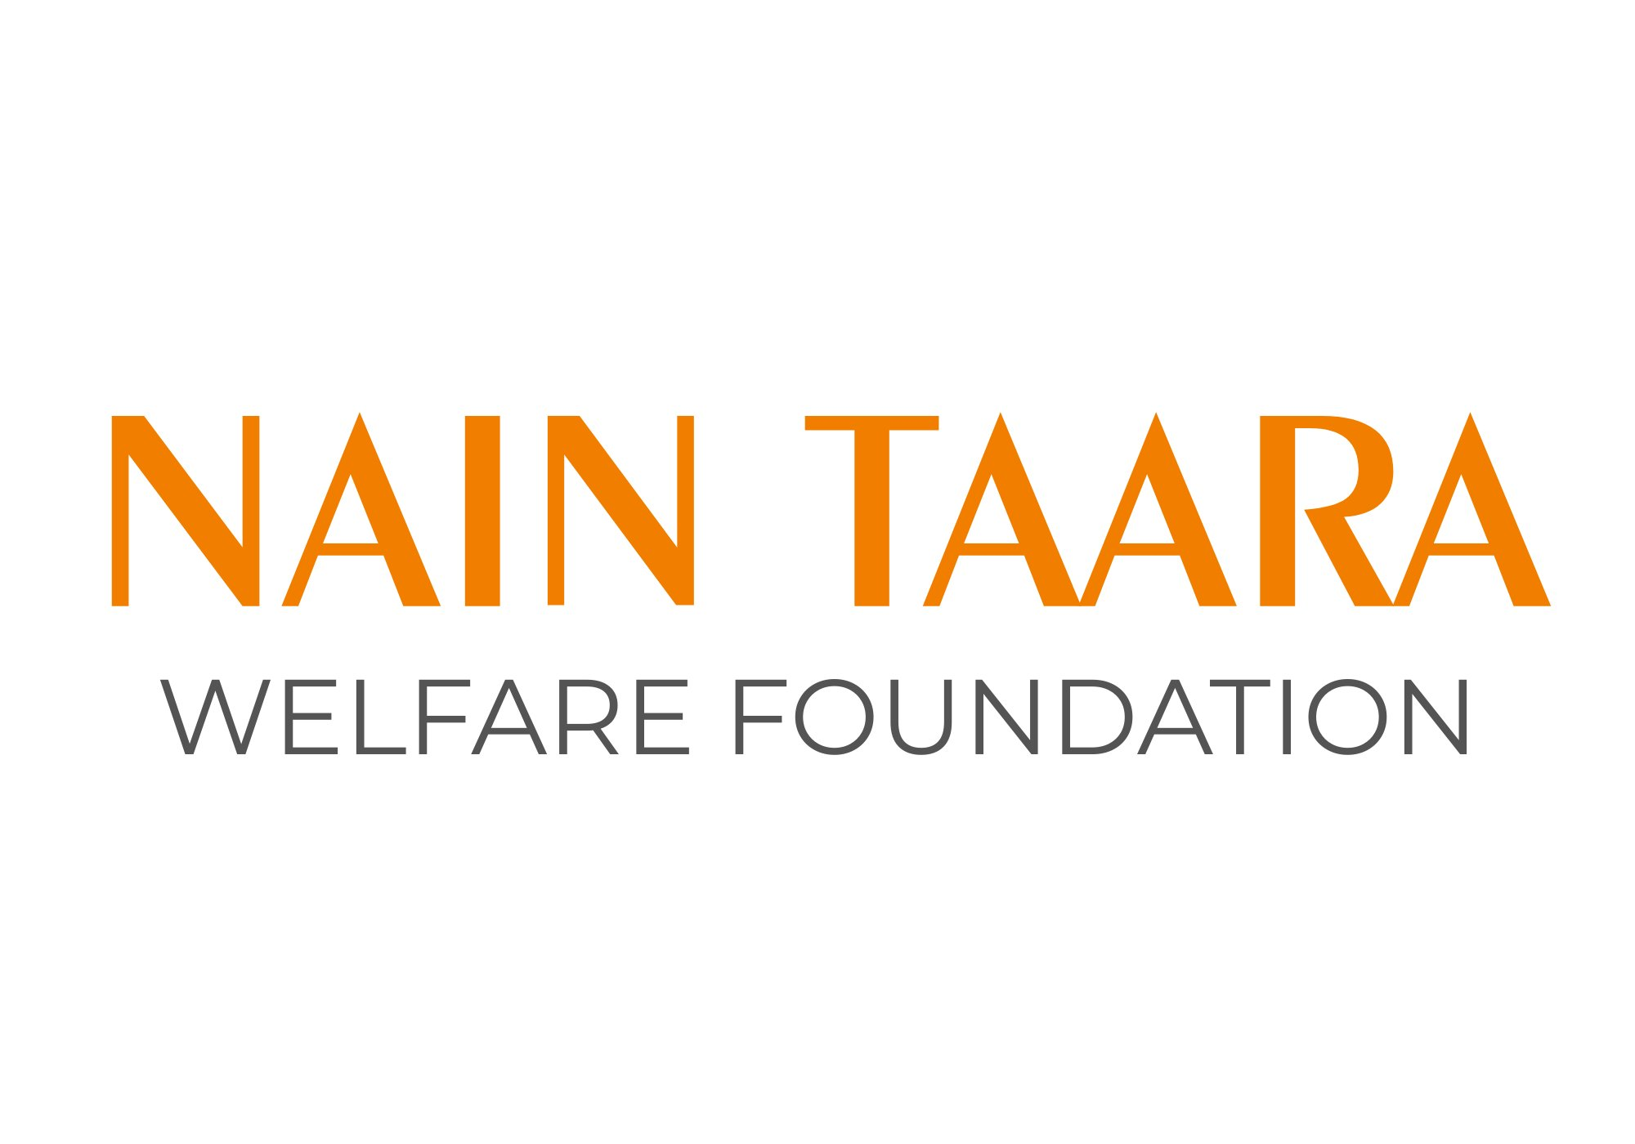
Restoring Sight. Transforming Lives.

ABOUT US
Nain Taara Welfare Foundation is a dedicated eye care and community health organisation committed to eliminating preventable blindness across India. The name 'Nain Taara' — meaning 'star of the eye' — reflects our belief that clear vision is not a privilege but a right that every individual deserves, regardless of geography, income, or circumstance.
Founded on the principles of compassion, service, and excellence, Nain Taara Welfare Foundation works at the intersection of healthcare and social development. We operate in underserved communities where access to quality eye care is scarce, deploying skilled teams, modern equipment, and a people-first approach to create lasting change.
Our work spans four core areas: large-scale eye screening camps; cataract surgeries; community vision centers; and skill development training programs that build local capacity and create sustainable livelihoods in eye care. Together, these pillars form a comprehensive ecosystem that addresses the full cycle of preventable blindness — from early detection to long-term community care.
OUR VISION

Vision: A world where no one loses their sight to preventable causes — where every individual, in every community, has access to the eye care they need to live, work, and thrive with dignity.
We envision an India where geography is never a barrier to sight, where rural and urban communities receive equal access to quality ophthalmic care, and where empowered local health workers sustain eye care well into the future.
OUR MISSION

Mission: To deliver compassionate, high-quality eye care to underserved communities through screening, surgery, and accessible vision centers — while building a skilled local workforce that ensures lasting, community-led eye health.
We pursue our mission through four pillars of action:
01 | Eye Screening Camps  Large-scale, free eye camps that bring early detection, diagnosis, and referral services directly to underserved communities — where need is greatest and access is least.

02 | Cataract Surgeries  Free and subsidised cataract surgeries that restore sight and independence to patients who would otherwise remain in preventable darkness.

03 | Vision Centers  Accessible vision centers established in remote and semi-urban areas to provide ongoing, affordable eye care — from prescriptions and spectacles to follow-up treatments.

04 | Skill Development Training  Training programs that build a skilled local workforce of optometrists, health workers, and volunteers — creating sustainable, community-led eye care for generations.

WHO WE SERVE
Our work is focused on communities where the need is greatest and access is most limited:

- Rural villages and remote hamlets with no nearby eye care facility
- Children in government schools with undiagnosed vision impairment
- Elderly individuals with untreated cataracts or diabetic eye conditions
- Daily wage workers and marginal farmers for whom vision loss means loss of livelihood
- Women and girls, who are disproportionately affected by eye disease and less likely to seek care independently
PARTNER WITH US
We are actively seeking partners who share our belief that no one should lose their sight for lack of access. Here is how you can be part of this mission:

- Funding Support — Sponsor screening camps, school vision programs, or surgical interventions. Even small contributions create measurable, life-changing impact.
- Corporate CSR Partnerships — Align your organisation's CSR mandate with a high-impact, transparent, and growing health initiative.
- In-kind Support — Donate spectacles, diagnostic equipment, medicines, or mobility support for camp operations.
- Volunteer & Pro-Bono — Ophthalmologists, optometrists, community health workers, and professionals in communications, HR, and finance are welcome.
- Institutional Grants — We welcome conversations with foundations, bilateral agencies, and government schemes aligned to eye health and rural development.
LEGAL & GOVERNANCE
Registration | NainTaara Welfare Foundation is registered as a non-profit organisation under Section 8 Company Act 2013

12A / 80G | We are in the process of obtaining 12A and 80G certifications from the Income Tax Department, which will make donations eligible for tax exemption.

GET IN TOUCH

Organisation | Nain Taara Welfare Foundation
Contact Person | Faraz Mirza, Founder and Executive Director
Email | naintaarafoundation@gmail.com
Phone | +91 9205050993
Address | Delhi

Every pair of eyes that sees clearly is a life reclaimed. That is the Nain Taara’s promise.

