Christ University, Delhi NCR
Data Engineering — Project Report
AirLens
An Air Quality Monitoring Pipeline Implementing the Complete Data Lifecycle
Submitted by
Hiten Mandhyan (24215117)
Naman Jiwnani (24215125)
Tejas Kashyap (24215043)
5 BCA A
27 October 2026

1. Abstract
AirLens is an end-to-end data engineering project that monitors air pollution in five Indian cities: Delhi, Mumbai, Bengaluru, Kolkata and Chennai. It implements every stage of the data lifecycle on a live dataset. Hourly PM2.5, PM10, NO₂ and AQI readings are collected from a public API, stored in a relational database, cleaned, aggregated, analysed against India's legal pollution limit, published through an interactive dashboard, and archived under a defined retention policy. The project demonstrates that the data lifecycle is not an abstract model but a sequence of concrete, automatable and auditable engineering steps.

2. Introduction and Objectives
Air pollution is a persistent public-health problem in Indian cities, with Delhi regularly recording PM2.5 levels several times the national standard. Data on this is freely available but arrives hourly, with gaps and sensor errors, and in a form that is not directly useful to a reader. Turning such raw data into reliable, understandable information is the central task of data engineering. The objectives of this project were to:
- Build an automated pipeline that implements collection, storage, cleaning, transformation, analysis, sharing and archival on real data.
- Make each stage observable, so the pipeline records what it did and can be audited.
- Present the results in a dashboard that communicates findings clearly to a non-technical reader.
- Apply governance practices such as retention policies, run logging and data-quality measurement.

3. Data Source and Dataset
Data is obtained from the Open-Meteo Air Quality API, which provides hourly pollutant concentrations derived from the Copernicus Atmosphere Monitoring Service (CAMS) and requires no authentication. The API allows up to 92 days of past data in one request, which the pipeline uses for its initial backfill. The reference threshold used throughout is India's National Ambient Air Quality Standard for PM2.5 of 60 µg/m³ averaged over 24 hours.
Variable | Unit | Description
pm2_5 | µg/m³ | Fine particulate matter below 2.5 µm
pm10 | µg/m³ | Particulate matter below 10 µm
nitrogen_dioxide | µg/m³ | NO₂, mainly from vehicle exhaust
us_aqi | index | US Air Quality Index, 0 to 500

The dataset currently covers 27 July 2026 to 27 October 2026, with 7,265 raw hourly records in the working store, 3,895 archived records and 465 city-day aggregates.

4. System Architecture and Tools
The system has two components: a batch pipeline (pipeline.py) that runs on a schedule, and a dashboard (dashboard.py) that reads from the same database on demand. SQLite was chosen because it is file-based, needs no server, and still provides SQL, primary keys and upserts; the design is portable to PostgreSQL without changes to the pipeline logic.
Layer | Tool | Role
Collection | Python requests | Calls the Open-Meteo API per city
Raw storage | JSON files + SQLite | Immutable API snapshots and raw_readings table
Processing | pandas | Cleaning, imputation, outlier detection, aggregation
Analytics storage | SQLite | clean_readings, daily_summary, archive_readings
Reporting | matplotlib, Markdown | Written summary and charts in reports/
Sharing | Streamlit, Plotly | Interactive web dashboard
Governance | pipeline_runs table, logging | Audit log of every run
Scheduling | cron / Task Scheduler | Daily execution

5. Implementation of the Data Lifecycle

Stage 1: Collect
For each city the pipeline requests hourly readings with past_days=92 on the first run and past_days=2 on later runs. Re-fetching the last two days is intentional: it picks up values revised by the provider.

Stage 2: Store
Every API response is written unchanged to data/raw/ as a timestamped JSON file so the original data can always be reprocessed. Parsed rows are upserted into raw_readings on a composite key of city and timestamp, which makes the pipeline idempotent: running it twice never duplicates data.

Stage 3: Clean
Forecast hours later than the current time are dropped; negative concentrations, which are physically impossible, are set to null; gaps of three hours or less are filled by linear interpolation and flagged was_imputed; longer gaps are dropped; and any PM2.5 value more than three standard deviations from the city's centred seven-day rolling mean is flagged is_outlier. Outliers are kept in the store for transparency but excluded from analysis.

Stage 4: Transform
Valid hourly rows are aggregated into daily_summary, one row per city per day, with mean and maximum PM2.5, mean PM10 and NO₂, mean AQI, contributing hours and a categorical AQI label. This table is upserted, never truncated, so it accumulates history indefinitely.

Stage 5: Analyse
A Markdown report and two charts are regenerated on every run, covering city rankings, the worst city-days, the share of days above the limit, weekday versus weekend averages and the peak hour for each city.

Stage 6: Share
The Streamlit dashboard reads directly from the database and offers CSV and Markdown downloads, so results are available interactively and as portable files.

Stage 7: Archive and govern
Hourly rows older than 60 days move from raw_readings to archive_readings; raw JSON older than 30 days is deleted; daily aggregates are kept permanently; the database is compacted with VACUUM. Every execution writes a record to pipeline_runs with timing, row counts and status, alongside a text log.
Stage | Live figure from the database
Raw rows stored | 7,265
Rows after cleaning | 7,200
Short gaps filled | 0
Outliers flagged | 35
Daily aggregates | 465
Rows archived | 3,895
Pipeline runs logged | 4

6. Dashboard and Visualisation
The dashboard is designed as an air-quality bulletin rather than a generic admin panel. It opens with a headline stating the worst current reading relative to the legal limit and a plain-language health advisory. Below this, haze bands show the last seven days for each city hour by hour, coloured on a single scale from blue (clear air) through amber (exactly the legal limit) to brown and soot. The same scale is reused in every chart.
The lifecycle is visualised in two ways: a rail of seven stages showing live figures from the database and file system, and a row ledger showing where every collected row ends up, with losses at the cleaning and outlier stages highlighted so the arithmetic from collection to analysis is visible. Further sections provide per-city trend panels against the limit, an hour-by-weekday heatmap, a one-square-per-day calendar, a data-quality table, the run audit log and download buttons.
Insert dashboard screenshots here (headline and haze bands; lifecycle rail and ledger; trend panels).

7. Results and Key Findings
Figures below are computed from the database for 27 Jul 2026 to 27 Oct 2026.
City | Mean PM2.5 (µg/m³) | Worst day (µg/m³) | Days above limit | Peak hour
Delhi | 63.9 | 134.9 | 55 % | 23:00
Kolkata | 38.3 | 95.0 | 27 % | 22:00
Mumbai | 30.7 | 100.7 | 14 % | 14:00
Chennai | 18.7 | 51.3 | 0 % | 19:00
Bengaluru | 13.3 | 39.2 | 0 % | 20:00

- Delhi recorded the highest mean PM2.5 (63.9 µg/m³) and exceeded the legal limit on 55 % of days, with a worst daily average of 134.9 µg/m³.
- Bengaluru was the cleanest city, averaging 13.3 µg/m³ and exceeding the limit on only 0 % of days.
- Pollution in Delhi peaks around 23:00, a pattern consistent with night-time temperature inversions that trap emissions near the ground.
- Data quality from the source was high: only 0 hourly values needed interpolation and 35 were flagged as statistical outliers out of 7,200 cleaned rows.
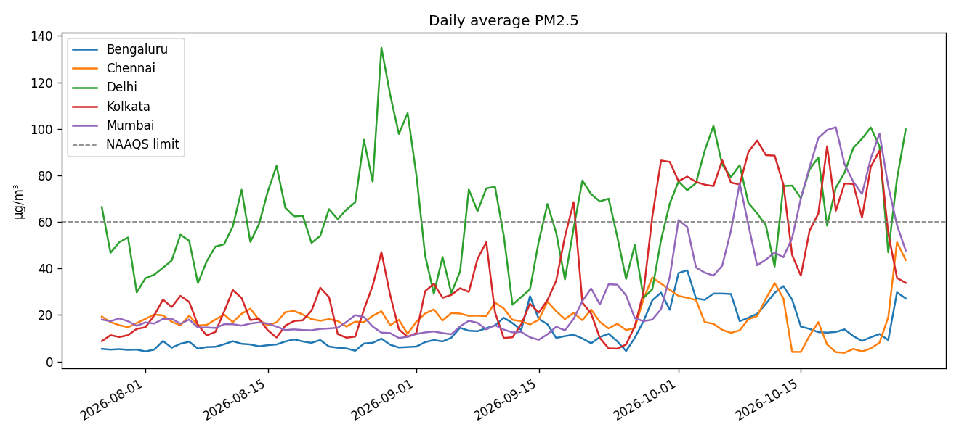
Figure 1. Daily average PM2.5 per city against the NAAQS limit.
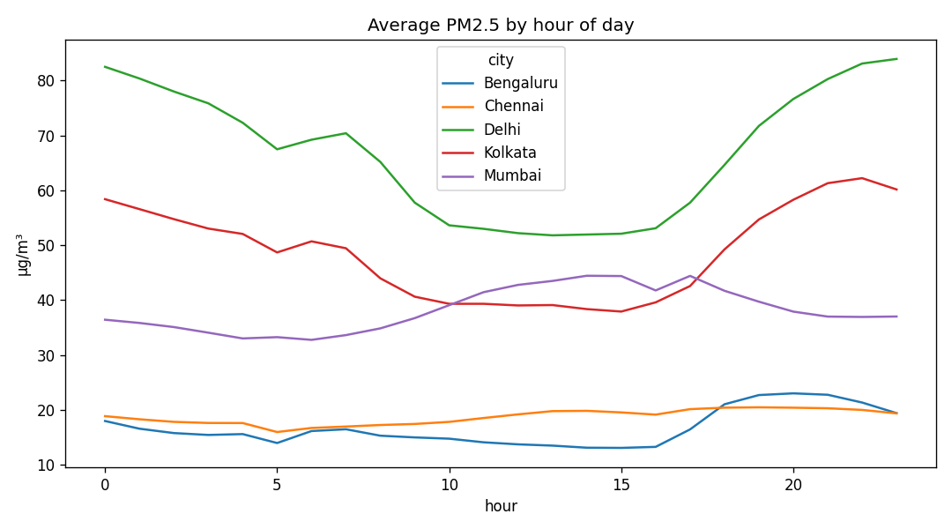
Figure 2. Average PM2.5 by hour of day.

8. Challenges, Limitations and Future Work

Challenges
- The API returns forecast hours mixed with observations, which had to be filtered out at the cleaning stage.
- The retention policy had to be designed so that archiving hourly rows did not destroy the daily aggregates derived from them.
- The dashboard had to handle empty or partial states gracefully, such as before the first backfill or while the archive is still empty.

Limitations
- Readings are model-derived from CAMS rather than ground sensors and may differ from CPCB station data.
- Only five cities and four pollutants are covered; the 92-day API limit means earlier history cannot be recovered.
- SQLite is adequate for this volume but not for concurrent writers.

Future work
- Integrate CPCB ground-station data for validation.
- Add threshold alerts by e-mail or messaging when a city crosses the limit.
- Migrate storage to PostgreSQL and scheduling to Apache Airflow.
- Add a festival calendar to quantify Diwali-period spikes, and extend coverage to more cities and pollutants.

9. Conclusion
The project shows that the full data lifecycle can be implemented on a small, live dataset with open tools, and that doing so turns noisy hourly feeds into a trustworthy, explainable picture of air quality. The most valuable lessons were engineering ones: making the pipeline idempotent, keeping raw data immutable, separating detail from aggregates so retention does not destroy history, and recording every run so the system can describe itself. These practices scale directly to larger production data systems.

References
- Open-Meteo, Air Quality API documentation, https://open-meteo.com/en/docs/air-quality-api
- Copernicus Atmosphere Monitoring Service (CAMS), ECMWF
- Central Pollution Control Board, National Ambient Air Quality Standards, 2009
- United States EPA, Technical Assistance Document for the Reporting of Daily Air Quality
- pandas, Streamlit and Plotly official documentation

