CarRental - UML Diagrams
Workshop Activity 2, Exercise 3 (CET2007, Week 2)

What is UML?
UML is a way of showing a program as pictures. This document has two pictures, both drawn from the real C# code of the CarRental project.
The class diagram shows what the program is made of: its classes, interfaces and how they connect. Think of it as a parts list.
The sequence diagram shows what happens over time when someone rents a car. Think of it as a story told step by step.

1. UML Class Diagram
This picture matches the C# files: Vehicle.cs, Car.cs, IRentable.cs, IPaymentProcessor.cs, CardPaymentProcessor.cs, CashPaymentProcessor.cs and Program.cs.
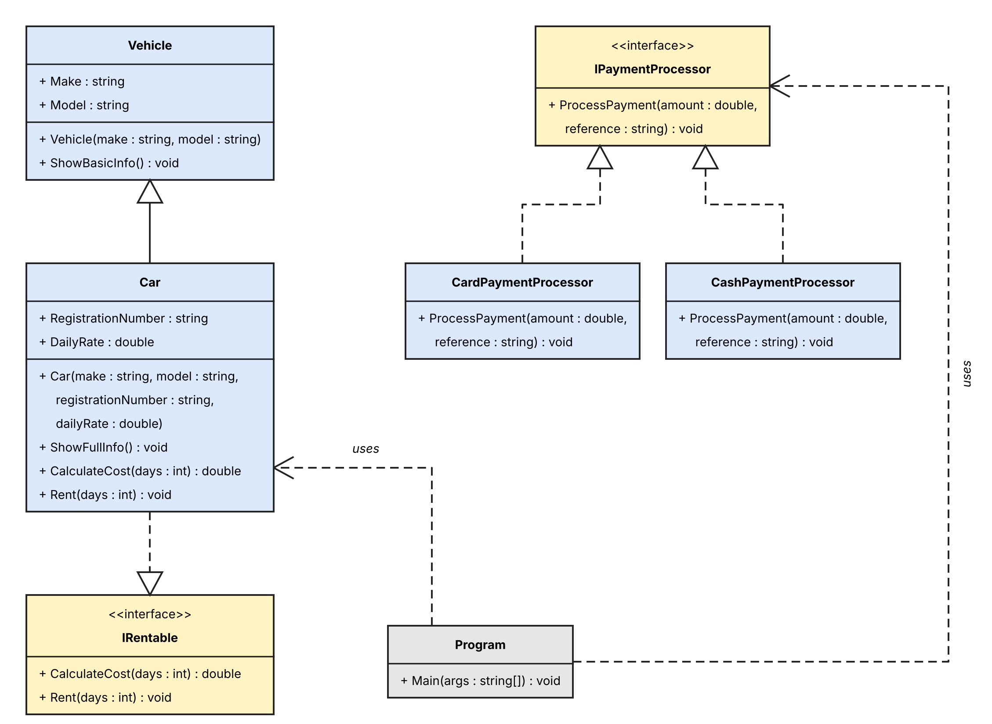

2. UML Sequence Diagram
This picture shows the rental and payment steps inside Main in Program.cs, in the order they happen.
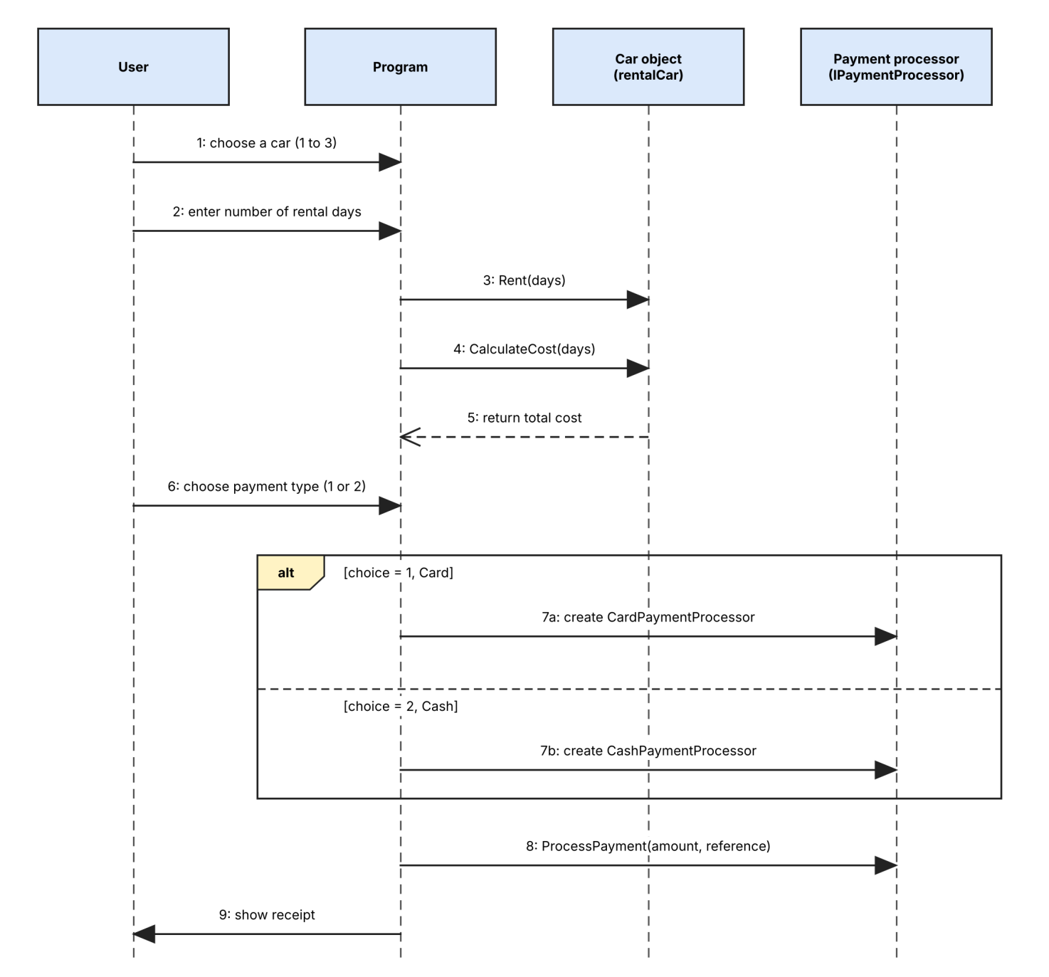

3. Short Explanation
The class diagram shows the fixed structure of my code, using the same class names, method names and types that are in my C# files. Its lines show that Car inherits from Vehicle, that Car follows IRentable, that the card and cash classes follow IPaymentProcessor, and that Program uses Car and IPaymentProcessor. The sequence diagram shows the order of events in Main, from choosing a car and entering the days, through Rent and CalculateCost, to choosing a payment type and calling ProcessPayment. The alt box matches the if and else in my code that builds either a card processor or a cash processor, so together the two diagrams describe what my program is and what it does.

