1. Place New water order

End points: http://localhost:8080/orders

Request Body

[

{

"farmId": "11",

"startDateTime": "2020-01-19T13:43:00",

"duration": "0.1"

}

]

Method:POST

Sample request

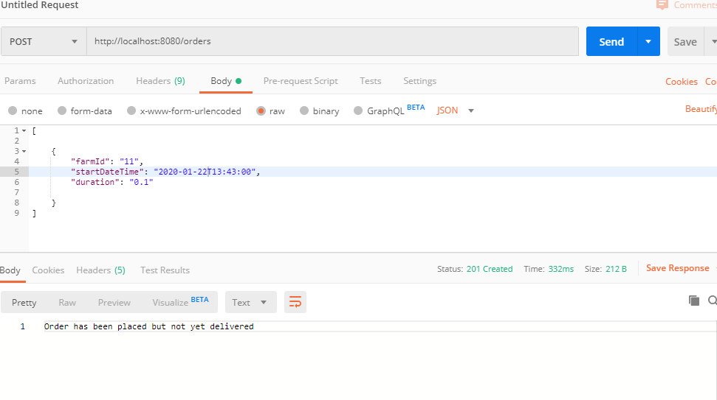

(When time overlaps with same farmId)

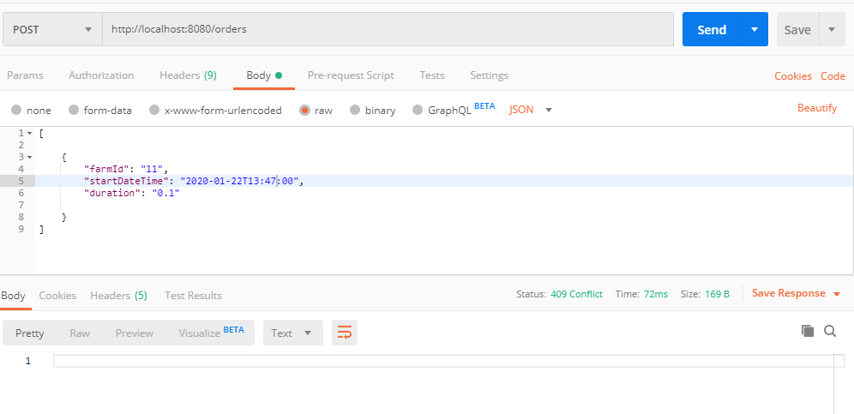

1. Get all Orders

**End Points:**

<http://localhost:8080/orders>

**Method:GET**

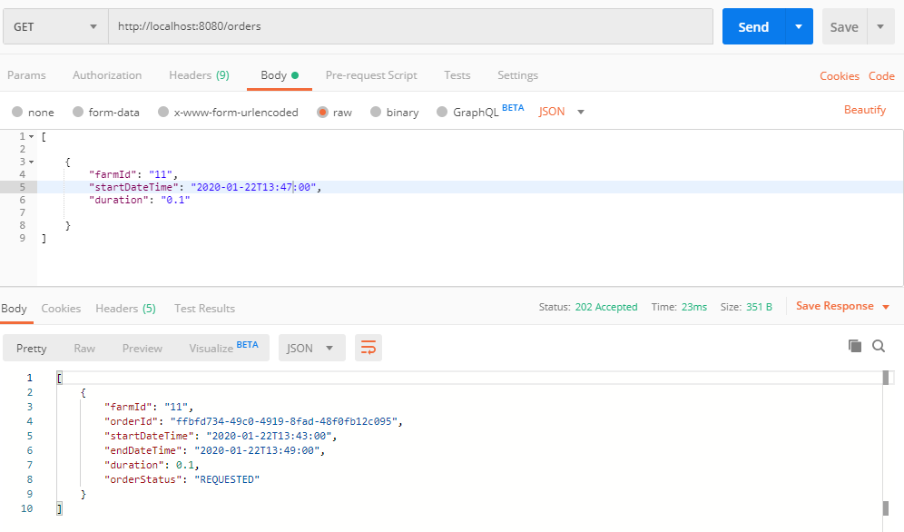

2.1 Get details of given orderId

End Points:

http://localhost:8080/orders/ffbfd734-49c0-4919-8fad-48f0fb12c095

METHOD:GET

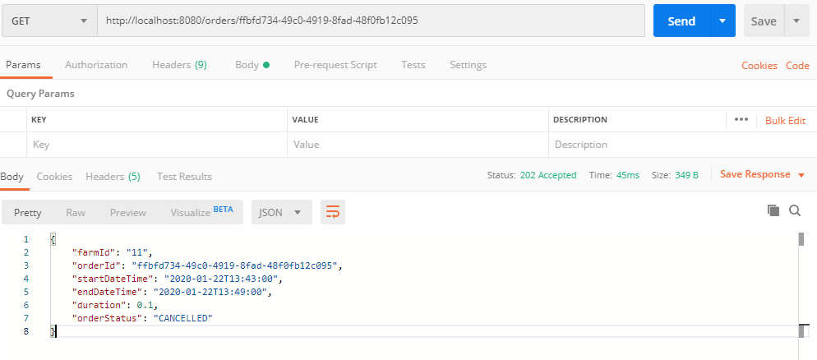

1. Cancel order

End Points: <http://localhost:8080/orders/ffbfd734-49c0-4919-8fad-48f0fb12c095>

METHOD:DELETE

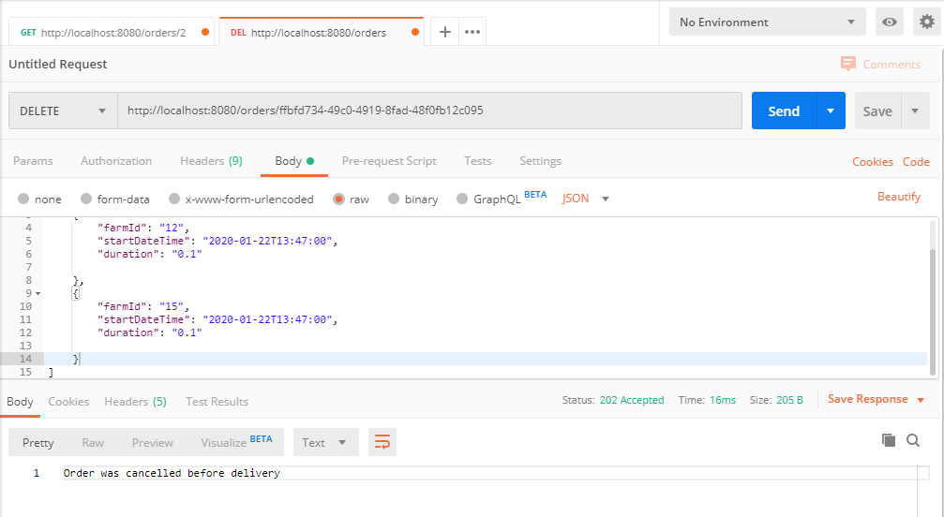

For the given request

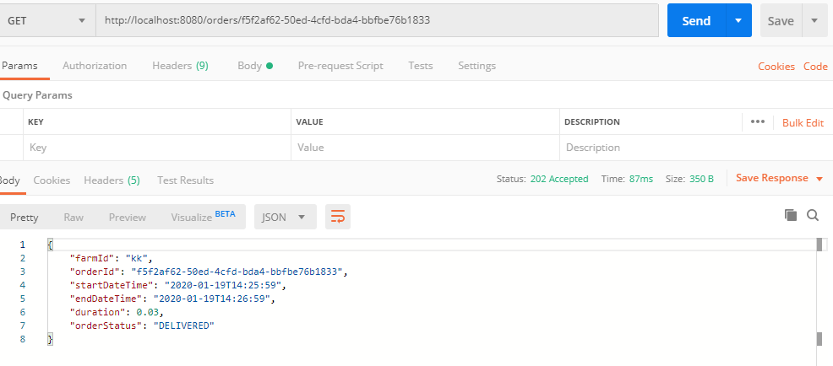

When trying to delete DELIVERED order

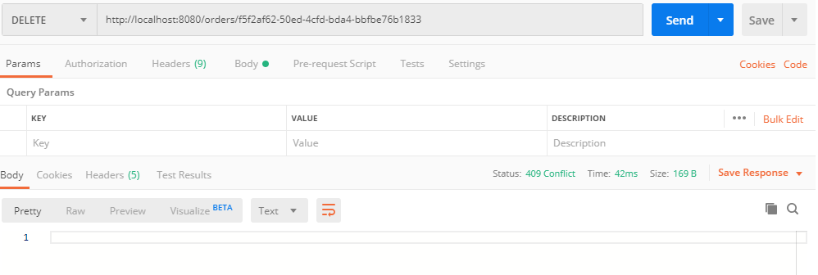

When trying to delete delivered order