RAM – SPare Parts

Additional information can be added if needed (project, contract, lot, customer, etc...)

{Delete table not in use}
{For wet signature}
APPROVAL
 | Role/Job Title | Name and Signature | Date
Written by
Verified by
Approved by
(add/remove rows if needed)

{For electronic signature}
APPROVAL
 | Name and Role/Job Title | Esignature
Written by
Verified by
Approved by
(add/remove rows if needed)

LOG OF CHANGES
Revision | Date | Author | Change Description
001 |  |  | First release
002
003

Contents
1. Title level 1 6
1.1 Title Level 2 6
1.1.1 Title Level 3 6
2. Title Level 1 8
2.1 Title Level 2 8
2.1.1 Title Level 3 8
APPENDIX A Title 9
A.1 Level 1 9
A.1.1 Level 2 9
APPENDIX B Title 10
B.1 Level 1 10
B.1.1 Level 2 10

List of Tables
Table 1 Title 6

List of Figures
Figure 1 Title 7

References

Documents
Id | Reference
[RAMP_Gen] | RAM Plan Generic: 3BU 15000 1712 DUAPA, Ed.05
[Spare_Parts] | Spare parts calculation; 1AA 00210 0004 ASZZA, Ed. 02
Table 2: Referenced Documents

Standards
Id | Reference
[GTS_FailureRate] | Reliability Standard Failure Rate Factor;  ANV: 1AA 00210 0001 BCZZA, Ed. 04; (THALES Standard)
[Rel_Classes] | Reliability Standard Reliability Classes  1AA 00210 0002 DSZZA, Ed. 03
[EN_50126] | EN 50126-1:2017 Railway applications. The specification and demonstration of reliability, availability, maintainability and safety (RAMS)
[ERTMS/ETCS] | ERTMS/ETCS RAMS Requirements Specification Chapter 2 – RAM; 02S1266- v 6-issue 30/09/98
[MIL_HDBK217F] | US MIL-HDBK 217F, Reliability prediction for electronic equipment
Table 3: Referenced Standards

RAM Basic concepts

Reliability
Definition: The probability that a system operates without failure over a specified period.

Mean Time Between Failures (MTBF)
Definition: The average operational time between two consecutive failures of a system.
Calculation: MTBF is calculated as the total operational time divided by the number of failures.
MTBF= Number of Failures/ Total Operational Time​
Example: If a system runs for 1000 hours and 5 failures occur, the MTBF is 200 hours.
Importance: A higher MTBF value indicates higher reliability and less frequent failures, which is crucial for safety-critical systems like ETCS.

Failure Rate (λ)
Definition: The rate at which a system or component fails, typically expressed in failures per hour.
Calculation: Failure rate is the reciprocal of MTBF.
Example: If MTBF is 10,000 hours, the failure rate 𝜆 is 0.0001 failures per hour.
Importance: A lower failure rate indicates higher reliability, meaning the system is less likely to fail over time.
MTBF= 1/ λ

Availability
Definition: The probability that a system is operational at a given time.
Availability (A) = MTBF / MTBF + MTTR
Example: If a system has an MTBF of 8760 hours and an MTTR of 24 hours, the availability is approximately 99.73%.

Maintainability
Definition: The ease with which a system can be maintained or repaired to restore its functionality.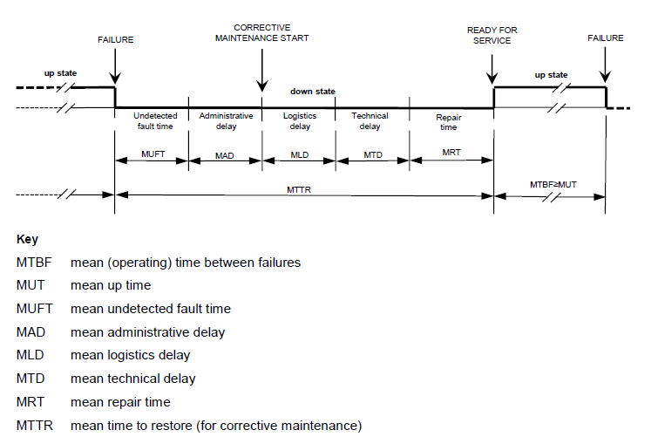
Figure 2: EN50126-1: Availability concept and related terms
​

HOw to create Spare Parts List

Input
- BoM is necessary to get the exact architecture of the system under consideration
  - BoM needs to specify the exact quantity of each component deployed, should state the exact 3BU number of each component
- Calculation of components failure rates
Failure rates of components have to be calculated by following company’s standard method described in the document "Reliability Standard Failure Rate Factor” [GTS_FailureRate].
This method is principally based on the models of the military handbook MIL-HDBK-217F [MIL_HDBK217F]. In order to avoid too conservative data, a corrective factor (Alcarel-factor) is applied reflecting experiences of the failure behaviour in field.
The calculation of the overall failure rate of PBAs and devices must be done by means of the so-called part stress method. This military handbook term means that the failure rate is determined by summing up all components, whereby the whole set of parameters of the MIL-HDBK is used to evaluate the failure rates.
For indoor systems a ground, benign (GB40) environment is assumed, for outdoor trackside systems a ground, fixed (GF40) environment is assumed.
Once we have the most recent BoM and have calculated/collected all failure rates for all components and know the exact number of quantities. we need to know the following information:
  - Any special requirements by the customer?
Example: The minimum number of spares for the initial outdoor equipment installation is at least 10 % spares.
For how many years?
One central Spare Parts stock?

calculate
- Component: Name of the component
- Material Nr.: 3BU Number
- Qty: Quantity deployed in field
- Failure rate [FiT]: based upon the failure rate calculations provided in the reliability analysis documents
- NFF: The failure percentage is conservatively enhanced to also include a certain amount of NFF (no failure found) items.
- Irreparable items: A weighting factor (%) is used to determine the number of irreparable items per year.
    - Balises/ SD cards, etc: 100%, will not sent to repair but will be replaced
    - Other components: around 20%
- Spares: besides any customer requirements, there are standard RAM suggestions based on typical settings stated by other Railway Authorities for comparable systems.
    - < 10 items in use: at least 1 spare
    - < 100 items in use: at least 2 spares
Spares = Years*Qty*FiT+NFF*irrepair%
Repairs = Years*Qty* FiT+NFF
Comp. | Material  Nr. | Qty | [FIT] | MTBF  [h] | Failure rate  + 30% NFF | amount  irrepair.  [%] | Spares  3years | Repairs  3years
MEN-D6 | 3CR30120AAAA | 100 | 3 780 | 264 500 | 4,3% | 20% | 4 | 13

END OF DOCUMENT

