Project specific RAM Plan - DIL - Generic Application / Solution Element Virtual Interlocking

APPROVAL
 | Name and Role/Job Title | Esignature
Written by | F. Moser  RAM-AM
Verified by | F. Rotter  QAM
Approved by | E. Stemmer  SEM

LOG OF CHANGES
Revision | Date | Author | Change Description
01 PD 01 | 2025-08-13 | Florian Moser | First proposal
01 RL | 2025-09-24 | Florian Moser | First edition
02 PD 01 | 2025-10-12 | Florian Moser | See section 1.5.3

Contents
1. Scope 6
1.1 Purpose 6
1.2 Identification 6
1.3 Intended audience 7
1.4 Document Management 7
1.5 Change History 7
1.5.1 Edition 01 PD 01 7
1.5.2 Edition 01 RL 7
2. References and Terms 8
2.1 Referenced Documents 8
2.2 Standards and Procedures 8
2.3 Terms, Abbreviations and Acronyms 9
3. Description of the system 11
3.1 Project overview 11
3.2 System overview 11
3.3 RAM Design Rules 17
3.4 Availability Classes 20
4. RAM Requirements 21
4.1 Reliability Requirements 21
4.2 Availability Requirements 22
4.3 Maintainability Requirements 22
5. RAM Plan 23
5.1 Methods and Tools used 23
5.2 RAM detailed activities, analyses and documents 23
5.2.1 RAM Design Rules 23
5.2.2 RAM HW-FMEA 23
5.2.3 Preliminary Reliability Analysis 23
5.2.4 Reliability Analysis 23
5.2.5 Maintainability 24
6. RAM Deliverables 25
6.1 List of RAM deliverable Documents 25
6.2 RAM Requirements 25
6.3 Periodical RAM activities report 26

List of Tables
Table 1: Solution Identification GA DIL 6
Table 2: Solution Element Identification SE VIL 6
Table 3: Referenced Documents 8
Table 4: Standards and Procedures 9
Table 5: Terms, Abbreviations and Acronyms 10
Table 6: RAM Design Rules Related Definitions 18
Table 7: General RAM Design Rules 18
Table 8: RAM Design Rules for CG, CN and CE 19
Table 9: Availability classes 20

List of Figures
Figure 1: System architecture GA DIL 12
Figure 2: Example georedundant NMR-System 14
Figure 3; System overview DIL 15
Figure 4: VIL Core and VIL MUX redundancy 16
Figure 5: Availability concept and related terms 21
Figure 6: Availability requirements 25

Scope

Purpose
This document presents the Reliability, Availability and Maintainability Plan (RAM) of Generic Application Digital Interlocking OBB 1.0.0 and solution element VIL OBB 1.0.0.
The RAM plan defines the reliability, availability and maintainability objectives, tasks to be performed and documents to be produced and delivered at various phases of the project’s lifecycle, to address the functional and technical requirements specified in the respective feature lists and requirements documentation.
For information about organisation, work packages, milestones and application of the Management System refer to [SEMP_GA] and [SEMP_VIL].

Identification
Project Name: | DSTW ÖBB Entwicklung
Project ID: | 100025795 / ATRELDE91
Solution / System: | Generic Application Digital Interlocking OBB 1.0.0 (GA DIL OBB 1.0.0)
Contract: | Digitales Stellwerk DSTW – Rahmenvereinbarung
Identification: | LockTrac 6131 ELEKTRA  LockTrac 6192 DCA  FieldTrac 6315 AzLM
Customer: | ÖBB
End Customer: | ÖBB
SIL Level: | SIL 4
Table 1: Solution Identification GA DIL
Project Name: | DSTW ÖBB Entwicklung
Project ID: | 100025795 / ATRELDE91 (CFRD)
Solution / System: | Solution Element Virtual Interlocking Phase 1 (VIL OBB 1.0.0)
Contract: | Digitales Stellwerk DSTW – Rahmenvereinbarung
Identification: | LockTrac 6131 ELEKTRA
Customer: | Generic Application Digital Interlocking OBB 1.0.0 (GA DIL OBB 1.0.0)
End Customer: | ÖBB
SIL Level: | SIL 4
Table 2: Solution Element Identification SE VIL

Intended audience
The intended audience of the project specific RAM Plan are the following functions:
- Project Design Authority (PDA)
- Project Manager (PM)
- Solution Engineering Manager (SEM)
- RAM Assurance Manager (RAM-AM)
- Safety Assurance Manager (SAM)
- Quality Assurance Manager (QAM)
- Validator (VAL)
- Verifier (VER)
- Project Security Manager (PSM)

Document Management
The management of this document will be performed according to the Document Management Rules [DMR] and the Document List and Review Matrix [DLRM].

Change History

Edition 01 PD 01
- First proposal.

Edition 01 RL
- First edition.

Edition 02 PD 01
- References updated.

References and Terms

Referenced Documents
Id | Reference
[ARC_GA] | Top Level Architecture Drawing - Generic Application - Digital Interlocking OBB;  3BU 17300 1218 DSAPA, Ed.04
[CRS_DSTW] | DSTW Streckenausrüstung OBB - Teil D Leistungsbeschreibung und Lastenhefte;  3BU 17300 0004 DSAPC, Ed.06
[PH_RAMS] | Pflichtenheft Digital Interlocking OBB - D2.2 Teilpflichtenheft RAMS,  3BU 17300 0022 DTAPC, Ed.02
[SD_DSTW] | Digitales Stellwerk - Technische Konzepte  3BU 17300 0010 DSAPC, Ed.07
[RAM_Plan_Generic] | RAM Plan Generic;  3BU 15000 1712 DUAPA, Ed.07
[RAMP_DFE] | Project specific RAM Plan – DSTW - Digital Field Elements;  3BU 62800 0018 DUAPA, latest
[SEMP_GA] | System Engineering Management Plan (SEMP) Generic Application Digital Interlocking OBB;  3BU 17300 1200 DPAPA, latest
[SEMP_VIL] | System Engineering Management Plan (SEMP) Solution Element Virtual Interlocking;  3BU 15000 6955 DPAPA, latest
[SEMP_IPS] | System Engineering Management Plan (SEMP) IPS Solution - Digital Interlocking OBB:  3BU 17300 2001 DPAPA, latest
[SEMP_DFE] | SEMP Solution Element - Digital Field Elements;  3BU 62800 0000 DPAPA, latest
[PBS_DSTW] | Product Breakdown Structure (PBS) - Generic Application - Digital Interlocking OBB;  3BU 17300 1215 DPAPA, Ed.01
[SP_DSTW] | Safety Plan DSTW;  3BU 17300 1204 DUAPA, Ed.02
[SSS_DIL] | SYSTEM REQUIREMENTS SPECIFICATION DIGITAL INTERLOCKING (DIL);  3BU 17300 1251 DTAPA, Ed.02PD01
[RMP_GA] | Requirements Management Plan (RMP) Generic Application Digital Interlocking OBB;  3BU 17300 1207 DUAPA, latest
Table 3: Referenced Documents

Standards and Procedures
Id | Reference
[Alcarel] | Reliability Standard Failure Rate Factor; 1AA 00210 0001 BCZZA
[Birolini] | Reliability Engineering. Theory and Practice; ISBN: 354040287X, 6th Ed
[DLRM] | Document List and Review Matrix for engineering projects;  83530224-DOC-AUT-EN-012
[DMR] | Document Management Rules;  83530061-DOC-AUT-EN-014
[EN 50126-1] | EN 50126-1:2017 Railway applications – The Specification and Demonstration of Reliability, Availability, Maintainability and Safety (RAMS), Part 1: Generic RAMS process.
[IEC60050(192)] | IEC 60050-192:2015; International Electrotechnical Vocabulary (IEV) - Part 192: Dependability
[MIL_HDBK217F] | US MIL-HDBK 217F:1991, Reliability prediction for electronic equipment
Table 4: Standards and Procedures

Terms, Abbreviations and Acronyms
Term/Abbreviation | Meaning
AzLM | Multi Section Axel Counter (one type of TDS)
CC | Central Controller
CE | Computing Element; One logical computing channel. Can be executed on a physical or virtual machine.
CG | Computing Group; Set of computing nodes, replicated for availability. Examples of a CG are 1oo2 CN-redundancy, 1oo4 CN-redundancy, 2oo4 CN-redundancy, but also 1oo1 CN-redundancy in the extreme case.
CN | Computing Node; Set of replicated Computing Elements building a safe entity. Examples of a CN are 2oo2 CE-redundancy, but also 1oo1 CE-redundancy in the extreme case.
DCA | Distributed Controller Architecture
DFE | Digital Field Elements
DGP | Diagnostic Processor
DIL / DSTW | Digital Interlocking = DSTW, Digitales Stellwerk = DIL
EC-MUX | Element Controller Multiplexer
EULYNX | European Initiative to Linking Interlocking Systems
IEC | International Electrotechnical Commission
Failure rate | Limit for $δt→0$ of the probability that an item will fail in the time interval $(t,t+δt]$, given that the item was new at $t=0$ and did not fail in the interval $(0,t]$, divided by $δt$. [Birolini]
FiT | Failures in time (unit: $10^{-9}h^{-1}$)
FES | Field Element Station
Ground Benign (GB) | Nonmobile, temperature and humidity-controlled environments readily accessible to maintenance; includes laboratory instruments and test equipment, medical electronic equipment, business and scientific computer complexes, and missiles and support equipment in ground silos. [MIL_HDBK217F].
Ground Fixed (GF) | Moderately controlled environments such as installation in permanent racks with adequate cooling air and possible installation in unheated buildings; includes permanent installations of air traffic control radars and communication facilities [MIL_HDBK217F].
GB 40 | Ground Benign 40˚ C
GF 40 | Ground Fixed 40˚ C
[MIL_HDBK217F] | The Military Handbook is published by the US Department of Defense, and provides mathematical models for electrical, electronic and electro-mechanical components. Each model calculates the component failure rate for given combinations of environmental conditions, component value and type, electrical stress conditions and manufactured quality level
MTBF | The expectation of the operating time between failures. [IEC 60050(191)].  $MTBF$ is usually reserved for items with constant failure rate $λ$. In this case, $MTBF=1/λ$is the expected value (mean) of the exponentially distributed item’s failure-free operating time. In particular $MTBF≈T/k$, where $T$ is the given, fixed cumulative operating time and $k$ the total number of failures (failed items) during $T$. [Birolini]  See also [EN 50126-1].
MTTR | The expectation of the time to restoration. [IEC 60050(191)]  $MTTR$ is the expected value (mean) of an item’s repair time. It is obtained from the distribution function $G(t)$ of the repair time as $MTTR=\int_{0}^{∞}{(1-G(t))dt}$. For reliability or availability calculation a constant repair rate $μ$ (i.e. exponentially distributed repair times with $μ=1/{MTTR}$) can often be used to get approximate results. [Birolini]  See also [EN 50126-1].
NMR | NxMooM Redundancy, Examples of NMR are 2x2oo2, 4x2oo2, but also 1x1oo1 in the extreme case. NxMooM Redundancy is a shorthand for 1ooN CN-redundancy with each CN forming an MooM CE-redundancy.
Nx2oo2 | N times 2 out of 2, Denotes a 1ooN CN-redundancy with each CN forming a 2oo2 CE-redundancy.
PBA | Printed Board Assembly
RCU | Remote Control Unit
Redundant VIL | A group of VIL redundant nodes that run synchronously in order to provide high availability based on hot-hot redundancy. If one redundant node fails, another one shall seamlessly take over.
VIL | VSTW / Virtual interlocking
VIL redundant node | A “VIL redundant node” is a self-contained set of SW components that perform the VIL functions and provide safety. It forms the basic element of a redundant VIL. A VIL redundant node is deployed on one or several virtual machines.  Note: A VIL redundant node is not just a TAS Platform Computing Node (CN) as it also includes the EC-MUX, which has a different redundancy implementation
VIL-Instance | A redundant VIL that is configured by appropriate station data to control a certain railway station or station zone. The DIL system shall comprise many VIL instances. A VIL Instance is a set of CGs consisting of a VIL-Core CG and one to four VIL-MUX CGs, see Figure 4.
VIL-Applications | Core System (CC/RCU/DGP) and EC-MUX
Table 5: Terms, Abbreviations and Acronyms

Description of the system
For detailed information on the products used, refer to [PBS_DSTW].
For an overview about customer expectation see [CRS_DSTW].

Project overview
The Generic Application Digital Interlocking ÖBB (GA DIL OBB 1.0.0) is the overarching system responsible for integrating, verifying, validating, and assessing multiple solution elements for deployment across Austrian railway infrastructure. It is designed to support up to 435 virtualized interlockings across two to three centralized computing centres (incl. geo-redundancy).
The Virtual Interlocking (VIL OBB 1.0.0) is a subsystem of the GA DIL OBB, responsible for executing interlocking logic centrally. It replaces traditional station-based interlocking systems with a virtualized, software-based solution hosted in data centres.

The Generic Application DIL is primarily responsible for the overall integration of individual components and for managing the underlying work packages, which include the Virtual Interlocking (VIL), Digital Field Elements (DFE), and the IPS Solution. For more details refer to [SEMP_GA].
The Virtual Interlocking (VIL) is a subsystem of the Generic Application DIL and handles central control functions. The underlying infrastructure is provided by the IPS Solution subsystem, which includes servers, networking equipment, and cluster management. For more details refer to [SEMP_VIL].
The solution elements IPS Solution and Digital Field Elements (DFE) are not covered within the scope of this RAM Plan. Their RAM-related activities, analyses, and documentation will be addressed separately in their respective, dedicated RAM Plans, aligned with the overall system engineering and project management framework. For more details refer to [SEMP_IPS] and [SEMP_DFE].
Note: IPS Solution and DFE are not part of this document.

System overview
The top-level architecture of the technical product "Generic Application Digital Interlocking (GA DIL)" is illustrated in Figure 1, taken from [ARC_GA].
The Generic Application Digital Interlocking ÖBB (GA DIL OBB 1.0.0) represents a modular and scalable digital interlocking solution designed for deployment across Austrian railway infrastructure. It is built upon cloud and virtualization technologies, structured into three availability zones interconnected via a high-availability network. This architecture ensures operational continuity even in the event of zone failure, with automatic recovery and reintegration of affected components.
The VIL-Instance is responsible for executing interlocking logic centrally within a virtualized computer cluster. It operates using a hot-hot redundancy concept (2x2oo2 for ELEKTRA Core and 1oo2 for EC-MUX) on TAS Platform 2.6.x. Applications such as Central Controller (CC), Remote Control Unit (RCU), and Diagnostic Processor (DGP) run in parallel on virtual machines, continuously synchronized and compared to ensure fault tolerance.
The system supports diagnostic and maintenance capabilities, including FRACAS monitoring, and is aligned with CENELEC [EN 50126-1] standard for RAM compliance.
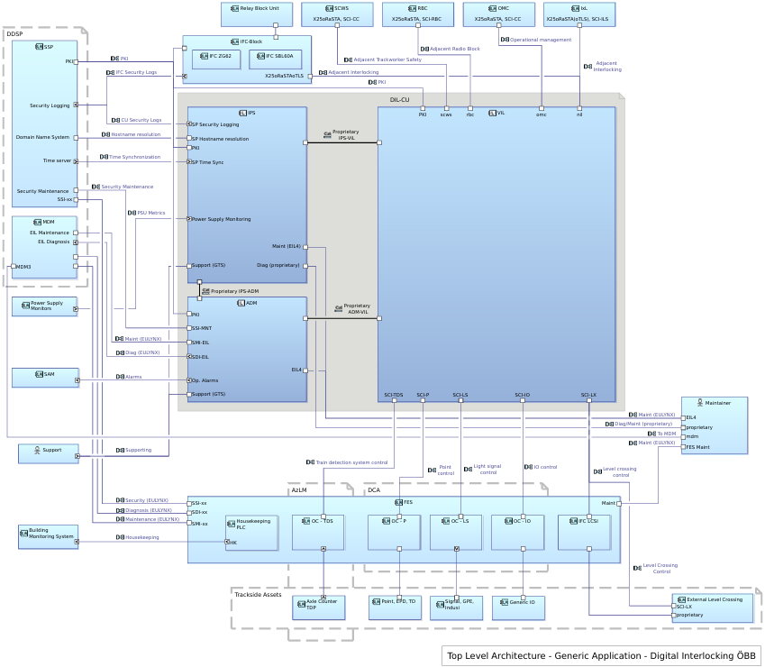
Figure 1: System architecture GA DIL
Figure 3 below, taken from [SD_DSTW], presents the architectural overview of the ELEKTRA 4.0 Central Unit (DIL-CU) and its connected subsystems. The system is structured around a cloud-based infrastructure divided into three Availability Zones, each hosting server racks interconnected via a high-availability network. This setup ensures continuous operation even if there is an outage of one availability zone.
The architecture includes dedicated server units for coordination (Control Plane), maintenance, diagnostics, and data storage, as well as computing nodes for executing virtual interlocking instances (VIL-Instance). These VILs are distributed evenly across the zones and operate in a synchronized Hot-Hot redundancy mode. The system is designed to support seamless reintegration of failed components and can be extended with georedundant sites for enhanced availability.
Figure 4, taken from [SD_DSTW], illustrates the redundancy architecture of the ELEKTRA 4.0 VIL Cores and VIL MUX systems. The VILs are distributed across different servers as well as availability zones, following the RAM Design Rule of “balanced distribution (see section 3.3 RAM Design Rules). The VIL Core operates on the TAS Platform using 2x2oo2 or 4x2oo2 Hot-Hot redundancy, depending on whether georedundancy is applied. Applications are executed in parallel across multiple virtual machines, continuously synchronized and compared to ensure fault tolerance and seamless failover.
The VIL MUX system, responsible for multiplexing and adapting communication with field elements, runs securely on a single hardware instance within the same redundancy framework. It supports up to four MUX instances, each operating in Hot-Hot mode. In case of failure, any MUX instance can be reintegrated without operational impact.
The EC-MUX function within DIL architecture operates on a single Computing Element (CE) and does not utilize a 2oo2 configuration. Therefore, in this context, a Computing Node (CN) consists of only one CE, representing a 1oo2 architecture. Multiple such CNs form a Computing Group (CG), which provides system-level redundancy through parallel EC-MUX instances running in hot-hot redundancy
The DIL-CU (Digital Interlocking Central Unit) is built on a cloud infrastructure composed of commercial off-the-shelf (COTS) server and network hardware. This infrastructure is divided into three Availability Zones, each hosting server racks that are interconnected via a high-availability network.
The Virtual Interlocking (VIL) subsystem is hosted on virtual machines running on the TAS Platform. These VMs execute applications such as CC (Central Control), RCU (Remote Control Unit), and DGP (Diagnostic Gateway Processor). The VIL architecture supports both local and georedundant configurations, with synchronized Hot-Hot operation across multiple CNs.
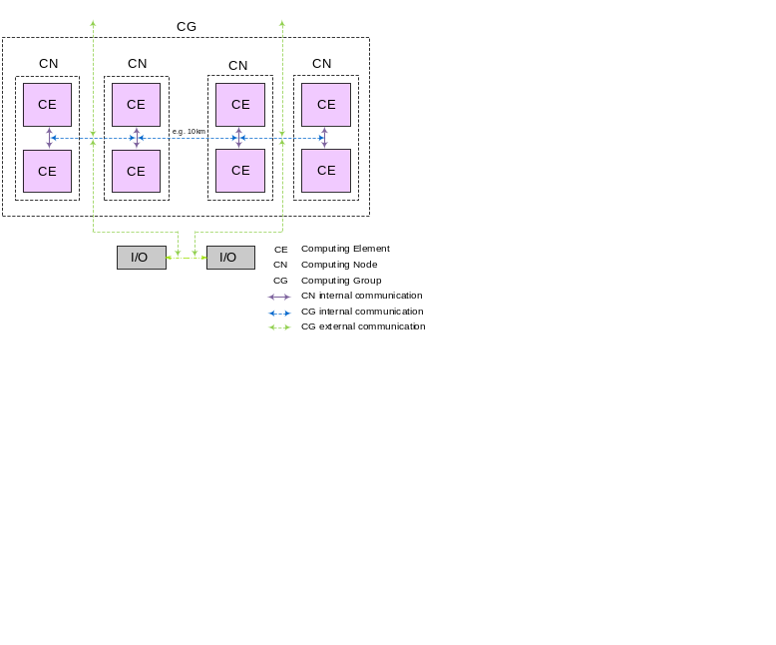
Figure 2: Example georedundant NMR-System
Figure 2 above illustrates a redundant computing architecture based on an NMR (NxMooM) configuration. It shows four Computing Nodes (CNs), each comprised from two Computing Elements (CEs) in a 2oo2 configuration, distributed across two geographically separated sites. This setup represents the georedundant deployment of the Generic Application DIL. Each CN ensures safety via 2oo2 redundancy, while the group of four CNs (forming a Computing Group, CG) ensures high availability with a 1oo2 configuration for each location and an 1oo4 configuration in georedundant deployment. The hot-hot redundancy concept, meaning all CNs are active and synchronized allows the system to tolerate the failure of up to three CNs without operational impact, provided network connectivity is maintained.
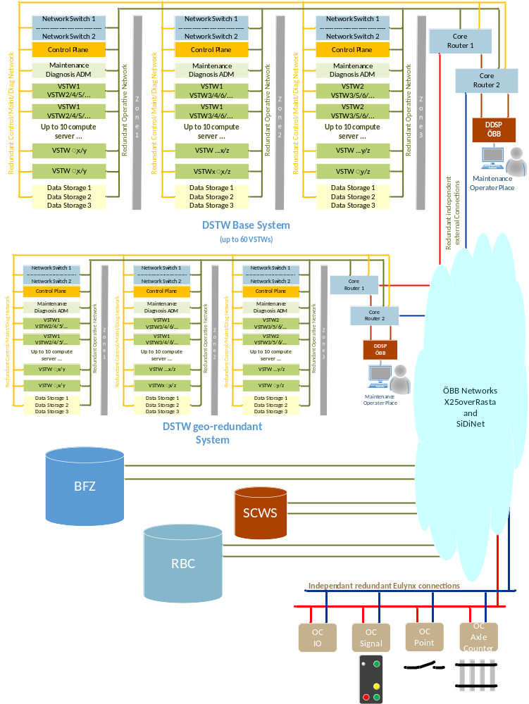
Figure 3; System overview DIL
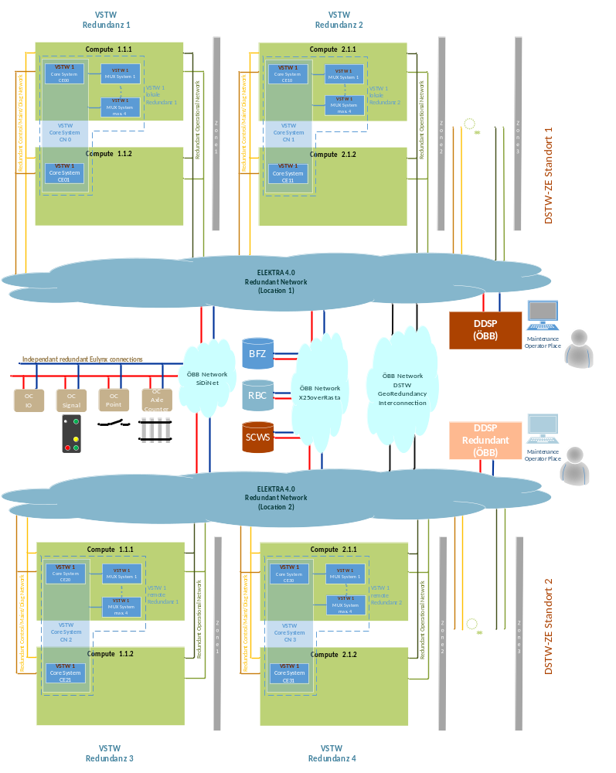
Figure 4: VIL Core and VIL MUX redundancy

RAM Design Rules
In order to ensure that the availability requirements (stated in section 6.2) are met, a series of rules, the so-called ‘RAM Design Rules’, will be developed and used as binding conditions for architectural design decisions. Note that each of these RAM Design Rules will also be explicitly mapped to one or more specific system requirements, ensuring traceability and compliance throughout the development lifecycle.
The rules are partitioned into
- General Rules
- Rules related to Computing Groups (CG), Computing Nodes (CN) and Computing Elements (CE)
- Rules related to the infrastructure components provided by IPS.
- Rules related to DFE
They share some common definitions described in the following table.
Term | Definition | Comment
Balanced distribution | A distribution of k items to n buckets is called balanced if the number of items per bucket differs by at most 1. | This term can be used for a balanced distribution of HW servers as well as for a balanced distribution of (SW) components.
Balanced increment | An increase in a balanced distribution by one item, so that the resulting distribution remains balanced. | This term can be used for a balanced increment of HW servers as well as for a balanced increment of (SW) components.
Affinity | A principle which establishes a preference for certain elements to work together or be placed together. | In OpenStack context:  Node Affinity: allows to constrain which nodes a pod can be scheduled on.  Pod Affinity: allows to schedule pods to be co-located with other pods.
Anti-Affinity | A principle which ensures that certain elements are not being placed together to avoid single points of failure | In OpenStack context:  Node Anti-Affinity: ensures that a pod is not scheduled on certain nodes.  Pod Anti-Affinity: ensures that a pod is not scheduled on the same node as certain other pods.
Equi-Distribution | Distributing workloads, data, or resources evenly to ensure balanced utilization and avoid overloading any single component | The balanced distribution defined above is an example of an equi-distribution.
Topology Spread | Distribution of elements across different availability zones | In OpenStack context:  Distribution of pods across different failure domains (for example availability zones) to ensure high availability and fault tolerance.
Table 6: RAM Design Rules Related Definitions
The following RAM related design rules are to be considered during the architectural design:
ID | Synopsis | Body
01.1 | Server distribution | The placement of the servers of the same type across the availability zones shall follow the balanced distribution principle. Server types are control server, compute server and storage server.
01.2 | Server reintegration | A reintegration of one or more servers of the same type shall follow the balanced increment principle.
02.1 | Server failure | In case of a server failure the services from this server shall be redistributed to the remaining servers following the balanced increment principle. This ensures a balanced distribution of the services on the remaining servers.
02.2 | No service redistribution after server reintegration | In case of reintegration of a server no services shall be redistributed. This prevents any additional disruption of operating services.
02.3 | Failure Diagnoses | Shutdown and reintegration of a component has to be provided in a unified customer-friendly way as well as for technical analyses. This information is then revised so that maintenance measures, for example, can be filtered. These data have to be made available, technically, and revised offline for the customer.
03.1 | Mapping component failure to severity level | The operative consequences of a failed hardware component shall be defined by the severity level of the availability class.
03.2 | Mapping corrective maintenance action to severity level | The operative consequences during a corrective maintenance activity shall be defined by the severity level of the availability class.
04 | Separate phase protection | Each power distribution unit (PDU) has to be separately protected. This means that an outage of one phase has no impact on other phases.
05 | Enable mapping of severity levels | The architectural concept shall be defined in a way to enable a mapping of severity levels to failed / reintegrated components.  Comment: For instance, redundancy properties like 2x2oo2, etc. and properties like Anti-Affinity, Equi-Distribution, etc. should be clearly stated in architecture documents for referencing.
Table 7: General RAM Design Rules

ID | Synopsis | Body
Group 06: [VIL]: CG - balanced distribution
06.1 | Equi-Distribution of CGs on physical servers - safety related components | CGs representing <VILs> shall be placed on different physical servers and on different availability zones following the balanced distribution principle.
06.2 | Topology spread constraint over availability zones - safety related components
Group 07: [VIL]: CN - balanced distribution
07.1 | Equi-Distribution of CNs on physical servers - safety related components | CNs belonging to the same CG shall be placed on different physical servers and on different availability zones following the balanced distribution principle.
07.2 | Topology spread constraint over availability zones - safety related components
07.3 | Anti-Affinity - CN
Group 8: [VIL]: CE - balanced distribution
08.1 | Equi-Distribution of CEs on physical servers - safety related components | CEs belonging to a CN shall be placed on different physical servers at the same availability zone following the balanced distribution principle
08.2 | Anti-Affinity - CE
Group 9: [APP]: VIL Applications
09.1 | Affinity - Applications | The VIL-applications which belong to a specific VIL-instance should be executed on the same physical server
Table 8: RAM Design Rules for CG, CN and CE

Availability Classes
The Generic Application Digital Interlocking ÖBB (GA DIL OBB 1.0.0) is assigned to Availability Class 1, ensuring maximum operational continuity and fault tolerance. The Virtual Interlocking (VIL) subsystem is categorized under Availability Class 2.
Following [PH_RAMS] and [SSS_DIL] the following availability classes and their respective subclasses are defined. The classes are furthermore subdivided into three subclasses addressing different MTTRs (“Mean Time to Restore”) ranging from mean time for fast automatic failure correction to mean time for manual restoration. Each availability class applies to a different scenario or fault category and is not a subcomponent of the overall downtime. This breakdown is shown in Table 9 below.

Class | System | Availability  [%] | MTTR  [min] | MTBF  [y] | TDT  [min/y]
1 | DIL | 99.999 |  |  | 5.25
 | Manual | 99.999 8 | 62 | 50 | 1.25
 | Automatic | 99.999 6 | 10 | 5 | 2
 | Automatic | 99.999 6 | 2 | 1 | 2
2 | VIL | 99.995 |  |  | 26.25
 | Manual | 99.997 9 | 225 | 20 | 11,25
 | Automatic | 99.999 9 | 10 | 2 | 5
 | Automatic | 99.999 6 | 2 | 1 | 2
Table 9: Availability classes
MTTR Mean Time To Restore
MTBF Mean Time Between Failures
TDT Total Down Time

RAM Requirements
The reliability, availability and maintainability requirements have to be identified and referenced within the Dependability Analysis. This Dependability Analysis should also provide a proper apportionment and refinement of these requirements according to the system design. A general description of all RAM aspects can be found in [RAM_Plan_Generic].

Reliability Requirements
Concerning reliability, RAM activities have to focus on the following goals:
- Consideration of all possible single failures of the system with focus to random hardware faults. Analysis of their consequences with respect to reliability, availability and maintainability (MTTR) and calculation of the associated failure rates.
- Determination of the impact of failures on the functionality of the system.

The key parameters for describing RAM features of a system, on the basis of [EN 50126-1] are:
    - Mean Up Time MUT, resp. Mean Time Between Failure MTBF,
    - Mean time to Restore MTTR and the
    - Availability A, resp. Unavailability (U = 1-A).
Figure 5, obtained from [EN 50126-1], illustrates key parameters of the availability concept.
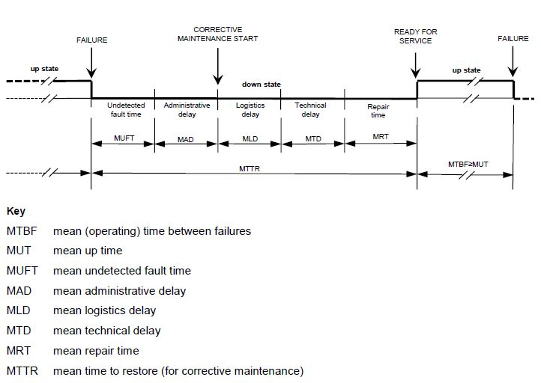
Figure 5: Availability concept and related terms
The MUT is the mean lifetime of a system between two failures. MTTR gives the time required from failure to restart operation.
For availability calculations, the following Mean Repair Time (MRT) is assumed [PH_RAMS]:
- Manual recovery of a fault: MRT = 0.5 hours

Availability Requirements
In order to show an appropriate behaviour of the system and sub-systems with respect to availability, a
system analysis shall be carried out to determine availability figures of components and sub-systems. The result shall be part of the Reliability Analysis. It shall be pointed out, that the availability figures depend on the proper installation, maintenance and operation conditions of the system and sub-systems as stated in the installation and maintenance manuals.

Maintainability Requirements
Concerning maintainability, RAM activities have to focus on the following goals:
- Identification and implementation of diagnostic measures to minimize system downtime
    - Detect fault alarms that have to be recorded during operation of the system.
    - Prepare appropriate counter measures in case of failures.
- Determine the time necessary for failure diagnosis and recovery of the availability of the system in case of system or component failures.
- Determine the operational impact (severity level) of the system in case of system or component failures.
- Identification of necessary maintenance actions including time required to conduct them.
All requirements concerning maintenance activities need to be summarized to plan necessary actions. Those actions subsume inspection, preventive and corrective maintenance, repair and spare part logistic.

RAM Plan

Methods and Tools used
The reliability calculation will be done according to [EN 50126-1] and the [MIL_HDBK217F] based Alcatel Reliability Standard [Alcarel] and according to the environmental conditions Ground Benign (GB) for indoor components and Ground Fixed (GF) for outdoor components.

RAM detailed activities, analyses and documents
Within this section, documents and activities necessary for defining and analysing reliability, availability and maintainability requirements are described.

RAM Design Rules
It is planned to develop a series of rules, so-called RAM Design Rules as binding conditions for architectural design decisions if possible. Each of these RAM Design Rules will be mapped to one or more specific requirement(s). See also section 3.3 RAM Design Rules.

RAM HW-FMEA
It is recommended to create a RAM HW-FMEA, that aims to analyse availability and maintainability aspects in terms of failed HW components or failed sub-systems and their operational consequences. It also analyses diagnostic capabilities of the system in order to support preventive and corrective maintenance actions.

Preliminary Reliability Analysis
Upon completion of the RAM Plan, it is recommended to create a preliminary Reliability Analysis document. This document must provide a rough estimation of the availability and reliability of the sub-systems described in chapter 3.
All relevant documentation shall be reviewed in order to define, at a preliminary level, the overall system structure and to recognise all the functional requirements, which may affect the RAM performance of the system.

Reliability Analysis
The Reliability Analysis is a key document, with focus on HW relevant aspects, describing reliability, availability and maintainability features.
Reliability aspects of SW have to be assured by following the rules of [EN 50126-1]. An analysis of SW reliability is not part of the Reliability Analysis where random HW faults and system failures will be analysed.
To be able to make reliable statements and to demonstrate that the required RAM goals will be obtained, the following information about the hardware and the purpose of the system has to be collected:
    - what kind of sub-systems / components will be used,
    - quantity of each sub-system / component,
    - Failure rates of all PBAs and devices used,
    - MTBF and MTTR for each sub-system / component.
The Reliability Analysis shall point out measures, how availability can be reached according to the mission goals.

Maintainability
To ensure a proper installation, operation and maintenance of the system, corresponding installation and maintenance documents have to be provided. MTTR, MRT and related terms have to be checked with respect to fulfilment of information stated in these documents.

RAM Deliverables

List of RAM deliverable Documents
This section summarizes the documents which are foreseen during RAM activities:
- RAM Plan (this document),
- RAM HW-FMEA (recommended),
- preliminary Reliability Analysis (recommended),
- Reliability Analysis (required).
Note: RAM documentation must be available according to the Document List and Review Matrix for engineering projects [DLRM].

RAM Requirements
The RAM related customer requirements need to be checked, clarified if necessary and appropriately refined during the different development phases. If additional RAM related aspects are to be considered in order to fulfill RAM related customer requirements, they should comply with corresponding standards [EN 50126-1].
The Generic Application Digital Interlocking OBB 1.0.0 and solution element VIL OBB 1.0.0 are subject to the dependability requirements stated by the customer in [SSS_DIL] and furthermore in [PH_RAMS]
The fulfillment of the following availability requirements must be shown in the Reliability Analysis:
Identifier | Titel
EL4-DIL-SSS-REQ-00406 | Availability - DIL-CU - Overall
EL4-DIL-SSS-REQ-00407 | Availability - DIL-CU - Disturbances - Manual Correction
EL4-DIL-SSS-REQ-00408 | Availability - DIL-CU - Errors without operational Impact
EL4-DIL-SSS-REQ-00409 | Availability - DIL-CU - Disturbances - Automatic Correction - 10 Minutes
EL4-DIL-SSS-REQ-00410 | Availability - DIL-CU - Disturbances - Automatic Correction - 2 Minutes
EL4-DIL-SSS-REQ-00587 | Availability - VIL - Overall
EL4-DIL-SSS-REQ-00569 | Availability - VIL - Disturbances - Manual Correction
EL4-DIL-SSS-REQ-00570 | Availability - VIL - Errors without operational Impact
EL4-DIL-SSS-REQ-00571 | Availability - VIL - Disturbances - Automatic Correction - 10 Minutes
EL4-DIL-SSS-REQ-00572 | Availability - VIL - Disturbances - Automatic Correction - 2 Minutes
Figure 6: Availability requirements

Periodical RAM activities report
The RAM Plan can be updated if necessary, in each phase of the product life cycle, described in [EN 50126-1].
Possible reasons are:
- Review comments of this document,
- Hardware changes,
- Change of standards and procedures.
Each change of the RAM Plan results in a new edition. At each new edition, the reasons for change will be documented in section 1.5

END OF DOCUMENT

Not in scope of this RAM Plan.
Not in scope of this RAM Plan.

