SEMP

System Engineering Management Plan

Solution Element

Digital Field Elements
APPROVAL
 | Name and Role/Job Title | Esignature
Written by | Bernhard Mandl / SEM DFE
Verified by | Fabian Rotter / QAM
Approved by | Erich Stemmer / SEM DIL

LOG OF CHANGES
Revision | Date | Author | Change Description
01 | 2025-05-09 | Bernhard Mandl | First Edition
02 | 2025-09-30 | Bernhard Mandl | See chapter 1.5.2

Contents
1. Scope 9
1.1 Identification 10
1.2 System Overview 10
1.3 Key Point 15
1.3.1 Milestones 15
1.3.2 Deliverables 16
1.4 Relation with other Plans 16
1.5 Document Version History 17
1.5.1 Edition 01 17
1.5.2 Edition 02 18
1.6 Open Points 18
2. References and terms 19
2.1 Referenced Documents 19
2.2 Standards and Procedures 21
2.3 Terms, Abbreviations and Acronyms 23
2.3.1 Role Abbreviations 23
2.3.2 Terms, Abbreviations and Acronyms 23
2.3.3 Abbreviations used in the project: 24
3. Solution engineering and development process 26
3.1 Organization of Solution Development and Engineering 26
3.1.1 Solution Core Team 26
3.1.2 Solution Team 27
3.1.3 External Project Roles 27
3.1.4 Configuration Control Board 27
3.1.5 Tailoring of role assignments 28
3.2 System Engineering Supplies 29
3.3 Input Data 30
3.4 Preconditions 30
3.5 Related Solutions 31
3.6 Technical Objectives 31
3.7 WBS/OBS and Engineering Work Packages 31
3.8 Training of System Engineering Team 34
3.9 Constraints 35
3.10 Work Contained Phase 1 35
3.10.1 WP3.DEV.3.2.3.1 - IFC ZG62 (HW + SW) 35
3.10.2 WP3.DEV.3.2.3.2 - FES S DCA 35
3.10.3 WP3.DEV.3.2.3.3 - FES M DCA 36
3.10.4 WP3.DEV.3.2.3.4 - FES M AzLM 36
3.10.5 WP3.DEV.3.2.3.5 - FES S IFC LCSI 37
3.11 Work not contained in Phase 1 38
3.12 Work contained in later Phases 38
3.12.1 Phase 2 38
3.12.2 Phase 3 39
3.13 Responsibility Assignment Matrix 39
3.13.1 Types of Involvement 39
3.13.2 Involvements 40
3.13.3 Explanation 40
3.14 Development Approach 40
3.15 Tools and Facilities 41
3.15.1 Project Management 41
3.15.2 Task Management 41
3.15.3 Requirements Management 41
3.15.4 Management Traceability 42
3.15.5 Configuration Management 42
3.15.6 Change Management 42
3.15.7 Documentation Management 43
3.15.8 Documentation Generation 43
3.15.9 Model Driven Engineering 43
3.15.10 Code Building 44
3.15.11 Hardware Engineering Environment 47
3.15.12 IVV Management 47
4. Process Control 49
4.1 Control of Solution Development 49
4.1.1 Deviation 49
4.1.2 Metrics 49
4.2 Monitoring and Control of System Engineering Activities 49
4.2.1 Periodic Internal Reviews and Meetings 49
4.2.2 Milestone Reviews and Audits 50
4.2.3 Reporting 51
4.3 Critical Technologies 51
4.4 Risk and Opportunities Control 51
4.5 Corrective Action Process 52
4.6 Independent Evaluation and Verification 52
4.7 Estimate/Re-Estimate 52
4.8 Planning 52
4.9 Value Analysis and Design to Cost 52
4.10 Peer Reviews 52
5. Development Scenario and Tailoring of the System Engineering Process 53
5.1 Orient the Solution 53
5.1.1 Overview 53
5.1.2 Input/Start 53
5.1.3 Activities and Deviations 53
5.1.4 Output 54
5.2 Design the Solution 54
5.2.1 Overview 54
5.2.2 Input/Start 55
5.2.3 Activities and Deviations 55
5.2.4 Output 55
5.3 Develop the Solution 56
5.3.1 Overview 56
5.3.2 Input/Start 56
5.3.3 Activities and Deviations 56
5.3.4 Output 57
5.4 Integrate and Verify the Solution 57
5.4.1 Overview 58
5.4.2 Input/Start 58
5.4.3 Activities and Deviations 58
5.4.4 Output 60
5.5 Validate the solution 60
5.5.1 Overview 60
5.5.2 Input/Start 60
5.5.3 Activities and Deviations 60
5.5.4 Output 62
6. System Engineering Support 63
6.1 Data and Configuration Management 63
6.2 Confidentiality 63
6.3 Export Control 63
6.4 Capitalization 63
6.5 Measurements and Analysis 63
6.6 Technical and Non-Technical Requirements Management and Control 63
6.7 Validation of Requirements 63
6.8 Decision Analysis and Resolution 63
6.9 Subordinate Plans 64
6.10 Quality Assurance 64
7. Approach and Criteria used for Tailoring of the System Engineering Process 65
8. Certification Support Activity 66
9. Notes 67
Appendix A : Criteria for the Selection of Techniques and Measures 68
END OF DOCUMENT 73

List of Tables
Table 1 Solution Identification 10
Table 2 Security / Maturity Level 10
Table 3 Milestones Phase 1 15
Table 4 Deliverables Phase 1 16
Table 5 Subordinate Planning Documents 17
Table 6 Referenced Documents 19
Table 7 Standards and Procedures 21
Table 8 Role Abbreviations 23
Table 9 Terms, Abbreviation and Acronyms 23
Table 10 Abbreviations used in the project 24
Table 11 Core Team Solution Element DFE 26
Table 12 Team 27
Table 13 External Project Roles 27
Table 14 CCB 27
Table 15 Suppliers Input Data 30
Table 16 Preconditions for Phase 1 30
Table 17 Related Solutions 31
Table 18 Technical Objectives 31
Table 19 WBS DFE 33
Table 20 Detailed OBS Solution Team 34
Table 21 Involvements table 40
Table 22 Project Management 41
Table 23 Task Management 41
Table 24 Requirements Management 41
Table 25 Management Traceability 42
Table 26 Configuration Management 42
Table 27 Change Management 42
Table 28 Documentation Management 43
Table 29 Documentation Generation 43
Table 30 Model Driven Engineering 43
Table 31 Hitachi Control - Continuous Build 44
Table 32 Build 44
Table 33 Eclipse Development 44
Table 34 Programming Languages/Compiler 45
Table 35 Elektra Tools 45
Table 36 ETCS Tools 46
Table 37 Legacy Tools 46
Table 38 Internal Used Products 46
Table 39 Development Platform 47
Table 40 HW Engineering Environment 47
Table 41 IVV Management 47
Table 42 Metrics 49
Table 43 Reviews and Meetings 49
Table 44 Milestone Reviews 51
Table 45 Orient the Solution, Activities and Deviations 53
Table 46 Design the Solution, Activities and Deviations 55
Table 47 Develop the Solution, Activities and Deviations 56
Table 48 I&V the Solution, Activities and Deviations 58
Table 49 Validate the Solution, Activities and Deviations 61

List of Figures
Figure 1 Scope Split 9
Figure 2 Solution Overview 9
Figure 3 System Architecture and Solutions 9
Figure 4 EULYNX System Architecture Baseline 4 Release 4 9
Figure 5 WBS DSTW ÖBB Entwicklung 9
Figure 6 OBS DFE Core Team 9
Figure 7 FES M DCA Schematic 9
Figure 8 FES M AzLM Schematic 9
Figure 9 Orient the Solution 9
Figure 10 Design the Solution 9
Figure 11 Develop the Solution 9
Figure 12 Integrate & Verify the Solution 9
Figure 13 Validate the Solution 9

Scope
The System Engineering Management Plan (SEMP) describes the Solution Work Plan and Engineering Process as it is to be applied.
It includes a description of the DDQS processes planned to
- Define the system requirements,
- Define the preferred system configuration,
- Satisfy the requirements,
- Provide the planning and control of the technical project tasks,
- Provide management of a totally integrated effort of product engineering including test, logistic, production engineering and to meet cost, schedule and product quality objectives.

Identification
Table 1 Solution Identification
Project: | DSTW ÖBB Entwicklung
Solution: | 100025795 / ATRELDE91
Solution / System: | Generic Application Digital Interlocking OBB 1.0.0 (GA DIL OBB 1.0.0)
Solution Element: | Digital Field Elements (DFE) Phase 1
Identification: | DFE 1.0.0  IFC 1.0.0
Contract: | Digitales Stellwerk DSTW – Rahmenvereinbarung
Customer: | ÖBB
End User: | ÖBB
SI-Level | SIL 4
In the following table (Table 2) SL-T is the target security level as required by the customer, SL-C is the capability security level of a particular component.
Table 2 Security / Maturity Level
Security Level | SL-T 3, SL-C 3
Maturity Level | ML 3

System Overview
For an overview about customer expectation see:
[CRS] „OBB_RA-DSTW-D1_Leistungsbeschreibung“
The detailed tasks are listed in the document, but in summary it should be noted:
- Development of the new ELEKTRA interlocking generation based on the ÖBB specifications for the digital interlocking solution and new field elements
- Possibly up to 435 interlockings (IxL) virtualized on site of two to three centralized computing centers (incl. geo-redundancy)
- reduction of facilities/buildings needs for the interlocking core and maintenance needs for the field elements by use of virtualization and object controllers,
- address the European standardization efforts of railway operators, known as the “EULYNX initiative”,
- cyber security on base of the IEC 62443, TS50701 and EULYNX BL 4, tackling the upcoming NIS2 directive and changed cyber threat situation
- Enabling roll-out projects
- Setting up a service infrastructure
- Overall integration of the interlocking solution into the ÖBB infrastructure

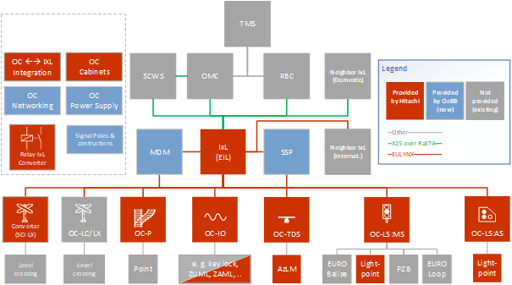
Figure 1 Scope Split

For more information about used products see [PBS]. The PBS distinguishes between:
- Make Developed within Hitachi Austria
- Team Developed within Hitachi Rail Ltd.
- Buy Developed by 3rd party
Therefore, the categorization between externally provided components and custom developed components from third-party suppliers according to the IEC 62443-4-1 .
For clarification on Figure 1 the Lightpoints will be integrated and delivered with the rollout, however a new development is NOT included in the project scope.
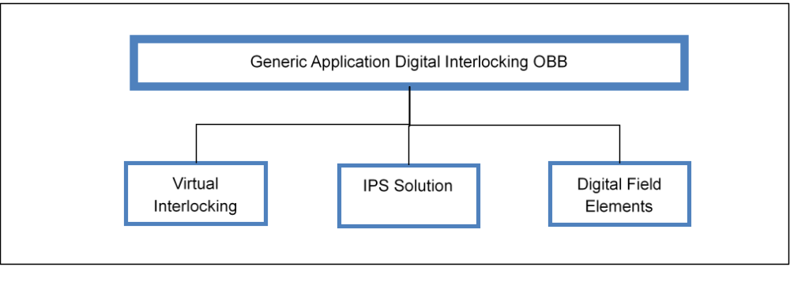
The project Generic Application Digital Interlocking OBB 1.0.0 (GA DIL OBB 1.0.0) is divided into three Solution Elements (see Figure 2).
Figure 2 Solution Overview

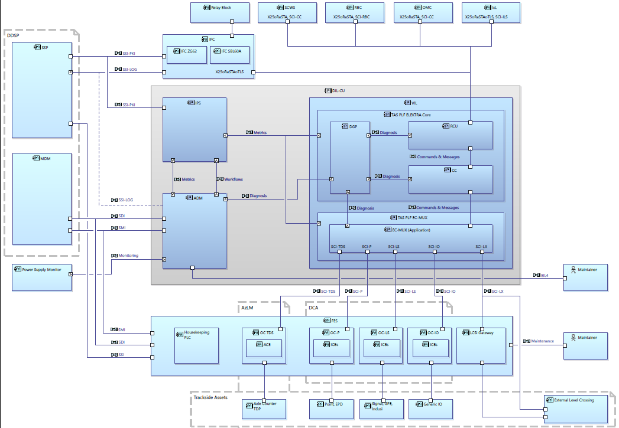
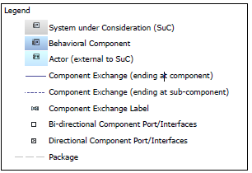
Figure 3 System Architecture and Solutions
This document describes the Solution Element Digital Field Elements in detail. This involves the implementation of EULYNX-compliant hardware, whereby the field elements:
- Subsystem - Point
- Subsystem - Light Signal
- Subsystem - Generic I/O general purpose IO, used for IO based elements that are not specified in EULYNX (e.g. key locks)
- Subsystem - Train Detection System
- Subsystem - External Level Crossing System
are integrated with the digital interlocking core unit (EULYNX component EIL – Electronic Interlocking) via the Interface SCI and controlled via Object Controllers located in Field Element Stations.
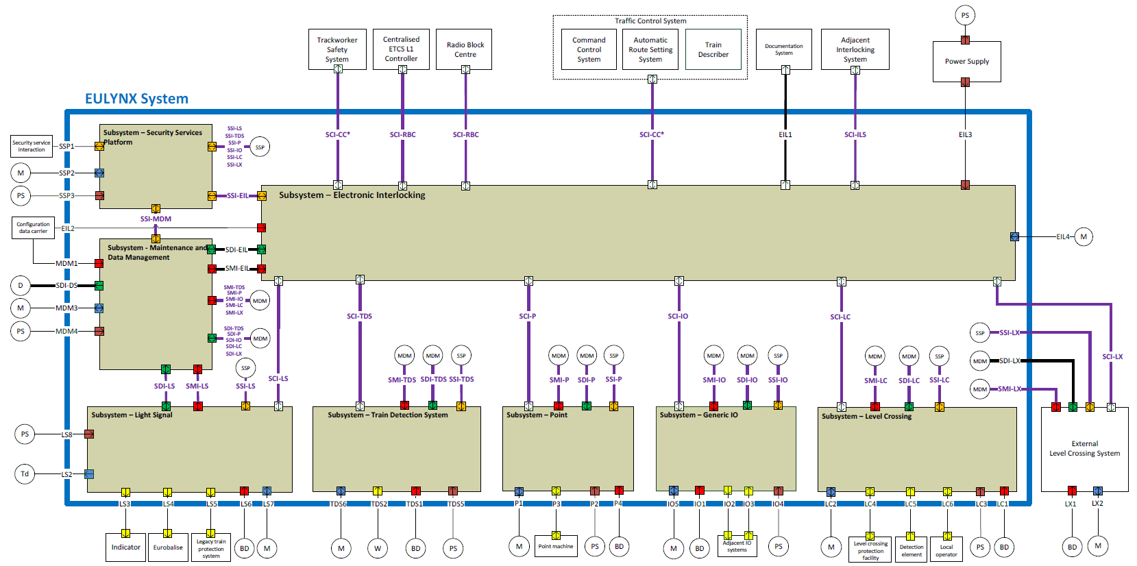
Figure 4 EULYNX System Architecture Baseline 4 Release 4
Additionally, Interface Converters (e.g. ZG62, Sbl60, Figure 3) to connect neighbor blocks are implemented in own cabinets, including hardware and software development. These converters are logically not part of the Digital Field Elements, but are nevertheless handled and developed in the Solution Element Digital Field Elements.
The development will be split in three Phases (see Chapter 3.10). In Phase 1, following Field Element Stations are developed:
- FES S (Small) DCA
- FES M (Medium) DCA
- FES M (Medium) AzLM
- IFC ZG62
- Support external supplier (Mission Embedded ME) for LCSI development
For more details regarding the different stations, see Chapter 3.7. Additionally, support for LCSI Gateway (delivered by external company Mission Embedded) starts in Phase 1 due to long timeline, even though the development and integration in a field element station is part of phase 2.

Key Point

Milestones
Since the delivery items are the stations, the milestones were divided according to the individual stations.
Table 3 Milestones Phase 1
Milestone | Target Date
Solution Orientation Review (SOR-1) | 4.4.2025
Solution Orientation Review (SOR-2) | T0 + 1 month
Solution Requirement Review (SRR-1) | 30.09.2025
Solution Requirement Review (SRR-2) | MS E03 + 3 months
Solution Functional Review (SFR-1) | 26.01.2026
Solution Functional Review (SFR-2) | MS E03⁶ + 5 months
Preliminary Design Review (PDR) | 11.09.2026
Critical Design Review (CDR) | 26.01.2027
Test Readiness Review (TRR1) FES M AzLM | 01.02.2027
Technical Qualification Review (TQR1) FES M AzLM | 08.10.2027
Test Readiness Review (TRR1) FES M DCA | 11.05.2027
Technical Qualification Review (TQR1) FES M DCA | 10.01.2028
Test Readiness Review (TRR1) FES S DCA | 15.07.2027
Technical Qualification Review (TQR1) FES S DCA | 17.01.2028
Test Readiness Review (TRR1) IFC ZG62 HW | 15.07.2027
Test Readiness Review (TRR1) IFC ZG62 SW | 14.05.2027
Technical Qualification Review (TQR1) IFC ZG62 HW + SW | 07.02.2028
Technical Qualification Review (TQR2) | 15.03.2028
Final Qualification Review (FQR) | 15.05.2028
All dates are under the assumption of a contract signature by end of 2025 (=T0). The milestones are related to the content of Phase 1 as included in the offer submitted to ÖBB in September 2025 (see Work contained in Chapter 3.10).

Deliverables
Table 4 Deliverables Phase 1
Deliverable | Completion Date | Customer
Developed and qualified FES M AzLM (AzLM version 7.10 with EULYNX BL4R4) DFE 1.0.0 | 08.10.2027 | Generic Application Digital Interlocking OBB 1.0.0 (GA DIL OBB 1.0.0)
Developed and qualified FES M DCA3.x (with EULYNX BL4R4) DFE 1.0.0 | 10.01.2028 | Generic Application Digital Interlocking OBB 1.0.0 (GA DIL OBB 1.0.0)
Developed and qualified FES S DCA3.x (with EULYNX BL4R4) DFE 1.0.0 | 17.01.2028 | Generic Application Digital Interlocking OBB 1.0.0 (GA DIL OBB 1.0.0)
Developed and qualified IFC ZG62 within a shelf (HW + SW) IFC 1.0.0 | 07.02.2028 | Generic Application Digital Interlocking OBB 1.0.0 (GA DIL OBB 1.0.0)
Prototype of LCSI Gateway DFE 1.0.0 | 01.10.2027 | Generic Application Digital Interlocking OBB 1.0.0 (GA DIL OBB 1.0.0)

Relation with other Plans
The SEMP describes the application of the Management System Solutions Engineering Processes (DDQS) to the design, development and deployment of the Solution Digital Field Elements.
This document will be updated as the Solution effort evolves.
A general overview of the Solution Element documents hierarchy and the baseline associated with each level of specification is shown in Configuration Management Plan.

Table 5 Subordinate Planning Documents
Title | Description | Ref.
Project Management Plan | Focuses on the Management System including organization, policies and plans that are carried out by Thales Austria in relation to the Project. | [PMP]
Configuration Management Plan | Provides details of the formal Configuration Management process. | [CMP_GEN], [CMP_HW]
Quality Management Plan | Describes requirements for all quality assurance measures and quality assurance activities to be carried out in the solution as contribution to the fulfilment of the project goals. | [QMP]
RAM Plan | Provides details of the tasks and activities about Reliability, Availability and Maintainability of the Solution. One Plan for Generic Application and one plan for Solution Element DFE. | [RAMP_DFE]
Safety Plan | Provides details of the tasks and activities of Solution safety management and Solution safety engineering required to identify, evaluate and eliminate or control hazards throughout the life cycle. Reference to Generic Safety Plan and Project Specific Plan | [SP]
Integration and Verification Plan | Is the general overview how it is planned to manage and test the Generic Application with the three Solution Elements. The generic IVP and a project specific plan following the ÖBB requirements is provided | [IVP]
Validation and Qualification Plan | Is the general overview how it is planned to manage and validate the Generic Application with the three Solution Elements. The generic VQP and a project specific plan following the ÖBB requirements is provided | [VQP]
Security Management Plan | Is the general overview how it is planned to address the security aspects in the Generic Application with the three Solution Elements. The generic SecMP and a project specific plan following the ÖBB requirements is provided | [SecMP]
Industrialization and Purchasing Plan DFE – Phase 1 | Is the general overview how it is planned to industrialize and purchase relevant parts and components for the Solution Element Digital Field Elements for Phase 1 | [IPP]
Test Plan | Is the overview of the planned test activities of the Digital Field Elements in Phase 1 | [Test Plan]

Document Version History

Edition 01
First Release

Edition 02
Document updates in regards to DFE related changes according to the 4th Edition of the offer placed to ÖBB at 12th of September 2025. These changes in regards to DFE are:
- X25 to X25oRaSTA Converter cancelled
- Converter Zustimmung cancelled
- EPD Box excluded
- Retrofit cancelled
Additionally, milestones, WBS/OBS and the according work package descriptions have been updated.

Open Points
IFC ZG62:
- Check whether the security requirements are met with TAS Platform 2.5.2, as it is actually currently running on the Compute Board SCA. Since the self-developed SEC/SEA implementation is running on the Computing Board, an update of the TAS Platform is possible if necessary.

References and terms

Referenced Documents
Table 6 Referenced Documents
 | Nr. /Title | Reference | Version
[CMP_GEN] | Configuration Management Plan – Generic | 3BU 15000 3338 QMAPA | 11RL
[CMP_HW] | Configuration Management Plan – Hardware Generic | 3BU 15000 8006 QMAPA | 02RL
[CRS] | DSTW Streckenausrüstung OBB - Teil D Leistungsbeschreibung und Lastenhefte | 3BU 17300 0004 DSAPC | 04RL
[CRS_Light Signals] | DSTW Streckenausrüstung OBB - Teil E Mitgeltende Dokumente  [715] LH Signalgeber DSTW V1.0 | 3BU 17300 0005 DSAPC | 04RL
[DoP] | Documentation Plan / PVR Solution Element – DFE Phase 1 | 3BU 62800 0000 ADAPA | 01PD03
[DVa] | Design Validation approval (DVa) | OeBB_Bid_DVa.docx  extended with updates and details from “Digitales Stellwerk - Technische Konzepte”  3BU 17300 0010 DSAPC | 12  04RL
[EngDB] | Engineering Dashboard (sharepoint) | 100025795_ATRELDE91_DSTW-ÖBB-Entwicklung_DFE_202503.xlsm | Latest
[IMP] | Integrated Master Schedule | Eng_Master_Schedule in SharePoint | Latest
[IPP] | Industrialization and Purchasing Plan - DFE Phase 1 | 3BU 62800 0050 MCAPA | 01PD02
[IVP] | Project Specific Integration and Verification Plan (IVP) | 3BU 17300 1206 DUAPC | 01RL
[MS-Report] | Milestone Report Solution | 3BU 62800 0002 ADAPA | Latest
[OBB_RA-DSTW] | OBB_RA-DSTW-D1_Leistungsbeschreibung | 3BU 17300 0004 DSAPC | 04RL
[PBS] | Product Breakdown Structure | 3BU 17300 1215 DPAPA | 02RL
[PMP] | Project Management Plan | 3BU 17300 1000 DPAPC | 01PD02
[QMP] | Quality Management Plan ELEKTRA | 3BU 17300 1202 QMAPC | at SOR-2
[RAMP_DFE] | RAM Plan DFE | 3BU 62800 0018 DUAPA | 02RL
[RiskReport] | Risk Report | 100025795_ATRELDE91-E0_DSTW_ÖBB_Entwicklung_Risk_List_20250930_ED02.xlsx | 02RL
[RMP] | Requirements Management Plan (RMP) Generic Application Digital Interlocking OBB | 3BU 17300 1207 DUAPA | 01RL
[SaCo] | Sicherheitskonzept, ELEKTRA  Safety Concept - Two Diverse SW Channels on a Redundant Platform  Safety Concept Elektra 4 Communication  Safety concept DIL | 3BU 15000 0622 DUAPC  3BU 15000 6957 DUAPA  3BU 15000 6956 DUAPA  3BU 17300 1212 DUAPC | 04RL  01PD02  01PD05  at SRR
[SecMP] | Project Specific Security Management Plan (SecMP) | 3BU 17300 1213 DPAPA | 01PD02
[SEMP_DIL] | System Engineering Management Plan Generic Application – Digital Interlocking OBB | 3BU 17300 1200 DPAPA | 02PD01
[SEMP_IPSS] | System Engineering Management Plan Solution Element IPSS | 3BU 17300 2001 DPAPA | 01PD02
[SEMP_VIL] | System Engineering Management Plan Solution Element Virtual Interlocking | 3BU 15000 6955 DPAPA | 01PD01
[SP] | Safety Plan DSTW | 3BU 17300 1204 DUAPA | 01RL
[Test Plan] | Test Plan - DFE Phase 1 | 3BU 62800 0100 QTAPA | 01RL
[ToolClass] | Hitachi Austria Tool Classification EN50129 | 3BU 15000 5135 190EN | Latest
[ToolClassSW] | Software Development, Tool Classification, EN 50128 | 3BU 15000 5135 AAAPA | Latest
[VQP] | Project Specific Validation and Qualification Plan (VQP) | 3BU 17300 1205 DUAPA | 01RL
[WBS/OBS] | WBS/OBS Solution Element Digital Field Elements | 3BU 62800 0013 BCAPA | 02RL
[Estimation Sheet_DSTW_HW] | Estimation Sheet DSTW Hardware | 3BU 00603 0149 BEAPA | 06RL
[Estimation Sheet_DSTW_NIC_SW] | Estimation Sheet DSTW Software / NIC | 3BU 00603 0214 BEAPA | 02RL

Standards and Procedures
Table 7 Standards and Procedures
Nr./Title | Publishing Date/ Reference | Version/ Revision
- IRIS Certification rules:2020 based on ISO/TS 22163:2017 | 2017 | n/a
- EN 50716:2023 – Railway application – Requirements for software development | 2023 | n/a
- EN 50129:2018 + AC:2019 Railway applications – Communication, signalling and processing systems – Safety related electronic systems for signalling | 2018/2019 | n/a
- ISO 9001 | 2015 | n/a
- EN 50126-1:2017 – Railway Applications – The Specification and Demonstration of Reliability, Availability, Maintainability and Safety (RAMS) – Part 1: Generic RAMS Process | 2017 | n/a
- EN 50126-2:2017 – Railway Applications – The Specification and Demonstration of Reliability, Availability, Maintainability and Safety (RAMS) – Part 2: Systems Approach to Safety | 2017 | n/a
- Management System Process Manage Risks and Opportunities | Part of 87200984-00-PRJ-GRP-EN (Chapter 8.6) | 2025-01
- Management System Process Manage Project | 87200984-00-PRJ-GRP-EN | 2025-01
- Minimum Requirements for the configuration management implementation | Part of 87100077-CFG-GRP | 007
- Management System Process 6.1 DDQS-SW - Design develop and qualify the Software solution | Part of 87202125-00-DDQ-GRP-EN | 2025-01
- Management System Process 6.1 DDQS-HW - Design develop and qualify the Hardware solution | Part of 87202126-00-DDQ-GRP-EN | 2025-01
- Management System Process Validate the Solution | Part of 87202127-00-DDQ-GRP-EN | 2025-01
- Management System Process Integrate and Verify the Solution | Part of 87202127-00-DDQ-GRP-EN | 2025-01
- Management System Process Orient the Solution | Part of 87202127-00-DDQ-GRP-EN | 2025-01
- Management System Process Design the Solution | Part of 87202127-00-DDQ-GRP-EN | 2025-01
- Management System Process Develop the Solution | Part of 87202127-00-DDQ-GRP-EN | 2025-01
- Management System Process 9.7 CFG - Manage Configuration | 87202424-00-CFG-GRP-EN | 2025-01
- Management System Process 9.3 Control Export | 87299999-00-EXP-GRP-EN | 2025-01
- Management System Guarantee quality and manage continuous improvement | 87200214-00-QCI-GRP-EN | 2025-01
- Protection of Group Information | 87201725-GOV-GRP-EN | 005
- Personal Data Protection Policy | 87212828-GOV-GRP-EN | 001
- Project Life Cycle | 83530275-DDQ-AUT-EN | 005
- Document Management Rules | 83530061-DOC-AUT-EN | 013
- Milestone Template Solutions | 83530019-DDQ-AUT-EN | 012
- Document List and Review Matrix for engineering projects | 83530224-DOC-AUT-EN | 010
- HSE Instruction | 83530048-HSE-AUT-DE | 020
- Agile Definition SMP | 83530312-DDQ-AUT-EN | 002
- ISA/IEC 62443-3-3 Industrial communication networks - Network and system security, Part 3-3: System security requirements and security levels, Edition 1, 09 2013 | 2013 | 01
- ISA/IEC 62443-4-1 - Security for industrial automation and control systems, Part 4-1: Secure product development lifecycle requirements, Edition 1, 01 2018 | 2018 | 01
- ISA/IEC 62443-4-2 - Security for industrial automation and control systems, Part 4-2: Technical security requirements for IACS components, Edition 1, 04 2019 | 2019 | 01
- EN 50159:2010, + A1:2020  Railway applications – Communication, signalling and processing systems – Safety-related communication in closed transmission systems | 2020 | n/a
- CLC/TS 50701:2023 – Technical Specification: Railway Applications – Cybersecurity | 2023 | 2023-10
- MLS Security Engineering Instruction | 83559080-DDQ-DEU-EN | 002

Terms, Abbreviations and Acronyms

Role Abbreviations
Table 8 Role Abbreviations
APM | Acquisition Project Manager
ARC | Architect
ATS | Acquisition Technical Support
CHARM | Change and Request Management
CM | Configuration Manager
DM | Document Manager
DPM | Data Preparation Manager
HwEM | Hardware Engineering Manager
IM | Industrial Manager
IVM | Integration and Verification Manager
IVVQM | Integration, Verification, Validation and Qualification Manager
PDA | Project Design Authority
PLM | Product Line Manager
PM | Project Manager
PPTM | Production Process and Technology Manager
PSM | Project Security Manager
QAM | Quality Assurance Manager
RAM-AM | Reliability, Availability, Maintainability Assurance Manager
RM | Requirements Manager
SAM | Safety Assurance Manager
SecAM | Security Assurance Manager
SEM | System Engineering Manager
SpE | Specialty Engineer
SVEM | Service Engineering Manager
SwEM | Software Engineering Manager
TM | Test Manager
VAL | Validator
VER | Verifier
WPM | Work Package Manager

Terms, Abbreviations and Acronyms
Table 9 Terms, Abbreviation and Acronyms
App | Applicable
CENELEC | European Committee for Electrotechnical Standardization
CCB | Configuration Control Board
CDR | Critical Design Review
CMP | Configuration Management Plan
DDQS | Design, Develop and Qualify the Solution
DWF | Document Web Frontend
ECM | Enterprise Content Management
FCA | Functional Configuration Audit
FQR | Final Qualification Review
ILS | Integrated Logistic Support
IVV | Integration, Verification and Validation
I&V | Integration and Verification
KOM | Kick of Meeting
LUT | Label Unit Tracking
M | Mandatory
NA | Not applicable
O | Optional
PCA | Physical Configuration Audit)
PCB | Printed Circuit Board
PCM | Primavera Core Model
PDR | Preliminary Design Review
PMP | Project Management Plan
QMP | Quality Management Plan
RAM | Reliability, Availability and Maintainability
RJC | Reuseable Java Components
SE | Solution Element
SEMP | System Engineering Management Plan
SFR | Solution Functional Review
SOR | Solution Orientation Review
SRR | Solution Requirement Review
SubIT | Subsystem Integration Test
SW | Software
T | Tailoring
TM | Test Manager
TQR | Technical Qualification Review
TRN | Thales Record Number
TRR | Test Readiness Review
VA | Validation
WBS | Work Breakdown Structure
WP | Work Package
WPM | Work Package Manager

Abbreviations used in the project:
Table 10 Abbreviations used in the project
AzLM | Multi Section Axel Counter (one type of TDS)
BI | Basic Integrity
CFI | Customer Furnished Item
DCA | Distributed Controller Architecture
DDSP | Daten Diagnose Service Plattform (CFI ÖBB)
DFE | Digital Field Elements
DGP | Diagnosis Processor (ELEKTRA)
DIL | Digital Interlocking = DSTW
DSTW | Digitales Stellwerk = DIL
DSTW-ZE | Digitales Stellwerk Zentraleinheit = EIL
ECMUX | Element Controller MultipleXer
EIL | Electronic Interlocking System according to EULYNX – equals to DSTW-ZE
EKSA | Eisenbahnkreuzungssicherungsanlage = LCSI (CFI ÖBB)
EULYNX | European Initiative to Linking Interlocking Systems
FES | Field Element Station
IEC | International Electrotechnical Commission
IFB | Interface Board
IFC | Interface Converter
GA DIL OBB | Generic Application Digital Interlocking ÖBB
IPS | Integrated Platform Services
IPSS | IPS Solution Element
LCSI | Level Crossing Safety Installation = EKSA
LX | EULYNX External Level Crossing
MDM | EULYNX, Maintenance and Data Management (CFI)
OBB | Oesterreichische Bundes Bahn (Austrian Railway Operator, ÖBB)
OC | Object Controller
OMC | Operation Management Center = BFZ (Betriebsführungszentrale)
RaSTA | Rail Safe Transport Application (safety protocol for railway signalling systems)
RBC | Radio Block Center (CFI ÖBB)
SCI | Standard Communication Interface (EULYNX interface for process data information)
SCWS | Signal Controlled Warning System
SDI | Standard Diagnostic Interface (EULYNX interface for diagnostics)
SiDiNet | SicherungsDienstNetzwerk (CFI ÖBB)
SMI | Standard Maintenance Interface (EULYNX interface for maintenance)
Solution | A consistent set of systems, equipment and services provided to the Customer to meet a specific requirement
Solution Element | A system, a sub-system, a product / equipment, or a service, a software component, a hardware component
SSI | Standard Security Interface (EULYNX interface for security)
SSP | Security Services Platform (CFI ÖBB)
TDS | Train detection system
VIL | Virtual Interlocking
VSTW | Virtuelles Stellwerk = VIL

Solution engineering and development process
The Solution will be conducted according to Hitachi Rail GTS Austria Management System. The Management System version valid at the start of the Solution is 2025-01.
As the Management System is continuously improving, it has to be mentioned, that in the devolution of the Solution, the respectively valid Templates have to be used according to the up-to-date version.
If Template changes are done, the document will only be adapted if they need to be revised anyway.

Organization of Solution Development and Engineering
The description of the roles mentioned below can be found on the Management System Portal.

Solution Core Team
Table 11 Core Team Solution Element DFE
Role | Resource | Deputy Resource
IVM | NN
PDA HW | A. Haunschmied | D. Baumgartner
PDA SW | R. Mittermayr | K. Aichner
PLM | R. Holzknecht | M. Dum
PSM HW | S. Peternel
PSM SW | T. Fischer
QAM | F. Rotter | A. Haslinger
RM | G. Eber | I. Miler
SAM HW | M. Pohl | C. Sünder
SAM SW | R. Büger | C. Sünder
SEM | B. Mandl | M. Goldenits
SEM Generic Application DIL | E. Stemmer | M. Gartner-Pohl
VAL HW | I. Grgic | M. Pohl
VAL SW | W. Luef
VER HW*) | H. Iqbal
VER SW*) | H. Walenta
WPM FES M AzLM | B. Mandl | M. Goldenits
WPM FES M DCA | B. Mandl | M. Goldenits
WPM FES S DCA | B. Mandl | M. Goldenits
WPM FES S IFC LCSI | B. Mandl | M. Goldenits
WPM ZG62 HW | B. Mandl | M. Goldenits
WPM ZG62 SW | K. Aichner | R. Rambo
*) For more detailed description regarding the role of HW VER, see chapter 3.1.5.2.

Solution Team
Table 12 Team
Role | Resource | Deputy Resource
ARC HW | E. Brenner | A. Haunschmied
ARC SW | K. Aichner | R. Mittermayr
DM | See chapter 3.1.5.3 | n/a
CM HW | D. Baumgartner
CM SW | K. Aichner
RAM-AM | F. Moser | M. Scheuer
SecAM | A. Willenberg
IM | R. Ratz
Test Manager HW | H. Schneider
Tester HW | See Table 20
Tester SW | See Table 20

External Project Roles
Table 13 External Project Roles
Role | Resource | Deputy Resource
Safety Assessor | Arsenal Race | n/a
Security Assessor* | tbd | tbd
Tester (EMC) | Bluetechnix Lab GmbH (EMC Vienna) | n/a
Tester (Shock, Vibration, Thermal) | RST LABS - Rail System Testing GmbH | n/a
Developer | Mission Embedded GmbH | n/a
*) Nomination of Security Assessor still open

Configuration Control Board
Table 14 CCB
Role | Resource | Comment | M/O
PLM | See Table 11 |  | M
PM | See Table 11 |  | M
PSM | See Table 11 |  | M
SEM | See Table 11 |  | M
PDA | See Table 11 |  | M
SAM | See Table 11 |  | M
WPM | See Table 11 |  | M
QAM | See Table 11 |  | M
CM | See Table 11 |  | O
IVVQM | See Table 11 |  | O
IM | See Table 12 |  | O
VAL | See Table 11 |  | M
VER | See Table 11 |  | M

Other project team members are invited to the CCB as needed.

Tailoring of role assignments

Role of IVVQM
The role IVVQM is not executed by a single person. The major IVVQM activities are distributed to other roles:
- Integration: is made by IVM
- Verification: is made by IVM
- Validation: is made by VAL
- Qualification: is made by VAL (in case of HW development)

Role of Verifier (VER) according CENELEC EN 50716 and EN 50129
The verification according CENELEC of all documents is performed through reviews by the roles defined in the Document List and Review Matrix for engineering projects [S25]. The role VER is not executed by a single person. The VER activities are distributed to other roles:
- Process Verification: is made by QAM
- Final document Verification: is made by RM
- Software/Code Verification: is made by an Independent Designer
- HW (Design) Verification: is made by HW VER
- Deliverables Verification: is made by IVM
- Enabling systems Verification: is made by CM
- Lifecycle phases Verification: is made by VER
- Collection of Verification results in Verification-report: is made by VER
The Verifier according to EN 50129 is equivalent to the Tester of EN 50716. Therefore, the HW verification tasks are handled by a tester.
The HW Design Verification is done by a dedicated role HW VER who is not involved in design, test and validation activities. The HW VER performs the documentation verification based on the basic questionnaire and creates a verification report as summary of the tests performed as well as the open defects resulting from them.

Role of DM
The role DM is not executed by a single person. The major DM activities are distributed to other roles:
- new ANV: can be obtained by SEM
- Document Index: is made by CM or SEM
- Formal check at release of a document: is made by QAM
- Other DM activities: are made by author of the document

System Engineering Supplies
For detailed description of used or purchased products, see [PBS].
The FES in phase 1 are available in 3 different versions + the outdoor elements:
- FES S DCA + FES M DCA supporting up to 2 Object Controller (S) and 10 Object Controller (M)
  - Housekeeping SPS
  - Lighting/Access Control
  - DCA-P 3.1.0
    - Interface Control Unit Point - ICB-P HW 3.0
  - DCA-LS 3.1.0
    - Interface Control Unit Output – ICB-O2
    - Interface Control Unit Light Signal – ICB-LS
  - DCA-I/O 3.1.0
    - Interface Control Unit Input/Output High Power – ICB I/O HP
    - Interface Control Unit Input – ICB-I2
  - ICB Carrier Boards
    - Carrier 19 Inch for 4 ICB
    - Carrier 19 inch for 2 ICB (Left)
    - Carrier 19 inch for 2 ICB
- FES M AzLM supporting TDS
  - Housekeeping SPS
  - Lighting/Access Control
  - Object Controller Module
    - AzLM v7.10
Outdoor Elements:
- Station Key Lock
- Line Key Lock
- Local Control Post
- iLED
- iAnzeiger
- AzLM Outdoor
Additionally, for phase 1, the IFC Cabinets include:
- IFC ZG62 1.0
  - Computing Board SCA
  - DCA 2.x IOC
  - Relay Group
For the LCSI-Gateway, in phase 1 only a prototype will be provided for first tests.

Input Data
The following table shows all necessary input versions on which Solution Element DFE is based.
Table 15 Suppliers Input Data
Item | Version | Provider
AzLM | 7.10 | Hitachi Rail Germany
DCA for IFC  DCA for DFE | 2.x  3.1.x | Hitachi Rail Spain (SW) + Germany (HW)
Computing Board SCA | 06 | Hitachi Rail Austria
TAS Platform for DCA 3.x  TAS Platform for AzLM  IFB for DCA 2.x  TAS Platform for SCA | 2.6  2.6  Platform IFB  2.5.2 | Hitachi Rail Austria
J4S | 3.1.0 | Hitachi Rail Austria
RCJ Core  RJC RaSTA | 1.1.0  2.0.0 | Hitachi Rail Austria

Preconditions
Table 16 lists all subsequent delivery versions on which the solution and development process/schedule depend.
Table 16 Preconditions for Phase 1
Deliverable | Completion Date | Provider
AzLM 7.10 (new subrack HW, not SW feature complete, but HW ready for qualification)* | 12/2026 (TRR-A Positive Assessment Report) | Hitachi Rail Germany
DCA 3.x Release 1 **) | 10/2026 | Hitachi Rail Spain
LCSI-Gateway 1st Prototype | 10/2027 | Mission Embedded
*) SMI Feature – no download, SDI – partially filling of OPC-UA, EULYNX BL4.4 valid release (but not all data fields), new HW and subrack Prototype will be available for Integration tests
**) New ICB HW to be expected until End of 2027 need to match with TRR1 FES M DCA

Related Solutions
Table 17 Related Solutions
Project / Solution | Solution Element | Responsibility
Project DSTW ÖBB Entwicklung | Generic Application Digital Interlocking (GA DIL OBB 1.0.0) | E. Stemmer (SEM)
Solution Element | Solution Element Virtual Interlocking (VIL OBB 1.0.0) | P. Bargiel (SEM)
Solution Element | Solution Element IPS Solution (IPSS OBB 1.0.0) | V. Vasilev (SEM)

Technical Objectives
Goal of the project Generic Application Digital Interlocking (GA DIL OBB 1.0.0) is to reduce buildings and hardware costs through virtualization of interlockings. Due to the high complexity of the project a 3-Phase approach for the development is defined (see [SEMP_DIL] chapter 3.9.1). This document is focusing on Phase 1.
The DFE Solution Element provides stations or cabinets that ensure EULYNX-compliant controlling and communication between the virtual interlockings and the field elements or legacy interlockings. The communication itself is done via so called Object Controllers (OC) located in the Field Element Stations. In Table 18 the dependencies between the subcomponents and the different stations is shown. For more information about used products see [PBS].
Table 18 Technical Objectives
FES S+M DCA (DFE 1.0.0) | FES M AzLM (DFE 1.0.0) | IFC ZG62 (IFC 1.0.0) | LCSI-Gateway 1.0*
DCA 3.x Release 1 for Phase 1 (New ICB HW to be expected until End of 2027)  TAS Platform 2.6.x | AzLM 7.10 (new subrack HW, not SW feature complete for Q-Test with fixed HW  TAS Platform 2.6.x | Computing Board SCA  TAS Platform 2.5.2**) | 1st Prototype
DCA 2.x IOC

Platform IFB
 |  | J4S 3.1.0
*) In phase 2 the LCSI-Gateway will be integrated in a FES S
**) Check if required Security features included in TAS Platform 2.5.2 or if update necessary is open (see 1.6)

WBS/OBS and Engineering Work Packages
The WBS for the Project DSTW ÖBB Entwicklung is shown in Figure 5 (see also [WBS/OBS]).
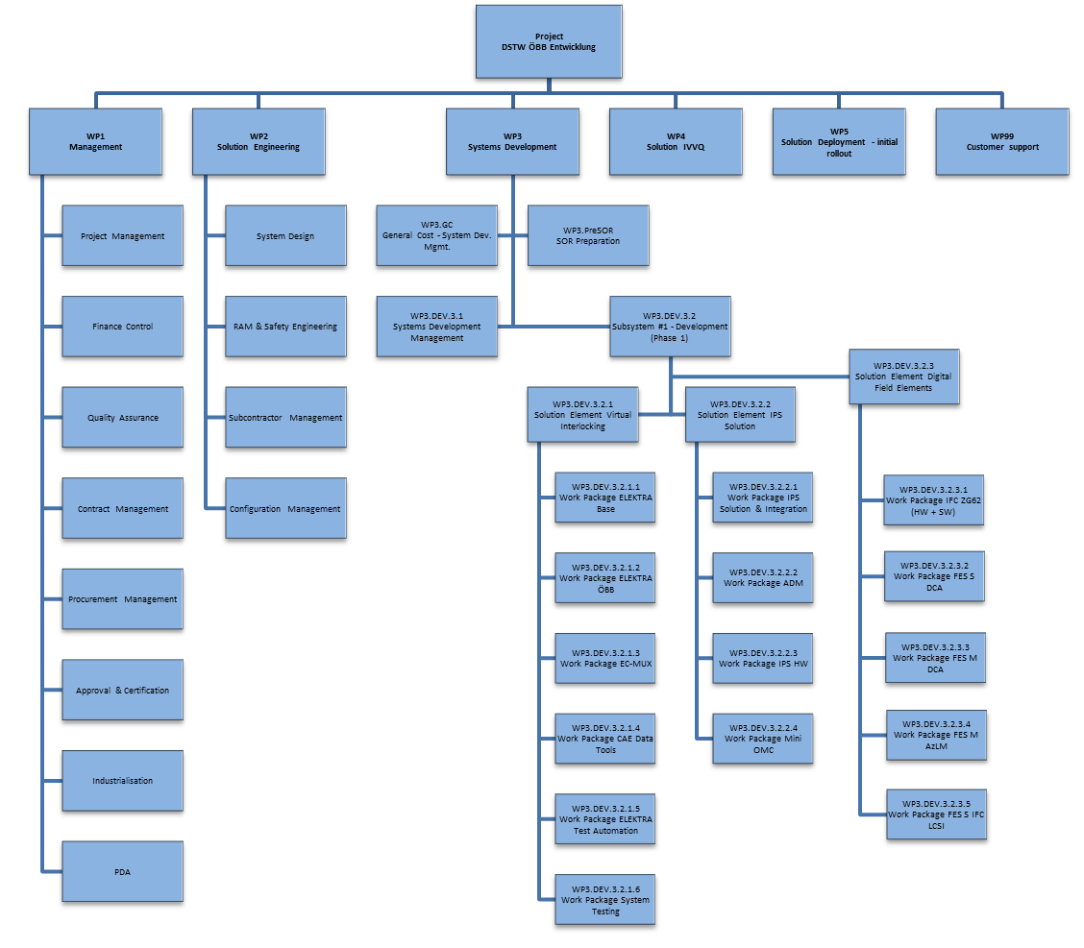
Figure 5 WBS DSTW ÖBB Entwicklung
Due to the high variance and complexity of the hardware, a WBS is selected to ensure compliance with the master plan. Therefore, it was advisable to structure the work packages in such a way that self-contained deliverables could be achieved.
The breakdown of the work packages shown is based on the FES size (number of object controllers) and the technology used for the object controllers or interface converters.
Station size S will be equipped exclusively with OCs consisting of DCA 3.x units. Station size M will be equipped with DCA 3.x units and AzLM units for the TDS.
The interface converter for ZG62 will be equipped with SCA and DCA 2.x for communication with neighboring interlockings.
This WBS enables independent qualification/approval of the respective deliverables and thus optimization of the schedule as needed.

Table 19 shows the Workpackages for the Solution Element DFE. For DFE see [WBS/OBS].
Table 19 WBS DFE
WP ID | WP Name | WP Manager | WP Management Approach
WP3.DEV.3.2.3.1 | IFC ZG62 (HW + SW) | B. Mandl HW / K. Aichner SW | Managed as WP
WP3.DEV.3.2.3.2 | FES S DCA | B. Mandl | Managed as WP
WP3.DEV.3.2.3.3 | FES M DCA | B. Mandl | Managed as WP
WP3.DEV.3.2.3.4 | FES M AzLM | B. Mandl | Managed as WP
WP3.DEV.3.2.3.5 | FES S IFC LCSI | B. Mandl | Managed as WP
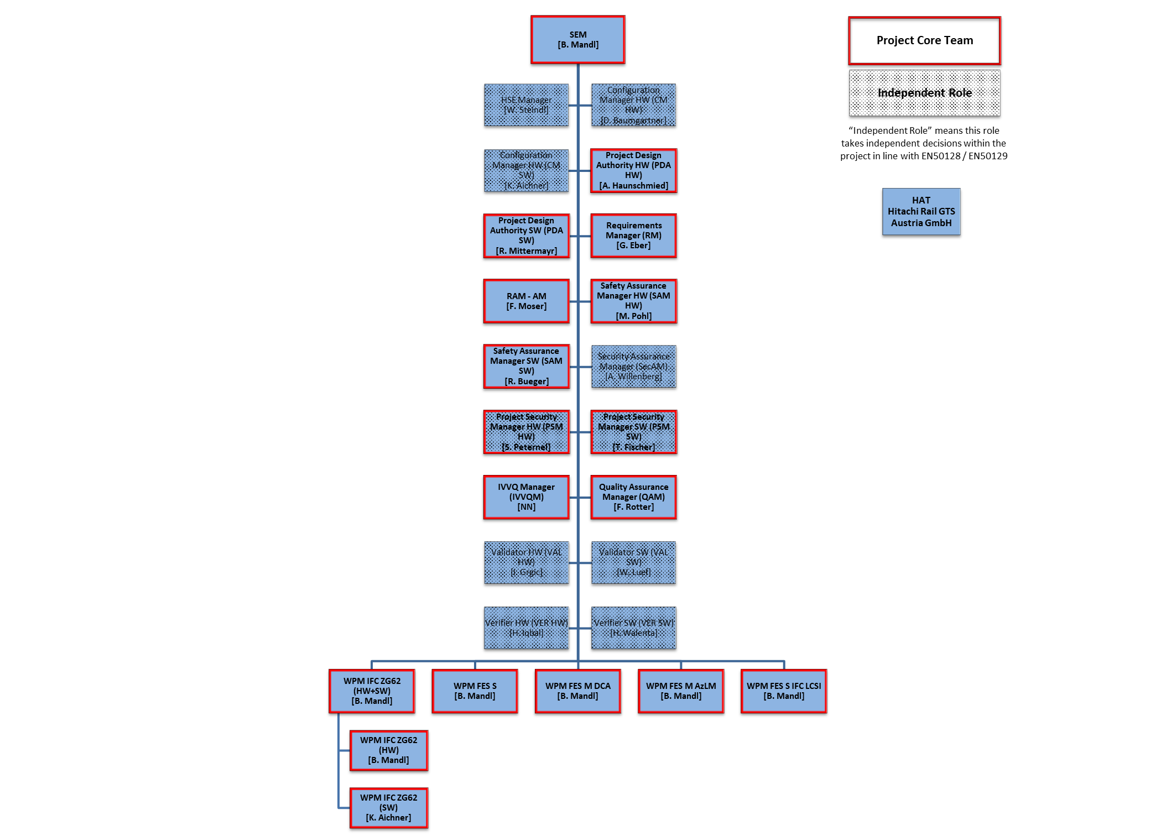
Figure 6 OBS DFE Core Team

The Figure above shows the Top-Level OBS for the Solution Element DFE. For a more detailed view, see [WBS/OBS]. More detailed information about the work packages is also shown in Table 20.
Table 20 Detailed OBS Solution Team
 | WP3  DEV.3.2.3.1  IFC ZG62 (HW + SW) | WP3  DEV.3.2.3.2  FES S DCA | WP3  DEV.3.2.3.3  FES M DCA | WP3  DEV.3.2.3.4  FES M AzLM | WP3  DEV.3.2.3.5  FES S IFC LCSI
WPM | B. Mandl HW  K. Aichner SW | B. Mandl | B. Mandl | B. Mandl | B. Mandl
System Architect | E. Brenner HW  K. Aichner SW | E. Brenner | E. Brenner | E. Brenner | E. Brenner
Designer 1 HW | A. Böhm | A. Böhm | A. Böhm | R. Hanel | J. Reuter
Designer 2 HW | J. Reuter | R. Altermann | R. Altermann | A. Haunschmied | A. Haunschmied
Designer 3 HW | L. Strehn | J. Reuter | J. Reuter | E. Hamp | L. Strehn
Designer 4 HW | A. Haunschmied | A. Haunschmied | A. Haunschmied |  | E. Hamp
Designer 5 HW | E. Hamp | E. Hamp | E. Hamp
Designer 6 HW |  | L. Strehn | L. Strehn
Testmanager HW | H. Schneider | H. Schneider | H. Schneider | H. Schneider | H. Schneider
Tester 1 HW | NN | NN | NN | NN | NN
Tester 2 HW | R. Hanel | R. Hanel | R. Hanel | J. Reuter
Tester 3 HW | R. Altermann | M. Schimkowitsch | M. Schimkowitsch | M. Schimkowitsch
Tester 4 HW | M. Schimkowitsch
Designer 1 SW | R. Mittermayer
Designer 2 SW | B. Mezödi
Tester SW | NN

Training of System Engineering Team
The majority of the engineers are employees with many years of experience in HW and/or SW development. Employees who have recently joined the team are subject to the Hitachi training program, which is coordinated with HR. Furthermore, there is mentoring specifically for the DSTW project from the experienced colleagues mentioned above. On top of that, the SEM is participating in trainings for IPMA certification. Any necessary training measures will be coordinated with the respective superiors.

Constraints
Aside from preconditions representing deliverables from other projects which are listed in Table 16. This table lists all subsequent delivery versions on which the solution and development process/schedule depend. The following preconditions and assumptions constitute the foundation for this plan:
- Delivery dates for DCA, AzLM will hold
- No changes in HW after TRR1 for DCA and AzLM
- Components for network communication provided by customer
- IFC ZG62
  - Based on SEC 2.5 (DCA-2 HW) and OBB Pilot development
  - Based on SCA board, Plf 2.5.2 (or higher if necessary, see 1.6), J4S 3.1, RJC Core 1.1.0
  - Network connectivity provided by customer, no supervision necessary
Constraints which are not listed here can be found in the [RiskReport].

Work Contained Phase 1
The complete DFE Development will be split in 3 Phases. This document and the Work Contained describes in detail phase 1.

WP3.DEV.3.2.3.1 - IFC ZG62 (HW + SW)
- Development/Qualification IFC ZG62 HW + SW
  - Based on ÖBB-Pilot DCA 2.x
  - Development/Integration of Computing Board SCA, DCA 2.x IOC, Relay Group
  - X25 over RaSTA
- Industrialization of HW
- Labor Setup

WP3.DEV.3.2.3.2 - FES S DCA
Development/Qualification of FES S (up to 2 OC) + M DCA (up to 10 OC)
- Development/Integration of the DCA 3.x (Object Controller Release 1 for EULYNX BL4R4 generic functionalities and OBB specific functionalities) version (HW)
- Development/Qualification of FES Modules
  - Module Network
  - Module Cable Distribution Frame
  - Module Power Supply
- Development/Qualification of
  - Housekeeping
  - Lighting / Access Control
  - Mechanics
  - Overvoltage & Lightning Protection
- Development/Qualification of additional Equipment:
  - Indusi Extender (for Subsystem Signal)
  - CAN-Extension for Distances > 100m (for Subsystem Signal)
- Development/Qualification of Subsystems
  - Point
  - Light Signal
  - Generic I/O (Station Key Lock, Line Key Lock, Local Control Post)
- Industrialization of HW
- Labor Setup

WP3.DEV.3.2.3.3 - FES M DCA
Development/Qualification of FES M DCA (up to 10 OC)
- Development/Integration of the DCA 3.x (Object Controller Release 1 for EULYNX BL4R4 generic functionalities and OBB specific functionalities) version (HW)
- Development/Qualification of FES Modules
  - Module Network
  - Module Cable Distribution Frame
  - Module Power Supply
- Development/Qualification of
  - Housekeeping
  - Lighting / Access Control
  - Mechanics
  - Overvoltage & Lightning Protection
- Development/Qualification of additional Equipment:
  - Indusi Extender (for Subsystem Signal)
  - CAN-Extension for Distances > 100m (for Subsystem Signal)
- Development/Qualification of Subsystems
  - Point
  - Light Signal
  - Generic I/O (Station Key Lock, Line Key Lock, Local Control Post)
- Industrialization of HW
- Labor Setup

WP3.DEV.3.2.3.4 - FES M AzLM
Development/Qualification FES M AzLM (TDS) v7.10.
- Development/Qualification of FES Modules
  - Module Network
  - Module Cable Distribution Frame
  - Module Power Supply
- Development/Qualification of
  - Housekeeping
  - Lighting / Access Control
  - Mechanics
  - Overvoltage & Lightning Protection
- Integration/Qualification of Subsystem AzLM (TDS) with EULYNX BL4R4 - target to be compliant with LFC10 / encryption
- Industrialization of HW
- Labor Setup

WP3.DEV.3.2.3.5 - FES S IFC LCSI
- Development Support FES S IFC LCSI
  - Support Supplier in LCSI Gateway development (Mission Embedded)
  - Pre-Test of 1st Prototype
The next two figures show a schematic buildup of a FES M DCA and a FES M AzLM.
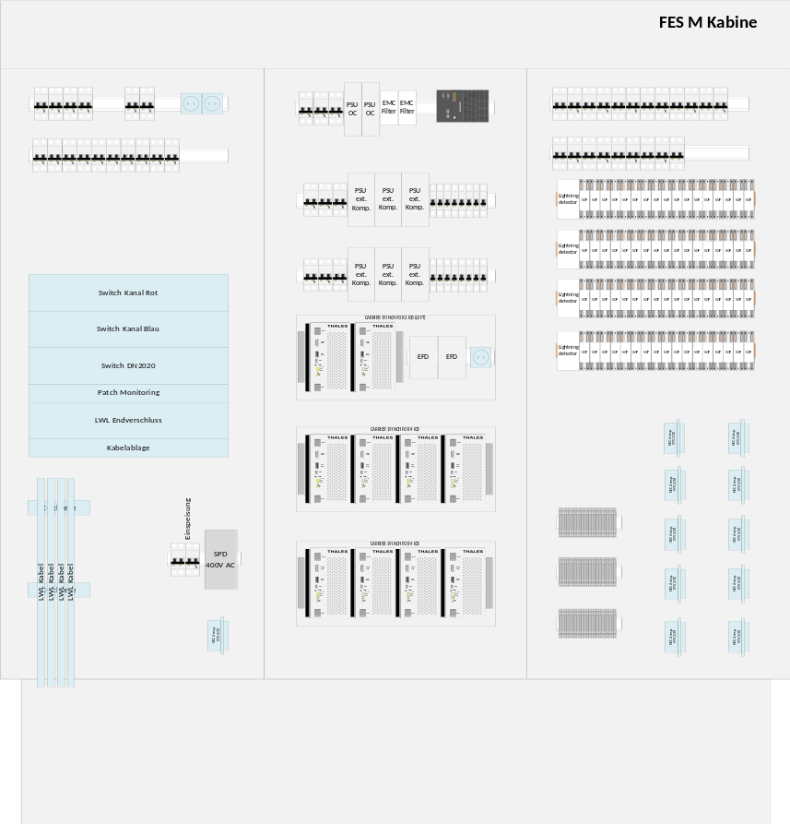
Figure 7 FES M DCA Schematic
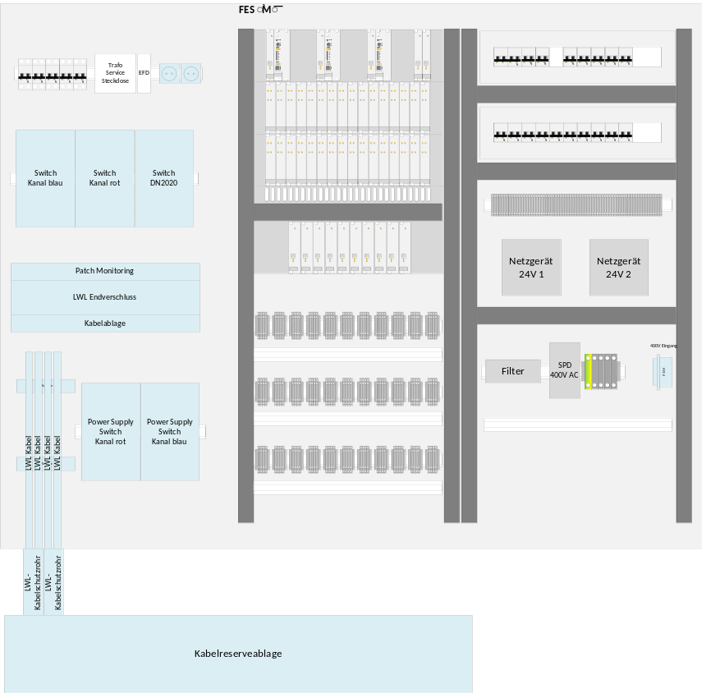
Figure 8 FES M AzLM Schematic

Work not contained in Phase 1
The following points are defined as Work not Contained:
- DCA Development
- AzLM Development
- Execution of Field tests on site
- Installation and put into operation at customer site
- Development/Integration iLED/iAnzeiger according to [CRS_Light Signals]

Work contained in later Phases

Phase 2
- Development/Qualification of FES L+XL with all included components (DCA 3.x Release 2, Including Data encryption with LFC20 Board due to CPU maximum load of 60% in operation, TAS Platform 2.6)
- Development/Qualification of FES L+XL with all included components (AzLM v7.11 Feature Complete, Cryptography, TAS Platform 2.6)
- Development/Qualification of IFC Sbl60A with all included components
- Development/Qualification of FES S IFC LCSI
  - Integration/Qualification of external developed LCSI-Gateway
- Full DDSP Integration (except self-test and SW activation)
- Extension of Laboratory Equipment

Phase 3
- Development/Qualification of FES XXL
- New Functionalities, Corrections or Obsolescences
- Self-Test and System-Activation for OC
- Tunnel Cabinet

Responsibility Assignment Matrix
The responsibilities of the roles at a Milestone Review can be seen in Milestone Template Solutions [S24].
The milestone review TQR2 confirms the successful completion of product validation and the readiness of all needed elements for customer acceptance and that the Solution is ready for Assessment according to CENELEC. The PDAs confirm with the approval to milestone TQR2 that the delivered solution meets their expectations.
The milestone review FQR confirms that the Design, Development and Qualification activities including Assessment according to CENELEC are complete and that the Solution is ready for production, deployment and transition to support.

Types of Involvement
A Approve
R Responsible for organization (incl. contribution)
C Contribute
AR Attend on request

Involvements
Table 21 Involvements table
Stakeholder | SOR | SRR | SFR | PDR | CDR | TRR | TQR | FQR
PM | C | C | C | C | C | C | C | C
PDA | A | A | A | A | A | A | A | A
PSM | C | C | C | C | C | C | C | C
ARC | C | C | C | C | C | - | - | -
SEM | R | R | R | R | R | C | C | R
IVVQM | C | C | C | C | C | R | R | C
HwEM | C | C | C | C | C | C | C | C
SwEM | C | C | C | C | C | C | C | C
SpE | AR | AR | AR | AR | AR | AR | AR | AR
PPTM | C | C | C | C | C | C | C | C
SVEM | C | C | C | C | C | - | C | C
APM | C | - | - | - | C | - | C | AR
ATS | AR | AR | AR | AR | AR | AR | AR | AR
CM | C | C | C | C | C | C | C | C
QAM | C | C | C | C | C | C | C | C
RAM-AM | C | C | C | C | C | C | C | C
SAM | C | C | C | C | C | C | C | C
RM | C | C | C | C | C | C | C | C
VAL | C | C | C | C | C | C | C | C
VER | C | C | C | C | C | C | C | C
WPMs | C | C | C | C | C | C | C | C

Explanation

Development Approach
The SW-Development Approach is shown in Agile Definition SMP [S27].
The development of a HW Solution has to be planned and executed according to the DDQS Processes of Management System.

Tools and Facilities
In this chapter the needed tools for executing the Solution Element DFE will be identified. The tool version is only mentioned if the corresponding tool has a direct effect to the deliverable (see also [ToolClass] and [ToolClassSW]).

Project Management
Table 22 Project Management
Name | Version |  | Rationale | User max/Concurrent | Reference to validation report
PCM Project Planner / Primavera |  |  |  | 2/2
Pertmaster Project Risk
Estimation Worksheet
OTL Timesheets |  |  |  | all

Task Management
Table 23 Task Management
Name | Version |  | Rationale | User max/Concurrent | Reference to validation report
TIPI
Jira
Jira / SCRUM
Jira AT Task Management / iTask

Requirements Management
Table 24 Requirements Management
Name | Version |  | Rationale | User max/Concurrent | Reference to validation report
Doors / RMF | 9.7 / 6.1 |  | DOORS/RMF as customer defined tool
Doors
Polarion

Management Traceability
Table 25 Management Traceability
Name | Version |  | Rationale | User max/Concurrent | Reference to validation report
Reqtify
Doors |  |  | DOORS/RMF as customer defined tool
Polarion

Configuration Management
Table 26 Configuration Management
Name | Version |  | Rationale | User max/Concurrent | Reference to validation report
ClearCase |  |  | Repository for DWF managed documents.  Repository for data prepared for tests and field
ClearCase UCM
CVS |  |  | Legacy
GIT
HG |  |  | Client only
Subversion
Subversion UCM
Bitbucket
Nexus
Shared Palma

Change Management
Table 27 Change Management
Name | Version |  | Rationale | User max/Concurrent | Reference to validation report
ClearQuest
ClearQuest CHARM
Gnats |  |  | Legacy
Jira
Jira CHARM

Documentation Management
Table 28 Documentation Management
Name | Version |  | Rationale | User max/Concurrent | Reference to validation report
CMCS
Clear Case, DWF
Confluence
Live link (TOL), ECM
Modulo
Subversion
Share Point

Documentation Generation
Table 29 Documentation Generation
Name | Version |  | Rationale | User max/Concurrent | Reference to validation report
Doxygen
Java Doc
Mozart
Soda
WEXP (Doors RMF)
Thales AT Word Exporter
MS Office
Polarion

Model Driven Engineering
Table 30 Model Driven Engineering
Name | Version |  | Rationale | User max/Concurrent | Reference to validation report
Melody/Advance
Rhapsody / Orchestra Profile
Rhapsody
Topcased
Visual Paradigm

Code Building

Hitachi Control - Continuous Build
Table 31 Hitachi Control - Continuous Build
Name | Version | App | Rationale | User max/Concurrent | Reference to validation report
Hudson + Subversion
Hudson + Clear Case
Maven | 3.6.2
Sonarqube | 9.9
Jenkins | 2

Hitachi AT Build
Table 32 Build
Name | Version | App | Rationale | User max/Concurrent | Reference to validation report
Ant
Bash | 4.4.20
Make | 4.1

Eclipse Development
Table 33 Eclipse Development
Name | Version | App | Rationale | User max/Concurrent | Reference to validation report
Eclipse IDE
<Plugins>

Programming Languages / Compiler
Table 34 Programming Languages/Compiler
Name | Version | App | Rationale | User max/Concurrent | Reference to validation report
C | As delivered by TAS Platform 2.5.2
C++
C#
Certified GCC
GNU C/C++
Drools
Java | 21
Perl
PHP
PL/SQL
Python
GraalVM native-image | 22.3.1

Hitachi AT Elektra Tools
Table 35 Elektra Tools
Name | Version | App | Rationale | User max/Concurrent | Reference to validation report
Audit Tools
CEL Tools
Configure Station
Data Difference Tool
DB Compare
DB Generator (DBG)
EditXMLFiles
Elektra Make files
GNU Chill compiler
Java4chill
PAMELA
VAX Interface

Hitachi AT ETCS Tools
Table 36 ETCS Tools
Name | Version | App | Rationale | User max/Concurrent | Reference to validation report
Audit Tools
Release Tools
Generated Configure. Spec.

Hitachi AT Legacy Tools
Table 37 Legacy Tools
Name | Version | App | Rationale | User max/Concurrent | Reference to validation report
VAX Tools
Aeos1, Aeos2 tools & techn.
Solaris tools

Hitachi AT Internal Used Products
Table 38 Internal Used Products
Name | Version | App | Rationale | User max/Concurrent | Reference to validation report
Data Prep. Tool AWS
Data Prep. Verif. Tool AWS
ELEPRO (Seibersdorf)
Orest | Developed for DSTW
TAS Platform | 2.5.x

Development Platform
Table 39 Development Platform
Name | Version | App | Rationale | User max/Concurrent | Reference to validation report
Linux/RedHat
Solaris
Linux/Ubuntu
Windows

Hardware Engineering Environment
Table 40 HW Engineering Environment
Name | Version | App | Rationale | User max/Concurrent | Reference to validation report
ATDM | V 3.25
Cadence | 22.1 S007
SOLIDWORKS | Premium 2022
TCIS | V4.7
LTspice | V24
EPLAN Electric P8 | 2024 Update 2

IVV Management
Table 41 IVV Management
Name | Version | App | Rationale | User max/Concurrent | Reference to validation report
DOORS
Coverity
Expect
GCOV
Mercury Win Runner
QF Test
Quick Test
Rational Test RT Mercury Loader
QAC
PurifyPlus
ICOV
EPS
Polarion
MS Excel
SOS (SCWS outside Area Simulator)

Process Control

Control of Solution Development
The Solution Element DFE assigned responsibilities are listed in Table 11.

Deviation
The development of a Solution has to be planned and executed according to the DDQS Processes of Management System. Deviation to the description in Project Life Cycle [S22] is described in section 5.

Metrics
The used metrics for control of the engineering process are identified in the Engineering Dashboard [EngDB].
Table 42 Metrics
ID | Name | App | Type
1 | Schedule | M | Indicators
1.1 | MTA | M | Metrics
1.2 | Actual Milestones | O | Metrics
2 | EAC vs CBB | M | Indicators
2.1 | CBB-EAC Synthesis | O | Metrics
2.2 | WP CBB-EAC | O | Metrics
2.3 | Workload diagram | O | Metrics
3 | Subcontractor | M | Indicators
3.1 | Subcontractor Status | O | Info

Monitoring and Control of System Engineering Activities

Periodic Internal Reviews and Meetings
Table 43 Reviews and Meetings
INTERNAL REVIEWS & MEETINGS
Meeting | Responsible | Attendees | Frequency | Objectives
Solution Core Team Meeting | SEM | Solution Core Team, ARC, WPM(s)  Only on demand:  CM, IM | Weekly | Solution Status and Action Points
Risk and opportunity review | SEM | SEM DIL, PLM, PDA, IVVQM, SAM, ARC, QAM, IM, SecAM | Quarterly or on demand | Reassess current risks and include new risks
Resource review | SEM | SEM DIL, HoD | Monthly | Check utilisation and additional needs of solution team
Change Control Board | SEM | See Table 14 | On demand
Daily Standup | WPM ZG62 SW |  | On demand | Internally handled by Agile SW Development
Weekly Sync Meetings | WPM ZG62 SW | WPM with Team members | Weekly | Status and Action Points
Sprint Planning Meeting | WPM ZG62 SW |  |  | Internally handled by Agile SW Development
Sprint Review and Sprint Retrospective | WPM ZG62 SW |  |  | Internally handled by Agile SW Development
Periodically Performance Project Review (PPPR) | SEM | PM, SEM, QAM | Monthly | Report of costs and progress, KPI dashboard, Progress Matrix, required decisions from SM to HoD Project engineering, HoD Engineering

Milestone Reviews and Audits
Milestone reviews are done according to Milestone Template Solutions [S24]. Quality Audits will be conducted through the QAM – see [QMP]. Safety Audits will be conducted through the SAM – see [SP].
Table 44 Milestone Reviews
Review | Responsible | Attendees | Objectives
SOR | SEM | As defined in Milestone Template Solutions [S24] | Start of Design phase for Solution  Approve preliminary solution architecture in particular with respect to make/team/buy
SRR | SEM | As defined in Milestone Template Solutions [S24] | Approve the solutions initial functional baseline
SFR | SEM | As defined in Milestone Template Solutions [S24] | Approve PBS and preliminary allocated baseline
PDR | SEM | As defined in Milestone Template Solutions [S24] | Approve allocated baseline and IVVQ strategy
CDR | SEM | As defined in Milestone Template Solutions [S24] | Approve the solution elements conformance to FBL and ABL and approve the completeness of the product baseline.
TRR1 | IVVQM | As defined in Milestone Template Solutions [S24] | Start solution integration and system testing with first work package released to System Test
TQR1/TRR2 | IVVQM | As defined in Milestone Template Solutions [S24] | Start solution validation
TQR2 | IVVQM | As defined in Milestone Template Solutions [S24] | The validation of the solution is finished. This milestone also includes the handover to external assessor.
FQR | SEM | As defined in Milestone Template Solutions [S24] | Approve functional and physical configuration audits as well as deviations and waivers.

Reporting
Reporting is done via the Engineering Dashboard [EngDB].

Critical Technologies
Critical technologies are managed in the risk management [RiskReport].

Risk and Opportunities Control
The Risk and Opportunities Control in this Solution will follow the Management System Process Manage Risks and Opportunities [S7] and is monitored in the [RiskReport].

Corrective Action Process
Information about the Corrective Action Process can be found in the Quality Management Plan [QMP].

Independent Evaluation and Verification
Independent evaluation and verification will be done by
- the verifier and domain experts upon instruction of the verifier (VER);
- the validator (VAL);
- the safety assurance manager (SAM).

Estimate/Re-Estimate
The initial estimation is either an input for the phase “Orientation the Solution” or is done or verified during this phase. Re-estimation of remaining work is done during the progress of working packages typically on a monthly period. The method used for estimation is mainly “Expert estimations” based on past experience, educated assumptions and risk considerations. See also Estimation Sheets [Estimation Sheet_DSTW_HW] and [Estimation Sheet_DSTW_NIC_SW].

Planning
Planning is done in the tool PCM and can be found there with the identification listed in Table 1.

Value Analysis and Design to Cost
Value Analysis and Design to Cost is done by the Engineering Dashboard [EngDB].

Peer Reviews
The Peer Reviews in this Solution will follow the Minimum Requirements for the configuration management implementation [S9]. An overview of mandatory Documents and Reviewer has to be done according to Document List and Review Matrix for engineering projects [S25].

Development Scenario and Tailoring of the System Engineering Process

Orient the Solution
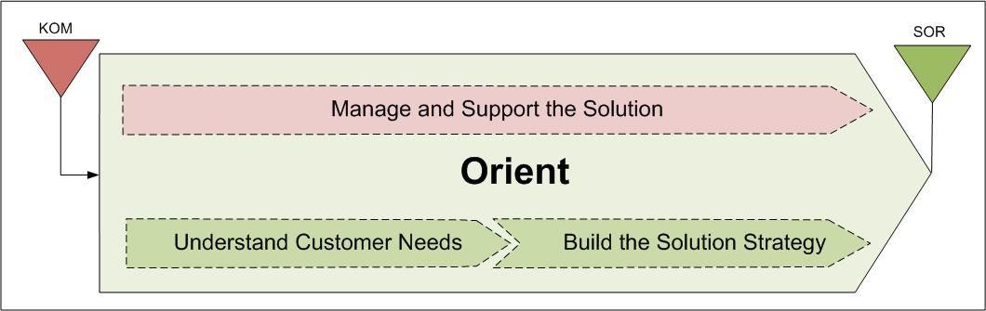
Figure 9 Orient the Solution

Overview
Objective: Understand Customer Needs and define a development strategy
The Design of the Solution is carried out according to the Management System Process Orient the Solution [S14].

Input/Start
The Start Review for this Solution is the KOM.
This SEMP Edition is based on the 4th Edition of the offer placed to ÖBB at 12th of September 2025 and the negotiations process is ongoing. KOM will take place after the contract has been signed. Current activities are based on the customer requirements [CRS]. SOR will be repeated after official KOM.

Activities and Deviations
The activities, details and deviations are planned according to the Management System Process Orient the Solution [S14].
Table 45 Orient the Solution, Activities and Deviations
Nr | Activity | Method* | Document
1 | Understand customer expectations |  | SEMP, FL
2 | Understand the impact of regulatory compliance including HSE
3 | Estimate the viability of the solution
4 | Update needs (Operational Concepts) |  | OCD
5 | Define the Solution life cycle strategy
6 | Prepare Validation and Qualification
7 | Develop industrial and support strategy
*Here are the methods listed used to conduct the activity. If there is a deviation, it will be shown in the cell and explained in the paragraph below.
Deviation:
No other deviation to the according to the Management System Process Orient the Solution [S14].

Output
The End Review for this Phase is the SOR.
The SOR is the consolidation of all collected information of the project and the related solutions (see Table 17).

Design the Solution
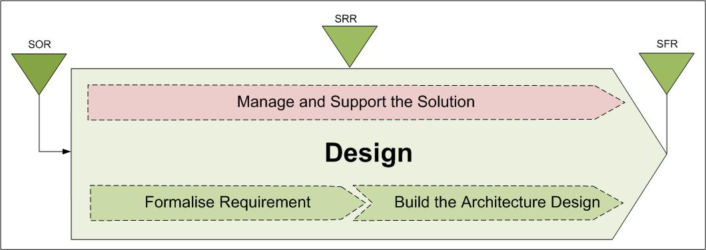
Figure 10 Design the Solution

Overview
Objective: Formalise any outstanding requirement, agree and finalise the chosen architectural design, specifications and plans used to develop the Solution.
The Design of the Solution is carried out according to the Management System Process Design the Solution [S15].

Input/Start
The Start Review for this Solution is the SOR.
Regarding the according Decision Review Report, see [MS-Report].

Activities and Deviations
The activities, details and deviations are planned according to the Management System Process Design the Solution [S15].
Table 46 Design the Solution, Activities and Deviations
Nr | Activity | Method* | Document
1 | Formalise stakeholder requirements |  | SSS
2 | Capture functions and capabilities
3 | Develop validation, test scenarios, test descriptions and environment
4 | Prepare for verification & qualification
5 | Define & justify architecture with respect to the product policy
6 | Develop logical and physical architecture
7 | Prepare integration and verification

Deviation:
No other deviation to the according to the Management System Process Design the Solution [S15].

Output
The End Review for this Phase is the SFR.
Regarding related solutions, see Table 17.

Develop the Solution
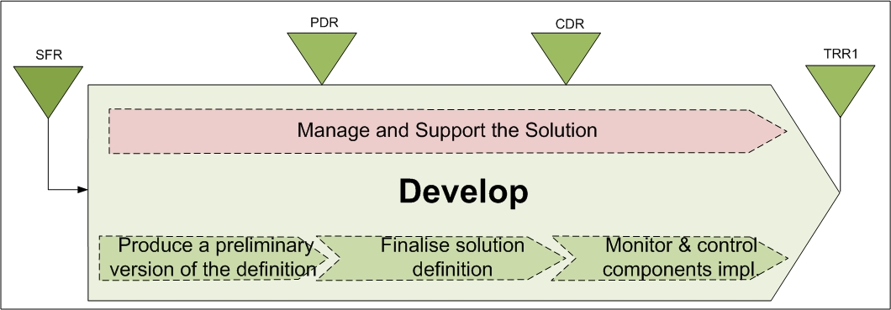
Figure 11 Develop the Solution

Overview
Objective: refine the lower level of requirements down to a complete definition (Solution elements, HW and/or SW components) and to consolidate definition up to the solution level with agreement of all concerned levels. At the lowest level, the Develop step leads, after definition consolidation, to implement hardware and/or software components according to the Make/Buy strategy.
The Development of the Solution is carried out according to the Management System Process Develop the Solution [S16].

Input/Start
The Start Review for this Solution is the SFR.
Regarding the according Decision Review Report, see [MS-Report].

Activities and Deviations
The activities, details and deviations are planned according to the Management System Process Develop the Solution [S16].
Table 47 Develop the Solution, Activities and Deviations
Nr | Activity | Method* | Document
1 | Formalise [solution element] requirements associated to a [solution element] preliminary design taking into account technology process and reuse, |  | SSS, SSDD, VCRM
2 | Specify [solution element] interfaces, |  | IDD
3 | Perform a [Preliminary Design Review (PDR)] with relevant stakeholders, |  | Project Status Review Report Solution
4 | Perform a component detail design, |  | HDD, SDD
5 | Complete the [Design Definition File DDF)] and the [Design Justification File (DJF)] |  | DDF, DJF
6 | Make or buy the software components
7 | Make or buy the hardware components
8 | Update validation plan and perform appropriate early validation tasks (simulation, modelling, prototyping, …) |  | IVVP, Design validation form (DVA)
*Here are the methods listed used to conduct the activity. If there is a deviation, it will be shown in the cell and explained in the paragraph below.
Deviation:
No other deviation to the according to the Management System Process Develop the Solution [S16].

Output
The End Review for this Phase is the TRR1.
Regarding related solutions, see Table 17.

Integrate and Verify the Solution
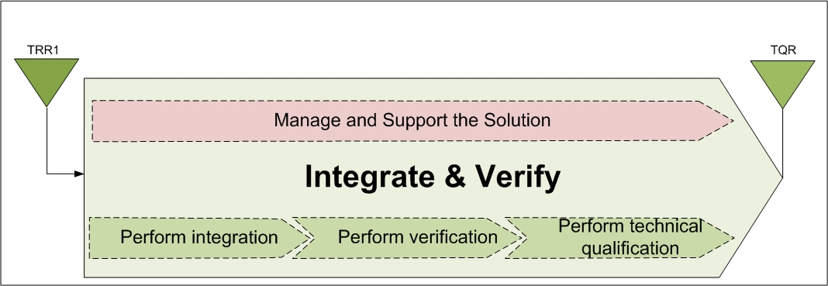
Figure 12 Integrate & Verify the Solution

Overview
The objective of the Integrate and Verify process step is to assemble the Solution Element in a logical and controlled manner and to evaluate the design, behaviour, interactions and performance, and confirm through provision of objectives evidences that the requirements against which it has been designed are fulfilled.
Integrate & Verify the Solution is carried out according to the Management System Process Integrate and Verify the Solution [S13].

Input/Start
The Start Review for this Solution is the TRR1.
Regarding the according Decision Review Report, see [MS-Report].

Activities and Deviations
The activities, details and deviations are planned according to the Management System Process Integrate and Verify the Solution [S13]. The verification tasks will be handled according to CENELEC [S2] EN 50716:2023 – Railway application – Requirements for software development.
Table 48 I&V the Solution, Activities and Deviations
Nr | Activity | Method* | Document
1 | Record and maintain the configuration of the elements constituting the component or system as received for any integration stage from production or supplier, and their interfaces
2 | Check product supplier elements (from internal or external suppliers) against their configuration description
3 | Maintain interface descriptions and update them after change approval
4 | Assemble and test in accordance with the Integration Plan including the logical order of integration events
5 | Begin to conduct tests when the minimum configuration is reached, for early identification of anomalies, features and risk reduction
6 | Measure quantitative results once the maximum configuration is reached
7 | Evaluate the solution design, behaviour, interactions and performance according to the integration plan
8 | Record the identity of the resources used
9 | Follow the verification procedure
10 | Compile the results documents
11 | Control the deviations
12 | Record verification results
13 | Communicate information on variances and anomalies to stakeholders
14 | Plan and perform the various supplier Functional Configuration Audits and Physical Configuration Audits for components and/or systems
15 | Ensure that the method for recording and managing defects found during testing is established and known, and that the mechanism is set-up and ready to use
16 | Ensure that the product data packages of solution elements are accurate and detailed enough for release to production
17 | Support the project management to obtain a declaration of technical qualification of solution elements
18 | Provide data and services to develop enabling systems required to produce, support or dispose of the solution including any test facilities, training assets, documentation and courses or support systems or logistical processes
19 | Revisit the solution qualification strategy
20 | Develop the engineering parts of Qualification plan
*Here are the methods listed used to conduct the activity. If there is a deviation, it will be shown in the cell and explained in the paragraph below.
Deviation:
No other deviation to the according to the Management System Process Integrate and Verify the Solution [S13].

Output
The End Review for this Phase is the TQR1.
Regarding related solutions, see Table 17.

Validate the solution
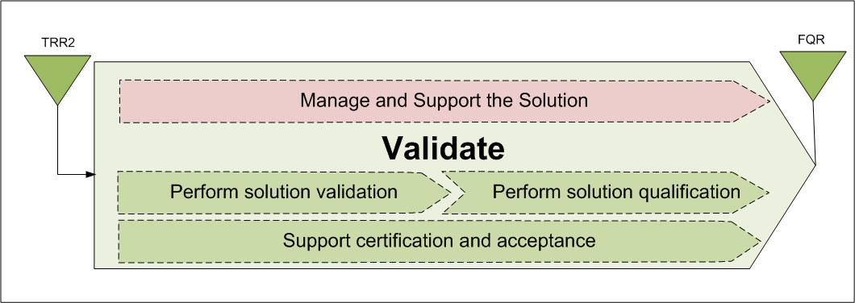
Figure 13 Validate the Solution

Overview
The objective of the Validate process step of DDQS process is to confirm through the provision of objective evidence, that the agreed and contracted requirements have been met by the solution and, from industrial point of view, confirm that all IVV activities are completed and that the Product Data Package is ready for release to production and to support.
Validate the Solution is carried out according to the Management System Process Validate the Solution[S12].

Input/Start
The Start Review for this Solution is the TQR1.
Regarding the according Decision Review Report, see [MS-Report].

Activities and Deviations
Here, the activities and the methods for reaching the objectives are listed and deviations are pointed out:
The Assessment Certification according to CENELEC is needed for this solution.
The activities, details and deviations are planned according to the Management System Process Validate the Solution [S12].
Table 49 Validate the Solution, Activities and Deviations
Nr | Activity | Method* | Document
1 | Confirm with objective evidence that the requirement for specific use or application of the solution is satisfied as defined in the contract (or any other formal agreement) in order to support the certification (if required)
2 | Confirm the production process is repeatable at the desired quality level and that the product conforms with the definition file
3 | Qualify the manufacturing process with the initial production items (demonstration of the production to cost objective at required quality level)
4 | Provide the evidence that the solution is reliable, maintainable, available and safe
5 | Prepare the means and documentation for installation, deployment into service and support of the solution to ensure the smooth transition into service and into support
6 | Provide data for the Functional Configuration Audit (FCA) and the Physical Configuration Audit (PCA) of the  solution
7 | Provide data for the Functional Configuration Audit (FCA) and the Physical Configuration Audit (PCA) of the  Solution components
8 | Develop and establish the safety cases
9 | prepare and support the external assessment
*Here are the methods listed used to conduct the activity. If there is a deviation, it will be shown in the cell and explained in the paragraph below.
Deviation:
No other deviation to the according to the Management System Process Validate the Solution [S12].

Output
The End Review for this Phase is the FQR.
Regarding related solutions, see Table 17.

System Engineering Support

Data and Configuration Management
Data and Configuration Management is carried out according to Management System Process 9.7 CFG - Manage Configuration [S17], Document Management Rules [S23] and the Configuration Management Plans [CMP_GEN] & [CMP_HW].

Confidentiality
The rules as listed in Protection of Group Information [S20] apply.

Export Control
Export Control is carried out according to Management System Process 9.3 Control Export [S18].

Capitalization
Capitalization is handled in the context of the related Manage Product Policy process.

Measurements and Analysis
See section 4.

Technical and Non-Technical Requirements Management and Control
For Requirement Management the tools DOORS and Polarion are used. The Requirements Manager ensures that requirements are
- uniquely identified
- unambiguous, testable and consistent
- traced from origin through all systems
- have all changes managed
The Requirements Manager manages changes throughout the life of the project. If requirements change, the impact will be reflected in the project plans, work products, and activities. Any inconsistencies between these customer- and/or system requirements and project plans, work products, and activities will be identified and resolved.

Validation of Requirements
The validation is done in accordance with the Validation Qualification Plan ([VQP]).

Decision Analysis and Resolution
Decision analysis and resolutions are part of design and review processes. The results are documented in design documents, review reports and in this document.

Subordinate Plans
Planning documents are mentioned in Table 5 as well as in [DoP].

Quality Assurance
The Quality Assurance in this Solution will follow Management System Guarantee quality and manage continuous improvement [S19]. Additional information can be found in the Quality Management plans as listed in [DoP].

Approach and Criteria used for Tailoring of the System Engineering Process
The Tailoring Methods are described in Chapter 5 for the respective Phase.

Certification Support Activity
See Safety Management Plans and Security Management Plans as listed in [DoP].

Notes
None

- Criteria for the Selection of Techniques and Measures
With each technique or measure in the tables there is a requirement for each software safety integrity level (SIL). In the version 2023 of the EN 50716, the requirements for software safety integrity levels 1 and 2 are the same for each technique. Similarly, each technique has the same requirements at software safety integrity levels 3 and 4. These requirements can be
“App” this column selects with “Yes” for all relevant "documentation", “technique” or “measure” for the actual project or “No” if this row isn’t mandatory for the project.
'M' this symbol means that the use of a technique is mandatory,
'HR' this symbol means that the technique or measure is Highly Recommended for this safety integrity level. If this technique or measure is not used then the rationale for using alternative techniques shall be detailed in the Software Quality Assurance Plan or in another document referenced by the
Software Quality Assurance Plan
'R' this symbol means that the technique or measure is recommended for this safety integrity level. This is a lower level of recommendation than an 'HR' and such techniques can be combined to form part of a package,
'-' this symbol means that the technique or measure has no recommendation for or against being used,
'NR' this symbol means that the technique or measure is positively “Not Recommended” for this safety integrity level. If this technique or measure is used then the rationale behind using it shall be detailed in the Software Quality Assurance Plan or in another document referenced by the Software Quality Assurance Plan.
Table A. 1 Lifecycle Issues and Documentation
DOCUMENTATION | App | Basic Integrity | SIL 1 | SIL 2 | SIL 3 | SIL 4 | References of Doc Type
Planning
1. Software Quality Assurance Plan |  | HR | HR | HR | HR | HR | [QMP]
2. Software Planning and Verification Report |  | R | HR | HR | HR | HR | VER REP
3. Software Configuration Management Plan |  | HR | HR | HR | HR | HR | [CMP_GEN], [CMP_HW]
4. Software Verification Plan |  | HR | HR | HR | HR | HR | [IVP]
5. Software Validation Plan |  | HR | HR | HR | HR | HR | [VQP]
Software requirements
6. Software Requirements Specification |  | HR | HR | HR | HR | HR | SSS
7. Overall Software Test Specification |  | HR | HR | HR | HR | HR | TCS
8. Software Requirements Verification Report |  | R | HR | HR | HR | HR | VER Rep
Architecture and design
9. Software Architecture Specification |  | R | HR | HR | HR | HR | SSDD
10. Software Design Specification |  | R | HR | HR | HR | HR | SSDD
11. Software Interface Specifications |  | HR | HR | HR | HR | HR | IFS
12. Software Integration Test Specification |  | R | HR | HR | HR | HR | TCS
13. Software/Hardware Integration Test Specification |  | R | HR | HR | HR | HR | TCS
14. Software Architecture and Design Verification Report |  | R | HR | HR | HR | HR | VER REP
Component Design
15. Software Component Design Specification |  | - | HR | HR | HR | HR | SDD
16. Software Component Test Specification |  | - | HR | HR | HR | HR | TCS
17. Software Component Design Verification Report |  | - | HR | HR | HR | HR | VER REP
Component Implementation and Testing
18. Software Source Code and supporting documentation |  | HR | HR | HR | HR | HR | Git
19. Software Component Test Report |  | - | HR | HR | HR | HR | Test Report
20. Software Source Code Verification Report |  | - | HR | HR | HR | HR | VER REP
Integration
21. Software Integration Test Report |  | R | HR | HR | HR | HR | Test Report
22. Software/Hardware Integration Test Report |  | R | HR | HR | HR | HR | Test Report
23. Software Integration Verification Report |  | R | HR | HR | HR | HR | VER REP
Overall Software Testing / Final Validation
24. Overall Software Test Report |  | HR | HR | HR | HR | HR | Test Report
25. Software Validation Report |  | HR | HR | HR | HR | HR | VAL REP
26. Tools Validation Report |  | - | HR | HR | HR | HR
27. Release Note |  | HR | HR | HR | HR | HR | VDD
Systems configured by application data
28. Application Requirements Specification |  | HR | HR | HR | HR | HR | N/A
29. Application Preparation Plan |  | R | HR | HR | HR | HR | N/A
30. Application Test Specification |  | HR | HR | HR | HR | HR | N/A
31. Application Architecture and Design |  | R | HR | HR | HR | HR | N/A
32. Application Preparation Verification Report |  | - | HR | HR | HR | HR | N/A
33. Application Test Report |  | HR | HR | HR | HR | HR | N/A
34. Source Code of Application Data |  | HR | HR | HR | HR | HR | N/A
35. Application Data Verification Report |  | R | HR | HR | HR | HR | N/A
36. Application Integration Test Specification |  | HR | HR | HR | HR | HR | N/A
37. Application Integration Test Report |  | HR | HR | HR | HR | HR | N/A
38. Application Release Note |  | HR | HR | HR | HR | HR | N/A
Software deployment
39. Software Deployment Manual |  | R | HR | HR | HR | HR | N/A
40. Deployment Records |  | R | HR | HR | HR | HR | N/A
41. Deployment Verification Report |  | R | HR | HR | HR | HR | N/A
Software maintenance
42. Software Maintenance Plan |  | R | HR | HR | HR | HR | N/A
43. Software Change Records |  | HR | HR | HR | HR | HR | N/A
44. Software Maintenance Records |  | R | HR | HR | HR | HR | N/A
45. Software Maintenance Verification Report |  | R | HR | HR | HR | HR | N/A
Software assessment
46. Software Assessment Plan |  | - | HR | HR | HR | HR | N/A
47. Software Assessment Report |  | - | HR | HR | HR | HR | N/A
For Basic Integrity, the content of the software verification plan can be limited to 6.2.4.9 a), b), c), d),
f).
For Basic Integrity the software interface specification is only highly recommended for the boundary of
the overall software (see also 7.3.4.18).
NOTE 1 According to 5.3.2.12 and 5.3.2.13, documents can be combined differently.
NOTE 2 Documents 29, 30 and 31 being HR or R depends on the importance defined in the process and where
the verification takes place, e.g. data can only be needed to be verified but tested in the system domain while
more functional properties need both test and verification. In this case HR has been marked but can be
optional R.
NOTE 3 Software Architecture Specification and Software Design Specification for Basic Integrity is important to
establish especially for long-term maintenance, selection can consider this (e.g. adding these information within
Software Requirements specification).

Table A. 2 Software Requirements Specification
TECHNIQUE/MEASURE | Ref | Basic Integrity | SIL 1 | SIL 2 | SIL 3 | SIL 4
1. Modelling | Table A.17 | R | R | R | HR | HR
2. Structured methodology | D.52 | R | R | R | HR | HR
3. Decision Tables | D.13 | R | R | R | HR | HR
Requirements:
1) The Software Requirements Specification shall include a description of the problem in natural
language and any necessary formal or semiformal notation.
2) The table reflects additional requirements for defining the specification clearly and precisely. One
or more of these techniques shall be selected to satisfy the Software Integrity Level being used.

Table A. 10 Software Maintenance
TECHNIQUE/MEASURE | Ref | Basic Integrity | SIL 1 | SIL 2 | SIL 3 | SIL 4
1. Impact Analysis | D.32 | R | HR | HR | M | M
2. Data Recording and Analysis | D.12 | HR | HR | HR | M | M

Techniques and measures according to EN 50129:2018 + AC:2019 Railway applications – Communication, signalling and processing systems – Safety related electronic systems for signalling:

Table E. 2 Safety Requirements Specification
TECHNIQUE/MEASURE | SIL 1 | SIL 2 | SIL 3 | SIL 4
1. Graphical description, e.g. block diagrams | R | R | HR | HR
2. Structured Specification | HR | HR | HR | HR | (a)
3. Formal or Semiformal Specification | - | - | HR | HR | (b)
4. Computer Aided Specification Tools | - | R | R | R | (c)
Approved combinations of techniques for SIL 3 and SIL 4 are:
- 1 and 2, or
- 2 and 3 (in case of semiformal specification), or
- 3 (in case of formal specification).

(a) In order to reduce complexity, it is recommended that a structured requirements specification is developed through a hierarchical structure of refined requirements. This technique structures the functional specification into partial requirements such that the simplest possible, visible relations exist between the latter. This analysis is successively refined until small clear requirements can be distinguished. The result is a hierarchical structure of requirements which provide a framework for the specification of the complete black-box functional and safety requirements. This method emphasizes the interfaces of the requirements and is particularly effective for avoiding interface specification errors.
(b) Formal or semi-formal specification provides a means of developing a description of a system based on a structured notation during the specification phase. Formal specifications are based on mathematical models of the system function and/or structure. Formal specification generally includes a verification process based on mathematical analyses to ensure the consistency of the resultant specification model. Semi-formal specification is recommended to express parts of a specification unambiguously and consistently, so that some mistakes, omissions and wrong behaviour can be detected. For semi-formal specification, in some cases the description can be analysed by machine or animated to display various aspects of the system behavior. For formal and semiformal methods see EN 61508-7:2010.
(c) Model oriented procedures with hierarchical subdivision, description of all objects and their relationship, common database, and automatic consistency check.

Furthermore, please refer to [IVP] Chapter 5.1, Table 7.

END OF DOCUMENT

Please note that at this stage the focus of the development of the Generic Application and the Solution Element DFE is on Phase 1 and this is indicated by 1.0.0 – for the phases see 3.10
The identification refers to the key products/solutions included in the Digital Interlocking
Please note that this SEMP Edition is based on the 4th Edition of the offer placed to ÖBB at 12th of September 2025 and the negotiations process is ongoing. The KOM will take place after the contract has been signed. Current activities are based on the customer requirements [CRS]. SOR will be repeated after official KOM
On the SL please note that ÖBB and also EULYNX clearly asks for SL3, an end-to-end implementation in Phase 1 will most likely NOT be possible. However, the setup and the describing documents shall be prepared for SL3
All dates are under the assumption of a contract signature by end of December 2025 (=T0). For latest available dates see [IMP].
MS E03 Pflichtenheft Freigabe from Customer OBB defined in [PMP]. MS E03 is currently forecasted with April 2026. For latest available dates see [IMP].

