Safety Plan Generic Application Digital Interlocking

Specialty Engineering Plan

APPROVAL
 | Name and Role/Job Title | Esignature
Written by | Roman Büger  SAM
Verified by | Christian Janneschitz  QAM
Approved by | Harald Wolfram  PM

LOG OF CHANGES
Revision | Date | Author | Change Description
01 RL | 2025-05-09 | Roman Büger | First edition.
02 RL | 2026-09-18 | Roman Büger | Rework of document.  For detailed changes see 1.4.1.2.

Contents
1. SCOPE 7
1.1 Purpose 7
1.2 Intended Audience 8
1.3 Relationship to other Plans 9
1.4 Evolution of the Safety Plan 10
1.4.1 History 10
1.5 Open Issues 10
2. References and Terms 11
2.1 Referenced Documents 11
2.2 Standards and Procedures 12
2.3 Terms and Abbreviations 13
3. System Overview 15
3.1 System description GA DIL 15
3.2 Solution Deliverables 16
3.3 Solution Purpose 16
3.4 Application Data Preparation and Verification 16
4. Safety and System lifecycle 17
4.1 Safety and System lifecycle 17
4.2 Process structure related to solution Generic Application Digital Interlocking (GA DIL) 17
5. Safety principles 18
5.1 Safety Objectives 18
5.2 Risks of the system 18
5.3 Risk Evaluation 18
5.4 Basis of the Safety 19
5.5 Concept of the Safety-Case 19
6. Safety management 20
6.1 Safety Organization 20
6.1.1 Description of roles and activities 20
6.1.2 Dependencies in organization 23
6.1.3 Independency of roles 24
6.1.4 Personnel competence 25
6.2 Safety Management Tasks 25
6.3 Documents 25
6.4 Time schedule 26
6.5 Subcontractors 26
6.6 Generic subsystems or parts 26
6.7 Safety Reviews 27
6.8 Safety Audits 27
6.9 Hazard Reporting Procedure 27
7. Risk and Hazard Analysis 28
8. Safety-related Information for the Application 29
9. Safety Requirements for the Change Control 30
10. Testing, Verification, Validation and Approval 31
10.1 Testing and Verification 31
10.2 Validation 31
10.3 Safety Assessment 31
10.4 Approval 31
10.5 Operational Safety Monitoring 31
Appendix A : Safety Case Structure 32
Appendix B : Safety Packages 36
END OF DOCUMENT 37

List of Tables
Table 1: Intended Audience of the Safety Plan 8
Table 2: Referenced Documents 11
Table 3: Standards and Procedures 12
Table 4: Terms and Abbreviations 13
Table 5: Roles and activities in safety lifecycle 20
Table 6: Additional Roles and activities in safety lifecycle 21
Table 7: Overview on parts and their suppliers (excerpt) 26

List of Figures
Figure 1: The V-cycle representation according to [EN 50126-1] 8
Figure 2: System structure of the product GA DIL (example for ÖBB) 15
Figure 3: Arrangement of dependencies 23
Figure 4: Organisational structure 24

SCOPE

Purpose
The purpose of this Safety Plan is to define all activities, responsibilities, measures, schedules and documents for the whole life-cycle of the safety-related parts of the technical product Generic Application Digital Interlocking (GA DIL).
This Safety Plan has to be consistent with the Project Management Plan [PMP] / System Engineering Management Plan or Change Management Report [SEMP] of the technical product Generic Application Digital Interlocking (GA DIL).
This Safety Plan is compliant with CENELEC standards [EN 50126-1], [EN 50126-2], [EN 50716] and [EN 50129] to assure that assessment and approval for the product emerging from the technical product Generic Application Digital Interlocking (GA DIL) can be reached. Therefore, it implements the Integrated Management System Policy [TSP].
The technical product Generic Application Digital Interlocking (GA DIL) is according to [EN 50126-2]/[EN 50129] a “generic application” for an electronic Interlocking system. This plan defines the principle set of activities, responsibilities measures and documents. For a concrete application development within one of the below mentioned Generic Application Digital Interlocking (GA DIL) products, a Project Safety Plan including the detailed activities, responsibilities and documents has to be provided in addition.
Generic Application Digital Interlocking (GA DIL) is currently developed for the Austrian market (OEBB) in several technical Product Versions (PV) based on a generic architecture and HW- and SW components.
For any particular development project, the necessary safety activities related to that development iteration shall be specified in the project safety plan (on the basis of this plan).
Based on these generic applications the specific applications for a specific station topology are achieved, which is differently organized within the specific target markets. This process is out of scope of this Safety Plan.
As Generic Application Digital Interlocking (GA DIL) is a generic application this safety plan is focused on the Phases 5, 6 and 7 of the life cycle for the system under consideration as defined in [EN 50126-1] (see Figure 1) and [EN 50126-2], ch. 6. However, the other phases (especially Integration, Operation and Maintenance) have to be considered within the solution development and appropriate handbooks have to be delivered (see also Chapter 8). For change control and safety monitoring during these phases see chapter 9 and 10.5.
Phases 1 to 4 are either defined already for the existing Generic Application Digital Interlocking (GA DIL) installed base by the railway duty holder or are part of the specific application for enhancements or tenders.
This safety plan takes into account [EN 50129] and [EN 50716], which define the relevant requirements for Generic Application Digital Interlocking (GA DIL) developments.
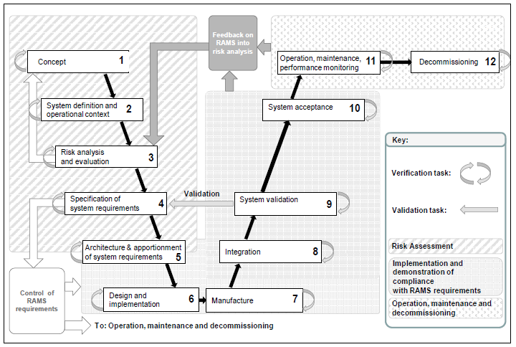
Figure 1: The V-cycle representation according to [EN 50126-1]

Intended Audience
The intended audience of this Safety Plan are the following functions within all Generic Application Digital Interlocking (GA DIL) solutions:
Table 1: Intended Audience of the Safety Plan
Role
Program Manager
Project Design Authority
System Engineering Manager
Quality Assurance Manager
Requirements Manager
Product Line Manager
Architect
Designer
Documentation Manager
Configuration Manager
Project Security Manager
Security Assurance Manager
Validator
Verifier
Test Manager
Safety Assurance Manager
RAM Assurance Manager
Assessor
Responsibilities and description of the roles and activities can be found in Project Life Cycle [PLC] together with a mapping to the roles as defined in [EN 50716] and [EN 50129]. See also Chapter 6.1.1.
Remark: the roles defined in [EN 50126-1]/[EN 50126-2] are, for the purpose of this safety plan, covered sufficiently by [EN 50716] and [EN 50129].
The content of this Safety Plan is to be treated confidential.

Relationship to other Plans
For each concrete Generic Application Digital Interlocking (GA DIL) solution the following plans are necessary:
- Project Management Plan (PMP) describes how the project is executed, monitored and controlled, and finally closed. It provides also support, which inputs/information should be available to ensure a successful processing of the project.
- The System Engineering Management Plan (SEMP) describes the application of the Systems Engineering processes to the design, development and deployment of the Generic Application Digital Interlocking (GA DIL) solution. The SEMP also contains the development life-cycle definitions, resource and responsibility allocations.
- The Quality Management Plan (QMP) describes the application of quality assurance management. It is a basis for the verification activities within the Generic Application Digital Interlocking (GA DIL) solution.
A general plan for all mentioned Generic Application Digital Interlocking (GA DIL) solutions is available for the following disciplines:
- Quality Management and its related activities and procedures are described in the Quality Management Plan [QMP]. It is a basis for the safety management activities within the Generic Application Digital Interlocking (GA DIL) solution.
- Configuration Management processes and procedures, including baseline management, are described in the Configuration Management Plan, ELEKTRA 2.x, ELEKTRA all countries [CMP].
- Requirements Management and its related activities are described in the Requirements Management Plan, Generic Application, Digital Interlocking OBB [RMP].
- RAM Management and its related activities and procedures within the whole life-cycle of the safety-related parts of the technical product are described in the RAM Plan Generische Anwendung - Digitales Stellwerk (ÖBB) [RAM_Plan].
- Integration and Verification and its related activities are described in the Integration and Verification Plan (IVP), GENERISCHE ANWENDUNG - DIGITALES STELLWERK (OEBB) [IVP].
- Validation and Qualification and its related activities are described in the Validation and Qualification Plan (VQP), Generic Application, Digital Interlocking OBB [VQP].
- Security measures according to the [IEC 62443-4-1] are planned in the Product Security Management Plan [PSecMP].

Evolution of the Safety Plan
The evolution of this document follows the rules defined in Document Management Rules [DOC_RULES].
This plan is a generic safety plan for all Generic Application Digital Interlocking (GA DIL) developments in Hitachi Rail Austria GmbH, a generic application according to [EN 50126-2]/[EN 50129]. The contents of this Safety Plan have to be checked at least at each key milestone (defined in [PMP] and [SEMP]) of any Generic Application Digital Interlocking (GA DIL) development project. The Safety Plan shall be updated and reviewed if subsequent alterations or additions are made to the original system/subsystem. For details about a concrete development project, a so-called “project safety plan” shall be drawn up in addition to this generic safety plan.
Project manager, system engineering manager and SAM are responsible for proposal of a new version of this Safety Plan.

History

Edition 01
First edition.

Edition 02
Updated to new structure of DIL.
Detailed changed:
- Removed “GTS” in company name
- Chapter 2: Updated references
- Chapter 3.1: Removed interface converter “X25” and “Zustimmung”
- Removed chapter 5.4. This is included in the DIL safety concept.
- Rework of chapter 5.5 and 6.6 due to new structure of DIL
- Replaced A.2 with new structure of DIL and reworked structure of subsystems accordingly
- Update of Appendix B according to changes in Appendix A

Open Issues
- Most of the referenced generic plans and the [SaCo] are not yet updated for GA DIL.
- Integration based on lates definition with ÖBB has to be included (see TR_2026-21)

References and Terms

Referenced Documents
Table 2: Referenced Documents
Id | Title | Reference | Edition
[CMP] | Configuration Management Plan, ELEKTRA 2.x, ELEKTRA all countries | 3BU 15000 3338 QMAPA | 11
[CRS_OBB] | Customer Requirements Specification  DSTW Streckenausrüstung OBB - Teil D Leistungsbeschreibung und Lastenhefte | 3BU 17300 0004 DSAPC | 06
[Gloss_EL] | ELEKTRA 2.x System, Glossary: Definitions, Acronyms and Abbreviations | 3BU 15000 0081 DCAPA | 06
[Gloss] | Glossary  See also http://trss-at.at.gts/glossword/ | 3BU 15000 8008 WDAPQ | 05
[ICD] | Interface Control Description (ICD) - Digital Interlocking | 3BU 17300 1219 PBAPA | 02
[IVP] | Integration and Verification Plan (IVP), GENERISCHE ANWENDUNG - DIGITALES STELLWERK (OEBB) | 3BU 17300 1206 DUAPC | 01
[PMP] | Project Management Plan (PMP) – individual for each Development Project | 3BU 17300 1000 DPAPC (for initial development) | 01 PD 02
[PSecMP] | Product Security Management Plan Digital Interlocking ÖBB | 3BU 17300 1213 DPAPA | 01 PD 02
[QMP] | Quality Management Plan, DSTW | 3BU 17300 1202 QMAPC | 01
[RAM_Plan] | RAM Plan Generische Anwendung - Digitales Stellwerk (ÖBB) | 3BU 17300 1209 DUAPC | 01
[RMP] | Requirements Management Plan, Generic Application, Digital Interlocking OBB | 3BU 17300 1207 DUAPA | 01
[SaCo] | Sicherheitskonzept, DIL | 3BU 17300 1280 DUAPC | Planned
[SaCo_2CANred] | Safety Concept, Two Diverse SW Channels on a Redundant TAS Platform | 3BU 15000 6957 DUAPA | 01
[SaCo_Comm] | Safety Concept, Communication | 3BU 15000 6956 DUAPA | 01
[SaProcess] | Assure Safety Process | 90000516-DDQ-AUT-EN | 001
[SEMP] | System Engineering Management Plan (SEMP) – individual for each Development Project | 3BU 17300 1200 DPAPA (for initial development) | 02
[TOOL_CLASS] | Software Development, Tool Classification | EN 50716: 3BU 00606 0000 191EN  EN 50129: 3BU 15000 5135 190EN  Current version for EL2, update or new document for DSTW expected. | Latest
[VQP] | Validation and Qualification Plan (VQP), Generic Application, Digital Interlocking OBB | 3BU 17300 1205 DUAPA | 01
Remark: The documents including Edition information in the table above are input documents for this plan. In case no edition is mentioned, this document is used for information only, and therefore a special edition is not relevant. The concrete edition of planning documents such as CMP shall be defined independently from this plan within the current development project.

Standards and Procedures
Table 3: Standards and Procedures
Id | Reference
[DLC_Guide] | Development Life Cycle guide  87201652-DDQ-GRP-EN, Rev. 011
[DOC_RULES] | Document Management Rules  83530061-DOC-AUT-EN, Rev. 014
[EN 50121-2] | EN 50121-2:2017 Railway applications – Electromagnetic compatibility – Part 2: Emission of the whole railway system to the outside world
[EN 50121-4] | EN 50121-4:2016 +A1:2019 Railway applications – Electromagnetic compatibility - Part 4: Emission and immunity of the signalling and telecommunications apparatus
[EN 50121-5] | EN 50121-5:2017 Railway applications – Electromagnetic compatibility - Part 5: Emission and immunity of fixed power supply installations and apparatus
[EN 50122-1] | EN 50122-1:2011 +A1:2011 +AC:2012 +A2:2016 +A3:2016 +A4:2017 Railway applications - Fixed installations - Electrical safety, earthing and the return circuit - Part 1: Protective provisions against electrical shock
[EN 50124-1] | EN 50124-1: 2017 Railway applications - Insulation coordination – Part 1: Basic requirements – Clearances and creepage distances for all electrical and electronic equipment
[EN 50125-3] | EN 50125-3:2003 +AC:2010: Railway applications - Environmental conditions for equipment - Part 3: Equipment for signalling and telecommunications
[EN 50126-1] | EN 50126-1:2017 +A1:2024: Railway Applications – The Specification and Demonstration of Reliability, Availability, Maintainability and Safety (RAMS) – Part 1: Generic RAMS Process
[EN 50126-2] | EN 50126-2:2017 +A1:2024: Railway Applications – The Specification and Demonstration of Reliability, Availability, Maintainability and Safety (RAMS) – Part 2: Systems Approach to Safety
[EN 50129] | EN 50129:2018 +AC:2019 – Railway applications – Communication, signalling and processing systems – Safety related electronic systems for signalling
[EN 50159] | EN 50159:2010 +A1:2020 – Railway application – Communication, signalling and processing: Safety-related communication in transmission systems
[EN 50716] | EN 50716:2023 – Railway application – Requirements for software development
[eTUP] | Engineering practices and tools portal  see https://etup.de.gts/group/index.html (Intranet)
[IEC 62443-4-1] | IEC 62443-4-1:2018 – Security for industrial automation and control systems – Part 4-1: Secure product development lifecycle requirements
[INS_SA] | Instruction: Safety assurance  87211146-QCI-GRP-EN, Rev. 004
[INS_TOOLS] | Instruction: Design, Develop and Qualify the Solution Tool Management  83530186-DDQ-AUT-EN, Rev. 004
[Mgmt_Sys] | Management System  see Management System (Intranet)
[PLC] | Project Life Cycle  83530275-DDQ-AUT-EN, Rev. 005
[RAM] | Assure RAM/LCC Process  83530293-DDQ-AUT-EN, Rev. 004
[SafetyEng] | Safety Engineering Instruction  87204905-DDQ-GRP-EN, Rev. 007
[TSP] | Integrated Management System Policy  83520012-GOV-AUT-EN, Rev. 005
Remark: References to standards always use the English title and date of publication mentioned by CENELEC. This is in order to exactly identify a certain version of the standard (date of proposal may differ in local implementation, but CENELEC publication date is mentioned there in any case, too.

Terms and Abbreviations
A Glossary of terms is provided in ELEKTRA 2.x System, Glossary: Definitions, Acronyms and Abbreviations [Gloss_EL]. Further railway terms and abbreviations can be found in Glossary [Gloss].
Additional terms used within this document:
Table 4: Terms and Abbreviations
Term | Explanation
ADM | Administration Diagnostic Monitoring
ARC¹ | Architect
AWS-IE | Automatic Warning System – Indoor Equipment
BI | Basic Integrity
CCB¹ | Configuration Control Board
CDR¹ | Critical Design Review
CTQ | CTQ is the target used for SIL4 cluster environment in a virtual machine.
DDQ¹ | Design, Develop and Qualify
DDQS | Design-, Develop-, Qualify- Solution (Process of Management System Framework)
DFE | Digital Field Elements
DSTW | Digital Interlocking
EN | "Europäische Norm" / European standard
EULYNX | European Initiative to Linking Interlocking Systems
FW | Firmware
GA DIL | Generic Application Digital Interlocking
GSM-R | Global System for Mobile Communications – Railway
Management System | Reference System and Governance Tool
IaaS | Infrastructure as a Service
IEC | International Electrotechnical Commission
IFC | Interface Converter
IPS | Integrierte Plattform Sicherungstechnik
Manage Project¹ | Process related to project management
MDM | EULYNX, Maintenance and Data Management
NMR | Fault tolerance service for TAS Platform applications for NxMooM architectures
OC | Object Controller
PDA¹ | Product Design Authority
PLM¹ | Product Line Manager
PM¹ | Project Manager
QAM¹ | Quality Assurance Manager
RAM-AM¹ | RAM Assurance Manager
SAM¹ | Safety Assurance Manager
RFID | Radio Frequency Identification
RM¹ | Requirement Manager
RSTW | Relaisstellwerk
Safety | According [EN 50126-1]: “freedom from unacceptable risk”
Safety authority | According [EN 50126-1]: “body responsible for delivering the authorization for the operation of the safety related system”.
Safety Engineering Authority | According [SafetyEng]: “A Senior Manager with delegated responsibility for accepting the Solution Safety Case on behalf of Hitachi Rail.”
SEM¹ | System Engineering Manager
SEMP¹ | System Engineering Management Plan
SFR¹ | Solution Functional Review
Solution¹ | A consistent set of systems, equipment and services provided to the Customer to meet a specific requirement.
Solution Element¹ | A system, a sub-system, a product / equipment, or a service, a software component, a hardware component.
SOR¹ | Solution Orientation Review
SRR¹ | Solution Requirement Review
TM¹ | Test Manager
TRR¹ | Test Readiness Review
VAL | Validator
VIL | Virtual Interlocking
VM | Virtual Machine

System Overview

System description GA DIL
The system structure of the technical system GA DIL is shown in Figure 2.
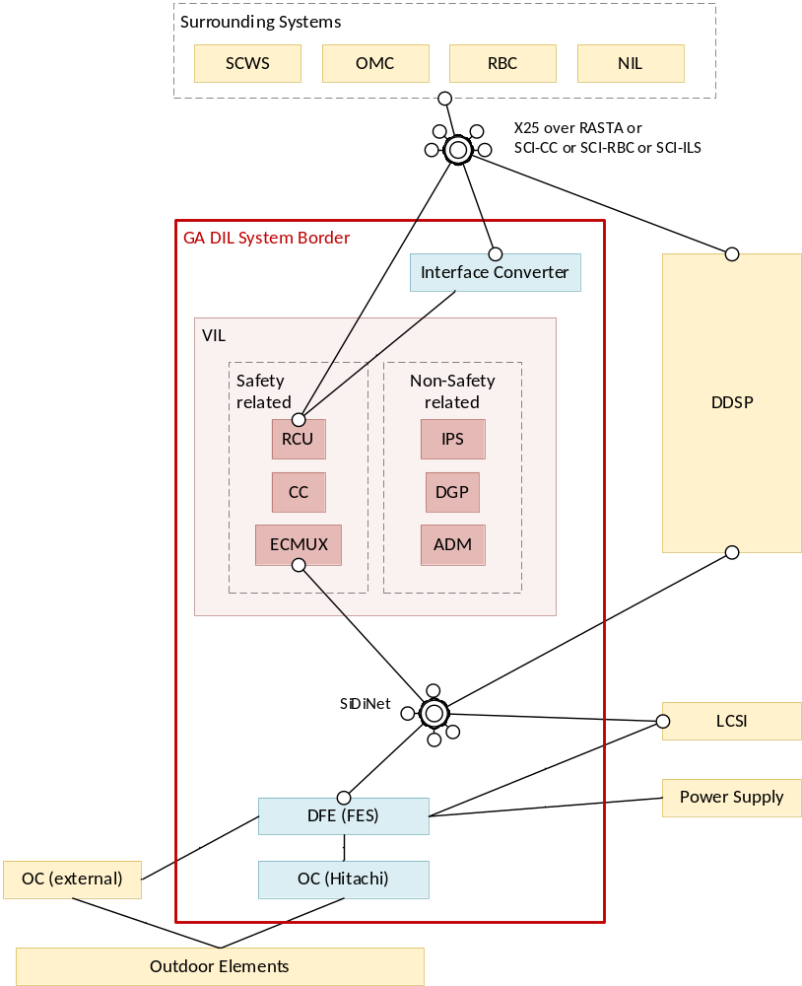
Figure 2: System structure of the product GA DIL (example for ÖBB)
GA DIL, is based on cloud and virtualization technologies. The cloud infrastructure requires a highly available network, data storage and cloud or virtualization control units. In the basic architecture, all server cabinets at a location are divided into three availability zones, which are connected to each other via a highly available network. The virtual interlockings (VILs) are distributed redundantly and evenly across the availability zones. The internal VIL connections are isolated via virtual networks over the highly available network. External interfaces are also routed to the outside via the highly available network. The architecture is designed in such a way that even if an availability zone fails, the function of the entire system is maintained and the failed units can be updated and integrated again.
The VIL Core System uses the Platform 2x2oo2 or 4x2oo2 redundancy concept (4x2oo2 in the case of geo-redundancy). The applications of the VIL Core System (CC, RCU and DGP) are executed synchronously hot-hot on several servers in virtual machines in parallel, permanently synchronized and compared. The two diverse software channels of the ELEKTRA application are retained in this concept and are operated on the two HW instances of the 2oo2 system. The 2oo2 system or the two diverse channels reliably detect hardware errors. The J4S redundancy concept is continued to be used for the VIL ECMUX. This concept allows the execution of the safe Java application in a Virtual TAS Platform VM on just one HW instance. To ensure redundancies, the VIL ECMUX functions are operated on one of the two 2oo2 HW instances of the 2x2oo2 (or 4x2oo2) system. The VIL ECMUX redundancies also run in hot-hot operation. Depending on the number of outdoor elements, one or more ECMUX subsystems can be configured and started.
The interface to the field elements is realized using the EULYNX concept. The EULYNX system definition defines five different (Object Controller level) subsystems:
- Subsystem – Point
- Subsystem – Light Signal
- Subsystem – Generic IO
- Subsystem – Train Detection System
- Subsystem – Level Crossing LX
In addition to the object controller subsystems, there are two interface converters:
- Block-IF ZG62
- Block-IF Sbl60A

Solution Deliverables
The solution deliverables can be found in the System Engineering Management Plan (SEMP) – individual for each Development Project [SEMP] of the individual Solutions.

Solution Purpose
The solution purpose is shown in the System Engineering Management Plan (SEMP) – individual for each Development Project [SEMP] of the individual Solutions.

Application Data Preparation and Verification
The process for preparation and verification of the station specific data of the Generic Application Digital Interlocking (GA DIL) has to be done by a safe method. This process is out of scope of this generic application Safety Plan.
Data preparation rules for Generic Application Digital Interlocking (GA DIL) have to be provided and updated with any new product release. Tool for the data preparation of Generic Application Digital Interlocking (GA DIL) is OREST. This tool is classified as T3 tool according [EN 50716].

Safety and System lifecycle

Safety and System lifecycle
For a description of the safety and system lifecycle see [SaProcess] chapter 6.

Process structure related to solution Generic Application Digital Interlocking (GA DIL)
Detailed information about the applied processes, phases and milestones can be found in the related system engineering management plan, see document System Engineering Management Plan (SEMP) – individual for each Development Project [SEMP], but basically they are all based on the DDQS process structure.
At each milestone of the DDQS process it shall be checked that the related tasks of the safety lifecycle had been performed.

Safety principles
For a description of the safety principles see [SaProcess] chapter 7.
The measures are coordinated for all phases and project areas so that the safety target is reached.
All measures mentioned in the following chapters are only necessary for safety-related functions.

Safety Objectives
The safety objective for Generic Application Digital Interlocking (GA DIL) is to fulfil the hazard rates given by the risk analysis from the railway duty holder of Austria. The Customer Requirements Specification [CRS_OBB] requests a hazard rate for the VIL and for the subsystems (Point, Light Signal, Generic IO, Train Detection System and Level Crossing LX) of smaller than 10⁻⁹ h⁻¹. Interfaces to surrounding systems as well as to the object controllers have to fulfil SIL4 requirements. While interfaces to ADM and power supply have to fulfil Basic Integrity requirements only.
If the railway duty holder does not prepare a safety analysis the safety objective is that the risk (especially risk of fatality) for the individual passenger is not increased in relation to existing systems (in this country).
If no hazard rate is defined within a risk analysis by the national railway authorities or within a tender for a specific project, the target for the Tolerable Hazard Rate of any hazard is defined as THR < 1*10⁻⁹ h⁻¹. According to [EN 50126-2] ch. 10.2.2 / [EN 50129] A.4.3.2 safety requirements, expressed at the system level for each hazard as THR, are linked to a specific functional composition defined by the selected system architecture and therefore translated into TFFR for each of the functions involved.
Without further detailed analysis, for Generic Application Digital Interlocking (GA DIL) the relationship between hazards and functions is defined as one-to-one. The quantitative safety integrity requirement of a hazard (expressed as THR) shall be completely allocated to the function that protects against a hazard (TFFR). The TFFR for safety-related functions of Generic Application Digital Interlocking (GA DIL) is therefore defined as TFFR < 1*10⁻⁹ h⁻¹ as it is the minimum THR for a SIL4 system according [EN 50126-2] Table A.2 / [EN 50129] Table A.1.

Risks of the system
The risks of the system which are considered for a hazard analysis are the intolerable risks which are described in Section 5.3.

Risk Evaluation
Intolerable risks for the system are listed in the table below:
- Generic Application Digital Interlocking (GA DIL)
  - Death of passenger
  - Death of staff
  - Death of other people
Tolerable risks are:
- Injure passenger by reason of an emergency brake
- Damage of equipment (rolling stock and track) by reason of an emergency brake
- Damage of equipment by reason of delayed clearance of the track (AWS/SCWS)
- Stop trains in tunnel, bridges and on other dangerous places
- Trains moving backwards in tubes in case of fire alarm
- Deposit on a scotch block
- Flank protection against hindrance
- movement on wrong track (passing a platform)
- special-purpose operation
For the tolerable risks measures have to be taken to lower their frequency.

Basis of the Safety
The safety of the system is based on HW with high availability and two independent items for vital outputs and inputs, SW with two diverse channels and communication with error detection protocols.
More details about the basis of the safety are described in Sicherheitskonzept, DIL [SaCo].

Concept of the Safety-Case
The generic application Generic Application Digital Interlocking (GA DIL) is a defined combination of subsystems which are based on generic equipment/components (like TAS Platform).
On the highest level there is a document summing up the allowed combinations of the safety and non-safety related parts of the GA DIL. This document is not to be considered as a safety case (See A.2).
The individual hierarchy of subsystem safety cases is shown in Appendix A :.
Interfaces between components and subsystems must be well defined. Compliance with the interface specification and in particular the Safety-Related Application Conditions (SRACs) shall be demonstrated as part of an integration justification, which may take the form of a dedicated safety case and associated assessment. It must be guaranteed, that all SRACs of subsystems or components are fulfilled on the highest level or propagated to the operator. It is possible that the fulfilment is already shown at a lower level. A possible fulfilment at any level is to propagate a SRAC as an identical, modified or new SRAC to the next level or to a dedicated user group of the generic solution Generic Application Digital Interlocking (GA DIL) at the highest level.
The structure of each safety case follows the structure which is defined in [EN 50129] and is described in chapter A.1.

Safety management

Safety Organization
For a description of the safety organization see [SaProcess] chapter 5.1.

Description of roles and activities
According to the CENELEC standards the following roles and activities are planned in the solution:
There exists no specific definition of responsibilities for [EN 50129], therefore requirements from [EN 50126-2] are used and shall be applied for the scope of Generic Application Digital Interlocking (GA DIL) solutions.
Table 5: Roles and activities in safety lifecycle
Function/  Role CENELEC | Function/Role in solution (element) Generic Application Digital Interlocking (GA DIL) | Responsibilities/Activities
Requirements Manager | Requirements Manager,  Architect,  Design Engineer | Responsibilities as defined in  - Table B.1 in [EN 50716] and  - Table G.1 in [EN 50126-2] (related to requirements)
Designer | Architect,  Design Engineer | Responsibilities as defined  - Table B.2 in [EN 50716] and  - Table G.1 in [EN 50126-2] (related to design)
Implementer | Design / Development Engineer | Responsibilities as defined  - Table B.3 in [EN 50716] and  - Table G.1 in [EN 50126-2] (related to implementation)
Tester | Tester (Development Engineer)  Test Manager | Responsibilities as defined in  - Table B.4 in [EN 50716] and  - Table G.2 in [EN 50126-2] (related to test)  Remark: Development engineer may test on component level (e.g. Code reading) but independence from component developer has to be achieved.
Verifier | Verifier | Responsibilities as defined in  - Table B.5 in [EN 50716] and  - Table G.2 in [EN 50126-2] (related to verification of life cycle phases)
Validator | Validator | Responsibilities as defined in  - Table B.6 in [EN 50716] and  - Table G.3 in [EN 50126-2] (related to scope of generic application)
Assessor | - | Responsibilities as defined in  - Table B.7 in [EN 50716] and  - Table G.4 in [EN 50126-2] (related to scope of generic application)
Project Manager | Project Manager and  System Engineering Manager | Responsibilities as defined in  - Table B.8 in [EN 50716] and  - Table G.5 in [EN 50126-2] (related to scope of generic application)  May be split up onto the two Management System Roles
Configuration Manager | Configuration Manager  Documentation Manager | Responsibilities as defined in Table B.9 in [EN 50716]

The following roles and responsibilities are additionally defined according to the Management System [Mgmt_Sys] and Project Life Cycle [PLC].
Table 6: Additional Roles and activities in safety lifecycle
Function/Role in solution(element) Generic Application Digital Interlocking (GA DIL) | Responsibilities/Activities
Configuration Control Board | Controls all changes to the requirements according to the procedures defined in the Configuration Management Plan
Project Design Authority  (optional Design Authority for Product Line) | Ensures that the Solution architectural design satisfies Customer needs, is implemented in line with the product policy and with applicable design legislation, rules and regulations, and that the technical risks are identified and mitigated
Documentation Manager | The Documentation Manager has the responsibility that the project and solution documents are complied with the specifications of Document Management Rules [DOC_RULES] during all stages of the project and solution.
Quality Assurance Manager | Provide to the customer the visibility on the quality actions progress to build trust on the conformity with the requirements and guaranty the conformity of products and services.  Ensure that the deliveries will be conform to customer and company expectations and all other relevant obligations  Monitor the application of defined quality requirements  Organize the team of Quality Assurance Managers necessary for all solutions and work packages within the solution and delegate tasks to the assigned managers  Contribute to define corrective and improvement actions and monitor their deployment  Take care of the surveillance of project activities to determine that all defined processes are being properly applied by definition of appropriate measures and necessary audits to ensure compliance with contract requirements  Prepare the regular Quality Management Reports  Responsible for the Quality Control and process verification  Ensures process compliance with standards, procedures, and requirements in the project
Safety Assurance Manager | The Safety Mission is to ensure that safety procedures are defined and followed correctly and that the product meets the safety requirements.  Define the safety requirements with respect to overall safety aspects.  Create the Safety Plan and the Safety Case.  Ensure that Safety procedures are defined and followed correctly in accordance with the corresponding Safety Plan  Ensure that the products or solutions meet the safety requirements  Conduct safety analysis  Organize and perform Safety Audits  Different aspects of Safety Validation (as defined in VQP)  The Safety Assurance Manager (SAM) shall exercise his/her duty to alert and right to veto whenever necessary (see also [INS_SA]).
RAM Assurance Manager | The RAM Assurance Manager ensures that RAM procedures are defined and followed correctly and that the product meets the related RAM requirements.  Specification of RAM requirements.  Determination of standards and procedures  Recording and prevention of negative impacts on RAM characteristics  Planning and implementation of RAM activities.  Demonstration of the achievement of RAM requirements.  Maintenance of the tool chain for the demonstration of the achievement of RAM requirements  Permanent monitoring of RAM-specific performance.
Work Package Manager (WPM) | Responsible for all activities within their project area, for the project tracking within their area and for the reporting to the PM, SEM and PDA.
Each role, which is defined in Table 5 and Table 6, contributes to safety.
The responsible persons for each role within the solution Generic Application Digital Interlocking (GA DIL) are defined in the System Engineering Management Plan (SEMP) – individual for each Development Project [SEMP]. Especially the mapping of the role IVVQM according to the Management System [Mgmt_Sys] to the above mentioned Tester, Verifier and Validator is important. The rules for this mapping are defined in detail in Integration and Verification Plan (IVP), GENERISCHE ANWENDUNG - DIGITALES STELLWERK (OEBB) [IVP].

Dependencies in organization
According to the CENELEC standards certain roles are arranged independently in the project (see also chapter 6.1 and Project Life Cycle [PLC]).

Documentation Management
(DM)
Configuration Management
(CM)
RAM Assurance Management
(RAM)
Quality Assurance Management (QAM)
Architect
Validator
Cfg. Control Board (CCB)
Project Design Authority (PDA)
External
Assessor
Project Manager (PM)

System Engineering Mgmt. (SEM)
Safety Assurance
Management
(SAM)
Requirements Management
(RM)
Tester
Verifier
Legend:
Reporting
Information
Support

Figure 3: Arrangement of dependencies

Independency of roles
Figure 4 shows the preferred organisational structure related to independence of roles inside project according to [EN 50716]. This structure is compliant with the requirements of [EN 50126-1] and [EN 50129].
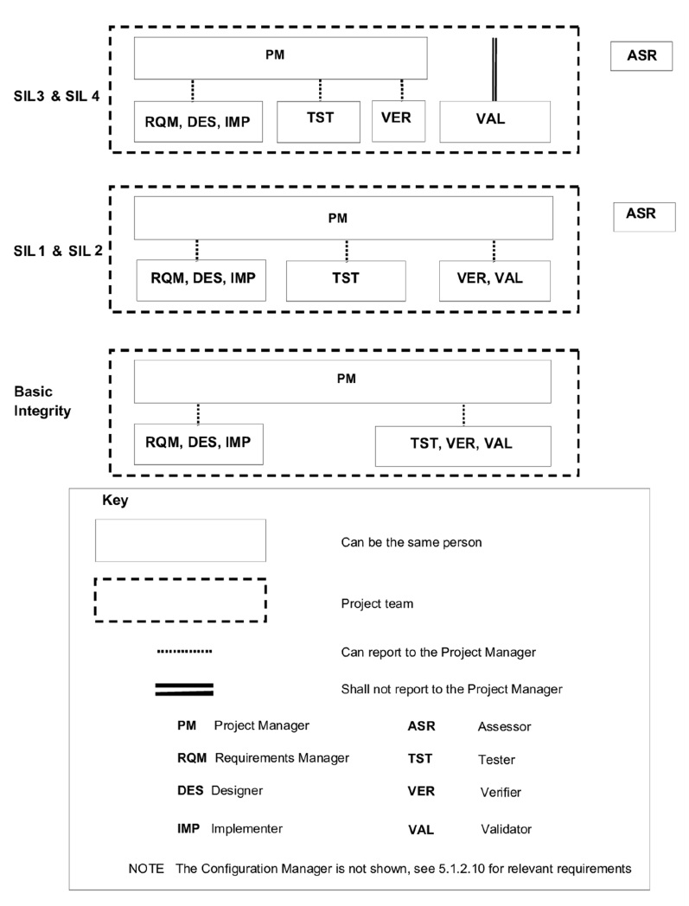
Figure 4: Organisational structure
A justification of independence according to [EN 50716] chapter 5.1.2.10, 5.1.2.11 and 5.1.2.12 has to be provided based on the project organisation described in System Engineering Management Plan (SEMP) – individual for each Development Project [SEMP] respectively in the Project Charter.
The role SAM is not mentioned in [EN 50716], but due to the fact that different aspects of safety validation are performed by SAM (see chapter 10.2) the same level of independence as defined for VAL has to be applied.

Personnel competence
For a description of the personnel competence see [SaProcess] chapter 5.2.

Safety Management Tasks
For a description of the safety management tasks see [SaProcess] chapter 8.3.

Documents
The documents prepared by the SAM are defined in the project documentation structure like the other documents of the project. The detailed safety documents to be updated or provided new for a specific project have to be defined in the Project Safety Plan.
The main documents prepared by the SAM are the following:
- Safety Plan (this document): The first version for a specific Product Version / Project has to be defined for the SOR. At each project milestone review the RAMS Assurance Manager has to check if the Safety Plan is still valid or need some update.
- Hazard Analysis: The SAM has to define either at the SOR or latest at the SRR, when and for which System / Subsystem / Component a (Preliminary and/or Final) Hazard Analysis is necessary. The SAM is responsible to define the methodology (FMEA, HAZOP, FTA) and the necessary team for the Hazard Analysis.
- Safety Cases (for structure see Appendix A.1)
- Safety Logs (could be included in the Safety Management Report)
The Safety Logs should include all project specific activities of the safety management in order to ensure the traceability of decisions and measures for achieving the safety targets of the Generic Application Digital Interlocking (GA DIL) solutions.
- Hazard Logs (see Ch. 6.9)
- Assessment plan: The SAM defines together with the external assessment body the structure and the time schedule for the assessment report(s).
- Approval Plan: The SAM defines together with the approval authorities of the target country the structure and the time schedule for the approval process.
Further, the SAM delivers inputs for the safety requirements within the specification documents. This activity is in cooperation with the Requirements Manager and the SEM.
The RAM Assurance Manager must be involved in the Architecture design and has to organize RAM-workshops on demand together with the SEM and the Architect (see Assure RAM/LCC Process [RAM]). The result is documented in:
- RAM Plan: Based on the generic RAM plan (RAM Plan Generische Anwendung - Digitales Stellwerk (ÖBB) [RAM_Plan]) the first version for a specific Product Version / Project has to be defined for the SOR. At each project milestone review the RAM Assurance Manager has to check if the RAM Plan is still valid or need some update.
- Input for the RAM requirements within the specification documents
- Dependability Analysis: This document contains the details of the RAM figures of the product / solution.

Time schedule
As Safety is not the task for one person (SAM) but for the safety organisation, there is no own time schedule for safety activities. All these activities and resource requirements are planned within the related solution and solution elements. The milestones and further information are described in the system engineering management plans of each solution/solution element, is committed at the Solution Orientation Review (defined in [Mgmt_Sys]) and documented in the relevant System Engineering Management Plan (SEMP) – individual for each Development Project [SEMP]. The time schedule is checked and updated if necessary in the Milestone Reviews.

Subcontractors
Subcontractors for Generic Application Digital Interlocking (GA DIL) are defined in the Project Management Plan (PMP) – individual for each Development Project [PMP] or System Engineering Management Plan (SEMP) – individual for each Development Project [SEMP] as “Suppliers” or “Partners”, depending on the contractual relationship, this includes the definition of the following points.
It must be defined for each of these subcontractors which tests for their deliverable are necessary.
It has to be defined by Safety and Quality Management whether the subcontractors need their own Safety and/or Quality Management or not. It also has to be defined who has the responsibility for the integration.

Generic subsystems or parts
Generic subsystems or parts are subsystems or parts which are developed for a use in more than one project and product.
These subsystems or parts should have their own safety case and therefore it is only necessary to show that all conditions of their safety cases are fulfilled (see also Chapter 5.5).
If the subsystems or parts have no own safety case, they must be treated like subsystems or parts of Generic Application Digital Interlocking (GA DIL). This especially applies if external partners or projects are providing these parts. The following table gives an overview of external partners or projects.
Table 7: Overview on parts and their suppliers (excerpt)
Components | Delivered by
AzLM | Hitachi Rail Germany
DCA | Hitachi Rail Spain
GA DIL Indoor Equipment | Hitachi Rail Austria GmbH
GA DIL Server Architecture (IPS) | Hitachi Rail Austria GmbH
iLED/RaiLed | Hitachi Rail Austria GmbH
J4S | Hitachi Rail Austria GmbH
TAS Platform | Hitachi Rail Austria GmbH
A detailed overview about all generic subsystems of Generic Application Digital Interlocking (GA DIL) is presented in Appendix A :.

Safety Reviews
The documents prepared by the safety management will be reviewed as the other vital documents in the project. Safety Management will review those other vital documents in the project.
The review system is part of quality management system.
Safety Management will carry out Safety Reviews at specific Process Milestones (SOR, CDR, FQR) with focus in the following items:
- Safety requirements
- Design principles
- Internal safety audit for fulfilment of [EN 50129] and [EN 50716]

Safety Audits
On request of the Assessor the fulfilment of [EN 50129] and [EN 50716] will be checked. The organization of this audit is in the responsibility of the SAM.
Internal safety audits will be held by the SAM as part of the Safety Reviews (see chapter 6.7).

Hazard Reporting Procedure
The Hazard Log is a list of identified potential hazards for the system under consideration. This will be updated throughout the entire product life cycle. According to [EN 50126-2], ch. 11, this is a refinement process of existing hazards mentioned in the Hazard Log based on the realisation of the system.
All project team members are obliged to report potential hazards to the SAM.
Entries in the hazard log can have the following origin:
- Results of the hazard analysis
- Hazard reports from the ongoing project or from the field
In Generic Application Digital Interlocking (GA DIL) solutions the hazard log entries are handled as follows:
- Resulting hazards from the hazard analysis are directly documented within the analysis documents and possible mitigation measures either result in Safety Requirements for the actual project or SRACs. Their fulfilment is part of the Validation process.
- Hazard reports from the ongoing project or from the field, which can be clearly allocated to a HW- or SW subsystem, are documented within the project specific defect database and are marked there with the Category attribute “safety-related”.
According to [CMP] Charm/MLS is used.
- Hazard reports from the ongoing project or from the field, which cannot be clearly allocated to a HW- or SW subsystem, are documented within the “SATHAZLG” Database of the tool “CHARM/MLS” for further analysis by the SAM.
The whole content of previously used HAZLG database in ClearQuest has been moved to SATHAZLG with identical identifier (number).
A hazard for which no technical method of control was possible or could not be implemented within a specific Product Version release, potential mitigation measures (e.g. application data preparation, operational measures) will be passed as a SRAC to the next higher system level. The actual state of the Hazard Log for Generic Application Digital Interlocking (GA DIL) subsystems at the Release of a Product Version is documented in the Safety Management Report.

Risk and Hazard Analysis
For a description of the risk and hazard analysis see [SaProcess] chapter 9.

Safety-related Information for the Application
The generic application Generic Application Digital Interlocking (GA DIL) provides safety-related documentation for application projects, which are the base for the specific user documentation.
The information for the operator is necessary for the operation and maintenance and for the decommissioning and disposal phase of the project. The information may be divided in different documents.
Following documents or handbooks are necessary:
- Installation handbook
- System operation handbook
- Maintenance handbook
- Decommissioning and disposal handbook
The related documents shall include all information (vital and non vital), especially the safety-related application conditions (SRACs), that are necessary for a correct use of the system. Hints should be given on places where wrong actions could lead to critical reactions. It is also possible to summarize all SRACs in a Safety Handbook and structure them for the different target groups.
For SRACs in general, section 5.3.13 of [EN 50129] has to be taken into consideration.
For each subsystem proper shutdown procedures shall be defined. The execution of the defined shutdown procedures of a subsystem shall result in a safe state.
Before a subsystem is decommissioned and disposed the defined shutdown procedures shall be executed and the subsystem shall be powered off. Disposal must be conforming to the laws.

Safety Requirements for the Change Control
For a description of the safety requirements for the change control see [SaProcess] chapter 10.

Testing, Verification, Validation and Approval

Testing and Verification
For a description of the testing and verification see [SaProcess] chapter 11.1.
Testing and Verification for the solution Generic Application Digital Interlocking (GA DIL) are defined in
- Quality Management Plan, DSTW [QMP]
- Integration and Verification Plan (IVP), GENERISCHE ANWENDUNG - DIGITALES STELLWERK (OEBB) [IVP]
Remark: The integration and verification measures for Generic Application Digital Interlocking (GA DIL) are defined in a generic IVP. For an individual Generic Application Digital Interlocking (GA DIL) solution (Product Version) the necessary integration and verification measures are depending on the changes in the individual components and must be documented in a specific test plan per project (Product-version).

Validation
For a description of the validation see [SaProcess] chapter 11.2.
Validation for the solution Generic Application Digital Interlocking (GA DIL) is defined in the Validation and Qualification Plan (VQP), Generic Application, Digital Interlocking OBB [VQP].

Safety Assessment
For a description of the safety assessment see [SaProcess] chapter 11.3.
The assessment plan has to be established by the SAM together with the selected external assessors and presented to the approval authority within each country together with the approval plan (see chapter 10.4).

Approval
The approval of the generic application Generic Application Digital Interlocking (GA DIL) will be done according to the valid national rules.
The approval plan has to be established by the SAM and has to be presented to the approval authority within each country.

Operational Safety Monitoring
For a description of the operational safety monitoring see [SaProcess] chapter 12.
- Safety Case Structure
- General
The safety case structure for the generic application Generic Application Digital Interlocking (GA DIL) consists of several subsystems which are integrated together. For some subsystems a hierarchical structure is applied. On various levels different kind of safety cases exist:
- HW - Safety case
- (Sub-) System Safety case (including HW and SW)
- Method Safety case: This may be used for different purposes:
  - show compliance of a concrete or principle implementation of a communication path according to EN 50159
  - provide the basis for a special methodology to achieve specific (safety) properties of an architecture
For each safety case, the structure defined in [EN 50129] chapter 7 has to be followed:
- Part 1 – Definition of system
- Part 2 – Quality Management Report
Remark: Part 2 - Quality Management Report is provided as a separate document by the QAM.
- Part 3 – Safety Management Report
Remark: Part 3 – Safety Management Report is provided as a separate document by the SAM
- Part 4 – Technical Safety Report
  - Section 1: Introduction
  - Section 2: Assurance of correct functional operation
  - Section 3: Effects of faults
  - Section 4: Operation with external influences
  - Section 5: Safety-related application conditions
Remark: Especially for top level safety cases, a separate document should be provided.
  - Section 6: Safety qualification test results
- Part 5 – Related Safety Cases
- Part 6 – Conclusion

Safety Cases which are used together with the ELEKTRA 2 are numbered <200. Numbers >=200 are GA DIL specific documents.
Integrated components are not in the scope of the defined safety cases. The integration of the interface to these components is considered.

- Structure for DIL
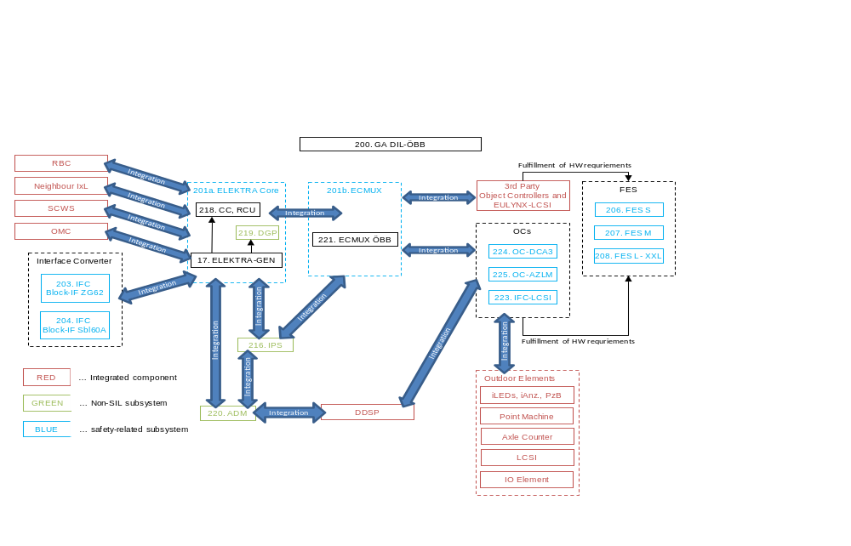
Notes:
200. GA DIL-ÖBB will be no safety case. It will contain a summary of all configuration variants.
Appendix B : describes which document will be available for the respective subsystem.
Until DDSP is available ADM needs to take over its basic functionalities (Diagnosis).
3rd party object controllers are optional after 10 years.
- Hierarchical structure for VIL - CHILL
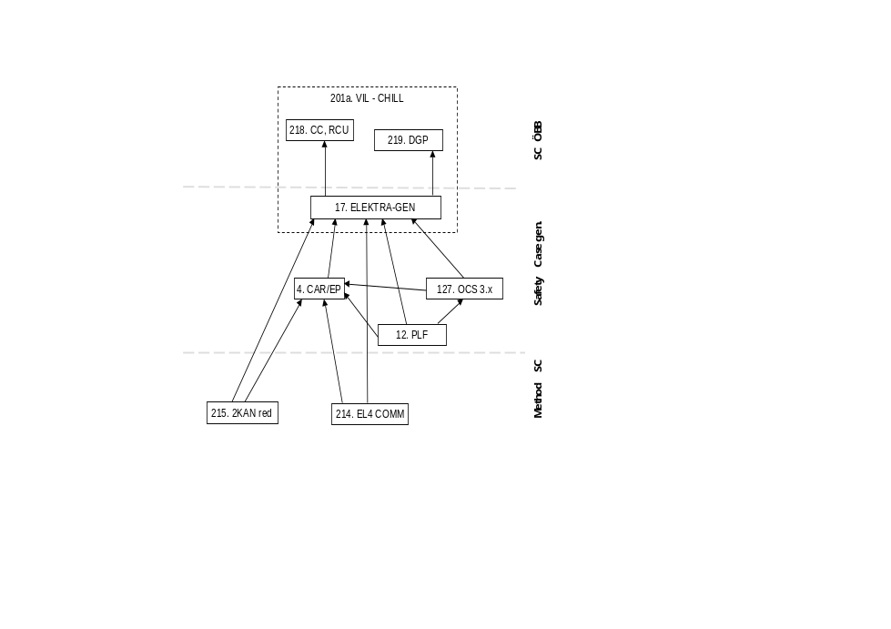

- Hierarchical structure for VIL - Java
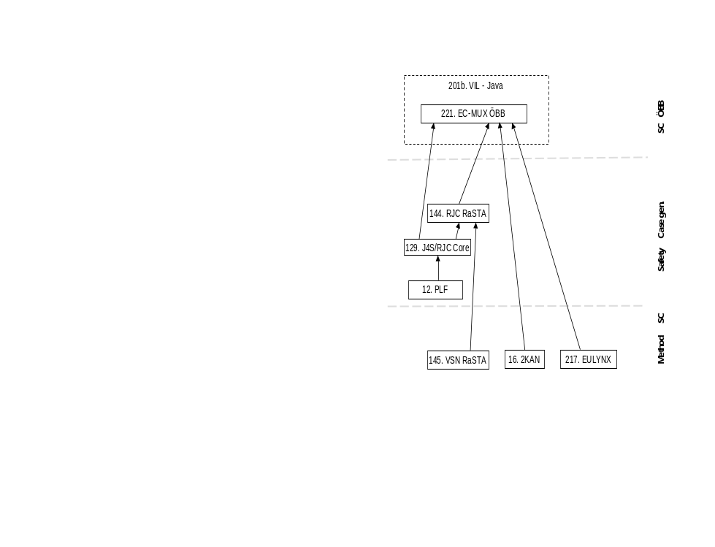

- Hierarchical structure for interface converter
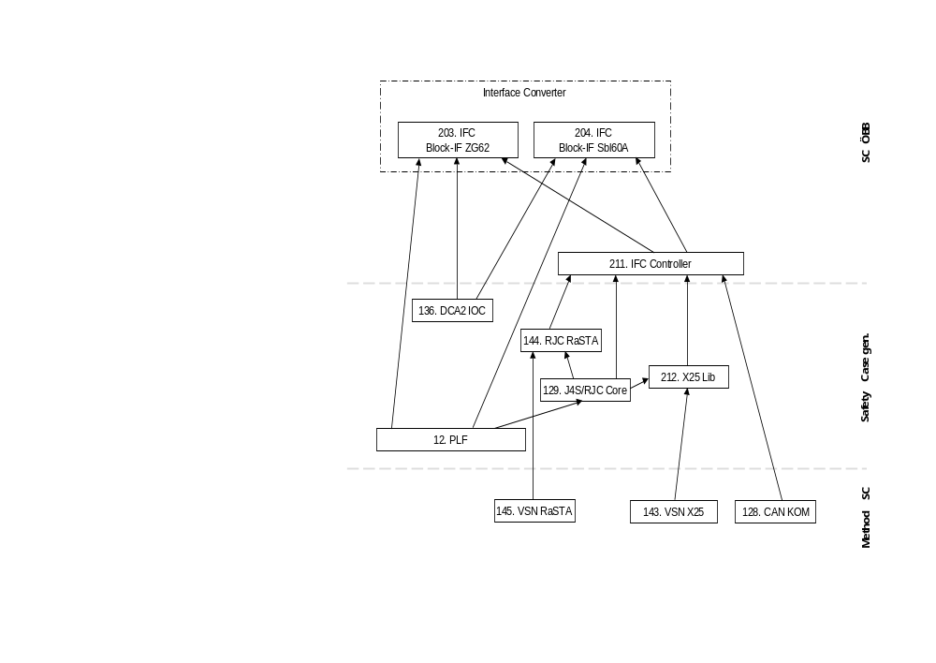

- Safety Packages
The safety case structure as presented in Appendix A : consists of packages, which are arranged in a hierarchical order. The following table provides an overview of these packages.
Remark: Within a special context, not all packages may be necessary. The ID should be unique, therefore IDs shall not be reused. A package ID which is no more used remains in this list.

ID | Short name | Description | ANV of safety case (if available)
4 | CAR/EP | Chill Application Runtime Sys. CAR/EP SW | 3BU 15000 5191 DUAPA
12 | PLF | TAS Platform 2.6.0 (redundant) | 3BY 87000 0669 DUAPA
16 | 2KAN | 2 SW-Kanäle auf 1 HW | 3BU 15000 0624 DUAPA
17 | ELEKTRA-GEN | ELEKTRA Generisch | 3BU 15000 5276 DUAPC
127 | OCS 3.x | OCS 3.x | 3BY 87000 1091 DUAPA
128 | CAN-KOM | VSiNa EN 50159 Kommunikation über CAN (SEA) | 3BU 15000 8015 DUAPC
129 | J4S / RJC Core | Java for Signalling 3.x  RJC Core | 3BY 03000 0116 DUAPA  3BU 01500 1005 DUAPA
136 | DCA2 IOC | Input/Output Controller DCA-IOC | No safety case available.
143 | VSN X25 | VSiNa EN 50159 X25 Protokoll | 3BU 15000 0631 DUAPC
144 | RJC RaSTA | Reusable Java Component RaSTA | 3BU 01500 0003 DUAPA
145 | VSN RaSTA | VSiNa EN 50159 RaSTA Protokoll | No safety case available.
200 | GA DIL-ÖBB | Digital Interlocking for ÖBB | Planned (no safety case)
201a | ELEKTRA Core | Virtual Interlocking for ÖBB – CHILL Part | Planned
201b | ECMUX | Virtual Interlocking for ÖBB – Java Part | Same as 221.
203 | IFC  Block-IF ZG62 | Interface Converter for Block-IF ZG62 | Planned
204 | IFC  Block-IF Sbl60A | Interface Converter for Block-IF Sbl60A | Planned
206 | FES S | Field Element Controller Size S | Planned
207 | FES M | Field Element Controller Size M | Planned
208 | FES L, XL, XXL | Field Element Controller Size L, XL and XXL | Planned
211 | IFC Controller | IFC Controller | Planned
212 | X25 Lib | X25 Library | Planned (Similar to OMC 3BU 51500 1122 DUAPC)
214 | EL4 COMM | Communication for server architecture | 3BU 15000 6956 DUAPA
215 | 2KAN red | 2 channel on redundant server architecture | 3BU 15000 6957 DUAPA
216 | IPS | Integrierte Platform Sicherungstechnik | No safety case planned, validation report only.
217 | EULYNX | EULYNX for ELEKTRA 4 | Planned
218 | CC, RCU | CC and RCU component for GA DIL | No safety case planned.
219 | DGP | DGP component for GA DIL | No safety case planned, validation report only.
220 | ADM | ADM component for GA DIL | No safety case planned, validation report only.
221 | ECMUX ÖBB | Application ECMUX ÖBB for GA DIL | 3BU 61400 0200 DUAPA
223 | IFC-LCSI | Interface Controller for Level Crossing | Planned
224 | OC-DCA3 | Object Controller for DCA3 Components (includes Point, Light Signal and Generic IO) | Planned
225 | OC-AZLM | Object Controller for Axle Counter | Planned

END OF DOCUMENT

Definition according to Management System framework, see especially [PLC]
This is a subset of the responsibilities as defined in Project Management Plan (PMP) – individual for each Development Project [PMP]
In the scope of the Management System framework documentation management is a subset of the data manager responsibilities.
Figure taken from [EN 50716].

