System Description

Interlocking System

LockTrac 6131 (ELEKTRA 2.x)

International

APPROVAL
 | Name and Role/Job Title | Esignature
Written by | Alexander Paul  PDA
Verified by | Christian Janneschitz  QAM
Approved by | Robert Strauss  SEM

LOG OF CHANGES
Revision | Date | Author | Change Description
01 | 20111024 | Paul A. | EL-Hungary “Szalad” project
02 | 20120221 | Kun R. | See Changes 10.2
02A | 20130121 | Schneider M. | See Changes 10.3
03 | 20130226 | Vajda S. | See Changes 10.4
03A | 20130610 | Vajda S. | See Changes 10.5
03B | 20130905 | Schnabl K. | See Changes 10.6
04 | 20130905 | Vajda S. / Strauss R. | See Changes 10.7
05 | 20160216 | Kovacs M. | See Changes 10.8
06 | 2016-05-24 | Kucera W. | See Changes 10.9  BL INT 02.00
07 | 2019-07-16 | M. Schneider | See Changes 10.10  RC INT_19.12.00
08 | 2020-12-11 | H. Anegg | See Changes in chapter 10.11  Update for RC INT_20.04.00,
09 | 2021-04-29 | A. Paul | See Changes in chapter 10.12  Update for BL INT_22.06,
10 | 2022-02-25 | A. Paul | See Changes in chapter 10.13  Update for BL INT_22.06
11 | 2022-09-19 | P. Kovacs | See Changes in chapter 10.14  Update for BL INT_23.02
12 | 2024-05-21 | A. Paul | See Changes in chapter 10.15  Update for SEC 2.5.0
12A | 2024-08-19 | A. Paul | See Changes in chapter 10.16  Update to Hitachi template; released by signature.

Contents
1. INTRODUCTION 11
1.1 Explanations about this document 11
1.2 Standard Distribution 11
1.3 References 11
1.3.1 TAS Platform general 11
1.3.2 Customer Documents, Norms and Standards 12
1.3.3 General System Principles 12
1.3.4 SW-Basis Technology 13
1.3.5 Hardware Documents 13
1.3.6 HW-interface board 15
1.3.7 SEC outdoor elements 18
1.3.8 Publications 18
1.4 Abbreviations and Definitions of Terms 19
1.5 Structure and Content 22
1.6 Conventions 24
1.6.1 Designation of Hardware Components 24
1.6.2 Communication 24
2. THE SYSTEM ELEKTRA 25
2.1 System Structure 25
2.1.1 Function Levels 25
2.1.2 Channels 30
2.1.3 Redundancies 30
2.1.4 Interfaces to the outside 31
2.1.5 Hardware Structure 32
2.1.6 Software Structure 35
2.2 Software Basic Technologies 36
2.2.1 Languages 36
2.2.2 Operating Systems 37
2.2.3 Runtime Environment 39
2.2.4 Communication Software and Protocols 39
2.2.5 Tool-Chain 40
2.2.6 Development Tools 41
2.3 Hardware-related Subdivision 42
2.3.1 Operating Level 42
2.3.2 Central Level 43
2.3.3 Element Level 43
2.3.4 Interface Converter 43
2.3.5 RIC - Remote Interface Controller 44
2.3.6 Diagnostic 44
2.4 Electronic Storage Medium 45
2.5 System Limits 45
2.5.1 Operating Level 45
2.5.2 Central Level 45
2.5.3 Element Level 45
2.5.4 Interface-Converter 46
2.6 Expansion Stages 46
2.7 Basic Version ELEKTRA 47
2.8 Remote EC 49
2.9 NIC - Neighbour Interface Controller 50
2.10 SEC – Single Element Controller 51
2.10.1 Interlocking interface (EC-MUX) 52
2.10.2 Trackside Control Unit TCU 53
2.10.3 Data and Power Transmission 55
2.10.4 intelligent Signal Elements (iSE) 56
2.10.5 Track code on eBlock lines 56
2.10.6 SEC Maintenance 57
3. DESCRIPTION OF THE HARDWARE COMPONENTS 58
3.1 Operating Level 58
3.1.1 Functional Components 58
3.1.2 Overview of Functional Components 59
3.1.3 Dependencies between the Functional Components 60
3.1.4 Integration of the Operating Level in the Entire System 60
3.2 Central Level 61
3.2.1 CCA, CCB (Central Controller Channel A, Channel B) 61
3.2.2 Hub 67
3.2.3 Switch 68
3.3 Element Level 69
3.3.1 Element Level (Element-Controller EC or EC-MUX) 70
3.3.2 Interface Control Level - IC1D 73
3.3.3 Input from Parallel Peripheral Systems - IMO1D, IMO2D 75
3.3.4 Output to Parallel Peripheral Systems - OMO1D 75
3.3.5 Hardware Interfaces 75
3.3.6 Interfaces to External Units 76
3.3.7 Components of the NIC 77
3.3.8 SEC components 78
3.4 Interface Converter 86
3.5 RIC – Remote Interface Controller 88
3.6 DGP (Diagnostic Processor) 89
3.6.1 Diagnostic/Maintenance Terminals 89
3.7 Electronic Storage Medium - ESM 89
3.7.1 Remote ESM/Printer Installation for Lines with Several Interlockings 89
3.7.2 Two External Operating Stations working as Recording Media 90
3.8 Cabinets 90
3.8.1 Computer Cabinet (CC/EC cabinet) 91
3.8.2 Interface Cabinets 91
3.8.3 SEC modem cabinet 91
3.8.4 TCU cabinet 92
3.9 Cable Connections 93
3.9.1 Connection of Serial Interfaces 93
3.9.2 Connection of Parallel Interfaces 93
3.9.3 Connection of Industrial PC with Linux Operating System (HMI) and Monitor 94
3.9.4 Connection of Power Supply Interfaces 94
3.9.5 Connection to External Device Interfaces 94
3.9.6 Connection to Internal Device Interfaces 95
4. DESCRIPTION OF SOFTWARE-SUBSYSTEM 96
4.1 Operating Level 96
4.2 Central Level 97
4.2.1 GCA (General subsystem of the central level Channel A) 98
4.2.2 GCB (General subsystem of the central level Channel B) 98
4.2.3 ICA, ICB (Interlocking Central subsystem Channel A, Channel B) 98
4.3 Element level 98
4.3.1 GPA, GPB (General subsystem of the peripheral level Channel A, Channel B) 99
4.3.2 EPA, EPB (Element subsystem the Peripheral level Channel A, Channel B) 99
4.3.3 EC-MUX (Element Controller Multiplexer, Channel A and Channel B) 99
4.3.4 OEC (Outdoor Element Controller, Kanal A und Kanal B) 99
4.4 Interface converter 100
4.4.1 RCA and RCB (Remote controller Channel A Channel B) 100
4.5 Diagnostic 100
4.5.1 DGP (Diagnostic Processor) 100
4.6 ESM 101
5. BOOTING, CHANGE-OVER 102
5.1 Booting 102
5.2 Change-Over 102
6. COMMUNICATION 103
6.1 General 103
6.2 Route-Copy 103
6.2.1 Channel-overlapping Applications 105
6.2.2 Channel-internal Applications 105
6.3 Example of a Communications Sequence 107
7. RELIABILITY PROCEDURES 111
7.1 Operating Level 111
7.2 Central Level 111
7.3 Element and Hardware interface Level 112
7.4 Element and Hardware interface level with SEC-Technology 112
7.5 Interface Converter 113
7.6 Diagnostics 113
8. SAFETY PROCEDURES 114
8.1 Measures based on the System Structure 114
8.1.1 Two Channels 114
8.1.2 Software Diversity 114
8.1.3 Software Voting 114
8.1.4 Communications Procedure 114
8.1.5 Hardware Voting of the Periphery Outputs 115
8.1.6 Safety-Bag Procedure 115
8.1.7 Procedure with Critical Operating Actions 115
8.1.8 Identification Procedure 115
8.1.9 Master-Slave Procedure 115
8.1.10 Life Cycle 115
8.2 Measures within the System 116
8.2.1 Software-specific Detail Safety Measures 116
8.2.2 Safety-Reaction-Routines (Shut Down-Mechanisms) 116
8.2.3 Code-Safety on Serial Data Lines 116
8.2.4 Redundant Periphery Messages in antivalent Design 116
8.2.5 Antivalency of the Status Messages 116
8.2.6 Diversified Occupation Methods of the Output Ports 116
8.2.7 Diversified Occupation Methods at the Scanner Inputs 116
8.2.8 Diversified Return Messages of the States of the Voter Relays 117
8.2.9 Command Suppression with Periphery Errors 117
8.2.10 Hardware-specific Detail Safety Measures 117
8.2.11 Earth Connection Fault Test Equipment 117
8.2.12 Panic Computer Shutdown 117
9. Open Items 118
10. CHANGES 119
10.1 Edition 01 119
10.2 Edition 02 119
10.3 Edition 02A 119
10.4 Edition 03 119
10.5 Edition 03A 119
10.6 Edition 03B 119
10.7 Edition 04 119
10.8 Edition 05 120
10.9 Edition 06 120
10.10 Edition 07 120
10.11 Edition 08 120
10.12 Edition 09 121
10.13 Edition 10 121
10.14 Edition 11 121
10.15 Edition 12 122
10.16 Edition 12A 122

List of Figures
Figure 1 System ELEKTRA in its environment 25
Figure 2 Basic Structure of the ELEKTRA 26
Figure 3 Interfaces to the Environment of the System ELEKTRA 31
Figure 4 Hardware Structure of the System ELEKTRA 33
Figure 5 Possible Hardware Structure of the Computers 34
Figure 6 Software Structure of the System ELEKTRA 35
Figure 7 Computer Architecture *) 46
Figure 8 Basic Version of the Electronic Interlocking System ELEKTRA 47
Figure 9 Example of remote operating station 49
Figure 10 NIC - Physical Architecture 50
Figure 11 Interlocking Interface of SEC 53
Figure 12 System Overview SEC 53
Figure 13 19" TCU-Shelf 55
Figure 14 data transmission rings 56
Figure 15 Functional Components of the Operating Level 60
Figure 16 Industrial Computer Celeron MEN-D6 (component-side) 62
Figure 17 Industrial Computer Celeron MEN-D6 (solder-side) 62
Figure 18 Industrial Computer Celeron MEN-D6 (frontside) 63
Figure 19 Industrial Computer Atom x7 MEN-D10 (component side) 64
Figure 20 Industrial Computer Atom x7 MEN-D10 (frontside) 65
Figure 21 Power Supply Unit for Industrial Computer Pentium and Celeron 66
Figure 22 Power Supply Unit for Industrial Computer Atom x7 67
Figure 23 Hub 3Com SuperStack II - Front Side 67
Figure 24 Switch Alcatel OmniStack LS-6124 - Front Side 68
Figure 25 Switch Alcatel OmniStack LS-6224 - Front Side 68
Figure 26 Switch Moxa IKS-6726 (the lower) - Front Side 68
Figure 27 Switch Moxa IKS-6726A (the upper) - Front Side 69
Figure 28 Components of the ELEKTRA Element Level 70
Figure 29 M-Module Carrier Card with 4 TTP-M-Modules 71
Figure 30 Transition Board for TTP 72
Figure 31 IC1D Hardware Architecture 73
Figure 32 IC1D with TTP-M-Module 74
Figure 33 System Architecture Element Level 75
Figure 34 NIC - 19-inch Cabinet for 75Hz Block for two Tracks 77
Figure 35 TCU for Blocksignals (full configuration) 79
Figure 36 TCU 80
Figure 37 Components inside the TCU cabinet 81
Figure 38 Connector Box schematic 83
Figure 39 Connectorbox including mounting 83
Figure 40 iLED with 160mm lens diameter 84
Figure 41 iAnzeiger 85
Figure 42: Overview example for open line block system with track circuit over line sections 86
Figure 43 M-Module Carrier Card with 4 HDLC-Modules 87
Figure 44 TCU housing 92
Figure 45 Software-Architecture of HMI 97
Figure 46 SW-Architecture of the Subsystems with Basic Routes for Operational Functionality 106
Figure 47 Manual Change-Over of a Switch / Command Direction 108
Figure 48 Manual Change-Over of a Switch / Reply Direction 110

INTRODUCTION

Explanations about this document
This document basically describes the principles, structures, methods and measures, as well as the expansion limits of the Interlocking System ELEKTRA. The goal of the document is to provide a description of the technical realisation of the Interlocking System ELEKTRA, whereby in particular the modular system architecture and the wide variety of expansions is dealt with in detail.
It is not the intention of this document, to deal with operational requirements in detail.
Structure and content of this document are chosen in such a way, the reader can easily and understandably get basic knowledge at system level. For more advanced information, as well as more comprehensive technical details and sequence descriptions, references are made to detailed documents, which are specified in the reference list in chapter 1.3.

Standard Distribution
Target reader group of this document include:
- Customer
- Appraisal and Auditing
- Project Manager
- System Engineering Manager
- Product Line Manager
- Project Design Authority
- Integration Verification Validation and Qualification Manager
- Quality Assurance Manager
- Safety Assurance Manager
- Test Manager
- Training Manager

References
Note: In this chapter, those documents are listed where references are made in the text. A complete list of the documents with their valid edition is given in the Document Plan [15]. The displayed document structure is not the same as in [15].
The entry always contains the original title of the documents and the second entry in brackets the English translation.

TAS Platform general
 | Grobarchitektur TAS Platform System Level  (Rough Architecture TAS Platform System Level) | 3CR 00055 0101 DEZZC  Edition 12

Customer Documents, Norms and Standards
 | International/ÖBB Spezifikation X.25 Schnittstelle  (Specification X.25 Interface) | 3BU 15000 4167 DTAPQ  Edition 56
 | CENELEC Norm EN 50126  (CENELEC Standard EN 50126)  Railway Applications - The Specification and Demonstration of Reliability, Availability, Maintainability and Safety (RAMS)  Part 1 - Generic RAMS Process  Part 2 - Systems Approach to Safety | 2017

 | CENELEC Norm EN 50128  (CENELEC Standard EN 50128)  Railway application – Communication, signalling and processing systems – Software for railway control and protection systems, | 2011 + A1:2020 + A2:2020
 | CENELEC Norm EN 50129: Railway Applications:  Safety Related Electronic Systems for Signalling  (CENELEC Standard EN 50129: Railway Applications:  Safety Related Electronic Systems for Signalling) | 2018 + AC:2019
 | CENELEC Norm EN 50159: Bahnanwendungen - Telekommunikationstechnik, Signaltechnik und Datenverarbeitungssysteme - Sicherheitsrelevante Kommunikation in Übertragungssystemen  (CENELEC Standard EN 50159: Railway applications  Communication,signalling and processing systems:  Safety-related communication in transmission systems) | 2010 + A1:2020
 | CENELEC Norm EN 50121-4  (CENELEC Standard EN 50121-4) | 2016+ A1:2019
 | CENELEC Norm EN 50124-1  (CENELEC Standard EN 50124-1) | 2017
 | CENELEC Norm EN 50125-3  (CENELEC Standard EN 50125-3) | 2003 +AC:2010
 | CENELEC Norm EN 60721-3-3  (CENELEC Standard EN 60721-3-3) | 2019
 | Specification Umgebungsbedingungen Elektra 2.x | 3BU 15000 5062 REAPQ  Edition 03

General System Principles
 | Systemsicherheitsnachweis ELEKTRA 2.x generisch  (System Safety Evidence ELEKTRA 2.x generic) | 3BU 15000 5199 DUAPC  Edition 10
 | Zuverlässigkeitskonzept Produktversion 2.x  (Reliability Concept Product Version 2.x) | 3BU 15000 0670 BEAPC  Edition 05
 | ELEKTRA Produktkatalog Produktversion 2.x  (ELEKTRA Product Catalogue Product Version 2.x) | 3BU 15000 2510 CEAPC  Edition 05
 | Document Index ELEKTRA 2.x International | 3BU 15000 9001 AAAPA  Edition 37

SW-Basis Technology
 | SSDD TAS Platform Core 2.x - System Level | 3CR 00055 6029 DEAPA  Edition 10
 | SW Anforderungsspezifikation Interface Controller  (SW Requirement Specification Interface Controller) | 3BU 15000 0428 PEAPC  Edition 10
 | ELEKTRA Betriebssystem CAR:  CHILL-Appl. Runtime Umgebung  (ELEKTRA Operating System CAR:  CHILL-Appl. Runtime Environment) | 3BY 00153 0002 DEAPC  Edition 01
 | Architectural Design Document System Architecture | 3BU 15000 0400 PEAPA  Edition 24
 | Specification of the TTP/C C21 Controller Protocol Implementation | 3BU 15000 0235 DSAPA  Edition 01
 | Safety Case, TAS Platform J4S 2.x | 3BY 03000 0116 DUAPA  Edition 07
 | Java Design Rules, TAS Platform J4S 2.x | 3BY 03000 0004 PCAPA  Edition 05

Hardware Documents
Note: Documents of the hardware components specified here exist in various styles (such as wiring diagrams, function circuits, functional descriptions, safety evidence etc.).
An overview can be found in [23], it describes backpanels, computer printed circuit boards, HW interface boards, interface modules, cables, plugs as well as all SEC parts like TCU, connector box, iLED and iAnzeiger.

 | Version Delivery Description, ELEKTRA Hardware | 3BU 15000 5225 ELAPA
The following reference list contains some item numbers out of [23] and additional information, e.g. cabling.

 | Rechner-Backpanel für MEN-D6/MEN-D10(n=2,3,4 für n Leiterplatten) | 3CR 0611n XXXX
 | Netzteil PS-230 for MEN-D6  (Power supply unit PS-230) | 3CR 30604 XXXX
 | M-module carrier board (ohne Module)  (M-module carrier board (without modules)) | 3CR 30304 XXXX
 | HDLC Modul MEN M75  (HDLC Module MEN M75) | 3CR 30312 XXXX
 | TTP Modul (mit Frontplatte)  (TTP Module (with front panel)) | 3BU 15233 XXXX
 | HDLC Carrier Board V1 bis V4  (mit x=1 bis 4 für 1 bis 4HDLC-Module)  (HDLC Carrier Board V1 to V4  (with x=1 to 4 for 1 to 4 HDLC-Modules)) | 3CR 3040x XXXX
 | TTP Carrier Board V1 bis V4  (mit x=5 bis 8 für 1 bis 4 TTP-Module)  (TTP Carrier Board V1 to V4  (with x=5 to 8 for 1 to 4 TTP-Modules)) | 3CR 3040x XXXX
 | IC1D-Rechner (C167)  (IC1D-Computer (C167)) | 3BU 15507 XXXX
 | Verkabelung ELEKTRA 2 | 3BU 15000 2510 EBAPC  Edition 10
 | Planning Guideline SEC HU | 3BU 62500 0101 GAAPA  Edition 04
 | Compact Flash Card | 3JA 80250 XXXX
 | Transition Board TB11D | 3CR 31021 XXXX
 | Transition Board TB12D | 3CR 31022 XXXX
 | Pentium-Rechner MEN-D6, 1 GB | 3BU 15585 XXXX
 | M-module carrier board D203 (ohne Module) | 3BU 15594 XXXX
 | HDLC Carrier Board V11 bis V14 (mit x=A bis D) | 3CR 15587 AxAA
 | TTP Carrier Board V11 bis V14 (mit x=A bis D) | 3CR 15589 AxAA
 | Bausatz Lüfterstörung | 3BU 15358 AAAA
 | SEC Modemschrank generisch | 3BU 61441 ABAA AAAPC
 | Overview of Connector Box Types / SEC HU | 3BU 62500 0100 DTAPA
 | Produktbeschreibung SEC Kabine Outdoor Schweiz | 3EF 02030 2000 DEBMC
 | Atom-Rechner MEN-D10, 2x4 GB | 3BU 15650 AAAC
 | Netzgerät MEN-D10 | 3BU 15651 ABAA
 | SCA board | 3BU 15660 AxAA
 | Specification, Track Code Receiver – EVPQ | 3BU 62407 AAAA DSAPA
 | Specification, Track Code Transmitter– VBUPQ | 3BU 62408 AAAA DSAPA
The group of letters XXXX identifies in the first two letters the function variants, in the two following letters, design variants. It starts from the designation AAAA.
Note: some document name contains a customer name (e.g. SBB) where this component was used the first time.
 | Single Board Backpanel (SBB) | 3BU 10307 AAAA ECAPC
 | ACUE (AIP + SCSE) | 3BU 95766 AAAA ECAPC
 | Advanced I/O Processor (AIP) | 3BU 10324 AAAA ECAPC
 | Serial Communication Unit Enhanced (SCSE) | 3BU 95968 AAAA ECAPC
 | Input/Output Backpanel (IOBP) | 3BU 10607 AAAA EDAPC
 | Parallel Output Serial (POBS) | 3BU 10313 AAAA ECAPC
 | Scanner Input Serial (SCIS) | 3BU 10314 AAAA ECAPC
 | Relaismodul (REM) | 3BU 10630 AAAA ECAPC
 | Relaismodul 12 V (REM 12) | 3BU 95947 AAAA ECAPC
 | Hardware SSDD, NIC Generic, ELEKTRA 2.x | 3BU 62300 1102 DSAPA
 | NIC 75Hz Block Generic Cabinet | 3BU 62400 AAAA HDAPA

HW-interface board
Note: some document name contains a customer name (e.g. SBB, ÖBB) where this component was used the first time.

Signals

HW-interface main-, distant-, subsidiary-, shunting-signal
 | Elektra Ungarn, Funktionsbeschreibung  HW-Interface Haupt-/Vorsignal, Ersatz-/Rangiersignal | 3BU 00272 0002 EDAPC, Ed. 02
 | Elektra 2.x BKV, Funktionsbeschreibung  HW-Interface Haupt-/Vorsignal / Ersatz-/Rangiersignal | 3BU 00272 0902 EDAPC, Ed. 01
 | Elektra International, Functional Description  HW-Interface Main/Distant Signal, Subsidiary/Shunting Signal | 3BU 15000 7045 EDAPA, Ed. 02

HW-interface shunting signal
 | Elektra MÁV, Funktionsbeschreibung  HW-Interface Rangiersignal | 3BU 00271 0001 EDAPC, Ed. 03
 | Elektra 2.x BKV, Funktionsbeschreibung  HW-Interface Rangiersignal | 3BU 00271 0901 EDAPC, Ed. 02
 | Elektra International, Functional Description  HW-Interface Shunting Signal | 3BU 15000 7047 EDAPA, Ed. 03

HW-interface stand-alone distant signal
 | Elektra MÁV, Funktionsbeschreibung  HW-Interface Alleinstehendes Vorsignal | 3BU 00273 0101 EDAPC, Ed. 02
 | Elektra 2.x BKV, Funktionsbeschreibung  HW-Interface Alleinstehendes Vorsignal | 3BU 00273 0901 EDAPC, Ed. 02
 | Elektra International, Functional Description  HW-Interface Standalone Distant Signal | 3BU 15000 7046 EDAPA, Ed. 02

HW-interface signal repeater
 | Elektra MÀV, Funktionsbeschreibung  HW-Interface Signalwiederholer | 3BU 00274 0001 EDAPC, Ed. 04
 | Elektra 2.x BKV, Funktionsbeschreibung  HW-Interface Signalwiederholer | 3BU 00274 0901 EDAPC, Ed. 02
 | Elektra International, Functional Description  HW-Interface Signal-Repeater | 3BU 15000 7044 EDAPA, Ed. 03

HW-interface subsidiary signal solver
 | Elektra 2.x BKV, Funktionsbeschreibung  HW-Interface Ersatzsignalauflöser | 3BU 00295 0901 EDAPC, Ed. 02

HW-interface buffer stop signal
 | Elektra 2.x BKV, Funktionsbeschreibung  HW-Interface Prellbocksignal | 3BU 00296 0901 EDAPC, Ed. 01

Switch

HW-interface switch
 | Elektra SBB, Funktionsbeschreibung,  HW-Interface Weiche | 3BU 00251 0000 EDAPC, Ed. 03
 | Elektra MÁV, Funktionsbeschreibung,  HW-Interface Weiche | 3BU 00281 0001 EDAPC, Ed. 03
 | Elektra International, Functional Description  HW-Interface Point | 3BU 15000 7062 EDAPA, Ed. 03

HW-interface switch with 2 switch machines
 | Elektra MÁV, Funktionsbeschreibung  HW-Interface Weiche mit 2 Antrieben | 3BU 10736 ABAA EDAPC, Ed. 01

HW-interface axle count repeater
 | Elektra SBB, Funktionsbeschreibung  HW-Interface Achszählwiederholer | 3BU 00287 0000 EDAPC, Ed. 06
 | Elektra International, Functional Description  HW-Interface Axle Counter Repeater | 3BU 15000 7064 EDAPA, Ed. 03

HW-interface track code and loop supervision
 | Elektra MÁV, Funktionsbeschreibung  HW-Interface Gleiscodierung | 3BU 00276 0001 EDAPC, Ed. 01
 | Elektra Ungarn, Funktionsbeschreibung  HW-Interface Schleifenüberwachung | 3BU 00277 0001 EDAPC, Ed. 02

Universal input/output

HW-interface universal input
 | Elektra SBB, Funktionsbeschreibung  HW-Interface Universal-Eingabe | 3BU 00288 0000 EDAPC, Ed. 02
 | Elektra International, Functional Description  HW-Interface Universal Input | 3BU 15000 7065 EDAPA, Ed. 02

HW-interface universal output
 | Elektra SBB, Funktionsbeschreibung  HW-Interface Universal-Ausgabe | 3BU 00285 0000 EDAPC, Ed. 02
 | Beschreibung, HW-Interface, Universal-Ausgabe 2 | 3BU 00462 0000 EDAPC, Ed. 01
 | Funktionsschaltung, Universal-Ausgabe 2 | 3BU 00462 0000 ECAPC, Ed. 01
 | Elektra International, Functional Description  HW-Interface Universal Output | 3BU 15000 7092 EDAPA, Ed. 02
 | Elektra International, Functional Description  HW-Interface Universal Output 2 | 3BU 15000 7063 EDAPA, Ed. 02

LCSI and LCSI adaption

HW-interface LCSI
 | Elektra ÖBB, Funktionsbeschreibung  HW-Interface Eisenbahnkreuzungs-Baugruppe | 3BU 10705 AAAA EDAPC, Ed. 02A
 | Elektra International, Functional Description  HW-Interface Level Crossing | 3BU 15000 7066 EDAPA, Ed. 02

LCSI adaption
 | Functional Description Interface ELEKTRA with Station LC - KOAX SR01 | 3BU 00339 0001 EDAPQ, Ed. 01
 | Technical Summary SFAE Station Level Crossing Interface | HTA 00005 0427 00HTA, Ed. 01

Block and Blockadaption

HW-interface block adaption board
 | Elektra ÖBB, Funktionelle Spezifikation  HW-Interface Blockanpassungs-Baugruppe | 3BU 15000 4039 DSAPC, Ed. 03
 | Elektra ÖBB, Funktionsschaltung  HW-Interface Blockanpassungs-Baugruppe | 3BU 10709 AAAA ECAPC, Ed. 04A
 | Elektra ÖBB, Funktionsbeschreibung  HW-Interface Blockanpassungs-Baugruppe | 3BU 10709 AAAA EDAPC, Ed. 06B
 | Elektra ÖBB, Funktionsschaltung,  BABG Blockanpassungsbaugruppe | 3BU 98320 AAAA ECAPC, Ed. 05

Block adaption
 | Elektra MÁV, Funktionsbeschreibung  Blockanpassung (Relais) | 3BU 00321 0001 EDAPN, Ed. 07
 | Elektra ÖBB, Funktionsschaltung,  RIC-Anpassung ZG62 | 3BU 10724 AAAA ECAPC, Ed. 02C
 | Elektra MAV, Funktionsschaltung,  RIC-Anpassung SBL-60a-Block | 3BU 10722 AAAA ECAPC, Ed. 01E
 | Elektra MAV, Funktionsschaltung,  RIC-Anpassung MAV-Block | 3BU 00325 0001 ECAPN, Ed. 01

HW-interface power supply interface
 | Elektra 2, Funktionsbeschreibung, HW-Interface  Stromversorgungsinterface | 3BU 00277 ABAA EDAPC, Ed. 03
 | Funktionsschaltung, Stromversorgungsinterface | 3BU 00277 0000 ECAPC, Ed. 05A

SEC outdoor elements
The SEC outdoor elements of ELEKTRA are defined in [23] which contains the parts TCU, connectorbox, iLED and iAnzeiger.

Publications
Erb A.: “Safety Measures of the Electronic Interlocking System ELEKTRA”, SAFECOMP‘89, Vienna, 1989.
Barachini F.: “PAMELA – A Declarative Programming Language for Realtime Applications”, Austrian Conference on Artificial Intelligence, 1987.
Johann Berger: "Das elektronische Stellwerk ELEKTRA", Signal und Draht, 84 (1992) 9
(Johann Berger: “The Electronic Interlocking System ELEKTRA”, Signal und Draht, 84 (1992) 9)
Johann Berger / Josef Helmwein: "Die Projektierung des Systems ELEKTRA", Signal und Draht, 86 (1994) 4
(Johann Berger / Josef Helmwein: “The Configuration of the System ELEKTRA”, Signal und Draht, 86 (1994) 4)
Gerhard Staffel / Walter Böhm: "Alcatel Stellwerkstechnik", e&i 3 / 2000
(Gerhard Staffel / Walter Böhm: “Alcatel Interlocking System Technology”, e&i 3 / 2000)
Thomas Gruber / Walter Böhm: "Elektronische Eisenbahnstellwerke", IT'S T.I.M.E. 01 / 2001
(Thomas Gruber / Walter Böhm: “Electronic Railway Interlocking Systems”, IT’S T.I.M.E. 01 / 2001)

Abbreviations and Definitions of Terms
In this document the following terms are used in the meaning specified here:
Action-safe
“Action-safe” is a functionality, which must be executed with the existence of certain conditions or events.
Booting
Booting is the start up of computers with conditions which are defined in a startup routine. Booting can take place for individual computers or for the entire system.
Restraint-safe
“Restraint-safe” is a functionality, which must not be executed, as long as at least one exclusion exists.
Safety-Bag-Mode
When processing in Safety-Bag-Mode, a command is only executed, if the independent checks in the logic channel as well as in the safety channel (Safety Bag) concurrently lead to a positive result.
Two-Channel-Mode
When processing in Two-Channel-Mode, a command is executed if only one of the two channels (Logic- or Safety Channel) leads to a positive result.
In this document the following abbreviations are used:
2fr 2-fold redundant
AC Alternating Current
ACE Axle Counter Evaluator (evaluation unit)
ACUE Advanced Communication Unit Enhanced
AEOS Alcatel Enhanced Operating System
AU12V Adaptation Unit 12V (NIC: for the connection to a neighbour block unit)
AzLM Achszähler Lorenz Mehrabschnitt / Axle counter Lorenz for multi-sections

BABG Block AnpassungsBauGruppe / Block Adaptation Module

CAN Controller Area Network
CAR CHILL Application Runtime-System
CBX Connectorbox
CCA Central Controller Channel A
CCB Central Controller Channel B
CCITT Comité Consultatif International Télégraphique et Téléphonique
CEC Centralized ETCS Controller
CHILL CCITT HIgh Level Language
CIE Converter ISDN Ethernet
CMD-V CoMmanD-Voter
COM COMmunication
COTS Commercial Off The Shelf
CPU Central Processing Unit
CRC Cyclic Redundancy Check
CS Communication System
CVM C Virtual Machine

DAKO Datenkonzentrator / Data Concentrator
DBS DataBase Server
DGP DiaGnostic Processor
DIS-C DISplay-Comparator
DIS-V DISplay-Voter

EBS Error Buffer Server
ECA Element Controller Channel A
ECB Element Controller Channel B
EC-MUX Element Controller - MUltipleXer (used for NIC and SEC)
EEPROM Electrically Erasable Programmable ROM
EP ELEKTRA Personality
EPA Element Subsystem Periphery Level Channel A
EPB Element Subsystem Periphery Level Channel B
EPS ELEKTRA Periphery Simulation
ESM Electronic Storage Medium

FCU Fan Control Unit
FEC Field Element Controller
FIFO First-In First-Out

GCA General Subsystem Central Level Channel A
GCB General Subsystem Central Level Channel B
GDB GNU DeBugger
GNU GNU’s Not Unix
GPA General Subsystem Periphery Level Channel A
GPB General Subsystem Periphery Level Channel B

HDLC High-level Data-Link Control
HMI Human Machine Interface (previously called MMI - Man Machine Interface)
HW HardWare

IC1D Interface Controller 1D
ICA Interlocking Subsystem Central Level Channel A
ICB Interlocking Subsystem Central Level Channel B
IF Interface
INS-H INStruction-Handler
INS-V INStruction-Voter
IOBG Ein-/Ausgabe-Baugruppe / Input/Output Module
IOC Input/Output Controller
ISO International Standards Organization
IP Internet Protocol

J4S Java for Signalling
JPS Juridical Protocol Service
JRE Java Runtime Environment
JSE Java Platform, Standard Edition

LAN Local Area Network (= Ethernet)
LDI Long Distance Interface
LWL LichtWellenLeiter (= fibre optics)

MDS Monitoring and Datacollection System
MEN-D6 Micro Electronic Nürnberg Celeron Computer Type D6
MEN-D10 Micro Electronic Nürnberg Celeron Computer Type D10

MSG-V MeSsaGe-Voter

NIC Neighbour Interface Controller

OCS One Channel Safe
OCS-SB OCS - Single Board
OEC Outdoor Element Controller (used for NIC and SEC)
OLT OnLine Test

PAMELA PAttern Matching Expert System Language
PBA Printed Board Assembly
PC Personal Computer
POBS Parallel Output Board Serial
POSIX Portable Operating System Interface for UniX

RAM Random Access Memory
RAM Reliability, Availability, Maintainability
RBC Radio Block Centre
RCU Remote Control Unit
REM RElay Module
RIC Remote Interface Controller
RMT Real-Time Multi-Tasking Operating System
RMTS RMT Server
ROM Read Only Memory

SAHARA SAfe and High Available and RedundAnt Protocol
SBP Safety Bag Processor
SCA Single Channel Controller Arm
SCA ext. Single Channel Controller Arm extended (with extension board “Extended PBA”)
SCC Single Channel Controller
SCC ext. Single Channel Controller extended (with extension board “Extended PBA”)
SCIS SCanner Input Serial
SCU Serial Control Unit
SEC Single Element Controller
SSU Serieller Schnittstellen Umsetzer / Serial Interface Converter (RCU + SCU)
SVA SuperVised Area
SW SoftWare

TAS Transport Automation Solutions
TCP Transport Control Protocol
TCU Trackside Control Unit (SEC-part in the signal box)
TTP Time Triggered Protocol

UART Universal Asynchronous Receiver Transmitter

Structure and Content
Chapter 2 contains a description of the system structure and the fundamental used technologies. In addition, this chapter contains an overview of the splitting up of the hardware and software, as well as an estimation of the system- and expansion limits.
Chapter 3 contains a description of the hardware components, i.e. those computers and printed circuit boards which are used in the various levels of the System ELEKTRA, as well as the cable connections.
Chapter 4 contains a task breakdown of the particular software-subsystems. Any differences in the tasks of the respective systems, with regard to the two software-channels, are especially pointed out.
Chapter 5 describes the behaviour of the entire system or the individual computers during booting and change-over. Here are also basically described the sequences which are executed during the startup of the system ELEKTRA.
Chapter 6 contains a description of the communication principle in the System ELEKTRA and the used signal types. Besides the mechanisms which are used in the system at the interfaces between the subsystems, special communication sequences are dealt with in detail.
Chapter 7 provides a list of the various reliability mechanisms, which are implemented in the various levels.
Chapter 8 contains a summary of all used safety procedures. Also the measures based on the system structure and measures within the system are dealt with in detail.

Conventions
In this document, where it is, possible the following conventions are used during the writing of the text and during the creation of the figures:

Designation of Hardware Components
- Numbering of the dual computer systems:
- Due to the design of the computers EC and IC1D, for the control of the external components there is no further subdivision into functional units.

Communication
The communication between the central computers takes place over a LAN (Ethernet), that exists single or dual redundant. The combining of the individual hardware components to form one unit (to one segment) is done with commercially available network components (HUBs or Switches). A HUB or a Switch is a distributor point in a network.
Connected to this LAN (over HUBs or Switches) are
- the computer of the Human Machine Interface (Man-Machine-Level),
- the CC-computer (Central Controller),
- the EC-computer (Element Controller),
- the RCU/SCU-computer (interface converter),
- the DGP (diagnostic processor), serial connected with the ESM (electronic storage medium), or configurable instead of the ESM, a printer.
Between the EC-computers (Element Controller) and the IC-computers (Interface Controller) the communication is realized via a TTP-Bus (Time Triggered Protocol), split up to several individual Bus-connections.

THE SYSTEM ELEKTRA
The System ELEKTRA is an electronic control- and communications system for the operation and safety of rail-mounted traffic installations. In its basic version, it is used as electronic interlocking system.

System Structure
The core of the System ELEKTRA consists of interconnected computer units, where the operational and technical functionalities are executed by software.
Around the computer core there are HW components as adaptation to the installation and as Human-Machine-Interface:
Figure 1 System ELEKTRA in its environment
Fundamental requirements which must be fulfilled are
- Function
- Safety
- Reliability
For this reason the architecture of the System ELEKTRA consists of
- Function levels
- Safety channels
- Redundancies for reliability

Function Levels
The software of every function level is executed on an own computer. The connection between the computers is done with communications software.
Figure 2 shows the safety architecture of the System ELEKTRA with two-channel capability in the software and the subdivision into the individual functional levels.
Figure 2 Basic Structure of the ELEKTRA

Central Level
The tasks of the computers of the central level (also called CC-level) are, to check the dependencies and exclusions between elements and element groups. This has to be done on the one hand after a command input of the operator and on the other hand as reaction to events at external components. In addition to the internal changes of states, messages are generated for display on the work monitor of the operator, as well as commands to the external components.

Operating Level
The tasks of the operating level, also called HMI (Human Machine Interface) – are to generate „commands“ to the CC-level from the inputs of the operator to elements or element groups (e.g. through activation with the mouse), as well as to display the states of the elements according to the „Display Messages“ of the CC-level on the work monitor of the operator.

Element Level
The tasks of the computers of the element level, (also called EC-level) are to send messages to the CC-level, according to the changes and events of the external components (e.g. change of a track relay from „free“ to „occupied“), as well as to set output ports for the control of the external components according to the commands from the CC-level (e.g. switch over a switch from left to right).
Instead of a conventional EC (for the control of external components via a parallel interface as described in chapter 2.1.1.4) an EC-MUX may be applied:
An EC-MUX computer hosts a Java-based SW application (J4S) and provides a redundant serial interface, e.g. for the control of a NIC (replacement/successor of the RIC block interface; see chapter 2.9) or SEC (Single Element Controller), which contains the element logic to control signal lamps (see chapter 2.10).

Interface Level
The tasks of the computers of the interface level, (also called IC-level) are to convert the serial data from the EC-level to a parallel interface (command direction), as well as to forward the parallel messages of the external elements serial to the EC-level (reply direction). The IC-level consists of two independent hardware channels with two software channels. For more details, see [17].
Alternatively, an OEC can be used for interfacing the external elements. In this case a CAN-bus is used. For more details see chapter 2.10.

Hardware Interfaces
The task of the hardware interfaces is to connect the control and monitoring of the external components with the outputs and inputs of the parallel ports of the IC-level computer.
The connections between the inputs and outputs of the computer and the backpanel of the hardware interfaces are realized with standardised system cables.

Communication within ELEKTRA
The CC-level communicates with the EC-level and the HMI via a (2-fold redundant abbreviated by 2fr) LAN (Ethernet).
The HMI-level communicates with each CC-level of ELEKTRA Systems it has to control via a 2fr LAN. This allows a remote control of several ELEKTRA Systems as flat framework.
The diagnostic processor is also connected to this LAN.
The IC-level is linked with the EC-level with a redundant TTP-Bus (Time Triggered Protocol). The TTP-Bus is a COTS-product - see Specification [20] and further information see www.tttech.com
In case of applying an EC-MUX on the EC-level the communication between OECs and the EC-MUX is accomplished via IP / OCS using the SAHARA protocol, a one-channel safe protocol based on a redundant ethernet connection.
By extending the 2fr LAN components like the HMI and the EC can be placed detached from the CC location. This allows certain remote control architectures.
In a classical network configuration the communication between ELEKTRA components takes place in a network of category 1 ("closed network" according to EN 50159 [6]). Further it is necessary to handle a secure communication in networks of category 2 ("open network with negligible risk of unauthorized access" according to EN 50159 [6]), which is applicable between different HMIs or between HMI and one or more CCs and DGPs (also of different operating stations).
Note: The connection between CC and EC or other ELEKTRA internal subsystems (RCU/SCU, DGP) has to comply to the requirements of category 1 (closed networks) according to EN 50159:2010. This has to be assured by additional technical measures.
LAN errors are indicated to the Operator via HMI as “Anlagenfehler” and printed on the error printer (“Störungsdrucker”). Every LAN error is reported by the error printer. The “Anlagenfehler” is only disabled when all LAN errors have been corrected.

Long Distance Interface-Level
The tasks of the computer of the Long Distance Interface level (LDI-level) are to establish serial connections to other systems – carried out with interface-converter RCU/SCU. The other system can be another electronic interlocking system, an interface computer to a relay interlocking system, a system at a super ordinate or subordinate level, train control systems (CEC, DAKO-RBC) or the electronic block centre.
The transmission is performed either via serial connections according to the X.25 standard or via Ethernet connections using TCP/IP.
In the case the transmission is performed via Ethernet connections via TCP/IP the used network can comply with the CENELEC-standard EN 50159 category 2.

Diagnostic Level
Disturbances and faults in the System ELEKTRA, in the power supply and at external components are displayed on the work monitor of the operator, archived in the electronic storage medium (ESM) and processed in the diagnostic processor. The diagnostic level supports the languages Bulgarian, English, German and Hungarian.
The task of the diagnostic computer is to receive diagnostic messages from all other computer levels, to display and save them and in the case of disturbances and/or faults, to support the maintenance personnel in locating the cause.
With additional equipment, the diagnostic messages can also be transmitted to other stations, e.g. to a maintenance control center.

Tasks of the DGP
The following tasks are performed by the subsystem DGP:
Display and recording of disturbances and faults of the external components, interfaces, and the computers,
Recording of operational procedures (such as interlocking actions, changes of the state of routes, etc.),
Recording of internal messages (internal irregularities, etc.) and of repairs.
As output media, the following terminals can be used:
Display unit (DSG) of the diagnostic terminal
Modem for data transmission (additional equipment needed)
Separate storage medium
Test link for laboratory- and on-site tests
On the diagnostic terminal the following outputs are provided:
Operating actions
Operation help messages
Messages about changes of the state of computers
Element disturbances in the EC-computers
Scanner faults
Inconsistencies of computer channels
On the diagnostic terminal, the following additional outputs are provided on request:
Element-related HW-configuration data
Overview of the states of all computers
Overview of the SW-versions implemented
On the serial interfaces the following additional outputs are provided on request:
Booting messages
Disaster / Warning messages
Command rejections
Error-Buffer entries
Route information
Outputs on the fault printer
Element status changes

Electronic Storage Medium - ESM
The electronic storage medium is used for the registration (event logging) - the logging of operating actions and the storage of fault texts - instead of a printer. It provides the possibility of reading out entries registered in the archive. The search results can thereby be printed out on a printer connected to the ESM or displayed on the monitor.
The ESM is available in two versions. ESM basic version (uses an MS-Windows OS) and the ESM2 version (successor product, based on the JPS (Juridical Protocol Service) application with Linux OS).
Configurable however at the interface of the DGP-computer, instead of an ESM, only a printer can be connected.

Channels
According to the required safety in the execution of operational functionalities, two different channels are used in the central- and element level:
- Logic channel (A-channel)
- Safety channel (B-channel)
This two-channel capability from the interface to the operating level up to the hardware interfaces requires a conversion of the operational functionalities in both channels, whereby diverse SW is used at the central level CC, the element level EC, as well as the serial interface level. The forwarding of the information is done separately in each channel ( in Figure 2). For the transitions the following monitoring mechanisms are applied, to ensure consistency and synchronism of the sequences in both channels:
- Between the computers of the levels a software-type comparison (Voter and Comparator) of the information in both channels is implemented.
- For the output of the computer of the element level to a hardware interface, a hardware-type comparison (logical AND-link) of the two outputs is performed, and a Voter return message is signalled back in both channels.
- For the input from the hardware interface to the element computer, the status messages occur simultaneously on both channels.
- In the central level, an additional monitoring mechanism is used, to ensure consistency and synchronism ( in Figure 2). For commands, which could lead from the safe side to a critical state, the processing takes place in Safety-Bag Mode: First the check of the admissibility takes place in the logic channel, with a positive result the safety channel is informed, which now in turn checks the admissibility of the command and can thereby detect any inconsistency with the logic channel.
The RCU on the LDI-level and the OEC of the SEC/NIC are also designed two-channel (not shown in Figure 2).
The diagnostic level has no safety-relevant tasks and is therefore only designed single-channel, whereby however it receives information from all channels (not shown in Figure 2).
The computers are connected via the LAN (Ethernet).

Redundancies
According to the required reliability, in the individual levels – due to the effect of the failure of one level on the operation – the computers are designed in the following redundancy:
- Dual redundancy in the computers of the operating level, the central level and in the EC-computers (element level)
- Single redundancy in the diagnostic level and IC-level
The SW of the redundancies is identical and runs on its own processor. The connection of the redundancies takes place over the LAN.
The redundant PC-computer in the operating level is in „hot stand-by“. For error detection reasons a periodical switchover between the redundant PC-computers is essential.
At the central level a so-called „warm stand-by“ redundancy concept is implemented. At the element level, every single EC consists of 2 computers in “hot stand-by” configuration, so that the failure of one EC-computer does not lead to any operational impairment.
For this see also [13].

Interfaces to the outside
The System ELEKTRA has interfaces to humans (operating personnel, inspection personnel and maintenance personnel) and to the installation (external components and serial systems), as shown in Figure 3. The interface to the power supply is not shown here.
Figure 3 Interfaces to the Environment of the System ELEKTRA

User Interface
The interface between operating personnel and System ELEKTRA is bidirectional, and consists of operating actions of the operating personnel and visual, acoustic and text messages of the System ELEKTRA.
The visual messages are shown on monitors with associative symbols, which represent the status of the external components and the status of the installation itself. The text messages occur via output texts to an electronic storage medium ESM, which is set up for the maintenance personnel separate from the user interface. A printer can be connected to the ESM. The acoustic messages are generated in the HMI – computer itself (sound card).
The operating actions are mouse movements, which are converted into cursor movements on the monitor. By pressing the two mouse buttons, the symbols can be activated and via a menu system inputs can be generated for the elements represented by the symbols.

External component Interface
The interface between external components and System ELEKTRA is bidirectional, and consists of the messages of analogue states of the external components and the controls of the external components by the System ELEKTRA. Devices with relay technology (e.g. like miscellaneous block systems) have a parallel interface and are connected as external elements to the System ELEKTRA. Such interface is also regarded as “external component interface”.
The serial connection of the axle counter system AzLM (FieldTrac 6315 AzLM) via an Ethernet interface with OCS/SAHARA protocol to the EC-level is possible.
The messages are element-specific. In case of the parallel interface these are defined by electrical status values.
The controls are element-specific. In case of the parallel interface these are done through the supply of electrical energy.
In case of SEC the logical information is transmitted through a digital interface where the energy supply does not contain any control information.
The precise definition of the interface is provided with the description of the respective external component including its connection to the System ELEKTRA.
The implementation of this interface with SEC technology is described in chapter 2.10.

Serial Interface
The interface between external systems with serial interface and System ELEKTRA is bidirectional. The exchange of data can be realized with different protocols via standardised physical interfaces. In general, the X.25 Standard is used, see Long Distance Interface – Level.
For more details, see [2].

Diagnostic Interface
The interface between maintenance personnel and System ELEKTRA is bidirectional, and consists of output requests of the maintenance personnel and visual and text messages of the System ELEKTRA.
The visual messages are fault texts on a monitor screen, the text messages are log- and fault texts, which can be optionally outputted to a connected printer. The output is requested with coded text inputs using a keyboard.

Interface to the Power Supply
The interface between power supply and System ELEKTRA consists of the power supply of the individual parts of the System ELEKTRA as well as indications about the status of the power supply and controls of the power supply by the System ELEKTRA.
The indications and controls of the power supply are designed in the same way as for external component interfaces.
The dimensioning of the power supply for the System ELEKTRA is dependent on the size of the installation. The interfaces are standardised power connections.

Hardware Structure
The hardware structure follows the basic structure of the System ELEKTRA, which is characterised by levels, channels and redundancies. In Figure 4 the hardware structure is shown according to the various levels.
Figure 4 Hardware Structure of the System ELEKTRA
The computer core contains of computers at every level, which can exist with multiple channels and multiple redundancies. To the outside, at all levels (except the central level) there are the hardware adaptations to the specified interfaces.
The adaptation to humans is realized with the terminals of the operating level and diagnostics, as defined by the railway administration. The adaptation to the installation is realized with hardware interfaces, which are specific for the individual external components and with serial converters (e.g. modem) for the communication with external systems. In case of IP connections network devices are used instead.
Between the computers and the adaptations there are common connections ( in Figure 4), which can also take over maintenance and switching functions between the channels and redundancies. Common connections are cables, distributors, fuses, switch units, etc.
Located between the application computers is a LAN (Ethernet). The hardware structure of the computers is shown in Figure 5. the abbreviations used thereby are explained in the following chapters. Through the networking via the LAN, the hardware-related basis is created to exchange information between all computers (every level, every channel, and every redundancy). The allowed connections are determined by the software and verified during operation.
Figure 5 Possible Hardware Structure of the Computers
The fully framed drawn computers are necessary in a typical ELEKTRA-installation for the control of the interlocking system elements. The dashed drawn interface converters are also added for the serial connection with external devices. For different variants, refer to the Product Catalogue [14].
The modular structure of the system ELEKTRA provides the possibility, to use the necessary terminals, modules and computers in the appropriate number according to the size of the installation. The terminals, modules and computers have defined interfaces among themselves, so local technology changes are possible, without having to perform global changes. Standardised devices are used, as well as basic technologies, through which the greatest reliability and exchangeability possible is guaranteed.

Software Structure
The software structure follows the basic structure of the System ELEKTRA, which is characterised by levels, channels and redundancies. In Figure 6 the software structure is shown according to the various levels.
Figure 6 Software Structure of the System ELEKTRA
The software of the System ELEKTRA contains at every level application software, operational subsystems, general subsystems and configuration data. In one level there are diverse subsystems corresponding to the number of channels. The redundancies of one level of one channel contain identical software.
Communication between the subsystems of the levels, channels and redundancies is done via the LAN. The communications software for operating the LAN is not shown in Figure 6.
The application software can, according to the aspect of usability, be split up into Generic Software and Configuration Data. The generic software is station-independent, while the configuration data contain the data specific for the station: topology of the external components, structure of the internal installation, element-specific variants of the functionality. The configuration data are stored in databases, which are populated with a configuration tool.
The generic software contains operational subsystems, which fulfil operational functionalities, and general subsystems, which fulfils technical functionalities.
The subsystems are built up with modules with defined interfaces, so local changes of the functionality are possible, without having to implement global changes. For the creation, check, implementation and execution, reliable basic technologies are used, through which the greatest possible reliability and exchangeability is guaranteed.

Software Basic Technologies

Languages

CHILL
The procedural programming language CHILL (CCITT High Level Language) has been internationally standardised by the CCITT in the recommendation Z.200. In CHILL, besides algorithmic language elements (similar to Pascal) the following additional language constructions are defined for the usage in real time systems:
- Processes can be defined as mutually independent operable program units. So the application software can be structured in the way, where individual processes can run quasi-parallel on one computer, or parallel on several computers.
- Processes can be started and stopped anytime during runtime.
- For the communication and synchronisation between the processes there are various language constructs available with asynchronous semantics (CHILL-Signals) and synchronous semantics (CHILL-Buffer and CHILL-Events).
- For error conditions, which are triggered through self-checks of the software, there is the language construct Exception available. With the Exception construction error conditions can be intercepted and handled; after the exception handling the execution can be resumed again at well-defined statements.
In the System ELEKTRA, optimising CHILL-Compilers are used, which are generating machine code for the used computers MEN-D6 (based on Celeron) or MEN-D10 (based on Atom x7), as well as for the LINUX-PC of the operating level and for the SUN-computers of the development environment. Thereby, the protection mechanisms provided by these processors are utilised for the localisation of possible software errors. See also CHILL-Documents.

PAMELA
The rule-oriented programming language PAMELA (Pattern Matching Expert system Language) is from the field of Artificial Intelligence and can be used for the implementation of an Expert system. The PAMELA language is used within the System ELEKTRA for programming in the second computer channel (“Safety channel”) (see also PAMELA-Documents in [105]).
The basic principle of a rule-oriented programming language is to formulate the necessary requirements as rules, respectively “decision instructions” in the form “If this or that condition is true, then form this results ...”, or “if ... is true, then ... is to be done”. A rule basically consists of two parts, which are known as left hand side (LHS) and right-hand side (RHS). Thereby the left-hand side of the rule corresponds to the “if”-part, the right-hand side to the “then”-part of the statement. By the entire set of rules formulated in the program (the so-called “Rule basis”) the required behaviour of the installation is described.
In addition to the conditions and the actions in the left- or right-hand side of the rules respectively, is also a representation of the known facts (the so-called “Working Memory”), in other words, all known “environment”-data, e.g. in which positions the switches and signals of a station are. The scope and content of this knowledge changes during the processing due to external events and through the execution of the rules. So, it is dependent from the current status of the installation, whether or not the conditions (left hand side) of certain rules are fulfilled. Rule basis and Working-Memory together are known as “Knowledge base”.
During the processing of such a program the computer checks, which condition of the individual rules are fulfilled, and selects the rule, where all conditions of the left-hand side are fulfilled. If several rules are thereby selected, then that with the highest priority is selected. The instructions prescribed in the right-hand side of the selected rule are then executed, through which the Working Memory can also be changed.
An essential feature of this method of programming is the meaning of the program is not dependent on the order of the rules. As a result, it is not necessary that the program developer must plan the detailed order of sequence of the individual rules, he can concentrate completely on the logical realisation of the requirements. The selection of the rules to be executed is performed exclusively by the computer with the help of the inference mechanism.
The automatic selection of the right-hand side to be executed requires, in comparison to a conventional program, additional processing steps in the computer. While for a conventional program after every individual instruction the next step is well-defined, in a program formulated rule-oriented, after every execution of a right-hand side it is calculated, which rule is to be performed next.
The PAMELA compiler maps the entire set of rules onto a logical network, so that for every selection of a rule not all conditions in the left-hand side of all rules need to be recalculated. As a result, the code generated by the PAMELA-Compiler fulfils the runtime requirements, which are determined by the use inside a real-time system.

Java
The object-oriented programming language Java is a development of Sun Microsystems. In combination with the associated runtime environment an environment is thereby created, which permits applications to be developed as independent as possible of the used HW platform.
Since Java also brings along comprehensive libraries for the design and implementation of interactive user interfaces, this programming language is applied for the ELEKTRA - HMI.
In case of a SEC/NIC Java is also used for the implementation of safety-relevant applications on the EC-level (EC-MUX) and for the OEC. The same paradigms as valid for CHILL or C are applied:
- Diversity of implementation
- Defensive programming
- Error detecting code
Additionally the usage of Java will be functionally restricted according to [21] and [22], to avoid unpredictable behaviour. Moreover a basic function set is used in the form of Java libraries, specially developed for the usage in SIL 4 environments (J4S).
On OEC, safety-relevant Java byte code is GCJ-compiled. Thus, the code segment of an application created with Java can be checked via OLT as well, what provides an essential safety condition.
On EC-MUX, the J4S James component continuously monitors Java bytecode class checksums to provide an OLT-equivalent checking mechanism.

Operating Systems
A general description of the concept of the operating system for the TAS platform is provided in [1] and [16].

AEOS 5.x
AEOS 5.x (Alcatel Enhanced Operating System) is a Linux based operating system. This ensures for extensive HW-independence and thus ensures the greatest possible portability of the operating system on various processors and computer circuit boards. It enables the evolution of the safe software applications in Hitachi Rail towards open standards and commercial-off-the-shelf (COTS) components.
The TAS Platform is based on a Linux kernel and a root file-system build from open source components. The Communication System (CS), the Fault Tolerance layer (FT) and the Online Tests (OLT) are based on this system.
AEOS 5.X comprises the following units:
- The Linux kernel is available for various target hardware (mainly Intel x86 and Power PC). The initial reference architecture of the TAS Platform is the Intel x86 processor family.
- User-level applications access system functionality through a POSIX compliant API.
- Application and API servers shall be implemented using the POSIX API.
- The TAS Platform root file-system is based on a layered file-system and supports File-system in User Space (FUSE). Multiple file-systems are supported (like minix, ext2, tmpfs ...).
- The TAS Platform offers the syslog interface where system conditions are reported in a human readable format (i.e. ASCII text).
- Following network protocols are supported to be used by the Linux socket interface:
UDP and TCP
- Following protocols are supported
FIBUSS/XFIBUSS
CAN bus
Time Triggered Protocol (TTP)
Multifunction Vehicle Bus (MVB)
- Supported devices in so called Linux kernel modules
Board Support Package D6
Board Support Package D10
Board Support Package EPCM
Board Support Package MCC
Board Support Package SCA
Board Support Package SCC
Board Support Package CIQ6
FIBUSS/XFIBUSS
CAN bus
Multifunction Vehicle Bus (MVB)
Time Triggered Protocol
Carrier Board for M-modules (CBM)
Dev Mapper
- Applications access system calls by shared user level libraries.
- Access to all kinds of message queues is performed via the POSIX message queue interface.

LINUX
Linux is used in the HMI-computer. LINUX is a COTS-product, a freely available operating system for personal computers. It can be used freely on the basis of POSIX and UNIX APIs. It supports 32 and 64 bit hardware and represents a stable Multiuser-, Multitasking-, Internet-capable operating system.
For more details, see in the Internet under www.linux.org

MS-Windows
Is used in the electronic storage medium ESM. MS-Windows is a COTS-product and is used with the industrial PCs available on the market.
For more detailed information, see in the Internet under www.microsoft.com

Runtime Environment

CAR
CAR (CHILL Application Runtime-System) is a runtime environment sitting on AEOS 5.X for CHILL programs. It contains the CHILL process model, the CHILL synchronisation- and communication media, an application database and the access to HW-related functionalities. Thereby the CHILL-Tasking-Semantics used mainly in the ELEKTRA are emulated (Run-to-completion, Priority stages, non-preemptive Scheduler).
CAR comprises the following units:
- RMTS (RMT Server): Loads the program, activates the Name-assignments for all RMTS object classes (Process, Signal, Route, Handler and AEOS-Server), manages the application program and provides a user interface for system test tasks.
- DBS (Database Server): provides a database structure with relations, which consists of a number of records, which in turn contain elements as smallest addressable units.
- EBS (Error Buffer Server): Manages the error buffer of the application
For more details, see [18].

Java
For the HMI – Application and EC-MUX, the Java™ 2 Platform Standard Edition 7.0 is used. For OEC, the Java code of the application is GCJ-compiled.

Communication Software and Protocols
This chapter describes the Elektra internal communication.

EP – ELEKTRA Personality
EP (ELEKTRA Personality) forms the functionality for the communication between the ELEKTRA application and the TAS Platform: EP is used as interface between the CHILL signals and the application and uses the Message Queues of the TAS Platform.
The hardware-independent TAS Platform uses POSIX Message Queues for the communication between the applications. These queues are not restricted to the same computer, they can also utilise the Ethernet (LAN) to reach another computer.
The Route-Copy mechanism of EP can forward CHILL-signals, which are received from one computer, to several computers. For more details about this, see 6.2 „Route-Copy“.

HDLC
For the transmission of information e.g. from the computers RCU/SCU or DGP, serial connections are used. As protocol, an HDLC-protocol (High-level Data-link Control) based on ISO (International Standards Organization) is implemented. To avoid any unnecessary effort, no Acknowledge and Retry mechanisms have been integrated. The block check is done from the hardware using two byte CRC (Cyclic Redundancy Check) of the CCITT-Polynomial. Two address bytes and one control byte are processed by the SW.

Time Triggered Protocol
Regarding the TTP see chapter 2.1.1.6.

OCS / SAHARA
For the communication between the EC-level and the OEC component of the SEC/NIC the SAHARA protocol is used, which is implemented in Java. Based on the combination of message parts from both channesl, a single-channel transmission of telegrams with safe (secured) content is possible (OCS principle).

CAN-Bus Protocol
The connection between the OEC and the IOCs is accomplished over a CAN bus protocol, suitable at best as field bus protocol due to its robustness. It connects to
- outdoor interfaces in case of SEC (iLED, iAnzeiger)
- block adaptation units or other interlocking systems in case of NIC

Tool-Chain

C 167 – Computer IC1D
The tool chain used for the Interface Controller IC1D is GCC 16X (from High Tech), based on GNU Compiler.
It consists of:
- Compiler
- Preprocessor
- Linker
For more details, refer to the High Tech manual „Development System for C 16X“

TAS Platform
The following tools are used, in order to obtain the flashcards for the computer Celeron MEN-D6 or Atom x7 MEN-D10 from the source modules:
- GNU-CHILL-Compiler
- GCJ compiler (for OEC)
- Linker (according to Target)
- Database-Generator
- PAMELA Precompiler
- Configuration generators
- Flashcard-Tools

Java
For Java applications, JavaTM 2 Platform Standard Edition 7.0 is used.
The following tools are used for the creation of Java (J4S) executables, suitable for SIL4 applications:
- Java-Compiler
- GNU-C-Compiler
Java binary files are transferred to flashcards analogously as described in 2.2.5.2.

Development Tools

OREST
OREST (designation for the ELEKTRA configuration tool) is a monitor screen-oriented tool for configuring an installation. Thereby a program-supported database is created, which contains all permanent configuration data necessary for an ELEKTRA installation. The following output products can be produced with it:
- Databases of the individual computers
- Monitor pictures
- Element data lists
- Route lists
- Cabinet pictures
- Cable lists
- Parts lists

ELEKTRA-Periphery-Simulation - EPS
EPS (ELEKTRA-Periphery-Simulation) is a test environment for external component simulation and for the simulation of train runnings in subsystem- and system test. The test tool runs on a commercially available Personal-Computer (under LINUX) or a UNIX-Workstation (Solaris operating system) under X Windows. It is connected via the LAN (Ethernet) with the System ELEKTRA.

Coverage Analysis
The tool “gcov” is used for the coverage analysis to determine the parts of the code processed during the module test.

GDB
GDB (GNU-Debugger) is a test environment for the module test of a CHILL program on a Host or Target with UNIX.

Tools for development of SEC/NIC
In the context of the SEC/NIC a development environment based on the following tools is used:
- Eclipse
- Hitachi Rail Austria plugins for managing requirements and test cases
- Tools for the measurement of test coverage
- Tools for the check of coding rules
- UML editors
- Code generator for decision tables
- Tools for the creation of virtual machines
- Continuous build tools including automatic test execution
Simulators are used for system tests (all Java-based):
- CC Simulator (also known as TPC for PC-SUBIT)
- EC-MUX Simulator
- OIF (iLED, iAnzeiger) Simulator
- OEC simulator

Hardware-related Subdivision
The hardware-related subdivision of the System ELEKTRA takes place analogous to that basic structure, as described in Chapter 2.1.
The hardware components of the individual levels are listed in summary in the following sections; a comprehensive functional description of the respective hardware components used follows in Chapter 3.
A mixed configuration of computer boards (MEN-D6, MEN-D10) in System ELEKTRA is not provided.

Operating Level
The hardware components of the operating level consist of:
Computer:
Industrial PC with Linux operating system
Terminals:
- Colour monitor (up to 6 monitors per operating station supported by hardware)
- Mouse
- Keyboard
- Loudspeakers (optionally in the monitor)
- KVM Switch (to control multiple computers from a single keyboard, video monitor and
mouse)

Central Level
In the central level, the subdivision into hardware components is restricted exclusively to the associated computer:
Computer: Industrial computer Celeron MEN-D6 or Atom x7 MEN-D10
CCA/CCB Central Controller Channel A / Central Controller Channel B

Element Level
Here, element level is the designation for element level + interface level with IC-computers and interface printed circuit boards.
The subdivision of the element level into hardware components is carried out according to sub-tasks that they fulfil:
Computer: Industrial computer Celeron MEN-D6 or Atom x7 MEN-D10
ECA/ECB Element Controller Channel A / Element Controller Channel B
Alcatel Embedded Computer
IC1D Interface Controller
Communication Units: Internal serial bus system (FE-Bus)
M-Module carrier card
TTP-M-Module
Transition Board
Hardware Interfaces - see Functional Descriptions for:
Electric remotely operated switch
Signals
Axle count repeater
Track relay
Level crossing module
Remote Interface Controller – Block adaptations with block adaptation module:
see chapter 2.3.5
Regarding SEC/NIC see chapters 0, 3.3.7 and 3.3.8.

Interface Converter
Computer: Industrial computer Celeron MEN-D6 or Atom x7 MEN-D10
Serial interface converter with the computer subsystems RCU/SCU
or split into two separate computers
RCU Remote Control Unit and
SCU Serial Control Unit
Communication units: for communication via X.25
M-Module carrier card
HDLC-Module

RIC - Remote Interface Controller
(Linked with ELEKTRA over the interface converter RCU/SCU)
Computer: ACUE (Hitachi Rail computer 16+)
Parallel inputs via printed circuit board SCIS
Parallel output via printed circuit board POBS
Interface to the block system or to the remote interlocking system:
Block adaptation module BABG

Diagnostic
Computer: Industrial computer Celeron MEN-D6 or Atom x7 MEN-D10
DGP Diagnostic Processor
Communication units: for communication with a Personal Computer / Terminal
M-Module carrier card
HDLC M-Module
Terminals:
WebRide or MDS (Monitoring and Datacollection System) using a Linux-PC

Electronic Storage Medium
Computer: MS-Windows PC or in the case of ESM2/JPS Linux-PC
Terminals:
Terminal
Printer

System Limits

Operating Level
A maximum of 40 operating places can be connected. Each operating place can be equipped with 1 to 6 colour displays – depending on the size of the installation and the setting range to be shown. The monitors can be arranged in 1 or 2 rows with an equal number of monitors.

Central Level
The maximum size is determined by the limits of the CCA / CCB computer.
With a magnitude of up to 350 switches, a corresponding average number of other elements is assumed (light signals, axle counter, track relays etc.). For the maximum number of every single element type, numbers are defined, but all limits must never be exploited simultaneously.

Element Level

Conventional ECs (with pure CHILL-based SW application)
The number of ECA / ECB computers connected is dependent on the number of external components controlled with the Interface Controller (IC1D). One Interface Controller is generally used for one Interface-module (Backpanel). However there are also exceptions to this, where 2 IC1Ds are used for one Backpanel or one IC1D for 2 Backpanels.
Up to 84 IC1D-computers can be connected to one ECA+ECB computer. For the largest installations, 6 EC-computers with altogether up to 504 IC1D-computers are therefore assumed.
The serial connection of the AzLM is always carried out by the EC computer.
One or more evaluation units (ACEs) are logically connected to an EC computer. An ACE translates the counting point information into occupied and idle states of the respective sections. Up to 20 ACEs can be attached (over switches) per EC computer, for a whole ELEKTRA system a total maximum of 40 ACEs is applicable. Each ACE can process up to 32 axle counter sections. Not more than 360 axle counter sections via serial connection can be managed in an ELEKTRA.
The serial connection of the AzLM is allowed only in combination with MEN-D6 or MEN-D10 computers. The access of the Ethernet connection is carried out directly at one slot “LAN3” of the MEN-D6 or MEN-D10 board.

EC-MUX (J4S-based EC)
An EC-MUX computer hosts a Java-based SW application (J4S). It has to be considered that at least 1 EC must be present to provide the interface to the power supply.
For an EC-MUX a MEN-D6 or MEN-D10 computer is admissible. The connection to the Ethernet is established directly via the "LAN4" jack of the HW board.
One EC-MUX can be connected up to 64 OECs (in case of MEN-D6) or up to 165 OECs (in case of MEN-D10) (NICs for block connections or TCUs for signals). One TCU can be connected to 16 iLEDs and 2 iAnzeiger out of which a maximum of 8 may light up at the same time.

Interface-Converter
The Interface Converter RCU/SCU (Celeron MEN-D6 or Atom x7 MEN-D10 computer) is also fitted with an „M-module carrier board HDLC-Module“ for X.25-connections. Of this addition there are 4 variants - for 2, 4, 6 or 8 interfaces, that represents 1, 2, 3 or 4 safe X.25-interfaces (over PAD).
Expansion not yet available: If required, a second „M-module carrier board HDLC-Module“ can also be added, so that up to 16 X.25 connections - 8 safe X.25-connections - can be connected.
When splitting into RCU and SCU-computer, for greater interface requirements up to 5 SCUs can be used, each with a „M-module carrier board HDLC-Modules“.

Expansion Stages
In a Basic-Configuration the possibility exists to expand the number of computers of the element level as required by connecting to the LAN. This applies in the same manner for the dual redundant as for the single redundant system. In the following Figure 7, the dual redundant configuration is shown for an ECA+ECB:
Figure 7 Computer Architecture *)
*) The Basic -Configuration is possible to be built up also with MEN-D10, but mixing of computer boards (MEN-D6, MEN-D10) within one ELEKTRA is not provided, see also chapter 2.3.

Basic Version ELEKTRA
The basic version ELEKTRA is shown in Figure 8.
The operating station of the electronic interlocking system ELEKTRA is equipped with colour display, mouse and keyboard. Acoustic messages are generated in the computer itself. The registrations are carried out on an electronic storage medium ESM, to which a printer can be connected as required (or configurable, only printer instead of the ESM).
In the logic channel (CCA) a safety-relevant command input by the signal man is first checked for operational and safety-relevant conditions. If the result is positive, the command in the logic channel is forwarded to the element level (ECA), and the safety channel (CCB) is informed about this, otherwise the command is rejected.
In the safety channel (CCB) the positive result of a command processed in the logic channel is checked according to the Safety Bag procedure with diverse methods. With a likewise positive result, the permission of the safety channel takes place, as well as the output of the command to the element level (ECB), with a negative result a system shutdown takes place.

Figure 8 Basic Version of the Electronic Interlocking System ELEKTRA
Operating instructions from the central level are forwarded to the corresponding hardware interfaces for output independent of each other in both channels of the element level by means of parallel output of the Interlocking Controller IC1D. Thereby the outputs of both channels are subjected again to a hardware-voting in the interfaces, before the external component concerned receives the operating instruction.
Message states of the external components, which are present at the interfaces, are interrogated via the Interface Controller IC1D and forwarded to the central level via ECA+ECB.
In addition to the safety procedures described above, with each incoming and outgoing message between central level and operating- or element level, a software comparison of the data of both channels is performed, through which consistency between the signals of both channels is ensured.
To be also able to link the electronic interlocking system ELEKTRA with neighbouring interlocking systems or substations in the framework of a remote-control concept, as well as to integrate already existing remote-control systems into the ELEKTRA system, there are special interface converters (RCU+SCU) available.
For maintenance and diagnostics, a separate diagnostic computer (DGP) is installed. It receives diagnostic information from the computers of all other levels.
Connected with the diagnostic computer is the electronic storage medium ESM, or a printer can be configured instead of the ESM.

Remote EC
The function "remote EC" is used to remote control small stations which are not managed by a dedicated interlocking system but which are controlled via a neighbouring CC. For this an EC with the corresponding interface cabinets is placed in the relevant station. This equipment is powered by a separate power supply. The connection to the CC is accomplished by extending the 2fr LAN via a redundant optical cable. Thereby the switches of the computer cabinets in the two stations are connected via an optical cable to a WAN (Wide Area Network) so that the functions of the application software as well as the TAS-platform cannot detect a difference to local application.
Consequently, all elements of the remote operating station and the local station must have different identifiers and X25-numbers because the managing operating station is in both cases the one where the CC is located.

Figure 9 Example of remote operating station

NIC - Neighbour Interface Controller
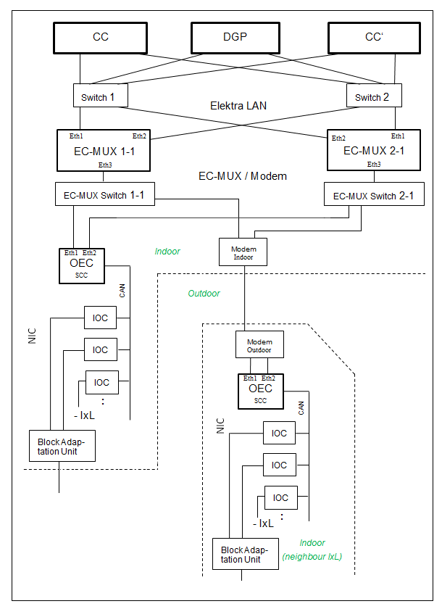
The following figure shows the physical architecture of NICs, connected to ELEKTRA. A NIC can stand either at the same location, where the other parts of the ELEKTRA are (left side on the figure), or far away on the other station (right side on the figure). The figure shows both variants (so two pieces of NIC at the same time).
Figure 10 NIC - Physical Architecture

ELEKTRA supports both types of block interface controllers, RIC and NIC. A mixed use of RICs and NICs for one and the same station installation is supported.
The mission of the peripheral component "NIC" is to communicate with neighbour relay-interlockings respectively relay block systems on behalf of the interlocking kernel (ELEKTRA CC).
A NIC includes an OEC, up to 12 IOCs, the "Block Adaptation Unit" and supplemental equipment (modem, power supply, fan, ...).
EC-MUX
An EC-MUX (which hosts a Java-based (J4S) SW application) provides a redundant serial interface for the control of the NIC component.
Analogous to a conventional EC, the EC-MUX consists of two redundant computers. Depending on the individual needs in field installations, configuration levels with more than one EC-MUX are possible.
The EC-MUX acts as gateway between the ELEKTRA CC/DGP and the (OEC component of the) NIC. It serves as a multiplexer by addressing the individual peripheral elements. The EC-MUX SW provides an interface for receiving commands and sending state and failure information back to the ELEKTRA CC. It does not contain any element logic, but acts as a forwarder between the ELEKTRA CC and the NIC OEC SW. The logical and physical interface to the CC is identical to this of a "conventional" (CHILL-based) EC. Due to this, ELEKTRA supports the parallel usage of both, conventional ECs and EC-MUXs.
OEC
Dependent on the present geographical situation the OEC is attached to an EC-MUX either directly or via a modem line (NIC located at a neighbouring interlocking, connected through WAN), using the SAHARA protocol via IP / OCS for the communication. An OEC is based upon a single-channel controller (SCC), serving as execution platform for the OEC software. It implements the element logic processes (element level) for the control of NIC elements. A defined set of NIC ports - dedicated to a particular NIC element - is used to control and observe respective IOC ports.
IOC
The IOC board is a generic interface board which provides a control interface for field elements with digital inputs and outputs. Up to 12 IOCs can be connected to an OEC, using the CAN bus interface.
Block Adaptation Unit
The "Block Adaptation Unit" consists of a relay circuitry which provides a customer defined interface to a relay block system. An adaptation unit is designed for 1 track, one NIC can handle 2 adaption units (so two connected tracks with block), each containing up to 4 track sections. To operate with existing ELEKTRA SW-commands related to a RIC, it is basically taken over unchanged.

SEC – Single Element Controller
SEC (Single Element Controller) is intended to establish a new way to control trackside railway equipment. Data necessary at the outdoor equipment location is transmitted using a single data connection even for multiple outdoor elements. The control of trackside railway equipment with HW-IFs connected via ICs and ECs is still possible in parallel, i.e. the mixture of conventional signalling and SEC is possible within one ELEKTRA.
With SEC technology the element logic to control the signal lamps (e.g. main signal or distant signal) is located directly at the signal mast in a combined control unit called TCU (Trackside Control Unit). It is connected to the relays room using only an interface by 4-wires. Two wires are used for power supply and the other two for data transmission (commands and element status messages).
iLEDs are used as signal lamps which are part of the RaiLed portfolio. In general, the RaiLed can be used to replace conventional filament lamps. The variant which is used together with SEC is called iLED and is connected with a CAN-bus-interface to the TCU. Through this bus-interface all commands are transmitted to the iLED light points and all status messages are transmitted from the iLEDs to the TCU.
For the green and yellow bars, a matrix indicator called iAnzeiger is used which is connected via the same CAN-bus.
The main components of the SEC solution in ELEKTRA are:
- Interlocking interface (EC-MUX)
- Trackside Control Unit (TCU)
- Data and power transmission
- iLED (with Connectorbox) and iAnzeiger

Interlocking interface (EC-MUX)
The connection to the indoor system is implemented according to the ELEKTRA architecture via the element controller level (EC level). A special EC computer, the EC-MUX, is used as a multiplexer and can be connected to up to 64 TCUs (in case of MEN-D6) or up to 165 TCUs (in case of MEN-D10) (see Figure 11). For reasons of availability, in case of MEN-D6, only up to 50 TCUs are currently permitted on one EC-MUX.
The function of the EC-MUX is limited to the protocol conversion from the CC-EC interface to the TCU interface and vice versa, but it does not implement any element logic for the elements that are controlled with the TCUs.
This homogeneous integration into the existing architecture means that conventional element controls and SEC technology can exist in parallel in an ELEKTRA 2 system.
The data connection between the EC-MUX and the TCUs is typically set up as ring, whereby up to 15 TCUs can be arranged in one data ring. This ring structure increases availability because if a connection between two TCUs fails or a complete TCU fails, the other TCUs can still be reached.
The connection for the power supply (400V AC 50Hz) is preferably designed in a star shape for reasons of availability. This enables that each TCU location can be switched off individually from the indoor system.

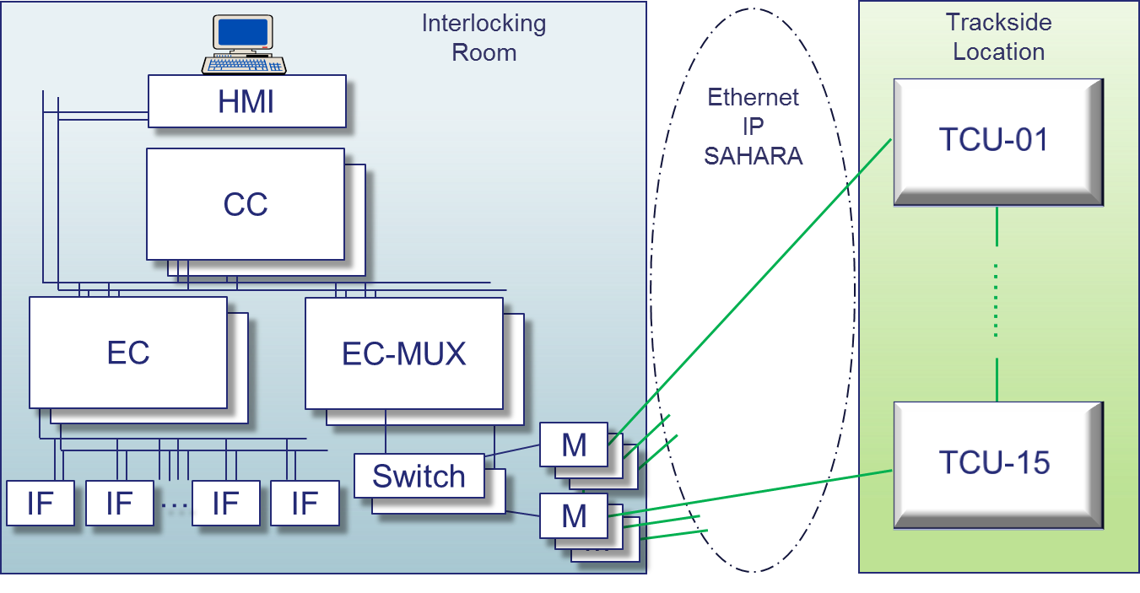
Figure 11 Interlocking Interface of SEC

Trackside Control Unit TCU
The core of the SEC architecture is the Trackside Control Unit TCU. It is placed in a signal box and has a modular structure. In addition to modem and power supply units, the TCU primarily contains the OEC (Outdoor Element Controller) logic unit. These components are manufactured in 19” technology and housed as exchangeable units in a shelf (see Figure 13 and Figure 37). It is also possible to connect one or two counting points of the FieldTrac 6315 AzLM axle counter via an additional board (CIE) in order to connect them to the indoor system via the SEC data connection.

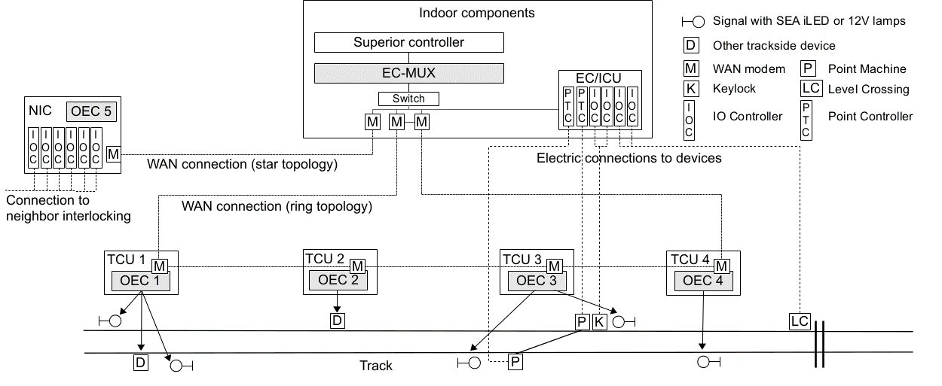
Figure 12 System Overview SEC

The OEC contains the element logic of the EC level and runs on the computer board SCC ext. or SCA ext. It processes the commands from the indoor system into commands to the LED light points and iAnzeiger, and reports the current element status back to the indoor system. Up to 16 light points and two iAnzeiger can be managed at one SEC location out of those maximally 8 can be lit simultaneously. The connection to the iLEDs and iAnzeiger is based on a CAN bus protocol (serial field bus).
All components in the TCU have a non-redundant structure. The components and all connected iLEDs / iAnzeiger are supplied with energy from the TCU. The power supply to the TCU is carried out with 400V AC (station area) or 500V AC (eBlock), which is provided directly by the power supply unit. The TCU also contains circuit breakers and a location coding plug. The TCU provides two CAN bus interfaces which can be connected up to two connector boxes on two separate signal masts. Alternatively, only one CAN bus can be used and the connector box can be connected to the connector box on the next signal mast (e.g. for main and distant signals – daisy chain variant). The connection is established via a single cable for data and energy transmission, to which the individual light points are connected. The connection between the TCU and the light points allows a distance of up to 100m in total and thus enables the TCU to be located away from the signal mast outside the danger area of the tracks.

With SEC HU 2.5.0 or from baseline INT_24.00 (PV INT 2.11.x) the following signal types are supported:
- Main signal
  - Station (including white lamp, bar (green and/or yellow) and green/yellow1/red/yellow2 lamps)
  - Block (green/yellow1/red/yellow2 lamps)
- Stand-alone distant signal (green/yellow1 lamps) – supported in station and block
- Signal repeater (white2/white1/green/yellow lamps) – supported in station and block
- Shunting signal (blue/white lamps)
- Reverse shunting allowed signal (including red lamp, white lamp)

A configuration option is to control more signals from one TCU if the total cable length between the TCU and the signals does not exceed 100m per CAN bus. This is a cost-saving variant that can be selected in the following combinations, taking availability into account:
- 2 main (combined) signals
- 2 stand-alone distant signals
- 2 signal repeaters
- 4 shunting signals
Or a mixture of the above signals, depending on the used connector boxes (see [43]).

Currently not supported signal types
- Subsidiary signal resolver
- Digit indicators
- Second green bar (V120)

Figure 13 19" TCU-Shelf

Data and Power Transmission
The information between the indoor system and the TCU (messages and commands as well as diagnostic information and data packages for configuration download) is usually transmitted via unshielded star quad cables using SHDSL or fibre optic using LWL modems. The data line can connect up to 15 signal locations in a ring topology and thus offers redundant transmission paths that can cope with the failure of a connection without loss of operational functionality (see Figure 14). Several rings can be connected to one EC-MUX, however, the maximum of 50 TCUs per EC-MUX (D6) or 165 TCU per EC-MUX (D10) must not be exceeded.
The energy supply for a SEC location includes all lamps of the signal mast and the TCU equipment. A 400V AC supply voltage is used for station areas which supports up to a distance of 6km with standard cables, for longer distances cables with a corresponding reduction factor need to be used.
In case of block signals a separate power supply cabinet is used supporting a 500V AC supply voltage and containing a splice box to connect two optical fibers for data transmission.

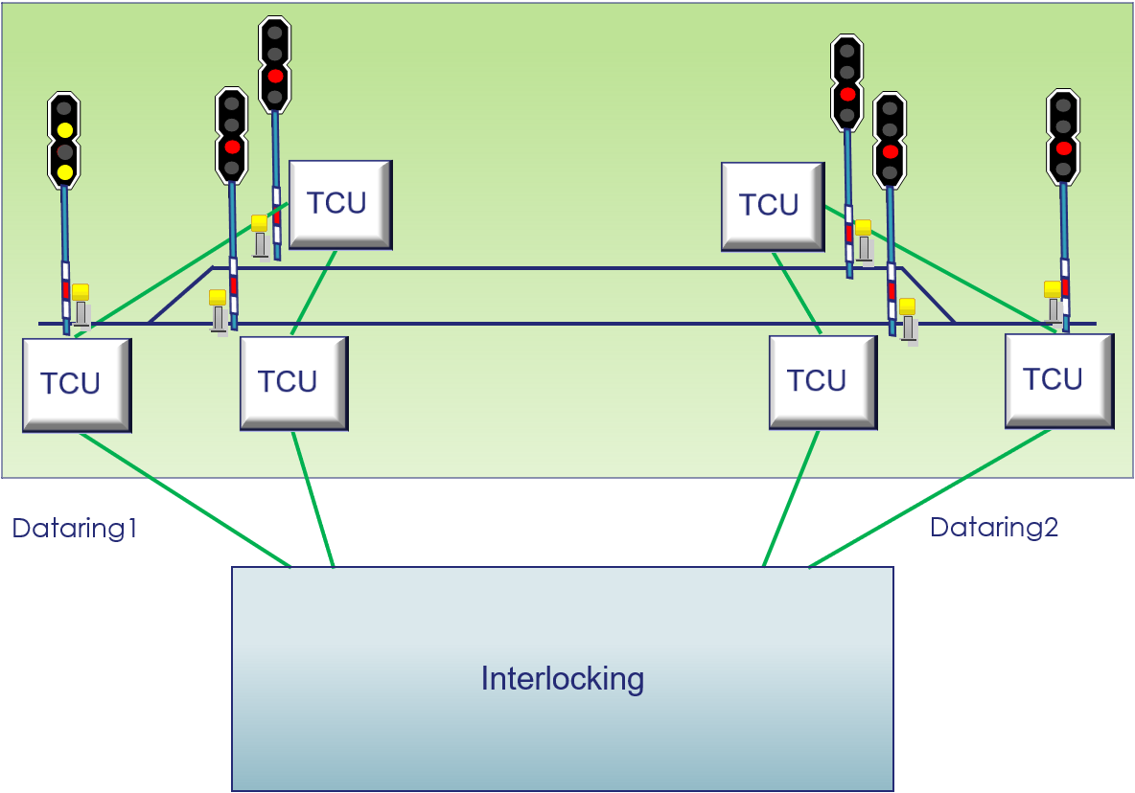
Figure 14 data transmission rings

intelligent Signal Elements (iSE)
The SEC controls the LED light points via a serial fieldbus (CAN) which transmits the commands to the iLED on the one hand and the status messages back to the OEC on the other hand. The iLED is permanently supplied with up to 30 VDC and manages the states dark, flashing and lit with the safety level SIL4. Mechanically and optically, there is no difference to the conventional RaiLED (apart from the load resistor, which is not required with the iLED). The iLED is available in red, yellow, green, white and blue with a front lens diameter of 160 mm (see Figure 40).
The iAnzeiger is used for the green and yellow bar (see Figure 41). It can be controlled like an iLED via CAN bus and also meets the safety level SIL4. One TCU supports up to two iAnzeiger in addition to the 16 iLEDs.

Track code on eBlock lines
For block signals and entry signals the TCU will control track code equipment based on the status of the signals and further conditions (state of line LCSI, occupation of block sections). One TCU supports a track code sender and a track code receiver simultaneously. The feeding direction is applied according to the block direction. In case the block signal stop command is activated the track code will switch continuously between Code1 and Code0 in a 10s interval.

SEC Maintenance
The maintenance concept of the SEC technology is based on a modular architecture. The 19” shelf contains the OEC, the power supply unit. The boards can be exchanged in a few simple steps without special tools. The newly installed OEC does not have any location-specific data, i.e. a spare part can be used for all signal locations. It receives the application software and all other element-specific data via download. The OEC location is identified via a coded connector, it uses this identification number to establish a connection with the EC-MUX of the indoor system.
Further components of the TCU such as the modem and, with the AzLM converter (CIE) and an Ethernet switch can also be exchanged in a few simple steps without special tools.
Due to the constant automatic checking of all components and connections, no periodic testing or preventive maintenance by railway personnel is necessary. With the help of accurate diagnostics, a well-directed and efficient repair is possible if necessary, which is basically limited to the simple exchange of modules.

DESCRIPTION OF THE HARDWARE COMPONENTS
In this chapter a description is provided for the hardware components, which are used in the System ELEKTRA. The description is only intended to be a general overview and, among other things, include the main characteristics, which are important for the implementation of the System ELEKTRA. The assembly of components and the location within an installation is also only described briefly, whereby these specifications can also deviate station-specific.
The subdivision of the chapter is according to the structure specified in section 2.3 „Hardware-related Subdivision“.
Components which are used for the connection of hardware components are not dealt with in the individual sections, rather grouped together in an overview in a separate section 3.9 „Cable Connections“. Distributors, power supply connections, power supply units and fuses are not described.

Operating Level
The hardware components of the operating level are based on commercial PC hardware. The terminals of the operating level are standard devices and are located at the operating station.

Functional Components

Commercial PC
The computer of the operating level is an industrial PC with Linux operating system in a casing with the following hardware components:
- Motherboard with an Intel-compatible CPU and a minimum of 512 MB RAM.
The technology of commercial PCs changes even faster than the other computer components of the System ELEKTRA, so that even at intervals of one year, in each case the employment of new types must be reckoned with.
- 1 free slot for a graphic card up to 6 display ports,
- 2 free slots for two Ethernet cards
- 1 free slot for a sound card
- USB interface for connecting the hardlock
- DVD ROM drive
- Card Reader

Keyboard
The keyboard is an input device for PCs. Supported keyboard are: English, German, Hungarian or Bulgarian.

Mouse
The mouse is an input unit for PCs with at least 2 buttons.

Graphics Card
The graphics card is an output unit for the display to a monitor. The graphics card must have the following minimum technical specifications:
Display Resolution (pixels) | Aspect Ratio | Screen Refresh Frequency (Hz) | Colour Palette
1280x1024 | 5:4 | 60 | 256 colours (8-bit)
1920x1080 | 16:9 | 60 | 256 colours (8-bit)
1600x1200 | 4:3 | 60 | 256 colours (8-bit)

Monitor
Commercial LCD monitors for PCs.
Alternatively also suitable monitors provided by customers.
All monitors to be used must be tested and approved by Hitachi Rail.

Sound Card and Loudspeakers
The acoustic unit consists of a commercial sound card and loudspeakers. The loudspeakers can be separate stand-alone units or built into the display.

Ethernet
Employment of commercial Ethernet cards for PCs.

Hard Disk
The hard disk is the storage unit of the operating level for storing all relevant data files. It is a commercial hard disk for PCs.

Hardlock
The hardlock is the identification unit of the operating level for the storage of all relevant identification data.

Flashcard
A flashcard is used to hold the EBO2 software and the station specific configuration.

Overview of Functional Components
The following figure shows the described functional HW-components of the ELEKTRA operating level incl. SW-components.
Figure 15 Functional Components of the Operating Level

Dependencies between the Functional Components
Between the functional components (incl. Software) of the ELEKTRA operating level there are a variety of dependencies (monitoring and data flow).
All hardware components are only addressed and supported by the Linux operating system, i.e. no other software components operate directly with the operating level hardware. The hardware-handling is performed with common drivers of the operating system.

Integration of the Operating Level in the Entire System
This subchapter provides a short overview about the integration of the operating level of ELEKTRA in the entire system. The operating level has a connection with two external interfaces, with the operator and the CC-level.
The operator interface consists of:
- Display components (monitors),
- Acoustic output (loudspeakers) and
- Input devices (mouse and keyboard).
The other external interface of the operating level are the computers of the central level CC (‘Central Control’). This interface is a LAN connection (Ethernet) to the:
- TAS Platform Communications System (CS) and
- the high-level protocol of the ELEKTRA application.

Central Level
The hardware components of the central level computer are designed in printed circuit board technology. The printed circuit boards are placed in the shelves of the computer cabinet.

CCA, CCB (Central Controller Channel A, Channel B)
The CC computer (Central Controller) with the subsystems CCA (channel A) and CCB (channel B) represents the central processing unit between the computers of the operating level and the computers of the element level. It forms the physical basis for the execution of the software of the central level subsystems.
The central level contains all functions, in order to process the inputs from the operating level into a safe output to the element level. In addition, the interfaces for the integration of LDC (Long-Distance-Communication) are included in the central level.
The components of this level are:
- Industrial computer Celeron MEN-D6 with Ethernet modules (as communication interfaces) for the execution of system- and application software - see following Figure 16 and Figure 17
Basic data | Intel Celeron M processor  1,0 GHz  Intel E7520 server chipset and 6300ESB southbridge  1 GB SDRAM (TAS-Platform supports 1x 512 MB)  4MB SRAM  512kB Level 2 Cache  CompactFlash (Flashcard)  6x Ethernet: 2 for ELEKTRA-internal connections,  1 for lab purposes, 3 for other applications
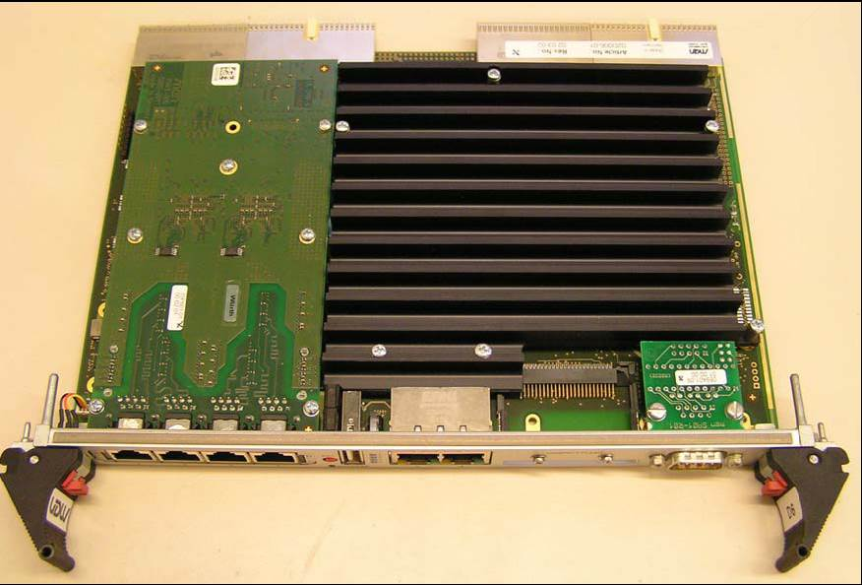
Figure 16 Industrial Computer Celeron MEN-D6 (component-side)
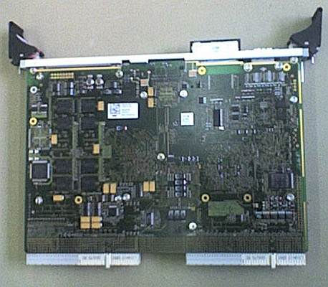
Figure 17 Industrial Computer Celeron MEN-D6 (solder-side)

Figure 18 Industrial Computer Celeron MEN-D6 (frontside)
- Industrial computer Atom x7 MEN-D10 with Ethernet modules (as communication interfaces) for the execution of system- and application software - see following Figure 19 and Figure 20
Basic data | - 2 MB cache  - 2 x 4 GB SDRAM  - 4MB FPGA Flash  - Intel Atom x7-E3950, 4 cores, 4 threads  - 1.6 GHz, 2.0 GHz Turbo Boost  • SD Card (Flashcard)  • 6x Ethernet: 2 for ELEKTRA-internal connections,  1 for lab purposes, 3 for other applications
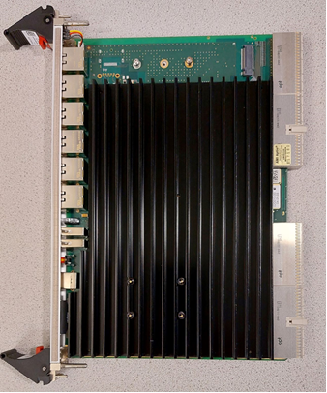
Figure 19 Industrial Computer Atom x7 MEN-D10 (component side)

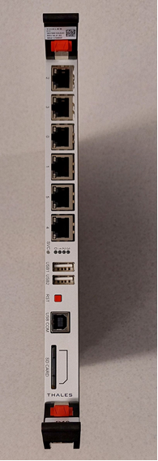
Figure 20 Industrial Computer Atom x7 MEN-D10 (frontside)

- Power supply unit [25] for industrial computer Celeron MEN-D6 [37]
Basic data | 160W  90-266V AC (input)
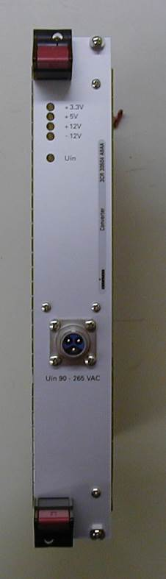
Figure 21 Power Supply Unit for Industrial Computer Pentium and Celeron

- Power supply unit [46] is only for industrial computer Atom x7 MEN-D10 [45] (usage for Celeron MEN-D6 not provided)
Basic data | 250W  90-265V AC (input)
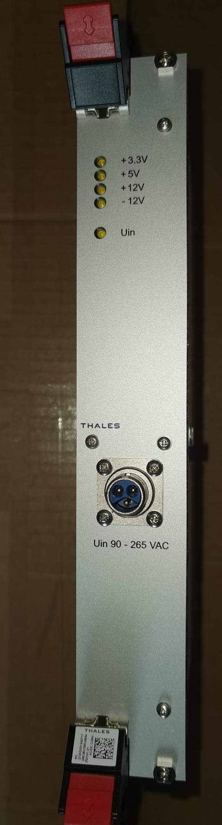
Figure 22 Power Supply Unit for Industrial Computer Atom x7

Hub
The following figure shows the Hub 3Com SuperStack II with the Ethernet connections.
Figure 23 Hub 3Com SuperStack II - Front Side

Switch
The following figure shows the Switch Alcatel OmniStack LS-6124 with the Ethernet connections.
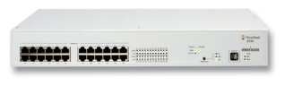
Figure 24 Switch Alcatel OmniStack LS-6124 - Front Side

The following figure shows the Switch Alcatel OmniStack LS-6224 with the Ethernet connections.
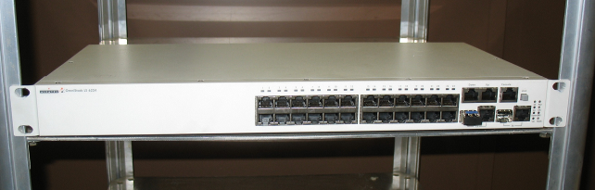
Figure 25 Switch Alcatel OmniStack LS-6224 - Front Side

The following figure shows the Switch Moxa IKS-6726 with the Ethernet connections.
Figure 26 Switch Moxa IKS-6726 (the lower) - Front Side
This switch is used in the SEC modem cabinet with a special configuration.

The following figure shows the Switch Moxa IKS-6726A with the Ethernet connections.
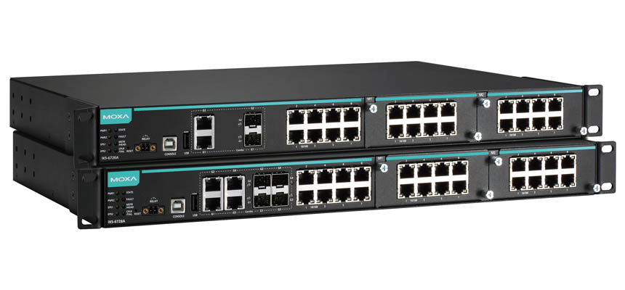
Figure 27 Switch Moxa IKS-6726A (the upper) - Front Side
This switch is used in the SEC modem cabinet with a special configuration.
At this switch type the behavior of the LEDs on the Ethernet ports between the fix installed ports (8 ports on the left port group) and the ports on the add-on modules (16 ports on the right port groups) is different. The following differences shall be noted:

Operating mode | Fix installed port |  | Port on the add-on modules
Operating mode | Left-side LED | Right-side LED | Left-side LED | Right-side LED
Booting | dark | dark | green | green
100Mbit | dark | green | green | dark
10Mbit | dark | orange | dark | green

Element Level
- In case of the control of external components via a parallel interface using conventional ECs (as opposed to EC-MUXs, e.g. applied for the SEC/NIC), the element level (also Field Element Controller - FEC) can be split into three parts
- Element level,
- Interface Control computers
- Hardware Interfaces
- The hardware components of the computer and hardware interfaces are designed in printed circuit board technology.
- The printed circuit boards of the computer and communication units of the element level are placed in the shelves of the computer cabinet; the printed circuit boards of the computer and communication units of the interface level (IC-computer) in the shelves of the interface cabinets.
- The hardware interfaces are placed in the shelves of the interface cabinets. The exact number and arrangement is station-specific and therefore is to be taken from the station-specific documents.
A basic representation of the hardware architecture of the element level is provided in the following figure.
Figure 28 Components of the ELEKTRA Element Level

Element Level (Element-Controller EC or EC-MUX)
In case of the control of external components via a parallel interface (using conventional ECs), the Element-Controller translates the logical control commands, which are generated in the central level, into serial interface commands for processing in the interface control level; in addition the serial scanner data generated in the interface control level into logical element states for the central level.
In case of the control of external components using EC-MUX, connections to OECs are established and supervised by the EC-MUX. The EC-MUX translates the protocols of the interfaces to the CC and to the OECs.
For the EC-MUX a MEN-D6 or MEN-D10 HW board like also used for the conventional (CHILL-based) EC and for the CC is applied (see chapter 3.2.1, Figure 16ff.). The EC-MUX is connected to OECs via Ethernet through the SEC modem cabinet (it does not operate a TTP-Bus).
An EC is a TAS Platform Computer, where both software channels (ECA and ECB) of the ELEKTRA application are realised.
The components of the Element Control level are
- Industrial computer Celeron (MEN-D6) with Ethernet interfaces (as communications interfaces to the central level) – see 3.2.1 with Figure 16 and Figure 17
- Industrial computer Atom x7 MEN-D10 with Ethernet interfaces (as communications interfaces to the central level) - see 3.2.1 with Figure 19 and Figure 20

- Power supply unit for industrial computer Celeron – see 3.2.1 with Figure 21
- M-Module carrier cards for TTP-M-Modules [24] (as physical communication interfaces to the interface level – FEC-internal serial bus system).
- An M-Module carrier card can pick up to four TTP-Modules [26], [28].
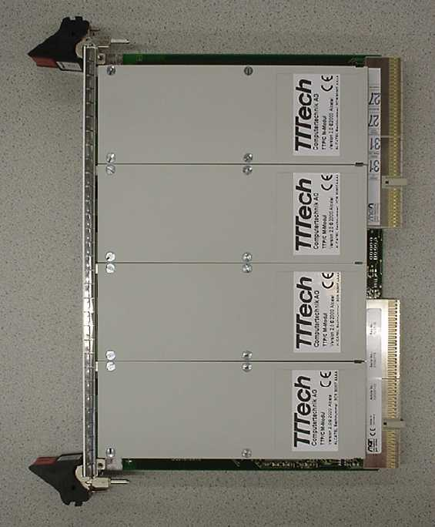
Figure 29 M-Module Carrier Card with 4 TTP-M-Modules
- TTP-M-Modules
Basic data: | 500V galvanic insulation  82C250 Line driver  C1 TTP-Chip (AMS)

- Transition Board for TTP for the back-to-front cabling between element level and interface level
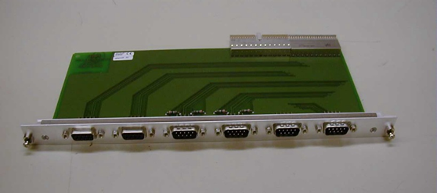
Figure 30 Transition Board for TTP

Interface Control Level - IC1D
In the interface control level, the interface controllers (IC1D) process the inputs from the element control level and control the hardware interfaces. The interface controllers (ICA, ICB) are based on micro-controllers and field bus technology (Hitachi Rail Embedded Computer).
Each interface controller (IC1D) consists of the following units
- Two micro-controllers (CPU C167CR) [29] with external components (Flash, RAM)
Basic data: | 2x C167CR 20MHz  2x 2MB RAM (16 x 128k)  2x 2MB Flash (16 x 128k)  2x 20 MosFET-Outputs  2x 50 Opto-inputs  60V Power-switch-off  2x RS232 (onboard)
- TTP-M-Modules (as communication units to the element level) – mounted in Piggy-back technology
- Power supply (internal for every IC channel)
- 60 V interfaces to the hardware interfaces
20 Output channels A
50 Input channels A
20 Output channels B
50 Input channels B
Figure 31 IC1D Hardware Architecture
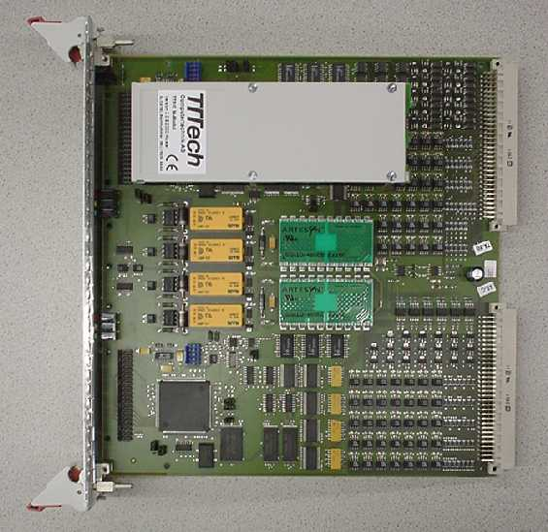
Figure 32 IC1D with TTP-M-Module

Figure 33 shows the system architecture of the element level.
Figure 33 System Architecture Element Level

Input from Parallel Peripheral Systems - IMO1D, IMO2D
Not used in Bulgaria and Hungary.

Output to Parallel Peripheral Systems - OMO1D
Not used in Bulgaria and Hungary.

Hardware Interfaces
The hardware interfaces are the link for commands and messages between the computers of the element- and interface level and the external components. They are produced in printed circuit board technology and placed in interface cabinets. They consist of a backpanel printed circuit board which contains the specific wiring and the connectors, and the corresponding number and type of interface printed circuit boards which contain the electric and electronic components. For more details on the used HW interface boards see the documents in chapter 1.3.6.

Interfaces to External Units
External units can either be placed in ELEKTRA-IF-cabinets or in their own module racks. They have interfaces which are compatible with the ELEKTRA-interfaces. Only this interface is part of the ELEKTRA.

Axle Counter Co. Hitachi Rail
The interface to the electronic axle counter Hitachi Rail EAA 6221-A3 is at the input- and output ports of the axle count repeater module. The electronic multi-section axle counter AzLM (Locktrack 6315) can also be connected to the same parallel port.
The interface to the electronic multi-section axle counter AzLM (Locktrack 6315) can be alternatively connected via a serial interface. In this case the AzLM can be carried out also as a 2oo3 system.

Components of the NIC
The following figure shows an outline of a fully equipped NIC cabinet for a 75Hz Block for two tracks:
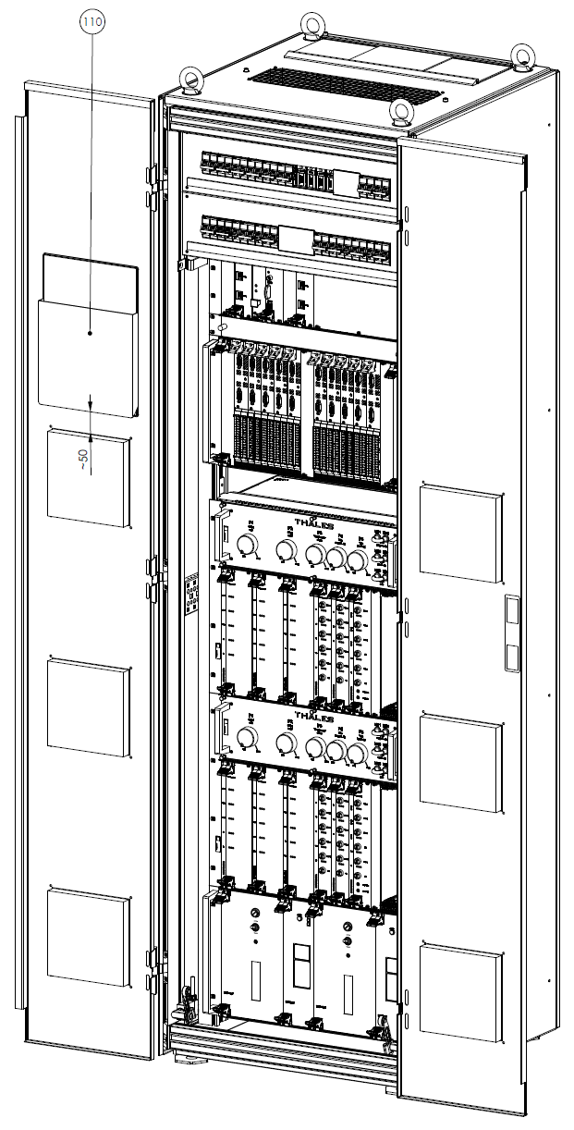

Figure 34 NIC - 19-inch Cabinet for 75Hz Block for two Tracks
The 19-inch cabinet serves as protection for the electronic equipment. It contains the following hardware components for a full equipped system supporting 2 tracks:
- Fan unit (3 fans)
- Fuse box (2 rows)
- OEC unit (DC/DC-Converter, SCCs)
- IOC unit (2x DC/DC-Converter, IOCs)
- 2x Track unit 75Hz block
- Track code subrack (2x track code receiver, 2x track code transmitter)
For details on the cabinet and individual hardware components refer to [60] and [59].

SEC components
With SEC technology, the components EC, IC and the interface boards of the indoor system are replaced by the EC-MUX, the modems in the modem cabinet and the components of the TCU. The core component of the TCU is the OEC, which contains the logic of the element level for the connected signals in the TCU.

EC-MUX
The EC-MUX is structured like a CC computer and runs on MEN-D6 or MEN-D10 cards. (see also 0).

Data Transmission
The data is transmitted via SHDSL or LWL modems, which are placed in a separate modem cabinet in the indoor system and at the signal location inside the TCU cabinet. For the ring topology, there are two modems per ring in the modem cabinet, which are connected to the two redundancies of the associated EC-MUX via two switches, so that all signal locations (TCUs) can still be reached in the event of failure of a component or a connection from the central level.

TCU
The TCU has two different configurations. For the station area only the TCU cabinet is equipped. On the open line for block signals additionally an ATP cabinet and a power supply cabinet are added.
Figure 35 TCU for Blocksignals (full configuration)

TCU Cabinet
The Trackside Control Unit TCU of the SEC contains the following parts on the mounting plate:
- TCU computer shelf (19 “) with the components
  - OEC (on single channel controller SCA)
  - Power supply unit for 5V (SCC/SCA) and 24V (SHDSL/LWL modem and iLED)
- Fan unit (optional)
- Main switch (400VAC or 500VAC)
- SHDSL or LWL modem
- Location ID plug
- Axle Counter AzLM components to connect one or two counting points (if applicable):
  - DSL / ETH converter
  - Ethernet switch
The TCU is placed inside an outdoor element box (see [44]) which is mounted on a cable distribution socket. The box is equipped with a door alarm.

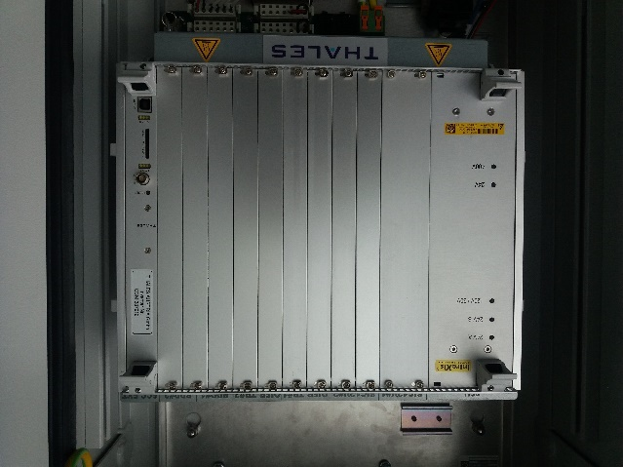
Figure 36 TCU

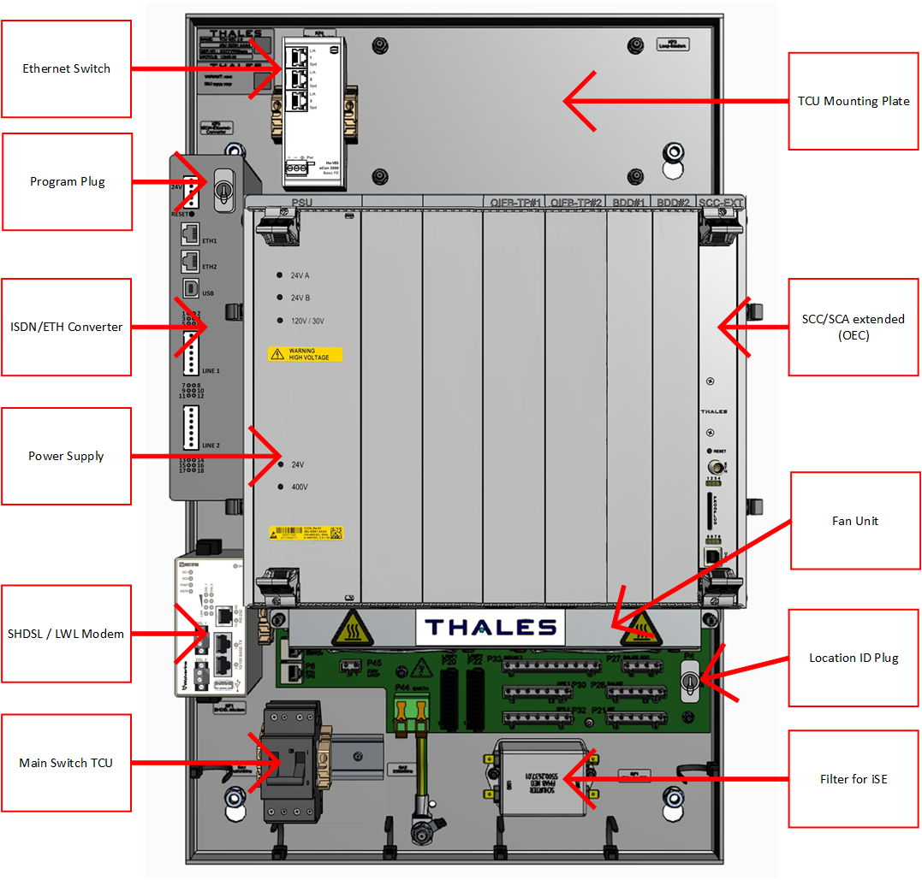
Figure 37 Components inside the TCU cabinet

ATP Cabinet (at blocksignals for track code)
75Hz track code system in a separate enclosure containing:
- 19-inch shelf for:
  - EVPQ (75Hz track code receiver) [48]
  - VBUPQ (75Hz track code transmitter) [49]
  - M relay for direction control
  - Up to 2 OIFB-TP for controlling M-relay, EVPQ and VBUPQ
  - Adjustment unit for 2 track sections
  - AC/AC Converter 230V 50 Hz / 75 Hz
- Mounting plate for:
  - 2 transformers, one for each track section
  - 1 transformer for synchronisation of track code
  - Switches for track code interruption to the tracks
  - Circuit breakers
  - Clamps for interconnections (power supply, track code) with clamp array, strain relief on the incoming side and possibility to connect the cable shield

Power Supply Cabinet (at blocksignals)
A cable connection enclosure containing:
- Mounting plate
- Inlet for two optical fibres with splice box
- Clamps for power cables (4*35mm² Al) with clamp array and space to fix them on the incoming side
- 2 transformers, 500V to 230V voltage reduction for 2 TCUs
- Separation devices for each direction of power supply (two times 500V are going from station to station and can be feed of both sides)
- Circuit breakers for TCUs, ATPs

This enclosure contains the equipment which is necessary to connect the TCU to the eBlock daisy chain system. The power supply of 2* 500V is done by 4 x 35 mm² Al cables with a diameter of 30 mm. The data is transferred via fibre cables to the individual TCU locations.

Connectorbox
The connection of the iLED light points to the TCU is structured as follows: A cable for data and energy transmission leads from the TCU to the foot of the signal mast. There it is connected to the cable which leads up the signal mast to an iAnzeiger (if applicable) and from there it leads to a connector box on the signal mast. The individual light points are connected to this connector box in a star topology (using the same cable type). If necessary, another cable leads to the connector box on the next signal mast (e.g. for two main signals connected to the same TCU). The cables from the connector box to the light points are part of the connector box and are permanently connected to it. There is a specially configured connector box for each type of signal (main signal with 2, 3 or 4 light points; distant signal, etc.). See Figure 38 and Figure 39. See [43] for details.
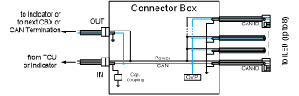
Figure 38 Connector Box schematic

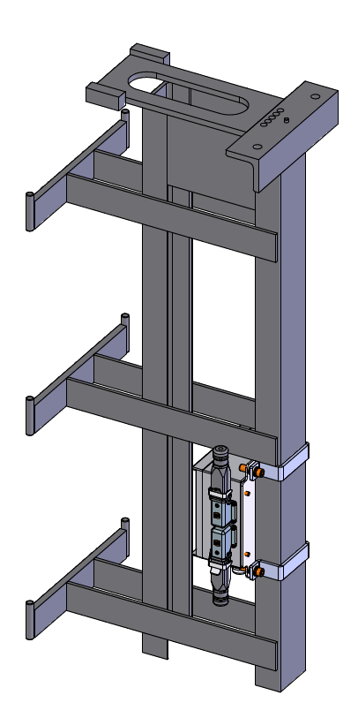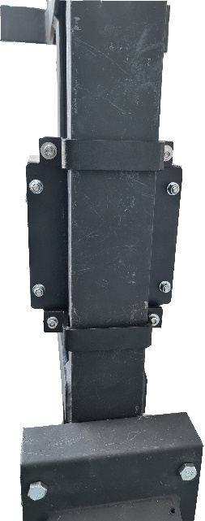
Figure 39 Connectorbox including mounting

iLED
The iLED light point consists of two parts, the front part of the housing with the front lens and the rear part of the housing, which contains the electronics. This rear part of the housing is called the iLED module. In the event of a repair, only the iLED module is exchanged, while the front part of the housing remains mounted on the signal plate. This means that no further optical adjustment work is required after the exchange.
Since the iLED is connected via CAN bus communication interface, no electrical adjustment is required during installation and maintenance works.
The cable from the connector box is connected to the LED light points with a connector specially designed for all weather conditions (incl. UV radiation). This connector contains a code that identifies the light point to be connected (red, yellow1, etc.), so that interchanging different colored iLEDs cannot lead to a hazard. The interchanging of iLEDs of the same color, has to be ruled out after assembly by a compliance test by the maintenance worker. OEC will not get operational (will do a reboot) if an iLED connects with an unexpected color.

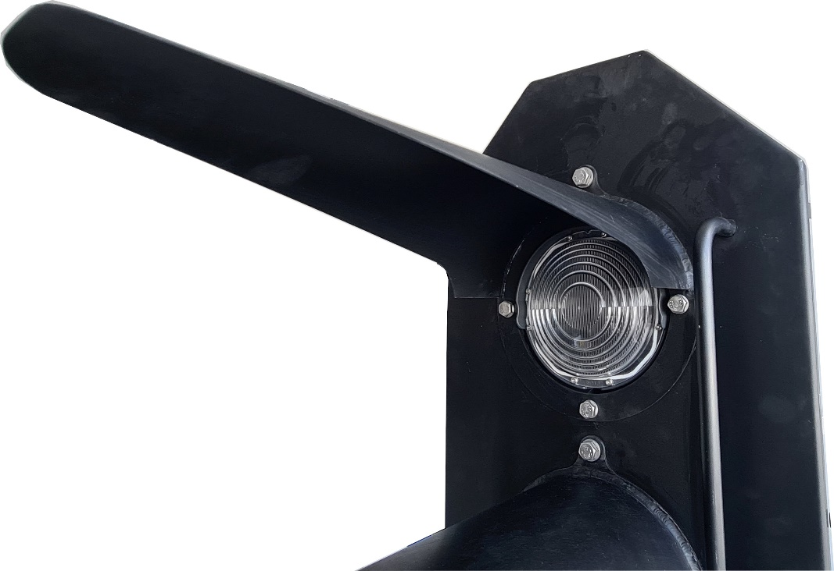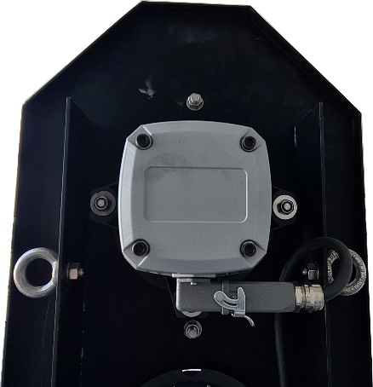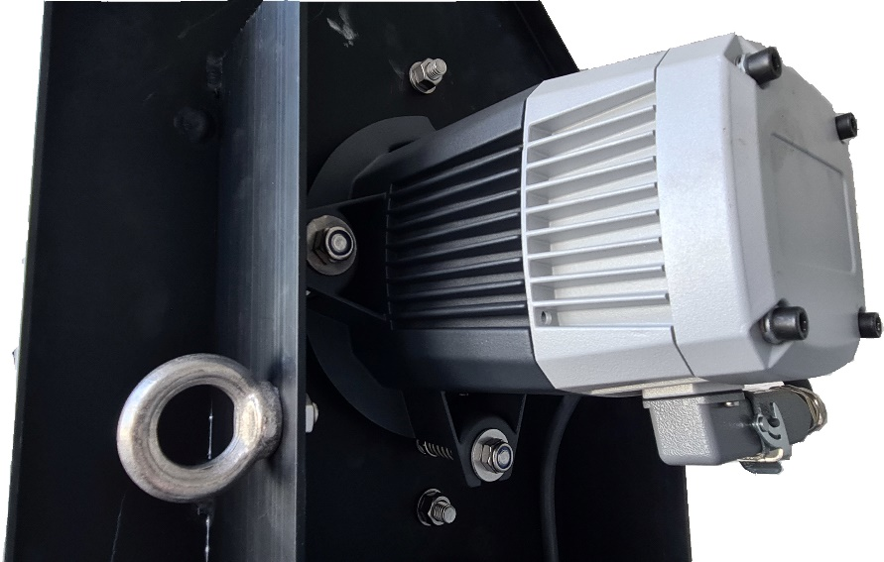
Figure 40 iLED with 160mm lens diameter

iAnzeiger
The iAnzeiger is indicating supplementary speed aspects additionally to the light points situated on main signal plate and consists of the housing and the circuit board which carries the LED light points and the electronics. The circuit board is mounted to the housing. The exchange of the circuit board can be carried out while the housing remains mounted to the signal mast, which means that no further optical adjustment work is required after the exchange. Since the iAnzeiger is connected via CAN bus communication interface, no electrical adjustment is required during installation and maintenance works. The connection to the OEC is made with the same type of cable as with a connector box. The iAnzeiger can be placed in the middle of the chain between the TCU and CBX.
Depending on the application, different display options of iAnzeiger Type-5 can be indicated from the same hardware (only one aspect at a time):
- yellow vertical bar
- green horizontal bar

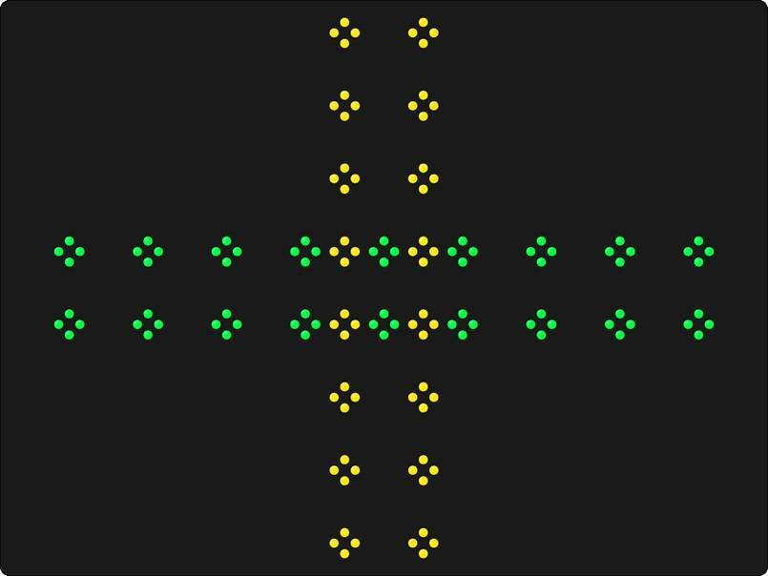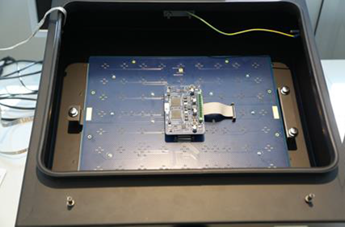
Figure 41 iAnzeiger

Track code (for eBlock)
The track code transmitter (VBUPQ) sends one of 4 possible speed codes, at the end of the electrically separated block section, to the rail. When at the beginning of the block section the receiver (EVPQ) receives this code from the track, the block section is free. If a train stops or travels in this block section, the track current is shorted by means of the axis of the train and the receiver no longer receives the track code. In addition, the track code (speed aspect) is also transmitted to the locomotive via antenna. When the direction of travel is reversed, transmitter and receiver are exchanged by electric switch over.
The track code units (VBUPQ and EVPQ) are pre-existing components. See [48] and [49].
Figure 42: Overview example for open line block system with track circuit over line sections
A maximum of 5 A shall be fed into the insulated track section for ATP purposes, which shall be able to adjusted in order to avoid too high currents which can lead to an inconsistent situation between the train detection system (axle counter) and track code receiver, either because of occurrence of loss of shunt or increase of drop shunt of a track event.

A bi-stable relay (M-relay) is used to interchange transmitter and receiver of the track code when the train direction is changed.

Interface Converter
The hardware components of the interface converter are designed in printed circuit board technology. The printed circuit boards are placed in the shelves of the computer cabinet.
The interface converter contains the subsystems RCU/SCU, or there are separate processors for RCU and SCU right from the start. It forms the connection from the computer CCA/CCB on the one side, and to the modem direction long-distance connection on the other.
It forms the physical basis for the conversion from ELEKTRA-protocol to a protocol according to X.25.
The computer RCU/SCU - or separate computers RCU and SCU – are realised as follows:
- Industrial computer Celeron (MEN-D6) with Ethernet Modules (as communications interface), for details see 3.2.1 with Figure 16 and Figure 17 or
- Industrial computer Atom x7 MEN-D10 with Ethernet interfaces (as communications interface), for details see 3.2.1 with Figure 19 and Figure 20
- M-Module carrier cards for HDLC-Modules [25], [27] (as physical communication interface over X.25) – see Figure 43
- HDLC-Modules
Basic data: | max. 2.5 Mbaud  2k FIFO for every channel for every direction  500V galvanic insulation  RS422/423 Line driver
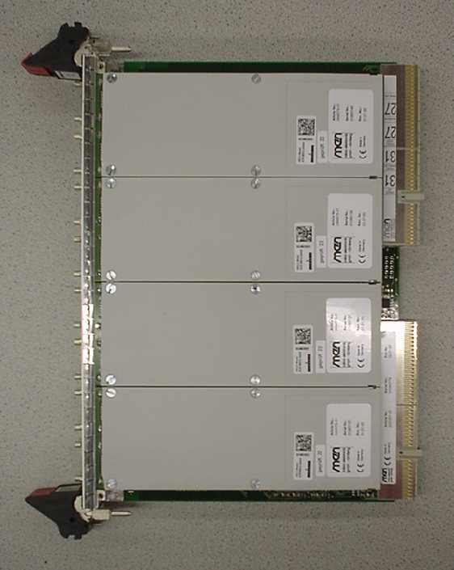
Figure 43 M-Module Carrier Card with 4 HDLC-Modules
- Power supply unit for industrial computer Celeron – see 3.2.1
The interface computer is connected to the modem via X.25 (X.21).

RIC – Remote Interface Controller
Also realized with a serial interface is the connection from the interface converter RCU/SCU to a computer RIC (Remote Interface Controller) for the adaptation to the block interface of a remote station (e.g. relay interlocking system) or for the permission, if the neighbouring station is so close, that there are overlapping routes.
The computer is realised in 16+ technology and uses the following printed circuit boards:
- SBB+ (Single Board Backpanel)
- ACUE (Advanced Communication Unit Enhanced) - Hitachi Rail computer 16+, consisting of
- AIP (Advanced I/O Processor) and
- SCSE (Serial Communication System Enhanced)
- IOBG (Input/Output module)
- POBS (Parallel Output Board Serial)
- SCIS (Scanner Input Board Serial)
Connected to the parallel output and input printed circuit boards POBS and SCIS are relays as connection to an adaptation group:
- BABG (Block Adaptation Module)
- REM (Relay Module) or
- REM 12 (Relay Module 12 V)
Diagnostics
The hardware components of the computer are designed in printed circuit board technology. The printed circuit boards are placed in the shelves of the computer cabinet.
The diagnostic terminals are standard devices and are located at the operating station of the maintenance personnel.

DGP (Diagnostic Processor)
The DGP-computer is the link between the diagnostic terminals and the computers of the central level. It forms the physical basis for the execution of the software of the diagnostic subsystems, and provides the adaptation at the serial interfaces to the diagnostic terminals.
The DGP-computer is realised as follows:
- Industrial computer Celeron (MEN-D6) with Ethernet modules (as communication interfaces) – see 3.2.1 or
- Industrial computer Atom x7 MEN-D10 with Ethernet interfaces (as communications interface), for details see 3.2.1 with Figure 19 and Figure 20
- M-Module carrier cards for HDLC-Modules (as physical communication interfaces over X.25) – see 0
- HDLC-Modules – Data as in the previous point
- Power supply unit for industrial computer Celeron – see 3.2.1

Diagnostic/Maintenance Terminals
The diagnostic terminals are responsible for the conversion of the information between the DGP-computer and the user interface, as it is defined for the maintenance personnel.
The terminals are highly reliable standard devices, which are connected to the corresponding ports, and can be exchanged by the maintenance personnel:
- Terminal (keyboard and monitor)
- Separate storage medium for long-term storage of diagnostic messages (ESM)
- Optional printer for the terminal

Electronic Storage Medium - ESM
With the electronic storage medium (ESM) log- and fault texts are archived. The ESM is an industrial PC with Windows or Linux (Linux used for the ESM2/JPS variant) operating system. It is connected serial with the DGP (Diagnostic Processor).

Remote ESM/Printer Installation for Lines with Several Interlockings
In case it is necessary to deploy the ESM at a remote location, which is not connectable via copper serial cable or a Serial-over-Fibre connection, it is also possible to tunnel the Serial interface via an IP/Ethernet connection. For example, can the ESM of an ELEKTRA along a line, where at one station locally no ESM is required, be relocated to a remote location. This remote location is e.g. the SVA operator workplace of the line. A pair of RS-485 to IP converters is used for Serial-over-IP transmission.
The following drawing provides an overview; the EDW-100 Serial Adapter solution is marked with the yellow area.
Note: At the remote location the pair of FRM220 devices is depicted exemplary and only required in case the serial connection shall be transmitted via fiber without IP connection.

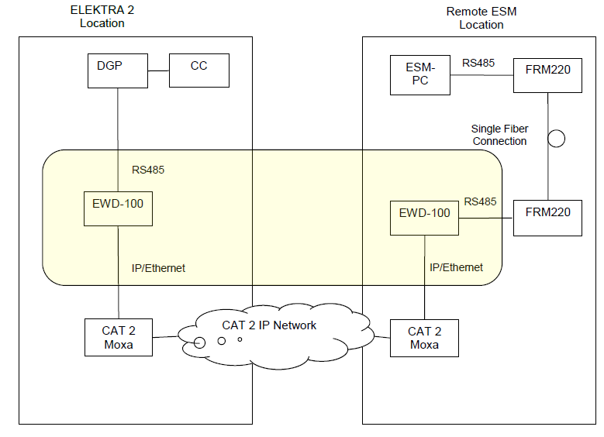

The network between the EWD-100 may be a category 1 or category 2 network according to EN50159.

Two External Operating Stations working as Recording Media
It is possible in an ELEKTRA station to configure one or two printer locations (“drucker_ort”) and up to two printer centrals (“drucker_zentrale”)
- for printer locations the ELEKTRA verifies that the printing actually happened. (documented commands are not executed until the printout is confirmed)
- for printer centrals the messages are forwarded by ELEKTRA but the actual printing out is not verified.
ELEKTRAs working as printer centrals receive copies of ESM messages.
At least one ELEKTRA (usually the local ELEKTRA) has to work as printer location in order to have at least one location for verified printouts.

Cabinets
The computers of the CC-, EC, DGP and RCU/SCU units are placed in 19“ cabinets. The dimensions of these cabinets are: 600mm x 600mm x 2100mm (width x depth x height).
The interface controllers and the hardware interfaces are placed in cabinets of the System 12 design. The dimensions of these cabinets are: 899mm x 453mm x 2220mm (width x depth x height).
The cabinet for NIC and TCU see in the corresponding chapter 3.3.7 and 3.3.8.3
The individual printed circuit boards are fixed in the racks of the shelves to guarantee the mechanical stability. The connection of the printed circuit boards is realized via plug connections in backpanels.
For the cabinets, in the computer room the environmental conditions according to CENELEC EN 50125-3 (Railway Applications – Environmental conditions for equipment – Part 3: Equipment for signalling and telecommunications), climate class T2, for accommodation in buildings must be considered:
Room temperature at the outside of the cabinets: -5 °C ... + 40 °C
whereby the range -5 °C to 0 °C after at least 1h of continuous operation is allowed.
Cold start: 0 °C
Humidity (operating condition): 5% ... 95 % RH, max. 22 g/m³ absolute, no dew formation.
Temperature for storage: - 25 ° ... + 55 °C
Vibrations and impacts
Only insignificant impact and vibration stresses of the computer cabinets may occur:
Stationary vibrations, random Class 3M11 acc. EN 60721-3-3
5 Hz to 200Hz: 0,01m/s²
Impacts no shock
Dust
The rooms must be cleaned and kept in good condition, which means, that regular removal of the dust accruing must be ensured according to the degree of contamination of the air.

Computer Cabinet (CC/EC cabinet)
At the computer cabinet the automatic circuit breakers are arranged in the top of the cabinet, and from here the internal wiring of the cabinet is carried out.
The computer hardware of the computer cabinet is build up in a modular system.
- Base unit is the backplane with the industrial computer Celeron MEN-D6 or Atom x7 MEN-D10
- Transition adapters at the back are used for the coding of the computer, the redundancy identification and the installation identification.
- One power supply unit is required for each redundancy
An EC-computer is connected physically and logically with an M-Module carrier card, which can pick up to 4 TTP-M-Modules.
- Transition boards at the back connect the TTP-M-Modules with the corresponding bus segment.
An RCU/SCU or DGP-computer is connected physically and logically with an M-Module carried card, which can pick up to 4 HDLC-Modules.
The MEN-D6 and MEN-D10 cabinet has additional ventilating fans at the top of the cabinet.

Interface Cabinets
At the interface cabinets, terminal strips and/or distributor backpanels are arranged in the top of the cabinet. At the front of shelf 1, or if applicable, also 2, are the automatic circuit breakers. In the following free shelves (up to the sixth) the hardware interfaces are installed. In shelf 7 the interface controllers are installed. The interface cabinets are configured installation-specific.

SEC modem cabinet
The SEC modem cabinet contains SHDSL modems and switches which enable the data transfer between EC-MUX and the OECs. The cabinet is designed for 2 or 4 switches and up to 24 modems and one pair of switches is assigned to one EC-MUX. Therefore, up to two EC-MUX can be supported with one cabinet. The cabinet contains circuit breakers and surge protection. The parts of the SEC modem cabinet contain no safety critical functions.
The OECs are typically connected via ring topologies which use two modems inside the cabinet per ring. One modem is connected to switch1-n and the other to switch2-n (where n is the EC-MUX number and 1 and 2 are the redundancies).
For further details see [42].
The NIC may be connected directly to the EC-MUX without the usage of the SEC modem cabinet.

TCU cabinet

Stations signals
The shelter at the outdoor location serves as a protection for the electronic equipment. For security reasons the box can be locked. The housing provides pollution class PD1 for the electronic components, that means protection class IP65. The outdoor enclosure is a COTS component made of aluminium.
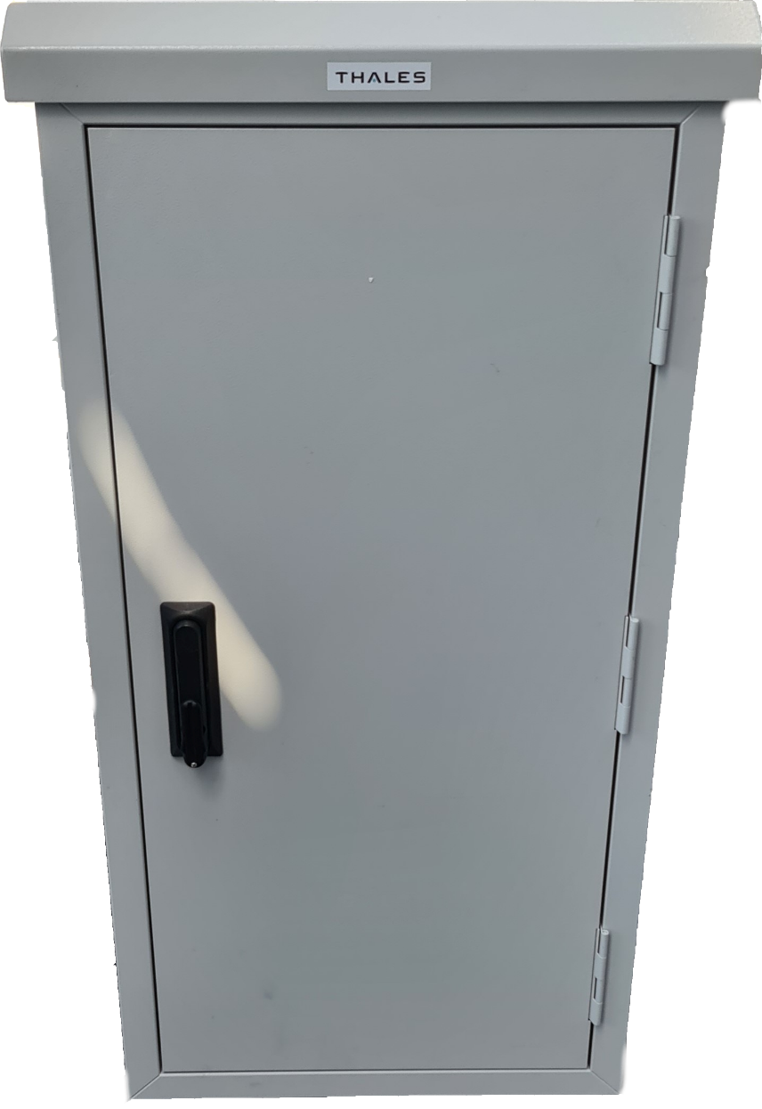
Figure 44 TCU housing

Block signals
At block signals three cabinets are placed containing the components described in chapter 3.3.8.3:
- TCU Cabinet
- ATP Cabinet (75Hz Track code unit)
- Power Supply Cabinet (Cabling Enclosure)

Cable Connections
For exact details about cables – cables between the hardware components for the electrical connection of interfaces with nominal voltages ≤ 60 Volt, connections to the power supply and to the external components – see [32].

Connection of Serial Interfaces

LAN/Ethernet - Cable
This is a patch cable EIA/TIA568B with RJ45 connectors. It is used:
between industrial computer Celeron and Hub or Switch
between industrial PC with Linux operating system (HMI) and Hub or Switch

TTP - Cable
The TTP-cabling is realized with shielded cables with DSUB-9 connector.

X.25 Cable
The cable is used for the connection:
between modems (RCU/SCU to RCU/SCU)
for HDLC-cable to the modem, to the ESM, to the radio clock

SHDSL Cable
The connection between the modem in the SEC modem cabinet and the cable termination frame is done using a specially twisted telecommunication cable. Part number 3BU 61411 0008 (e.g.: Lapp UNITRONIC 300 2 x AWG18 part-number: 301802). Additionally, the definitions in [33] have to be considered.

Printer Cable
The printer, which can be optionally connected to the ESM, is connected serial with a common printer cable. Also the printer, which can be configured instead of the ESM.

Connection of Parallel Interfaces
The connections of parallel interfaces are realized with system cables SYSK04 to SYSK64. These are 4-, 10-, 20- or 64-pin cables, both ends with System-12 sockets (2 x 2-, 2 x 5-, 2 x 10- or 2 x 32-pin).
They are used for the connection of parallel interfaces:
on back panels of modules
between back panels of modules
between back panels of modules and IC1D
between back panels of hardware interfaces and distributor back panel

Connection of Industrial PC with Linux Operating System (HMI) and Monitor
This connection is realised with a COTS component (monitor cable).

Connection of Power Supply Interfaces

Power Supply Cable
- These are 2- or 3-pin cables, both ends with Mate-N-Lok connectors.

Connection to the Power Supply Cabinet
These are double insulated PVC installation cables with terminals in the power supply cabinets and screw terminals at the top of the cabinet. They are used for the connection:
between power supply cabinet and computer cabinet
between power supply cabinet and interface cabinet
between power supply cabinet and operating- and diagnostic level

Power Supply within the Cabinet
Single wires with screw terminals on the top of the cabinet and Mate-N-Lok crimp connectors on the back panel in interface cabinets. Single wires with push-on couplings or cable eyelets inside the computer cabinets and interface cabinets.

Connection to External Device Interfaces

Power-conducting Electric Circuits
For power-conducting electric circuits (e.g. to switches, signals) 8-pin cables with pin and socket strips are used from the interface cabinet to the cable termination rack.

Check and Control Lines
For check- and control lines (e.g. to button boxes, warning systems) 64-pin cables with System-12 sockets are used from the interface cabinet to the cable termination rack.

SEC Cable
Star-quad cables are generally used for data transmission between the indoor and outdoor systems. The data is transferred using SHDSL. The use of several star quads in one cable is permitted. When using stranded cables, Hitachi Rail must ensure the quality by measuring the cable.
Two wires can be used for energy transmission in the same cable or in the same star-quad bundle. The voltage for the supply of the TCU is 400V AC or 500V AC. The required cable cross-section is determined by the power consumption and distance of the connected TCUs.
SEC supports iLED and iAnzeiger light points. Regardless of the number of light points (max. 16) and iAnzeiger (max. 2) on the mast, only a cable in which the power supply and CAN bus are combined needs to be connected to the TCU. One TCU supports two CAN bus connections.
Further details on cabling at SEC can be found in [33].

Connection to Internal Device Interfaces

Check and Control Lines
These are 64-pin cables with System-12 sockets at the side towards the interface cabinet for block, axle counter, external track free message and other internal devices.

Power Supply Message
These are multi-pin cables with System-12 sockets at the side towards the interface cabinet for the power supply messages.

DESCRIPTION OF SOFTWARE-SUBSYSTEM
In this chapter a description is given of the software subsystems that are used in the system ELEKTRA. The description should be only in an overview and among others include the main features that are important for use in the system ELEKTRA. There are also briefly given the used programming languages, the conversion of source code into machine code, and implementation.

Operating Level
The Software of the user interface is divided into the following modules:
- Construction
This module provides all globally (over all workplaces) available information. In particular, the following tasks are covered:
- Change of globally visible data, e.g. user information
- Synchronization of workplace redundancies
- Communication Interface
This module provides the connection to the local interlocking system.
- Event logging
This module provides a common interface for event logging.
- Element Repository
In this module:
- status reports from the CC–level are voted
- all element-specific data are collected
- Persistent Repository
In this module all data are collected, which have to remain available in case of a failure of any subsystem.
- Editor Set
This module provides the graphical representation about the states of the interlocking system.
- User Interface
In this module all user interactions are treated.
- Sound System
In this module the administration of all acoustic signals is summarized.
- Configuration
In this subsystem all system-specific configuration data are included.

Figure 45 Software-Architecture of HMI

Central Level
In the software subsystems of the Central Level the "Command" information from the operating level and the "Message" information from the element level are converted into internal information that describes the collected state of the ELEKTRA environment. The necessary reactions for any collected state are converted into "display" information for the operating level and "instruction" information for the element level.
The necessary reactions are taken from the railway management specific customer requirement specifications and obey general safety-related principles.
The software subsystems in the logic channel are written in CHILL, in safety channel to a large part in PAMELA and partly in CHILL. Global data areas are defined in RMT databases, which data is populated using a data preparation tool. From the source code an executable code is generated for the CAR operating environment of the CCX computer (CCA + CCB on one computer) (MEN-D6 or MEN-D10) by using the GNU tool chain.

GCA (General subsystem of the central level Channel A)
The subsystem GCA includes functions for issuing adjusting instructions to the periphery, as well as functions for receiving status reports from the station elements of the periphery. Furthermore, the subsystem GCA contains architecture specific processes for booting and life cycle supervision.
In addition the subsystem includes the following software-functions:
- CMD-V (Command-Voter)
- MSG-V (Message-Voter)
- DIS-C (Display-Comparator)
- INS-H (Instruction-Handler)
Their main tasks are:
- Comparison and synchronization of the two-channel CHILL signals:
- from the subsystems of the central level to the subsystems of the operating level (Display-Comparator),
- from the subsystems of the operating level to the subsystems of the central level resp. subsystems of the element level (Command-Voter),
- from the subsystems of element level to the subsystems of the central level (Message-Voter),
- from the subsystems of the central level to the subsystems of the element level (Instruction-Handler).
- Detection of malfunctioning with external impact, such as
- Corruption of the CHILL signal in the data area,
- Corruption of the CHILL signal in the time range

GCB (General subsystem of the central level Channel B)
The subsystem GCB contains the component of the safety bag, which are checking all safety related functions and decisions of the GCA regarding the command output to the periphery, as well as all status messages checked for consistency and synchronized to the control level, by methods and specifications implemented according to diverse programming.
Tasks and functions are identical to those of the subsystems GCA.

ICA, ICB (Interlocking Central subsystem Channel A, Channel B)
The subsystem ICA in the A channel and the subsystem ICB in the B channel contains the processes and submachines for functions of the electronic interlocking system.

Element level
In the software subsystems of the element level the "Instruction" information from the central level is converted into outputs to the hardware interfaces, and inputs from the hardware modules are converted into "Message" information to the central level. The required inputs and outputs are given according to the railway management specific customer requirement specifications and regulations.
The software subsystems are written in CHILL. Global data areas are defined in RMT databases, which data is populated by a data preparation tool. An executable code for the computer of ECX (ECA + ECB on one computer) (MEN-D6 or MEN-D10) under the operating system AEOS is generated out of the source code through the tool chain.

GPA, GPB (General subsystem of the peripheral level Channel A, Channel B)
They belong to the element level, contain the general processes (e.g., main control, life cycle, booting, and scanners treatment) in the computer + ECA ECB.
Furthermore, the software-voting function INS V (Instruction voter) is also contained for compare, vote and time supervision of dual-channel CHILL signals from the subsystems of the central level to the subsystems of the element level and detection of malfunctions with external impact (like the other voters).

EPA, EPB (Element subsystem the Peripheral level Channel A, Channel B)
They belong to the element level. The subsystem EPA in the A-channel and the subsystem EPB in the B-channel contain the processes and submachines for the functions of the electronic interlocking system, concerning the control of the external component and the scanning of the message states.

EC-MUX (Element Controller Multiplexer, Channel A and Channel B)
The EC-MUX behaves in the same way as an EC towards the CC and the DGP. Its task is limited to the protocol conversion of the commands from the CC to the interface in the direction of the OEC and vice versa of the messages from the OECs to the interface to the central level. Furthermore, the life cycle signals of the OECs on the one hand and the CC on the other hand are monitored and a safe reaction is initiated in the event of failure. Since these tasks are safety-relevant, two SW channels also work in the EC-MUX, EC-MUX-A and EC-MUX-B. The logic is written in Java, the required configuration data is generated by the configuration tool and stored in XML files.
In addition, the diagnostic broker for collecting the diagnostic information from the OECs runs on the EC-MUX. The diagnostic functions are not relevant for safety.

OEC (Outdoor Element Controller, Kanal A und Kanal B)
The OEC contains the element logic for the signals of a signal location. This logic has a two-channel diversified structure (OEC-A and OEC-B), is written in Java and is executed on the SCC or SCA computer board (see Chapter 3.3.8.3). The OEC is connected to the EC-MUX via an IP connection on which the SAHARA safety protocol runs and via this logically (for the operational functions) to the CC. In addition, the OEC controls the iLEDs, any iAnzeiger via a CAN bus interface.
The location-specific data (project data preparation) and the application software can be downloaded to the OEC. This means that (except for the location ID plug) no location-specific spare parts are required and also avoids having to go to the signal locations for a software upgrade. The software is downloaded from the EC-MUX. In case SCA is used the download can also be done in advance in the background. In the course of establishing a connection between the OEC and the EC-MUX, a version check is performed. When the check is successful, operation is started.

Interface converter
In the software subsystems of the interface converters the CHILL signals from the ELEKTRA are converted into serial messages (messages to peripheral systems). Generally, the standard X.25 is applied. The technical and substantive requirements must be taken from the International/ÖBB customer requirements specification of the X.25 interface [2]. The interface converter includes the subsystems RCU (with both channels RCA and RCB) and SCU (with SCA and SCB).

RCA and RCB (Remote controller Channel A Channel B)
They include administrative processes (life cycle, PROM-ID, configuration, DGP communication) and the interface processes themselves. There are:
- RCx_EL_VOTER: Receives the signals from CCx, hands over the signal data to the voter submachine to vote between channel A and B, synchronizes the frames from the channel A and B and forwards them to the controller.
- RCx_X25_CONTROLLER: Responds to status request telegrams with status report telegrams on existing CC, checks incoming frames (critical commands are checked on two-channel capability and checksums) and communicates with In- and Out processes with the SCU.
- RCx_FLOW_CONTROL: Regulates the data throughput from the RCU to the CC.
- RCA_X25_OUT_PROZ: Receives the frames from RCx_ILT_CONTROLLER, appends telegram sequence numbers and checksums and sends it to the SCU.
- RCA_X25_IN_VOTER: Receives frames from the SCU, checks message sequence numbers and checksums and forwards them to RCx_ILT_CONTROLLER.

Diagnostic
In the software subsystems of diagnosis, "diagnostic" information from all levels of the system Elektra in diagnostic texts is converted to the terminal diagnosis.
The software subsystems are written in CHILL. Global data areas are defined in RMT databases, which data is populated using a data preparation tool. From the source code is an executable code generated for the CAR operating environment of the DGP computer (MEN-D6 or MEN-D10) by using the GNU tool chain.

DGP (Diagnostic Processor)
The following tasks are performed by the subsystem DGP:
- Display and recording of disturbances and faults of the external components, interfaces, and the computers,
- Recording of operational procedures (such as interlocking actions, changes of the state of routes, etc.),
- Records of internal messages (internal irregularities, etc.) and of repairs.
As output media, the following terminals can be used:
- Display unit (DSG) of the diagnostic terminal
- Modem for data transmission (additional equipment needed)
- Separate storage medium
- Test link for laboratory and on-site tests
On the diagnostic terminal the following outputs are provided:
- Operating actions
- Operation help messages
- Messages about changes of the state of computers
- Element disturbances in the EC-computers
- Scanner faults
- Inconsistencies of computer channels
On the diagnostic terminal, the following additional outputs are provided on request:
- Element-related hardware configuration data
- Overview of the states of all computers
- Overview of the used software versions
On the serial interfaces the following additional outputs are provided on request:
- Booting messages
- Disaster and warning messages
- Command rejections
- Error-Buffer entries
- Route information
- Outputs on the fault printer
- Element status changes

ESM
The electronic storage medium is used for the registration (event logging) - the logging of operating actions and the storage of fault texts - instead of a printer. It provides the possibility of reading out entries registered in the archive. The search results can thereby be printed out on a printer connected to the ESM or displayed on the monitor.
Configurable however at the interface of the DGP-computer, instead of an ESM, only a printer can be connected.

BOOTING, CHANGE-OVER
In the following sections the actions during the various startup procedures are briefly described for the computer core respectively for the single computer.

Booting
Booting of the entire system is initiated automatically after a voltage breakdown and voltage recovery by booting the CCA / CCB computer, the operating computer, the RCU / SCU, the RIC, the ECA and ECB as well as the DGP-computer via the physical bus.
Booting can be initiated manually at any time by pressing the Reset-button on the corresponding computer.
During booting of the entire system, a hardware code (Plant-ID) about the version number and the station data is read in by the CC-computer. In every computer a comparison between the read in version numbers and the version numbers stored on the flash cards is done (target-actual comparison).
In addition, with the Transition Board for the respective MEN-D6 or MEN-D10 printed circuit board the computer ID is read in for the identification of the computer or the application respectively (whether it is a CC-, EC-, RCU/SCU-, DGP-computer).
Over an USB interface on the HMI-PC the workstation number is read in using the so-called „Hardlock” (Dongle) - therewith the application identifies the HMI.
This function is supported by a LINUX-Hardware-Driver. For information about this, refer to the Internet www.rnbo.com, www.softlok.com, www.csn.net/keylok

Change-Over
Change-Over of an EC-computer:
After a successful change-over operation in the element level, a general data update of the periphery elements is done by the CC-level, in order to keep the databases of the CC- and EC-computer consistent (e.g. due to the different message states of the primary and secondary computer in the case of an error).
Change-Over of a CC-computer:
With a change-over in the CC-level, the computer, which was previously in „standby“, with the functions CCA/CCB initiates a short data update process , in order to be able to resume the operation with the other computers.
(See also Chapter 7 „RELIABILITY PROCEDURES“)

COMMUNICATION

General
The communications principle of the System ELEKTRA is essentially based on the processing of CHILL signals. The origin of a CHILL signal can be in every one of the function levels or every subsystem described at the beginning.
In this chapter, only the signals for the communication between the individual subsystems and their paths are described. With regard to the subsystem-internal signal communication, reference is made to the respective subsystem descriptions. The description of other types of communication, e.g. via CHILL databases or by starting of processes - subsystem-internal or inter-subsystem- is also contained in the documents specified.

Route-Copy
The Route-Copy mechanism of the EP (ELEKTRA Personality) of one computer can forward a received CHILL signal to several computers. The EP is used as interface between the CHILL signals of the application and the Message Queues of the TAS Platform.
The hardware-independent TAS Platform uses POSIX Message Queues for the communication between the applications. These Queues are not restricted to the same computer, they can also utilise the Ethernet (LAN) in order to reach another computer.
The individual communications are thereby processed as follows:
If an EC-application sends a signal to the CC-applications, then it sends this via its EP to the EP of the CC-application of the same channel and this duplicates it for the other channel.
The following figure shows a signal from ECA to CCA and CCB. The bold arrows thereby symbolise the original signal, and the non-bold arrows, the created signal of the Route Copy.
In contrast, if a CC-application sends a signal to the EC-applications, it is sent to the own EP where it is duplicated and sent to both EC-applications.
The following figure shows a signal from CCA to ECA and ECB. The bold arrows thereby symbolise the original signal, and the non-bold arrows, the created signal of the Route Copy.
Communication between the two CC-applications: Here the CC-application sends over the own EP to the other CC-application. The following figure shows a signal from CCA to the CCB. The bold arrows thereby symbolise the original signal.
CCA and CCB as well as ECA and ECB are diversely implemented channels, in contrast the EP and the operating system, where the communication system is a single-channel non-diverse system. The operating system thereby runs only one time, the EP of each channel one time. The application thereby first inverts the information of one channel. The information (the original or the inverse depending on the channel) is then provided with a CRC by the application.

Channel-overlapping Applications
The Route-Copy mechanism is used channel-overlapping for:
- the Message Voter
Signals from the EC-computers do not arrive only direct on the same channel of the CC-level, but with Route-Copy also on the other channel.
Signals of the ECA with Route-Copy also on channel B,
Signals of the ECB with Route-Copy also on channel A.
- the Command Voter
Signals from the operating computer do not arrive only direct on the A-channel of the CC-level, but with Route-Copy also on the other channel.
- the Instruction Voter
Signals from the CC-computer do not arrive only direct on the same channel of the EC-level, but with Route-Copy also on the other channel.
Signals of the CCA with Route-Copy also on channel B,
Signals of the CCB with Route-Copy also on channel A.
- the Life Cycle
Software life clock signals are sent from the CCA computer with Route-Copy to all other computers in the system (except DGP).
- the Shut Down-Message
With Route-Copy, a shutdown signal of an EC- or operating computer to the CC-computer of the specific channel also arrives at the CC-computer of the other channel.
- the request of diagnostic information
With Route-Copy, a CHILL signal from the DGP to an EC-computer for the request of information for the purpose of diagnostics reaches all other EC-computers of the same channel.

Channel-internal Applications
The Route-Copy mechanism is applied channel-internal for:
- the “Instruction” signals of the command direction
Route-Copy, “Instruction” signals of the CCA to the ECA reaches all EC-computers of the A-channel
Route-Copy, “Instruction” signals of the CCB to the ECB reaches all EC-computers of the B-channel
Figure 46 SW-Architecture of the Subsystems with Basic Routes for Operational Functionality

Example of a Communications Sequence
Manual change-over of a switch
Command direction:
- An operator input (1) with mouse or keyboard is forwarded from the local window system (X – Server) via the Java runtime environment (JRE) to the HMI – Application.
The entire operating sequence is controlled by the User Interface module.
- Only after successful ending of all necessary input steps is the switch operating instruction (6) sent to the CC-level. On the transmission path these data are sent to both CC-channels (Route-Copy procedure).
- Both CC-channels receive the switch operating instruction from the operating computer. At the CC-level the data are processed by the Command Voters (CMD-V), where the inputs are compared. Only when two equivalent switch operating instructions are received within a defined time interval (Voter port time), is the command (7) processed further.
- In the subsystems ICA and ICB the admissibility of the change-over of the switch is checked with diverse methods. Relevant data, such as interlocks and occupied status of the switch, as well as notes about forced open switches, which have not been reset, are stored in the CC-level to test the effectiveness of an operational exclusion.
First the command in the ICA is checked: with a negative result the command is rejected; if the result is positive, the SBP is informed about this (8), and the output (9) to the element level is done. For its part the SBP checks the admissibility of the command, but does not perform any comparison of GCB at the same time (7). With a positive result the command (10) is executed, with a negative result it discloses the error with a system shutdown. Analogous to the transmission from the operating level to the CC-level, here the Route-Copy procedure is also taken into account, so that every EC-computer receives the commands of both CC-channels.
- In the element level (EC-level) the command data of both CC-channels are compared by the Instruction Voters (INS-V). Only when an Instruction Voter has received two matching commands from ICA and from ICB, it sends the command (11) to the switch process in the subsystem EPA or EPB.
- The setting (12) of the ports of the A-channel for starting the switch motor is initiated by the subsystem EPA. The subsystem EPB receives this information by means of a return message (13) via the Voter relay A. In the B-channel the output ports (14) are set, if the command from the CC-level and the associated return message (13) of the element output arrive within a defined time period. Only when both EC-channels have their output ports set, the switch can actually turn (15), since in the switch interface a logical AND-link of the output ports is performed for changing over the switch.
In case of SEC and switching on of an iLED the communications sequence is very similar except that on the periphery level the EC-MUX and OEC will be used.
Figure 47 Manual Change-Over of a Switch / Command Direction
Reply Direction:
- The position messages (1) of the switch arrive from the external component via the interfaces and interface controller IC1D at the EC-computer. In the framework of periodic scanning, every change of a state (2) is detected and forwarded from the scanner process of the subsystem GPA or GPB to the switch process in the subsystem EPA or EPB.
- In the subsystem EPA or EPB, the states of the individual message items are logically linked to element states such as “End position Left” or “Change over”. Therewith also time conditions can be taken into account, like the observance of the maximum allowed change over time. Every change of a state (3) of the switch is reported to the CC-level. Thereby with Route-Copy, every CC-channel receives the information from both EC-channels.
- The comparison of the status messages from both EC-channels is done in the Message Voters (MSG-V). Depending on the technical safety significance of the individual states relative to the interlocking system functionalities, two different voting modes are applied. While the forwarding (4) of an end position from the voter takes place, if it has been reported by both EC-channels (AND-voting), with the transition from an end position to another state the message from one EC is sufficient (OR-voting).
- In the subsystems ICA and ICB the current status is entered in the database (CCA) or in the Working Memory (CCB). In further succession, with these entries it is checked in the CC-level, whether the operational conditions are fulfilled. In order to enable a comparison, messages are sent (5) from the subsystems ICA and ICB to both CC-internal Display Comparators (DIS-C).
- Afterwards the messages (6) are sent to the Display Voter (DIS-V), where another comparison is performed.
For the channel comparison of these messages (DIS-V in the operating computer) an error detection measure is provided other than that for the comparison of messages that are formed in both CC-channels (DIS-C in CC). For the purpose of uniform processing in the operating computer and for the detection of transmission errors, a comparison is therefore performed again in the operating level.
- Analogous to the Message Voter, the selected voting mode of the Element Repository is depending on the technical safety significance of the message. As soon as the voting result supplies a new status, the Element Repository informs all affected aspects (Editor Set) of this change.
- The new status is represented in all active aspects which contain the element concerned. This representation takes place by utilising the JRE and the Window management established as a basis.
Figure 48 Manual Change-Over of a Switch / Reply Direction

RELIABILITY PROCEDURES
Reliability procedures are performed in the entire System ELEKTRA. Within the scope of quality control, above all highly reliable hardware components are used, the installations and installation parts are subjected to strict inspection- and testing procedures before being used, and measures for maintenance are kept simple and documented in precise instructions.
In addition, structural measures are implemented in the System ELEKTRA, in order to keep the probabilities and consequences of total failures, partial failures and single failures to a minimum. Here modularisation and redundancy are applied as methods. In order to achieve a trouble-free state again without forfeiting reliability, the repair of the failed unit is performed with subsequent automatic integration.
In the following sections, besides the general error detection concept, the structural measures for the individual levels and the behaviour in the case of an error are described.
Precise details about the reliability procedures are provided in [13].

Operating Level
The hardware components of the HMI consist of COTS products, such as
- Common industrial PC (as under Point 3.1.1.1)
- Standard PC mouse and keyboard
- Standard sound card (16 or 32 Bit)
- Standard graphics cards and monitors (CRT, LCD).
The introduction of the Ethernet as communications medium right up to the operation stations has the advantage, that with ELEKTRA the operating stations are independent from each other. Every operating station has its own access to the redundant network. This also enables the installation of redundancy in the operating stations.
ELEKTRA basically enables the use of up to 32 operating stations.
At one operating station with redundancy, the HMI-PC is contained twice in the signal man table, including Ethernet cards and dongles. The monitor(s), keyboard and mouse only exist one time in the table of the signal man – reserve units for these are however stowed away in the immediate vicinity and can be easily exchanged by him. A redundant operating station is working in “hot-stand-by” configuration. The redundant operating station is to be activated for safety reasons periodically by announcing and serving. The change from one redundancy to the other one is realized with switching box, which switches monitors, keyboard and mouse of a PC to the other one.

Central Level
Like in the operating level, in the central level also COTS hardware is used. The used processors are also commercially available industrial computers MEN-D6 or MEN-D10. In the central level, the realisation of the concept of balance was the top priority. For the redundant variant, a so-called „warm stand-by“ redundancy concept is implemented. A warm stand-by constellation consists of one operationally active and one operationally passive computer component. On the operationally passive component, technical processes are always running, but no dynamic operational processes, (therefore the term „warm“, and not „cold“ or „hot“). The technical processes are used for the error detection of the passive component and ensure that with a failure of the active component an error-free switchover to the redundancy is possible.
The present kind of redundancy in the central level is an operationally passive redundancy. If the active component fails, 2 cases must be differentiated:
- The active component fails in case of a software error and is able to inform all other levels and they perform a software restart. In this case of an error the switchover time is kept to a minimum, so that with such rare occurrences the short outage time leads only to a slight impairment of the operation.
- The active component fails in case of a hardware error and all other levels cannot be informed. In this case all other levels perform a hardware restart, since the failure can concern to the own hardware. This case behaves like booting of the entire system.

Element and Hardware interface Level
The hardware structure of the element level of ELEKTRA can be split into 4 subsections:
- Element Controller (EC) – Subsystem
- TTP-Bus - Subsystem
- Interface Controller (IC1D) - Subsystem
- Hardware Interfaces.
The EC-Subsystem can be based on up to 6 ECs. Each individual EC is structured dual redundant and consists of 2 computers in “hot stand-by” configuration, so that the failure of one EC-computer does not lead to any operational impairment. Like in the central level, the used processors are MEN-D6 or MEN-D10 Boards.
For reliability reasons the active ECA and ECB subsystems are not executed on the same computer component when both redundancies are available. During integration of both redundancies, or shortly after integrating the second redundancy this distribution is triggered by the CC.
The TTP–Bus, which establishes the connection between EC-Subsystem and IC-Subsystem, is also designed dual redundant.
In the IC-Subsystem there is segmentation. One EC can control up to 4 segments each with 21 IC1Ds. The individual IC1Ds are designed single redundant, since the failure of one IC1D only affects a group of up to max. 4 IF-Boards.
The connection of the FieldTrac 6315 AzLM via OCS/SAHARA is designed redundant as “hot”-“hot” connection.

Element and Hardware interface level with SEC-Technology
The hardware structure of the SEC (see 3.3.8) includes:
- Element controller multiplexer (EC-MUX) subsystem
- Data transfer EC-MUX – OEC
- TCU with all component subsystem
- iLEDs and iAnzeiger including connection cable and connector box
Like every EC, the EC-MUX has a double redundancy structure and consists of 2 computers in “hot stand by” configuration, so that the failure of one EC computer does not lead to any operational restrictions. The EC-MUX function is available on MEN-D6 or MEN-D10 boards.
All components in the TCU (especially the OEC) are non-redundant. This applies also for the NIC
The data connection to the OECs is implemented in a ring structure, which means that a failure of a link can be handled without any operational restrictions.
The electronics in the iLED and iAnzeiger are not redundant.

Interface Converter
Also in this level there is the possibility of implementing a „stand-by“ redundancy to increase the availability. The type of the stand-by – redundancy can be „hot“, „warm“ and „cold“.
Whether the necessity of an additional technical measure to increase the redundancy actually exists is installation-specific.

Diagnostics
The individual components which support diagnostics, as well as the DGP itself, are designed single redundant. With the introduction of the dual redundant LAN, it is secured also in case of a failure of a system component or a network connection, diagnostic messages can be received.

SAFETY PROCEDURES
Safety procedures are performed in the entire System ELEKTRA, in order to achieve the required operational safety. Suitable measures are thereby implemented for all components and their interaction in all phases (development, construction, operation).
These procedures allow Hitachi Rail to obtain a safety approval with Safety Integrity Level 4 (SIL 4) for the total ELEKTRA System. This includes, of course, that the interlocking system is approved by Independent Safety Authority according to CENELEC standards (EN 50126, EN 50128, EN 50129 and EN 50159).
In the following sections the measures during running operation and their objectives are described. For more details, refer to the System Safety Evidence [12].

Measures based on the System Structure

Two Channels
Objective
Basic error management measure in the case of hardware failures, which compared to other methods ensures maximum safety, especially with failures of the computer hardware due to the use of “High Integrated Circuits” (e.g. microprocessors).

Software Diversity
Objective
Guarantee, that undetected errors in the software (residual software errors) do not lead to any operation-endangering state.

Software Voting
Objective
Guarantee of the data consistency in the A-channel and in the B-channel due to the software comparison of incoming and outgoing signals in both channels.

Communications Procedure
Objective
Guarantee, that safety-relevant functions due to the operational and technical requirements in the system are processed in such a way, that with the occurrence of an error in one channel, no operation-endangering state occurs. This is achieved either through two-channel data transmission (e.g. between CC and EC) or through single-channel transmitted but two-channel secured telegrams (OCS / SAHARA; e.g. between EC-MUX and OEC).

Hardware Voting of the Periphery Outputs
Objective
Basic measure, in order to prevent an inadmissible operating instruction to the external components with output errors to the parallel interface.

Safety-Bag Procedure
Objective
Basic measure, in order to verify all safety-relevant actions for the purpose of technical signalling safety (exclusions and dependencies) through the Safety-Bag process in the B-channel, so that faulty calculations in the A-channel do not lead to any operation-endangering state.

Procedure with Critical Operating Actions
Objective
- Guarantee, that no critical operating actions are falsified at the central level, and can also not be triggered independently.
- Increase of the “Operating Safety” in case of the input of a critical operating actions with restraint threshold.

Identification Procedure
Objective
This is to guarantee at system start the EEPROMs and Flashcards in all computers correspond with the declared outputs of the Baseline.

Master-Slave Procedure
Objective
- Synchronisation mechanism between A- and B-channel for output in the element level to the hardware interfaces and when connecting the SEC peripherals (in the iLED).
- Support of the diversity due to the defined alternating sequence control between A- and B-channel (Master-Slave) according to the diversified return information of the states of the voter relays.
- In time error detection due to the coupled sequence control between A- and B-channel, that with the occurrence of errors leads to a command suppression of the output.

Life Cycle
Objective
Cyclic monitoring for the proper function of all computers, as well as switchover to redundancy computer or system shutdown in the case of an error.

Measures within the System

Software-specific Detail Safety Measures
Objective
This is to guarantee an immediate error detection, as well as the initiation to assume a “Fail-Safe” state.

Safety-Reaction-Routines (Shut Down-Mechanisms)
Objective
Error management with selective computer- or system shutdown with the occurrence of an anomalous software state.

Code-Safety on Serial Data Lines
Objective
Guarantee of technical signalling safe transmission on serial data lines.

Redundant Periphery Messages in antivalent Design
Objective
Technical signalling safe evaluation of safety-relevant periphery messages with the occurrence of hardware errors.

Antivalency of the Status Messages
Objective
Supportive measure for the software diversity.

Diversified Occupation Methods of the Output Ports
Objective
Avoidance of the output of illegal operating instructions to external components with the two-channel occurrence of systematic series errors at output modules or with software errors.

Diversified Occupation Methods at the Scanner Inputs
Objective
Avoidance of incorrectly derived status messages with the two-channel occurrence of systematic series errors at input modules or with software errors.

Diversified Return Messages of the States of the Voter Relays
Objective
Supportive measure for the software diversity.

Command Suppression with Periphery Errors
Objective
Guarantee of the assuming or the maintaining of a “Fail-Safe” state after the occurrence of hardware errors.

Hardware-specific Detail Safety Measures
Objective
Guarantee of inherently safe or conditionally inherently safe hardware.

Earth Connection Fault Test Equipment
Objective
Detection of earth connection faults and short circuits in direct-voltage and alternating-voltage networks.

Panic Computer Shutdown
Objective
Error management with selective computer shutdown.

Open Items
- Add modifications which were done in Hungarian version only (Changes from HU version 10 -> 10A)
- Update reference [21] Safety Case, TAS Platform J4S 2.x (3BY 03000 0116 DUAPA) for J4S 3.x once available

CHANGES

Edition 01
First Edition, Merge of 3BU 15000 4110 EDAPC EL-HU Ed 05 and 3BU 15000 7008 EDAPA EL-BG Ed 02

Edition 02
From the document 3BU 15000 4110 EDAPC EL-HU Ed 05 the chapter 4 “Beschreibung der Software-Subsysteme” has been taken over (see 4).
Correct the references and figures.

Edition 02A
Add the document references to the "Functional Descriptions, HW-Interface ..." for Elektra International in chapters 1.3.6.1.1, 1.3.6.1.2, 1.3.6.1.3, 1.3.6.1.4, 1.3.6.2.1, 1.3.6.3, 1.3.6.5.1, 1.3.6.5.2, 1.3.6.6.1.

Edition 03
Add description for remote EC in chapters 2.1.1.6 and 2.8.

Edition 03A
Add document Document Index of Elektra International in reference of chapter 1.3.
Add supported Ethernet connections to Long Distance Interface in chapter 2.1.1.7.
Change functional components of HMI-PC in chapter 3.1.1.
Change Dongle interface of HMI-PC from parallel input to USB interface in chapter 5.1.

Edition 03B
Add an additional comment in chapter 8 (SAFETY PROCEDURES) concerning the Safety Integrity Level of the system.

Edition 04
Chapter 1.4: add abbreviations “2fr”, “ACE”, “AzLM”.
Chapter 2.1.4.2: add external component - serial interface to AzLM.
Chapter 2.5.3: add system limits of serial interface to AzLM.
Chapter 3.3.6.1: Interfaces to external units - add serial interface to AzLM.
Chapter 7.3: reliability periphery level – add serial interface to AzLM.

Edition 05
Chapter 3.2.2: type added (3Com SuperStack II)
Chapter 3.2.3: available switch types added

Edition 06
Chapter 1.3.4: Reference [18] changed considering AEOS 5.x
Edition added to reference [17], [19] and [20].
Chapter 2.2.2.1: Changes done for upgrade from AEOS 4 (TAS platform 1.x) to AEOS5 (TAS platform 2.x).
Chapter 2.5.1: Number of working places and number of monitors changed considering the feature “Remote Control new”.

Edition 07
General change of the term "Periphery Level" to "Element Level"
Chapters 1.3.2, 1.3.4, 1.3.5: Update/extension of documentation references.
Chapter 1.4: Added missing abbreviations; added new abbreviations related to EC-MUX and NIC.
Chapter 1.5: Added missing referencing of chapter 4.
Chapters 2.2.3.2, 2.2.5.3, 3.1.2: update of Java™ edition from 6.0 to 7.0.
Modified/extended chapters related to the introduction of EC-MUX and NIC:
2.1.1.3, 2.1.1.6, 2.1.2, 2.1.4.2, 2.2.1.3, 2.2.4.3 - 2.2.4.5, 2.2.6.5, 2.3.3, 2.5.3.1 - 2.5.3.2, 2.9, 3.3, 0, 3.3.7

Edition 08
Update for the tickets
- “PELINT-3857 [INT:FL:FEA:0284] EBO2 communication over a category 2 network”,
refer to chapter 2.1.1.6
- “PELINT-3854 [INT:FL:FEA:0285] Remote ESM/Printer installation for lines with several Interlockings”, refer to chapter 3.7.1
- “PELINT-4234 [CR] Support of two external operating stations working as recording media”, refer to chapter 3.7.2.
- “PELINT-3645 [CR] additional internal LAN-error shall be indicated to the operator and recorded”, refer to chapter 2.1.1.6

Edition 09
- Added signal SEC in scope of SEC HU 2.4.0 implemented in BL INT 22.06 (chapters 1.3.7; 2.10; 3.3.8; 3.8.3; 3.9.1.4; 3.9.5.3; 4.3.3; 4.3.4; 7.4)
- Repaired figure captions
- Typo corrections

Edition 10
- Chapter 1.3 updated references
- Chapter 1.4 SCC abbreviation corrected
- Chapter 2.2.4.4 OCS/SAHARA description updated
- Chapter 2.10.4 iSE description updated
- Chapter 830 iLED description updated
- Chapter 0 iAnzeiger description updated
- Chapter 3.9.1.4 SHDSL cable description updated
- Figures:
  - Figure 14 data transmission rings update with HU signals
  - Figure 30 Transition Board for TTP move picture here from wrong chapter 2.10.5.
  - Figure 34 NIC - 19-inch Cabinet for 75Hz Block for two Tracks updated
  - Figure 36 TCU updated
  - Figure 37 updated
  - Figure 44 TCU housing updated
  - Figure 39 Connectorbox including mounting replaced with HU version
  - Figure 41 iAnzeiger replaced with HU version

Edition 11
Changes are for baseline INT_23.02 (PV 2.10.0).
Due to PELINT-3855: “[INT:FL:FEA:0277] MEN-D6/MEN-D2 successor (MEN-D10) Integration”
- Chapter 1.3 updated references
- Chapter 1.4 updated abbreviations
- Chapters 2.2.1.1, 2.2.2.1, 2.2.5.2, 2.3, 2.3.2, 2.3.3, 2.3.4, 2.3.6, 2.5.3, 2.5.4, 2.6, 0, 3.3.8.1, 3.3.8.7, 3.6, 3.8.1, 0, 4.3, 4.5, 5.1, 7.2, 7.3, 7.4 are updated with usage of MEN-D10 computer board.
- Chapter 3.2.1 is updated with description of MEN-D10 computer board and corresponding power supply

Due to PELINT-4777: “[CR] CCX: increase maximum number of OECs for CC databases”
- Chapters 2.5.3.2, 2.10.1: Maximum number of OECs per ECMUX is computer board dependently added.

Due to PELINT-4709: “[CR] Signal SEC HU 2.4.1 - Reverse Shunting Allowed Signal”
- Chapter 0 is updated with release of Reverse shunting allowed signal

Edition 12
Changes are for SEC 2.5.0 in baseline INT_24.00 (PV 2.11.0).
- Chapter 1.3.5 added references for SCA board, EVPQ and VBUPQ and updated references
- Chapter 2.10 added blocksignal and track code
- Chapter 3.3.8 added blocksignal and track code
- Added chapter 3.8.4 for TCU cabinet
- Chapter 3.9.5.3 added second CAN bus
- Chapter 4.3.4 added download feature
- Added JPS and MDS
- Removed MEN-D2 from the document

Edition 12A
Changes are for baseline INT_24.00 (PV INT 2.11.0).
Update to Hitachi template. Replaced “Thales” by “Hitachi Rail”.
- Chapter 1.3 update references [2], [11], [33], [70].
- Chapter 3.2.1 correct reference error in description in front of Figure 21 Power Supply Unit for Industrial Computer Pentium and Celeron.
- Chapter 4.3.4 correct description regarding download feature for SCA.

END OF DOCUMENT

Previously, the term MMI – Man Machine Interface was used for this.

