SAFETY CONCEPT ECMUX

APPROVAL
 | Name and Role/Job Title | Esignature
Written by | Roman Büger / SAM
Verified by | Christian JANNESCHITZ / QAM
Approved by | Christoph Sünder / Safety Engineering Authority

LOG OF CHANGES
Revision | Date | Author | Change Description
01 PD 01 | 2026-08-XX | R. Büger | First Proposal

Contents
1. INTRODUCTION 6
1.1 Object under consideration 6
1.2 Scope 6
1.3 Document Overview 6
1.4 Document Management 7
1.4.1 Configuration Management 7
1.4.2 Document Archiving 7
1.4.3 History 7
1.5 Open Issues 7
2. References and Terms 8
2.1 Referenced Documents 8
2.2 Standards and Procedures 8
2.3 Terms and Abbreviations 9
3. Definition of the System 10
3.1 System Overview 10
3.2 Communication between subsystems 11
3.3 Reliability 12
3.4 Structure of the safety cases 12
3.5 Safety Goal 12
3.5.1 Risk evaluation 12
3.5.2 Safe State 13
3.5.3 Principles of the Safety Demonstration 13
3.5.4 Control of Hazards 13
4. Safety Strategy 15
4.1 General safety principles 15
4.2 Safety strategies implemented within the ECMUX subsystem 15
4.2.1 Diverse software channels 15
4.2.2 Software voting 16
4.2.3 J4S 17
4.2.4 Two software channels on one hardware 17
5. Summary 20
APPENDIX A Preliminary Hazard Analysis 21

List of Tables
Table 1: Referenced Documents 8
Table 2: Standards and Procedures 8
Table 3: Terms and Abbreviations 9

List of Figures
Figure 1: Structure of DIL 11
Figure 2: TAS Platform redundant software architecture from [SaCo TAS Plf] 18

INTRODUCTION

Object under consideration
This Safety Concept applies to the safety-related components and functions developed within the ECMUX subsystem.
Specifically, its scope includes:
- ECMUX application,
- safety-related communication interfaces.
The ECMUX subsystem forms part of the overall system architecture of the Generic Application Digital Interlocking (GA DIL) and provides safety-related functions for the interfacing and control of field elements. The safety evidence produced within the ECMUX subsystem contributes to the overall safety justification of the GA DIL and supports the safety assurance activities at system level.

Scope
This Safety Concept describes the safety principles, safety architecture, and safety assurance strategy for the subsystem ECMUX developed and integrated within the overall Digital Interlocking (DIL) system.
The purpose of this document is to describe the measures implemented to ensure that the ECMUX subsystem satisfies its allocated safety requirements and does not introduce any unacceptable risks to the safe operation of the railway system. The Safety Concept forms the basis for the development of the safety evidence and the associated Safety Cases.
Furthermore, this document describes:
- the safety-related functions of the ECMUX subsystem,
- the underlying safety principles,
- the allocation of safety responsibilities,
- the identification and control of risks and hazards,
- the allocation of safety functions and the safety-related interfaces between the ECMUX subsystem and other subsystems forming part of the overall Digital Interlocking (DIL) system.
The safety evidence is developed in accordance with the requirements of the applicable CENELEC standards, in particular [EN 50126-2], [EN 50129], [EN 50716] and [EN 50159].

Document Overview
The document is structured as follows:
- Chapter 2 contains all referenced documents, standards, procedures, terms and abbreviations.
- Chapter 3 provides an overview of the ELEKTRA 2.x system, including a description of the system architecture and its subsystems, the reliability concept, and the associated safety objectives.
- Chapter 4 describes the Safety Concept and the underlying safety strategies.
- Chapter 5 contains a summary.
- APPENDIX A contains a preliminary hazard analysis.

Document Management
The evolution of this document follows the rules defined in Document Management Rules [DOC_RULES].

Configuration Management
Starting with the first edition, this document is subject to the configuration management process. The implementation of this process ensures that each version of this document and each proposal distributed for review is uniquely identified within the configuration management system (see [CMP]).

Document Archiving
The archiving of this document shall be performed in accordance with the Document Management Rules [DOC_RULES]. Each edition of this document shall be stored in the online document archive.

History

Edition 01
First Edition.

Open Issues
Open issues are:
- Preliminary Hazard Analysis shall be added in Appendix A.

References and Terms

Referenced Documents
Table 1: Referenced Documents
Id | Title |  | Reference | Edition
[CMP] | Configuration Management Plan, ELEKTRA All countries |  | 3BU 15000 3338 QMAPA | 11
[Gloss_EL] | ELEKTRA 2.x System, Glossary: Definitions, Acronyms and Abbreviations |  | 3BU 15000 0081 DCAPA | 06
[Gloss] | Glossary  See also http://trss-at.at.gts/glossword/ |  | 3BU 15000 8008 WDAPQ | 04
[SaCo] | Sicherheitskonzept, DIL |  | 3BU 17300 1280 DUAPC | 01
[SaCo_Comm] | Safety Concept, Communication |  | 3BU 15000 6956 DUAPA | 01
[SaCo TAS Plf] |  | Safety Concept - TAS Platform Core - 2.6.0 non-redundant - System Level | 3BY 87000 0525 DUAPA | 04
[SaProcess] | Assure Safety Process |  | 90000516-DDQ-AUT-EN | 001
[SC_2CAN1HW] | Safety Concept, Two Diverse SW channels on the same HW Board |  | 3BU 15000 0624 DUAPA | 03
[SC J4S 3.6.0] | Safety Case, TAS Platform J4S 3.x |  | Planned | -
[SC PLF 2.6.0] | Safety Case - TAS Platform Core - 2.6.0 non-redundant |  | 3BY 87000 0670 DUAPA | 02
[SP EL] | Safety Plan, Generic Application Digital Interlocking |  | 3BU 17300 1204 DUAPA | 02
[SSDD] | SEA SW GEN SSDD - System Subsystem Design Description |  | 3BU 61400 0200 DSAPA | 01

Standards and Procedures
Table 2: Standards and Procedures
Id | Reference
[DOC_RULES] | Document Management Rules,  83530061-DOC-AUT-EN, Rev. 014
[EN 50126-1] | EN 50126:2017+A1:2024 Bahnanwendungen – Spezifikation und Nachweis der Zuverlässigkeit, Verfügbarkeit, Instandhaltbarkeit, Sicherheit (RAMS) – Teil 1: Generischer RAMS-Prozess
[EN 50126-2] | EN 50126:2017 Bahnanwendungen – Spezifikation und Nachweis der Zuverlässigkeit, Verfügbarkeit, Instandhaltbarkeit, Sicherheit (RAMS) – Teil 2: Systembezogene Sicherheitsmethodik
[EN 50129] | EN 50129:2018 +AC:2019 Bahnanwendungen – Telekommunikationstechnik, Signaltechnik und Datensicherungssysteme; Sicherheitsrelevante elektronische Systeme für Signaltechnik
[EN 50159] | EN 50159:2010 +A1:2020 – Bahnanwendungen – Telekommunikationstechnik, Signaltechnik und Datenverarbeitungssysteme – Sicherheitsrelevante Kommunikation in Übertragungssystemen
[EN 50716] | EN 50716:2023 Bahnanwendungen –  Anforderungen für die Softwareentwicklung
[SafetyEng] | Safety Engineering Instruction,  87204905-DDQ-GRP-EN, Rev. 007

Terms and Abbreviations
A Glossary of terms is provided in ELEKTRA 2.x System, Glossary: Definitions, Acronyms and Abbreviations [Gloss_EL]. Further railway terms and abbreviations can be found in Glossary [Gloss].
Additional terms used within this document:
Table 3: Terms and Abbreviations
EIL | Electronic Interlocking
CENELEC | Comité Européen de Normalisation Electrotechnique  (Europäisches Komitee für Elektrotechnische Normung)
DFE | Digital Field Elements
DIL | Digital Interlocking
GA DIL | Generic Application Digital Interlocking
IPS | Integrated Platform Services
J4S | Java for Signalling
OC | Object Controller
Safety Engineering Authority | Entsprechend [SafetyEng]: “A Senior Manager with delegated responsibility for accepting the Solution Safety Case on behalf of Hitachi Rail Austria.”
VIL | Virtual Interlocking

Definition of the System

System Overview
ECMUX is a component to control trackside (outdoor) railway equipment via Eulynx standardized interfaces. Following the Eulynx reference architecture, the ECMUX is part of the Electronic Interlocking (EIL) subsystem and there acts as interface component between an interlocking core logic and the Eulynx subsystems for outdoor element control, the Object Controllers (OCs). The main task of ECMUX is to command and control the Object Controllers assigned to it.
The ECMUX is not a stand-alone product, it is designed to be part of the Digital Interlocking (DIL) system. Together with the ELEKTRA Core and Diagnosis components it implements the Virtual Interlocking (VIL) subsystem within Digital Interlocking (DIL) system. ECMUX is based on a non-redundant TAS Platform. The applicable general safety mechanisms are described in Safety Concept, Two Diverse SW channels on the same HW Board [SC_2CAN1HW].
Within DIL, ECMUX acts
- as a protocol translator - ELEKTRA CC interface protocol is translated to Eulynx protocols, and
- as multiplexer - it’s able to connect many OCs and offer one single interface connection to the interlocking core logic
The ECMUX is intended to be executed in an virtualized environment within a centralized data center. The operated Object Controllers are located on-site in a station next to the track to control all hardware devices nearby. Therefore, high distances to the OCs are the general case, so all connectivity is IP-based.
The structure according to the Safety Plan, Generic Application Digital Interlocking [SP EL] is shown in the following figure:
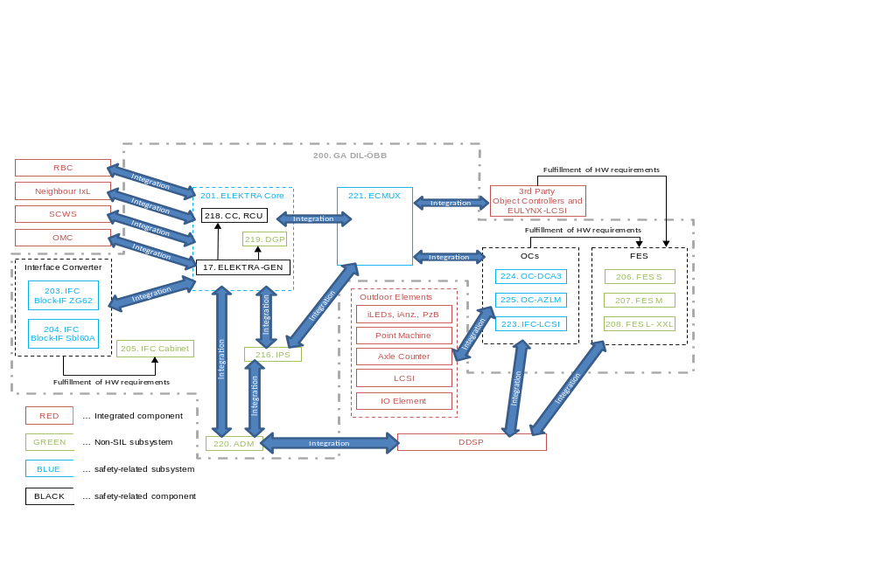
Figure 1: Structure of DIL

This Safety Concept is limited to the ECMUX subsystem (221), as shown in Figure 1.
The following items are outside the scope of this Safety Concept:
- all other components shown in Figure 1;
- the integration activities associated with the interfaces between ECMUX and adjacent subsystems.
The ECMUX subsystem is responsible for the specification, development, integration, verification, and validation of the ECMUX application, and for demonstrating compliance with the interface specifications to ensure their safe integration into the overall system architecture.
A detailed description of the ECMUX can be found in SEA SW GEN SSDD - System Subsystem Design Description [SSDD].

Communication between subsystems
- ECMUX – OCs
Interface Eulynx SCI-x - IP based communication over WAN/LAN / single-message-safe principle using RaSTA: the protocol SCI-x is the Eulynx application layer interface for communication between ECMUX and OCs. On transport layer, according to Eulynx it is sent via the RaSTA protocol.
- ECMUX – IPS
The ECMUX is intended to be executed in an virtualized environment within a centralized data center. This environment is provided by IPS together with a non-redundant TAS Platform as basis.
- ECMUX – VIL-Chill
Interface to the interlocking core for transmission of element specific commands and states as well as diagnosis. This interface is based on the OCS protocol.

Reliability
The reliability of the ECMUX subsystem is ensured through a hot-standby redundancy concept. Meaning the outage of one ECMUX redundancy is tolerated without any operational interruption if optimal distribution of active ECMUX channels is given.
Communication between the DFE components is performed via standardized digital interfaces. Communication links are continuously monitored. Communication failures are detected and result in predefined fault reactions by the affected subsystems.
Reliability mechanisms on DIL level, such as georedundancy, are not considered here.
The detailed reliability figures, availability targets, and supporting evidence are specified in the RAM Plan and in the associated safety and reliability documentation.

Structure of the safety cases
The safety assurance approach for the ECMUX subsystem is based on the principles established in the Safety Plan, Generic Application Digital Interlocking [SP EL].
A safety case and an assessment are planned for the ECMUX subsystem. This is based on the safety assurance of the non-redundant TAS Platform.
Package 200 (GA DIL-ÖBB) does not contain an independent safety argument. It serves to consolidate the approved configuration variants and documents the permissible combinations of subsystems together with their associated Safety Cases.

Safety Goal
The safety objectives of the ECMUX subsystem are derived from the higher-level safety objectives of the Generic Application Digital Interlocking (GA DIL). Compliance with the safety requirements allocated to the individual ECMUX subsystem shall be demonstrated through the respective Safety Case. Where safety-related functions are concerned, these functions shall be developed and justified in accordance with the requirements of the Generic Application Digital Interlocking for SIL 4.
The Sicherheitskonzept, DIL [SaCo] specifies an overall safety objective of a system hazard rate (SHR) below 10⁻⁹/h. Achievement of this objective is supported by the ECMUX subsystem through compliance with its allocated safety requirements and associated safety integrity requirements. For the ECMUX a tolerable hazard rate of 2 * 10⁻¹⁰ h⁻¹ is assigned in [SaCo]. This is a preliminary value which might be adapted in coordination with the other subsystems.

Risk evaluation
The risk evaluation of the ECMUX subsystem is performed on the basis of the safety objectives defined in the Safety Plan, Generic Application Digital Interlocking [SP EL] and the hazard analyses developed for the ECMUX subsystem.
A Hazard Log shall be established and maintained throughout the entire lifecycle for the ECMUX subsystem. Identified hazards shall be assessed with regard to their impact on the safe operation of the railway system and controlled by appropriate technical or organizational measures.
Intolerable risks are risks that may result in loss of life or comparable safety-critical events. Such risks shall be eliminated by appropriate measures or reduced to an acceptable residual risk level.
Tolerable risks may include operational disruptions, loss of availability, or damage to property, provided that they do not result in a hazard to persons. Appropriate measures shall be implemented to limit the likelihood of occurrence and the consequences of such risks to an acceptable level.
The assessment of risks is performed within the respective Safety Cases of the ECMUX subsystem. In addition, risks arising from interfaces with external subsystems shall be considered.

Safe State
A safe state of the train, besides when it is moving in its movement authority, is given when the train stands still.
Therefore, a fail-safe state for one train is given when the train stands still.
A global fail-safe state for the system is given when all trains stand still. This means that all signals show the stop indication and the corresponding signal aspect is sent to the ETCS neighbour system (e.g. Radio Block Center, Centralized Line Side Electronic Unit) or at least the interface to the neighbour system is in a “disconnected state”. In the latter case the neighbour system is responsible to enter a safe state.
Furthermore, the system shall be in a safe state when the power is off.
The safe states defined for the ECMUX subsystem shall be such that compliance with the higher-level safety objectives of the Generic Application Digital Interlocking (GA DIL) is maintained. A fail-safe state of the ECMUX can be reached either with a shutdown of the ECMUX or a connection interruption.

Principles of the Safety Demonstration
The safety demonstration of the ECMUX subsystem is based on the requirements of [EN 50129] and [EN 50716]. An overview about the principles is given in Sicherheitskonzept, DIL [SaCo] chapter 3.6.3. The selection and application of the relevant techniques and measures are defined and justified within the Safety Case of the ECMUX subsystem.
Safety measures suitable for the specific application and associated risks shall be selected. These measures include, but are not limited to, system architecture, hardware and software design and development, safety-related communications and interface management.
The justification of the selected techniques, measures, and architectural solutions is provided in the corresponding Safety Case of the ECMUX subsystem.

Control of Hazards
Hazard control shall, as a general principle, be implemented at the level of the subsystem in which the respective hazard originates or can be detected. The corresponding safety measures and safety reactions shall be specified and justified within the Safety Case of the respective subsystem.
For the ECMUX subsystem, hazard analyses and safety evidence shall demonstrate that identified hazards are detected, assessed, and controlled by appropriate technical or organisational measures. Failures shall either be prevented, detected in a timely manner, or mitigated by defined safety reactions leading the subsystem to a safe state or be disclosed by unequal outputs of the two channels (see Section 4.2.1).
In addition, hazards arising from the integration of multiple subsystems or from interfaces with external systems shall be considered. This includes, in particular, hazards resulting from faulty interface implementations, inconsistent configurations, unmet safety assumptions, or unaddressed Safety Related Application Conditions (SRACs).
The results of the hazard analyses, safety evidence, and integration assessments constitute the basis for the approval of permissible configuration variants within the GA DIL.

Safety Strategy
The safety strategy is considered from different perspectives:
- General safety principles
- Safety strategies implemented within the ECMUX subsystem

General safety principles
General safety principles which are applied for the ECMUX subsystem such as:
- two-channel architecture,
- diverse software channels (see 4.2.1),
- software voting (see 4.2.2),
- communication mechanisms,
- identification mechanisms,
- life cycle,
- reactivity supervision,
- TAS Platform
are described in Sicherheitskonzept, DIL [SaCo].

Safety strategies implemented within the ECMUX subsystem
This chapter contains a more detailed description of some general safety principles mentioned in chapter 4.1 with focus on the measures applied for the ECMUX subsystem. Additionally, it contains ECMUX specific safety strategies.

Diverse software channels
Objective: To ensure that residual software defects not detected during development and verification cannot result in a hazardous operating state.
Furthermore, software diversity provides a means of detecting systematic faults affecting processor boards (CPU faults), the operating system, or other underlying software layers.
Software diversity is identified in [EN 50716], Table A.3, as a strongly recommended technique within an approved combination of methods and techniques for Software Safety Integrity Levels (SSIL) 3 and 4.
Description: Software diversity is achieved through the use of different software implementations in the A and B channels. While implementing the same specified functionality, the diverse software versions are developed using different design approaches. A general description of software diversity in the GA DIL can be found in [SaCo].
Within the ECMUX subsystem, both application software channels are implemented in Java programming language and share the same design structure of packages, classes and interfaces. Safety critical sections or classes within this structure are realized in a diverse manner using one or more of the following techniques:
- diverse programming approaches: channel A is realized using a procedural approach (object-oriented programming), maybe combined with a state machine pattern, channel B is realized by generating code through defining decision tables
- diverse algorithms: things that are common to both channels are designed to use different algorithms, for instance within voters or comparators or even for the calculation of safety codes (e. g., CRC calculation by algorithm in contrast to looking up predefined patterns in tables)
- diverse usage of synchronized time: use the incoming synchronized time in a diverse manner, e.g. channel A triggers a task every period (time period has to expire), channel B triggers an exception if a timeout is reached (time period must not expire)
- diverse data representation: the two channels use a data representation which is different from the other channel, e.g. channel A uses boolean values for storing a connection state, channel B uses integer numbers with predefined values. As a consequence of the diverse data representation, also the access methods to the stored data are different, resulting in completely different byte code in the software channels.
- diverse usage of underlying system layers: whenever the services of an underlying system is used by the Java virtual machine, the operation system TAS Platform or the hardware itself, each of the two channels will do this in a diverse manner. Based on the above mentioned techniques, this is already defined for some aspects of these underlying system layers, i.e. diverse data representation provides diverse usage of any kind of memory, diverse algorithms introduces diverse usage of computational resources
- diverse usage in time: a further concept to realize diversity for low level, simple and atomic operations, is by using time diversity: a common, non- diverse operation is called in different points in time in the two channels, e.g. channel A triggers a check every 15th minute of an hour, channel B every 45th. This is used for periodically tasks, such as integrity checks.
For more details see SEA SW GEN SSDD - System Subsystem Design Description [SSDD].

Software voting
Objective: To ensure the consistency of data processed in Channel A and Channel B by means of software-based comparison of incoming and outgoing signals in both channels.
Description: With this method, the computers of a given level are connected through the communication network and exchange information (input and output data) in order to perform cross-comparisons.
In the ECMUX architecture, comparison mechanisms are applied at the communication interfaces to ensure the integrity and consistency of exchanged data.
At the interface between the ECMUX and the Central Computer (CC), incoming messages received via the RASTA protocol are independently compared. An input voting mechanism is performed to verify that the information received from both channels is consistent before further processing. Depending on the command type execution-safe commands are forwarded immediately, whereas restraint-safe commands are forwarded only after successful voting. In both cases, successful voting is required. Failure to achieve a valid voting result leads to fault detection and the consequent transition of the system into a safe state. If no voting result can be obtained within a defined time interval, fault detection and the corresponding system shutdown are likewise initiated. No output voting is performed by the ECMUX, there is only voting in the subsequent system (CC).
At the interface between the ECMUX and the Object Controllers (OCs), a single-message-safe principle is applied. Messages sent from the two ECMUX channels are subjected to a output voting process in both channels, resulting in a single validated message to the OCs via Eulynx.
If an inconsistency between the channel messages is detected, the ECMUX initiates the corresponding fault handling procedures in accordance with the system safety concept. In combination with the software diversity concept (see Section 4.2.1), this mechanism enables the detection of faults originating from application software, operating systems, hardware, communication links, or data transmission processes.
The voter and comparator functions are always implemented as the first or the last element within the data flow of a component, depending on the direction of communication.

J4S
Objective: To serve as a qualified execution platform for safety-related applications written in the Java programming language in a server environment.
Description: J4S provides a GraalVM enhanced with safety mechanisms, enabling the implementation of applications in the Java programming language.
J4S is based on the TAS Platform (variant "non-redundant") and GraalVM (Native image for virtualized target). Its safety concept is based on diverse software channels (see Section 4.2.1) and software voting (see Section 4.2.2), which shall be implemented within the application.
The safety mechanisms provided by J4S include monitoring of the hardware tests performed by the TAS Platform. Since the Java code to be executed is compiled into binary form, the existing TAS Platform mechanism (Text Segment Check) can be used to detect unauthorized modifications of the executable code during operation. In addition, an Instruction Test runs in the background, cyclically verifying all available Java instructions.
J4S is supplied with an independent safety assessment.

Two software channels on one hardware
Objective: Reduction of the hardware effort required for safety-related applications (and therefore not a safety principle in itself) by deploying two diverse application software channels on a common hardware platform and a common operating system, instead of deploying one application software channel on each of two separate hardware channels.
Description: When the hardware, operating system, and additional libraries used by both channels are utilised in a diverse manner by the application software, faults in the hardware or operating system affect the two application software channels differently. Consequently, both application software channels may be deployed on a common hardware platform, provided that the logical equivalence of the outputs of the two application software channels is monitored externally.
The underlying architecture is described in [SaCo TAS Plf] and [SC PLF 2.6.0].
Figure 2 below provides an overview of the components made available by the TAS Platform. However, the non-redundant architecture utilises only a limited subset of these components, namely:
- Hardware monitoring (OLT)
- Communication via Remote Message Queues (CS Remote)
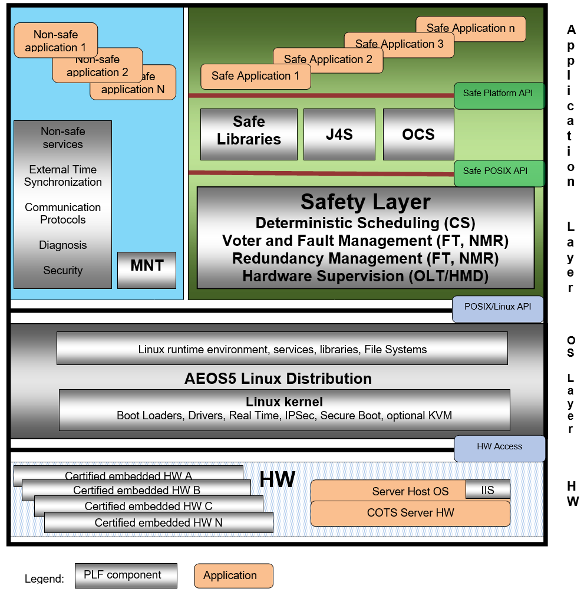
Figure 2: TAS Platform redundant software architecture from [SaCo TAS Plf]
Prerequisites for the implementation of SIL 4 functions are:
- Diverse utilisation of the operating system and the provided libraries.
- Safe voting of the outputs of both channels within a subsequent system.
- Monitoring of the life cycle signals of both channels by a subsequent system.
The approach described here is applied only within the ECMUX, as the components of the ELEKTRA Core are based on a redundant TAS Platform.
Within the ECMUX Java is used as the programming language. The TAS Platform is likewise used as the underlying platform. The corresponding mechanisms have been extended to enable their application in a Java-based environment.
The methods applied within the ECMUX are addressed in detail in the Safety Case, TAS Platform J4S 3.x [SC J4S 3.6.0].
For the ECMUX, the following subsequent systems shall be considered:
- CC: Within the CC, the requirement for an independent subsequent system performing output comparison is fulfilled by the Message Voter (see Section 4.2.2). Supervision of channel availability is achieved through cyclic monitoring of the life cycle signals generated by both channels.
- OCs: Beschreibung für OCs ergänzen.

Summary
This Safety Concept presents an overview of the safety principles adopted for the ECMUX subsystem, including the individual safety mechanisms and their interaction within the overall safety architecture.
The existence of this Safety Concept does not, in itself, demonstrate the safety of a specific ECMUX implementation. Its purpose is to support and guide the development of the ECMUX subsystem. The safety of each subsystem, function, or application shall be demonstrated separately through the corresponding safety assessment and Safety Case.

- Preliminary Hazard Analysis
Aus SaCo ÖBB Pilot:
The elements, which are addressed within the ECMUX subsystem, are already in use in ELEKTRA PV ÖBB 1.x and 2.x. Therefore, the existing hazard analysis is used as basis and will be extended, in order to provide a preliminary hazard analysis.
Since the existing documentation is written in German language, the following analysis uses also German language:
Elektrisch Fernbediente Weiche (Bestandsanalyse, siehe Gefährdungsanalyse 3BU 10708 AAAA BCAPC, Ed. 01):
- Bestand: Grundstellungsmeldung, nur wenn die Weiche eine Endlage aufweist
- Bestand: Falsche Lagemeldung bei definierter Lage der Weiche
- Bestand: Unzeitiges Umlaufen der Weiche
- Ergänzung: Auffahrmeldung nicht senden à über Verlust der Endlage
- Ergänzung zeitliche Aspekte à Meldung des Verlassens der Endlage innerhalb 1 Sekunden, Verzögerung der Auffahrmeldung um 1 Sekunde „projektierbar“ erlaubt
Die Ergebnisse der PHA sind im Dokument SSS SEA System Level, 3BU 61400 0141 DTAPA, als Anforderungen wie folgt inkludiert:
- SEA:SRS:REQ:0904, Gefährdungsbilder – Weiche – Zustandsmeldung
- SEA:SRS:REQ:0905, Gefährdungsbilder – Weiche - Kommandos

Eisenbahnkreuzungssicherungsanlage (Bestandsanalyse, siehe Gefährdungsanalyse 3BU 10705 AAAA BCAPC, Ed. 01):
- Bestand: Unzeitiges Kommando “Grundstellung” (Schranken offen)
- Bestand: Unzeitige Meldung einer “Wirkstellung” (Schranken geschlossen)
- Ergänzung: Verarbeitung einer fahrtbewirkten Einschaltung innerhalb einer Sekunde (in jedem Fall)
- Ergänzung zeitliche Aspekte generell à Ein Außenanlagenzustand, der zum Verlust des Haltgebots führen kann, muss innerhalb 1 Sekunde gemeldet werden.
Die Ergebnisse der PHA sind im Dokument SSS SEA System Level, 3BU 61400 0141 DTAPA, als Anforderungen wie folgt inkludiert:
- SEA:SRS:REQ:0906, Gefährdungsbilder – EKSA - Zustandsmeldung
- SEA:SRS:REQ:0907, Gefährdungsbilder – EKSA - Kommandos
- SEA:SRS:REQ:0908, Gefährdungsbilder – EKSA - Fahrtbewirkte Einschaltung

Gibt es außer Schlüsselsperren weitere Element am generischen IO?
Bahnhofsschlüsselsperre (Bestandsanalyse, siehe Gefährdungsanalyse 3BU 10707 AAAA BCAPC, Ed. 01):
- Bestand: Unzeitiges Auftreten einer Schlüsselfreigabe
- Bestand: Grundstellungsmeldung bei entnommenem Schlüssel
- Bestand: Grundstellungsmeldung bei Schlüsselfreigabe
- Ergänzung zeitliche Aspekte: Ein Verlassen der Grundstellung muss innerhalb 1 Sekunde gemeldet werden
Streckenschlüsselsperre (Bestandsanalyse, siehe Gefährdungsanalyse 3BU 10714 BCAPC, Ed. 01):
- Bestand: Unzeitiges Auftreten einer Schlüsselfreigabe
- Bestand: Grundstellungsmeldung bei entnommenem Schlüssel
- Bestand: Grundstellungsmeldung bei Schlüsselfreigabe
- Ergänzung zeitliche Aspekte: Ein Verlassen der Grundstellung muss innerhalb 1 Sekunde gemeldet werden
Die Ergebnisse der PHA sind im Dokument SSS SEA System Level, 3BU 61400 0141 DTAPA, als Anforderungen wie folgt inkludiert:
- SEA:SRS:REQ:0909, Gefährdungsbilder – Schlüsselsperre - Zustandsmeldung
- SEA:SRS:REQ:0910, Gefährdungsbilder – Schlüsselsperre - Kommandos
Train Detection System/Gleisfreimeldung/Achszähler
???
Signale Aus SC SEA 3BU 61400 0151 DUAPC
- Das Gefährdungsbild "Fahrbegriff zur Unzeit" darf nie permanent auftreten
- Das Gefährdungsbild "Zu hoher angezeigter Fahrbegriff" darf nie permanent auftreten.
- Ungültige Signalbegriffe dürfen nie permanent auftreten.
- Wird durch eine Elementstörung (iLED) ein Signalbegriff geändert, so muss dieser im Regelfall vom EC-MUX in weniger als 500ms an die CC-Ebene gemeldet werden.
- Als zeitlich tolerierbare Obergrenze für das Auftreten eines solchen Gefährdungsbildes ist <1 Sekunde definiert. Diese Grenze gilt auch generell für die Reaktionszeit der Applikation auf Kommandos sowie für die Meldung von Fehlern in den Komponenten der Applikation.
- Generell muss sichergestellt sein, dass jegliche Zustände bzw. Zustandsübergänge (Ereignisse) reihenfolgegetreu kommuniziert werden.

Die Ergebnisse der PHA sind im Dokument SSS SEA System Level, 3BU 61400 0141 DTAPA, als Anforderungen wie folgt inkludiert:
- Das Gefährdungsbild "Fahrbegriff zur Unzeit" darf nie permanent auftreten. (SEA:SRS:REQ: 0620)
- Das Gefährdungsbild "Zu hoher angezeigter Fahrbegriff" darf nie permanent auftreten. (SEA:SRS:REQ: 0642)
- Ungültige Signalbegriffe dürfen nie permanent auftreten. (SEA:SRS:REQ: 0735)
- Wird durch eine Elementstörung (iLED) ein Signalbegriff geändert, so muss dieser im Regelfall vom EC-MUX in weniger als 500ms an die CC-Ebene gemeldet werden. (SEA:SRS:REQ: 0643)
- Als zeitlich tolerierbare Obergrenze für das Auftreten eines solchen Gefährdungsbildes ist <1 Sekunde definiert. Diese Grenze gilt auch generell für die Reaktionszeit der Applikation SEA auf Kommandos (Error! Reference source not found., SEA:SRS:REQ: 0568) sowie für die Meldung von Fehlern in den Komponenten der Applikation SEA (Error! Reference source not found., SEA:SRS:REQ: 0562).
- Generell muss sichergestellt sein, dass jegliche Zustände bzw. Zustandsübergänge (Ereignisse) reihenfolgegetreu kommuniziert werden. (Error! Reference source not found., SEA:SRS:REQ: 0631)

END OF DOCUMENT

