Project specific RAM Plan - DSTW - Digital Field Elements

Solution Element

Digital Field Elements

APPROVAL
 | Name and Role/Job Title | Esignature
Written by | Florian Moser / RAM-AM
Verified by | Fabian Rotter / QAM
Approved by | Bernhard Mandl / SEM

LOG OF CHANGES
Revision | Date | Author | Change Description
01 PD 01 | 2025-06-13 | Florian Moser | First proposal
01 RL | 2025-06-25 | Florian Moser | First edition
02 PD 01 | 2025-09-24 | Florian Moser | See section 1.5.3
02 RL | 2025-10-03 | Florian Moser | See section 1.5.4
03 PD 01 | 2026-10-13 | Florian Moser | See section

Contents
1. Scope 7
1.1 Purpose 7
1.2 Identification 7
1.3 Intended audience 7
1.4 Document Management 8
1.5 Change History 8
1.5.1 Edition 01 PD 01 8
1.5.2 Edition 01 RL 8
1.5.3 Edition 02 PD 01 8
1.5.4 Edition 02 RL 8
2. References and Terms 9
2.1 Referenced Documents 9
2.2 Standards and Procedures 9
2.3 Terms, Abbreviations and Acronyms 10
3. Description of the system 11
3.1 System Overview 11
3.2 Solution Elements 11
3.3 DCA 3.x Component Versions 12
3.4 Interface Converter Cabinets 12
3.5 FES Configuration 12
3.6 RAM Design Rules 14
3.7 Availability Classes 16
4. RAM Requirements 17
4.1 Reliability Requirements 17
4.2 Availability Requirements 18
4.3 Maintainability Requirements 18
5. RAM Plan 19
5.1 Methods and Tools used 19
5.2 RAM detailed activities, analyses and documents 19
5.2.1 RAM Design Rules 19
5.2.2 RAM HW-FMEA 19
5.2.3 Preliminary Reliability Analysis 19
5.2.4 Reliability Analysis 19
5.2.5 Maintenance 20
6. RAM Deliverables 21
6.1 List of RAM deliverable Documents 21
6.2 RAM Requirements 21
6.3 Periodical RAM activities report 21

List of Tables
Table 1: Solution Identification 7
Table 2: Referenced Documents 9
Table 3: Standards and Procedures 9
Table 4: Terms, Abbreviation and Acronyms 10
Table 8: RAM Design Rules DFE 15
Table 5: Reliability figures by classes according to severity level 16
Table 6: Availability requirements Digital Field Elements 21

List of Figures
Figure 1: FES M DCA Schematic 13
Figure 2: FES M AzLM Schematic 14
Figure 3: Availability concept and related terms 17

Scope

Purpose
This document presents the Reliability, Availability and Maintainability Plan (RAM) of the solution element Digital Field Elements (DFE) Phase 1.
The RAM plan defines the reliability, availability and maintainability objectives, tasks to be performed and documents to be produced and delivered at various phases of the project’s lifecycle, to address the functional and technical requirements specified in the respective feature lists and requirements documentation with main focus on hardware.
For information about organisation, work packages, milestones and application of the Management System refer to [SEMP_DFE].

Identification
Project: | DSTW ÖBB Entwicklung
Solution: | 100025795 / ATRELDE91
Solution / System: | Generic Application Digital Interlocking OBB 1.0.0 (GA DIL OBB 1.0.0)
Solution Element: | Digital Field Elements (DFE) Phase 1
Identification: | DFE 1.0.0  IFC 1.0.0
Contract: | Digitales Stellwerk DSTW – Rahmenvereinbarung
Customer: | ÖBB
End User: | ÖBB
SIL Level | SIL 4
Table 1: Solution Identification

Intended audience
The intended audience of the project specific RAM Plan are the following functions:
- Project Design Authority (PDA)
- Project Manager (PM)
- Solution Engineering Manager (SEM)
- RAM Assurance Manager (RAM-AM)
- Safety Assurance Manager (SAM)
- Quality Assurance Manager (QAM)
- Validator (VAL)
- Verifier (VER)
- Security Assurance Manager (SecAM)

Document Management
The management of this document will be performed according to the Document Management Rules [DMR] and the Document List and Review Matrix [DLRM].

Change History

Edition 01 PD 01
- First proposal.

Edition 01 RL
- Review comments considered.

Edition 02 PD 01
- Updated references.
- Changes due to updated [SEMP_DFE]:
- X25 to X25oRaSTA Converter cancelled
- Converter Zustimmung cancelled
- EPD Box excluded
- Retrofit cancelled
- Update of section 3.6 RAM Design Rules

Edition 02 RL
- Review comments considered.

Edition 03 PD 01
- Updated references.

References and Terms

Referenced Documents
Id | Reference
[CRS_DSTW] | DSTW Streckenausrüstung OBB - Teil D Leistungsbeschreibung und Lastenhefte;  3BU 17300 0004 DSAPC, Ed.06
[PH_RAMS] | Pflichtenheft Digital Interlocking OBB - D2.2 Teilpflichtenheft RAMS,  3BU 17300 0022 DTAPC, Ed.02
[RAM_Plan_Generic] | RAM Plan Generic;  3BU 15000 1712 DUAPA, Ed.07
[RAMP_DIL] | Project specific RAM Plan – DIL – Generic Application / Solution Element Virtual Interlocking;  3BU 17300 1209 DUAPA, latest
[SEMP_DFE] | SEMP Solution Element - Digital Field Elements;  3BU 62800 0000 DPAPA, Ed.02
[PBS_DSTW] | Product Breakdown Structure (PBS) - Generic Application - Digital Interlocking OBB;  3BU 17300 1215 DPAPA, Ed.02
[SP_DSTW] | Safety Plan DSTW;  3BU 17300 1204 DUAPA, Ed.02
[IPP_DSTW] | IPP Digital Field Elements Phase 1;  3BU 62800 0050 MCAPA, Ed.01PD02
Table 2: Referenced Documents

Standards and Procedures
Id | Reference
[Alcarel] | Reliability Standard Failure Rate Factor; 1AA 00210 0001 BCZZA
[Birolini] | Reliability Engineering. Theory and Practice; ISBN: 354040287X, 6th Ed
[DLRM] | Document List and Review Matrix for engineering projects;  83530224-DOC-AUT-EN-012
[DMR] | Document Management Rules;  83530061-DOC-AUT-EN-014
[EN 50126-1] | EN 50126-1:2017 Railway applications – The Specification and Demonstration of Reliability, Availability, Maintainability and Safety (RAMS), Part 1: Generic RAMS process.
[IEC60050(192)] | IEC 60050-192:2015; International Electrotechnical Vocabulary (IEV) - Part 192: Dependability
[MIL_HDBK217F] | US MIL-HDBK 217F:1991, Reliability prediction for electronic equipment
Table 3: Standards and Procedures

Terms, Abbreviations and Acronyms
Term/Abbreviation | Meaning
AzLM | Multi Section Axel Counter (one type of TDS)
DCA | Distributed Controller Architecture
DFE | Digital Field Elements
DIL | Digital Interlocking = DSTW
DSTW | Digitales Stellwerk = DIL
EKSA | Eisenbahnkreizungssicherungsanlage = LCSI (CFI ÖBB)
EULYNX | European Initiative to Linking Interlocking Systems
IEC | International Electrotechnical Commission
IFB | Interface Board
IFC | Interface Converter
Failure rate | Limit for of the probability that an item will fail in the time interval 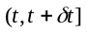, given that the item was new at and did not fail in the interval 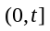, divided by . [Birolini]
Fault tree | A logic diagram showing which fault modes of subitems or external events, or combinations thereof, result in a given fault mode of the item. [IEC60050(192)]
FiT | Failures in time (unit: 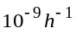)
FES | Field Element Station
Ground Benign (GB) | Nonmobile, temperature and humidity-controlled environments readily accessible to maintenance; includes laboratory instruments and test equipment, medical electronic equipment, business and scientific computer complexes, and missiles and support equipment in ground silos. [MIL_HDBK217F].
Ground Fixed (GF) | Moderately controlled environments such as installation in permanent racks with adequate cooling air and possible installation in unheated buildings; includes permanent installations of air traffic control radars and communication facilities [MIL_HDBK217F].
[MIL_HDBK217F] | The Military Handbook is published by the US Department of Defense, and provides mathematical models for electrical, electronic and electro-mechanical components. Each model calculates the component failure rate for given combinations of environmental conditions, component value and type, electrical stress conditions and manufactured quality level
MTBF | The expectation of the operating time between failures. [IEC 60050(191)].  is usually reserved for items with constant failure rate . In this case, 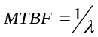is the expected value (mean) of the exponentially distributed item’s failure-free operating time. In particular 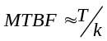, where is the given, fixed cumulative operating time and the total number of failures (failed items) during . [Birolini]
MTTR | The expectation of the time to restoration. [IEC 60050(191)]  is the expected value (mean) of an item’s repair time. It is obtained from the distribution function 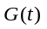 of the repair time as 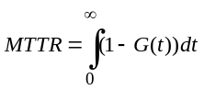. For reliability or availability calculation a constant repair rate (i.e. exponentially distributed repair times with 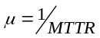) can often be used to get approximate results. [Birolini]
PBA | Printed Board Assembly
Table 4: Terms, Abbreviation and Acronyms

Description of the system
For detailed information on the products used, refer to [PBS_DSTW].

System Overview
As stated in [SP_DSTW], the EULYNX system definition defines following Object Controller (OC) level subsystems:
- Subsystem – Point
- Subsystem – Light Signal
- Subsystem – Generic I/O
- Subsystem – Train Detection System (TDS)
- Subsystem – Level Crossing (LX)
Additionally, two interface converters are utilized:
- IFC ZG62 (Blockconverter)
- IFC Sbl60 (Blockconverter)

Solution Elements
According to [IPP_DSTW], the Solution Element contains five work packages: (see also [SEMP_DFE])
- IFC ZG62 HW + SW
  - Based on ÖBB-Pilot DCA 2.x
  - Development/Integration of Computing Board SCA, DCA 2.x IOC, Relay Group
- FES M AzLM (TDS v7.10)
  - Development/Qualification of FES Modules
    - Module Network
    - Module Cable Distribution Frame
    - Module Power Supply
    - Integration AzLM ACE
- FES S DCA (FES S (up to 2 OC))
  - Development/Integration of the DCA 3.x (Object Controller Release 1 for EULYNX BL4R4 generic functionalities and OBB specific functionalities) version (HW)
  - Development/Qualification of FES Modules
    - Module Network
    - Module Cable Distribution Frame
    - Module Power Supply
  - Development/Qualification of additional Equipment
    - INDUSI-Extender (for Subsystem Signal)
    - CAN-Extension for Distances > 100m (for Subsystem Signal)
  - Development/Qualification of Subsystems
    - Point
    - Light Signal
    - Generic I/O (Station Key Lock, Line Key Lock, Local Control Post)
- FES M DCA
  - Same as FES S DCA, with extended capacity
- FES S IFC LCSI (start of development in phase 1, finalization phase 2)
  - Support Supplier in LCSI Gateway development (Mission Embedded)

DCA 3.x Component Versions
- DCA-P 3.1.0
  - Interface Control Unit Point - ICB-P HW 3.0
- DCA-LS 3.1.0
  - Interface Control Unit Output – ICB-O2
  - Interface Control Unit Generic IO – ICB-IO
- DCA-I/O 3.1.0
  - Interface Control Unit Input/Output High Power – ICB I/O HP
  - Interface Control Unit Input – ICB-I2
- ICB Carrier Boards
  - Carrier 19 Inch for 4 ICB
  - Carrier 19 inch for 2 ICB (Left)
  - Carrier 19 inch for 2 ICB

Interface Converter Cabinets
The IFC Cabinets include:
- IFC ZG62 1.0
  - Computing Board SCA
  - DCA 2.x IOC
  - Relay Group

FES Configuration
As per [SEMP_DFE]:
- Station Size S: Equipped exclusively with DCA 3.x units (LCSI Gateway in phase 2).
- Station Size M: Equipped with DCA 3.x units and AzLM units for TDS.
- Interface Converters (ZG62): Equipped with SCA and DCA 2.x for communication with neighboring interlockings
The next two figures (taken from [SEMP_DFE]) show a schematic buildup of a FES M DCA and a FES M AzLM.
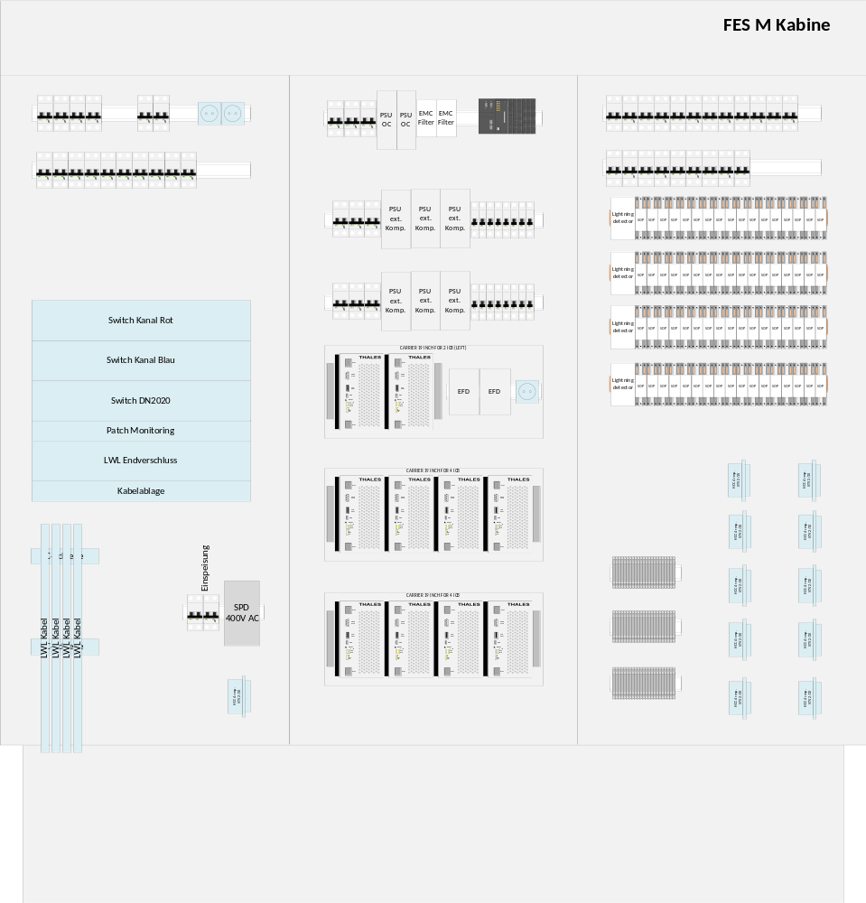
Figure 1: FES M DCA Schematic
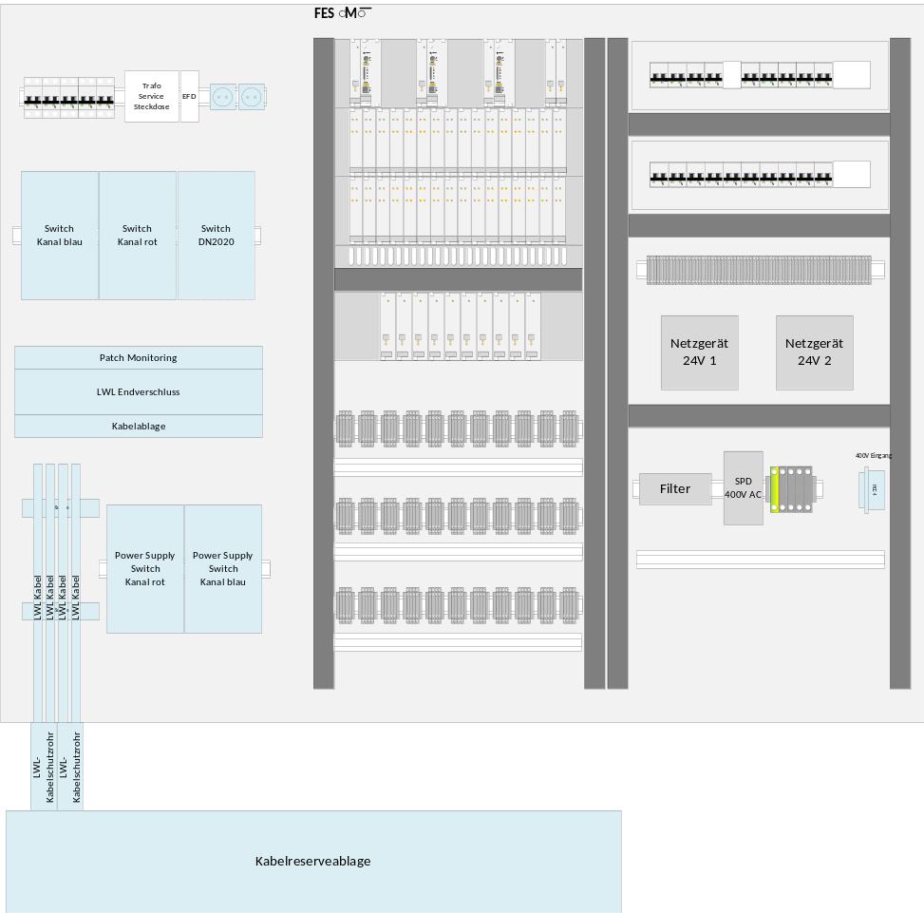
Figure 2: FES M AzLM Schematic

RAM Design Rules
In order to ensure that the availability requirements (stated in section 6.2) are met, a series of rules, the so-called ‘RAM Design Rules’, will be developed and used as binding conditions for architectural design decisions. Note that each of these RAM Design Rules will also be explicitly mapped to one or more specific system requirements, ensuring traceability and compliance throughout the development lifecycle.
The common definitions and partitioning of the RAM Design Rules is described in detail in [RAMP_DIL] and is not in scope of this document. The following table presents the RAM Design Rules related to DFE.

ID | Synopsis | Body
Group 01: General
01.1 | Diagnostic logging | All shutdown events of FES and OC components shall be provided in a unified customer-friendly way as well as for technical analyses. This information is then revised so that maintenance measures, for example, can be filtered. These data have to be made available, technically, and revised offline for the customer.  Comment: also includes Blockconverter and EKSA
01.2 | Reintegration | Reintegration of FES and OC components shall be provided in a unified customer-friendly way as well as for technical analyses.  Comment: also includes Blockconverter and EKSA
01.3 | Mapping component failure to severity level | The operative consequences of a failed hardware component shall be defined by the severity level of the availability class.
01.4 | Mapping corrective maintenance action to severity level | The operative consequences during a corrective maintenance activity shall be defined by the severity level of the availability class.
01.5 | Separate phase protection | Each power distribution unit (PDU) has to be separately protected. This means that an outage of one phase has no impact on other phases.  Critical HW components which are related to availability must be supplied by separate phases.
01.6 | Enable mapping of severity levels | The architectural concept shall be defined in a way to enable a mapping of severity levels to failed / reintegrated components.
Group 02: Availability
02.1 | OC Failure Isolation | A failure of one OC must not affect the operation of other OCs within the same FES.
02.2 | Power Failure Resilience | FES must support automatic recovery after power restoration without manual intervention.
02.3 | Power Supply Redundancy | Critical HW components which are related to availability must be equipped with two independent power supplies.
Group 03: Diagnostics
03.1 | Local Failure Indication | Each OC must provide local visual indicators (e.g., LEDs) for power, communication, and fault status.
03.2 | Diagnostic Data Support for Maintainability | Ensure that Field Element Stations (FES) and Object Controllers (OC) provide structured and accessible diagnostic data to support efficient fault detection, analysis, and corrective maintenance. (Requires SDI-compliant diagnostic interface on all OCs).  Comment: also includes Blockconverter and EKSA
Group 04: Maintainability
09.1 | Hot-Swap Capability | OCs must be replaceable without shutting down the FES or affecting other OCs.
Table 5: RAM Design Rules DFE

Availability Classes
[PH_RAMS] states the following availability classes for the Digital Interlocking. Each of the three reliability classes are subdivided into three subclasses addressing different MTTRs (“Mean Time To Restore”) ranging from fast automatic failure correction to mean time for manual restoration. This breakdown is shown in Table 6 below.
Class | Availability  [%] | MTTR  [min] | MTBF  [y] | TDT  [min/y]
K1 | 99.999 |  |  | 5.25
 |  | 62.5 | 50 | 1.25
 |  | 10 | 5 | 2
 |  | 2 | 1 | 2
K2 | 99.995 |  |  | 26.25
 |  | 225 | 20 | 11.25
 |  | 10 | 2 | 5
 |  | 2 | 1 | 2
K3 | 99.99 |  |  | 52.5
 |  | 225 | 10 | 22.5
 |  | 10 | 2 | 5
 |  | 2 | 1 | 2
Table 6: Reliability figures by classes according to severity level
MTTR Mean Time To Restore
MTBF Mean Time Between Failures
TDT Total Down Time

RAM Requirements
The reliability, availability and maintainability requirements have to be identified and referenced within the Dependability Analysis. This Dependability Analysis should also provide a proper apportionment and refinement of these requirements according to the system design. A general description of all RAM aspects can be found in [RAM_Plan_Generic].

Reliability Requirements
Concerning reliability, RAM activities have to focus on the following goals:
- Determination of all possible failures of the system with focus to random hardware faults. Analysis of their consequences with respect to reliability, availability and maintainability (MTTR) and calculation of the associated failure rates.
- Determination of the impact of failures on the functionality of the system.

The key parameters for describing RAM features of a system, on the basis of [EN 50126-1] are:
    - Mean Up Time MUT, resp. Mean Time Between Failure MTBF,
    - Mean time to Restore MTTR and the
    - Availability A, resp. Unavailability (U = 1-A).
Figure 3, obtained from [EN 50126-1], illustrates key parameters of the availability concept.
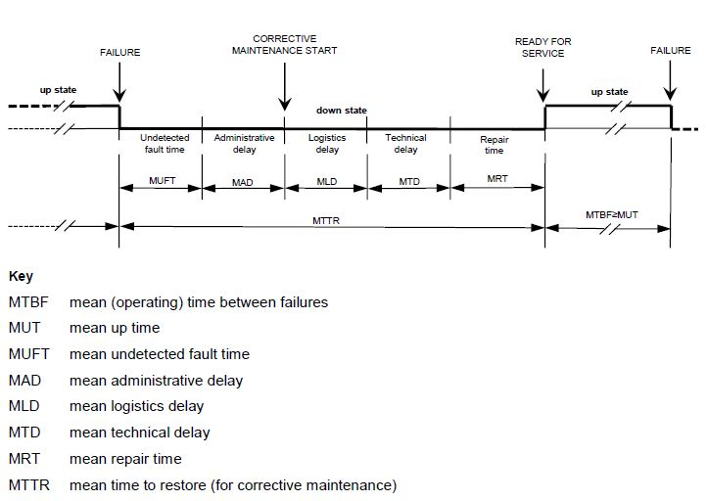
Figure 3: Availability concept and related terms
The MUT is the mean lifetime of a system between two failures. MTTR gives the time required from failure to restart operation.

Availability Requirements
In order to show an appropriate behaviour of the system and sub-systems with respect to availability, a
system analysis shall be carried out to determine availability figures of components and sub-systems. The result shall be part of the Reliability Analysis. It shall be pointed out, that the availability figures depend on the proper installation, maintenance and operation conditions of the system and sub-systems as stated in the installation and maintenance manuals.

Maintainability Requirements
Concerning maintainability, RAM activities have to focus on the following goals:
- Identification and implementation of diagnostic measures to minimize system downtime
    - Detect fault alarms that have to be recorded during operation of the system.
    - Prepare appropriate counter measures in case of failures.
- Determine the time necessary for failure diagnosis and recovery of the availability of the system in case of system or component failures.
- Identification of necessary maintenance actions including time required to conduct them.
All requirements concerning maintenance activities need to be summarized to plan necessary actions. Those actions subsume inspection, preventive and corrective maintenance, repair and spare part logistic.

RAM Plan

Methods and Tools used
The reliability calculation will be done according to [EN 50126-1] and the [MIL_HDBK217F] based Alcatel Reliability Standard [Alcarel] and according to the environmental conditions Ground Benign (GB) for indoor components and Ground Fixed (GF) for outdoor components.

RAM detailed activities, analyses and documents
Within this section, documents and activities necessary for defining and analysing reliability, availability and maintainability requirements are described.

RAM Design Rules
It is planned to develop a series of rules, so-called RAM Design Rules as binding conditions for architectural design decisions if possible. Each of these RAM Design Rules will be mapped to one or more specific requirement(s). See section 3.6.

RAM HW-FMEA
It is recommended to create a RAM HW-FMEA, that aims to analyse availability and maintainability aspects in terms of failed HW components or failed sub-systems and their operational consequences. It also analyses diagnostic capabilities of the system in order to support preventive and corrective maintenance actions.

Preliminary Reliability Analysis
Upon completion of the RAM Plan, it is recommended to create a preliminary Reliability Analysis document. This document must provide a rough estimation of the availability and reliability of the sub-systems described in chapter 3.
All relevant documentation shall be reviewed in order to define, at a preliminary level, the overall system structure and to recognise all the functional requirements, which may affect the RAM performance of the system.

Reliability Analysis
The Reliability Analysis is a key document, with focus on HW relevant aspects, describing reliability, availability and maintainability features.
Reliability aspects of SW have to be assured by following the rules of [EN 50126-1]. An analysis of SW reliability is not part of the Reliability Analysis where only permanent random HW faults and system failures will be analysed.
Failure rates for indoor components will be calculated
To be able to make reliable statements and to demonstrate that the required RAM goals will be obtained, the following information about the hardware and the purpose of the system has to be collected:
    - what kind of sub-systems / components will be used,
    - quantity of each sub-system / component,
    - Failure rates of all PBAs and devices used,
    - MTBF and MTTR for each sub-system / component.
The Reliability Analysis shall point out measures, how availability can be reached according to the mission goals.

Maintenance
To ensure a proper installation, operation and maintenance of the system, corresponding installation and maintenance documents have to be provided. MTTR and related terms have to be checked with respect to fulfilment of information stated in these documents.

RAM Deliverables

List of RAM deliverable Documents
This section summarizes the documents which are foreseen during RAM activities:
- RAM Plan (this document),
- RAM HW-FMEA (recommended),
- preliminary Reliability Analysis (recommended),
- Reliability Analysis (required).
Note: RAM documentation must be available according to the Document List and Review Matrix for engineering projects [DLRM].

RAM Requirements
The RAM related customer requirements need to be checked, clarified if necessary and appropriately refined during the different development phases. If additional RAM related aspects are to be considered in order to fulfill RAM related customer requirements, they should comply with corresponding standards [EN 50126-1].
The solution element Digital Field Elements (DFE) are subject to the dependability requirements stated by the customer in [CRS_DSTW] and furthermore in [PH_RAMS].
The fulfillment of the following availability requirements must be shown in the Reliability Analysis.
Availability of … | Class | Percentage | ID
FES | K2 | 99.995 % | 02_124
FES – manual correction | K2 | 99.9979 % | 02_127
FES – no operational impact | K2 | 99.7154 % | 02_128
FES – 10 min automatic correction | K2 | 99.999% | 02_129
FES – 2 min automatic correction | K2 | 99.9996 % | 02_130
OC | K3 | 99.99 % | 02_132
OC – manual correction | K3 | 99.9957 % | 02_135
OC – no operational impact | K3 | 99.7154 % | 02_136
OC – 10 min automatic correction | K3 | 99.999 % | 02_137
OC – 2 min automatic correction | K3 | 99.9996 % | 02_138
Table 7: Availability requirements Digital Field Elements

Periodical RAM activities report
The RAM Plan can be updated if necessary, in each phase of the product life cycle, described in [EN 50126-1].
Possible reasons are:
- Review comments of this document,
- Hardware changes,
- Change of standards and procedures.
Each change of the RAM Plan results in a new edition. At each new edition, the reasons for change will be documented in section 1.5

END OF DOCUMENT

For information about the different phases of DFE refer to [SEMP_DFE].

