Project specific RAM Plan - IPS Solution

Digital Interlocking ÖBB

APPROVAL
 | Name and Role/Job Title | Esignature
Written by | Florian Moser / RAM-AM
Verified by | Ramy Al Ali / QAM
Approved by | Vladimir Vasilev / SEM

LOG OF CHANGES
Revision | Date | Author | Change Description
01 PD 01 | 2025-09-26 | Florian Moser | First proposal
01 RL | 2025-10-03 | Florian Moser | See section 1.5.2
02 PD 01 | 2026-10-13 | Florian Moser | See section

Contents
1. Scope 6
1.1 Purpose 6
1.2 Identification 6
1.3 Intended audience 7
1.4 Document Management 7
1.5 Change History 7
1.5.1 Edition 01 PD 01 7
1.5.2 Edition 01 RL 7
2. References and Terms 8
2.1 Referenced Documents 8
2.2 Standards and Procedures 8
2.3 Terms, Abbreviations and Acronyms 9
3. Description of the system 11
3.1 System Overview 11
3.2 Hardware Components 12
3.3 RAM Design Rules 14
4. RAM Requirements 16
4.1 Reliability Requirements 16
4.2 Availability Requirements 17
4.3 Maintainability Requirements 17
5. RAM Plan 18
5.1 Methods and Tools used 18
5.2 RAM detailed activities, analyses and documents 18
5.3 RAM Design Rules 18
5.4 RAM HW-FMEA 18
5.5 Preliminary Reliability Analysis 18
5.6 Reliability Analysis 18
5.7 Maintainability 19
6. RAM Deliverables 20
6.1 List of RAM deliverable Documents 20
6.2 RAM Requirements 20
6.3 Periodical RAM activities report 22

List of Tables
Table 1: Solution Identification 6
Table 2: Security/Maturity Level 7
Table 3 : Referenced Documents 8
Table 4 : Standards and Procedures 9
Table 5 : Terms, Abbreviations and Acronyms 10
Table 6: RAM Design Rules Related Definitions 14
Table 7: IPS DPR requirements 22

List of Figures
Figure 1: IPS Overview 11
Figure 2: System architecture GA DIL 12
Figure 3: IPS basic structure 13
Figure 4: Availability concept and related terms 16

Scope

Purpose
This document presents the Reliability, Availability and Maintainability Plan (RAM) Integrated Platform Services (IPS) solution element – IPS Solution OBB 1.0.0 (IPSS OBB 1.0.0).
The RAM plan defines the reliability, availability and maintainability objectives, tasks to be performed and documents to be produced and delivered at various phases of the project’s lifecycle, to address the functional and technical requirements specified in the respective feature lists and requirements documentation.
For information about organisation, work packages, milestones and application of the Management System refer to [SEMP_IPS].

Identification
Project Name: | DSTW ÖBB Entwicklung
Project ID: | 100025795 / ATRELDE91
Solution / System: | Generic Application Digital Interlocking OBB 1.0.0 (GA DIL OBB 1.0.0)
Solution Element: | Solution Element – IPS Solution OBB 1.0.0 (IPSS OBB 1.0.0)
Contract: | Digitales Stellwerk DSTW – Rahmenvereinbarung
Identification: | IPS 40.0.0  ADM 40.0.0  HW GENCAB SERV 1.0  HW GENCAB NETW 1.0
Customer: | Generic Application Digital Interlocking OBB (GA DIL OBB 1.0.0)
End Customer: | ÖBB
SIL Level: | NON-SIL / Non-safety solution
Table 1: Solution Identification
Security Level: | SL-T 3, SL-C 3
Maturity Level: | ML 3
Table 2: Security/Maturity Level

Intended audience
The intended audience of the project specific RAM Plan are the following functions:
- Project Design Authority (PDA)
- Project Manager (PM)
- Solution Engineering Manager (SEM)
- RAM Assurance Manager (RAM-AM)
- Safety Assurance Manager (SAM)
- Quality Assurance Manager (QAM)
- Validator (VAL)
- Verifier (VER)
- Security Assurance Manager (SecAM)

Document Management
The management of this document will be performed according to the Document Management Rules [DMR] and the Document List and Review Matrix [DLRM].

Change History

Edition 01 PD 01
- First proposal.

Edition 01 RL
- Review comments considered.

Edition 02 PD 01
- References updated.

References and Terms

Referenced Documents
Id | Reference
[ARC_GA] | Top Level Architecture Drawing - Generic Application - Digital Interlocking OBB;  3BU 17300 1218 DSAPA, Ed.04
[CRS_DSTW] | DSTW Streckenausrüstung OBB - Teil D Leistungsbeschreibung und Lastenhefte;  3BU 17300 0004 DSAPC, Ed.06
[PH_RAMS] | Pflichtenheft Digital Interlocking OBB - D2.2 Teilpflichtenheft RAMS,  3BU 17300 0022 DTAPC, Ed.02
[SD_DSTW] | Digitales Stellwerk - Technische Konzepte  3BU 17300 0010 DSAPC, Ed.07
[RAM_Plan_Generic] | RAM Plan Generic;  3BU 15000 1712 DUAPA, Ed.07
[RAMP_DFE] | Project specific RAM Plan – DSTW - Digital Field Elements;  3BU 62800 0018 DUAPA, latest
[RAMP_DIL] | Project specific RAM Plan – DIL – Generic Application / Solution Element Virtual Interlocking;  3BU 17300 1209 DUAPA, latest
[RMP_IPS] | Requirements Management Plan (RMP) Solution Element IPS;  3BU 17300 2010 DUAPA, latest
[SEMP_GA] | System Engineering Management Plan (SEMP) Generic Application Digital Interlocking OBB;  3BU 17300 1200 DPAPA, latest
[SEMP_VIL] | System Engineering Management Plan (SEMP) Solution Element Virtual Interlocking;  3BU 15000 6955 DPAPA, latest
[SEMP_IPS] | System Engineering Management Plan (SEMP) IPS Solution - Digital Interlocking OBB:  3BU 17300 2001 DPAPA, latest
[SEMP_DFE] | SEMP Solution Element - Digital Field Elements;  3BU 62800 0000 DPAPA, latest
[PBS_DSTW] | Product Breakdown Structure (PBS) - Generic Application - Digital Interlocking OBB;  3BU 17300 1215 DPAPA, Ed.02
[SSS_IPS] | Subsystem Requirements Specification; Integrated Platform Services (IPS);  3BU 17300 2051 DTAPA, Ed.01PD02
[RMP_GA] | Requirements Management Plan (RMP) Generic Application Digital Interlocking OBB;  3BU 17300 1207 DUAPA, latest
Table 3 : Referenced Documents

Standards and Procedures
Id | Reference
[Alcarel] | Reliability Standard Failure Rate Factor; 1AA 00210 0001 BCZZA
[Birolini] | Reliability Engineering. Theory and Practice; ISBN: 354040287X, 6th Ed
[DLRM] | Document List and Review Matrix for engineering projects;  83530224-DOC-AUT-EN-012
[DMR] | Document Management Rules;  83530061-DOC-AUT-EN-014
[EN 50126-1] | EN 50126-1:2017 Railway applications – The Specification and Demonstration of Reliability, Availability, Maintainability and Safety (RAMS), Part 1: Generic RAMS process.
[IEC60050(192)] | IEC 60050-192:2015; International Electrotechnical Vocabulary (IEV) - Part 192: Dependability
[MIL_HDBK217F] | US MIL-HDBK 217F:1991, Reliability prediction for electronic equipment
Table 4 : Standards and Procedures

Terms, Abbreviations and Acronyms
Term/Abbreviation | Meaning
ADM | Administration Diagnostic Monitoring
CE | Computing Element; One logical computing channel. Can be executed on a physical or virtual machine.
CG | Computing Group; Set of computing nodes, replicated for availability. Examples of a CG are 1oo2 CN-redundancy, 1oo4 CN-redundancy, 2oo4 CN-redundancy, but also 1oo1 CN-redundancy in the extreme case.
CN | Computing Node; Set of replicated Computing Elements building a safe entity. Examples of a CN are 2oo2 CE-redundancy, but also 1oo1 CE-redundancy in the extreme case.
DCA | Distributed Controller Architecture
DDSP | Daten Diagnose Service Plattform
DFE | Digital Field Elements
DGP | Diagnostic Processor
DPR | Dependability Requirement
DIL / DSTW | Digital Interlocking = DSTW, Digitales Stellwerk = DIL
EC-MUX | Element Controller Multiplexer
EULYNX | European Initiative to Linking Interlocking Systems
IEC | International Electrotechnical Commission
IPS | Integrated Platform Services
Failure rate | Limit for $δt→0$ of the probability that an item will fail in the time interval $(t,t+δt]$, given that the item was new at $t=0$ and did not fail in the interval $(0,t]$, divided by $δt$. [Birolini]
FiT | Failures in time (unit: $10^{-9}h^{-1}$)
FES | Field Element Station
Ground Benign (GB) | Nonmobile, temperature and humidity-controlled environments readily accessible to maintenance; includes laboratory instruments and test equipment, medical electronic equipment, business and scientific computer complexes, and missiles and support equipment in ground silos. [MIL_HDBK217F].
Ground Fixed (GF) | Moderately controlled environments such as installation in permanent racks with adequate cooling air and possible installation in unheated buildings; includes permanent installations of air traffic control radars and communication facilities [MIL_HDBK217F].
GB 40 | Ground Benign 40˚ C
GF 40 | Ground Fixed 40˚ C
[MIL_HDBK217F] | The Military Handbook is published by the US Department of Defense, and provides mathematical models for electrical, electronic and electro-mechanical components. Each model calculates the component failure rate for given combinations of environmental conditions, component value and type, electrical stress conditions and manufactured quality level
MTBF | The expectation of the operating time between failures. [IEC 60050(191)].  $MTBF$ is usually reserved for items with constant failure rate $λ$. In this case, $MTBF=1/λ$is the expected value (mean) of the exponentially distributed item’s failure-free operating time. In particular $MTBF≈T/k$, where $T$ is the given, fixed cumulative operating time and $k$ the total number of failures (failed items) during $T$. [Birolini]  See also [EN 50126-1].
MTTR | The expectation of the time to restoration. [IEC 60050(191)]  $MTTR$ is the expected value (mean) of an item’s repair time. It is obtained from the distribution function $G(t)$ of the repair time as $MTTR=\int_{0}^{∞}{(1-G(t))dt}$. For reliability or availability calculation a constant repair rate $μ$ (i.e. exponentially distributed repair times with $μ=1/{MTTR}$) can often be used to get approximate results. [Birolini]  See also [EN 50126-1].
NMR | NxMooM Redundancy, Examples of NMR are 2x2oo2, 4x2oo2, but also 1x1oo1 in the extreme case. NxMooM Redundancy is a shorthand for 1ooN CN-redundancy with each CN forming an MooM CE-redundancy.
Nx2oo2 | N times 2 out of 2, Denotes a 1ooN CN-redundancy with each CN forming a 2oo2 CE-redundancy.
PBA | Printed Board Assembly
POD | Smallest deployable unit in Kubernetes kontext.
VM | Virtual Machine (OpenStack)
Table 5 : Terms, Abbreviations and Acronyms

Description of the system
For detailed information on the products used, refer to [PBS_DSTW].
For a detailed description of the IPS Solution refer to [SD_DSTW].
For an overview about customer expectation see [CRS_DSTW].
Information about Generic Application Digital Interlocking OBB 1.0.0 (GA DIL OBB 1.0.0) and Solution Element Virtual Interlocking Phase 1 (VIL OBB 1.0.0) can be found in [SEMP_GA], [SEMP_VIL] and [RAMP_DIL].
Information about Digital Field Elements (DFE) can be found in [SEMP_DFE] and [RAMP_DFE].

System Overview
The IPS Solution is a core element of the Digital Interlocking ELEKTRA 4.0 (DSTW). It provides the virtualization infrastructure for the Virtual Interlocking (VSTW) and Administration, Diagnosis & Monitoring (ADM) subsystems, as well as COTS computing and network hardware. The system is designed to support up to 435 interlockings across geo-redundant computing centers, enabling centralized control and high availability.
The top-level architecture of the technical product "Generic Application Digital Interlocking (GA DIL)" is illustrated in Figure 2, taken from [ARC_GA].
The Integrated Platform Services (IPS) solution element provides the core virtualization platform for the Digital Interlocking Central Unit (DIL-CU), see Figure 1 below.
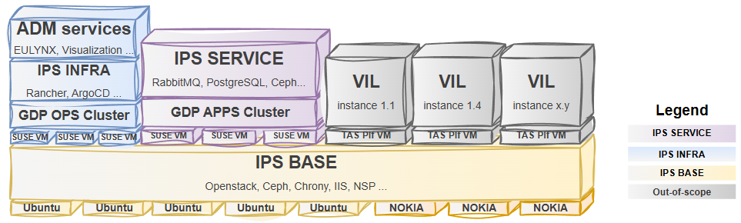
Figure 1: IPS Overview
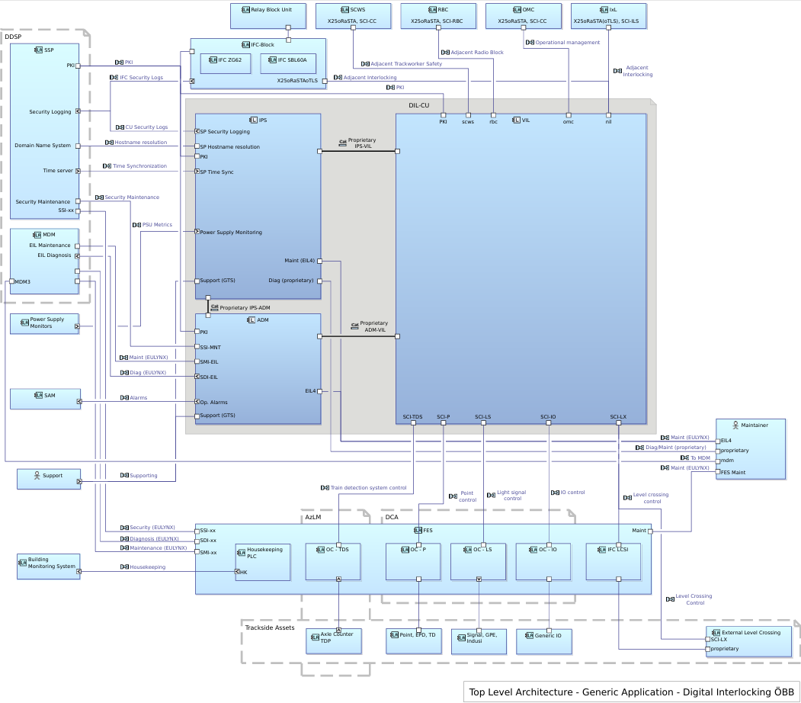
Figure 2: System architecture GA DIL

Hardware Components
The IPS Solution comprises several hardware elements, structured for modularity and maintainability:
- HW GENCAB SERV 1.0: Server cabinet hosting virtualized applications.
- HW GENCAB NETW 1.0: Network cabinet for internal and external communication.

The IPS platform operates on Standard Commercial Off The Shelf (COTS) hardware, the current plan is to use HPE ProLiant DL345 Gen 11 Servers. Nokia 7250 IXR-e routers are currently planned for the network.
- The IPS components are logically structured into three functional areas per location: Network, Computing, and Storage.
- These components are physically distributed into Availability Zones (AZs), typically corresponding to physical racks.
- The AZ serves as the largest assumed failure unit per location. If a complete rack fails (one AZ), the remaining two Availability Zones maintain sufficient computing power and storage capacity to ensure uninterrupted operation of the location.
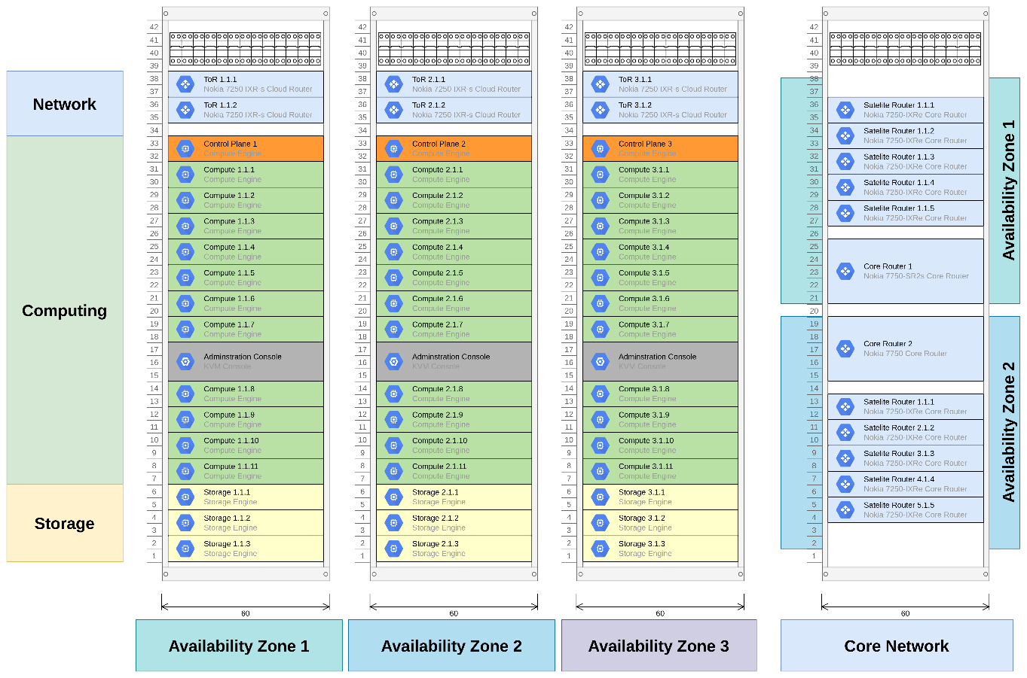
Figure 3: IPS basic structure
All hardware components, such as Computing Servers, Network Routers, and Power Distribution Units (PDUs), are designed to be redundant, both logically and physically.
Servers and network devices are equipped with at least two power supplies (PSUs) and fans, allowing for hot-pluggable component exchange.
The power supply distribution within the cabinets ensures that critical components like servers, routers, and switches have two hot-redundant (1oo2) power supplies connected to different PDUs.

RAM Design Rules
In order to ensure that the availability requirements are met, a series of rules, the so-called ‘RAM Design Rules’, will be developed and used as binding conditions for architectural design decisions. Note that each of these RAM Design Rules will also be explicitly mapped to one or more specific system requirements, ensuring traceability and compliance throughout the development lifecycle.
They share some common definitions described in the following table
Term | Definition | Comment
Balanced distribution | A distribution of k items to n buckets is called balanced if the number of items per bucket differs by at most 1. | This term can be used for a balanced distribution of HW servers as well as for a balanced distribution of (SW) components.
Balanced increment | An increase in a balanced distribution by one item, so that the resulting distribution remains balanced. | This term can be used for a balanced increment of HW servers as well as for a balanced increment of (SW) components.
Affinity | A principle which establishes a preference for certain elements to work together or be placed together. | Node Affinity: allows to constrain which nodes a Pod/VM can be scheduled on.  Pod/VM Affinity: allows to schedule Pod/VM to be co-located with other Pod/VMs.
Anti-Affinity | A principle which ensures that certain elements are not being placed together to avoid single points of failure | Node Anti-Affinity: ensures that a Pod/VM is not scheduled on certain nodes.  Pod/VM Anti-Affinity: ensures that a Pod/VM is not scheduled on the same node as certain other pods.
Equi-Distribution | Distributing workloads, data, or resources evenly to ensure balanced utilization and avoid overloading any single component | The balanced distribution defined above is an example of an equi-distribution.
Topology Spread | Distribution of elements across different availability zones | In OpenStack context:  Distribution of pods across different failure domains (for example availability zones) to ensure high availability and fault tolerance.
Table 6: RAM Design Rules Related Definitions
Note:
- A node in the context of OpenStack refers to a physical server on which multiple virtual machines (VMs) can be operated.
- A pod is a term from Kubernetes and represents the smallest deployable unit (container). In contrast, in OpenStack, VMs are the smallest unit of work.
The common definitions and partitioning of the RAM Design Rules are described in detail in [RAMP_DIL] and is not in scope of this document.

RAM Requirements
The reliability, availability and maintainability requirements have to be identified and referenced within the Dependability Analysis. This Dependability Analysis should also provide a proper apportionment and refinement of these requirements according to the system design. A general description of all RAM aspects can be found in [RAM_Plan_Generic].

Reliability Requirements
Concerning reliability, RAM activities have to focus on the following goals:
- Determination of all possible failures of the system with focus to random hardware faults. Analysis of their consequences with respect to reliability, availability and maintainability (MTTR) and calculation of the associated failure rates.
- Determination of the impact of failures on the functionality of the system.

The key parameters for describing RAM features of a system, on the basis of [EN 50126-1] are:
    - Mean Up Time MUT, resp. Mean Time Between Failure MTBF,
    - Mean time to Restore MTTR and the
    - Availability A, resp. Unavailability (U = 1-A).
Figure 4, obtained from [EN 50126-1], illustrates key parameters of the availability concept.
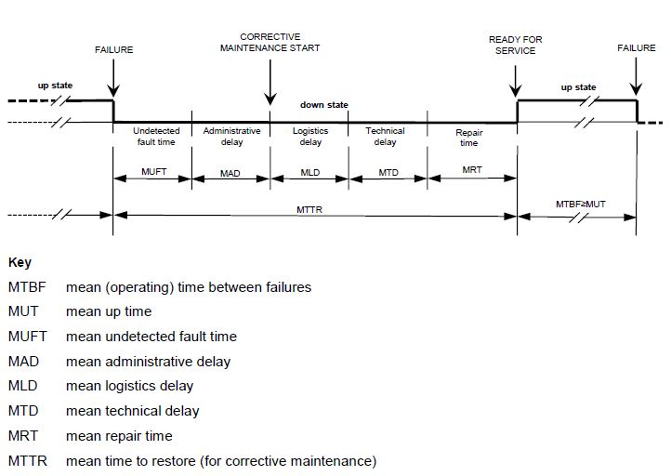
Figure 4: Availability concept and related terms
The MUT is the mean lifetime of a system between two failures. MTTR gives the time required from failure to restart operation.

Availability Requirements
A system analysis shall be carried out to determine availability figures of components and sub-systems. The result shall be part of the Reliability Analysis. It shall be pointed out, that the availability figures depend on the proper installation, maintenance and operation conditions of the system and sub-systems as stated in the installation and maintenance manuals.

Maintainability Requirements
Concerning maintainability, RAM activities have to focus on the following goals:
- Identification and implementation of diagnostic measures to minimize system downtime
    - Detect fault alarms that have to be recorded during operation of the system.
    - Prepare appropriate counter measures in case of failures.
- Determine the time necessary for failure diagnosis and recovery of the availability of the system in case of system or component failures.
- Identification of necessary maintenance actions including time required to conduct them.
All requirements concerning maintenance activities need to be summarized to plan necessary actions. Those actions subsume inspection, preventive and corrective maintenance, repair and spare part logistic.

RAM Plan

Methods and Tools used
The reliability calculation will be done according to [EN 50126-1] and the [MIL_HDBK217F] based Alcatel Reliability Standard [Alcarel] and according to the environmental conditions Ground Benign (GB) for indoor components and Ground Fixed (GF) for outdoor components.

RAM detailed activities, analyses and documents
Within this section, documents and activities necessary for defining and analysing reliability, availability and maintainability requirements are described.

RAM Design Rules
It is planned to develop a series of rules, so-called RAM Design Rules as binding conditions for architectural design decisions if possible. Each of these RAM Design Rules will be mapped to one or more specific requirement(s). See also section 3.3 RAM Design Rules.

RAM HW-FMEA
It is recommended to create a RAM HW-FMEA, that aims to analyse availability and maintainability aspects in terms of failed HW components or failed sub-systems and their operational consequences. It also analyses diagnostic capabilities of the system in order to support preventive and corrective maintenance actions.

Preliminary Reliability Analysis
Upon completion of the RAM Plan, it is recommended to create a preliminary Reliability Analysis document. This document must provide a rough estimation of the availability and reliability of the sub-systems described in chapter 3.
All relevant documentation shall be reviewed in order to define, at a preliminary level, the overall system structure and to recognise all the functional requirements, which may affect the RAM performance of the system.

Reliability Analysis
The Reliability Analysis is a key document, with focus on HW relevant aspects, describing reliability, availability and maintainability features of Integrated Platform Services (IPS) solution element – IPS Solution OBB 1.0.0 (IPSS OBB 1.0.0).
Reliability aspects of SW have to be assured by following the rules of [EN 50126-1]. An analysis of SW reliability is not part of the Reliability Analysis where only permanent random HW faults and system failures will be analysed.
Failure rates for indoor components will be calculated
To be able to make reliable statements and to demonstrate that the required RAM goals will be obtained, the following information about the hardware and the purpose of the system has to be collected:
    - what kind of sub-systems / components will be used,
    - quantity of each sub-system / component,
    - Failure rates of all PBAs and devices used,
    - MTBF and MTTR for each sub-system / component.
The Reliability Analysis shall point out measures, how availability can be reached according to the mission goals.

Maintainability
To ensure a proper installation, operation and maintenance of the system, corresponding installation and maintenance documents have to be provided. MTTR and related terms have to be checked with respect to fulfilment of information stated in these documents.

RAM Deliverables

List of RAM deliverable Documents
This section summarizes the documents which are foreseen during RAM activities:
- RAM Plan (this document),
- preliminary Reliability Analysis (recommended),
- RAM HW-FMEA (recommended),
- Reliability Analysis (required).
Note: RAM documentation must be available according to the Document List and Review Matrix for engineering projects [DLRM].

RAM Requirements
The RAM related customer requirements need to be checked, clarified if necessary and appropriately refined during the different development phases. If additional RAM related aspects are to be considered in order to fulfill RAM related customer requirements, they should comply with corresponding standards [EN 50126-1] and the definitions defined in [RMP_GA] and [RMP_IPS].
The Solution Element – IPS Solution OBB 1.0.0 (IPSS OBB 1.0.0) is subject to the DPR requirements stated in [SSS_IPS] (see Table 7 below) and furthermore in [PH_RAMS].
ID | Synopsis
EL4-IPS-SSS-REQ-00010-DPR | [IPS] shall provide local redundant centralized alerting capabilities for infrastructure, networks and applications
EL4-IPS-SSS-REQ-00013-DPR | [IPS] shall provide highly available geo-redundant setup for all infrastructure and services including compute, storage and network, across up to 3 geographically separated DC locations
EL4-IPS-SSS-REQ-00014-DPR | [IPS] shall provide multiple, dedicated virtual networks with configurable Quality of Service (QoS) parameters. These networks shall be managed as Software-defined-Network (SDN) enabling centralized control, dynamic configuration and seamless scalability
EL4-IPS-SSS-REQ-00021-DPR | [IPS] shall provide automatic switch-over to geo-redundant connections in the event of primary connection failure
EL4-IPS-SSS-REQ-00022-DPR | [IPS] shall provide manual switch-over capabilities to geo-redundant location, allowing to re-route network traffic in the event of primary connection failure
EL4-IPS-SSS-REQ-00024-DPR | [IPS] shall support geo-redundant, consistent configuration and application binary storage. Configurations, VMs and Images shall be synchronized between Datacenters
EL4-IPS-SSS-REQ-00025-DPR | [IPS] shall support local, consistent configuration and application binary storage. Configurations, VMs and Images shall be locally availabl
EL4-IPS-SSS-REQ-04009-DPR | The availability of the database systems within the IPS INFRA and SERVICE block shall be 99.9999%.
EL4-IPS-SSS-REQ-01102-DPR | The Core Network shall be able to provide two-fold redundant connections to the Power Supply Monitor device from Gustav Klein
EL4-IPS-SSS-REQ-01103-DPR | The Core Network shall be able to provide two-fold redundant connections to the OEBB network Datennetz 2020
EL4-IPS-SSS-REQ-01301-DPR | The Core Network shall provide 99.9999% availability
EL4-IPS-SSS-REQ-01304-DPR | The network connection to each server cabinet shall be two-fold redundant
EL4-IPS-SSS-REQ-01306-DPR | The network connection to each RaSTA network shall be two-fold redundant
EL4-IPS-SSS-REQ-02001-DPR | The volumes provided by the storage system shall provide 99.9999% availability.
EL4-IPS-SSS-REQ-02002-DPR | The operating system on all storage servers shall use at least 2 storage devices in a RAID1 array.
EL4-IPS-SSS-REQ-02003-DPR | The storage server shall provide additional storage devices for the provision of the common storage space for the applications.
EL4-IPS-SSS-REQ-03101-DPR | The operating system on all compute servers shall use at least 2 storage devices in a RAID1 array.
EL4-IPS-SSS-REQ-04015-DPR | [IPS] shall provide high available storage and computing services spanning 3 availability zones
EL4-IPS-SSS-REQ-04025-DPR | [IPS] shall support local Availability Zone concept for VMs
EL4-IPS-SSS-REQ-04026-DPR | [IPS] shall support Geo-Redundancy (multiple regions) concept for VMs
EL4-IPS-SSS-REQ-04030-DPR | [IPS] shall support automatic restart of the VMs on the server after this server restart
EL4-IPS-SSS-REQ-04031-DPR | [IPS] shall support scale-in / out (increase or decrease) additional computing resources per Availability zone
EL4-IPS-SSS-REQ-04032-DPR | [IPS] shall support scale-in / out (increase or decrease) additional network resources per Availability zone
EL4-IPS-SSS-REQ-04033-DPR | [IPS] shall support scale-in / out (increase or decrease) additional storage resources per Availability zone
EL4-IPS-SSS-REQ-05104-DPR | The INFRA cluster shall provide a storage for application files with an availability of 99.9999%.
EL4-IPS-SSS-REQ-05105-DPR | The INFRA cluster shall provide a storage for data preparation files with an availability of 99.9999%
EL4-IPS-SSS-REQ-05106-DPR | The INFRA cluster shall provide a storage for configuration files with an availability of 99.9999%
EL4-IPS-SSS-REQ-05306-DPR | The availability of the PKI service for management of certificates shall be 99.9999%.
EL4-IPS-SSS-REQ-06306-DPR | The availability of the message broker shall be 99.9999%.
EL4-IPS-SSS-REQ-08306-DPR | IPS shall provide redundant communication path between NMR application instances.
EL4-IPS-SSS-REQ-09902-DPR | IPS shall redistribute remaining services following the balanced increment principle in case of a server failure
EL4-IPS-SSS-REQ-09903-DPR | IPS shall not redistribute services in case of server reintegration to prevent any additional disruption of operating services.
EL4-IPS-SSS-REQ-09906-DPR | IPS shall execute a group of services which belongs to a specific sub-station on the same physical server (colocation/grouping).
EL4-IPS-SSS-REQ-09911-DPR | IPS shall place IPS service instances belonging to the IPS INFRA Cluster on different servers and different availability zones following the balanced distribution principle.
EL4-IPS-SSS-REQ-09912-DPR | IPS shall execute IPS service instances belonging to the IPS INFRA Cluster 2oo3 hot-redundant or 1oo2 hot-redundant or 1oo3 hot-redundant (high availability).
EL4-IPS-SSS-REQ-09913-DPR | IPS shall place IPS Service instances belonging to an IPS SERVICE Cluster on different servers and different availability zones following the balanced distribution principle.
EL4-IPS-SSS-REQ-09914-DPR | IPS shall execute IPS Service instances belonging to an IPS SERVICE Cluster 2oo3 hot-redundant or 1oo2 hot-redundant or 1oo3 hot-redundant (high availability).
Table 7: IPS DPR requirements

Periodical RAM activities report
The RAM Plan can be updated if necessary, in each phase of the product life cycle, described in [EN 50126-1].
Possible reasons are:
- Review comments of this document,
- Hardware changes,
- Change of standards and procedures.
Each change of the RAM Plan results in a new edition. At each new edition, the reasons for change will be documented in section 1.5

END OF DOCUMENT

The identification refers to the key products/solutions included in the Solution Element - IPS Solution
On the SL please note that ÖBB and also EULYNX clearly asks for SL3, an end-to-end implementation in Phase 1 will most likely NOT be possible. However, the setup and the describing documents shall be prepared for SL3. MiniOMC will not be classified as SL3 since it is based on OMC 3.0

