System Segment Design Document iLED2.0

Signal Elements
iLED 2.0
ÖBB, BLS, SBB, MAV, GySEV, NRIC

APPROVAL
 | Name and Role/Job Title | Esignature
Written by | M. Schimkowitsch / HW-ARC
Verified by | R. Al Ali / QAM
Approved by | A. Amon / SEM

LOG OF CHANGES
Revision | Date | Author | Change Description
01 PD 01 | 2026-03-13 | M. Schimkowitsch | First draft

Contents
1. SCOPE 8
1.1 Identification 8
1.2 System Overview 8
1.3 Document Overview 9
1.4 Intended Audience and Distribution 9
1.5 Evolution of the System Design Document 10
1.5.1 Distribution 10
1.5.2 Configuration Management and Archival 10
1.6 Relationship to other Plans 10
1.7 Change History 10
1.7.1 Edition 01 PD 01 10
2. References and Terms 11
2.1 Referenced Documents 11
2.2 Standards and Procedures 12
2.3 Terms, Abbreviations and Acronyms 14
3. Operational Concepts 15
3.1 Missions 15
3.2 Threats 15
3.3 Logistic Support 15
3.4 Supplies 15
3.5 Certification Restrictions 15
4. System Wide Design Decisions 16
4.1 Safety related Principals 17
4.1.1 MPU defects 17
4.1.2 LED-Converter defect 18
4.1.3 MPU-Converter defect 18
4.1.4 LED Supervisor defect 18
4.1.5 LED Current Low Pass Filter defect 18
4.1.6 LED defect 18
4.1.7 4mA Current Source defect 18
4.1.8 Safety Switches defect 18
4.1.9 EMC-Filter and Inrush Current Limiter 19
4.2 RAM related Principals 19
4.2.1 Reliability 19
4.2.2 Availability 19
4.2.3 Maintainability 19
4.3 Security related Principles 20
5. System Architecture 21
5.1 Logical Architecture 21
5.1.1 Global Architecture 21
5.1.2 External Interfaces 21
5.1.3 Internal Interfaces 23
5.1.4 Komponenten 24
5.2 Physical Architecture 25
5.3 Definition of Components and related Interfaces 25
5.3.1 Linefilters 25
5.3.2 Inrush current limiter and Power supply supervision 26
5.3.3 Power supply 26
5.3.4 2-Channel-Supply-Switch of LED-Converter 27
5.3.5 MPUs 28
5.3.6 CAN-Transceiver 29
5.3.7 LED-Driver 29
5.3.8 LED-Current supervision 30
5.3.9 LED-INDIVIDUAL VOLTAGE MONITORING 31
5.3.10 Hardware Watchdog 32
5.3.11 Fuses 32
5.3.12 Temperature Measurement 32
5.3.13 Reference Voltage 33
5.3.14 Operating Hour Indicator 33
5.3.15 LED-Board 35
5.4 Manufacturing 36
6. Functional and Operational Scenarios 37
6.1 Startup Procedure 37
6.2 MPU Startup (Initializing phase) 37
6.3 MPU Main Tasks (Operating phase) 37
6.4 Environmental Conditions 38
6.4.1 Climatic Environmental Conditions 38
6.4.2 Mechanic Environmental Conditions 38
6.4.3 Electromagnetic Environmental Conditions 38
6.4.4 Pollution 38
6.4.5 Storage and Transport 38
6.5 Safety Integrity Level and Approval 39
6.6 Measures against systematic HW errors according to EN 50129 39
6.7 Safety requirements for electrical equipment 40
6.8 Lifetime 40
6.9 Documentation 40
7. System Design 41
7.1 Hardware 41
7.2 Software 41
8. Traceability of requirements 42
9. Notes 43

List of Tables
Table 1: Referenced Documents 11
Table 2: Standards and Procedures 14
Table 3: Pinning of Harting plug 22
Table 4: STDC14 Connector pinout 23
Table 5: Pinning LED Board 24
Table 6: Pinning Operating Hour Indicator 24
Table 7: Technical service life indication 25
Table 8: Electrical characteristics iLED supply input 26
Table 9: Release of input voltage 26
Table 10: Electrical characteristics Channel supply 27

List of Figures
Figure 1: Sytem overview iLED and TCU 8
Figure 2: Mechanical modular system iLED 9
Figure 3: Block diagram iLED 2.0 17
Figure 4: iLED Components 21
Figure 5: Harting HAN-Q12 21
Figure 6: STLINK-V3 23
Figure 7: iLED housing with operating hour indicator 25
Figure 8: Arrangement of safety switches 27
Figure 9: Layout recommendation for ISOW1044BDFMR 29
Figure 10: Principle of buck-boost converter for LEDs 30
Figure 11: Principle of LED Current Supervision 31
Figure 12: Principle of LED Voltage Monitoring 31
Figure 13: Combined Reset and Watchdog 32
Figure 14: 3.0V Voltage Reference 33
Figure 15: Possible RGY-LED for Operating hour indicator 33
Figure 16: Excerpt from [Spec_LEDB4] 35
Figure 17: GTS Design Environment 41

SCOPE
The existing iLED is undergoing a redesign due to a new tender from ÖBB (Austrian Federal Railways) and component obsolescence. Additionally, a required operating hours counter will be implemented. The iLED's mechanical components will remain unchanged. The new ÖBB specifications are summarized in the feature list [FLiLED].
This document provides the HW System Segment Design of the Intelligent RaiLed (iLED 2.0). The optical and mechanical aspects are covered by [ADD M/O].

Identification
The usage of light bulbs in light points declines steadily since LEDs got more reliable and energy efficient. Using LEDs instead of light bulbs can be achieved by the following two ways:
- Drop in replacement that mimics all characteristics of a light bulb (no change of the interlocking interface)
- Complete new design with no legacy to consider (major change of the interlocking interface)
The iLED 2.0 follows the second approach and is a completely new design but the mechanical and optical features are shared with the RaiLed AT 1.1 (which is a drop-in replacement type).
In contrast to the conventional light point, the iLED 2.0 is always powered and therefore able to acquire supervision information via its inbuilt microcontrollers. The iLED 2.0 communicates via a CAN-bus with a controller at or near the stand of the railway signal that links the outdoor equipment with the indoor interlocking.

System Overview
Figure 1: Sytem overview iLED and TCU
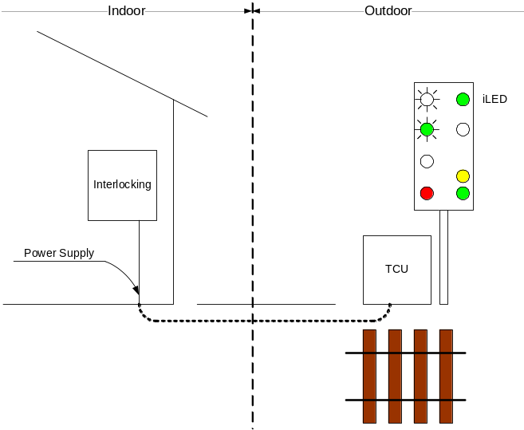
The iLED is just a small part of the overall system. It needs a TCU (Trackside Control Unit) to communicate with the interlocking. This unit makes use of the OEC (Outdoor Element Controller) which is responsible for the correct activation of each connected light point (iLED).
The indoor unit of the system is the EC-MUX (Element Controller Multiplexer) and the Modem cabinet. These devices are needed to connect several TCU sites with the interlocking system. The monitoring of all connections (life cycle) is also done by the EC-MUX.
The mechanical part of the iLED is designed as a modular system.
Figure 2: Mechanical modular system iLED
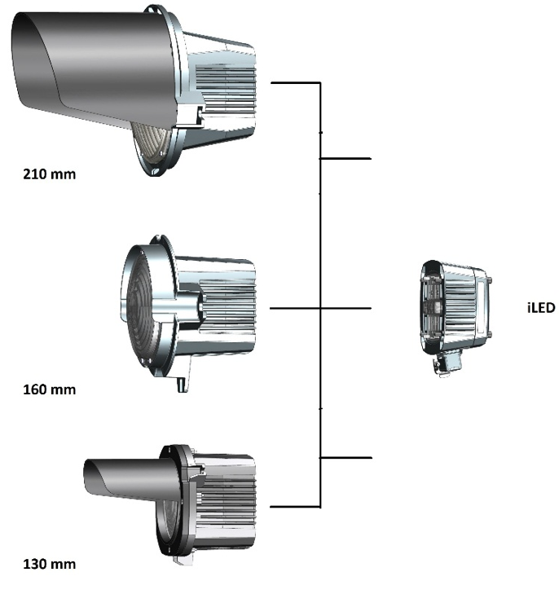
The front part contains the lens system for the different sizes and the rear part contains the control electronics with the LED board of the defined color (Red, yellow, green, white or blue).

Document Overview
The System Design Description describes the architecture, components, interfaces, and behavior of a system.
It is divided into the following areas:
- Logical Architecture
- Physical Architecture
- System Design

Intended Audience and Distribution
- Solution Engineer Manager (SEM)
- Work Package Manager (WPM)
- Project Manager (PM)
- Test Manager (TM)
- Product Line Manager (PLM)
- Quality Assurance Manager (QAM)
- Safety Assurance Manager (SAM)
- RAM Assurance Manager (RAM-AM)
- Hardware Designer (HD)
- Architect (ARC)
- Verifier (VER)
- Validator (VAL)
- Assessor

Evolution of the System Design Document

Distribution
A new version (proposal) of this document has to be sent via e-mail to all functions listed in section 1.4, “Intended Audience and Distribution”.
A new version (proposal) of this document has to be distributed to all participants of Decision-Reviews.
All released versions of this document have to be kept in Hitachi Rail Austria archive. Proposals may be stored in the archive too. The document manager is responsible for archiving the document.

Configuration Management and Archival
A new version of this document has to be created, if the architecture or interfaces change or if mistakes are found in the existing document.
The System Design Document should be drawn up during the planning phase of the project. The content of this System Design Document has to be checked at least at each key milestone (defined in Project Plan). The System Design Document shall be updated and reviewed if subsequent alterations or additions are made to the original system/subsystem.
The Technical Project Manager is responsible for proposal of a new version of this System Design Document.

Relationship to other Plans

Change History

Edition 01 PD 01
First Draft

References and Terms

Referenced Documents
ID | Title | Reference | Version
[QMP] | Quality Management Plan (QMP)
[SP] | Safety Plan (SP)
[RAM] | RAM Plan (RP)
[SecMP] | Security Management Plan (SecMP)
[FLiLED] | Feature_List, Feature List Signalgeber (iLED/iAnzeiger/RaiLED) | 3BU62200 10001 FLAPQ | Ed. 01
[ADD M/O] | Architectural Design Document Optischer / Mechanischer Teil, iLED 1.0 | 3BU 61000 0809 PEAPC | Ed. 09
[CAN Spec] | Schnittstellenbeschreibung, Interface Specification OEC / OIFB | 3BU 61400 0035 PBAPA | Ed. 09
[Env_Spec] | Specification, Umgebungsbedingungen ELEKTRA 2.x - Entwicklungsvorgaben | 3BU 15000 5062 EDAPC | Ed. 07
[SSDD HW RaiLED] | Architectural_Design_Document, SSDD Hardware RaiLed | 3BU 61000 0406 DSAPC | Ed. 04
[Dimen_LEDCBRD] | Konstruktionszeichnung, Platzangebot Steuerungsboard | 3BU 61000 0114 HDAPC | Ed. 01
[Circuit_LEDB4] | Schaltung, LEDB4 LED Board 4 | 3BU 61030 BZAA ECAPA | Ed. 02
[Spec_LEDB4] | Specification, Bahnsignal Gen2 | 3BU 61030 BZAA DSAPC | Ed. 17
[SSS_ILED_SW] | SSS, iLED NG
[Signal_V2_ÖBB] | V2, Signalvorschrift der ÖBB | 22. Änderung 12/2013
[DV_30_01] | DV 30 01, Betriebsvorschrift V3 | 2020
[Lastenheft_OeBB] | Lastenheft DSTW für LED Signalgeber V1.1 vom 21. 05. 2025 | 3BU 17300 0005 DSAPC | Ed 04
Table 1: Referenced Documents

Standards and Procedures
ID | Title | Publishing Date / Reference | Version / Revision
[AM-VO] | [S17] Arbeitsmittelverordnung – AM-VO, BGBl. II Nr. 330/2024 | 03. 12. 2024
[ASchG] | ArbeitnehmerInnenschutzgesetz – AschG BGBl. I Nr. 56/2024 | 05. 06. 2024
[CAN-Guide] | A Comprehensible Guide to Controller Area Network, Wilfried Voss | ISBN: 0-9765116-0-6
[DIN6163] | DIN 6163:2015: Farben und Farbgrenzen für Signallichter: Signallichter der Eisenbahn und im öffentlichen Verkehr | 2015
[EisbAV] | Gesamte Rechtsvorschrift für Eisenbahn-ArbeitnehmerInnenschutzverordnung, idF BGBl. II Nr. 471/2021 | 17. 11. 2021
[EN50121-4] | OVE EN 50121-4:2017 + A1:2020: Railway applications - Electromagnetic compatibility - Part 4: Emission and immunity of the signalling and telecommunications apparatus | 2017, 2020
[EN50122-1] | OVE EN 50122-1:2023: Railway applications – Fixed installations – Electrical safety, earthing and the return circuit - Part 1: Protective provisions against electric shock | 2023
[EN50124-1] | OVE EN 50124-1:2018 + AC:2023: Railway applications - Insulation coordination -- Part 1: Basic requirements - Clearances and creepage distances for all electrical and electronic equipment | 2018, 2023
[EN50125-3] | EN 50125-3:2003 + AC:2010: Railway applications – Environmental conditions for equipment, Part 3: Equipment for signalling and telecommunications | 2003, 2010
[EN50126-1] | OVE EN 50126-1:2025: Railway applications - The specification and demonstration of Reliability, Availability, Maintainability and Safety (RAMS) -  Part 1: Generic RAMS process | 2025
[EN50126-2] | OVE EN 50126-1:2018 + A1:2025: Railway applications - The specification and demonstration of Reliability, Availability, Maintainability and Safety (RAMS) -- Part 2: Systems approach to safety | 2018, 2025
[EN50129] | OVE EN 50129:2024: Railway Application - Communication, signalling and processing system - Safety related electronic systems for signalling | 2024
[EN50159] | EN 50159:2010 + A1:2020: Railway applications – Communication, signalling and processing systems – Safety-related communication in transmission systems | 2010, 2020
[EN50716] | EN 50716:2024: Railway Applications – Requirements for software development | 2024
[EN60529] | IEC 60529:1989 + A1:1999 + A2:2013 + COR1:2019: Degrees of protection provided by enclosures (IP Code) | 1989, 1999, 2013, 2019
[IEC60721-3-1] | OVE EN IEC 60721-3-1:2019: Classification of environmental conditions -- Part 3-1: Classification of groups of environmental parameters and their severities - Storage | 2019
[IEC60721-3-2] | OVE EN IEC 60721-3-1:2019 + AC:2023: Classification of environmental conditions -- Part 3-2: Classification of groups of environmental parameters and their severities - Transportation and Handling | 2019, 2023
[IEC62443-3-3] | IEC 62443-3-3:2013 + Corr:2014: Industrial communication networks–Network and system security -- Part 3-3: System security requirements and security levels | 2013, 2014
[IEC62443-4-1] | IEC 62443-4-1:2018: Security for industrial automation and control systems -- Part 4-1: Secure product development lifecycle requirements | 2018
[IEC62443-4-2] | IEC 62443-4-2:2020: Security for industrial automation and control systems - Part 4-2: Technical security requirements for IACS components | 2020
[ISO11898-1] | ISO 11898-1:2024: Road vehicles - Controller area network (CAN) - Part 1: Data link layer and physical coding sublayer | 2024
[ISO11898-2] | ISO 11898-2:2024: Road vehicles - Controller area network (CAN) - Part 2: High-speed physical medium attachment (PMA) sublayer | 2024
Table 2: Standards and Procedures

Terms, Abbreviations and Acronyms
ADC | Analog Digital Converter
CAN | Controller Area Network
CPU | Central Processing Unit
EC | Element Controller
EC-MUX | Element Controller Multiplexer
EMI | Electro Magnetic Interference
GMBS2.0 | Hitachi Rail Management System
iLED | Intelligent LED
iLEDCB | Intelligent LED Control Board
ÖBB | Österreichische Bundesbahn
OEC | Outdoor Element Controller
PCB | Printed Circuit Board
PWM | Pulse Width Modulation
SEA | Sichere Elektronische Außenelementansteuerung
SEC | Single Element Controller
TCU | Trackside Control Unit

Operational Concepts

Missions
The goal of this project is to replace the existing iLED1.0. The iLED1.0 has been in use for 15 years, and its components will soon be discontinued. The new design will involve switching to a modern 32-bit processor technology. Particular attention must be paid to ensuring the long-term availability of the new components. The SiliconExpert tool can be used for this purpose for example.

Threats
A hazard from the perspective of the overall application within a signalling system occurs, if the signal aspects allows too high velocity.
From the perspective of a single iLED, the following two hazardous situations are assumed:
- The iLED reports a different state than the one it currently has (e.g. iLED is on but reports off).
- The iLED is on, although it has been commanded off.

Logistic Support
A maintenance- and repair manual is provided for the operator of the iLED.

Supplies
A part number must be created for each colour and diameter combination. Part numbers must also be created for the rear sections containing the control board and the LED board, which serve as spare parts.

Certification Restrictions
The iLED may only be used in conjunction with a SEC-TCU or a future system which uses the proprietary CAN-Bus protocol and is able to work in conjunction with the iLED to build from the safety aspect a SIL4-System. Only in this configuration is a compliant safety response from the entire system possible.

System Wide Design Decisions
To guarantee SIL4-safe control of the LED light point, the 2-channel approach is adopted, as with the previous iLED1.x. One channel controls the LEDs brightness whereas both channels measure the LEDs current (the LEDs current is proportional to the light intensity). Both channels can easily check each other and react to any malfunction.
The following precautions are taken:
- Both CPU’s communicate over CAN-Bus with different Channel-Numbers.
- One CPU controls via PWM-signal the brightness of the light point.
- Both CPU’s check the resulting LED current according to plausibility (correct PWM-Value).
- Both CPU’s check LED failure on the LED-Board.
- Two electronic switches are connected in series to supply the PWM-Converter for a 2-channel safety reaction.
- Both CPU’s must switch on the power supply of the PWM-Converter dynamically via an electronic (safety) switch.
- One CPU has to disable both electronic (safety) switches via dedicated port pins.
- Both CPU’s detect the ambient temperature and switch off if outside the specified working range.
- Both CPU’s have to check the correct power supply range.
- Both CPU’s shall be taken from STM32L4 series, because of their Long-term availability and the availability of certified compilers and self-test utilities.

Safety related Principals
The functionality of the safety-related principles is described using the following block diagram.
Figure 3: Block diagram iLED 2.0
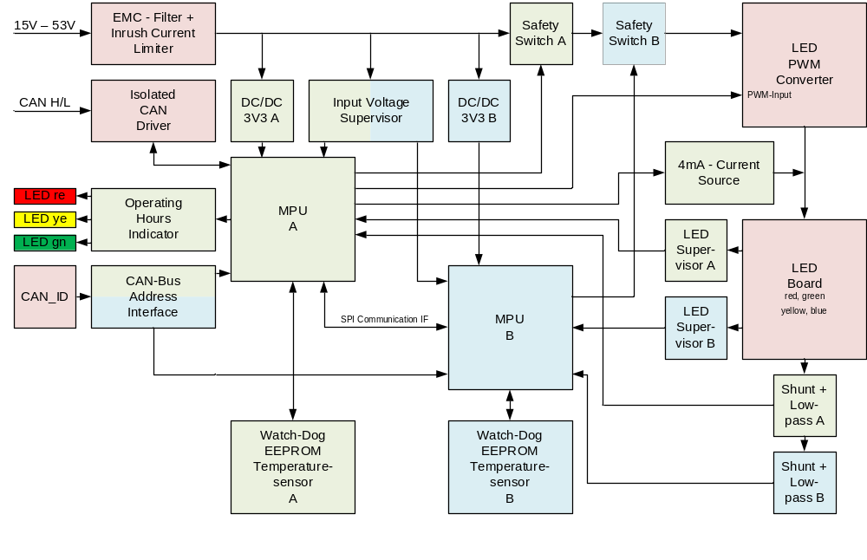
A two-channel approach is used in a master-slave configuration. This means that an action is initiated by the master and the slave must agree to it. The intercommunication link between both MPU’s is used to synchronize the correct action between both channels from the software point of view.
The communication to the TCU or a future system is done via a CAN-Bus Interface. The protocol is defined in [CAN Spec]. The Master-MPU has the CAN-Bus-Interface physically implemented and send the slave-related telegrams via the intercommunication link to the Slave-MPU.

MPU defects
The MPU is controlled using a watchdog that must be dynamically controlled. This activation is done via an output port of the MPU. If this control cannot be carried out in a timely manner due to an internal software malfunction, an NMI (Non Maskable Interrupt) interrupt occurs on the MPU. After this NMI interrupt occurs, the MPU must adjust its function so that it only outputs the error message via the CAN bus and writes the error information to the EEPROM. The dynamic control of the safety switch is then disabled, and the LEDs are switched off.
If the watchdog has expired a mechanism has to be integrated that disables the corresponding safety switch until the power supply is removed
On the software side, the MPU is continuously tested for the correct functioning of its internal components using a certified safety package. If a fault is detected, the MPU also ceases operation and the watchdog timer is triggered. The cause of the fault, as detected by the safety package, is written to the EEPROM.
The correct power supply of the MPU is monitored via an external reset chip.
The content of the EEPROM is secured with a CRC check of the entire contents of the EEPROM.
The ambient temperature of the MPU inside the iLED housing is continuously monitored. If it falls outside the defined range, the MPU shuts down and writes the reason to the EEPROM.

LED-Converter defect
A defect in the LED converter is indirectly measured via the LED current. One possible cause could already lie in the control via the PWM signal. A defect in the galvanically separation between the windings of the converter can be detect, when both safety switches are turned on and a voltage can be measured on the secondary side of the converter.

MPU-Converter defect
A defect in the MPU converter manifests itself in either no voltage or that the supply voltage is outside the defined limits of the MPU. If there is no voltage, the defect is triggered by the other MPU, no intercommunication is possible. The supply voltage must be supervised by the reset circuit of the MPU. So, if the supply voltage is out of range, the MPU is held in reset. This is also detected by the other MPU.

LED Supervisor defect
Each channel has its own independent of the other channel LED supervisor circuit. A short circuit of a LED can be detected by these circuits.

LED Current Low Pass Filter defect
The current is measured across a shunt resistor and the PWM-signal is averaged arithmetically using a low-pass filter. This low-pass filter must be designed so that the ripple is less than one bit of the resolution of the A/D converter in the MPU. A defect is detected when the independent measured values of both channels differ by a defined range and both MPUs initiate a safety reaction.

LED defect
An interruption of the LED is detected by the measured LED Current.
Another fault scenario, where the brightness of the LED is reduced by a parallel resistor, is detected by a constant current source of 4 mA. This small test current causes a "broken" LED to be detected by the LED supervisor circuit, and the safety reaction is initiated.

4mA Current Source defect
A defect is detected with the aim of the 2-channel LED current low pass filter for current measurement when the 4mA current has a wrong value.

Safety Switches defect
An interruption in the safety switch circuit is detected by the absence of LED current.
A short circuit in the safety switch is detected, triggering a staggered power-on of the LED PWM converter. The safety switches are activated sequentially. The LED current is only allowed to flow during the second switching operation. The next time the LED PWM converter is powered on, the order of the safety switches is reversed.

EMC-Filter and Inrush Current Limiter
A defect of both components is detected by a 2-channel monitoring of the supply voltage. If the supply voltage is not in the defined range, the associated channel will not enable the corresponding MPU. Both MPU’s have to be enabled for correct function of the iLED. Otherwise, the iLED will report a fault.

RAM related Principals
These principles are addressed in a separate document [RAM] and cover the following aspects.

Reliability
How the system or component will perform its required function without failure for a specified period under stated conditions.
Key aspects are:
- Probability of failure-free operation
- Mean Time Between Failure (MTBF)
- Failure modes and effects (FMEA, FMECA)
- Lifecycle fatigue, stress factors (thermal, mechanical, electrical)

Availability
The percentage of time a system is operational and ready for use.
Availability depends on:
- Reliability (how often failures occur)
- Maintainability (how quickly repairs can be made)
- Logistics (spare parts, tools, access)

Maintainability
How easily and quickly a system can be inspected, repaired, or restored to operation.
Measured by:
- Mean Time to Repair (MTTR)
- Accessibility of components
- Diagnostic tools and built-in test features (BIT)
- Modular design

Security related Principles
Following principles will be applied:
- Verified boot images
- Secure firmware updates
- Secure Boot: Ensures that only signed and trusted firmware and software run on the device.
- Signed firmware images
- Locked-down JTAG/SWD
- Use of a proprietary CAN-Bus-Protocol
A more detailed description of these principles is presented in a separate document, [SSS_ILED_SW].

System Architecture

Logical Architecture

Global Architecture
Figure 4: iLED Components
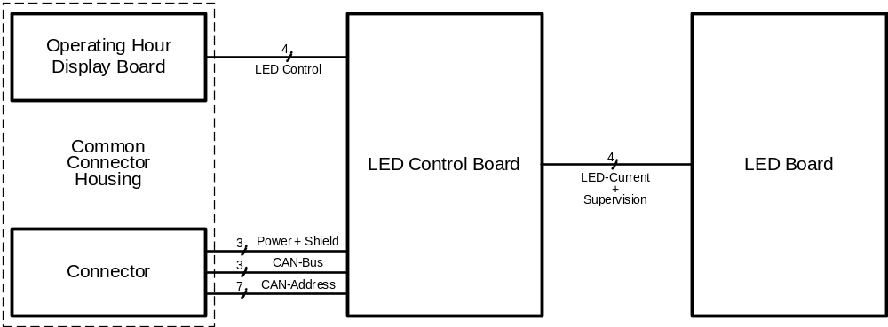

The iLED product comprises four components: the connector, the operating hours indicator, the LED Board with the LEDs, and the central control and monitoring unit, the LED Control board.

External Interfaces

Connector Harting
The connection to the TCU or a compatible system is made using a rugged Harting connector (12 pins + PE). Usage of a rugged connector is essential because of the harsh environmental conditions an iLED will experience during its lifetime. Therefore, the overall iLED enclosure (chassis + front lens and plug with integrated Operating Hour Indicator) needs to meet at least IP65 performance.
One cable (Power and CAN-bus) connects the TCU to a connector box at the rear side of the signal plate. In this connector box the electrical connections are made with the cables coming from the iLEDs.
The Harting socket is connected with single wires to the iLED Control Board.
Figure 5: Harting HAN-Q12
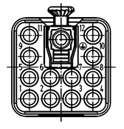
Table 3: Pinning of Harting plug
11 | POWER_1 | PE  EARTH |  |  |  | 12 | POWER_2
9 | CAN_H |  |  |  |  | 10 | GND
5 | CAN_L | 6 | CAN_ID_0 | 7 | CAN_ID_1 | 8 | CAN_ID_2
1 | CAN_GND | 2 | CAN_ID_3 | 3 | CAN_ID_4 | 4 | CAN_ID_5
…. Pin numbers are bold and signal names are in italic letters

CAN-Interface
A Controller Area Network (CAN) bus is used to control the iLEDs. The OEC is connected via a cable (CAN_H, CAN_L, CAN_GND, POWER_1, POWER_2) to the connection box at the signal pylon. All elements are connected to a plain bus topology, this means that all nodes connected to the bus are able to receive the same data at the same time.
To fulfil safety requirements a polling interval of 50 ms is used. To transmit the relevant data of all elements connected to one CAN bus a speed of 250 kBit/s is needed. This calculation is based on a full-blown signal pylon installation (16 iLEDs).
Due to the needed CAN bus speed required by the overall design (250 kBit/s) its length is limited to 100m. A solution for cable distance of 250m has to be found.
The specification of the protocol can be found in [CAN Spec].

Power-Interface
Due to the fact that the iLED uses two microcontrollers for all operations the power supply is essential. To simplify the use of an iLED its design is flexible to adapt to different supply voltages. It is possible to operate an iLED with 15 V_{DC} up to 53 V_{DC}. The highest efficiency is achieved when it’s powered with 48 V_{DC}.
The huge difference between a conventional light point and the iLED is that a “dark” light point still consumes power. The idea behind the iLED is that it is always powered and therefore able to permanently monitor all safety critical functions (LED current, environment temperature …). Every fault is broadcasted via its CAN bus to the OEC.
Depending on its state the power consumption of an iLED is assumed to the following values:
- Switched off: < 2 W
- Switched on:
red: 7,8 W (iLEDCB: 4,0 W + LEDB: 3,8 W)
green: 8,5 W (iLEDCB: 4,0 W + LEDB: 4,5 W)
yellow: 9,2 W (iLEDCB: 4,0 W + LEDB: 5,2 W)
white: 8,8 W (iLEDCB: 4,0 W + LEDB: 4,8 W)
blue: 8,8 W (iLEDCB: 4,0 W + LEDB: 4,8 W)
The input current must be limited to a maximum of 1 A.

Device Identifier
A typical signal aspect consists of several light points, so mixing up light points is a severe safety problem. Therefore, each iLED is identified by a unique identifier, the CAN_ID. Each node (iLED) is connected to the CAN bus and address via its unique ID. To assign such an address to each iLED a device ID is coded into the Harting plug.
It consists of 7 pins:
- GND
- CAN_ID_0, CAN_ID_1, CAN_ID_2, CAN_ID_3, CAN_ID_4, CAN_ID_5, CAN_ID_6
Left open the CAN_ID_x pins results in a logical high “1”, if connected to GND the bit is logical low “0”. This results in fix defined voltages that each CAN_ID_x bit. These voltages are fed into 6 digital I/O lines at each channel.
To fulfil safety requirements the CAN_ID is protected via two parity bits. The remaining 4 CAN_ID (2⁴ = 16) bits are used to address 16 iLEDs.

Internal Interfaces

Jtag Socket
For each MPU (Channel A and B) a dedicated socket has to be foreseen. This socket is from type SAMTEC FTSH-107-01-L-DV-K-A.
Table 4: STDC14 Connector pinout
Pin number | Description | Pin number | Description
1 | Reserved | 2 | Reserved
3 | T_VCC | 4 | T_JTMS/T_SWDIO
5 | GND | 6 | T_JCLK/T_SWCLK
7 | GND | 8 | T_JTDO/T_SWO
9 | T_JRCLK | 10 | T_JTDI/NC
11 | GNDDetect | 12 | T_NRST
13 | T_VCP_RX | 14 | T_VCP_TX
More information can be found in https://www.st.com/resource/en/user_manual/dm00526767.pdf
For debugging purpose and software downloading the STLINK-V3 von ST (Manufacturer of MPU STM32L4x) has to be used.
Figure 6: STLINK-V3
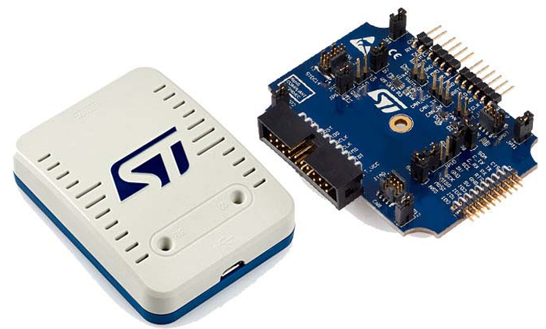
Interface: USB Micro-B connector

Intercommunication Interface
Both channel (A, B) are separated and communicate with each other via a direct serial link. The serial link is electrically protected by safety resistors to ensure the independence of both channels.
Up to 2 SPI-Interfaces of the STM32L4x can be used for this communication.

Interface to LED-Board
The LED Board is connected via a 4 pole plug where 2 pins are used to power the LED’s and the remaining two pins are used for the LED supervision. A Tyco: 2-292174-4 compatible plug has to be used.
Table 5: Pinning LED Board
Pin | Signal name
1 | Ueberwachung_A
2 | Ueberwachung_B
3 | LED +
4 | LED -
For more information about the LED Board see [SSDD HW RaiLED].

Interface to Operating Hour Indicator
The Operating Hour Indicator consists mainly of light-emitting diodes (LED). The colours are red, yellow and green.
Table 6: Pinning Operating Hour Indicator
Pin | Signal name
1 | LED green
2 | LED yellow
3 | LED red
4 | Common GND

Komponenten

ILED Control Board
The dimensions of the iLED / LED control board must meet the requirements of the Swarco-Futurit specification [Dimen_LEDCBRD]. The maximum installation height of the iLED / LED control board must not exceed 10mm in the direction of the LED board and 30mm in the direction of the housing cover. In addition to the prescribed air and creepage distances, additional 1.5 mm must be considered.

LED Board
The LEDB4 and its derivatives with part number 3BU 61030 BxAA are used. The mechanical dimensions can be seen in [Spec_LEDB4].

Operating hours Indicator Board
A new housing for the HAN3A connector must be used to accommodate the additional operating hour indicator. The dimensions for this circuit board must be defined and a corresponding optical display designed.

Physical Architecture
The mechanical design remains the same except for the operating hour indicator.
Figure 7: iLED housing with operating hour indicator
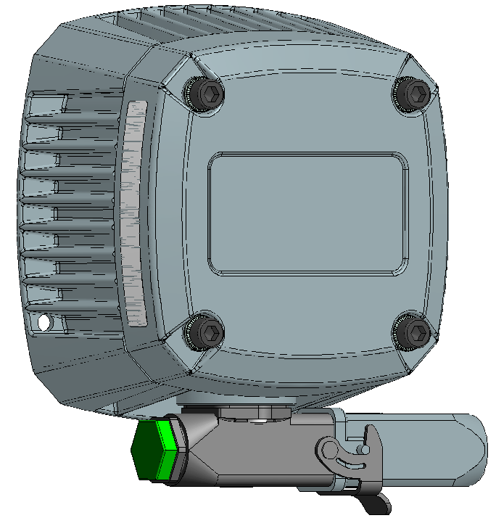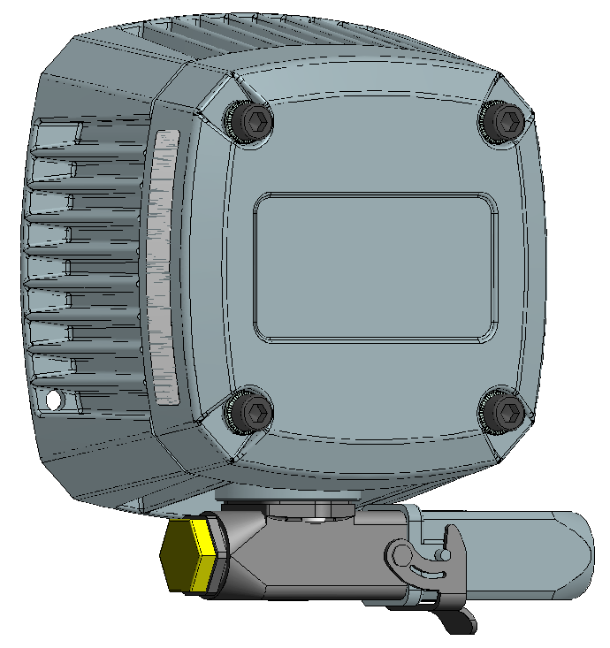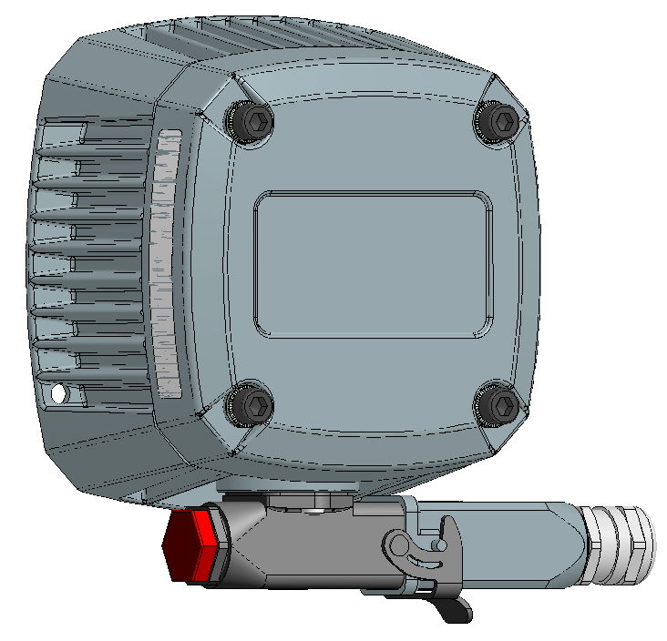
Figure 7 shows the arrangement of the iLED rear section with the operating hours indicator.
The position of the operating hours indicator (M20 blanking plug, semi-transparent) is shown in Figure 7.
Once the iLED is powered, the indicator illuminates green, yellow or red, depending on the number of operating hours. The possible states of the operating hours indicator are shown in Table 7.
The following areas for colour codes are required:
Table 7: Technical service life indication
Colour | Green | Yellow | Red
Technical Service life [%] | < 68% | > 68.1% < 81.1% | > 81,2%

Definition of Components and related Interfaces

Linefilters
Electric filters like chokes, capacitors and so forth are necessary for following interface lines:
- Power Supply
- CAN-Bus
- CAN-Bus address lines
- Operating Hours Indicator
They filter the provided supply voltage and CAN-Bus by the TCU. To suppress in- and outgoing Electromagnetical Interference (EMI) several high voltage capacitors are used. A common mode choke reduces EMI once again. Additional measures like suppressor diodes and metal oxide varistors limit the input voltage of the power supply stages further.

Inrush current limiter and Power supply supervision
To limit the inrush current and the total power consumption at power up a start-up circuit is implemented. Its aim is to reduce the inrush current to a reasonable value. If the current surge is too large the voltage drop at the feed line would waste too much energy and therefore start a power up / power down loop due to the undervoltage shutdown.
- The start-up time has to be less than 2 seconds.
- The inrush current has to be limited to a value smaller than 1,5 A. Typically inrush current of 1 A is preferred.
- The supply voltage range is 15 V to 53 V.
- If the supply voltage of the iLED is too high or too low, it switches off automatically (safe state).
The voltage at the large input capacitors is measured and the converters for the MPUs are enabled after a sufficient voltage is reached. A 10 ms interruption of the power supply has to be covered by these capacitors.
To prevent large feed line losses a low resistance (-> large cross section for the supply cable) is essential.
Table 8: Electrical characteristics iLED supply input
Input voltage range [V_{DC}] | Input current [A]
15 - 53 | Max 1,5
The input voltage monitoring must be switchable depending on the input voltage. Two zones must be provided.
The inrush current limiter may only be enabled in the following areas, depending on the input voltage.
Table 9: Release of input voltage
Input voltage range [V_{DC}] | Inrush enable range [V]
0 – 35 | 15 – 35
35 - 53 | 35 - 53

Power supply
Both channels are powered via separated power supplies. These step-down (buck) converters are powered by the Filter and Rectifier unit. Basically, these converters use Pulse Width Modulation (PWM) to store energy in a coil. If the output voltage drops below a predefined threshold the converter recharges the coil again.
Channel A differs in following way form Channel B. For the galvanically separated CAN-Bus-Interface a power supply voltage of 5 V is necessary.
So, in Channel A a DC/DC-converter to 5 V is necessary with a dropout regulator to 3,3V for the MPU and its periphery. This voltage of 5 V is also used for the CAN-Address Input interface and the operating hour indicator.
In Channel B a DC/DC-converter to 3,3 V is used so supply the MPU with its periphery.
The output current on both channels (A and B) should be limited to max. 0,5A.
Table 10: Electrical characteristics Channel supply
Channel | Input voltage range [V_{DC}] | Output voltage [V] | Output current [A]
A | 15 - 53 | 5 | 0,5
B | 15 - 53 | 3,3 | 0,5
The 3.3V supply voltage of the MPUs must be monitored within the required range of 3.0–3.6 V. If the supply voltage is outside this range, the corresponding MPU is held in reset mode. The MPUs must also measure the supply voltage of the other MPU and detect a safety issue. Also, the 5V supply of channel A has to be monitored.

2-Channel-Supply-Switch of LED-Converter
These two independent switches are the most important components to guarantee a safety response in all cases. These two independent switches are the most important components to guarantee a safety response in all cases.
If a fault is detected in one of the two channels, both safety switches must be able to be deactivated from that channel.
An additional mechanism must be implemented when the external watchdogs of the MPUs expire.
The correct function of the switches must be checked every time the LED is switched on. This switching must be done sequentially to test the correct activation of each of the two switches. In the next switching cycle, this procedure must be reversed. This ensures that each switch can be tested individually.
A minimized solution is shown in following Figure 8:
Figure 8: Arrangement of safety switches
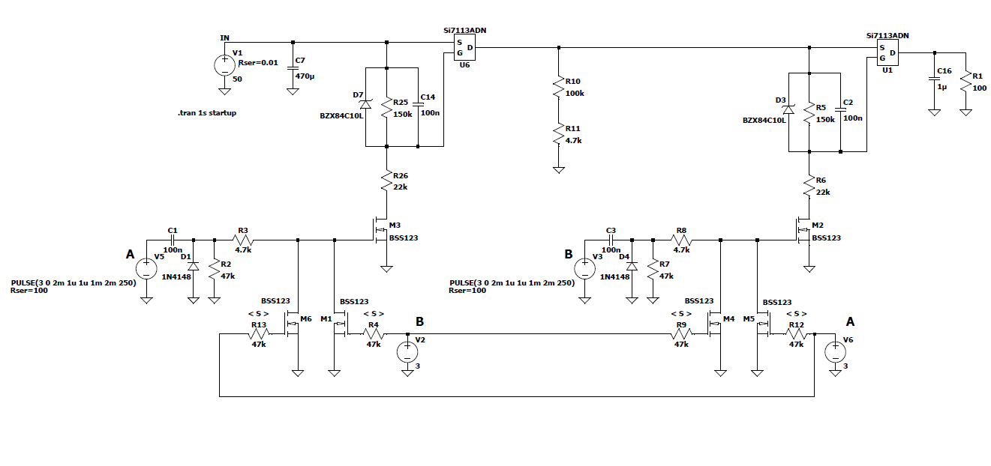
This Figure 8 is taken from a principal simulation to show the correct functionality of the safety-switches. If the MPUs are not working or they are in the reset state additional pull-ups have to disable the safety switches across the FETs. A single 3-Input AND-Gate (74LVC1G11GW) can also be used instead of the FET control circuit.
If a fault occurs in both safety switches and a short circuit exists in the subsequent LED converter, an additional fuse must be provided.
The output voltage of the safety switches has to be monitored periodically to detect a misfunction. During these tests, the switching on must be done alternately in order to test both FETs.

MPUs
For the processing of data, which are received via the CAN bus and handling the I/O lines which control the iLED 2.0 a 32-bit microcontroller (Member of STM32L4 Series)) is used.
For further information about the software see [SSS_ILED_SW].

MPU A
- CPU (Member of STM32L4 Series)
- Watch-Dog
- Reset
- External memory (EEPROM or FERAM across SPI-Interface)
- Intercommunication interface (1 or 2 SPI-Interface(s))
- CAN-Interface
- Operating Hour Interface on Channel A (no safety function)
- Channel Separation according Insulation Coordination
- Parallel-Interface for GPIO, Operating Hour Interface, PWM for LED brightness, CAN-ID
- ADCs for measurement of LED-Current, power supply voltages, temperature
- ADC-Test against second reference (e.g. power supply)
- Perform online tests to check correct functionality with certified ST Safety package.
- Hard coded port pins to detect correct MPU channel.
- ST-Link, JTAG-Interface, serial interface for software development

MPU B
The features of the B channel are nearly identical to the ones of the A channel. The difference is that the diverse firmware is loaded to the MPU B. The messages of the CAN-Interface are received over Intercommunication interface form MPU A.

CAN-Transceiver
This interface enables communication with the TCU. All iLEDs are connected to the TCU via this interface. The selection of the appropriate iLED is done using a 4-bit wide address secured with 2 bits.
The CAN interface is only connected to channel A. Information for channel B is also received from channel A and passed on to channel B unchanged via the intercommunication link.
- Galvanic Separation of 2000V_{AC}
- CAN H/L – Driver Interface with dedicated CAN-GND as reference potential.
- Preferred driver chip Texas Instruments ISOW1044BDFMR
The layout recommendations of the data sheet have to be observed:
Figure 9: Layout recommendation for ISOW1044BDFMR
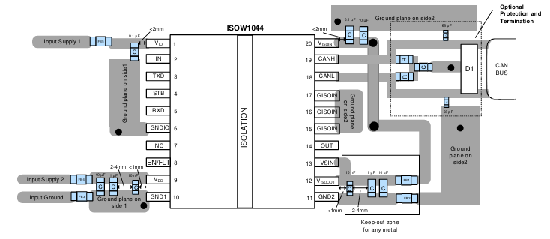

LED-Driver
Since the input voltage can fluctuate over a very wide range, and the LED boards on the other hand require a defined voltage with a regulated constant current, a back-boost converter must be used. To cover these requirements a new approach was used. To cover this wide spectrum, a transformer is needed.
A short circuit detection by measuring the voltage on the secondary side of the transformer is necessary.
To cover these requirements a new approach was used. The LEDs are operated with a constant current and they are dimmed by a PWM signal. The DIM signal is generated by channel A via its inbuilt PWM unit. Channel B enables the LED current with a AND-Gate. So, both channels are needed to generate a valid DIM signal. Flash is generated by channel A with 1 (2 Hz are foreseen for new markets). The DIM signal is used to define the brightness of the LEDs. A constant current of 200 mA has to be used.
To detect a specific fault case of the individual LEDs, in which a bypass resistor becomes effective and reduces the brightness of the LED, a current source with 4 mA must be implemented for testing purposes.
A defect in the 4mA current source can be detected by the LED current supervision circuits. A possible realization can be seen in following figure.

Figure 10: Principle of buck-boost converter for LEDs
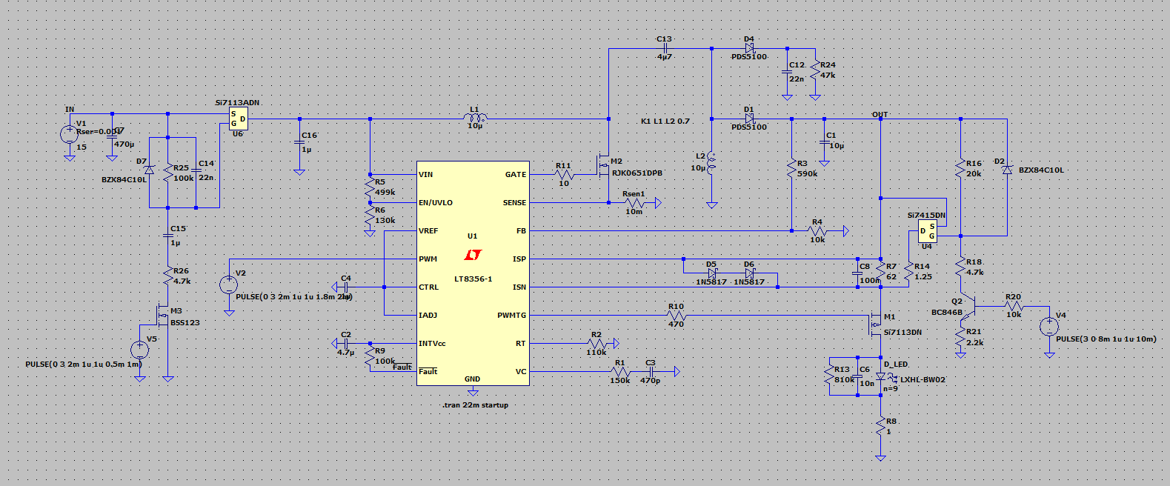

LED-Current supervision
The LED current monitoring is implemented in a 2-channel manner using 2 shunt resistors connected in series. To avoid current measurement being distorted by contact resistances, a Kelvin voltage tap should be used.
The 2-channel current supervision must be decoupled using safety resistors.
The PWM LED current to be measured must be smoothed with a 4th-order low-pass filter. Its cut-off frequency should be 50 Hz. This ensures that a smoothed signal arrives at the MPU's ADC.
To better measure the 4mA test current, a switchable amplifier should be implemented after the low-pass filter. The amplifier has to be controlled by the MPU.
Figure 11: Principle of LED Current Supervision
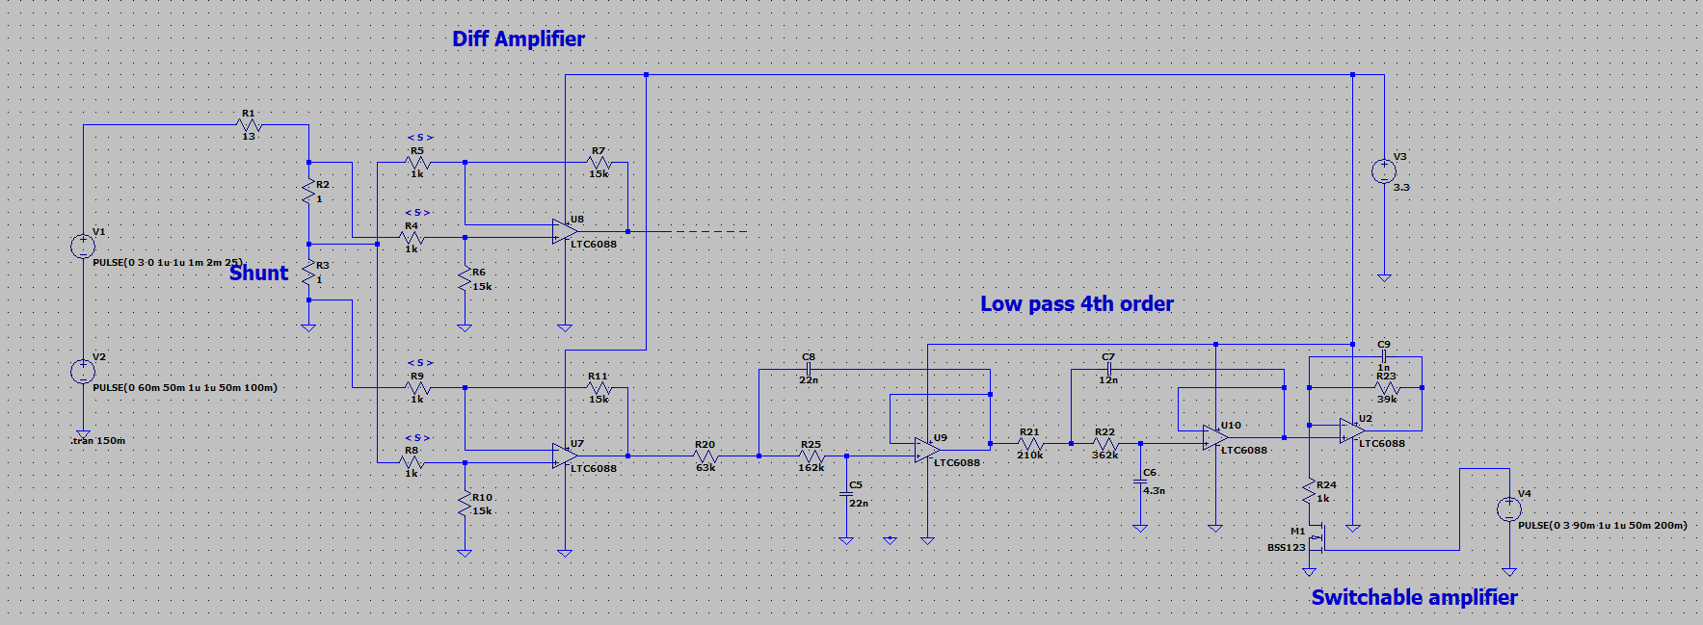

LED-INDIVIDUAL VOLTAGE MONITORING
The individual LED voltage monitoring is located on LED Board 4 [Circuit_LEDB4].
To detect a short circuit in the LED, an optocoupler with a series resistor is used in each channel. If a short circuit occurs, the entire chain voltage of the optocoupler outputs becomes high-impedance.
If all LEDs are working correctly, a PWM signal of the LED current passes through the optocoupler chain to a low-pass filter, which averages out the PWM signal and generates an LED OK to the MPU.
Figure 12: Principle of LED Voltage Monitoring
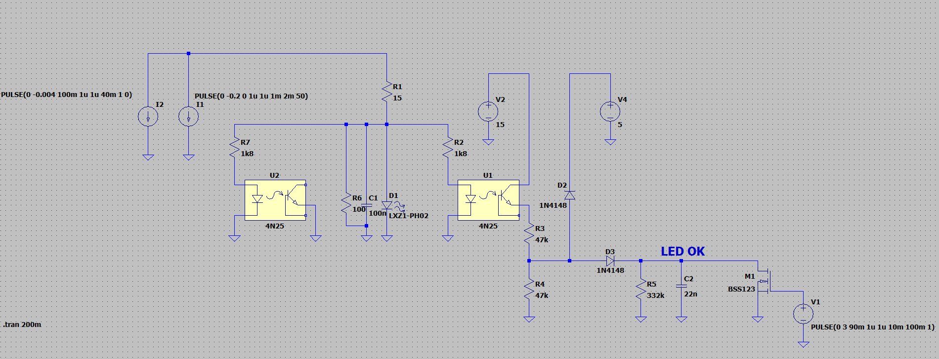
To reduce the discharge time of the low-pass filter, a FET is used to discharge the capacitor before the 4mA fault detection function is activated. This ensures that the fault can be detected within a short test time.

Hardware Watchdog
The following circuit is taken from an already implemented project using an STM32 MPU. The reset circuit monitors the supply voltage at 3.3 V and only enables the reset when the voltage is within this range. Resistor R353 allows you to select whether the MPU reset is triggered in addition to an interrupt.
Figure 13: Combined Reset and Watchdog
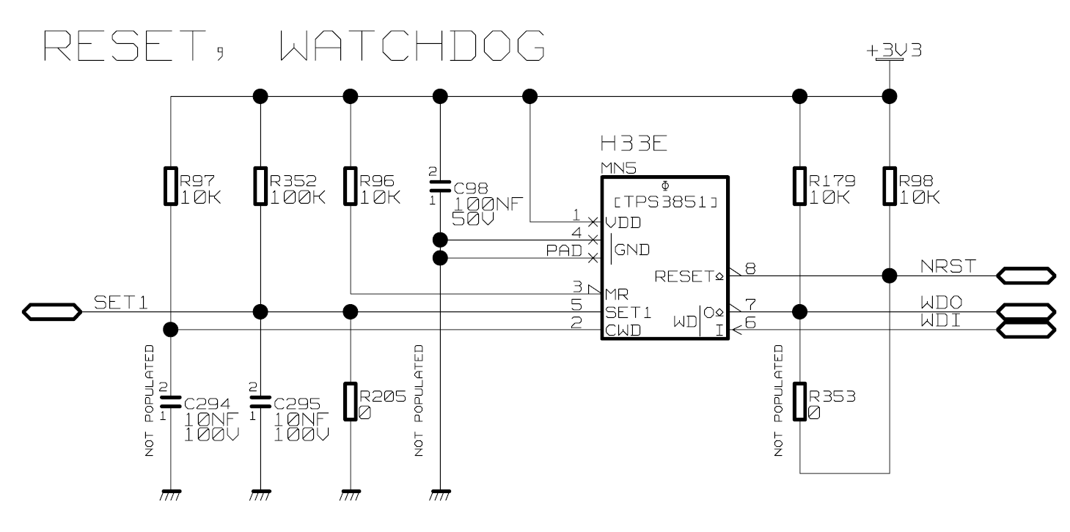

Fuses
A fuse must be installed in the input circuit to prevent a short circuit from causing the entire signal mast to fail.
Since a lot of energy is stored in the backup capacitors for the 10ms time bridging, an additional fuse must be connected in series with the "safety switches" for safety reasons.

Temperature Measurement
To measure the temperature, a sensor is connected to an I2C interface of the MPU. A component from the following family is used for this purpose. Additionally, the humidity can also be measured.
Manufacturer: Sensirion Type: SHT4x
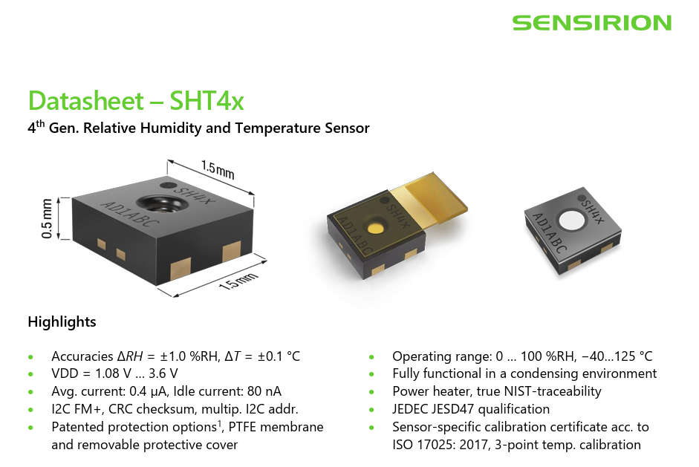

Reference Voltage
For precise measurement of the LED currents with the MPU A/D-converters, a precision voltage reference with a tolerance of 0.1% is used. This reference can be tested against the internal reference of the MPU.
Manufacturer: Analog Devices Type: ADR5043BKSZ-REEL7
Figure 14: 3.0V Voltage Reference
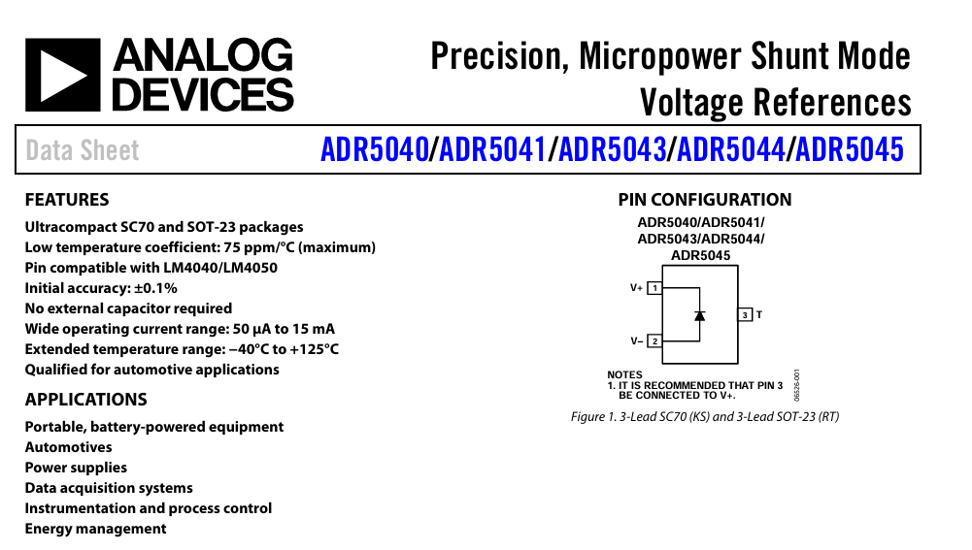

Operating Hour Indicator
The operating hours indicator is implemented on a separate circuit board using an RGY LED. The series resistors and capacitors for EMC protection are also located on this circuit board.
Figure 15: Possible RGY-LED for Operating hour indicator
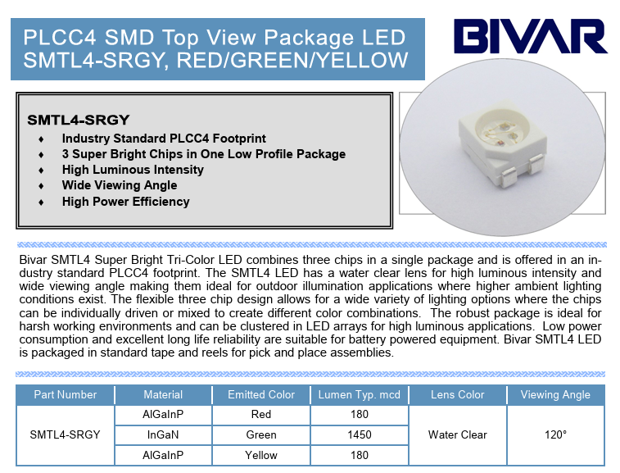
The operating hours indicator must be able to display three states:
- Green: up to 68% of the technical service life
- Yellow: from 68.1% to 81.1% of the technical service life
- Red: from 81.2% of the technical service life
The elapsed running time is counted by the MPU of channel A and stored in the EEPROM. This time can be read out over the CAN-Interface by a special command sequence.
Instead of a triple LED 3 separated LEDs can also be taken for better availability.

LED-Board
LED board 4, part number 3BU 61030 BxAA, is carried over unchanged from the previous project. Depending on the colour, it has 7 - 9 LEDs connected in series on the carrier board. Individual LED monitoring with optocouplers is also integrated on this board in a 2-channel configuration.
Figure 16: Excerpt from [Spec_LEDB4]
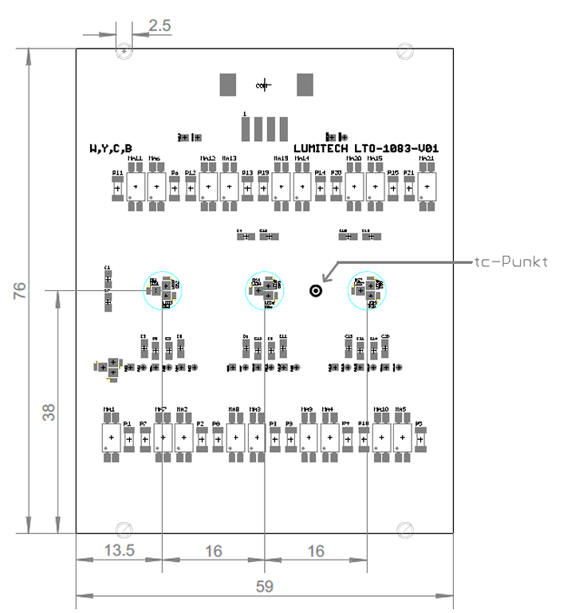
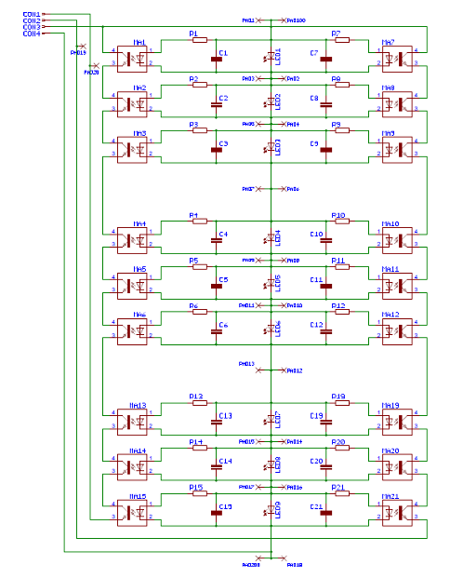

Manufacturing
The components of the iLED 2.0 (iLEDCB, LED Board) are assembled in the chassis of the light point. The available space is defined by the manufacturer of the chassis.
An unchangeable serial number is programmed into the microcontroller during the manufacturing process. This is done to track all changes to an iLED 2.0 (e.g. replacement of components, operating hours…).
The default mode of an iLED 2.0 is also non-erasable programmed into the flash. Several Modes are available like light points that indicate stop are switched on and the free indicating ones are switched off. This information depends on the colour information of the light point. This is why the colour is also stored at the flash memory for software purpose.
The luminous test procedure is done analogue to the RaiLed AT 1.1

Functional and Operational Scenarios

Startup Procedure
When the supply voltage is applied, the input voltage must be evaluated before the inrush current limiter is enabled. This is absolutely necessary so that if the input voltage falls below half the supply voltage, the iLED is switched off to prevent the supply voltage from collapsing completely.
Next, the inrush current limiter begins charging the decoupling capacitors that are necessary for the 10ms input voltage interruption.
Then the DC/DC converters start up to supply the MPUs.
The reset ICs hold the MPUs in reset until the supply voltage for the MPUs are in their working area.

MPU Startup (Initializing phase)
After the reset is released the MPU starts to work in following manner:
- Check the program memory for correct content (Flash checked against stored CRCs)
- Check the RAM for correct functionality
- Check the MPU functionality with the safety package of ST.
- Check EEPROM with CRC
- Retrigger Watchdog
- Measure ambient temperature and check for operating range
- Check correct function of A/D-Converter by comparison of external and internal voltage reference
- Check Channel Information (A or B)
- Start communication with MPU of second channel (Master – Slave Prinzip)
- Test Safety switches in combination with other MPU
- Check for disabled LEDs with measurement of LED current
- Switch ON/OFF of LED in dependence of the operating mode
- Read CAN-Address
- Start communication with TCU

MPU Main Tasks (Operating phase)
- Check CAN-Interface for received frames. If necessary, send them unaltered to the slave MPU.
- Change the operating for the light point to one of the following modes, On, Off, day or night and blinking.
- Permanently supervise the LED Current for its correct value
- Every 10 minutes check the measuring circuit by varying the LED Current (e.g. +/- 10%) alternating with the 4mA test current for bypass resistor on a defined LED.
- Permanently check supply voltage and temperature for correct operating range
- Alternating connection of the LED driver in the following manner:
  - Safety switch 1 -> Safety switch 2 -> PWM on
  - Safety switch 2 -> Safety switch 1 -> PWM on
  - PWM on -> Safety Switch 1 -> Safety Switch 2
The LED current may only flow once the last of the 3 steps has been completed.
- Permanently check the Flash and RAM memory of the MPU
- Permanently check the intercommunication between both MPUs
- Permanently check the correct function of the MPU
- Measure operating time and save it to the EEPROM

More detailed information for the software running on the MPUs can be found in [SSS_ILED_SW].

Environmental Conditions

Climatic Environmental Conditions
The iLED 2.0 will be designed according to the [EN50125-3], “EN 50125-3” / temperature class T1/T2 enhanced to +45°C (-40°C up to +45°C, humidity in tunnels) altitude class AX (2000m) and wind speed of 35m/s.
The radiated power of the sun will be considered (1120W per square meter) or it will be protected from direct sun light.

Mechanic Environmental Conditions
The iLED 2.0 will be designed according to the [EN50125-3], “EN 50125-3” / table 5 and 6 (outside the track 1 to 3m from the rail).

Electromagnetic Environmental Conditions
The iLED 2.0 will be designed according to the [EN50121-4], “EN 50121-4”.

Pollution
The iLED 2.0 will be designed for the level high according to the [EN50125-3], “EN 50125-3”, table 4.

Storage and Transport
The iLEDs (including the packaging material) must be stored and transported in a temperature range of
-40°C to + 70°C at an air pressure down to 70 kPa in accordance with [IEC60721-3-1], [IEC60721-3-2], “IEC 60721”.

Storage:
Climatic conditions 1K23
Biological conditions 1B1
Chemically active substances 1C2
Mechanically active substances 1S11
Mechanical conditions 1M11
The meaning of the classes is described in [IEC60721-3-1], “IEC 60721-3-1”
Transport:
Climatic conditions 2K12
Biological conditions 2B1
Chemically active substances 2C2
Mechanically active substances 2S5
Mechanical conditions 2M4
The meaning of the classes is described in [IEC60721-3-2], “IEC 60721-3-2”
To protect the LEDs at the LED Board during transport a protective layer (e.g. black plastic foil) is attached to the front lens assembly. This measure eliminates the risk of overheating by avoiding the bundling of the sun's rays through the lens.

Safety Integrity Level and Approval
The iLED 2.0 is developed for SIL4 applications according to the CENELEC standard. That means, that the standards and regulations [EN50121-4], [EN50122-1], [EN50124-1], [EN60529], [DIN6163], [EN50125-3], [EN50126-1], [EN50129], “Sgnalvorschrift V2” [Signal_V2_ÖBB], “Betriebsvorschrift V3” [DV_30_01] must be observed to obtain the approval according to CENELEC.
When using [EN50121-4], overvoltage category OV3 must be used.
A safety case has to be created according to [EN50126-1], [EN50126-2] and [EN50129]Error! Reference source not found.. When creating the safety report, it should be noted that the product life of the iLED 2.0 can ideally be up to 25 years and the LED signal may only be switched on every 2 years.
The tolerable hazard rate must be less than 1e-9 / h for the service life of 25 years.

Measures against systematic HW errors according to EN 50129
The types of faults are defined in the [EN50129]. The measures against the systematic HW errors according to [EN50129] have to be considered in the "iLED hazard analysis".
Single faults may not lead to a hazard. Due to the 2-channel architecture only a double fault could cause a hazard and has to be excluded by appropriate error detection (coordination between hardware and software measures).

Safety requirements for electrical equipment
The statutory provisions from the [AM-VO], “Employee Protection Act”, [EisbAV], “Railway Employee Protection Ordinance”, [AM-VO], “Work Equipment Ordinance for Work Safety of Austrian Railways (ÖBB)” must also be observed.
Special attention must be paid to hot surfaces.

Lifetime
designed life time is validated via the RAMS analysis. The product lifetime of 15 years, which is required in has to be fulfilled.
The failure rate during this time must not be more than 2% per year. It is assumed that there are 300 switch-on cycles (permanent light) per day or a lighting duration of 24 hours per day at an average ambient temperature of 20° C.
Due to the nature of the iLED 2.0 and its underlying technology no change in the lifetime is expected when operated in blinking mode.
When choosing components, the following points have to be considered:
- Fulfilment of environmental conditions, observance of the specified limits in the data sheets
- Availability from other suppliers („Second Source “) if applicable
- Future-proofed technology
- Components with long life-time have to be chosen
Over dimensioning of components (e.g. larger cases for resistors)

Documentation
For design, development, test, verification and validation a GTS Management compatible document set has to be created.
An installation and maintenance manual must be prepared. If settings or measurements are necessary on the product, a data or measurement sheet must be created.
Documents for planning, acceptance and commissioning regulations with a structure according to [Lastenheft_OeBB] have to be created.
The customer documentation has to be done in German language.

System Design

Hardware
During the design phase, simulation or testing with evaluation boards from the component manufacturers can be done.
Circuit diagrams, parts lists and layouts are created using the Hitachi Rail Electronic Workbench. This workbench is running on AWS-Server. The Cadence Tool Set supports circuit design and the integration of the layout tool. All information is stored and versioned with the Pulse system of Cadence.
The components are taken from the Component Information System (CIS), which is a Windchill PDMLink application. New components must be requested in the CIS system. This system manages, among other things, the symbols for the circuit and the footprint of the component.
The part list is stored in shared Palma.
Figure 17: GTS Design Environment
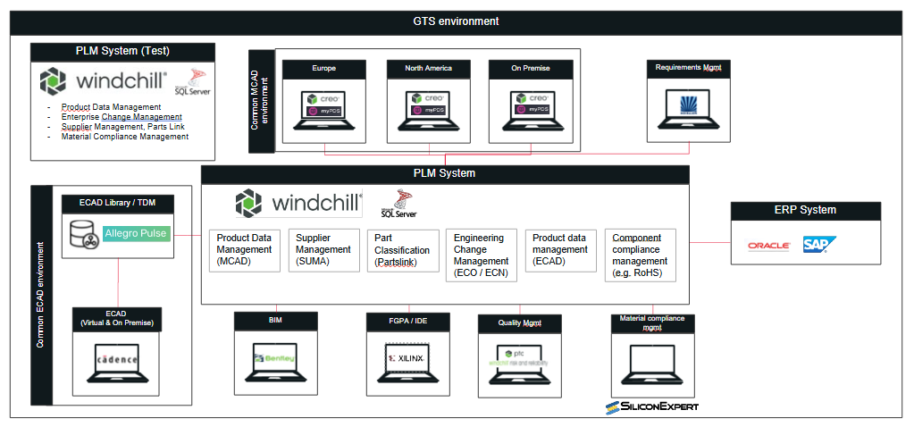

Software
The creation of the software is covered in a separate document [SSS_ILED_SW]. The following points are addressed there:
- Usage of compilers (certified for [EN50716])
- Test environment for module tests, integrations tests on software level
- Integrations test into the overall system
- Code coverage
- Use of Coding rules
- Code readings
- Verification, Validation of software

Traceability of requirements
!!! T.b.d. when requirements are available !!!

Notes

END OF DOCUMENT

