
COSBench User Guide
Version 2.8.6
Oct., 2018
Wang, Yaguang
This document describes how to install, configure, and run COSBench (a cloud storage benchmark tool) step by step, explains how to define workloads using configuration files, and provides reference examples.
Document Number: 328791-001US
INFORMATION IN THIS DOCUMENT IS PROVIDED IN CONNECTION WITH INTEL® PRODUCTS. NO LICENSE, EXPRESS OR IMPLIED, BY ESTOPPEL OR OTHERWISE, TO ANY INTELLECTUAL PROPERTY RIGHTS IS GRANTED BY THIS DOCUMENT. EXCEPT AS PROVIDED IN INTEL'S TERMS AND CONDITIONS OF SALE FOR SUCH PRODUCTS, INTEL ASSUMES NO LIABILITY WHATSOEVER, AND INTEL DISCLAIMS ANY EXPRESS OR IMPLIED WARRANTY, RELATING TO SALE AND/OR USE OF INTEL PRODUCTS INCLUDING LIABILITY OR WARRANTIES RELATING TO FITNESS FOR A PARTICULAR PURPOSE, MERCHANTABILITY, OR INFRINGEMENT OF ANY PATENT, COPYRIGHT OR OTHER INTELLECTUAL PROPERTY RIGHT. UNLESS OTHERWISE AGREED IN WRITING BY INTEL, THE INTEL PRODUCTS ARE NOT DESIGNED NOR INTENDED FOR ANY APPLICATION IN WHICH THE FAILURE OF THE INTEL PRODUCT COULD CREATE A SITUATION WHERE PERSONAL INJURY OR DEATH MAY OCCUR.
Intel may make changes to specifications and product descriptions at any time, without notice. Designers must not rely on the absence or characteristics of any features or instructions marked "reserved" or "undefined." Intel reserves these for future definition and shall have no responsibility whatsoever for conflicts or incompatibilities arising from future changes to them. The information here is subject to change without notice. Do not finalize a design with this information. The products described in this document may contain design defects or errors known as errata which may cause the product to deviate from published specifications. Current characterized errata are available on request. Contact your local Intel sales office or your distributor to obtain the latest specifications and before placing your product order. Copies of documents which have an order number and are referenced in this document, or other Intel literature, may be obtained by calling 1-800-548-4725, or by visiting Intel's Web Site http://www.intel.com/.
Software and workloads used in performance tests may have been optimized for performance only on Intel microprocessors. Performance tests, such as SYSmark* and MobileMark*, are measured using specific computer systems, components, software, operations and functions. Any change to any of those factors may cause the results to vary. You should consult other information and performance tests to assist you in fully evaluating your contemplated purchases, including the performance of that product when combined with other products. For more information go to http://www.intel.com/performance.
*Other names and brands may be claimed as the property of others.
Copyright © 2013 Intel Corporation. All rights reserved. Intel and the Intel logo are trademarks of Intel Corporation in the U.S. and other countries.
0413/RJM/MESH/PDF 328791-001US
Contents
1 Introduction 11
1.1 Reference Hardware Configuration 12
1.2 System Requirements 12
1.3 Supported Cloud Object Storage System Matrix 13
1.4 What’s in the Rest of This Guide 13
2 Installing COSBench 15
2.1 Installing the Operating System 15
2.1.1 Installing the Java Runtime Environment (JRE) 16
2.1.2 Installing Curl 16
2.2 Installing COSBench 17
2.2.1 Preparation 17
2.2.2 Installation 17
2.3 Directory Structure 18
2.3.1 Scripts 18
2.3.2 Sub-directories 19
2.4 Verifying Install 19
2.4.1 Launching COSBench 19
2.4.2 Checking Controllers and Drivers 20
2.4.3 Testing the Install 21
2.5 Deploying COSBench 22
3 Configuring and Running 23
3.1 General 23
3.2 Configuring the Controller 23
3.2.1 Conf/controller.conf 23
3.3 Configuring the Driver 24
3.3.1 Conf/driver.conf 24
3.4 Starting Drivers 25
3.5 Starting Controllers 26
3.6 Submitting Workloads 27
3.6.1 Defining Workloads 27
3.6.2 Submitting Workloads 30
3.6.3 Checking Workload Status 31
3.7 Stopping Drivers and Controllers 32
3.8 Configuring Tomcat 33
3.9 Workload management 33
4 Configuring Workloads 34
4.1 Introduction 34
4.2 Selection Expression (also referred to as Selector) 34
4.2.1 Overview 34
4.2.2 Selector 35
4.2.3 Allowable Combinations 36
4.3 Workload 36
4.3.1 General Format 36
4.3.2 Attributes 37
4.4 Auth 37
4.4.1 General Format 37
4.4.2 Attributes 37
4.4.3 Authentication Mechanisms 37
4.5 Storage 40
4.5.1 General Format 40
4.5.2 Attributes 40
4.5.3 Storage Systems 40
4.6 Work Stage 45
4.6.1 General Format 46
4.6.2 Attributes 46
4.7 Work 46
4.7.1 General Format 46
4.7.2 Attributes 48
4.8 Special Work 49
4.8.1 General Format 49
4.8.2 Supported Special Work 49
4.9 Operation 52
4.9.1 General Format 52
4.9.2 Attributes 52
4.9.3 Supported operations 52
4.9.4 Examples 56
4.10 Additional comments 57
4.10.1 Overview 57
4.10.2 Division strategy 57
5 Results 59
5.1 Structure 59
5.2 Per-Run Data 59
5.2.1 Overall Performance Data (e.g., w1-demo.csv) 60
5.2.2 Timeline Data (e.g., s3-main.csv) 60
5.2.3 Response-Time Histogram Data (e.g., w1-demo-rt-histogram.csv) 60
5.2.4 Response Time breakdown (e.g., s3-main.csv) 61
5.2.5 Workload-config.xml 61
5.2.6 Workload.log 61
5.3 Metrics 62
5.3.1 Throughput (Operations/s or Op/s) 62
5.3.2 Response Time (in ms) 62
5.3.3 Bandwidth (MB/s) 62
5.3.4 Success Ratio (%) 62
5.3.5 Other Metrics 62
6 FAQs 63
6.1 General 63
6.2 Swift 66
6.3 AmpliStor 67
6.4 S3 69
6.5 Ceph 69
6.6 CDMI 69
Appendix A. Sample Configurations 71
Swift 71
AmpliStor 72

Revision History
Revision | Date | Description
0.5 | July 14, 2012 | Initial version
0.6 | July 18, 2012 | Add “init” and “dispose” stages in AmpliStor* example and description for special stages
0.7 | July 20, 2012 | Add “nsroot” to storage parameter list to access AmpliStor v2.5 namespace; by default, it’s “/namespace”, set to “/manage/namespace” for v2.5
0.8 | July 24, 2012 | Change default listening ports:  - 8088->18088  - 8089->18089  - 9088->19088  - 9089->19089
0.9 | August 1, 2012 | Change example port numbers to 19088 and 18088 to avoid confusion
1.0 | August 9, 2012 | Add one section to describe data results and one section for FAQs
1.1 | August 13, 2012 | - Add one paragraph in result to explain metrics  - Modify AmpliStor sample to reflect v2.5 needs  - Add parameter list
1.2 | August 24, 2012 | Enhance content based on internal and external user feedback
1.3 | August 30, 2012 | - Add Red Hat screenshot  - Change runtime from 60 to 300 for AmpliStor example to avoid confusion  - Remove internal link for package downloading  - Fix one bug in “cleanup” stage of Swift sample
1.4 | September 14, 2012 | Fix inconsistencies
1.5 | September 17, 2012 | Change default OS to Ubuntu* 12.04.1 LTS desktop
1.6 | November 2, 2012 | Major modifications:  - Transfer all scripts to Ubuntu 12.04.1 compatible  - Add OS installation steps  - Add object integrity check parameter  - Add details about selector description  - Add details about directory structure  - Move workload configuration section from Appendix A to main body
1.7 | November 13, 2012 | Minor modifications:  - Correct batch script names  - Add one item in FAQ for handling “OOM” error
1.8 | November 20, 2012 | Change parameter “url” to “auth_url” for swauth and keystone to avoid confusion
1.9 | January 14, 2013 | - Add parameter “tenant_name” for keystone  - Add items in FAQ to explain testing with large objects
2.0 | January 25, 2013 | - Correct two minor typographic errors  - Add explanation about histogram data  - Reword FAQ #12
2.1 | February 19, 2013 | - Constrain supported AmpliStor versions to v2.3 and v2.5  - Minor formatting modifications
2.2 | March 7, 2013 | - Fix one typo from “apt-get” to “apt-get install”  - Correct one word from “turn-around point” to “tipping point”  - Add section 6.1.14 for how to split read/write  - Enhance section 6.1.6 for how to reuse data  - Minor rewording from “policy” to “policy UID” in section 6.3.1  - Enhance section 6.1.7 for configuring multiple same stages  - Add section 6.3.3 for how to simplify policy UID setting
2.3 | March 8, 2013 | - Add explanation about using “ps” in section 3.7  - Add explanation about how to do pre-test in section 6.2.2  - Reword section 6.1.12 to explain conditions for using only one worker  - Replace “Excel” with “spreadsheet program” in section 5.2.2  - Add case for multiple client daemons in AmpliStor section of Appendix A  - Add explanation for what commands do in section 2.2.2  - Add example controller configuration to show multiple drivers supporting in section 3.2.1  - Correct one typographic error in section 6.1.9
2.4 | March 13, 2013 | - Change “enlarging” to “expanding” and add example
2.5 | March 29, 2013 | - Change “127.0.0.1” to “192.168.250.36” in text and screen captures of sections 2.4.3, 3.5, 3.6, 4.4.3, and Appendix A  - Add AmpliStor v3.1 in section 1.1  - Remove mention of licensing in section 2.3.1
2.6 | April 7, 2013 | - Add package list information in section 2.1 and provide one separate pkg.lst  - Add “retry” parameter for auth to overcome failures at high concurrent requests for authentication.  - Change “mandatory” to “required” in section 3.2.1
2.7 | July 22, 2013 | - Add filewrite usage information in section 4.9 (from Niklas)  - Add sequential selector in section 4.2.2 (from Niklas)  - Change the measurement unit for bandwidth from MiB/s (=1024*1024 Byte/s) to MB/s (=1000*1000 Byte/s).
2.7.1 | July 29, 2013 | - Add S3 configuration information in section 4.5.3  - Add S3 FAQ in section 6.4  - Change mailing list url in section 1  - Add supported storage system matrix in section 1.3
2.7.2 | August 27, 2013 | - Minor rewording
2.8 | October 31, 2013 | - Add direct auth for swift in section 4.5.3  - Add sproxyd adapter parameter list in section 4.5.3  - Add “delay” stage in section 4.8.2  - Add tomcat related configuration information, including web authentication for web console in new section 3.8  - Add configurable “archive” folder in section 3.2  - Add workload management information in section 3.9  - Add sentences about multiple stages in workload configuration UI page in section 3.6.1  - Add histogram selector in section 4.2.2
2.8.1 | November 14, 2013 | - Add section 4.10 to describe additional hints like data division strategy for workload configuration.  - Correct sentences in section 4.2.2 for range selector,  - Add FAQ 6.1.17 to explain how to use range selector in normal stage.  - Add “afr” parameter in section 4.7.2
2.8.2 | Feb 13, 2014 | - Add parameter “pool_size” for Scality sproxyd adapter in section 4.5.3.  - Add explanation for “nsroot” parameter in section 6.3.4.  - Update the binary package link in section 2.2.1  - Correct description for histogram selector to emphasis the number is weight instead of percentage in section 4.2.2.  - Add “httpauth” authentication mechanism in section 4.4.  - Add “cdmi” storage type in section 4.5.
2.8.3 | May 12, 2014 | - Added advanced config UI related information in  section 3.6.1 and 3.6.2  - Add cvstool as optional prerequisites if user may need it to process generated results.  - Add “driver” parameter in section 4.7.2.  - Add section 6.5 for ceph FAQ.  - Update compatibility list in section 1.3.  - Add section 5.2.4 for response time breakdown information.  - Add section 6.6 for CDMI FAQ.  - Add cdmi_swift in section 4.5.3.  - Add FAQ in 6.2.4 for tempauth.
2.8.4 | July 3, 2014 | - Add “policy” parameter in swift for storage policy feature in section 4.5.3.  - Add one FAQ entry to explain how to enable storage policy for swift in section 6.2.5  - Correct the extension of tomcat configuration files from .conf to .xml in section 3.8  - Add one FAQ entry to explain how to make multiple drivers running on the same physical node in section 6.1.18.
2.8.5 | Oct. 22, 2014 | - Add librados storage parameters in section 4.5.3.1.9  - Add FAQ entry to explain how to change logging level to disclose more detailed information for trouble shooting in section 6.1.19  - Add “caching” parameter for Auth in section 4.4.3  - Add new “list” operator in section 4.9.3
2.8.6 | Oct. 11, 2018 | - Add Hitachi Content Platform to Supported Cloud Object Storage Matrix in section 1.3  - Add where to find XML example for Hitachi Content Platform storage config in section 3.6  - Add section 4.3.5.1.11 defining the valid parameters for configuring the hcp storage adaptor  - Add section 6.7 for FAQ for HCP storage adaptor
- Introduction
COSBench is a distributed benchmark tool to test cloud object storage systems, it supports a few cloud object storage systems so far (see 1.3 “Supported Cloud Object Storage System Matrix”). COSBench also allows users to create adaptors for additional storage systems. Please refer to the “COSBench Adaptor Development Guide” for details.
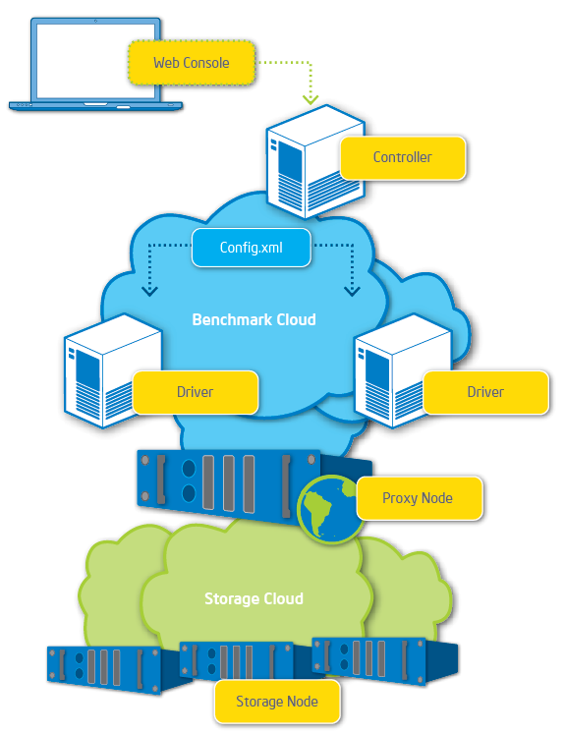
COSbench consists of two key components:
- Driver (also referred to as COSBench Driver or Load Generator):
- Responsible for workload generation, issuing operations to target cloud object storage, and collecting performance statistics.
- Can be accessed via http://<driver-host>:18088/driver/index.html.
- Controller (also referred to as COSBench Controller):
  - Responsible for coordinating drivers to collectively execute a workload, collecting and aggregating runtime status or benchmark results from driver instances, and accepting workload submissions.
  - Can be accessed via http://<controller-host>:19088/controller/index.html.
The controller and driver can be deployed on the same node or different nodes, and the node can be a physical machine or virtual machine (VM) instance.
Intel source code for COSBench is being released under the Apache 2.0 license, and hosted at http://github.com/intel-cloud/cosbench/.
A mailing list has been established for COSBench at the following location: http://cosbench.1094679.n5.nabble.com/.

  - Reference Hardware Configuration
The hardware configurations used for validation purposes in Intel labs are given below. This information is provided for reference only, as the appropriate systems for various implementations are highly dependent upon individual usage scenarios. Also note that network resources play a vital role in COSBench implementations.
Hardware | Configuration
Controller
Processor | Two Intel® Xeon® processors X5570 @ 2.93 GHz
RAM | 12 GB RAM
Storage | 1x 120 GB+ disk drive
Network | Intel® 82574 Gigabit Ethernet Controller
Driver
Processor | Two Intel Xeon processors X5570 @ 2.93 GHz
RAM | 12 GB RAM
Storage | 1x 50 GB+ disk drive
Network | Intel® 82599 10 Gigabit Ethernet Controller
  - System Requirements
NOTE: The current release of COSBench features Ubuntu* 12.04.1 LTS Desktop, but the COSBench development team assumes that organizations will install using various OSs and contribute related feedback to the community.
- Ubuntu 12.04.1 LTS Desktop
- Java* Runtime Environment 1.6 or later
- Curl 7.22.0 or later
- Csvtool if processing generated csv files is required.
- Free TCP port (ensure these ports are accessible non-locally):
  - On COSBench controller machine: 19088
  - On COSBench driver machines: 18088
NOTE: Throughout this document, command line is bolded and italicized; yellow text is used for emphasis, to draw attention to specific information.
  - Supported Cloud Object Storage System Matrix
Generally, two parts will be involved to access each cloud object storage system, they are the authentication mechanism and object access semantics. To meet the complexity from different systems, COSBench treats them separately, and encapsulate into two APIs (AuthAPI and StorageAPI).
Developer can implement them in different bundles, or combine them into one, and users can combine one Auth API implementation with multiple storage API implementations, or associate multiple Auth API implementations with one storage API implementations. Please refer to the “COSBench Adaptor Development Guide” for details.
Below table lists the status of different AuthAPI and StorageAPI combinations so far, it may be updated time to time:
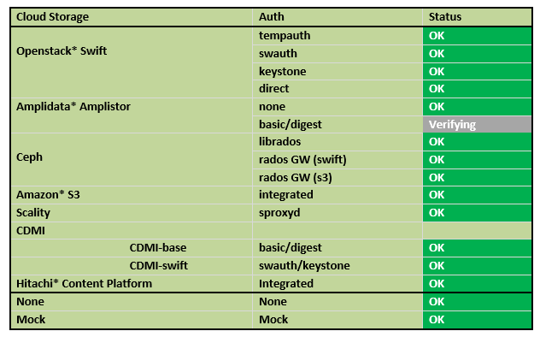

Note:
* librados is contributed by Niklas Goerke - niklas974@github,
* sproxyd is contributed by Christophe Vedel from Scality
  - What’s in the Rest of This Guide
This document describes how to install, configure, and use COSBench, a cloud storage benchmarking tool.
- Section 2 covers the initial installation and testing of COSBench.
- Section 3 explains how to configure and run the tool.
- Section 4 instructs the user about how to define workloads.
- Section 5 explains the results provided by COSBench and how to interpret them.
- Section 6 answers frequently asked questions.
- Appendix A provides sample configurations for different storage systems.
- Installing COSBench
  - Installing the Operating System
- Download Ubuntu Desktop 12.04.1 LTS.
- Follow the instructions in the Ubuntu installation guide.
- Below are screenshots from major steps during installation, which include the creation of one user named “cosbench”; all other settings may be left at their defaults or modified at the user’s discretion.
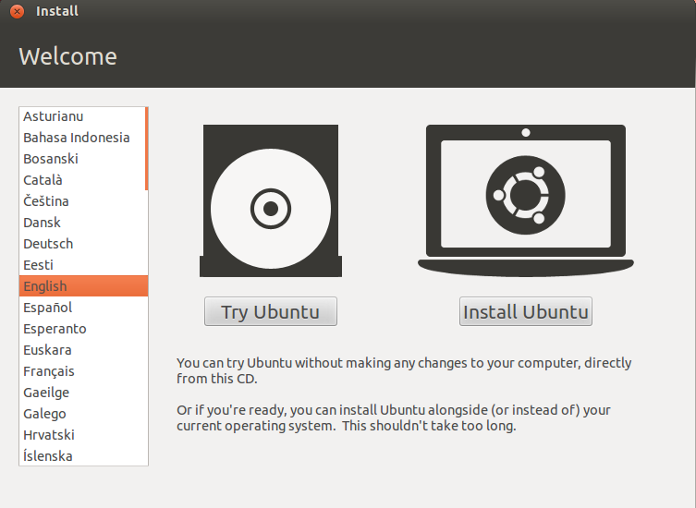
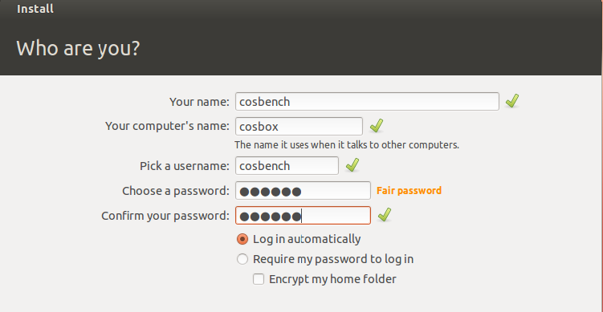
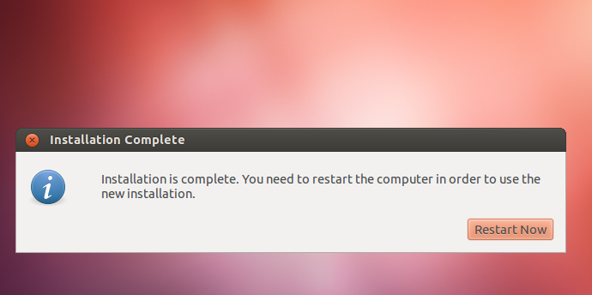
- The final package list after installation can be found in the file “pkg.lst” on the github site.
    - Installing the Java Runtime Environment (JRE)
- OpenJDK is the default JRE; Oracle JRE should also work.
- If an Internet connection is available, the package can be installed through apt-get as follows:
cosbench@cosbox:~$ sudo apt-get update
cosbench@cosbox:~$ sudo apt-get install openjdk-7-jre
- If no Internet connection is available, the JRE can be installed using Debian* software packages; two packages are essential: JRE-LIB and JRE-HEADLESS.
- Those packages can be installed as follows (this procedure uses “/tmp” as an example; a different folder may be used at the user’s discretion):
cosbench@cosbox:/tmp$ sudo dpkg –i –force depends openjdk-7-jre-lib_7u7-2.3.2a-0ubuntu0.12.04.1_all.deb
(Reading database …

cosbench@cosbox:/tmp$ sudo dpkg –i –force depends openjdk-7-jre-headless_7u7-2.3.2a-0ubuntu0.12.04.1_amd64.deb
Selecting previously unselected package openjdk-7-jre-headless …

cosbench@cosbox:/tmp$ java –showversion
java version “1.7.0_07”
…
    - Installing Curl
- If an Internet connection is available, Curl can be installed as follows:
cosbench@cosbox:~$ sudo apt-get update
cosbench@cosbox:~$ sudo apt-get install curl
- If no Internet connection is available, install Curl using Debian software packages:
cosbench@cosbox:/tmp$ sudo dpkg –i curl_7.22.0-3ubuntu4_amd64.deb

cosbench@cosbox:/tmp$ curl –V
curl 7.22.0 (x86_64-pc-linux-gnu) …
  - Installing COSBench
    - Preparation
In the current release, the COSBench controller and driver are combined; they do not each have a separate package.
Obtain the installation package <version>.zip (e.g., 2.1.0.GA.zip) from https://github.com/intel-cloud/cosbench/releases and place it at COSBench package under the home directory on the controller node.
    - Installation
Follow the commands below to finish the installation, which unpacks the COSBench package into one folder, create one symbolic link called “cos” to it, and make all bash scripts executable:
cosbench@cosbox:/tmp$ cd ~
cosbench@cosbox:~$ unzip 2.1.0.GA.zip
cosbench@cosbox:~$ rm cos
cosbench@cosbox:~$ ln –s 2.1.0.GA/ cos
cosbench@cosbox:~$ cd cos
cosbench@cosbox:~$ chmod +x *.sh
  - Directory Structure
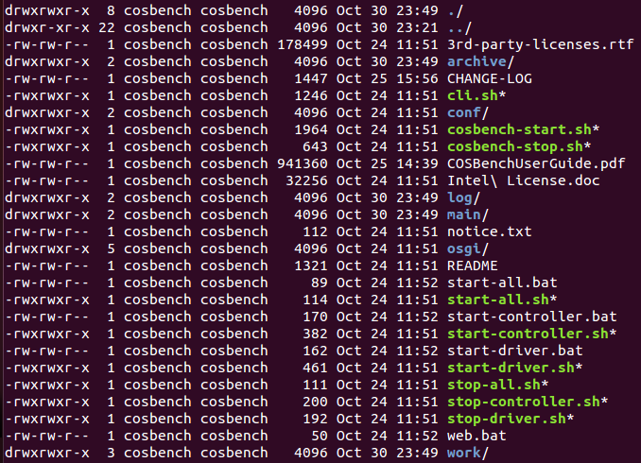
    - Scripts
Script | Description
start-all.sh  stop-all.sh | Start/stop both controller and driver on current node
start-controller.sh  stop-controller.sh | Start/stop controller only on current node
start-driver.sh  stop-driver.sh | Start/stop driver only on current node
cosbench-start.sh  cosbench-stop.sh | Internal scripts called by above scripts
cli.sh | Manipulate workload through command line
A few Windows* batch scripts are also included, for demonstration purposes only.
Script | Description
start-all.bat | Start both controller and driver on current node
start-controller.bat | Start controller only on current node
start-driver.bat | Start driver only on current node
Web.bat | Open controller web console through locally installed browser
    - Sub-directories
Sub-directory | Description
archive | Stores all generated results; see the Results section of this document
conf | Configuration files, including COSBench configurations and workload configurations
log | Runtime log files; the important one is system.log
osgi | Contains COSBench libraries and third-party libraries
main | Contains the OSGi launcher
  - Verifying Install
The following steps launch the controller and driver on the current node and test to ensure that the installation is correct.
    - Launching COSBench
HTTP proxy breaks the interaction between controller and driver. To avoid HTTP requests routing, you need to bypass the proxy setting:
cosbench@cosbox:~$ unset http_proxy
Start up the COSBench driver and controller on the current node. By default, the COSBench driver listens on port 18088, and the COSBench controller listens on port 19088.
cosbench@cosbox:~$ sh start-all.sh
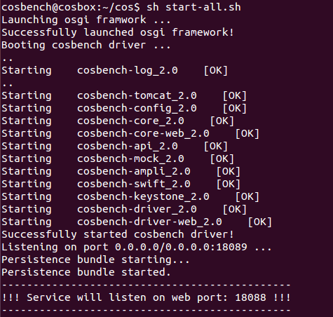
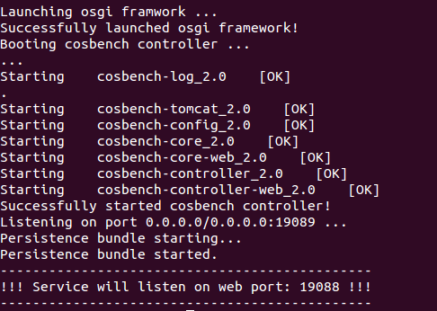
    - Checking Controllers and Drivers
cosbench@cosbox:~$ netstat –an |grep LISTEN |grep 19088 # check controller.
tcp 0 0 :::19088 :::* LISTEN

Cosbench@cosbox:~$ netstat –an |grep LISTEN |grep 18088 # check driver
tcp 0 0 :::18088 :::* LISTEN
    - Testing the Install
Cosbench@cosbox:~$ sh cli.sh submit conf/workload-config.xml # run mock test.
Accepted with ID: w1

cosbench@cosbox:~$ sh cli.sh info
Drivers:
driver1 http://127.0.0.1:18088/driver
Total: 1 drivers

Active Workloads:
W1 Thu Jul 12 04:37:31 MST 2012 PROCESSING
Open http://127.0.0.1:19088/controller/index.html in a browser to monitor status. In the example below, one “processing” workload is listed in the “active workloads” section.
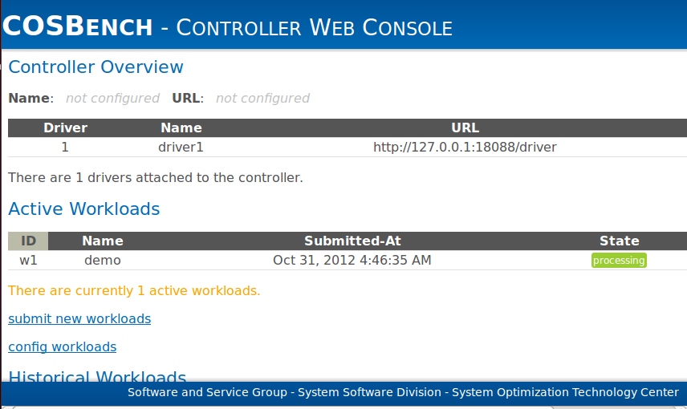
COSBench is now successfully installed on the current node. Optionally, the workload may be cancelled and COSBench may be stopped as follows:
cosbench@cosbox:~$ sh cli.sh cancel w1
W1 Thu Jul 12 23:34:14 MST 2012 CANCELLED

cosbench@cosbox:~$ sh stop-all.sh
Stopping cosbench controller ...
Successfully stopped cosbench controller.

==================================================
Stopping cosbench driver ...
Successfully stopped cosbench driver.
  - Deploying COSBench
- Copy <version>.zip to the remaining COSBench nodes by means such as scp or shared folder.
- Repeat the procedures listed above for installing COSBench and verifying the installation on each node.
- Configuring and Running
  - General
The COSBench controller and driver depend on different system configuration files to start up, and those configuration files are only for COSBench itself, as opposed to workload configuration.
The following table gives an overview of all the configurations COSBench expects.
Configuration | Description | File Path
controller | Configuration for a controller; read by the controller during its initialization | conf/controller.conf
driver | Configuration for a driver; read by the driver during its initialization | conf/driver.conf
workload | Configuration for a workload being submitted | Submitted via controller’s web interface
  - Configuring the Controller
    - Conf/controller.conf
An INI format file is required for configuration of the COSBench controller, as in the following example:
[controller]
concurrency=1
drivers=3
log_level = INFO
log_file = log/system.log
archive_dir = archive

[driver1]
name=driver1
url=http://192.168.10.1:18088/driver

[driver2]
name=driver2
url=http://192.168.10.2:18088/driver

[driver3]
name=driver3
url=http://192.168.10.3:18088/driver

[controller]
Parameter | Type | Default | Comment
drivers | Integer | 1 | Number of drivers controlled by this controller
concurrency | Integer | 1 | Number of workloads that can be executed simultaneously
log_level | String | “INFO” | “TRACE”, “DEBUG”, “INFO”, “WARN”, “ERROR”
log_file | String | “log/system.log” | Where the log file is stored
archive_dir | String | “archive” | Where the archived workload results are stored
The driver section for the nth driver should be named driver<n> in order to be recognized.
[driver<n>]
Parameter | Type | Default | Comment
name | String |  | Label used to identify the driver node. Note that driver name is not necessarily the node’s hostname
url | String |  | Address to access the driver node
  - Configuring the Driver
    - Conf/driver.conf
This file is optional; the COSBench driver can start up without this configuration file, although the web console can’t correctly label the driver node. Configuration is an INI format file, as in the following example:
[driver]
name=driver1
url=http://192.168.0.11:18088/driver

[driver]
Parameter | Type | Default | Comment
name | String |  | Label used to identify the driver node; note that driver name is not necessarily the node’s hostname
url | String |  | Address to access the driver node
  - Starting Drivers
- Edit conf/driver.conf on driver nodes, if desired.
- By default, COSBench driver listens on port 18088.
- Launch driver on all driver nodes.
sh start-driver.sh
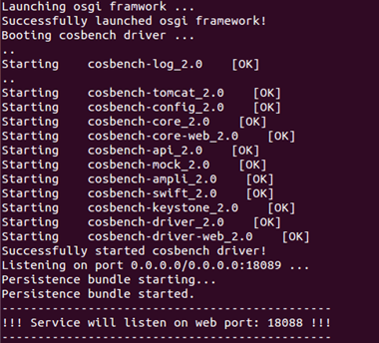
- Ensure that all drivers are accessible from the controller using an HTTP connection.
- By connecting with Curl, one valid HTML file is expected in the console:
curl http://<driver-host>:18088/driver/index.html
- When http://<driver-host>:18088/driver/index.html is opened in a web browser, the following web page displays:
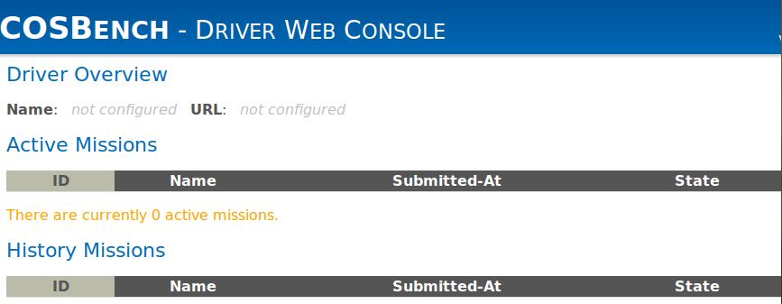
NOTE: If any errors or unexpected results occur, please check system configurations; common issues include firewall filtering or http proxy routing.
  - Starting Controllers
- Edit conf/controller.conf on the COSBench controller machine.
- By default, the COSBench controller listens on port 19088.
- Launch Controller on the controller node.
sh start-controller.sh
- Ensure that the controller is started successfully.
  - By connecting with Curl, one valid HTML file is expected in the console:
curl http://<controller-host>:19088/controller/index.html
  - When http://<controller-host>:19088/controller/index.html is opened in a web browser, the following web page displays (note that the <controller-host> IP address 192.168.250.36 shown in the screen capture below is replaced with the actual IP address of the controller node):
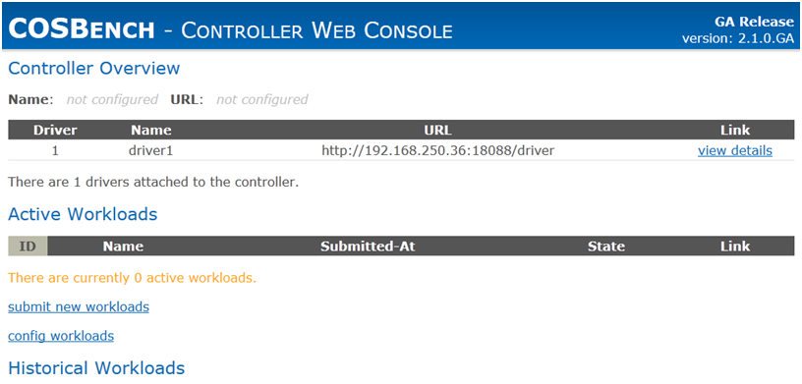
  - Submitting Workloads
A few templates are provided for reference in the conf/ directory:
- workload-config.xml is a template with comments to describe how to configure for different storage types. It will access mock storage to help with verification.
- swift-config-sample.xml is a template for the OpenStack Swift storage system.
- ampli-config-sample.xml is a template for the Amplidata AmpliStor v2.3 and v2.5 storage systems. See Appendix A for version-specific configuration information.
- s3-config-sample.xml is a template for Amazon S3 compatible storage system.
- aliyun-config-sample.xml is a template for Aliyun OSS storage system
- hcp-config-sample.xml is a template for Hitachi Content Platform storage system
    - Defining Workloads
For details of how to create a workload config file for user-defined workloads, please see the Workload Configuration section of this document.
Basic workload configuration options are also available from the workload configuration page on the controller web console; please refer to the Workload Configuration section of this document to customize the XML file for maximum flexibility. (Note that the <controller-host> IP address 192.168.250.36 shown in the screen capture below should be replaced with the actual IP address of the controller node.)
The workload configuration page supports to define multiple same stages, and also it allows to insert delay between stages to help identify boundary.
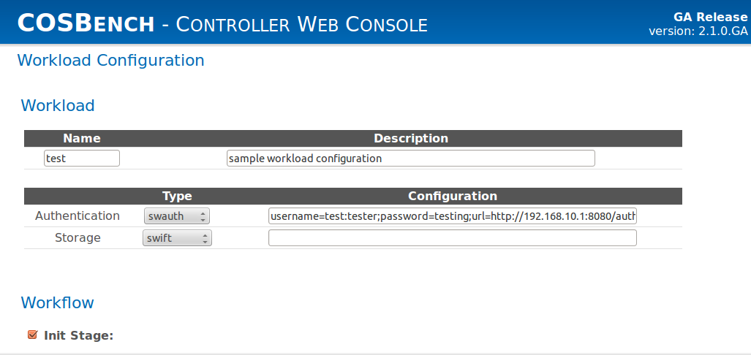
To define bulk workloads, we can use 'advanced config for workloads' hyperlink on controller web console. Advanced config UI helps to automatically generate a very large number of different combinations of various input parameters such as object sizes, objects per container, number of containers, workers, read-write-delete ratios.
Once you click on 'advanced config for workloads' hyperlink, you will go to advanced config screen. From here, you can either generate workloads files or submit workloads directly.
In this section we will look into how to generate workload files. Whatever value you enter in 'Workload Matrix Name', a directory with that name will be generated inside 'workloads' directory under COSBench installation directory on machine where controller is installed.
For each workload you define from this screen, a file with name equal to the string you entered inside 'Workload Name' field will be created and will be placed under workload matrix directory created in previous step. There are some constraints on the names which you can enter in 'Workload Matrix Name' and 'Workload Name' fields. You should use alphabets or numbers, special characters allowed include _ - #. ( ) / % &. Length of string entered should be between 3 to 50 characters. Authentication and Storage configurations will be common to all workloads on advanced config UI page. Similarly attributes like Runtime, Rampup, Delay and Number of drivers will be common to all workloads defined on this web page. Following input parameters are necessary for defining each workload:
Parameter | Type | Default | Comment
Object sizes | String | 4,128,512 | Can be comma separated or can be a range
Object size unit | String | KB | Drop down box consisting of values like Byte, KB, MB, GB
Objects per container | String | 1000 | Comma separated string
Containers | String | 1,1000 | Comma separated string
Workers | String | 1,2,4,8,16,32,64 | Comma separated string
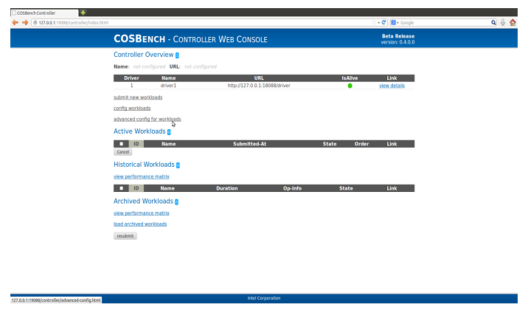
Apart from these parameters, you can also add as many read-write-delete combinations as you want to any workload with the help of 'Add RWD ratio' button. You can also add as many workloads as you want with the help of 'Add Workload' button.
Once done with filling all these fields with appropriate values, you can then click on 'Generate Workload File/s' button. This will generate all configuration files at already mentioned location. You can edit these configuration files if you want and then submit them through workload submission UI screen. We also have option to submit to workloads directly through this page. We will look into that method in next sub-section.
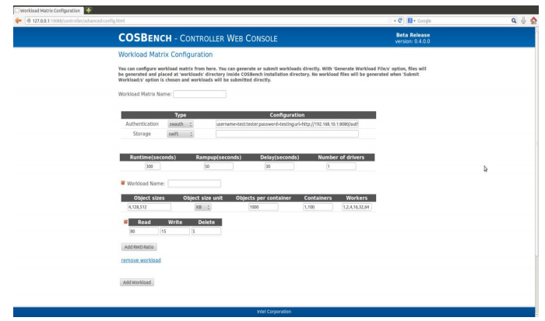
    - Submitting Workloads
There are two ways to submit workloads to COSBench.
- Using the command-line interface:
sh cli.sh submit conf/config.xml
- Using the web console:
Open http://<controller-host>:19088/controller/index.html in a browser to monitor running status. (Note that the <controller-host> IP address 192.168.250.36 shown in the screen capture below should be replaced with the actual IP address of the controller node.)
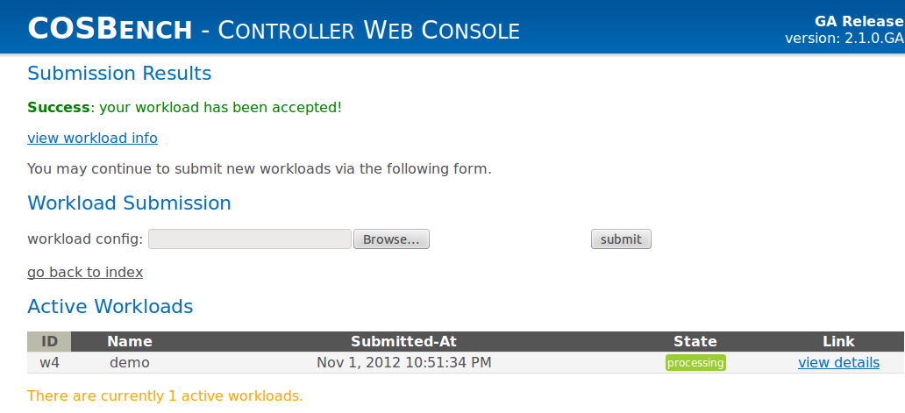
    - Checking Workload Status
There are also two ways to check workload status.
- Using the command-line interface:
sh cli.sh info
- Using the web console:
Open http://<controller-host>:19088/controller/index.html in a browser to monitor running status. (Note that the <controller-host> IP address 192.168.250.36 shown in the screen capture below should be replaced with the actual IP address of the controller node.)
You can also submit workloads directly through advanced config UI page. However, this page submits workloads generated which are defined through this page itself. You can use ‘Submit Workload/s’ button for the same. To learn how to define workloads through advanced config UI, please refer to previous sub-section.
Clicking view details in the Active Workload section of that interface screen displays runtime performance data, as shown below:
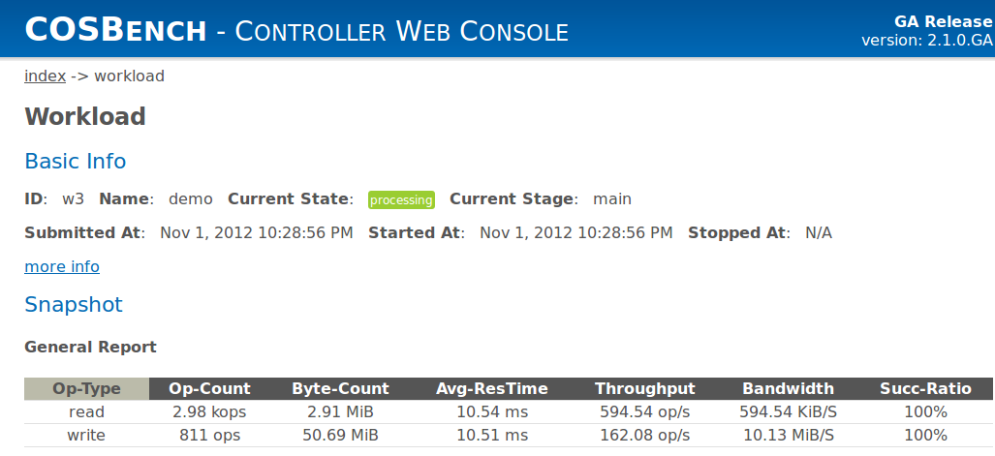
  - Stopping Drivers and Controllers
ps |grep java # you should see java here.
sh stop-driver.sh
ps |grep java # should be no java running.

ps |grep java
sh stop-controller.sh
ps |grep java
The “ps” command is used to help confirm whether the driver or controller process is stopped. If the Java process doesn’t stop as expected, the user may forcibly stop it by killing the process.

  - Configuring Tomcat
COSBench controller and driver use Apache Tomcat as the web server, the following table gives an overview of all the configurations related to Tomcat.
Configuration | Description | File Path
Tomcat for controller | Configuration for the web server on controller | conf/ controller-tomcat-server.xml
Tomcat for driver | Configuration for the web server on driver | conf/ driver-tomcat-server.xml
Tomcat web authentication | Configuration for web authentication, by default, there is a default username/password pair configured, user can change the “password” in configuration file to enforce username/password authentication when accessing web console. | conf/cosbench-users.xml
  - Workload management
COSBench can accept multiple workload submissions, it maintains one job queue for those workloads, and executes them one by one.
On controller web console, workloads are organized into three sections:
- Active workloads: those are just submitted and not finished yet, including the one is in processing and those are in queue.
- Historical workloads: those are the workloads which have finished.
- Archived workloads: those are the workloads which were done in previous cosbench restart. COSBench can recognize workload results which were generated by previous instance, and can load or unload them on demand.
COSBench supports to manage those workloads through below approaches:
- Reorder workloads in active list
- Load/unload archived workloads
- Re-submit historic or archived workloads
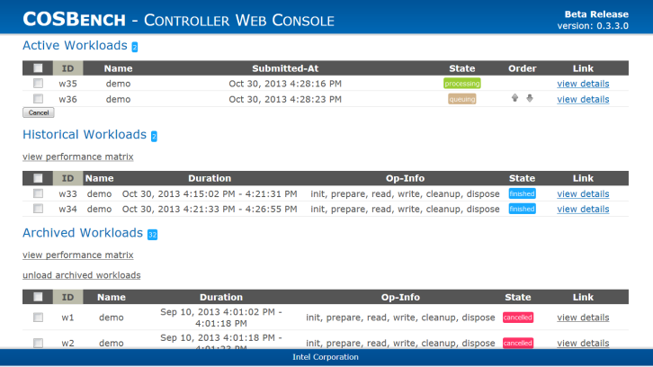
- Configuring Workloads
  - Introduction
workload
auth
storage
workflow
workstage
auth
storage
work
auth
storage
operation
A workload is represented as an XML file with the following structure:
- Workload → work stage → work → operation
- If necessary, one workload can define one or more work stages.
- Execution of multiple work stages is sequential, while execution of work in the same work stage is parallel.
- For each piece of work, “workers” is used to tune the load.
- Authentication definition (auth) and storage definition (storage) can be defined at multiple levels, and lower-level definitions overwrite upper-level ones. For example, operations use the definitions for auth and storage at its work instead of those at workload level.
  - Selection Expression (also referred to as Selector)
    - Overview
- In workload configuration, the elements below support one “config” attribute (auth, storage, work, operation); the attribute contains an optional parameter list with key-value pairs that use the format “a=a_val;b=b_val”.

<work name="read" workers="100" config="containers=u(1,32);objects=u(1,100)" />

Attribute
Parameter

- In the parameter list, commonly used keys include “containers”, “objects”, and “sizes”, which are used to specify how to select container, object, and size. One expression is used to help define selection.
- The number in an expression has a different meaning for object size versus object or container. For object size, the number represents a quantity, while for object or container, the number represents a numbering or label.
    - Selector
Expression | Format | Comments
constant | c(number) | Only use specified number  For example, c(1) means the element numbering will be fixed in one fixed number
uniform | u(min, max) | Select from [min, max] evenly  For example, u(1,100) means the element numbering is evenly selected from the 100 elements; the selection is random, and some numbers may be selected more than once, while some may never be selected
range | r(min,max) | Select from [min,max] incrementally  For example, r(1,100) means the element numbering incrementally increases from min to max, and each number is selected only once; this is generally used in special stages (init, prepare, cleanup, dispose), if it’s used in normal stage, please make sure you understand how to use it correctly (see FAQ 6.1.17 for details).
sequential | s(min,max) | Select from [min,max] incrementally  For example, s(1,100) means the element numbering incrementally increases from min to max, and each number is selected only once. This is done thread-safe.
histogram | h(min1|max1|weight1,…) | It provides a weighted histogram generator, to configure it, specify a comma separated list of buckets where each bucket is defined by a range and an integer weight. For example:  h(1|64|10,64|512|20,512|2048|30)KB  Which defines one profile where (1,64)KB is weighted as 10, (64,512)KB is weighted as 20, and (512,2048)KB is weighted as 30. The sum of weights is not necessarily 100.
    - Allowable Combinations
There are additional constraints for selectors based on the element type and work type; the following two tables list allowable combinations.

Selector versus Element:
Key | constant  (c(num)) | uniform  (u(min,max)) | range  (r(min,max)) | sequential  (s(min,max)) | histogram  (h(min|max|ratio))
containers | ✓ | ✓ | ✓ | ✓
objects | ✓ | ✓ | ✓ | ✓
sizes | ✓ | ✓ |  | ✓ | ✓
Selector versus Work:
Key | init | prepare | normal (read) | normal (write) | normal (delete) | cleanup | dispose
containers | r(), s() | r(), s() | c(), u(), r(), s() | c(), u(), r(), s() | c(), u(), r(), s() | r(), s() | r(), s()
objects |  | r(), s() | c(), u(), r(), s() | c(), u(), r() | c(), u(), r(), s() | r(), s()
sizes |  | c(), u(), h() |  | c(), u(), h()
  - Workload
    - General Format
<workload name=”demo” description=”demo benchmark with mock storage” />
    - Attributes
Parameter | Type | Default | Comment
name | String |  | One name for the workload
description | String |  | Some additional information
  - Auth
    - General Format
<auth type="none|mock|swauth|keystone"
config="<key>=<value>;<key>=<value>" />
    - Attributes
Attribute | Type | Default | Comment
type | String | none | Authentication type
config | String |  | Parameter list [optional]
    - Authentication Mechanisms
        - none (do nothing, default)
<auth type="none" config="" />
Parameter list:
Parameter | Type | Default | Comment
logging | Boolean | false | Print information to log
retry | Int | 0 | Specifies number of retry attempts if authentication fails
Caching | Boolean | False | Caching authentication information or not
        - mock (delay specified time)
<auth type="mock" config="" />
Parameter list:
Parameter | Type | Default | Comment
token | String | “token” | Token string
delay | Long | 20 | Delay time in milliseconds
retry | Int | 0 | Specifies number of retry attempts if authentication fails
        - swauth (for OpenStack Swift)
<auth type="swauth" config="username=test:tester;password=testing;url=http://192.168.250.36:8080/auth/v1.0" />
Note that the IP address 192.168.250.36 should be replaced with the actual IP address of the controller node.
Parameter list:
Parameter | Type | Default | Comment
auth_url | String | “http:/192.168.250.36:8080/auth/v1.0” | URL for auth node
username | String |  | Username for authentication. Syntax h account:user
password | String |  | Password for authentication
timeout | Integer | 30,000 | Connection timeout value in milliseconds
retry | Int | 0 | Specifies number of retry attempts if authentication fails
        - keystone (for OpenStack Swift)
<auth type="keystone" config="username=tester;password=testing;tenant_name=test;url=http://192.168.250.36:5000/v2.0;service=swift" />
Note that the IP address 192.168.250.36 should be replaced with the actual IP address of the controller node.
Parameter list:
Parameter | Type | Default | Comment
auth_url | String | “http://192.168.250.36:8080/auth/v2.0” | URL for auth node
username | String |  | Username for authentication. Syntax account:user
password | String |  | Password for authentication
tenant_name | String |  | Name of tenant to which the user belongs
service | String | “swift” | Service requested
timeout | Integer | 30,000 | Connection timeout value in milliseconds
retry | Int | 0 | Specifies number of retry attempts if authentication fails
        - httpauth (Http BASIC/DIGEST)
<auth type="httpauth" config="username=test;password=testing;auth_url=http://192.168.250.36:8080/" />
Note that the IP address 192.168.250.36 should be replaced with the actual IP address of the controller node.
Parameter list:
Parameter | Type | Default | Comment
auth_url | String | “http://192.168.250.36:8080/” | URL for auth node
username | String |  | Username for authentication.
password | String |  | Password for authentication
timeout | Integer | 30,000 | Connection timeout value in milliseconds
retry | Int | 0 | Specifies number of retry attempts if authentication fails
  - Storage
    - General Format
<storage type="none|mock|swift|ampli|s3|sproxyd|oss|…" config="<key>=<value>;<key>=<value>" />
    - Attributes
Attribute | Type | Default | Comment
type | String | “none” | Storage type
config | String |  | Parameter list [optional]
    - Storage Systems
        - none (do nothing, default)
<storage type="none" config="" />
Parameter list:
Parameter | Type | Default | Comment
logging | Boolean | false | Print information to log
        - mock (delay specified time)
<storage type="mock" config="" />
Parameter list:
Parameter | Type | Default | Comment
logging | Boolean | false | Print information to log
size | Integer | 1024 | Object size in bytes
delay | Integer | 10 | Delay time in milliseconds
errors | Integer | 0 | Set error limit to emulate failure
printing | Boolean | False | Print out data content
        - Swift (OpenStack Swift)
<storage type="swift" config="" />
Parameter list:
Parameter | Type | Default | Comment
timeout | Integer | 30,000 | Connection timeout value in milliseconds
token | String | AUTH_xxx | Authentication token, this parameter is only necessary if user expects to bypass authentication.
storage_url | String | http://127.0.0.1:8080/auth/v1.0 | The storage url, this parameter is only necessary if user expects to bypass authentication.
policy | String |  | Storage Policies is a feature introduced in Swift 2.0 that allows applications to select a different set of characteristics for their storage on a per container basis. See the latest Swift docs for full information at http://docs.openstack.org/developer/swift/overview_architecture.html.  It’s only necessary if user expects to leverage different storage policy instead of the default.
        - Ampli (Amplidata)
<storage type="ampli"config="host=192.168.10.1;port=8080;nsroot=/namespace;policy=14195ca863764fd48c281cb95c9bd555" />
Parameter list:
Parameter | Type | Default | Comment
timeout | Integer | 30,000 | Connection timeout value in milliseconds
host | String |  | Controller node IP to connect
port | Integer |  | Port
nsroot | String | “/namespace” | Namespace root
policy | String |  | Policy ID the namespace will access
        - S3 (Amazon S3)
<storage type="s3" config="accesskey=<accesskey>;secretkey=<scretkey>; endpoint=<endpoint>; proxyhost=<proxyhost>;proxyport=<proxyport>" />
Parameter list:
Parameter | Type | Default | Comment
timeout | Integer | 30,000 | Connection timeout value in milliseconds
accesskey | String |  | The base64-encoded username
secretkey | String |  | The base64-encoded password
endpoint | String | http://s3.amazonaws.com | The endpoint url (the url s3 storage exposes for external access).
proxyhost | String |  | The http proxy host name or ip address if required.
proxyport | integer |  | The http proxy port if required.
        - Sproxyd (Scality)
<storage type="sproxyd" config="hosts=<host1,host2,…>;port=<port>; base_path=<path>;pool_size=<maxTotal,maxPerRoute>" />
Parameter list:
Parameter | Type | Default | Comment
hosts | String | 127.0.0.1 | Comma separated list of host names/IP addresses. Requests are load balanced across all the hosts using a simple round robin algorithm
port | integer | 81 | Port used by the connector
base_path | String | /proxy/chord | Path to an sproxyd profile (this profile must have by_path_enabled = 1)
pool_size | integer or comma separated pair of integers | 60,10 | The first value s the size of the connection pool. The second value, if provided, is the maximum number of connections for a given HTTP route.
        - Cdmi (SNIA CDMI)
<storage type="cdmi" config="type=<cdmi|non-cdmi; custom_headers=<header:value_reference>" />
Parameter list:
Parameter | Type | Default | Comment
type | String | “cdmi” | Options: “cdmi” or “non-cdmi”, it indicates the content type to be used, “cdmi” means the storage access will follow cdmi content type, “non-cdmi” means the storage access will follow non-cdmi content type.
Customer_headers | String |  | This is an experimental parameter to see if possible to support cdmi derivatives, which may require additional headers. The parameter may be removed without notification.
        - Cdmi_swift (SNIA CDMI for swift)
<storage type="cdmi_swift" config="" />
Parameter list:
Parameter | Type | Default | Comment
timeout | Integer | 30,000 | Connection timeout value in milliseconds
        - librados (for Ceph)
<storage type="librados" config="endpoint=<endpoint>;accesskey=<accesskey>;secretkey=<secretkey>" />
Parameter list:
Parameter | Type | Default | Comment
endpoint | String | 127.0.0.1 | The endpoint could be e.g. the monitor node.
accesskey | String |  | The username like “admin”.
secretkey | String |  | The secretkey is the key from the admin keyring.
Note:
  - Don’t use librados to create containers (pools), they will default to only have 64 pgs, which renders them pretty useless, see http://ceph.com/docs/master/rados/operations/pools/
        - OSS (Aliyun OSS)
<storage type="oss " config="accesskey=<Access Key ID>;secretkey=< Access Key Secret>; endpoint=<endpoint>; proxyhost=<proxyhost>;proxyport=<proxyport>" />
Parameter list:
Parameter | Type | Default | Comment
 | Integer | 50,000 | Connection timeout value in milliseconds
accesskey | String |  | Is a identity to use aliyun API
secretkey | String |  | Is used to sign your access parameters to prevent tampering
endpoint | String | oss-cn-hangzhou.aliyuncs.com | The endpoint url (the url oss storage exposes for external access).
proxyhost | String |  | The http proxy host name or ip address if required.
proxyport | integer |  | The http proxy port if required.

Parameter | Type | Default | Comment
logging | Boolean | false | Print information to log
size | Integer | 1024 | Object size in bytes
delay | Integer | 10 | Delay time in milliseconds

        - HCP (Hitachi Content Platform)
<storage type="hcp" config="endpoint=<tenant>.<cluster>.<domain>.com;username=<tenantUser>;password=<password>;signer_version=v4;protocol=https;disable_cert_check=true" />

Parameter list:
Parameter | Type | Default | Comment
endpoint | String |  | The tenant endpoint to use
username | String |  | The tenant username with appropriate permissions
password | String |  | The password corresponding with the username
Protocol | String | https | Either http or https to specify whether or not to use SSL
max_error_retry | Integer | 0 | Maximum number of retries a client will do on error
connection_timeout | Integer | 60000 | Milliseconds allowed before timing out on a request
Socket_timeout | Integer | 30000 | Milliseconds allowed before a socket times out
signer_version | String | V4 | The type of authentication to use. Valid values are v4, v2, hcp, and anon
optimize_dir | Boolean | true | Whether or not to optimize the directory structure. Setting this to false. Will result in a flat directory structure
disable_cert_check | Boolean | true | Whether or not to disable certificate checking for SSL connections
use_expect_continue | Boolean | true | Whether or not each client should be configured to wait for the 100 continue response from the server before uploading data

Parameter | Type | Default | Comment
logging | Boolean | false | Print information to log
size | Integer | 1024 | Object size in bytes
delay | Integer | 10 | Delay time in milliseconds
  - Work Stage
    - General Format
<workstage name="<name>" >
</workstage>
    - Attributes
Attribute | Type | Default | Comment
name | String |  | One name for the stage
  - Work
    - General Format
<work name="main" type="normal" workers="128" interval="5" division="none" runtime="60" rampup="0" rampdown="0" totalOps="0" totalBytes="0" afr=”200000” config="" > . . . </work>
There is one normal and four special types of work (init, prepare, cleanup, and dispose). Section 4.7 focuses on normal work, while Section 4.8 covers the special types of work. The form given above is for a full set—different work types will have different valid forms. General rules are given below:
- workers is a key attribute, normally used to control load.
- runtime (including rampup and rampdown), totalOps and totalBytes are attributes that control how to end the work, called ending options. Only one can be set in a work.
    - Attributes
Attribute | Type | Default | Comment
name | String |  | One name for the work
type | String | “normal” | Type of work
workers | Integer |  | Number of workers to conduct the work in parallel
interval | Integer | 5 | Interval between performance snapshots
division | String | “none” | [“none”| “container”| “object”], controls how work is divided between workers
runtime | Integer | 0 | How many seconds the work will execute
rampup | Integer | 0 | How many seconds to ramp up workload; this time is excluded from runtime
rampdown | Integer | 0 | How many seconds to ramp down the workload; this time is excluded from runtime
totalOps | Integer | 0 | How many operations will execute; it should be a multiple of workers
totalBytes | Integer | 0 | How many bytes will transfer, it should be a multiple of the product of workers and size.
driver | string |  | Which driver will execute this work, by default, all drivers will participate the execution.
afr | Integer | 200000 – normal  0 – special work | Acceptable failure rate, it’s in millionth.
  - Special Work
    - General Format
<work type="init|prepare|cleanup|dispose|delay" workers="<number>" config="<key>=<value>;<key>=<value>" />
Special work is different from normal work in the following ways:
- It internally adopts and calculates “totalOps”, so no ending option need be explicitly included in the configuration.
- It has implicitly defined operations, so no operation is needed.
- “delay” is different from others, which causes the work just sleeps for specified seconds.
    - Supported Special Work
        - init (creating specific containers in bulk)
<work type="init" workers="4" config="containers=r(1,100)" />
Parameter list:
Parameter | Type | Default | Comment
containers | String |  | Container selection expression; for example:  c(1), r(1,100)
cprefix | String | mycontainers_ | Container prefix
csuffix | String | <null> | Container suffix
        - prepare (inserting specific objects in bulk)
<work type="prepare" workers="4" config="containers=r(1,10);objects=r(1,100);sizes=c(64)KB" />
Parameter list:
Parameter | Type | Default | Comment
containers | String |  | Container selection expression; for example:  c(1), u(1,100)
cprefix | String | mycontainers_ | Container prefix
csuffix | String | <null> | Container suffix
objects | String |  | Object selection expression; for example:  c(1), u(1,100)
oprefix | String | myobjects_ | Object prefix
osuffix | String | <null> | Object suffix
sizes | String |  | Size selection expression with unit (B/KB/MB/GB); for example:  c(128)KB, u(2,10)MB
chunked | Boolean | False | Upload data in chunked mode (or not)
content | String | “random”(default)  ”zero” | Fill object content with random data or all-zeros
createContainer | Boolean | False | Create related container if it does not exist
hashCheck | Boolean | False | Do work related to object-integrity checking
        - cleanup (removing specific objects in bulk)
<work type="cleanup" workers="4" config="containers=r(1,10);objects=r(1,100)" />
Parameter list:
Parameter | Type | Default | Comment
containers | String |  | Container selection expression; for example:  c(1), u(1,100)
cprefix | String | mycontainers_ | Container prefix
csuffix | String | <null> | Container suffix
objects | String |  | Object selection expression; for example:  c(1), u(1,100)
oprefix | String | myobjects_ | Object prefix
osuffix | String | <null> | Object suffix
deleteContainer | Boolean | False | Delete related container if it exists
        - dispose (removing specific containers in bulk)
<work type="dispose" workers="4" config="containers=r(1,100)" />
Parameter list:
Parameter | Type | Default | Comment
containers | String |  | Container selection expression; for example:  c(1), u(1,100)
cprefix | String | mycontainers_ | Container prefix
csuffix | String | <null> | Container suffix
        - delay (inserting a few seconds delay)
<workstage name=”delay” closuredelay=”60” >
<work type="delay" workers="1" />
</workstage>
Parameter list:
Parameter | Type | Default | Comment
closuredelay | Integer |  | How long to delay in seconds.
  - Operation
    - General Format
<operation type="read|write|delete" ratio="<1-100>" config="<key>=<value>;<key>=<value>" />
    - Attributes
Attribute | Type | Default | Comment
type | String |  | Operation type
ratio | Integer
division | Integer |  | Division strategy for this operation
config | String |  | Parameter list
    - Supported operations
        - container/object naming convention:
- By default, containers are named using the format “mycontainers_<n>”, and objects are named using the format “myobjects_<n>”, where <n> is a number defined by one selection expression in the parameter list.
- Container/object naming can be modified through cprefix/csuffix or oprefix/osuffix.
        - read
<operation type="read" ratio="70" config="containers=c(1);objects=u(1,100)" />
Parameter list:
Parameter | Type | Default | Comment
containers | String |  | Container selection expression; for example:  c(1), u(1,100)
cprefix | String | mycontainers_ | Container prefix
csuffix | String | <null> | Container suffix
objects | String |  | Object selection expression; for example:  c(1), u(1,100)
oprefix | String | myobjects_ | Object prefix
osuffix | String | <null> | Object suffix
hashCheck | Boolean | False | Do work related to object-integrity checking
        - write
<operation type="write" ratio="20" config="containers=c(2);objects=u(1,1000);sizes=c(2)MB" />
Parameter list:
Parameter | Type | Default | Comment
containers | String |  | Container selection expression; for example:  c(1), u(1,100)
cprefix | String | mycontainers_ | Container prefix
csuffix | String | <null> | Container suffix
objects | String |  | Object selection expression; for example:  c(1), u(1,100)
oprefix | String | myobjects_ | Object prefix
osuffix | String | <null> | Object suffix
sizes | String |  | Size selection expression with unit (B/KB/MB/GB); for example:  c(128)KB, u(2,10)MB
chunked | Boolean | False | Upload data in chunked mode (or not)
content | String | “random”(default)  “zero” | Fill object content with random data or all zeros
hashCheck | Boolean | False | Do work related to object-integrity checking
        - filewrite
<operation type="filewrite" ratio="20" config="containers=c(2);fileselection=s;files=/tmp/testfiles" />
Parameter list:
Parameter | Type | Default | Comment
containers | String |  | Container selection expression; for example:  c(1), u(1,100)
cprefix | String | mycontainers_ | Container prefix
csuffix | String | <null> | Container suffix
fileselection | String |  | Which selector should be used only put selector identifier (e.g. s for sequential). *
files | String |  | Path to the folder containing the files to be uploaded. Path must exist
chunked | Boolean | False | Upload data in chunked mode (or not)
hashCheck | Boolean | False | Do work related to object-integrity checking
*) Objects are not read by filename. Java reads the files in the folder in a random way. Use Sequential selection to assure each object will be picked once, before the first object is picked a second time. Limit the amount of objects put by using totalOps or runtime in your work definition.
        - delete
<operation type="delete" ratio="10" config="containers=c(2);objects=u(1,1000)" />
Parameter list:
Parameter | Type | Default | Comment
containers | String |  | Container selection expression; for example:  c(1), u(1,100)
cprefix | String | mycontainers_ | Container prefix
csuffix | String | <null> | Container suffix
objects | String |  | Object selection expression; for example:  c(1), u(1,100)
oprefix | String | myobjects_ | Object prefix
osuffix | String | <null> | Object suffix
        - list
<operation type="list" ratio="10" config="containers=c(2);objects=u(1,1000)" />
Parameter list:
Parameter | Type | Default | Comment
containers | String |  | Container selection expression; for example:  c(1), u(1,100)
cprefix | String | mycontainers_ | Container prefix
csuffix | String | <null> | Container suffix
objects | String |  | Object selection expression; for example:  c(1), u(1,100)
oprefix | String | myobjects_ | Object prefix
osuffix | String | <null> | Object suffix

    - Examples
        - pure read
e.g: 100% read, 16 users, 300 seconds
<work name="100r16c30s" workers="16" runtime="300">
<operation type="read" ratio="100" config="..." />
</work>
        - pure write
e.g.: 100% write, 8 clients, 600 seconds
<work name="100w8c600s" workers="8" runtime="600">
<operation type="write" ratio="100" config="..." />
</work>
        - mixed operations
e.g.: 80% read, 20% write, 32 clients, 300 seconds
<work name="80r20w32c300s" workers="32" runtime="300">
<operation type="read" ratio="80" config="..." />
<operation type="write" ratio="20" config="..." />
</work>

  - Additional comments
    - Overview
A few parameters need additional emphasis to make user define exact workload, this section will cover them.
    - Division strategy
Division strategies are used to divide a work into multiple non-overlapping partitions which have smaller ranges of containers or objects, there strategies are supported: container (based), object (based), or none.
Different stage type has different default division strategy, for init/dispose, the default is “container”, for prepare/cleanup, the default is “object”, and for normal, the default is “none”.
We will use one example to explain the difference between different division strategies, here is a work as following:
<work name="main" workers="4" runtime="300" division=”?”>
<operation type="read" ratio="100" config="containers=u(1,8);objects=u(1,1000)" />
</work>
If "division=container", it means the data range will be partitioned by container, the access pattern looks like:
Worker | Container Range | Object Range
#1 | 1-2 | 1-1000
#2 | 3-4 | 1-1000
#3 | 5-6 | 1-1000
#4 | 7-8 | 1-1000
(Note: it's not supported if # of workers is larger than # of containers.)
If "division=object", it means the data range will be partitioned by object, the access pattern looks like:
Worker | Container Range | Object Range
#1 | 1-8 | 1-250
#2 | 1-8 | 251-500
#3 | 1-8 | 501-750
#4 | 1-8 | 751-1000
(Note: it's not supported if the # of workers is larger than the # of objects.)
If "division=none", it is used to turn off division so that each worker does exactly what the work has specified—there is no partitions of the work, so each worker may touch all containers or objects.

- Results
All results are stored in the “archive” directory.
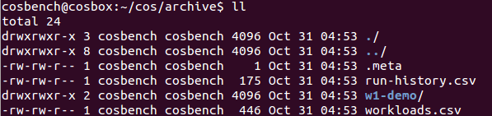
  - Structure
- .meta
  - The starting run id
- run-history.csv
  - Record all historical workload runs, including time and major stages
- workload.csv
  - Record overall performance data for all historical workload runs
- Sub-directories
  - Prefixed with “w<runid>-” store data for each workload run
  - Per-Run Data
The following is a sample per-run data list:
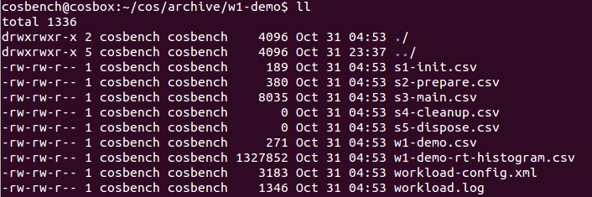
    - Overall Performance Data (e.g., w1-demo.csv)
One line per stage:
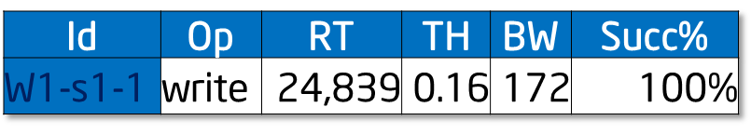
    - Timeline Data (e.g., s3-main.csv)
One file per stage; can be imported into a spreadsheet program to draw a timeline chart, or processed with csvtool:
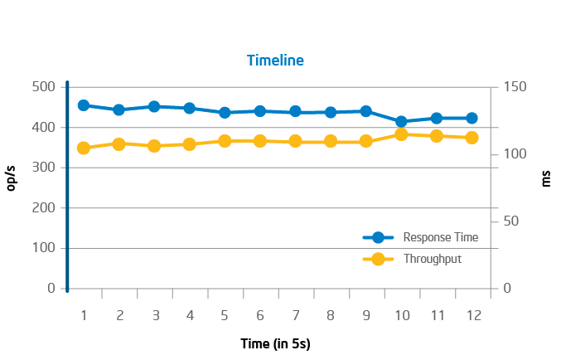
    - Response-Time Histogram Data (e.g., w1-demo-rt-histogram.csv)
Distribution of response time is a valuable indicator to understand Quality of Service; histogram data is generated for this purpose. The data is grouped from 0 to 500,000 ms with 10 ms stepping.
In a histogram diagram, the bar represents the number of samples in each grouping. The curve is the Cumulative Distribution Function (CDF), which can reveal insights regarding topics such as the response time at the 90th percentile.
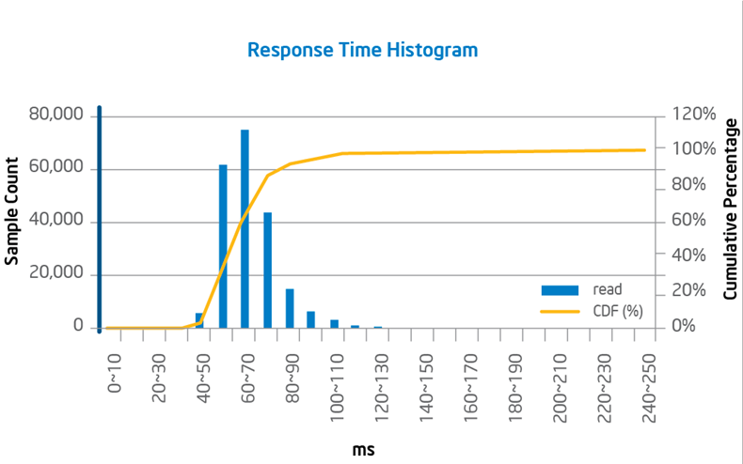
90th Percentile
    - Response Time breakdown (e.g., s3-main.csv)
Beside average response time, average processing time will also be reported in data file, it would help understand performance bottleneck through time breakdown.
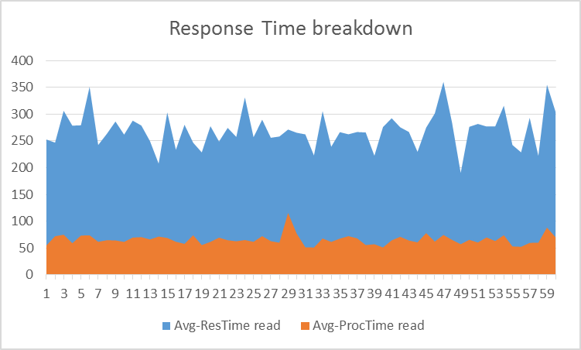
    - Workload-config.xml
- The workload configuration file used in this run
    - Workload.log
- The run time log, which is helpful for troubleshooting
  - Metrics
    - Throughput (Operations/s or Op/s)
- The operations completed in one second
- The reported throughput is calculated by dividing total successful requests by total run time
    - Response Time (in ms)
- The duration between operation initiation and completion
- The reported Response Time is the average of response time for each successful request
- One additional processing time is already reported to help breakdown response time.
    - Bandwidth (MB/s)
- The total data in MB transferred per second
- The reported bandwidth is calculated by dividing total bytes transferred by total run time
- 1 MB = 1000*1000 bytes
    - Success Ratio (%)
- The ratio of successful operations
- The reported success ratio is calculated by dividing the number of successful requests by the total number of requests
    - Other Metrics
- Op-count: total number of operations
- Byte-count: total data transferred
- FAQs
  - General
- Is listening on port 19088/18088 configurable, and, if so, how?
Yes; conf/controller-tomcat-server.xml specifies the port to be used for the controller, and driver-tomcat-server.xml specifies the port to be used for the driver.
- What is the difference between “cancelled” and “terminated”?
“Cancelled” means the workload is cancelled by user at runtime, while “terminated” indicates errors during runtime, which typically require user action for resolution.
- Can I submit multiple workloads to be run sequentially?
Yes; COSBench can accept multiple workloads at one time and run them one by one.
- Is it possible to cancel a queued workload?
No; cancellation is only for the running workload.
- Can COSBench be installed on other Linux* distributions, such as Red Hat Enterprise Linux?
Yes; versions prior to v2.1 support Red Hat Enterprise Linux 6 by default, and versions beginning with v2.1 have adopted Ubuntu 12.04.1 LTS as the default OS.
- Is it possible to reuse the files from a previous test without removing or cleaning up the old files?
Yes; the special stages such as init, prepare, cleanup, and dispose are all optional, and even regarding the main stage, users can choose the stage sequence appropriate to their testing requirements. To reuse data, the user needs to fill all data and perform all tests before the cleanup and dispose stages (for example, in the sequence init, prepare, test1, test2, … cleanup, dispose). A related sample workload configuration file is included in conf/reusedata.xml.
- Is it possible to define multiple main or other stages?
Yes; to avoid name confusion, they should be named with different labels. For example, users can define multiple init stages to create different container sets, or define multiple main stages to perform different tests in one workload.
- If errors occur on running workloads, where can users see more details?
There is one workload.log under that workload’s corresponding folder (archive\<workload id>\workload.log); inspecting this file can help determine the cause of errors.
- What steps should be taken to resolve a test being stuck at the init stage?
Verify that all COSBench machines are accessible through an HTTP connection using Curl (“curl http://<controller-host>:19088/controller/index.html” or “curl http://<driver-host>:18088/driver/index.html”). If a firewall has blocked the HTTP connection, the user must open the appropriate ports on the firewall. For the controller node, the ports are 19088 and 19089; for driver nodes, the ports are 18088 and 18089.
- Is there a tool to distribute COSBench on multiple nodes?
Although COSBench itself does not provide a tool for this type of package distribution, many external solutions exist for this purpose, such as scp and shared folder (samba).
- Why does COSBench show a workload test as “complete,” even though there are errors reported in workload.log?
A test may reflect “complete” status although errors are recorded in the log for normal work, as long as special work has completed successfully.
COSBench treats “init”, ”prepare”, ”cleanup,” and “dispose” operations as special work that must be completed without error to result in “completed” status; errors in special work will terminate the test.
On the other hand, normal work associated with performance measurement can tolerate failures, which are tracked by the “success ratio.”
- Are there any recommendations for the number of workers in the “init”, “prepare”, “cleanup,” and “dispose” stages?
Work performed in the “init” and “dispose” stages creates and deletes containers. In our testing with Keystone plus Swift, these tasks can be completed in approximately three minutes with a recommended ratio of one worker for every 32 containers, with 100 objects in each container and a 64 KB object size. Generally, the number of containers should be defined as a multiple of the number of workers.
Work performed in the “prepare” and “cleanup” stages creates or deletes objects, and the time required depends on the number of objects. Generally, the number of objects should be defined as a multiple of the number of workers. Increasing the number of workers can accelerate the process.
Work performed in the “main” identifies bottlenecks, and tuning the workers parameter controls the load to the storage system. The number of workers should be gradually increased until performance decreases.
- How can “OutOfMemory” errors from the driver be prevented after running COSBench for a long time?
Maximum heap size for the Java process can be specified in the “cosbench-start.sh” script to prevent exhausting memory. For example, the parameter “-Xmx2g” would limit the maximum heap size to 2 GB.
- How can read and write be split to different containers?
Users can assign containers to be accessed at the operation level, to split reads and writes to different containers; the different container range can be set using the “containers” parameter in “config” as follows:
<operation type=”read” ratio=”80” config=”containers=u(1,2);objects=u(1,50)” />
<operation type=”write” ratio=”20” config=”containers=u(3,4);objects=u(51,100);sizes=c(64)KB” />
One sample workload configuration file is included in conf/splitrw.xml.
- How can different containers be specified for different configurations, such as those with different object sizes?
Users can assign different container sets for different configurations using the “cprefix” parameter. For example, users can differentiate between configurations with different sizes by specifying an object size such as “64K” using “cprefix” to avoid confusion and unexpected overwriting as follows:
<operation type=”read” ratio=”80” config=”cprefix=100M_;containers=u(1,32);objects=u(1,50)” />
In this case, the container name will be prefixed with “100M_” in the target storage system. Users can take advantage of this capability by browsing to the location http://<IP of Amplistor controller node>:8080/namespace as shown below:
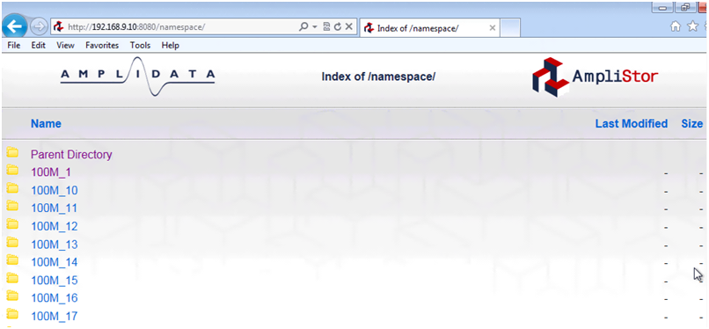
- When a workload is terminated, where can users obtain the log files to help troubleshoot the issue?
Log files are located in two separate places:
- In the “log” folder within the COSBench installation folder. The “system.log” file in this location documents COSBench system activities, including the check for workload configuration file. If a required parameter is missing or mistyped (for example, “sizes” in the “prepare” stage), this file will contain an entry such as “driver report error: no such key defined: sizes” as shown below:
- In the “workload” folder in the “archive” folder within the COSBench installation folder. The “workload.log” file in this location documents workload runtime activities. If failed operations occur while the workload is running, an error (typically HTTP-related) will be logged in this file.
- Can I use range selector in normal stage, how to do it?
Yes, range selector can be used in normal stage, but it’s discouraged, as it will involve some subtle constraints. Firstly, range selector normally needs combine with “totalOps” to terminate the execution when all elements are enumerated. Secondly, the count of container should be relatively-prime to the count of objects, otherwise, the actual access range is only one of the greatest command divisor of the two counts. E.g., for below configuration, it’s expected to create 1600 unique objects, but actually, it only creates 800 (=32*50/2) unique objects.
<work name="main" workers="8" totalOps="1600">
<operation type="read" ratio="100" config="containers=u(1,32);objects=u(51,100);sizes=c(64)KB" />
</work>
- Can I run multiple drivers on the same node, how to do it?
Yes, COSBench doesn’t constraint how many drivers can run on the same node, but as by default driver will listen on port 18088, to avoid port confliction, user needs set different driver process to different listening ports.
To change the listening port, user needs edit conf/driver-tomcat-server.xml, and change “port” value below to distinguished number for different driver
<Connector port="18088" protocol="HTTP/1.1" />
- If there’s any way from COSBench side to identify which object was created failed ?
Yes, it’s possible to print out the object name, but it requires to change the logging level for COSBench Driver processes. General steps are as following:
- On each driver node, creating one driver.conf file in conf/ folder with below lines if not exists:
[driver]
Log_level = DEBUG
- Restarting all driver processes
  - Swift
- How can long prepare times associated with large object sizes (e.g., 1 GB) be avoided?
A large number of large objects can saturate network bandwidth, resulting in low performance. If network bandwidth is not saturated, the “workers” parameter can be increased, to better utilize bandwidth.
- Are there any special changes for operating with large object sizes (e.g., 1 GB)?
Yes; for testing with large object sizes, consider the following:
- Longer ramp-up time (specified using the parameter “rampup”) can help drive higher performance, while longer run time (specified using the parameter “runtime”) can help drive more consistent results. The optimal combination of settings for these parameters depends on individual usage circumstances. To help determine appropriate settings, run a test case with “runtime” set for a long run time (e.g., 30 minutes) without setting the “rampup” parameter. Consult the resulting timeline curve to determine how many seconds are needed to ramp up in this case; the “runtime” parameter can then be set to 10 times that “rampup” value.
- As the time for each operation to complete increases, it becomes more likely that timeout errors will occur; this effect can be mitigated using the “timeout” parameter in “config”, which uses milliseconds as units. For Swift, typical syntax is as follows:
<storage type="swift" config="timeout=100000" />
- Users should also verify proper setup of the system under test, outside the scope of COSBench itself; for example, errors or performance deficits may occur because of improper setup of back-end storage.
- How can the termination of workloads in the authentication phase be overcome when large numbers of workers (e.g., 1024) are configured with Keystone, so that testing can be completed successfully?
The new parameter “retry” is introduced for the “auth” section in the workload configuration file to help overcome failures in the authentication phase. Following is a sample configuration:
<auth type="keystone" config="username=operator;password=intel2012;tenant_name=cosbench;auth_url=http://10.10.9.100:5000/v2.0;service=swift;retry=10"/>
- How to test with tempauth?
Tempauth actually follows the same procedure as swauth, so just use swauth authentication mechanism for tempauth.
- Is storage policy supported, how to get it working?
Yes, the storage policy (http://docs.openstack.org/developer/swift/overview_architecture.html) was supported starting from v0.4.0.0 release.
The supporting involves one new “policy” parameter as following:
<storage type="swift" config="policy=gold " />
Here “gold” could be replaced with any policy name user defines in “/etc/swift/swift.conf” as following:
[storage-policy:0]
name = gold
default = yes

[storage-policy:1]
name = silver
In this case, the policy name may be “gold” or “silver”, which will be used in COSBench workload configuration file.
For those who don’t care about storage policy, just remove “policy” parameter in swift workload configuration file.
  - AmpliStor
- Where does the system get the string for the policy in the .xml file?
Users can access the Amplidata controller node and manage the available policies by browsing to the location http://<IP of Amplistor controller node>:8080/manage/policy as shown below:
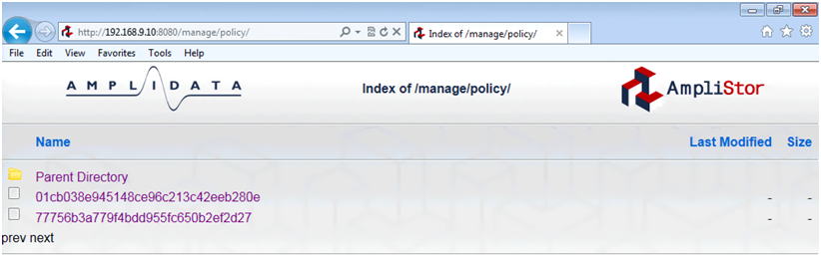
- How can object range affect performance?
Expanding the object range may improve write performance by reducing write conflicts. For example, changing “u(1,100)” to “u(1,10000)” will expand the object range from 100 objects to 10,000 objects.
- How can one simplify policy UID settings?
Only the “init” stage needs policy UID; other stages such as prepare, main, cleanup, and dispose don’t need to have the policy UID set. If there is no “init” stage in the workload, no policy UID is needed.
- How to use “nsroot” parameter in different stages?
“nsroot” parameter is introduced to support amplistor v2.5 and plus, where accessing namespaces needs a separate root path from objects. So this parameter is only necessary for the work involving namespace accessing like that in init/dispose stages. For other stages such as prepare, main, cleanup, there are two options, one is just removing “nsroot” parameter, another one is to set “nsroot” to “/namespace” instead of “/manage/namespace”.
If “nsroot=/manage/namespace” is set in main stage, normally, some similar exceptions will pop up as below:
2013-11-20 10:45:33,764 [ERROR] [Writer] - fail to perform write operation
com.intel.cosbench.api.storage.StorageException: org.apache.http.client.ClientProtocolException
...
Caused by: org.apache.http.client.NonRepeatableRequestException: Cannot retry request with a non-repeatable request entity. The cause lists the reason the original request failed.
...
Caused by: java.net.SocketException: Broken pipe
...

  - S3
- What’s the usage for parameter “proxyhost” and “proxyport”?
In some cases (e.g., in corporate network), users need go through one http proxy to reach Amazon S3 service, “proxyhost” and “proxyport” is used to give chance to configure http proxy settings.
- Can I route requests to specified region in Amazon S3?
S3 adaptor supports one parameter named "endpoint", which is capable to support routing requests to different regions. e.g., setting "endpoint=https://s3-us-west-1.amazonaws.com" will create buckets in Oregon region. Detailed s3 regions can be found at: http://docs.aws.amazon.com/general/latest/gr/rande.html#s3_region
  - Ceph
- What approaches are supported to access Ceph Object Storage?
COSBench supports to access Ceph Object Storage through Rados Gateway, in this case the exposed protocol for access could be S3 or Swift, depending on Rados Gateway configuration. From user’s perspective, the Ceph cluster is a S3 or Swift compatible object storage, and the workload configuration follows S3 or Swift’s configuration rules.
Also, COSBench could interact with Ceph Object Storage with Rados protocol through librados. In this case, the storage adapter should be “librados”. One Caveat is the ceph librados package should be installed on COSBench driver nodes.

  - CDMI
- How to test swift through cdmi protocol?
The storage type “cdmi_swift” is for swift, one sample workload file conf/cdmi-swift-config-sample.xml could help for reference.
- Why using two different cdmi storage types?
COSBench includes two cdmi related adapters: cdmi and cdmi-swift, the major difference is on authentication. CDMI standard adopts HTTP standard authentication mechanisms, while swift uses token-based authentication. CDMI is a general protocol to help accommodate different profiles in one standard, it’s open for extensions, and it’s expected to see more cdmi flavored adapters.
  - HCP
- How to configure HCP to work with the hcp storage adaptor?
Create a tenant with MAPI enabled and use the tenant URL as the endpoint for the hcp storage adaptor
- How to configure HCP to work without SSL, with anonymous authentication, or operate on an existing namespace?
Create a tenant with MAPI enabled as well as a namespace. Configure this namespace to have S3 enabled as well as any other configuration values that you are going to be tested. Edit your XML workload so that it points to this existing namespace. For example setting cprefix=namespace and containers=r(1,1) will use the namespace called “namespace1”.
- Why am I getting 409 conflicts on writes?
This is most likely because the XML workload specified is writing files that already exist in the specified namespace. To mitigate this either change the namespace being written to, change the object prefix, or enable versioning on the specified tenant and namespace

- Appendix A. Sample Configurations
  - Swift
The sample workload configuration describes the following test scenario:
- The test includes five stages: init, prepare, main, cleanup, and dispose.
- The test creates 32 containers, each containing 50 objects 64 KB in size.
- The operation requests are issued to three controller nodes.
- The requests include 80 percent GET(read) operations and 20 percent PUT(write) operations; read operations randomly request an object from the 50 objects from #1 to #50, while write operations randomly create objects with object numbering from #51 to #100.
- At completion, the test cleans up all objects and drops all containers.
To use keystone authentication, use the commented keystone authentication line as a sample (note that the IP address 192.168.250.36 should be replaced with the actual IP address of the controller node).
<?xml version="1.0" encoding="UTF-8" ?>
<workload name="swift-sample" description="sample benchmark for swift">

<storage type="swift" />

<!-- MODIFY ME -->
<auth type="swauth" config="username=test:tester;password=testing;auth_url=http://192.168.10.1:8080/auth/v1.0" />

<!-- Keystone Authentication
<auth type="keystone" config="username=tester;password=testing;tenant_name=test;auth_url=http://192.168.250.36:5000/v2.0;service=swift" />
-->

<workflow>

<workstage name="init">
<work type="init" workers="1" config="containers=r(1,32)" />
</workstage>

<workstage name="prepare">
<work type="prepare" workers="1" config="containers=r(1,32);objects=r(1,50);sizes=c(64)KB" />
</workstage>

<workstage name="main">
<work name="main" workers="8" rampup="100" runtime="300">
<operation type="read" ratio="80" config="containers=u(1,32);objects=u(1,50)" />
<operation type="write" ratio="20" config="containers=u(1,32);objects=u(51,100);sizes=c(64)KB" />
</work>
</workstage>

<workstage name="cleanup">
<work type="cleanup" workers="1" config="containers=r(1,32);objects=r(1,100)" />
</workstage>

<workstage name="dispose">
<work type="dispose" workers="1" config="containers=r(1,32)" />
</workstage>

</workflow>

</workload>
  - AmpliStor
The workload configuration describes the following test scenario:
- The test includes five stages: init, prepare, main, cleanup, and dispose.
- The test creates 32 containers (namespaces), each containing 50 objects 64 KB in size.
- The operation requests are issued to three controller nodes, and each controller node hosts two client daemons.
- The requests include 80 percent GET(read) operations and 20 percent PUT(write) operations; read operations randomly request objects from the 50 objects numbered #1 to #50, while write operations randomly create objects with object numbering from #51 to #100.
- At completion, the test cleans up all objects and drops all containers (namespaces).
For the AmpliStor v2.5 release, “nsroot=/manage/namespace” is necessary for all namespace-related work (init/dispose), for release prior to v2.5, just remove below “nsroot=/manage/namespace” snippets.
<?xml version="1.0" encoding="UTF-8" ?>
<workload name="ampli-sample" description="sample benchmark for amplistor">

<storage type="ampli" config="host=192.168.10.1;port=8080;policy=14195ca863764fd48c281cb95c9bd555" />

<workflow>

<workstage name="init">
<storage type="ampli" config="host=192.168.10.1;port=8080;nsroot=/manage/namespace;policy=14195ca863764fd48c281cb95c9bd555" />
<work type="init" workers="1" config="containers=r(1,32)" />
</workstage>

<workstage name="prepare">
<work type="prepare" workers="1" config="containers=r(1,32);objects=r(1,50);sizes=c(64)KB" />
</workstage>

<workstage name="main">
<work name="c1p0" workers="16" rampup="100" runtime="300">
<storage type="ampli" config="host=192.168.10.1;port=8080" />
<operation type="read" ratio="80" config="containers=u(1,32);objects=u(1,50)" />
<operation type="write" ratio="20" config="containers=u(1,32);objects=u(51,100);sizes=c(64)KB" />
</work>
<work name="c1p1" workers="16" rampup="100" runtime="300">
<storage type="ampli" config="host=192.168.10.1;port=8081" />
<operation type="read" ratio="80" config="containers=u(1,32);objects=u(1,50)" />
<operation type="write" ratio="20" config="containers=u(1,32);objects=u(51,100);sizes=c(64)KB" />
</work>

<work name="c2p0" workers="16" rampup="100" runtime="300">
<storage type="ampli" config="host=192.168.10.2;port=8080" />
<operation type="read" ratio="80" config="containers=u(1,32);objects=u(1,50)" />
<operation type="write" ratio="20" config="containers=u(1,32);objects=u(51,100);sizes=c(64)KB" />
</work>
<work name="c2p1" workers="16" rampup="100" runtime="300">
<storage type="ampli" config="host=192.168.10.2;port=8081" />
<operation type="read" ratio="80" config="containers=u(1,32);objects=u(1,50)" />
<operation type="write" ratio="20" config="containers=u(1,32);objects=u(51,100);sizes=c(64)KB" />
</work>

<work name="c3p0" workers="16" rampup="100" runtime="300">
<storage type="ampli" config="host=192.168.10.3;port=8080" />
<operation type="read" ratio="80" config="containers=u(1,32);objects=u(1,50)" />
<operation type="write" ratio="20" config="containers=u(1,32);objects=u(51,100);sizes=c(64)KB" />
</work>
<work name="c3p1" workers="16" rampup="100" runtime="300">
<storage type="ampli" config="host=192.168.10.3;port=8081" />
<operation type="read" ratio="80" config="containers=u(1,32);objects=u(1,50)" />
<operation type="write" ratio="20" config="containers=u(1,32);objects=u(51,100);sizes=c(64)KB" />
</work>

</workstage>

<workstage name="cleanup">
<work type="cleanup" workers="1" config="containers=r(1,32);objects=r(1,100)" />
</workstage>

<workstage name="dispose">
<storage type="ampli" config="host=192.168.10.1;port=8080;nsroot=/manage/namespace" />
<work type="dispose" workers="1" config="containers=r(1,32)" />
</workstage>

</workflow>

</workload>
As mentioned at the beginning of this guide, COSBench also allows users to create adaptors for additional storage systems. Please refer to the “COSBench Adaptor Development Guide” for details.

