**Project Description**

This project is about docker. Now the question comes what is docker? Basically , **Docker** is a set of [platform as a service](https://en.wikipedia.org/wiki/Platform_as_a_service) (PaaS) products that uses [OS-level virtualization](https://en.wikipedia.org/wiki/OS-level_virtualization) to deliver software in packages called containers. Containers are isolated from one another and bundle their own software, [libraries](https://en.wikipedia.org/wiki/Library_(computing)) and configuration files; they can communicate with each other through well-defined channels. All containers are run by a single [operating system kernel](https://en.wikipedia.org/wiki/Kernel_(operating_system)) and therefore use fewer resources than [virtual machines](https://en.wikipedia.org/wiki/Virtual_machine).

Docker uses a technique called containerization. And docker is a tool of container engine. Docker was developed by Solomon Hykes in 2013.Docker is basically known for launching operating system in just one second. They are not actually operating system but they are containers because they contain applications. They have their own IPAddress.

**Some pre requisite for using docker :**

1.You should have RedHat (linux) in your system.

2. You should have the knowledge of some general commands in linux.

3. yum should be configured for docker.

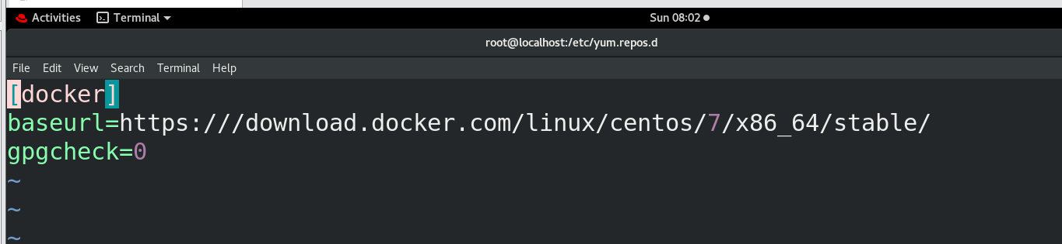

**Guidelines to run the project:**

1. Install python3 in your RedHat.

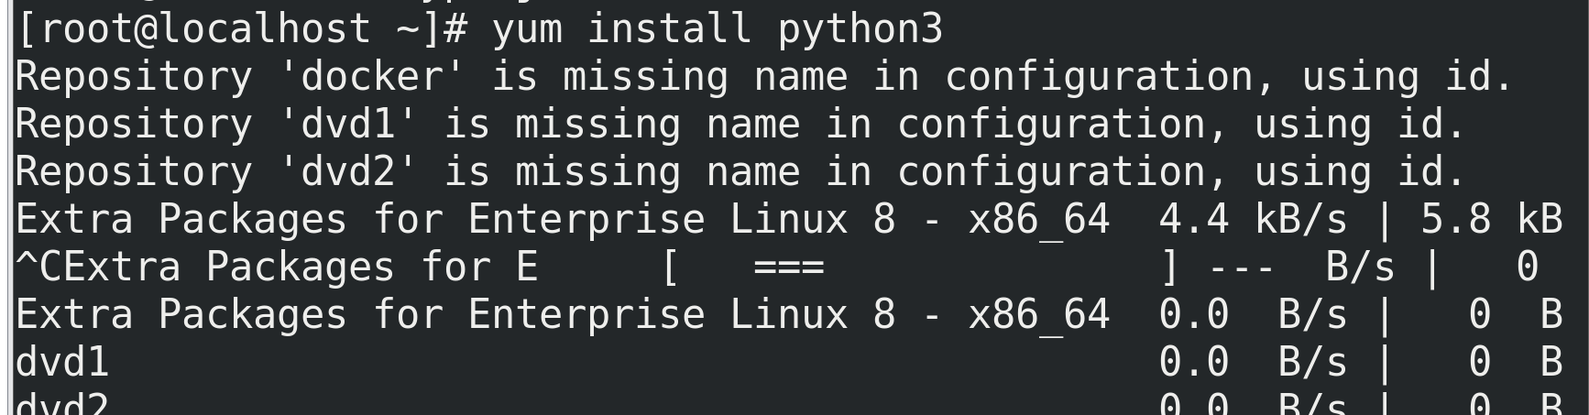

2. Run "python3 project.py" to run this project

3. This screen will appear to you.

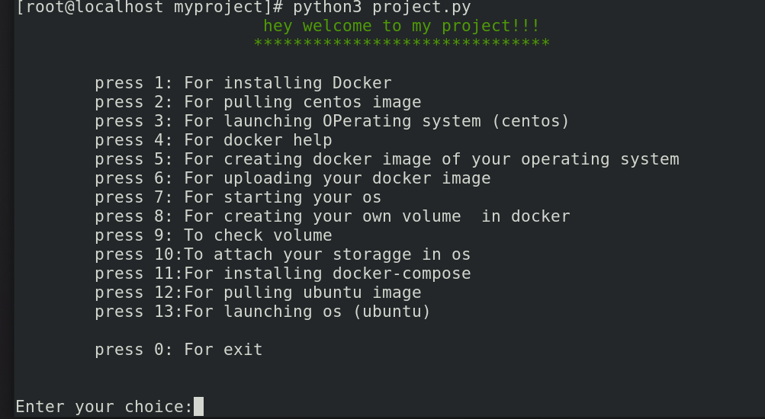

4. Enter your choice.

**Some important points:**

1. Before installing docker , yum must be configured.

2. Before creating an docker image , you must have at least one os launched.

3. Without installation of python , the project won't able to run.

4. Launched container will look like:

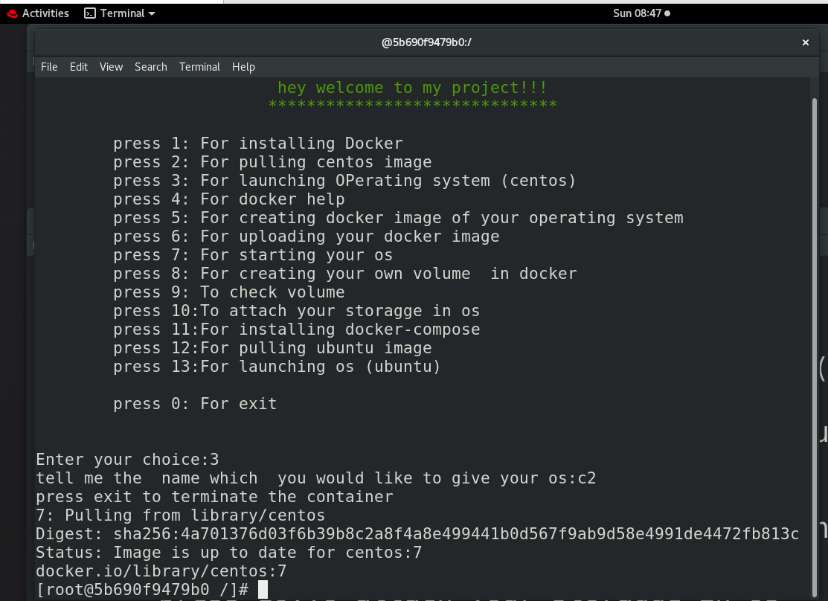

**Links for reference:**

1. For docker-ce installation:

<https://download.docker.com/linux/centos/7/x86_64/stable/Packages/>

2. For installing docker-compose:

a.curl -L "https://github.com/docker/compose/releases/download/1.25.5/docker-compose-$(uname -s)-$(uname -m)" -o /usr/local/bin/docker-compose

**b.** chmod +x /usr/local/bin/docker-compose