**What is WCF? Why should we use WCF?**

**What is WCF?**

WCF stands for ‘Windows communication foundation’. WCF is Microsoft platform for building distributed and interoperable application.

**What is distributed application?**

Distributed application is application where part of it run on two or more computer nodes. Distributed application are also called ‘Connected system’.

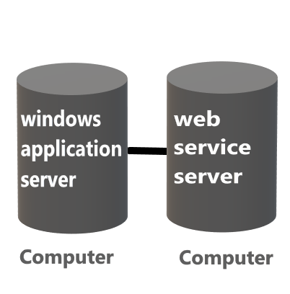

Now consider diagram where windows application is on one computer and web service that it is consuming is on other computer that is present somewhere in world. This is connected system.

**Why build distributed application?**

1. **An enterprise application may need to use the service provide by other enterprise.**

For example an ecommerce application using paytm for payments.

1. **for better scalability**

We can break down application into different layers and these layers will run on different computers. Each of these computers will have its own memory and processor, which help into improving scalability of application. Scalability of application means number of visitor application can handle without degrading performance.

**What is interoperable application?**

An application that can communicate with any other application that is built on any platform is called interoperable application. Web service can communicate with any application built on any platform, whereas .NET remoting service can be consumed only by another .NET application.

**Why should we use WCF?**

**Without WCF**

Consider situation where we have 2 clients and we need to implement service for them.

First client is using java application to interact with our service. This client wants message to be in XML format and protocol to be in http. Without WCF, to satisfy first client requirement we will create ASMX web service.

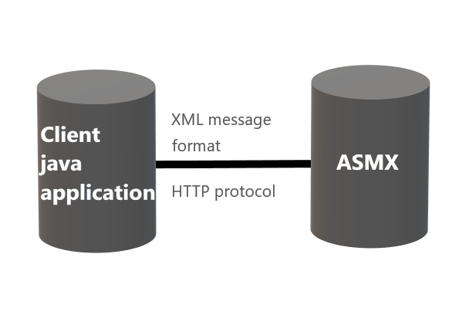

Second Client is using .NET and for better performance, this client wants message format in binary format and protocol to be in TCP. Without WCF, to satisfy second client we will create .NET remoting service.

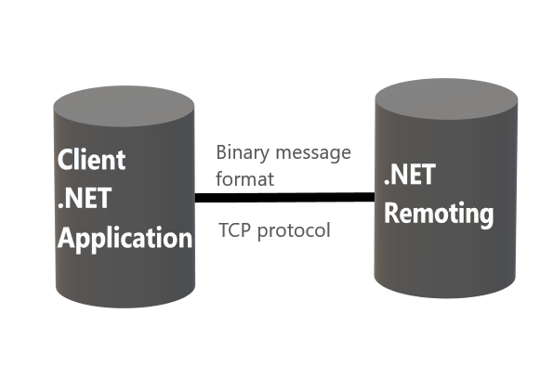

.NET remoting and ASMX are two different technologies, and have complete different programming model. Therefore, developer have to learn two different technology which is time and cost consuming.

So to unit and bring all these communication technologies under one roof Microsoft has come up with a single programming model that is called a WCF. So WCF is going to unify everything that is .NET remoting, IPC, MSMQ queue, TCP, Peer networking and all other communication technology we have.

**With WCF**

With WCF for both client we will implement only one service and to satisfy requirement of different client we will configure different end points.

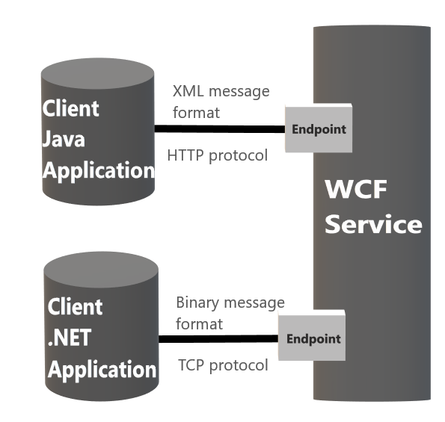

Here first endpoint will transport message in XML format over HTTP protocol and second endpoint will transport message in binary format over TCP protocol. Here we don’t need to change service code to configure these endpoints. Now if we have 3rd client who needs binary message over HTTP protocol, to satisfy that client requirement all we need to do is create new endpoint.

So, we have a single service but then to satisfy requirements of different clients we are creating/configuring different endpoints.