Name: Hitanshi Meshram
CS(AIML)-A
Batch: 03
Roll no. 41

Experiment no.: 03 Date: 13th August, 25

Title:
Write the client server programs using TCP Berkeley socket primitives for wired/wireless network for following
a. To say Hello to Each other.
b. File transfer.

Aim and Objectives:
The aim of this experiment is to design and implement client-server communication using TCP Berkeley socket primitives over wired and wireless networks. The objectives are to establish a reliable TCP connection between client and server, exchange simple greeting messages (“Hello”) to demonstrate basic communication, and perform file transfer to validate reliable, ordered, and complete data delivery. This experiment also helps in understanding socket programming concepts such as socket creation, binding, listening, accepting connections, data transmission, and termination, while comparing performance in wired and wireless environments.

Theory:
Computer networks enable communication between devices over wired (LAN) or wireless (Wi-Fi) media. The TCP/IP protocol suite ensures reliable, connection-oriented data transfer. TCP guarantees error-free, ordered delivery of messages, making it suitable for applications like file transfer and messaging.
Sockets act as communication endpoints. Using the Berkeley Socket API, functions such as socket(), bind(), listen(), accept(), connect(), send(), and recv() allow programmers to implement client-server communication.
In the client-server model, the server listens for client requests and provides services, while the client initiates connections. In this experiment:
- A simple Hello exchange shows successful connection setup.
- A file transfer demonstrates reliable data delivery.
TCP works seamlessly across both wired and wireless networks, abstracting physical differences and ensuring proper communication.

Program:
helloserver.cpp
#include <iostream>
#include <cstring>
#include <unistd.h>
#include <netinet/in.h>

#define PORT 8080

int main() {
int server_fd, new_socket;
struct sockaddr_in address;
int addrlen = sizeof(address);
char buffer[1024] = {0};
const char* hello = "Hello from Server!";

server_fd = socket(AF_INET, SOCK_STREAM, 0);
if (server_fd == 0) {
perror("Socket failed");
return 1;
}

address.sin_family = AF_INET;
address.sin_addr.s_addr = INADDR_ANY;
address.sin_port = htons(PORT);

bind(server_fd, (struct sockaddr*)&address, sizeof(address));
listen(server_fd, 3);

std::cout << "Server listening on port " << PORT << std::endl;

new_socket = accept(server_fd, (struct sockaddr*)&address, (socklen_t*)&addrlen);
read(new_socket, buffer, 1024);
std::cout << "Client: " << buffer << std::endl;

send(new_socket, hello, strlen(hello), 0);
std::cout << "Hello message sent" << std::endl;

close(new_socket);
close(server_fd);
return 0;
}

helloclient.cpp
#include <iostream>
#include <unistd.h>
#include <arpa/inet.h>
#include <string.h>

#define PORT 8080

int main() {
int sock = 0;
struct sockaddr_in serv_addr;
char buffer[1024] = {0};
const char* hello = "Hello from Client!";

sock = socket(AF_INET, SOCK_STREAM, 0);
serv_addr.sin_family = AF_INET;
serv_addr.sin_port = htons(PORT);

inet_pton(AF_INET, "127.0.0.1", &serv_addr.sin_addr);

connect(sock, (struct sockaddr*)&serv_addr, sizeof(serv_addr));
send(sock, hello, strlen(hello), 0);
std::cout << "Hello message sent" << std::endl;

read(sock, buffer, 1024);
std::cout << "Server: " << buffer << std::endl;

close(sock);
return 0;
}

Sample output:
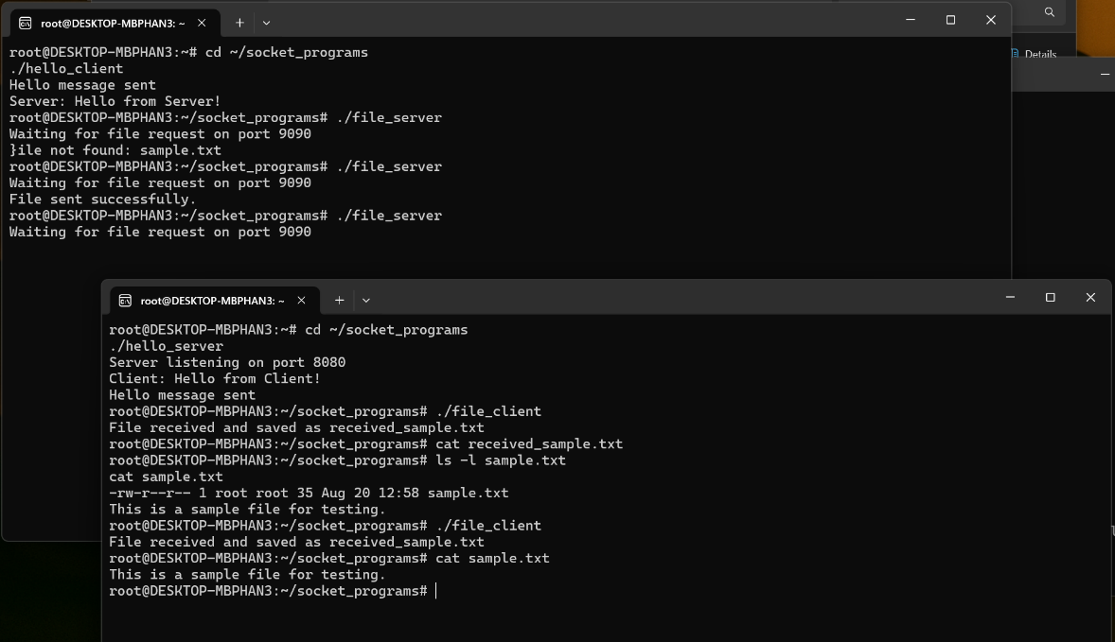

Conclusion:
The client-server programs were successfully implemented using TCP Berkeley socket primitives. The Hello exchange confirmed proper connection establishment, while the file transfer demonstrated reliable and error-free data transmission. The experiment provided hands-on understanding of socket programming, TCP communication, and the working of client-server architecture in both wired and wireless networks.

